Owen Smith (1905121)

Subtitle: Introduction to Sports Management
Due date: Friday 13th March

FUndamentals of Sports Management

Contents page

- Introduction
- Defining the marketing concept within the Sports Industry.
- Marketing for Sports organisations and events
- Public sector
- Private Sector
- not-for-profit sectors.
- How sports marketing can help organisations grow and develop.
- Illustrate theoretical concepts.
- References cited in Harvard referencing style.
- Conclusion

Introduction to Sports Management
Introduction
In this essay it will contain creditable information discussing and defining the key concepts in sports marketing. Information about marketing planning and strategies for major sporting events and sporting organisations will also be explained during this essay, with information being used from top sporting teams and top sporting organisations. It will be explained in three parts, events and organisations run in the public sector, private sector and the not-for- profit sector. Then the next subject for the essay will be how an organisation can benefit from marketing to grow and develop into a successful organisation.
Marketing Concepts
The concept of marketing within sports industry refers to promoting goods and services, through the duration of sporting events and the endorsements by major brands on professional athletes. Sports teams and event organisers will target people who are interested in the sport or event. (Hitesh Bhasin, 2019). This is done so that they can gain the maximum profit by targeting people who love sports or certain specified sports. This is mainly about promoting sports in general and promoting other products within that sport such as equipment and kits. It’s not always about strategy in sports marketing but how the sport is portrayed to the audience. Sometimes just using the sport will allow the hype to build up for a major event like the football world cup and the summer Olympic games. Sports marketing can be found everywhere as it is used in so many different ways and placed on many different platforms. This could include things like billboards on the side of busy roads, advertising boards in stadiums, television advertising, printed media and social media. Social media platforms like Instagram, Facebook and Twitter have become massively important for sports teams and organisations like FIFA, UEFA and UKA.
Marketing in the private sector of the sports industry is important as clubs and organisations are always looking to profit from their audience. Sport teams like for example Chelsea football club will use all three social media platforms to promote match day ticket sales, merchandising, behind the scenes footage of the team which also helps sell mechanise. This is a major benefit to the club as the use of social media platforms is completely free. Organisation like FIFA/UEFA will use these platforms to promote event such as the FIFA World Cup, UEFA champions league and Europa League, these platforms allow FIFA and UEFA to post information about the event straight to the targeted audience. This will allow fans to stay up to date with new rules about the game or updates about certain tournaments or matches.
Another way the private sector advertise is by using athletes from various of different sports to endorse their products. This can either be over a long period of time which is usually classed as a sponsorship deal, where the athlete will get free merchandise and money on a regular basis whether it be annually or monthly. This helps promote the brand as most athletes these days have millions of followers on all social media platforms. It is important that the organisation picks the right athlete that fits their product. For example, a brand like Puma would pick a footballer to endorse as that is their main market for selling products. (PUMA , 2020). They endorse some high-profile names in the football world such as Sergio Aguero, Oliver Giroud and Antoine Griezmann. Athletes will be sponsored by many different companies from different companies like sportswear, sports drinks, commercial, insurance and many other types of companies. It’s so important for companies to use high profile athletes otherwise it will be harder to promote their product. High profile athletes are more expensive but will gain a wider audience for the company and bring a better awareness by customers to the company’s products.
The public sector is an organisation run and promoted by the government to help benefit the local or national public. ‘Sport Wales is the main adviser to the Welsh Government on sport and supports the delivery of its strategic priorities through the vision for Sport in Wales and the Sport Wales Strategy.’ (Sport Wales , 2020). Sport wales are responsible for sports in schools/education, community and grassroots sport, partners, performance sport, individuals and families. Community and grassroots are at the heart of the organisation as that’s where they believe people are most likely to fall in love with a sport. Sport Wales plan is to increase the percentage of people active in Wales and tackle the areas with the most inactivity. (Sport Wales , 2020). Sport Wales work very closely with the education sector to provide professional advice, resources and funding to help development of children who are active and inactive in Sports. The aim is to get every child playing and enjoying sports while they are going through the education system. Schools are particularly important to the scheme but so are nurseries, college and higher education.
Not-for- profit sector has to use similar techniques to the private sector, but they can portray to much bigger audiences or even much smaller audiences. This will depend on whether it’s a national scheme by the government or a local council run scheme. This means it good involve between 10-20 people or 5-10 million people. The public sports sector will vary with the target audience being, pupils from secondary/primary schools, college and university students, events that are funded by FAW or the WRU. These organisations aren’t always funded completely by the government but most of them usually are as they are set up to protect the sports against complete privatisation. FAW is the Football Association of Wales, they are responsible for all professional and non-professional football in Wales. There also responsible for futsal in Wales and responsible for both Wales’s mens and women’s national football teams. The FAW have a good relationship with McDonald’s to help improve the participation in football at a younger age. The name of this initiative between both parties is called McDonald’s fun football. McDonald’s are also involved with the English, Irish and Scottish FA in the same initiative to get more children playing football from a young age. The FAW also have another initiative called ‘Huddle’ which was designed to help more girls aged 5-12 to play football in a fun, friendly and social environment. There were 23 huddle centres launched in September 2019. There is still a stigma against women participation in sports and this has started to change especially in football. women’s football has been growing rapidly over the last decade with the last two women’s world cup events getting over 10’s of millions of viewers. This means that there will been more and more women’s professional football teams popping up all around the UK and even the world.
The Marketing Mix
The marketing mix definition is about putting the right product or a combination put in place, at the right time, and at the right place. The marketing mix is about the 7 P’s that make a business run productively. (The Marketing Mix , 2020).

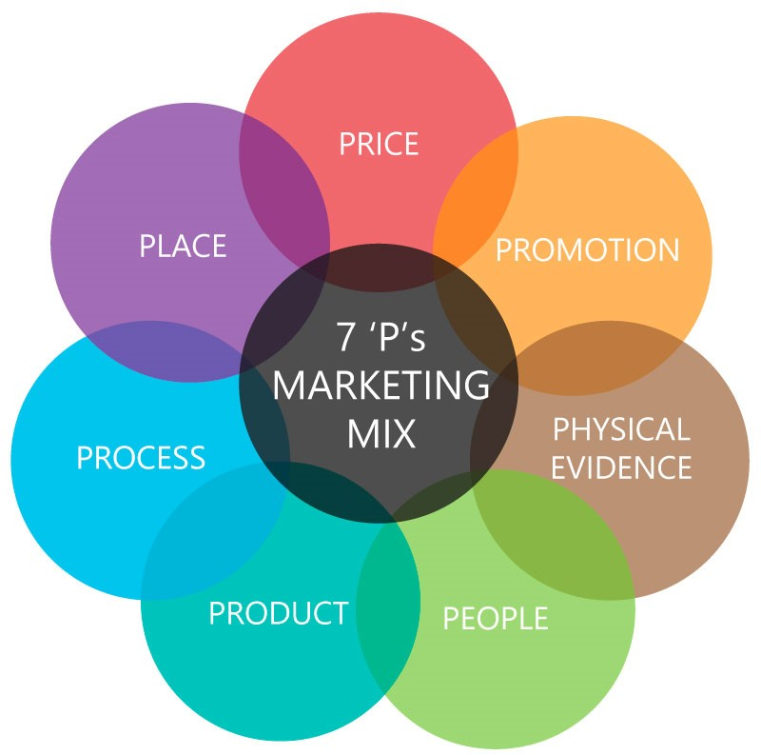

Marketing Strategy
A marketing strategy is a company’s or businesses overall plan for reaching their consumers and widening their target audience. Using adverts and other forms of advertising to grow their products and services to increase the value of the business. A marketing strategy contains the company’s budget for marketing, brand image and message, data about customers, and high-level elements.

SWOT analysis
The SWOT analysis will be based off the information found about the FAW (Football association Wales).
Strength- Something that the organisation is strong and consistent at. The Football association of Wales have the power of the funding over the Welsh national football teams for men and women. They are also in charge of the main Welsh football leagues. They have years of experience from budgeting the team’s yearly budget and organising the league and cup fixtures for the Welsh leagues.
Weakness – this is something that the organisation struggles with, which can then become their Achilles heel. They are left with a lot of responsibility which means if something goes wrong with the budget, teams or league they will be blamed.
Opportunity- This is when something is a set time or place where something can be done. The FAW will provide many opportunities to the people of Wales with options for education in coaching badges and referee courses. These courses can be accessed online and the location of all the centres are provide on the website. The website offers a vary of different coaching roles at many different levels from a leader’s award to a pro license. This shows that they have plenty of opportunities for young coaches, the different levels allow of coaching allow people to go down different pathways. (FAWALES, 2020).
Threats- This is a statement of negative intent. The main threat against the FAW is that they always need to make money as the government don’t fund 100% of their budget. They also rely on other revenue streams like merchandise, ticket sales, sponsorship deals and stadium concession stand within the ground. If any of these sales were to drop below average or target, then it could result in the organisation losing money. It is vital that all of these streams of revenue are bringing the maximum profit possible.

Pestle- ‘PESTLE is a mnemonic which in its expanded form denotes P for Political, E for Economic, S for Social, T for Technological, L for Legal and E for Environmental.’ (PESTLE Analysis , 2020).
Political- when something is political it will always involve the government whether it be the Welsh government or the British government. The FAW are supported by the Senedd which is the Welsh government. Even though the biggest teams in Wales such as Swansea and Cardiff are both under the English FA as they play their domestic matches in the English higher divisions.
Economic- ‘Economics is a social science concerned with the production, distribution, and consumption of goods and services.’ (Jim Chappelow, 2019). The FAW will rely on the money generate through their revenue streams like sponsorship and ticket sales.
Social- The enjoyment of other people around you and wanting to make face to face interaction with people rather than using technology but social media can be used to interact. The FAW is about engaging as many people as possible to play football, whether it be men or women. (Merriam-Webster , 2020).
Technological- ‘[The technology sector is the category of stocks relating to the research, development and/or distribution of technologically based goods and services. ... The technology sector offers a wide arrange of products and services for both customers and other businesses.’ (Jake Frankenfeield , 2019). Technology has come very far as people are now able to purchase their tickets online and bring e-tickets on their mobile phones to the match.

Legal-‘lawful, legal, legitimate, licit mean being in accordance with law. lawful may apply to conformity with law of any sort (such as natural, divine, common, or canon).’ (Merriam-Webster , 2020). There are probably thousands of legal rules and regulations that the FAW have to comply with, but they would have a good legal which make sure that they don’t break any laws. They would also have insurance to cover any unexpected costs or claims against them.
Environmental- This is relating to the natural world and what impact mankind has had on it. Over the last few decades a big concern over climate change and the sea levels rises has concerned a majority of the world’s population. Sadly, a wealthy minority who have been a huge negative effect on the natural world, still believe that climate change is a hoax. (Greenpeace , 2020).

Conclusion
What the findings from the essay show is that marketing is needed in almost every sector especially the private, public and not-for-profit sector as all of them what to raise awareness of what they’re either selling, giving or providing. Businesses like McDonald’s are interested in increasing the number of children participating in football even though they are a fast food restaurant. This shows that even businesses who produce products that are negative to the body still want to be involved in the sports industry.

Reference List
FAWALES, 2020. FAW COURSES. [Online]
Available at: https://www.fawcourses.com/courses
Greenpeace , 2020. Greenpeace. [Online]
Available at: https://www.greenpeace.org.uk/
Hitesh Bhasin, 2019. Marketing91. [Online]
Available at: https://www.marketing91.com/what-is-sports-marketing-sports-marketing-discussed-in-detail/
Jake Frankenfeield , 2019. Investopedia. [Online]
Available at: https://www.investopedia.com/terms/t/technology_sector.asp
Jim Chappelow, 2019. Economics. [Online]
Available at: https://www.investopedia.com/terms/e/economics.asp
Merriam-Webster , 2020. Merriam-Webster/ Legal. [Online]
Available at: https://www.merriam-webster.com/dictionary/legal
Merriam-Webster , 2020. Merriam-Webster/ SOCIAL. [Online]
Available at: https://www.merriam-webster.com/dictionary/social
PESTLE Analysis , 2020. PESTLE Analysis-What is PESTLE Analysis?. [Online]
Available at: https://pestleanalysis.com/what-is-pestle-analysis/
PUMA , 2020. PUMA. [Online]
Available at: https://about.puma.com
Sport Wales , 2020. COMMUNITY AND GRASSROOTS SPORT. [Online]
Available at: https://www.sport.wales/community-and-grassroots-sport/
Sport Wales , 2020. Sports Wales- About Sports Wales. [Online]
Available at: https://www.sport.wales/what-is-sport-wales/
The Marketing Mix , 2020. The Marketing Mix 4P’s and 7P’s Explained. [Online]
Available at: https://marketingmix.co.uk

