Installing Oracle Virtual Box – Virtual Machine
Download or open a previously installed version.
Click on the ‘new’ button
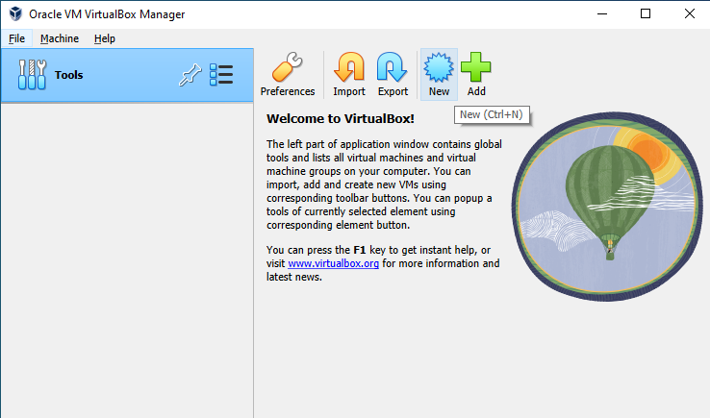

Make sure you have an ISO image of the operating system of your choice and store it somewhere accessible on your computer. In this example, it is stores in the ‘C:\ISO’ directory.
We will use a Windows7 installation for this example
Give your virtual machine a name – ‘Win7’ for example, and choose a directory to store the VM – C:\VM in this case (which has already been set up in windows explorer)

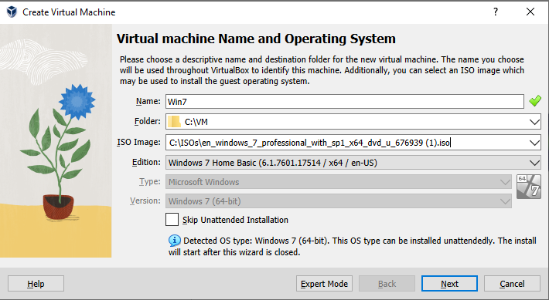

Click ‘next’

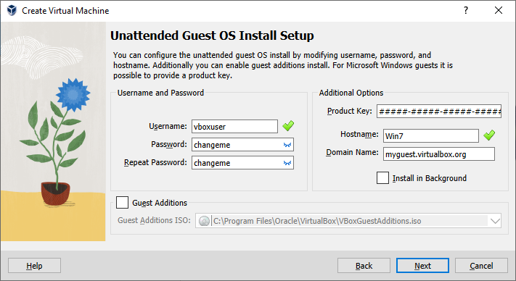
Make the Password visible and change it if you want to. Click next
Noe we select how much RAM and how many CPU cores we want to allocate to our VM.
In this case, the host computer has 16GB of RAM and 8 cores available, so we can afford to allocate 4GB and 2 cores to the VM – this might vary with your own computer and different needs.
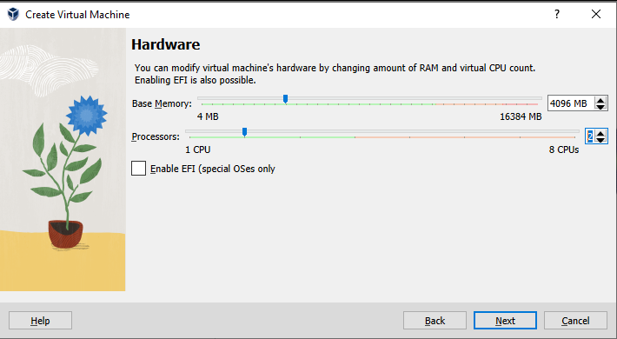

Now we need to allocate space for a virtual hard disk. Depending on how much spare space you have, select accordingly, but the default 32GB will be fine for experimenting.
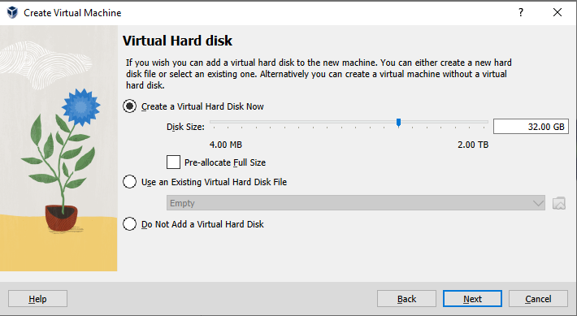

You’ll next see a summary table – check all looks ok and then click ‘finish’ to start the installation of the Virtual Machine.
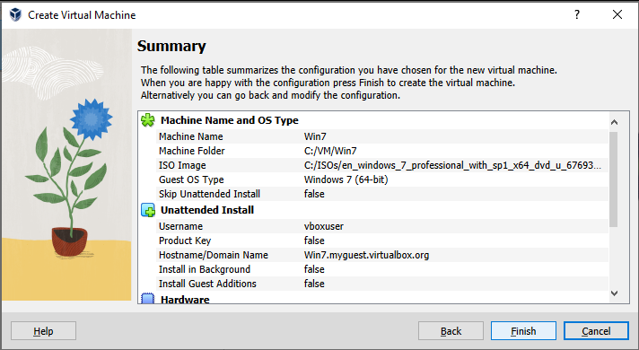

You will now have two windows. One is the VirtualBox Manager:
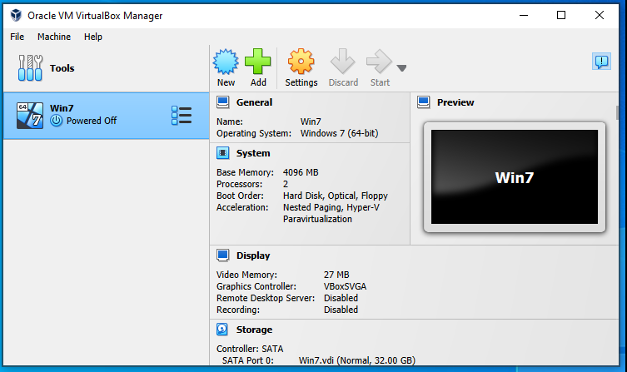

And you will also have the Virtual Machine. Let it run through the Windows install procedure:
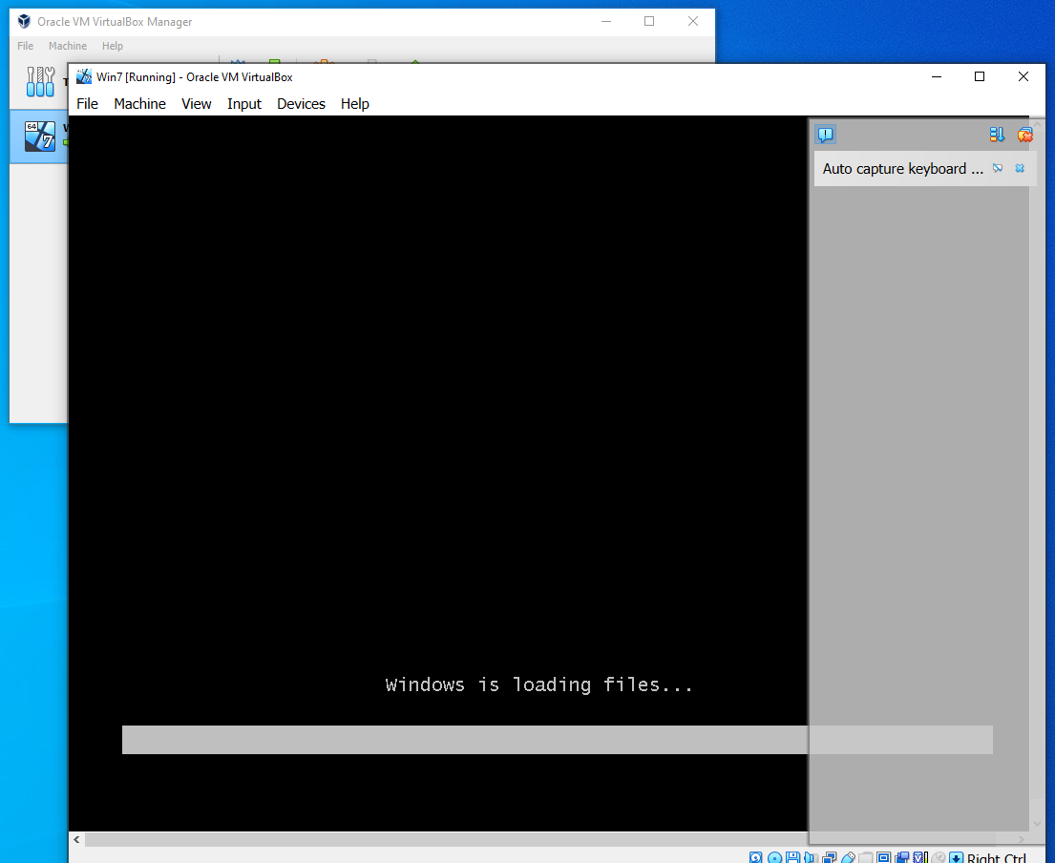

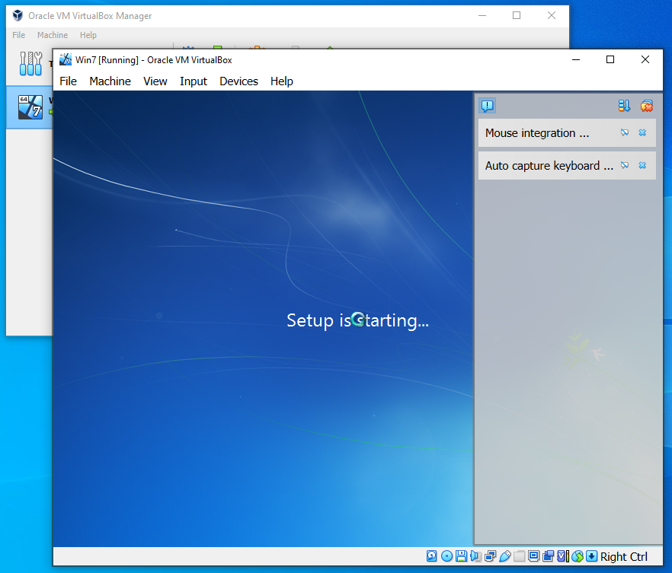

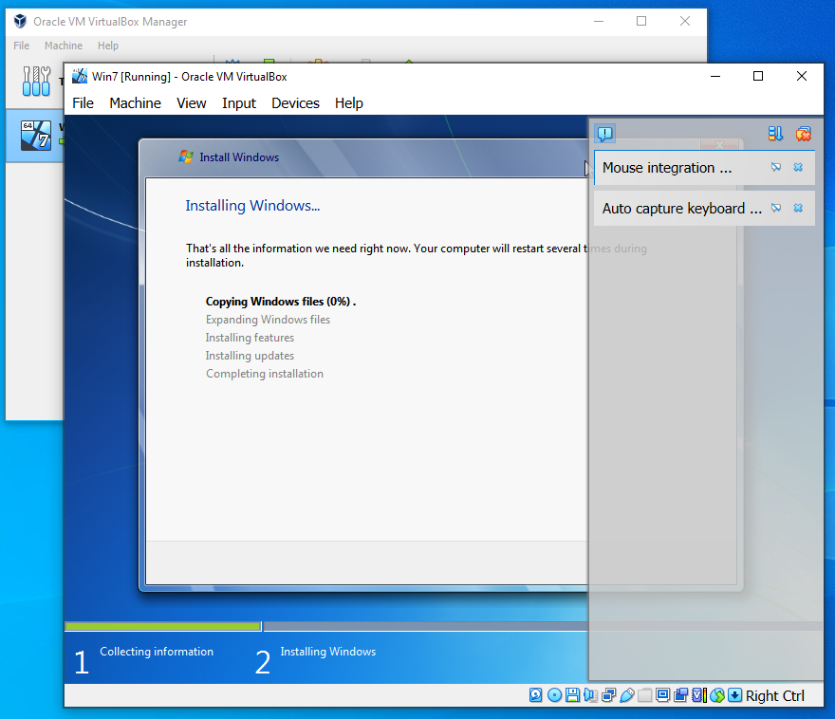
Eventually, you will end up with a normal, windows7 installation, running inside its own Virtual Machine window.
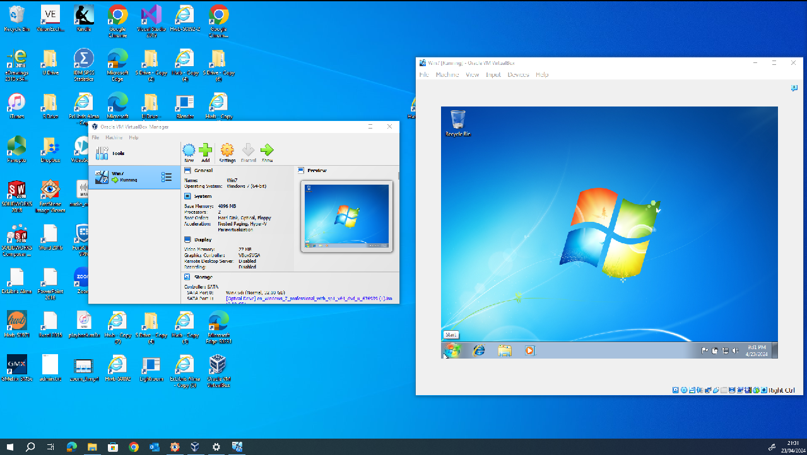

Lets check the drivers, and we’ll also split the virtual hard disk into 2 partitions, to create a separate E: drive we can use later.
Select the control panel
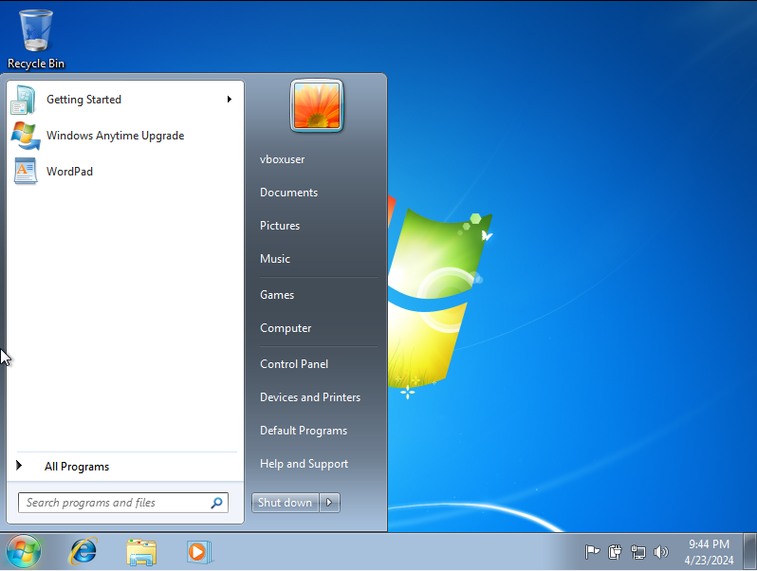

This is the default view of the Control Panel, but click on the dropdown ‘category’ View on the top right, and change it to ‘small icons’
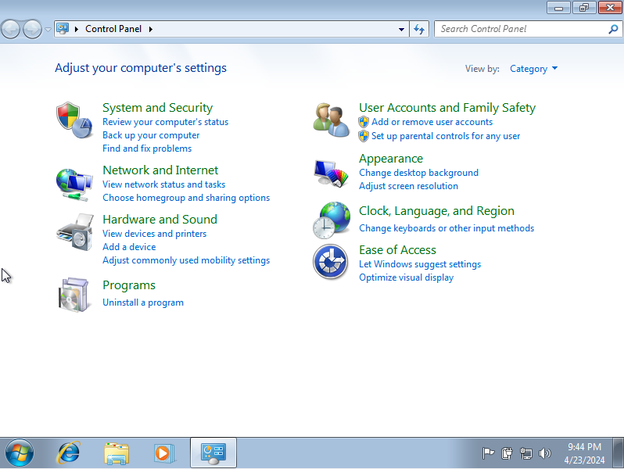##

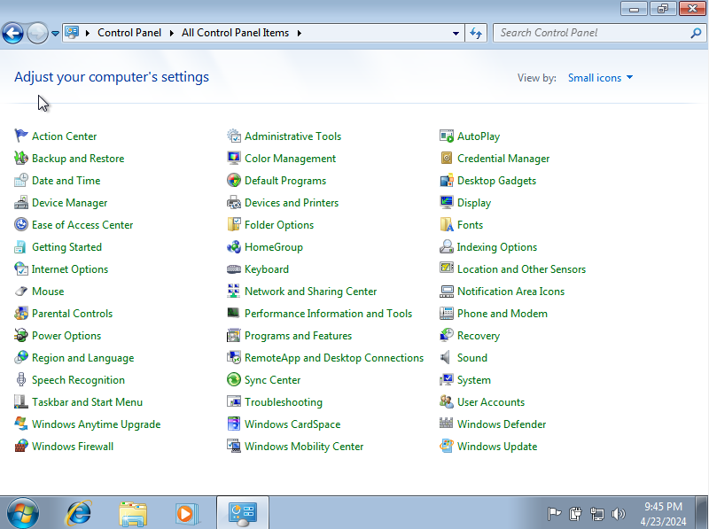
We can click on ‘system’ and check the general specification of our Virtual Machine
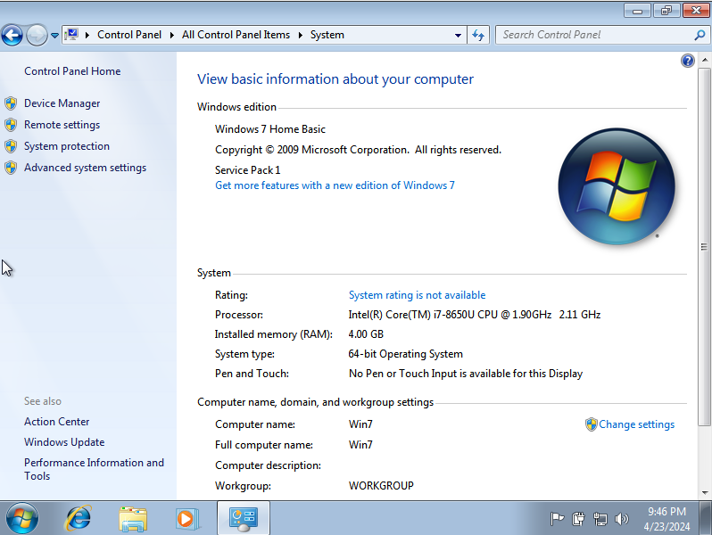

And then we can click on ‘Device manager’ to check the status of all the devices we have.
(note -there are other shortcuts to get to pages like this!)
We can click on the various items, check their status, see what drivers are installed, update drivers etc. Do your own investigation here.
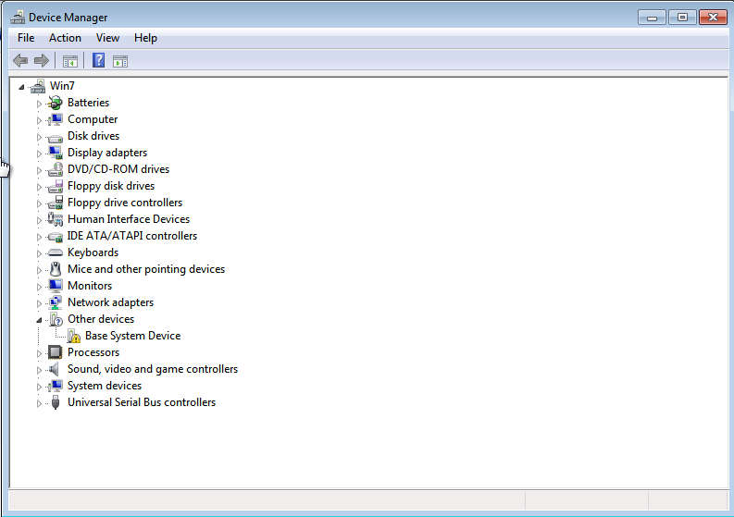

After you have finished, go back to the ‘all control panel items’ window, but this time, select the ‘administrative tools’, and select ‘computer management’, then ‘storage’ > ‘disk management’
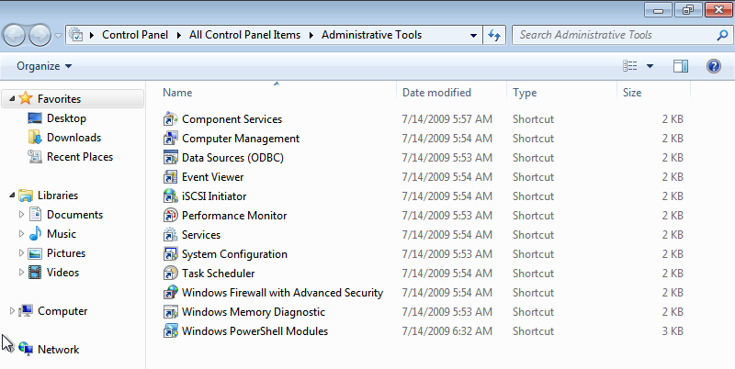

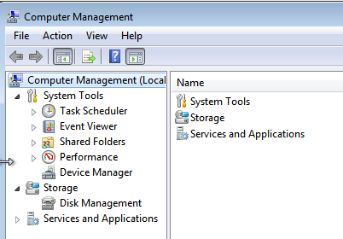

Now you are able to view the status of the drives in your system.
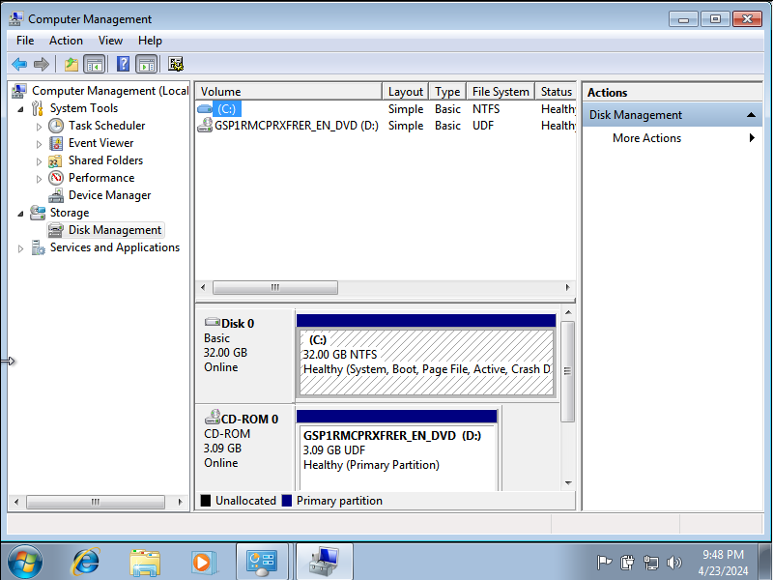

We are now going to repartition the (virtual) hard disk. Select by clicking on the C: area to the right of the ‘Disk0’ which is towards the middle of the screen here. Right click in the middle of the selected box and a menu will pop up. Select ‘shrink volume’
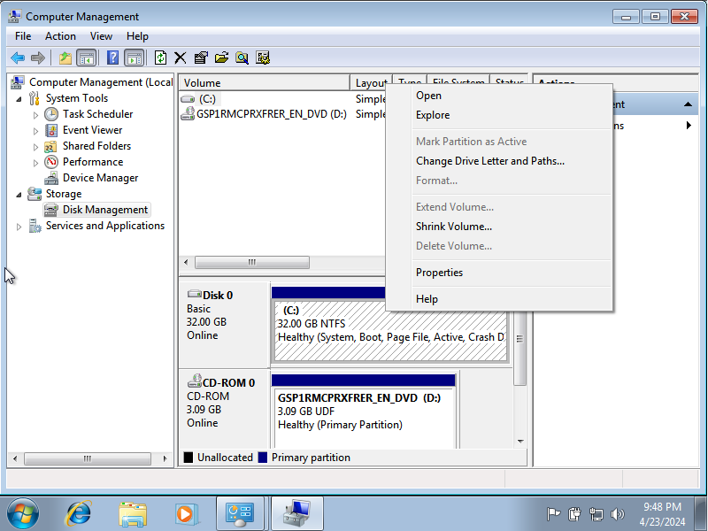
Lets make it roughly half the size
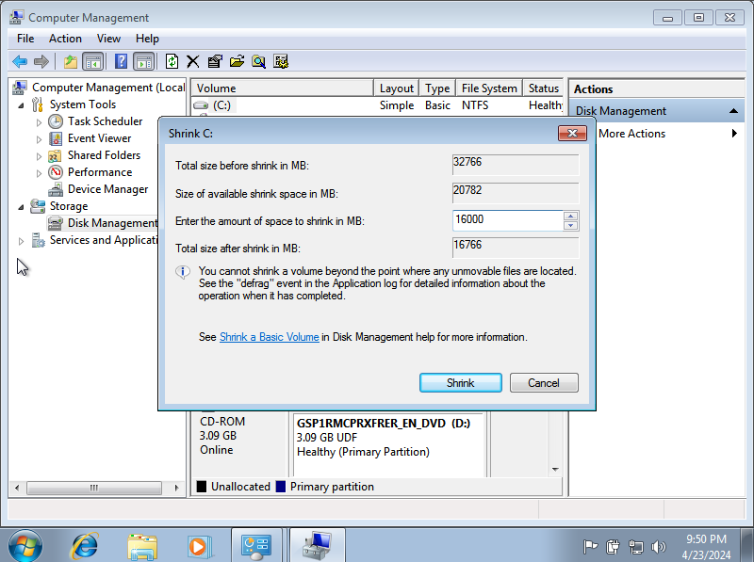

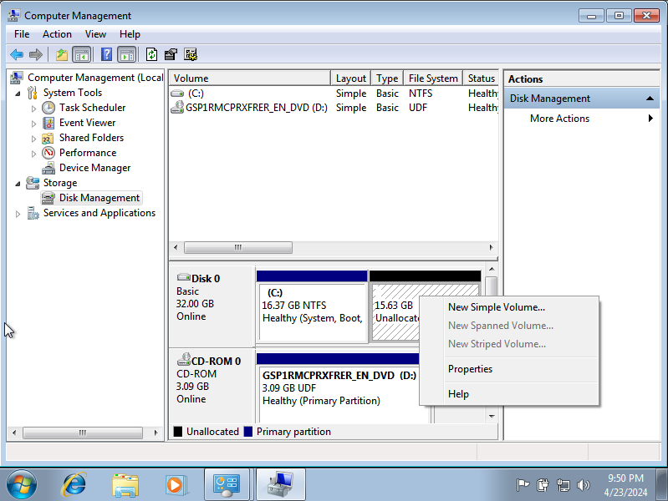

We can see now some new, unallocated space (with a black bar).
Right click, and select ‘new simple volume’
We can then assign a Drive letter to this new space – e.g. E:
Then once that is done, we can format the volume with a file system type of our choice – do some research into the differences between FAT32, exFAT and NTFS. Lets choose NTFS for now.
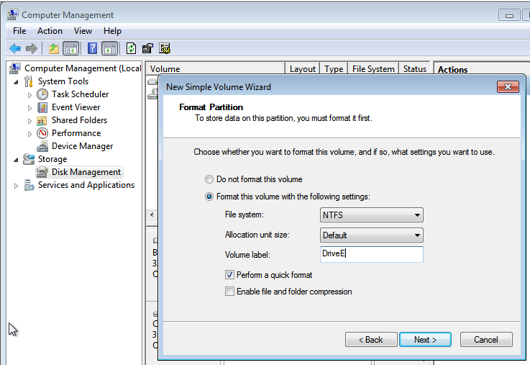

You can finish with the disk management window, use windows explorer, and you should now see a smaller C: but also a new E: drive available.
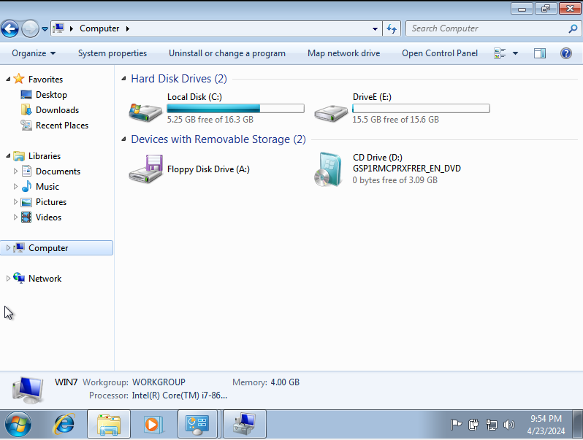

You can now experiment and play with your new Virtual computer.
Try installing some software onto it.
A suggestion: It comes with Internet Explorer which is now fairly old, but fire it up, and search for ‘install chrome’.
Follow the instructions and install Google chrome which will be an up to date browser.
Then, using chrome, search for ‘Open Office’ but Apache. Navigate to their site and download this free Office lookalike suite.

Note – your virtual machine is able to access your ‘real’ machines USB and Network ports, but these aren’t always set up by default, so you might have to manually do this (and of course you’ll need the network port to work, to be able to access the internet to install chrome and open office)
There are plenty of sources on the net/youtube to help you with tutorials etc on how to do this, but as a start, try this method:
In the ‘Devices’ option of the VM control window (that your Win7 machine is running within), you can select various devices, and change options.
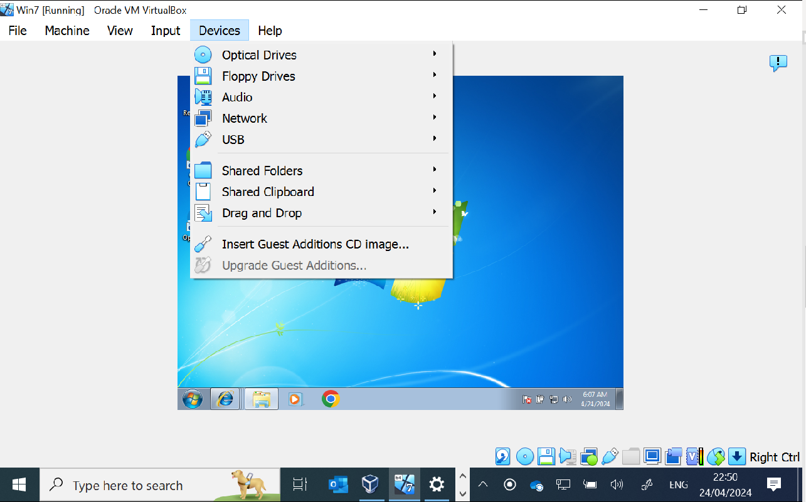

For the Network, select the ‘network settings’ and change to ‘Bridged Adapter’
Depending on your host machine, hopefully this will ‘Bridge’ the data stream from your main host computer into your virtual computer, and so your windows 7 VM will be able to have network access and thus internet access. This seems to work for home machines connected to a standard BT/Virgin media home hub type network.
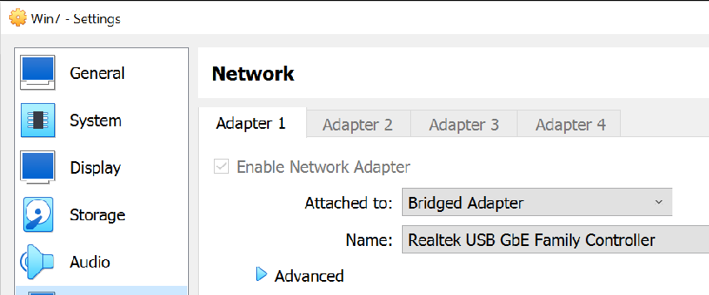

If the ‘Bridge’ setting doesn’t work in University, try setting it back to ‘NAT’. Note that there is some considerable time delay for the system to sort itself out, so keep an eye on the bottom right status bar and the networking icon and wait for it to change from having a red cross over it (not connected), to then having a yellow exclamation mark (no internet access), to finally the exclamation mark disappearing, and hovering over it will confirm ‘internet access’.
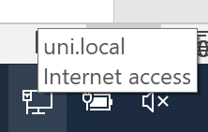
At this point, now you can try your web browser.

Note - A similar process is needed to enable the USB ports if you want to experiment with those. Plug your USB device/Memory stick in, Again, use the ‘settings’ option, select ‘USB’ then select the device you want to use. It hopefully will then work.
For some machines, you need to use the ‘Devices’ button again, then select the ‘Insert Guest Additions CD Image’
You will then see in windows explorer, that a Virtual CD is available as a drive. Navigate to this and run the VBoxWindowsAdditions file, THEN try and enable the USB ports (do a google search on how to enable USB ports in Oracle VM if this doesn’t work)

