A case study on Megan Mattravers work
Student number: 220776- Karen Reistad
Applied drama | drama Health and wellbeing
Case study

Introduction
Megan Mattravers is a freelance drama practitioner, writer, and director. In this case study I will be focusing on the work she does as a drama practitioner at Ty Llidiard, what kind of methods she uses and what ethical issues she has to consider while working there. I chose to write about her because of a workshop she facilitated in our class, this made me interested in her work and in this case study I am going to dig a little deeper into how she works as a drama practitioner.

Background
What is Ty Llidiard?
Ty Llidiard is a mental health unit based in South Wales, Bridgend. It is part of CAMHS: Child and Adolescent Mental Health Service. The unit is working for teenagers around aged 12-18 years old. The ward helps teenagers with serious mental issues such as depression, anorexia, and psychosis (NHS Wales University Health Board, 2015; Mattravers, 20222).

What does Mattravers do?
Mattravers works as a drama practitioner, writer, and director in different settings. She works with different groups of all ages, using different methods depending on the group.
Additionally, she is teaching creative writing to adults, she does different kind of creative workshops in primary school, and she works in Ty Llidiard (Mattravers, 2022, email, November 13th).

Creative methods and Theories
Mattravers uses different type of artforms as a way for teenagers to express themselves. She is juggling a great balance between fun- and therapeutic exercises.
I will now explain some of the methods she uses and the theory behind it.

Drama and warmup games:
Mattravers often starts a session off with warmup games to make the group ready, as well as drama games as a way of engaging the group.
One of the games she often uses is “the balloon game”. The goal of the game is to hold the balloon in the air for as long as possible. This is a good game to make the group ready without them feeling too big of a pressure to achieve. This game has advantages since there are no winners, instead the exercise focusses on beating the groups record, and work together as a group.
Another great exercise she uses in these groups is “sun shines on”. The rules of the game are: Everyone in the group sit in a circle on a chair. One person stands in the middle and says something that resonates with them, and everyone else that resonates with that phrase has to stand up and grab a free chair as fast as possible. The one left standing has to come up with a new phrase.
This game is good at finding similarities in the group. When she facilitated the workshop in our class, she told us the importance of letting the game go on for a while. This is because the group start of by finding more shallow similarities, but after a while they will often go deeper and ask more personal questions. This is a great opportunity to get to know each other better, but also an opportunity to address personal problems, without it forcing the participants to be too vulnerable. It will also allow and show how many that may feel/think the same way as you, and the participants in the group can end up feeling less alone.

Puppetry
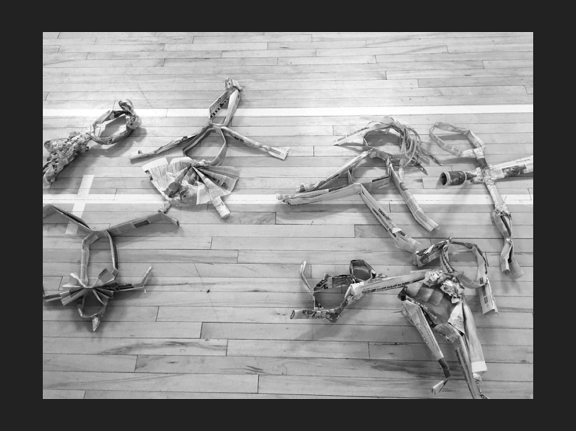 (Mattravers, 2022)
Puppetry is another artform Mattravers often bring into the group. She let the group make their own puppets, by using tape and paper. After they have made them, they use the puppets to create scenes. By using puppets, the participants can find it easier to be vulnerable. And perhaps without their noticing, the puppet often ends up representing themselves and it can be a great way to show how they feel (Mattravers, 2022).

Free writing exercises
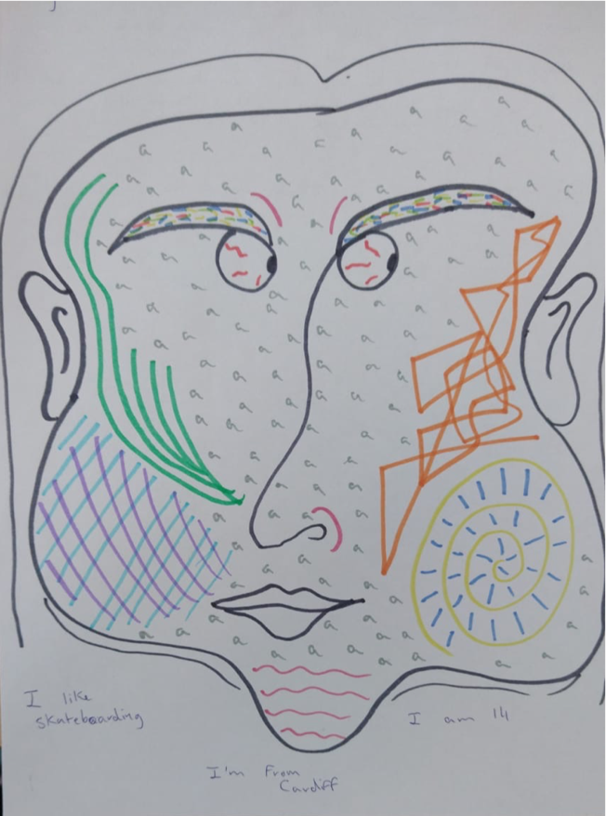(Mattravers, 2022)

Mattravers uses different writing exercises in the group. She starts by giving them a theme or a sentence they can write about. In one of the exercises participants start off with drawing their own face with closed eyes. Next, they write about what they know about themselves, on the same paper as the drawing. We did this exercise with her, and I found that exercise to be really powerful. Drawing with the eyes closed is a great exercise because it takes away the pressure of getting the drawing perfect. The writing task works well because they have to be objective, and it can be a quiet an empowering exercise, by writing about all the things they know about themselves, for example what their good at.

Another writing exercise the participants do is to answer these questions: I am… I Love... I hate...
I remember one person in my class questioning why Mattravers uses the sentence “I hate”, because they felt that can be a bit negative approach, especially to the group in Ty Llidiard. Mattravers meant the opposite, and that it can be a great way for the group to release the anger on a piece of paper, instead of letting it build up inside them.

I think the participants in Ty Llidiard can find it hard to express how they feel, so giving them an opportunity to express themselves by using different artforms is a great way for the participants to heal.

Projects
Mattravers has many projects in different settings. She is a writer, a director and a drama practitioner (Mattravers, 2022). She works in Ty Llidiard once a week as a drama practitioner.
I am now going to look a little deeper into what projects she is working on in Ty Llidiard.

Mattravers has one or two groups weekly throughout the academic year. She usually does not have an end goal for the group. This is partly because she does not want to overwhelm them, but also because many of the participants does not stay through the whole academic year (Mattravers, 2022, email, November 13th). Therefore, her aims for the group is: To get them in the room, to get them to stay in the room, to get them to talk and to get them to participate. (Mattravers, 2022). Her work depends greatly on who is in the group, and what they are capable of. But much of her work focuses on play and communication. By using competitive games and giving feedback to the participants, Mattravers feels that they are able to open up and get more engaged in the workshop. “I facilitate games to enable engagement and participation” (Mattravers, 2022, email, November 13th).

Is Mattravers a drama therapist?
Mattravers uses drama therapeutically, as a way for the teenagers to express themselves. She works in many similar ways as drama therapists does, but she is not a drama therapist. So, what are the differences? I am now going to compare similarities and differences between Mattravers work as an applied practitioner and drama therapists.

Similarities: In drama therapy they often use fictionalised characters to express their feelings, using exercises such as puppetry and role play. “Acting out an idea or an experience allows it to become ‘more real’ so it can be dealt with through feeling rather than just trough thought…” (Bailey, 2007, p.167).
Mattravers and drama therapist have similar setups in their workshop. They both start with a check in to get an idea of how the group is feeling, and what kind of work that can suit the group on exactly that day. Then they do a warmup to get the group ready and next onto activates like role play, physical theatre, or puppetry. The work they do is process based and the end goal is not performing (Bailey, 2007, p.164-173; Prendergast and Saxton, 2013, p. 1).

Differences: In drama therapy the goal is to help the participants grow and heal, while Mattravers end goal is a bit different. I would say that her work is not focused on the participants healing, but rather to get them to engage and participate. By getting them to engage and participate, the work can become healing (Mattravers, 2022, email, November 13th).
Mattravers is not a drama therapist, but she is an applied drama practitioner, and her approach is therefore going to be different to a drama therapist. Drama therapist has training in drama therapy, psychology, and psychotherapy while Mattravers work is more based on drama exercises and the work around being a facilitator (Bailey, 2007, p.167; Prendergast and Saxton, 2013, p. 1-2).

Even though Mattravers is not a drama therapist, her work is therapeutic and can help the patients to open up and heal.

Is Mattravers work categorised as applied drama?
Mattravers uses different type of artforms, while working in Ty Llidiard. She defines herself as a drama practitioner, but is all of her work categorised as applied drama?
One of the common exercises she is doing in the groups is creative writing. She often sees that many of the participants find their voice when they write. Someone may feel that it is easier to put their thoughts into words when they have a piece of paper. Another reason to use writing is that it is easier for some of the participants. Many of the participants have conditions that restrict them form moving around too much. It can be difficult to just use drama exercises with these restrictions. Therefore, some of her work is not categorised as applied drama since she is not only using drama, but also different creative approaches. However, her way to combinate drama and other creative methods is maybe the perfect thing for groups in Ty Llidiard.
Ethical consideration:
One of the main goals while taking ethical considerations, is to “Keeping participants safe- physically, emotionally and mentally” (Franks, 2022, p. 3).
It is clear that Mattravers think through her workshops and is aware of the ethical consideration. By having those aims “To get them in the room, to get them to stay in the room, to get them to talk and to get them to participate” (Mattravers, 2022). It shows that she knows what to expect from the participant, she is not too ambitious in her work and keeps the aims realistic. This makes the participants confident in what they do, and they do not feel overwhelmed by the expectations.

Mattravers is also being aware of what kind of objects are in the room, and what can trigger the participates. She does not bring object that can be a harmful to the participants or can trigger them in some way. “You do not want your workshops to trigger any behaviors around their diagnosis” (Mattravers, 2022, email, November 13th).

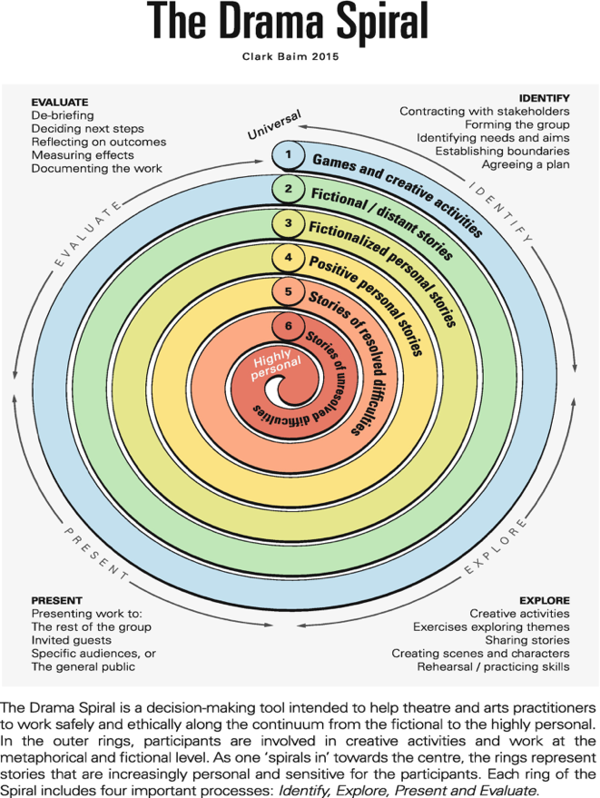(Baim, 2015, p.120)
The work of Mattravers, can reflect back to the drama spiral. She often starts in the outer circle, by using games as a way to get to know the group, and where some of the games works deeper. When the groups know each other better she will slowly work her way into the circle. Since she is working with people at risk, she is careful not to stay at the inner circle but giving the participant opportunity to dip into the inner circle. Most of her work is in the other circle. By rather working in the circle that is “fictionalized personal stories”, as puppetry, she gives the participants opportunities to create characters, while giving them the opportunity to be vulnerable, but still with a fictionalized distance.

Conclusion:
Megan Mattravers work focuses on using the art as a way to express thoughts and feelings. She is creating a room where it is okay to feel every feeling. I think Mattravers work as a drama practitioner has a big impact on the participants. Her combination of fun games and therapeutic exercises, makes it possible to both have fun, but also be vulnerable and share experiences together. I wished more mental hospital had this type of help.
Even though not all of her work may categories as applied drama, the way she works is well thought through and suits the group.

References:
Baim, C., (2015) Staging the personal, a guide to safe and ethical practice. Birmingham: Palgrave Macmillan.

Blatner, A. and Wiener,. D. J. ( 2007) Interactive and improvisational drama. Lincoln: iuniverse.

Franks, A. (2022). Ethical Considerations. (Slide 3) What does this mean to me as a practitioner? Available at: https://moodle.uwtsd.ac.uk/course/view.php?id=3372 (Accessed 13th November 2022).

Mattravers, M (2022). Email to Karen Reistad, November 14th.

Mattravers, M. (2022). Drama health and wellbeing. (All slides). What is an adolescent mental health ward? Available at: https://moodle.uwtsd.ac.uk/pluginfile.php/646163/mod_resource/content/1/Presentation%20Ty%20Llidiard%20.pdf (Accessed 7th November 2022)

NHS Wales University Health Board. (2015). New ward opens for children and young people with mental health disorders. Available at: https://cwmtafmorgannwg.wales/new-ward-opens-for-children-and-young-people-with-mental-health-disorders/ (Accessed 7th November 2022)

Prendergast, M. and Saxton, J. (2013) Applied Drama- A facilitators handbook for working in community. Chicago: Intellect Ltd.

