Q1. Evaluate the extent to which the flat non-hierarchical structure was appropriate under Kirstens ownership and the extent to which the hierarchical bureaucratic structure is suitable under Chaffinch Group’s ownership. (AC 1.1)

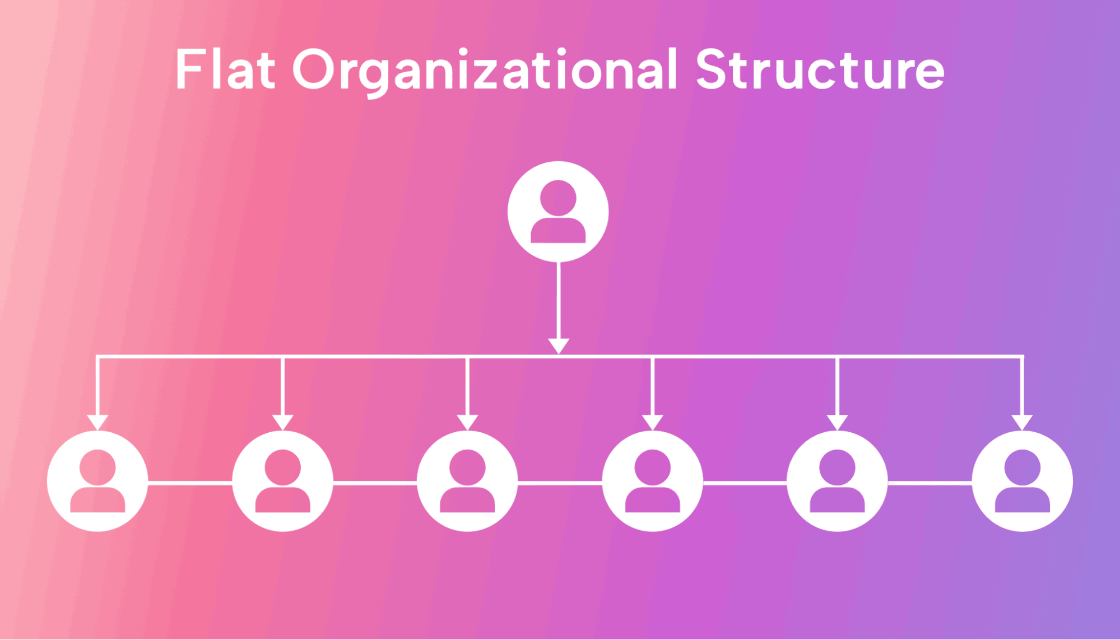
A flat organisational structure is when there are very few layers between management and employees. It is suitable for organisations to give people more say in decisions instead of traditional managers giving orders. This is popular in small - mid-size companies. (Mercadal, 2021) As companies grow it can be harder to keep roles clear, and managers find themselves juggling too much with can lead to inefficiency.
(Image) What Is a Flat Organizational Structure? (Pros, Cons, Tips, and FAQs (2023) .
Under Kirsten’s leadership, Calmere House operated with a flat organisational structure, ideal for its small team of 42 employees. Fewer management layers made communication direct and efficient, helping staff feel heard and involved. Research shows that flatter organisations increase employee engagement and responsiveness (Mercadal, 2021; Klyagin, 2023). Kirsten’s open-door approach reinforced trust and made staff feel valued. Open-door policies are proven to boost retention and improve morale (Akalp, 2022; Davis, 2024). Employees were also actively involved in decisions, especially around recruitment, regular staff meetings lifted team spirit and helped keep staff from leaving (Urme et al., 2023;).
The care home focused strongly on its residents, offering personalised room choices that reflected its values. The flexible way Calmere was run helped create a positive working environment and kept staff turnover low but as Calmere house grew, problems started to appear. The organisation relied heavily on Kirsten, and her increasing workload made it harder to support staff as closely as before, without formal policies things became inconsistent. When Kirsten left, the lack of planning and structure made it difficult for the organisation to manage the change.
Overall, the flat structure suited small, valued driven organisation. It helped staff stay engaged and deliver personalised care, but it lacked the formal systems needed to grow and handle major changes over time.
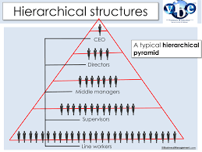
A hierarchical structure is a traditional way of organising businesses and organisations. Decisions usually start at the top and move down through the ranks. (Mercadal, 2021;).
Image - (<i>Hierarchical Structures</i>)
Chaffinch group uses a hierarchical bureaucratic structure, which works well for larger organisations because it provides consistency and control. Standardised policies across sites ensure uniformity and clear rules and responsibilities which strengthens accountability. Centralised management supports strategic planning and resource allocation which research shows is a key advantage of hierarchical systems in large scale operations. (Mercadal, 2021; AccountingTools, 2025).
However, this structure does not suit Calmere House. Staff feel undervalued, and turnover increases as the personal touch disappears—rooms look identical, and residents’ preferences are ignored. Kath’s strict leadership and lack of staff involvement create disengagement, which aligns with evidence that hierarchical rigidity and poor change management reduce morale and retention (Urme et al., 2023; Akalp, 2022). Experienced employees leave, and agency workers replace them, causing care quality to decline. This reflects findings that employee participation and open communication are critical for engagement and service quality (Davis, 2024).
While hierarchical structures can be appropriate for large organisations due to their ability to maintain control and efficiency, they require effective change management and staff involvement to avoid negative impacts. Without these, the model remains unsuitable for Calmere House despite the size of the parent organisation (Klyagin, 2023; Mercadal, 2021).

Q2 Analyse how Chaffinch Group could use a rational approach to strategy formulation to
ensure that services provided Need customer needs (AC 1.2)

To analyse how Chaffinch group could apply a rational approach to strategy involves
Structure and goal setting for direction to help the organisation make better decisions to meet resident’s needs. (Abey Francis, 2024). A rational approach to strategy is about being organised and logical when planning for the future. It means looking carefully at what is happening inside the organisation and outside and the wider environment. For Chaffinch Group this could involve checking what residents need, what requirements and staff are available and what local policies or healthcare trends night affect them. From there the organisations can set specific targets like improving residents satisfaction and make sure everyday activities such as staff training or resource allocation are focused on reaching these goals. By regular reviewing process and adjusting plans when needed Chaffinch Group can make better decisions and stay responsive to residents need in a clear and sustainable way.

A rational approach to strategy, also known as the prescriptive or deliberate approach, is a structured process that emphasises logical analysis, clear goal setting, and evidence‑based decision making. (VQ Solutions, 2025) The direction, aims, and objectives of Calmere House under Kirsten’s leadership were strongly person‑centred, reflecting a family‑run ethos. The aims were to provide high‑quality personalised care and maintain strong employee engagement to ensure resident satisfaction. The objectives included retaining highly skilled staff, maintaining resident population, and fostering a supportive, value‑driven culture. This approach prioritised emotional and personal needs, ensuring that both residents and staff felt valued and supported. In contrast, Chaffinch Group’s current strategy appears to prioritise operational efficiency and financial return, with less emphasis on the emotional and personal needs of residents and staff. While efficiency and profitability are important, this approach risks undermining resident satisfaction and staff engagement, ultimately threatening long‑term sustainability. To restore Calmere House’s reputation and align services with customer needs, Chaffinch Group could adopt a rational strategy that balances operational goals with personalised care by:-

1.Listen
The rational approach begins with gathering evidence. Chaffinch Group should talk to residents, families, and staff to understand what is most important to them. This stage can be supported by a SWOT analysis, identifying strengths (e.g., skilled staff), weaknesses (e.g., disengagement), opportunities (e.g., demand for personalised care), and threats (e.g., competition from other providers) ((Will Kenton, 2025)
2. Set Goals
Clear and measurable goals should be established. For example, aiming to improve satisfaction for both residents and staff would reduce turnover and enhance the resident experience. Goals provide direction and ensure alignment between operational efficiency and human‑centred outcomes (Knowledgiate, 2017).
3. Decision Making
Decisions should be guided by feedback and performance figures. This could mean allowing residents to choose their room style, involving staff in policy decisions, and adapting procedures to reflect the ethos of Calmere House. Evidence‑based decision making ensures transparency and accountability (MBA Knowledge Base, 2020).
4. Be Open and Supportive
Plans should be shared clearly with staff and residents, with training offered to support changes. Gradual implementation allows adaptation without overwhelming stakeholders, reinforcing a supportive, value‑driven culture.
5. Check In
Regular reviews with staff and residents ensure goals are being met and highlight areas for adjustment. Celebrating improvements reinforces engagement and builds trust.

By following these stages, Chaffinch Group can move from a one‑size‑fits‑all approach to a rational, evidence‑based strategy that balances efficiency with personalised care. This would restore Calmere House’s reputation, strengthen staff engagement, and meet the emotional and personal needs of residents while maintaining operational sustainability.

SWOT Analysis: Calmere House vs. Chaffinch Group (Will Kenton, 2025)

Factor | Calmere House (Kirsten’s Management) | Chaffinch Group (Current Strategy)
Strengths | - Person‑centred, family‑run ethos  - High quality personalised care  - Strong employee engagement  - Stable resident population | - Financially driven strategy  - Structured systems for cost control  - Larger organisational scale
Weaknesses | - Smaller scale may limit resources  - Higher reliance on staff commitment  - Potential vulnerability to financial pressures | - Less emphasis on emotional/personal needs  - Risk of staff disengagement  - Resident dissatisfaction  - Reputation decline
Opportunities | - Growing demand for personalised care  - Ability to build strong community reputation  - Staff development and retention | - Financial growth opportunities  - Potential to integrate person-centred practices
Threats | - Competition from larger providers  - Financial sustainability risks | - High staff turnover  - Negative public perception  - Loss of resident trust  - Increased competition from more person-centred providers

Q3 Analyse one external factor that’s currently having a negative impact on the
residential care industry and one external factor that is currently having a positive impact
on the residential care industry. (AC 1.3)
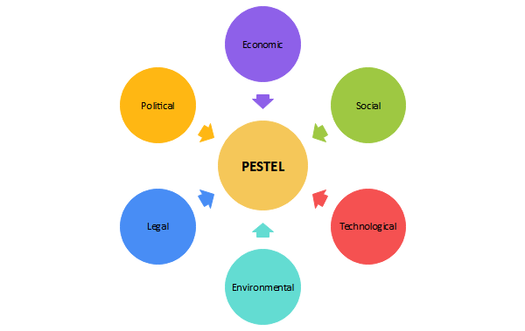

PESTLE is a useful tool that helps organisations look at
the bigger picture and understand what’s happening
around them. It focuses on six key areas that can
influence how a business makes a decision and plan for
the future.

Negative External Factor

One major external factor currently affecting the care industry is inflation. Rising costs across
the board are putting serious financial strain on care homes. This includes increases in the
National Living Wage and employer National Insurance contributions which are especially
tough for homes that rely heavily on part time staff. Food prices have gone up, making it harder
to maintain good nutrition for resident. Energy bills are also climbing adding monthly
expenses. (Milsted Langdon, 2025,)(Emma Lunn, 2025) To cope many care homes have had no choice but to raise their fees which can make care less affordable for families. For smaller independent care homes these pressures can be overwhelming. Examples from the UK residential care sector include:
- 98% of care homes report that costs continue to rise month-on-month due to inflationary pressures, with National Living Wage increases and employer National Insurance cited as the biggest challenges. As a result, 71% have made operational or staffing changes, and 63% struggle to meet individual nutritional needs under current resource constraints. (care of england, 2025)
- According to (LaingBuisson, 2025), one in seven independent nursing homes now charge over £1,800 per week for new residents. This is driven largely by wage uplifts and rising National Insurance contributions, pushing care costs beyond local authority funding levels.
- (Daniel Smith, and James Hichens, 2024) reports that care home operators continue to face rising overheads including energy, food, and staff costs. The increased costs mean residents or local authorities must subsidise the gap, and many smaller homes are reaching breaking point.

To survive, care homes are having to rethink how they operate. This might mean using technology so save time and money teaming up with others providers to buy supplies in bulk or changing how services are delivered to ensure to stay sustainable without
compromising the standard of care. (CIPD, 2025)

Positive External Factor

One positive external factor for care homes is the rise of digital technology. Moving away from old school pen and paper systems to electronic health records has transformed how information is stored and shared. Tools like electronic health records and AI powered pain assessment devices are changing how care homes work. These innovations make it easier to keep residents safe, spot health issues early and reduce paperwork. By streamlining tasks staff have more time to focus on person centred care and improve quality and efficiency. Technology also strengthens security through CCTV systems and keypad entry which will create safer environments, but digital systems can also come with new challenges like potential data breaches or hacking of patient notes online. Overall, technological progress is making care homes more efficient, secure, and aligned with modern standards. (Care Quality Commission, 2024; NHS Digital, 2024; Psychreg, 2025).

Q4. Under Kirsten’s ownership of Calmere House, there was little investment in technology. Chaffinch Group want to change this approach and have decided to implement technology to deliver better patient care and employee experience. Assess how technology could be used by Chaffinch Group and how this would impact work at Calmere House. (AC 1.4)

Under Kirsten’s ownership, the home relied on traditional pen and paper systems with little tech investment. Moving to digital solutions marks a big difference that could transform care delivery and staff experience.
The rise of digital technology is reshaping residential care, moving away from traditional paper-based systems toward integrated digital solutions. One of the most significant changes is the adoption of Electronic Health Records (EHRs). These systems replace manual notes with secure, centralised digital records, giving staff instant access to care plans and medical histories. This reduces errors, improves communication and ensures that critical information is available in real time, which is vital for safeguarding and continuity of care (Care Quality Commission, 2024).
Another major advancement is remote monitoring through wearable devices and sensors. These tools track vital signs such as heart rate, oxygen levels, and movement patterns, alerting staff to early health concerns before they escalate. This proactive approach not only enhances resident safety but also reduces hospital admissions and emergency interventions, supporting better health outcomes and cost efficiency (Skills for Care, 2024).
Finally, AI-powered tools for pain and mobility assessment are revolutionising clinical decision-making. Devices like PainChek® use facial recognition and AI algorithms to detect pain in residents who cannot communicate verbally, such as those with dementia. This enables timely interventions, reduces unnecessary medication, and improves overall comfort and wellbeing (Psychreg, 2025).
These innovations free up staff time by automating routine checks and paperwork, allowing them to focus on person-centred care.

While these technologies improve efficiency and safety, they also introduce challenges such as data security risks and the need for staff training. Nevertheless, their benefits in enhancing care quality and operational resilience make them a positive external factor driving the sector forward.

All of the above could have a positive impact on Calmere House. Sharing real time data means staff can spot changes in residents health quickly and act before problems escalate. This helps prevent unnecessary hospital visits and improves overall care. Digital systems also cut down on paperwork, freeing up time for staff to focus on person centred care. Safety and compliance will be strengthened through secure digital record keeping and abide by regulatory standards. Staff experience will improve with tools for scheduling and e-learning which support professional development and reduce administrative workload.
Implementing technology also brings challenges. Staff will require training to develop digital skills which could be time consuming to begin with. Finances is another factor as devices, software and connectivity will be a necessary cost and older adults may need support to adapt to digital tools ensuring tat technology enhances Calmere House rather than hinders.

Q5. Using theories and models which examine organisational and human behaviour, explain why problems have arisen following the takeover of Calmere House by Chaffinch Group. (AC 2.1)
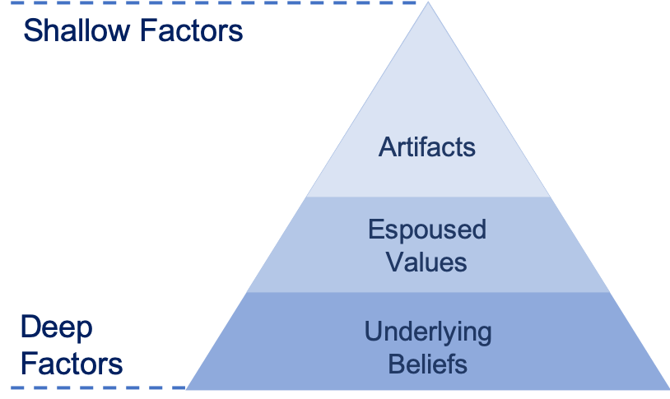
Edgar Schein’s Organisational Culture Model is a key framework for understanding workplace culture. It identifies three levels of culture, each reflecting a different depth of influence. Below is why, in my view problems arose after the takeover using Schein’s model.

Image- (<i>Edgar Schein’s organisational Culture Triangle: A Simple Summary</i>2019)

Artifacts

Before takeover Calmere house felt like a family home, everyone reported to Kirsten which developed a flat structure. The staff and Kirsten had informal communication, residents chose their own room decor and regular staff meetings were held to share thought and ideas. (Fripp, 2021).

After the takeover the artifacts changed dramatically, a hierarchical structure was introduced, policies replaced informal approaches and rooms were refurbished to look identical. These changes affected the culture of Calmere House and created immediate discomfort for employees and residents. (Westover, 2024).

Espoused Values

Calmere House values of high-quality care with a personal touch, the involvement of employees and the respect for the individuality of residents.

Once Chaffinch group took over, they prioritised investment return, emphasised efficiency and consistency. The different values led employees to feel that their opinion were no longer valued, and residents individuality was being ignored. As a results of this morale declined, and employees began to leave Chaffinch Group.

Underlying Beliefs

At Calmere House people believed that care should be personal and tailored to each resident. Staff expertise mattered in making decisions but Chaffinch group had a different view.

Chaffinch Group focused on profit and decisions coming from management rather than their staff which caused a big cultural issue. Employees felt undervalued leading to them leaving, higher sickness and low morale. Residents felt their individual needs were ignored.

These differences is the reason the take over by Chaffinch Group led to serious issued for both residents and staff.

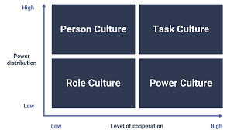
Handy’s model helps us understand different types of workplace cultures and why problems arose when Chaffinch group took over. Image - (<i>Handy model of organisational culture</i>)

Before the takeover, Calmere House had a person culture with elements of task culture. Kirsten encouraged staff input and held regular meetings, creating a family-like atmosphere. Its flat structure meant everyone reported directly to Kirsten, giving employees a sense of belonging that aligned with Calmere’s values.
After Chaffinch Group took over, they introduced a role culture, which is hierarchical and rule-based. They added layers of management and standardised policies across all homes. Kath, the new manager adopted an autocratic style issuing instructions without discussion which was sharp contrast to what staff were used to (Handy, 1993).
This sudden shift caused problems. Employees lost their voice and felt undervalued, leading to stress, frustration, and high turnover. Residents were also affected as rooms were no longer personalised. The takeover ignored Calmere’s strong people-centred culture and failed to manage a smooth transition (Westover, 2024).
Chaffinch imposed a very different way of working without considering what made Calmere successful. This cultural clash led to unhappy staff and departures of both staff and residents. Clear communication, careful handling, and involving staff could have prevented many issues (PeopleShift, 2019).

Q6. Assess how changes to selection and employee voice have impacted organisational culture and behaviours at Chaffinch Group. (AC 2.2)

Since Chaffinch group took over Calmere House, the way staff are selected and how their voices are heard has changed dramatically, which has had a big impact on the culture and behaviour within the home. Research shows that organisational change without staff involvement often undermines trust and morale (Ellis et al., 2023). Recruitment was a team effort with staff helping to choose new colleagues who shared the same values as them, which created a strong sense of belonging and teamwork, an approach supported by evidence that values-based recruitment improves cohesion and care quality (Spilsbury et al., 2022).
Since Chaffinch took over, the way Calmere House hires staff is now handled centrally, and agency workers are brought in based on qualifications with no check on whether they fit the culture. Studies highlight that heavy reliance on agency staff can disrupt continuity of care and weaken team relationships, leading to poorer outcomes for residents (Stepick, 2024). This means staff have lost their voice increasing turnover (Attom, 2020).
Under Kirsten, employees were involved in decisions and kept informed, but Kath’s autocratic style means communication is one way and feedback isn’t welcomed. Evidence shows autocratic leadership often results in low morale, stress, and reduces trust (Srinivas and Ashok, 2024; Scott, 2024). These changes have led to frustration, low morale and a breakdown of trust, with research linking poor communication and lack of involvement to disengagement and sickness absence (Dawson and West, 2012).
Staff turnover and sickness have increased, and those who remain feel under pressure and unsupported. The home’s culture has shifted from a warm, family-like environment to a rigid, corporate structure leaving employees feeling disconnected and residents missing the personal care they once enjoyed. This mirrors findings that organisational cultures moving from relational to transactional models often compromise person centred care (Spilsbury et al., 2024; CQC, 2024).

Q7. Explain how Chaffinch Group could have better managed the change from a small owner-managed care home to Calmere House being part of a large organisation. (AC 2.3)

When managing change, organisations can adopt different approaches to ensure a smooth transition.

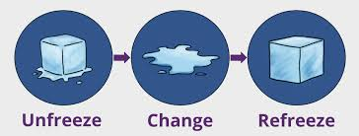
Lewin’s three-step model suggests unfreezing existing behaviours, introducing change gradually and refreezing to integrate new practices, which would have helped Chaffinch Group prepare staff and maintain stability (Burnes, 2020; Expert Program Management, 2021). (<i>Lewin’s Change Management Model</i>2023) - image

To apply this effectively, Chaffinch could have:

- Unfreeze: Communicated early and transparently about the reasons for the sale and the benefits of joining a larger organisation. Holding staff meetings, listening sessions, and involving employees in discussions would have reduced shock and built trust.
- Change: Introduced new policies and structures gradually rather than imposing a strict hierarchical model immediately. For example, keeping some team decision-making and familiar routines while gradually adding corporate standards would have made the cultural shift easier.
- Refreeze: Reinforced new practices through training, mentoring, and recognition programs. Celebrating small wins and showing how the new structure supports resident care and staff development would have helped embed the changes and restore morale.

This approach would have maintained continuity, reduced resistance, and supported staff emotionally during the transition from a family-run care home to a corporate environment.

(bitesize learning) – Image.

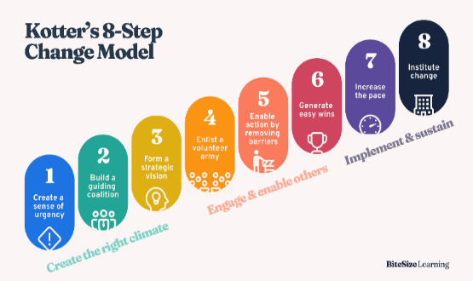
Chaffinch Group could have managed the transition more effectively by applying Kotter’s eight-stage model. Starting with creating urgency, building a strong change team and sharing a clear vision (Kotter Inc., 2024). Explaining the need for change and involving staff would have reduced resistance and built trust.
Rather than reacting to financial pressures, a proactive plan could have prepared staff for the new structure (Change Management Insight, 2023). Gradual integration of corporate standards while retaining familiar practices such as team based decision making would have eased cultural adjustment.
The shift from a family-run flat structure to a hierarchical model was too radical. Gradual changes blending old and new practices supported by clear communication, leadership, and training, would have helped staff adapt. Considering internal factors like morale and culture alongside external drivers such as economic pressures and resident expectations could have ensured a smoother transition (The Happy Manager, n.d.).

Q8 Explain the experience of change for the employees at Calmere House and examine how this is reflected through the stages of one model. (AC 2.4)

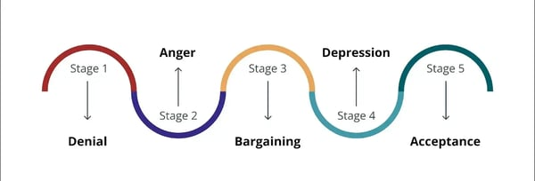
The employees at Calmere House faced a big change when Kirsten sold the care home to Chaffinch group. Under Kirsten, the workplace was friendly and open, everyone had a voice in decision making and everyone worked as a team which made them a strong workforce. Staff felt valued and secure which gave them a real sense of purpose.

The Kubler-Ross model outlines five stages. The employees at Calmere House experienced these stages by:-

- Denial
When Kirsten told staff she was selling chaffinch group everyone was shocked. They had always seen Kirsten as fully committed to Calmere House so staff couldn’t believe her decision. This reaction showed the denial stage where people found it hard to accept the change was really happening. (Prosci, 2024; Change Management Coach, n.d.).

- Anger
When the new structure and strict management style was put in place from Chaffinch group staff were frustrated as the staff of Calmere House were used to an open, team focused culture where their opinions mattered and they suddenly felt ignored. Kaths comment “I know what Chaffinch wants” made them feel powerless. Anger was aimed at the company for taking away their culture they valued. (Volonte, n.d.; InvGate, 2024).

- Bargaining
Staff tried to keep the old ways going like working as a team and putting residents first, they sometimes worked extra hours to possibly influence management decisions. This is what’s called as bargaining where people look for ways to keep some control during change. (Change Management Coach, n.d.; Prosci, 2024)

- Depression
The more time went on the more the workload increased and colleagues left and residents became unhappy. As a result of this employees were off sick with some caring less about their work. This shows the depression stage and morale drops. (InvGate, 2024; Volonte, n.d.).

- Acceptance
To accept the change from Chaffinch Group this meant leaving the care home completely for some employees. Others stayed and followed the new rules and structure. They understood and accepted the old culture was not coming back. (Prosci, 2024; Change Management Coach, n.d.).

The employees journey through the Kubler-Ross stages shows how badly change can affect people emotionally. Poor communication, ignoring staff and the sudden culture change made things worse. (Volonte, n.d.; InvGate, 2024).

Q9 Assess two factors that could impact employees wellbeing at Calmere House including why it is important that these factors are addressed. (AC 2.5)

Mental health has become a major concern for employees at Calmere House due to the organisations changes. The increased workloads, longer hours and the effect to the close knit team relationship has caused stress and anxiety and the feeling of hopelessness. The result of these changes and feeling resulted in employees being off sick showing signs of exhaustion which effects their confidence and wellbeing. (WHO, 2024; APA, 2024).
If these wellbeing concerns are not addressed the trust between staff and Calmere House will break down leading to more people leaving and care standards failing (CQC, 2022; Coleman, 2024). Supporting mental health through open communication, access to wellbeing help and fair workloads is vital to keep staff healthy, motivated and be able to provide good care to residents. (CDC, 2025; Sutton & Schaffner, 2025).

Employees used to feel valued and connected to their work under Kirstens inclusive approach, but the new autocratic structure has taken away their voice and sense of control. Loosing autonomy has made employees less satisfied with their jobs and more stressed. When people feel ignored, it breaks trust with others (Lipman, 2022; Zychová et al., 2024). Motivation decreased as staff are no longer able to see their efforts make any difference which leads to no rewards. This disrupts the effort-performance-reward cycle as described in the Expectancy Theory. When this link is broken motivation and commitment decrease.

The expectancy theory is how people stay motivated. It’s based on the idea that “Motivation depends on how much we want something and how likely we think we are to get it. (Vroom, as cited in The Decision Lab, n.d.) Employees put in the efforts when they believe it will lead to good performance and that good performance will bring rewards and the rewards matter to them. (The Decision Lab, n.d.).

It’s important to address this issue when employees lose their sense of purpose as it leads to disengagement, stress and breakdown of trust which can lead to increase in turnover. (CDC, 2025; WHO, 2024). Restoring purpose and involvement is key to rebuild commitment and maintain high standards of care. (Lipman, 2022; Zychová et al., 2024).

Q10 Discuss how the people manager, recruitment advisor and employment relations case advisor could support the retention stage of the employee lifecycle. (AC3.1)

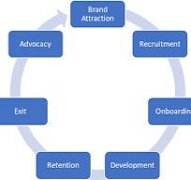
Retention focuses on keeping employees motivated, engaged, and committed through recognition, fair treatment, and career development (AIHR, 2023; SHRM, 2024). At Chaffinch Group, retention was challenged by loss of autonomy, poor communication, increased workloads, and cultural change, which led to stress, low morale, and high turnover.

The People Manager directly supports staff wellbeing and engagement by maintaining open communication, monitoring workloads, and providing recognition. At Chaffinch, they could have introduced regular team meetings, wellbeing check-ins, and flexible scheduling to reduce stress and rebuild trust. (HRTech NewsRoom, 2023; eFMC Conference, 2024). The Recruitment Advisor ensures recruitment aligns with organisational culture and values and supports onboarding to improve early engagement. At Chaffinch, they could have revised job descriptions to reflect the new structure, ensuring candidates understand expectations. Supporting onboarding with cultural integration sessions would help new employees settle. (AIHR, 2024; Atlassian, 2025). The Employment Relations Case Advisor handles grievances, ensures fair treatment, and advises managers on compliance and employee relations. At Chaffinch, they could have addressed complaints promptly, mediated conflicts caused by the sudden hierarchical shift, and advised on fair workload distribution. This would prevent escalation and maintain trust. (LinkedIn HR Perspective, 2024; AllVoices, 2023).
Retention at Chaffinch failed because employees felt ignored, overworked, and disconnected. These roles working together through communication, fair processes, and cultural alignment would have reduced stress, improved morale, and supported long-term commitment.

Q11 Analyse how people practices could help Chaffinch Group to fill 100% of residents room within six months (AC 3.2)

People practice is essential for making sure the workforce strategy supports the organisation’s goals and everyday operations. HR teams work closely with senior leaders the ‘Top Table’ to ensure people plans help achieve objectives like growth, service quality and customer satisfaction. This is called business partnering and involves two key ideas:
vertical integration, which means aligning HR strategy with the overall business strategy, and horizontal integration, which means HR, Learning and Development (L&D), and Organisational Development (OD) working together effectively (Sreekanth, 2024; CIPD, 2025).
For Chaffinch Group, the goal of filling all resident rooms within six months needs a strong people strategy that stabilises staffing, boosts engagement and improves care quality to attract and keep residents. People practices do this through services like policy development, legal compliance, recruitment, L&D, skills analysis and management training. For example, HR can make recruitment fair and transparent, L&D can build skills and career paths, and OD can help manage cultural change. These services support both employees and the business by improving morale, capability and performance, which directly helps achieve organisational goals (Sreekanth, 2024; CIPD, 2025).
In practice, Chaffinch Group could use values based recruitment to hire permanent staff, provide leadership training for managers to adopt a more inclusive style and introduce reward schemes linked to occupancy targets. By integrating people practices vertically and horizontally, the organisation can rebuild trust, improve service quality and strengthen its reputation key factors for reaching full occupancy within the required timeframe.

Q12 Discuss how Kath could consult and engage with employees to understand why employee turnover at Calmere House has increased (AC 3.3)

Kath can start by talking openly with employees and understand why turnover has increased. On to one conversations and team meetings create safe spaces for honest conversations while anonymous surveys or suggestion boxes encourage feedback from those who hesitate to speak up. (CIPD, 2024; CIPD, 2025). It’s vital that Kath listens actively, acknowledging concerns and showing employees that their feedback leads to real change. Active listening builds trust and boost morale. (MindTools, 2025; LinkedIn, 2025). By sharing feedback results and involving staff in finding solutions around issues like workload, management style and wellbeing. Kath can demonstrate respect and commitment helping to rebuild trust and reduce turnover.

Consulting processes in people practice are about understanding what employees and managers need and making sure those needs are met. This starts with listening and gathering information through meetings, surveys and feedback sessions. Stakeholder analysis helps identify who is affected by decisions and what matters most to them. (CIPD, 2025). Needs analysis looks for gaps in skills, resources pr processes so solutions can be planned. Regular and open communication is key. Keeping stakeholders informed and involved builds trust and reduces resistance to change. Ongoing liaison ensures that people practice stays aligned with business goals and employee expectations. These steps make people practice more effective and responsive supporting organisation and its people.

