

The Psychological Toll of Policing: A Critical Evaluation of the Stress, Trauma and Support Systems within the UK.

Name of Student: Holly Elizabeth Davies
Student Number: 2236338
Degree Title: BSC (HONS) PROFESSIONAL POLICING PRACTICE

Acknowledgements –
I would like to recognise and express my gratitude to my Family and Friends for their unwavering support during this entire course. I would also like to thank my current and previous teammates for their encouragement and support in pushing me to finish this degree and pursue my professional ambitions.

I would also like to take this opportunity to thank South Wales Police and the entire Staff at the University of Wales Trinity Saint David for their assistance in providing me with the resources and the chance to finish my degree.

Declaration

This work has not previously been accepted in substance for any degree and is not being concurrently submitted in candidature for any degree.
Signed: H. Davies
Date: 06/10/2025

STATEMENT 1
This dissertation is being submitted in partial fulfilment of the requirements for the degree of BA.
Signed: H. Davies
Date: 06/10/2025

STATEMENT 2
This dissertation is the result of my own independent work/investigation, except where otherwise stated.
Other sources are acknowledged by footnotes giving explicit references. A bibliography is appended.
Signed: H. Davies
Date: 06/10/2025

STATEMENT 3
I hereby give consent for my dissertation, if accepted, to be available for photocopying and for interlibrary loan, and for the title and summary to be made available to outside organisations.
Signed H. Davies
Date: 06/10/2025

STATEMENT 4
I hereby give consent for my dissertation, if accepted, to be available on the university’s IT system to those who have consent to use the system.
Signed: H. Davies
Date: 06/10/2025

ABSTRACT
Police Officers perform duties in situations of great stress, that are marked by moral ambiguity, public scrutiny and violence. These conditions frequently result in chronic stress, PTSD, and other mental health issues. Based on review of empirical research and qualitative interviews with active officers, the study investigates how stigma, organisational culture, and resource constraints increase psychological stress. It assesses institutional solutions including counselling services, peer support programmes and new mental health initiatives that the College of Policing has launched. The study reveals notable discrepancies between legislation and reality, indicating that societal obstacles to request assistance is still very much in place. The report also criticises the reactive rather than preventative character of existing therapies, advocating for a more comprehensive strategy that incorporates leadership, responsibility and mental health resilience training. In the end, this dissertation makes the case that significant reform necessities both better mental health services and a shift in the policing profession's occupational culture to place an equal emphasis on psychological well-being and operational efficiency. The results add to the continuing discussions and organisational responsibility and occupational mental health in police officers.

TABLE OF CONTENTS

DESCRIPTION | PAGE NUMBER
Acknowledgements | 2
Declaration | 3
Abstract | 4
Table of Contents | 5
Chapter 1 – Research Proposal  - Introduction  - Objectives  - Literature Overview  - Research Methodology and Planning  - Analysis of Result | 7
Chapter 2 – Literature Review  2.1 Introduction  2.2 Objectives  2.3 What stress and trauma is encountered by Police Officers on a day-to-day basis?  2.4 What support is provided to Police Officers, in relation to stress, trauma and mental health?  2.5 Do Police Officer’s believe that enough support is provided to themselves? | 11
Chapter 3 – Research Methodology  3.1 Introduction  3.2 Methodology Selected  3.3 A qualitative and quantitative research method  3.4 Questionnaires  3.5 Data Collection | 15
Chapter 4 – Analysis of Results | 17
Chapter 5 – Conclusion and Recommendations  5.1 Findings  5.2 Conclusions  5.3 Recommendations | 21
Chapter 6 - References | 25
Appendix  Appendix A – Application for Ethical Approval  Appendix B – Blank Survey Questions | 29

Chapter 1 – Research Proposal

  - Introduction
The purpose of this dissertation is to investigate the effect that stress, and trauma have on individual police officers, as well as what support systems have been implemented within police workforces to alleviate the increase in mental health problems. The dissertation will also look to explore whether there could be any further support systems to be put in place, to benefit both individual police officers and the police workforce itself. I have noted multiple online articles indicating that the mental health of police officers is a significant concern currently and has been for many years, due to continual stressors, trauma, and daily exposure to violence.
The researcher aims to identify what the main impact factors are for such rise in figures, what has been done at present to assist in supporting individual police officers’ mental health and what further support systems can be implemented to ensure the wellbeing of police officers and their mental health.
Individual police officers’ mental health has a massive relevance to society, the mental health issues can impact a police officer’s decision making, overall performance and their interactions with the public. By addressing the need for improvement in police officer mental health, many beneficial outcomes will be sighted, such as an increase in trust from the public, which will subsequently lead to a healthier workplace environment for police officers themselves.
At present, there are a wide range of articles that discuss the growing problem of the issues of mental health within the police force. However, no articles to discuss the decrease of the issues of mental health within the police force, therefore the researcher would like to delve deeper into this problem to understand why that is.

1.2 Objectives
The researcher would like to use their research to evaluate the chosen topic, where they would like to gain an insight into what stressors and traumatic incidents Police Officers are exposed to, and if any, what support systems are out there currently to support Police Officers following such situations.
The researcher wants to use the research collected to evaluate the advantages and disadvantages of the chosen topic. The study wants to establish:
- To identify and analyse the ongoing issue surrounding Police Officers’ mental health, with focus on the stress and trauma that is encountered by Police Officers on a day-to-day basis.
- To select an appropriate research method to understand Police Officer views and understanding of the support systems provided to themselves, to tackle the decrease in Police Officer mental health within the police workforce.
- To analyse the data collected to understand the relationship between Police Officer mental health and the support systems provided to themselves, and whether they believe that enough support exists and is provided to themselves.
- If required, provide recommendations on the relationship between Police Officer mental health and support systems.

  - Literature Review
In the UK, police officers face unique occupational dangers that may have a significant impact on their mental health. Police officer’s high-stress environment, exposure to tragic incidents, and organisational expectations exacerbate a range of mental health issues, including depression, anxiety, stress, and post-traumatic stress disorder (PTSD). This research study examines the presence of these difficulties, their contributing factors, and the availability of support resources within the UK Police Force.
Recent findings show a troubling trend in mental health disorders among UK police officers. In 2022, officers missed an average of one week of work due to mental health struggles, for a total of 774,000 lost days. The represents a 55% increase since 2019. These stressors include work-related stress, anxiety, depression and PTSD, as discussed by Davies, M (2024). Furthermore, a record 14,508 police officers in England, Wales and Scotland were signed off work for mental health reasons last year, a 130% increase from 2012-2013 and a 9% increase from the previous year (Police Federation, 2024).
The mental health issues that UK police officers are confronted with are caused by several factors, such as the pressure of organisational culture when dealing with stressors. A culture that focusses heavily on ‘fear and discipline’ can raise stress levels. The death of Anugrah Abraham, a 21-year-old trainee, serves as a vivid reminder of the harmful impacts of such environment. The unfortunate case of Anugrah Abraham stemmed from the pressure he felt from his workload, as well as being exposed to difficult environments and feeling bullied by his team (Russell, 2024).
Numerous interventions and support systems have been put in place to address these issues, such as a Police Rehabilitation Centre called Flint House. Flint House, a charity-funded facility, provides complete rehabilitation services to both active and retired police officers, which includes mental health care. Flint House was created in 1890 and provides personalised treatment regimens, emphasising the importance on professional support services (Wikipedia, 2025).
At present, although it can be identified through online articles, organisational strategic plans and textbooks that there is a statistical increase in the amount of UK police officers who experience some form of mental health challenge, where there is also mention of support systems, the researcher was unable to identify any statistics which demonstrate a decrease in UK police officer mental health rates so far. Therefore, additional research will need to be conducted by the researcher into the research problem.

  - Research Methodology and Planning
The primary and preferred method of research will be a survey. The survey will be anonymous or not collect any personal data. The best way to get accurate results from research on a topic that may be controversial. Is to do it anonymously. If this isn't done, participants may feel pressured to meet the expectations of the organisation, which could lead to faulty research. A mixed method approach will be used to obtain the findings.
- Questionnaires will be provided to current serving Police Officers within South Wales Police; to obtain the findings that this piece of work will present.
- Interviews will also be undertaken with the Staff on the Senior Leadership Team, whereby they will be approached on their thoughts of their Police Officers dealing with work related stress, traumatic incidents, and support relating to their mental health.

  - Analysis of Results
At the time of drafting this proposal, the researcher did not have any results from the research method. However, the survey results will be compiled into an interpretable forming using the online survey platform, chosen by the researcher.

  - Conclusions and Recommendations
At the time of the researcher writing this proposal, the researcher does not yet have any recommendations or conclusions. However, upon the findings of the research being obtained, the findings of the literature analysis, and self-study will serve as the basis for the project’s conclusions and recommendations.

Chapter 2 – Literature Review

2.1 Introduction
The purpose of this dissertation is to investigate the effect that stress, and trauma have on individual police officers, as well as what support systems have been implemented within police workforces to alleviate the increase in mental health problems. The dissertation will also look to explore whether there could be any further support systems to be put in place, to benefit both individual police officers and the police workforce itself. The researcher has noted multiple online articles indicating that the mental health of police officers is a significant concern currently and has been for many years, due to continual stressors, trauma, and daily exposure to violence.
The researcher aims to identify what the main impact factors are for such rise in figures, what has been done at present to assist in supporting individual police officers’ mental health and what further support systems can be implemented to ensure the wellbeing of police officers and their mental health.
Individual police officers’ mental health has a massive relevance to society, the mental health issues can impact a police officer’s decision making, overall performance and their interactions with the public. By addressing the need for improvement in police officer mental health, many beneficial outcomes will be sighted, such as an increase in trust from the public, which will subsequently lead to a healthier workplace environment for police officers themselves.
At present, there are a wide range of articles that discuss the growing problem of the issues of mental health within the police force. However, no articles to discuss the decrease of the issues of mental health within the police force, therefore the researcher would like to delve deeper into this problem to understand why that is.

2.2 Objectives
- To identify and analyse the ongoing issue surrounding Police Officers’ mental health, with focus on the stress and trauma that is encountered by Police Officers on a day-to-day basis.
- To select an appropriate research method to understand Police Officer views and understanding of the support systems provided to themselves, to tackle the decrease in Police Officer mental health within the police workforce.
- To analyse the data collected to understand the relationship between Police Officer mental health and the support systems provided to themselves, and whether they believe that enough support exists and is provided to themselves.
- If required, provide recommendations on the relationship between Police Officer mental health and support systems.

2.3 What stress and trauma is encountered by Police Officers on a day-to-day basis?
Chronic occupational stress is frequently linked to organisational demands, including high workloads in hospital shifts, scarce resources and hierarchal management, according to research (Houdmount et al, 2023). High levels of ‘job strain’, in which Police Officers face demanding tasks with little control, have been linked to increased medical attention being sought, burnout, and anxiety or other mental health factors. Such stress reactions are further intensified by bureaucratic expectations, performance targets, and public criticism (Garbarino, Cuomo, and Magnavita, 2024). Even in the absence of serious events, these stressors can build up over time and cause long term psychological strain on Police Officers.
In addition to routine demands police officers are frequently exposed distressed incidents these include responding to violent assaults, sudden deaths, suicides, road traffic collisions and cases of domestic abuse or child abuse. According to Miller, Brown and Mitchell (2021), more than 90% of UK Police Officers have experienced at least one traumatic event in their professional lives. Brewin, Andrews, and Valentine (2021) found that 2% of Police Officers had C-PTSD and a further 3% of Police Officers had PTSD, with the risk being much higher for those lacking managerial assistance and support.
Chronic weariness is exacerbated by rising demand for Police Officers and an inadequate workplace. The ‘always available’ requirement exacerbates stress and confuses work-life boundaries, especially when it relates to digital communications (Sage Journals, 2024). Shift patterns, particularly rotating from day shifts, afternoon shifts, and night shifts, throw off an individual’s circadian rhythm, which can lead to irritability, poor concentration and lack of sleep for Police Officers (Oliver et al, 2023). As a result of this, individual Police Officer emotions may arise more so than normal, resulting in address stress levels which may be difficult to endure.
In relation to stress in which Police Officers endure, cultural variables exacerbate stress even more. Police Officers are continued to be shaped by a ‘macho’ culture that stigmatises emotional weakness. As a result, instead of reaching out and discussing such stress factors, Police Officers may internalise their grief, which will only worsen their mental health. As a result of this, Police Officers may delve into a downward spiral whereby they may reach to unhealthy coping strategies, like binge drinking alcohol or becoming emotionally detached (Bell and Eski, 2020).
External Stressors is another aspect of modern-day policing. High standards of responsibility, social media criticism and ongoing public scrutiny can all lead to pressure and a fear of harm in one's reputation (Roach et al, 2024). It is noted by the researcher that Police Officers state that this atmosphere exacerbates everyday stress by encouraging worry and hyper vigilance. Exposure to trauma is frequently heightened in specialist roles. For example, Police Officers who investigate child sexual abuse material suffer from ‘moral injury’, wherein feeling betrayed by the institution and repeatedly exposed to gruesome information leads to feelings of guilt, despair, and compassion fatigue (Papazoglou and Tuttle, 2024). Poor working circumstances including inadequate sleep, irregular shift patterns, and insufficient oversight from superior roles have also been found to be important factors that exacerbate the effects of traumatic events, according to a 2020 Cambridge University study.

2.4 What support is provided to Police Officers, in relation to stress, trauma and mental health?
It is often acknowledged that being a Police Officer exposes individuals to traumatic events, organisational strain, and continual stress, making it one of the most psychologically taxing careers. UK Policing has created and developed multiple support systems to enhance resilience and mental health, to tackle the profound issue of the decrease in Police Officer’s welfare.
Firstly, a centralised framework for mental health support is offered nationally by the National Police Wellbeing Service (NPWS), which is run via the Oscar Kilo Platform. To assist officers in managing cumulative trauma exposure, the NPWS provides useful toolkits, leadership training and wellness initiatives including Trauma Risk Management (also known as TRiM) and resilience programmes (Oscar Kilo, 2024). Additionally, it oversees a round-the-clock Mental Health Crisis Line for Police Officers experiencing psychological distress. Such initiative aligns with the National Police Chief’s Council (NPCC) Mental Health Strategy 2022-2025.
The National Police Chief’s Council (NPCC) launched the Mental Health Strategy 2022-2025 with the strategic objectives of strengthening leadership accountability, integrating evidence-based practice across all UK Police Forces, and promoting consistency in wellbeing services (NPCC, 2022). By placing a strong emphasis on prevention, early intervention, and post-incident care, this approach harmonises police procedures with the larger mental health agenda of the UK government.
Additionally, in some regions cross-sector partnerships, like the Cambridgeshire Mental Health Triage Cars, team Police Officers with Mental Health Professionals to efficiently handle crisis situations, which has subsequently been seen to lower operational stress and enhance results for both officers and the public (Cambridgeshire Constabulary, 2023). By both partnerships working together, the researcher has noted a significant decrease in the strain on police resources, as they are not deemed to be doing ‘all the jobs’. Furthermore, Police Officer’s mental health support is also supplements by a variety of independent organisations and charities. For both active, and retired Police Officers and staff, Police Care UK offers psychological rehabilitation, trauma counselling, and family assistance (Police Care UK, 2024).

2.5 Do Police Officer’s believe that enough support is provided to themselves?
It's complicated to determine whether Police Officers in the UK feel adequately supported when it comes to stress, trauma, and mental health, despite the recent expansion of support frameworks. For example, Oscar Kilo as stated above, empirical data indicates that many police officers continue to doubt their efficacy, citing perceptual, practical, and cultural limitations.
Police Officers generally view organisational and operational demands as deteriorating to their mental health, regardless of years’ service, according to a significant study titled ‘Understanding the mental health of UK Police Officers’ (Sage Journals, 2024). This study addressed the issue that participants, in this case being Police Officers, commonly complained that formal assistance from supervisors failed to address the underlying issues, such as lack of control, long shifts, and understaffing. From such study, the researcher was given the impression that for many Police Officers, they hold the opinion that the support provided is seen as ‘reactive’, instead of ‘preventative’, which is something that requires change in today’s society of Police Officer’s.
According to the Police Federation’s ‘Pay and Morale Survey’ (2022), more than half the participants thought their force’s wellness support was ‘inadequate’, and 80% of respondents reported feeling worried or anxious about the previous year. Police Officers stated that they were frustrated that wellness programmes still mostly ignore structural stressors including shift work, resource scarcity, and bureaucratic goals.
On the other hand, there are indications of a slow shift in culture within UK Police Forces. Critics have commended the implementation of the 24/7 Police Mental Health Crisis Line and the growth of Trauma Risk Management (also known as TRiM), for providing a prompt, private access to mental health services, like Oscar Kilo (2024) that is stated above. There is a gradual but significant change in the culture of policing, as younger Police Officers have shown greater openness to discussions about mental health, than the older generation of Police Officers have done so. While 77% of Police Officers were aware that their force had mental health services, just 44% of them felt that their organisation truly cared about their wellbeing, according to the National Police Wellbeing Survey (Oscar Kilo, 2023). The researcher believes that this discrepancy demonstrates a disconnect between Police Officer’s trust in the efficacy of help and its availability to themselves.
Specialist Department Police Officers have been acknowledged as being especially unhappy with the support provided, in comparison to regular frontline Police Officers. According to a study on moral injury among investigators of child sexual abuse material, trauma debriefing and clinical supervision were valued but considered infrequent and poorly coordinated (Wiley Online Library, 2024). Many Specialists Department Police Officers believed that institutional solutions disengaged themselves from receiving such support systems, as they understated the cumulative emotional toll of their profession.

Chapter 3 – Research Methodology

3.1 Introduction
In order to address the matter, the researcher intends to use their existing role as a police constable to organise in-house first-hand study in relation to their topic; The Psychological Toll of Policing: A Critical Evaluation of the Stress, Trauma and Support Systems within the UK. According to Driscoll (2011, p.156), two important research goals are identifying fresh material that can be independently validated and eliminate personal bias. Careful planning and background research necessary for any major undertaking to be successful. When conducting primary research, the researcher will try to select the best approach; this can be a time-consuming procedure, but it provides the most recent and up-to-date information (BBC Bitesize, 2024).

3.2 Methodology Selected
When conducting research, the researcher is cognisant of the many philosophies and recognises the importance of differentiating between different sorts of study and their accessibility. After reviewing the available data, the researcher concluded that their methodology was most consistent with the pragmatist approach because it allowed them to gather information on people's perceptions of the situation as it was happening, rather than how they were feeling at the time, which allowed them to take an objective stance. As Pistrang and Barker (2012. P, 13) once stated, the researcher is aware of their own cognitive style and personal preferences, and they will inevitably find that some procedures or strategies and more desired than others.

3.3 Questionnaires
Dichotomous questions are frequently asked in surveys and are categorised as closed-ended questions because they only offer two possible answers. They can be true or false, agree or disagree, yes or no, or fair or unjust. According to Hilbert et al. (2016), dichotomous questions are absolute and a great way to find out someone's viewpoint or level of comprehension on a subject. Because dichotomous questions are brief and straightforward, the researcher is aware of both their benefits and drawbacks, which makes them useful for assessing the results.
Other question styles, especially openended ones, on the other hand, provide responders much more freedom to convey their actual ideas and feelings, giving the reader significantly more accurate and helpful information. This is why it's crucial to remember this while using dichotomous questions and to only do so when their advantages outweigh any disadvantantages. (SmartSurvey, 2024).
According to Saul Mcleod (2023), a questionnaire is a kind of research instrument that consists of questions and is used to gather data from participants. On the other hand, the researcher does not always need to be present, and subsequently data can be collected rapidly.

3.4 Data Collection
To support or contradict the primary objective of the study the researcher wants to Collect information from their colleagues in the organisation. To do so, the researcher will use survey questions to get their opinions or viewpoints from such questions being asked. To gather information and do research on the subject, the researcher intends to speak with senior managers at South Wales Police and other police officers. To efficiently assess and produce successful research, the investigator will look at several information gathering techniques. There are other techniques that collect and analyse data, such as through qualitative and quantitative approaches.

3.5 Summary
In summary, this chapter describes how the researcher uses a mixed method approach to complete the study by integrating a qualitative and quantitative strategy. The first step in the process is understand and assess the research topic; The Psychological Toll of Policing: A Critical Evaluation of the Stress, Trauma and Support Systems within the UK. Participants may withdraw from the study at any moment, and the researcher had to conclude the participant replies and data did not accurately represent their perceptions of the organisation.

Chapter 4 – Analysis of Results

4.1 Introduction
The Mid Glamorgan Sector employees of South Wales Police received the selected survey method via email. The email, which was distributed to 100 members of the Mid Glamorgan Sector, included a URL that allowed access to the questionnaire. Since all responses were anonymous, no specific person could be identified. Out of the 100 recipients, 42 responded to the survey, which is a 42% response rate. However, this is not a true representation because there is an unknown number of receivers in the email group who may have quit their jobs, stopped using the email, or did not receive it for other reasons. All the participants within the survey were all Police Officers. The researcher also utilised the poll to ascertain the respondents’ length of service, finding that 59.5% had served for fewer than five years, 14.3% had served for five to ten years, 11.9% had served for ten to fifteen years and 14.3% had served for sixteen years or longer.

Table 2
To determine whether men and women have different perspectives on work related stress, traumatic experiences and the resources available to help them deal with these problems, the survey asked important questions concerning the respondent’s identification. 35.7% of the respondents were male, another 35.7% of the respondents were female, and 28.6% of the remaining participants preferred not to say. Although there is the 28.6% of participants who did not wish to identify themselves, the participants who did identify themselves was a 50:50 split, suggesting that a wide range of genders took part in the survey.

Table 3
During the study, four questions were asked in relation to work related stress and traumatic incidents encountered by Police Officers; 7.1% of participants believe that the role of a Police Officer is occasionally stressful, 61.9% of participants believe that the role of a Police Officer is often stressful, and 7.1% of participants believe that the role of a Police Officer is overwhelmingly stressful. It is evident from such participant answers, the role has been described as ‘stressful’ in some way, to what extent appears to be varied.

Table 4
The Respondents were also asked if they would know where to find support following a traumatic incident, whereby 19% of the respondents stated that they would know where to find support, 23.8% of the respondents stated that they were unaware where to find support, however were willing to ask a Colleague/Supervisor, and 52.4% of respondents stated that they were unaware where to find such support and would not feel comfortable asking a Colleague/Supervisor.

Table 5
The Respondents were also asked if more support could be provided to Police Officers following a traumatic incident, whereby the findings showed that 100% of the participants stated yes. 0% of participants answered ‘No’ or ‘Prefer not to say’ to this question.

Due to the surveys design, even if responses are anonymous, they can be viewed as additional information that can be looked at.
Respondent 2 is a 18 – 24 year old male officer who currently works within the Mid Glamorgan sector and has done for less than 5 years. They have stated that within their career so far, they have encountered two to four traumatic incidents, and believe that the role as a Police Officer is overwhelmingly stressful at times. Respondent 2 stated that although he knows where the support for dealing/processing with such traumatic incidents can be found, he believes that more support could be provided to Police Officers.
Respondent 8 is a 45–54-year-old male officer who currently works within the Mid Glamorgan sector and has done so for over 16 years. Such individual has stated that within their career, they have experienced more than five traumatic incidents and believe that the role as a Police Officer is overwhelmingly stressful at times. Respondent 8 stated that he is unaware where to find support for dealing/processing with such traumatic incidents can be found, however would not feel comfortable asking his Colleagues/Supervisors where such information can be found. Respondent 8 stated that he believes that more support could be provided to Police Officers.
Respondent 17 is a 25–34-year-old female who currently works within the Mid Glamorgan sector and has done so for 5-10 years. Such individual has stated that they would prefer not to state how many traumatic experiences they have encountered whilst working as a Police Officer, however stated that they find the role of a Police Officer as often stressful. Respondent 17 stated that she is unaware where to find support for dealing/processing with such traumatic incidents can be found, however would feel comfortable asking a Colleague/Supervisor where to find such information. She also believes that more support could be provided to Police Officers.
Respondent 29 is a a 18 – 24 year old female officer who currently works within the Mid Glamorgan sector and has done for less than 5 years. They have stated that within their career so far, they have encountered one traumatic incident, and believe that the role as a Police Officer is sometimes stressful at times. Respondent 2 stated that although she knows where the support for dealing/processing with such traumatic incidents can be found, he believes that more support could be provided to Police Officers.
Respondent 36 is a 34-44 year old male officer who currently works within the Mid Glamorgan sector and has done for the last 5-10 years. They have stated that within their career so far, they have encountered two to four traumatic incidents, and believe that the role as a Police Officer is often stressful at times. Respondent 36 stated that he is unaware where to find support for dealing/processing with such traumatic incidents can be found, however would not feel comfortable asking his Colleagues/Supervisors where such information can be found. Respondent 36 stated that he believes that more support could be provided to Police Officers.
Responded 42 is a 18-24 year old female officer who currently works within the Mid Glamorgan sector and has done for less than five years. They have stated that within their career so far, they have encountered one traumatic incident, and believe that the role as a Police Officer is oftem stressful at times. Respondent 42 stated that although she knows where the support for dealing/processing with such traumatic incidents can be found, he believes that more support could be provided to Police Officers.

Chapter 5 – Findings, Conclusion and Recommendations

5.1 Findings
This section of the researcher’s dissertation highlights the findings of the study that sought to determine the level of work-related stress/traumatic incidents Police Officers are exposed to, how such exposure may affect Officers and whether there is enough support out there following such exposure. This chapter explains how the collected data was examined, evaluated, and interpreted in relation to the goals on questions of the study. The poll, which was sent by e-mail from the researcher to current Police Officers and employees in the South Wales Police Mid Glamorgan sector garnered 42 responses.
The survey completed by the researcher consisted of numerous tick box question and answers. From looking at the responses to the questions asked by the researcher, the following can be ascertained; 100% of the 42 participants answered yes to question 10, whereby they believe that further support can be provided to Police Officers, in relation to stress, trauma and mental health challenges. Such findings support the following study: ‘A study of police personnel wellbeing in England and Wales’ (Roach et al, 2024). Many of the participants in the mix-method study felt that the psychological care they received was insufficient. The Police Officers who participated in the qualitative interviews claimed that wellbeing initiatives were frequently shallow, underfunded, and unrelated to the actual demands of Police Officers.
Additionally, in relation to question 9, 52.4% of the participants answered ‘No, and I would not feel comfortable asking a Colleague/Supervisor’. Such findings suggest that organisational culture and the stigma in policing is still very much present, whereby Police Officer’s will always deem themselves as ‘okay’ and ‘being able to cope in their surroundings within the workplace’. Such findings can be compared to Porter et al’s (2024) article; ‘Understanding the Mental Health of Police Officers’, whereby according to the survey, many Police Officers view disclosing their mental health struggles as a sign of weakness or professional vulnerability. This implies to the reader that today’s policing culture still very much has an emotional control of Police Officers.
Furthermore, 19% of participants answered ‘Yes, I know where to find support’ in relation to question 9. This suggests to the researcher that although the vast majority do not know where to find support within the workplace, there are a few who do understand where to find support. Similarly, the further 23.8% of participants stated ‘No, but I would feel comfortable asking a Colleague/Supervisor’, suggesting that the Police Force has not fully conformed to the organisational culture and stigma surrounding speaking out about such struggles, which can be seen as beneficial.
Moreover, in relation to question 6, 100% of the participants have implied that the role of a Police Officer is stressful. Albeit, they have graded the level of stress between being occasionally stressful, often stressful, and overwhelmingly stressful. This raises the researchers concern regarding such stress, whereby consideration needs to be made within the Police Force on how such stress levels can be minimised, to prevent Police Officer’s feeling burnt out. Such findings from question 6 relates to Roach et al’s (2024) study: ‘A study of police personnel wellbeing in England and Wales’, whereby the role of a Police Officer was described as ‘emotionally draining’ in relation to pressures from the organisation itself and operational duties.
Upon review of the overall data, there was a common theme from all participants. Such theme was that the role of a Police Officer is considered stressful, and although many Police Officers will not discuss such mental health concerns, more can be done to alleviate any challenges that Police Officers may/will be experiencing.

5.2 Conclusion
At the start of this research, the researcher set out to answer the following: ‘The Psychological Toll of Policing: A Critical Evaluation of the Stress, Trauma and Support Systems within the UK’. Initially, the researcher was hesitant due to the stigma surrounding mental health within not only policing itself, but in general day-to-day life. The evidence highlighted by the researcher has been analysed, and upon reviewing the data, there is a definitive answer that more support is required to be provided to Police Officers, regardless of their length of service, age, or gender.
Barriers to seeking out and utilising mental health support effectively still exists in modern-day policing, despite the advancements. Numerous Police Officers still appear to be deterred from exposing mental health issues by stigma, a lack of confidentiality, and concerns about potential career consequences, according to studies conducted by the College of Policing (2023). Engaging with accessible services is limited by the policing culture of resilience, which frequently views asking for assistance or speaking out as a weakness. Furthermore, access may differ geologically since smaller forces with fewer resources may find it difficult to provide the same calibre of case as larger urban organisations.
The researcher has also considered several other factors, such as the financial implications to the Police Forces within the UK. Although, to source and apply support to Police Officers regarding stress, trauma, and mental health management will come at a cost to UK Police Forces, it will also uphold benefits which would out way such funding.
The opinion of the researcher is that while Police Forces in the UK have made great strides thanks to national, local and philanthropic initiatives, more needs to be done to normalise discussions about mental health and guarantee that all forces have fair access to support. In the absence of sufficient mental health support across all Police Forces, as well as the drastic change in the culture of policing, the demands of the police profession will continue to have a detrimental psychological impact on serving Police Officers, should there be no change. Access to therapy and crisis intervention are therefore necessary for the support provided to Police Officers to be deemed as effective, but systematic change is also necessary to lessen organisational stress and promote a psychologically health workforce.
To conclude, further implementation of support services being provided to Police Officers, in relation to their mental health, as well as the trauma they are exposed to, and the stress that they may endure, means that Police Forces within the UK, as well as globally, need to tackle the prevalent issues that are highlighted within this dissertation, starting with a supervisory input. By doing so, the researcher believes that Police Officer’s wellbeing will be at the forefront of most decisions made. For example, aiming to reduce the organisational culture and stigma within Police Forces, as well as focussing on the allocation of workload to officers, and time spent within the workplace, ensuring that there is a work life balance. Such change should not be a one-time occurrence but instead will be required to be revisited and evaluated monthly, to ensure that should any changes arise, then they can be reconsidered and altered effectively, where appropriate.

5.3 Recommendations
Whilst the researcher has competed this dissertation, they have explored multiple avenues and makes the below recommendations, which they believe are achievable. The researcher believes that the recommendations below, may pose further ideas for other Police Forces or Police personnel in the future.
- National Survey – A National Survey would allow data to be collected from both serving and retired Police Officers and Staff Members. This would allow for a wide range of personal viewpoints, which in turn would allow for a better understanding on the overall issue.
- Enhanced training – All Supervisors from the rank of Sergeant and above should be given thorough and comprehensive training in managing the morale of their Police Officers, and providing mental health support, when deemed necessary. This can assist multiple Police Forces, by managing Police Officer’s mental health before it becomes ‘too late’.
- Enhance collaboration with Mental Health Professionals – Collaboration with Police Officers and Trauma Specialists whereby Police Officer’s are accompanied to crisis incidents, can offer shared expertise and reduced exposure for Police Officers – like Cambridgeshire Mental Health Triage Cars.
- Reduce stigma and promote cultural change – Campaigns should be held with Police Officers., whereby ‘lived-experience storytelling’ can normalise discussions surrounding an individual’s mental health. Such ‘storytelling’ does not need to be a Police Officer and could instead be a mental health advocate.
- Enhance confidentiality and accessibility of support systems – Anonymous self-referral pathways and external counselling partnerships could improve such issues within UK Police Forces.
- Strengthen leadership and accountability – The attitudes and behaviour of senior leadership members can have a profound impact on Police Officers through direct influence, regarding whether Police Officers will feel supported or not. Supervisors should be examined on not only their team wellbeing, but how efficiently they can prioritise emotional intelligence and trauma-informed supervision.
- Address organisational stressors – Supervisory should review staffing levels, allocation of resources, and rotas to ensure that Police Officers are not becoming fatigued in their role, which in turn can improve the work life balance of such Police Officers.
- Peer Support – Encouragement for Police Officers to engage with one another surrounding stressors they may encounter, as well as the topic of their mental health, may alleviate organisational culture and the current level of stigma surrounding such topic.

REFERENCES

BBC Bitesize (2024) Planning and organising primary research. Available at: https://www.bbc.co.uk/bitesize/guides/z9rn3k7/revision/7

Bell, S. and Eski, Y. (2020) ‘“Break a Leg – It’s All in the Mind”: Police Officers’ Attitudes Towards Mental Health’, Policing: A Journal of Policy and Practice, 14(4), pp. 976–987.

Brewin, C.R., Andrews, B. and Valentine, J.D. (2021) ‘Prevalence of PTSD and Complex PTSD in UK Police Officers’, Occupational Medicine, 71(5), pp. 207–214. Available at: https://pubmed.ncbi.nlm.nih.gov/34415342/

Cambridgeshire Constabulary (2023) Mental health staff team up with police called out to those in crisis. Available at: https://www.cambs.police.uk/news/cambridgeshire/news/2023/january/mental-health-staff-team-up-with-police-called-out-to-those-in-crisis

College of Policing (2023) Relationships between police officer help-seeking intentions and organisational factors. Available at: https://www.college.police.uk/research/projects/relationships-between-police-officer-help-seeking-intentions-and-individual-and-organisational-factors-cross-sectional-survey

Davies, M (2024), Police officers take a week off work every year for mental health issues. The Times [online]. Available at: https://www.thetimes.com/uk/crime/article/police-officers-week-off-year-mental-health-crisis-crime-justice-commission-wwztpn8zb

Driscoll, D.L. (2011) ‘Introduction to primary research: Observations, surveys, and interviews’, in Lowe, C. and Zemliansky, P. (2) Writing Spaces Reading on Writing. South Carolina: Parlour Press LLC, pp: 152-179.

Garbarino, S., Cuomo, G. and Magnavita, N. (2024) ‘Burnout and PTSD in Policing: A Meta-Analytic Review’, Journal of Police and Criminal Psychology. Available at: https://link.springer.com/article/10.1007/s11896-024-09713-7

Hilbert, S., Kuchenhoff, H., Nakagawa, T.T. and Buhner, M. (2016) ‘The influence of the response format in a personality questionnaire: an analysis of a dichotomous, a likert-type, and a visual analogue scale’, TPM, 23(1), pp: 3-24. Available at: https://www.tpmap.org/wp-content/uploads/2017/09/Vol-23-n.1-article-1.pdf

Houdmont, J., Kerr, R. and Randall, R. (2023) ‘Work Stress and Health Among UK Police Employees’, BMJ Open, 13(5), p. e1027927. Available at: https://pmc.ncbi.nlm.nih.gov/articles/PMC10227927/

Mcleod, S. (2023) ‘Questionnaire method in research’, Simply Psychology, 13 December. Available at: https://www.simplypsychology.org/questionnaires.html#

Miller, J., Brown, R. and Mitchell, J. (2021) ‘The Development of a UK Police Traumatic Events Checklist’, European Journal of Psychotraumatology, 12(1), pp. 1–13. Available at: https://www.researchgate.net/publication/350770551

National Police Chiefs’ Council (NPCC) (2022) Mental Health Strategy 2022–2025. Available at: https://www.npcc.police.uk/SysSiteAssets/media/downloads/publications/publications-log/2022/npcc-mental-health-strategy.pdf

Oscar Kilo (2024) Wellbeing Resources for Individuals. Available at: https://www.oscarkilo.org.uk/for-individuals

Papazoglou, K. and Tuttle, B. (2024) ‘Protecting the Protectors: Moral Injury and Mental Health of UK Police Officers Investigating Child Sexual Abuse Material’, Policing and Society, 34(2), pp. 133–150. Available at: https://www.researchgate.net/publication/386079282

Pistrang, N. and Barker, C. (2012) ‘Varieties of qualitative research: A pragmatic approach to selecting methods’, in Cooper, H. (2) Research Designs: Quantitative, Qualitative, Neuropsychological, and Biological. Washington DC: American Psychological Association. pp: 5-18.

Police Care UK (2024) Supporting Police and Families. Available at: https://www.policecare.org.uk

Police Federation of England and Wales (2022) Pay and Morale Survey 2022: Summary of Key Findings. Available at: https://www.polfed.org

Police Federation (2024), Record 14,508 officers signed off with poor mental health in past year [online]. Available at: https://www.polfed.org/news/latest-news/2024/record-14-508-officers-signed-off-with-poor-mental-health-in-past-year/#:~:text=Figure%209%20per%20cent%20up,Oracle%20survey%2011%20years%20ago.&text=More%20than%2014%2C500%20officers%20were,traumatic%20stress%20disorder%20(PTSD).

Porter, L., Roach, J. and Cartwright, A. (2024) Understanding the Mental Health of UK Police Officers, Policing and Society, 34(2), pp. 112–130. Available at: https://journals.sagepub.com/doi/10.1177/0032258X241280217

Russell, R (2024), End ‘fear and discipline’ police culture, says family of trainee who killed himself. BBC News [online]. Available at: https://www.bbc.co.uk/news/articles/cly2xj3yk84o

SAGE Journals (2024) Understanding the Mental Health of UK Police Officers. Available at: https://journals.sagepub.com/doi/10.1177/0032258X241280217

SmartSurvey (2024) Dichotomous questions. Available at: https://www.smartsurvey.co.uk/survey-questions/dichotomous-questions#:~:text=What%20are%20dichotomous%20questions%3F,Disagree%20and%20Fair%20or%20Unfair

University of Cambridge (2020) UK Policing: Psychological Damage Among Officers Heightened by Bad Working Conditions. Available at: https://www.cam.ac.uk/research/news/uk-policing-psychological-damage-among-officers-heightened-by-bad-working-conditions

Wikipedia (2025), Police Rehabilitation Centre, Flint House [online]. Available at: https://en.wikipedia.org/wiki/Police_Rehabilitation_Centre,_Flint_House

Wiley Online Library (2024) Moral Injury, Coping Styles and Mental Health of UK Police Officers Investigating Child Sexual Abuse Material. Available at: https://onlinelibrary.wiley.com/doi/full/10.1002/jcop.23014

Appendix A – Application for Ethical Approval

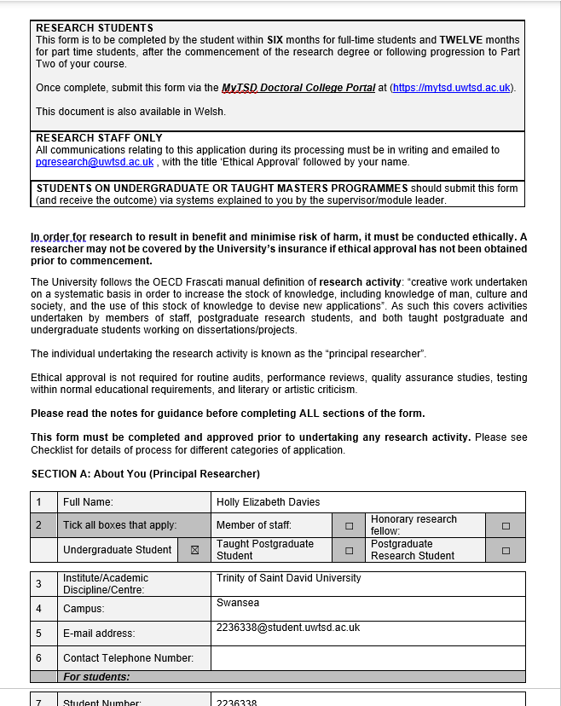

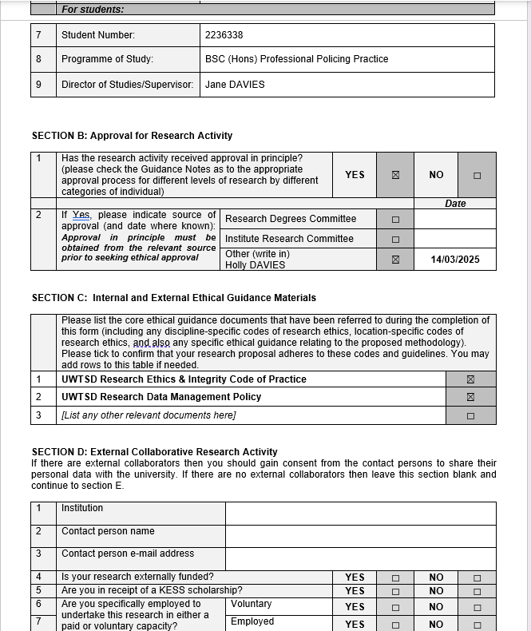

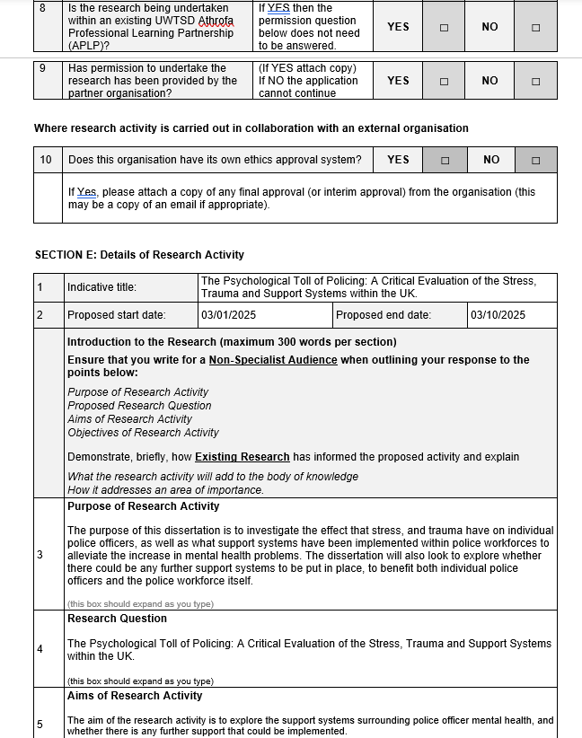

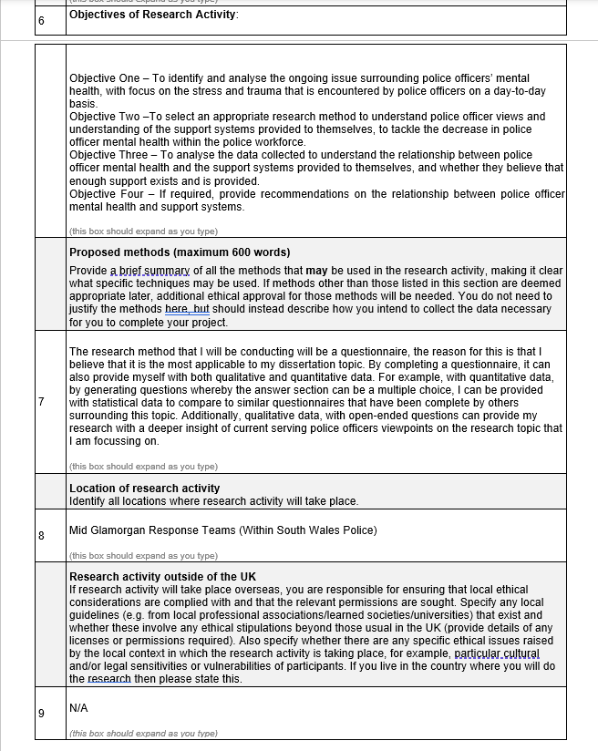

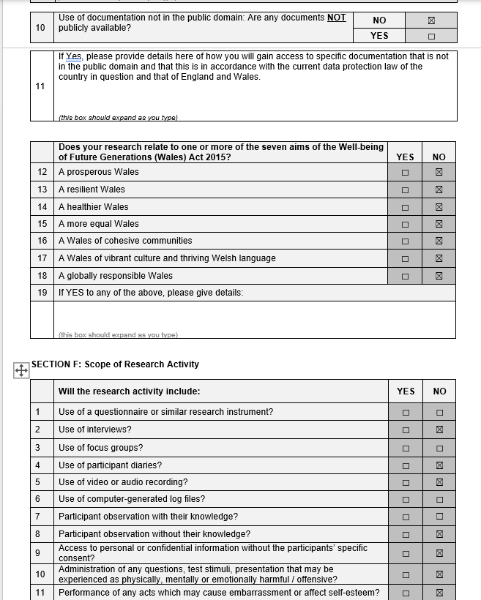

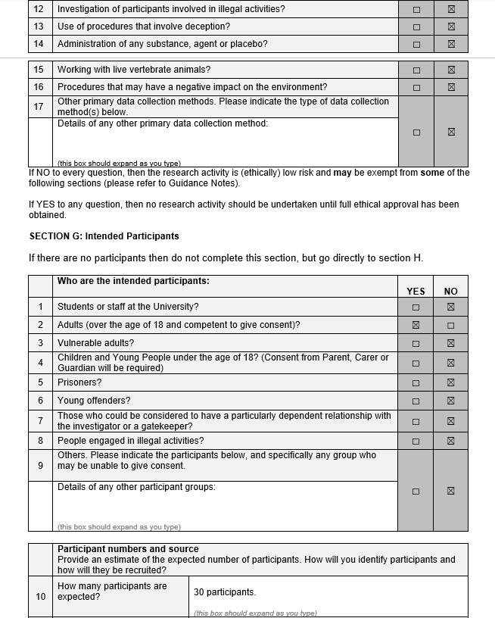

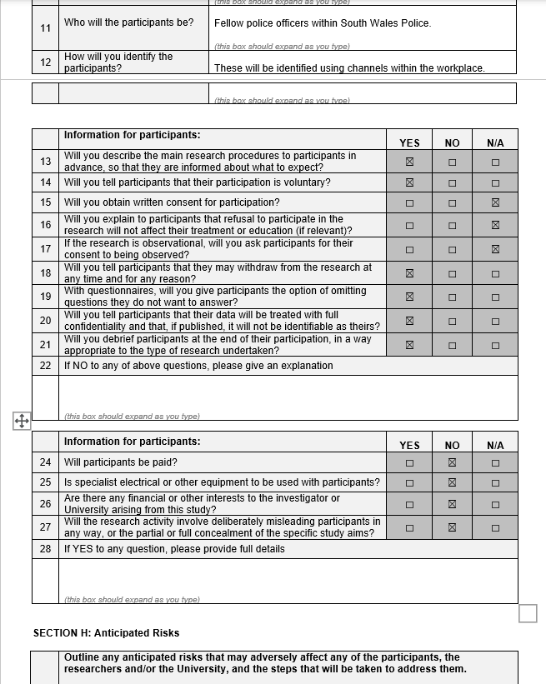

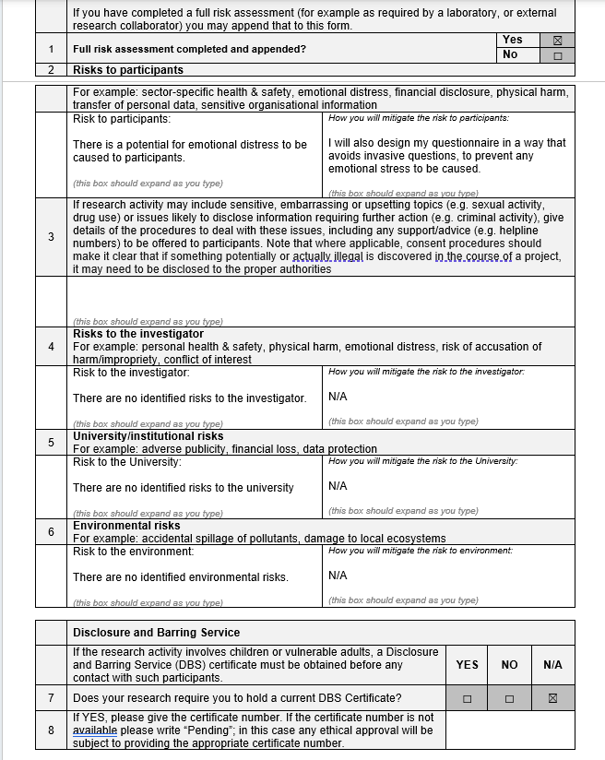

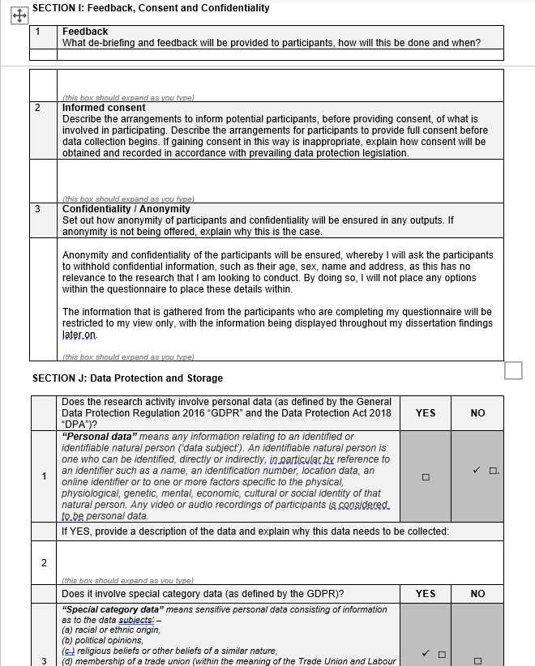

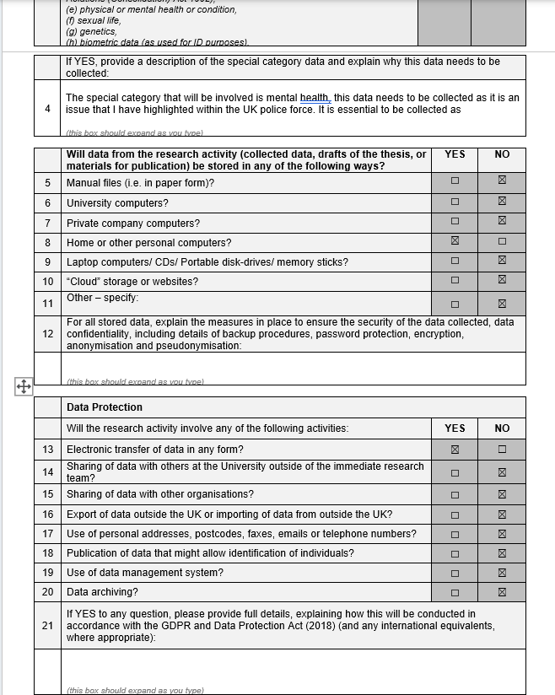

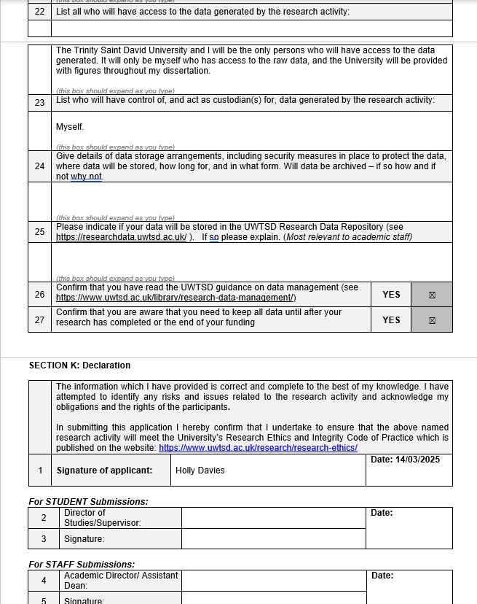

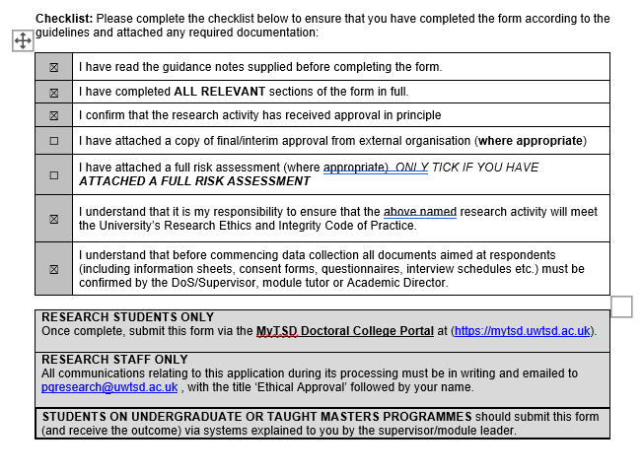

Appendix B – Blank Survey Questions


