ASSIGNMENT 1:
ESSAY IN RESPONSE OF THE TASK GIVEN


By Linda roze (2219027)

Lecturer: Riaz bhatti

module: MANAGEMENT ECONOMICS (LCBB5008)

Contents
Introduction 3
Economic Problems 4
Solutions to the Economic Problems 9
The Importance of Supply and Demand Chain 13
The Difference Between Elasticity and Inelasticity 16
Supply and Demand Laws 18
Conclusion 21
References: 22

Introduction

UK economic disruptions brought about by the COVID-19 pandemic and Brexit have resulted in problems with supply chains, price inflation, and financial instability. This essay addresses strategic options including supply chain optimisation and government action as it examines these economic issues, which include shortages, rising costs, and changes in consumer behaviour.

Economic Problems
Covid-19 Rules of Doing Business
Strict safety and health protocols have been placed in reaction to the COVID-19 pandemic. These constraints altered the manner in which multinational firms conducted their operations. Operating expenditures and logistical issues increased as a result of social isolation, distant employment, and enhanced cleanliness practices (Salah et al., 2021).
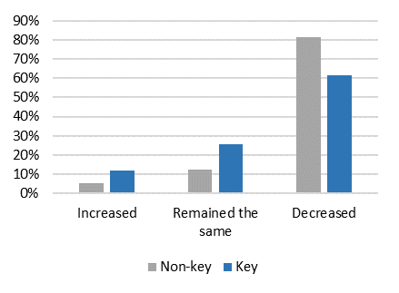
Figure 1: The impact of Covid-19 over the labour
Source: webapps.ilo.org

Shortages of Demand Due to Increased Demand
As a result of the increased consumer demand caused by the pandemic, there was a shortage of various products. According to Kopishynska and Umaieva (2022), panic purchasing and hoarding exacerbated the situation by putting pressure on supply networks and leading to product shortages in several industries.
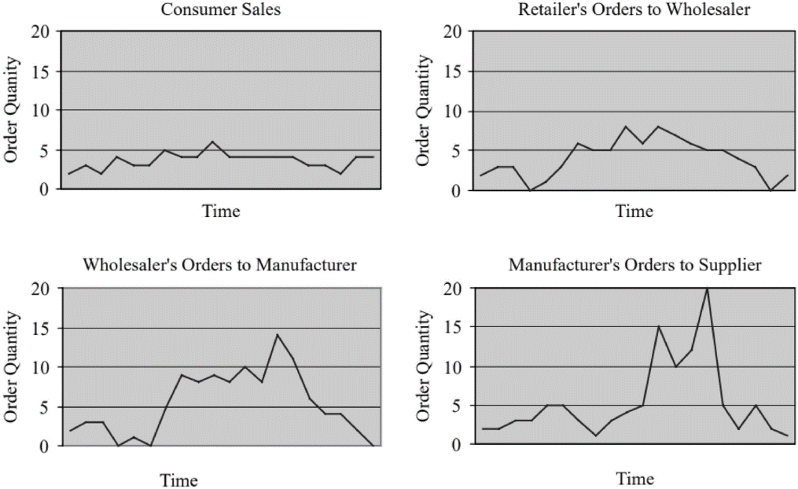
Figure 2: Product Shortages
Source: Paik and Bagchi (2007)

Shortages of Supply
As a result of the COVID-19 epidemic and Brexit, drivers have departed both the European Union and the United Kingdom, which has led to a lack of drivers. Situational factors were the root cause of the shortfall. Due to this shortage which can be seen in the below graph which was on its highest point in COVID 19 period, experienced a delay in product delivery as well as an increase in transportation expenses as a direct consequence of the disruption that occurred in supply networks (Ivanov and Dolgui, 2022).
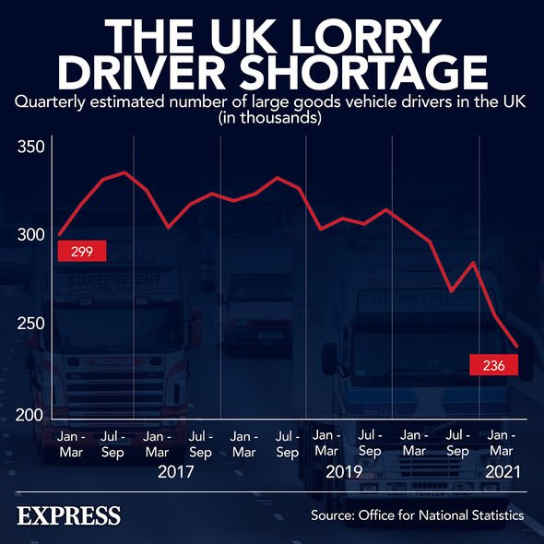
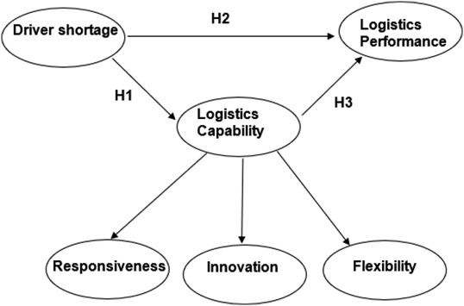
Figure 3: Logistic Capability

Source: Wang et al. (2022) Source: Murrison (2022)

Effects of BREXIT on Demand and Supply Chain
The immigration regulations and trade tariffs resulting from Brexit create complexities in the supply chain activities within the United Kingdom. Companies faced disruptions and higher costs due to the decline in migrant labour and the increase in customs checks (Bloom et al., 2019).
Panic Buying
Consumer panic shopping during the outbreak led to significant shortages of vital commodities. The relocation resulted in supply chain disruptions, leading to depleted store shelves and exacerbating the scarcity of food and petrol (Luan, 2021).

Shortage of Fuel Supply
The combined impact of driver shortages and increased demand led to a significant fuel supply crisis in the UK. This shortage affected not only consumers but also businesses reliant on consistent fuel supplies (Ghafour and Aljanabi, 2022).
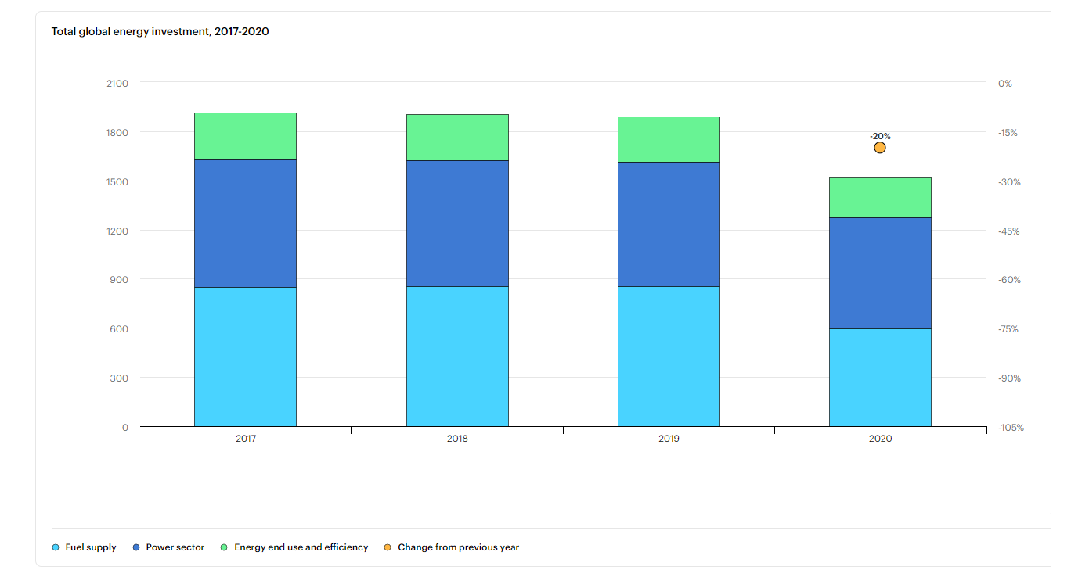
Figure 4:Total global energy investment, 2017-2020
Source: IEA
Rocketed Price Changes in the Cost of Fuel
The economic impact of increased fuel prices is profound, leading to inflationary pressures across various sectors. Higher fuel costs elevate transportation and production expenses, subsequently raising the prices of goods and services, which affects both businesses and consumers (None Reza Setiawan and None Rosita, 2023; Al Fajrin et al., 2023).

Excessive Debt Taken Out to Pay Increasing Living Expenses
High borrowing rates have been used by both businesses and consumers to offset rising living expenses brought on by price inflation and unstable economic conditions. This financial strain has led to increased debt levels and heightened vulnerability to economic shocks (Najmulmunir, 2008).
End of Furlough and Redundancies
The termination of government furlough schemes has resulted in significant redundancies, exacerbating economic instability. The end of such support has left many businesses struggling to retain employees, leading to higher unemployment rates and reduced consumer spending (Ahmed, 2023).
Bankruptcies Due to Lack of Funds to Pay High Borrowings
The inability to service high borrowings has led to an increase in business bankruptcies. The financial strain from elevated operational costs and reduced revenue has forced many companies to shut down, contributing to economic downturns (Rahim and Yusoff, 2019).
Shift in Consumer Appetite from Services to Goods
Instead of reducing their use of services, the epidemic has resulted in an increase in the purchase of commodities. The failure of supply networks to cope with the heightened demand has led to a decrease in demand for services, increasing costs, and shortages of some goods (Widiantari et al., 2023). This modification has led to a reduction in the need for service industries.

Solutions to the Economic Problems

Government Intervention
To address the economic problems caused by the epidemic, the government must step in. This entails putting laws into effect, offering financial assistance, and enhancing communication. to bring about market stability. According to 2020 research by Abutabenjeh and colleagues, supply chain problems may be resolved by effective public procurement and regulatory standards. Subsidies and fiscal packages are examples of financial assistance strategies that can assist in the rehabilitation of these businesses and mitigate their financial issues.
Relaxing Some Stringent Covid-19 Rules
By modifying the degree of severity Covid-19 could make business processes more efficient. With restrictions loosened, businesses may carry on as usual while maintaining safety (Tregear, 2023). This lessens disruptions to operations. Park, Hong, and Baek (2016) claim that these adjustments may boost the efficiency and availability of the labour force, which is important for pandemic-affected sectors like manufacturing and retail. These adjustments may result in a sharp increase in staff availability.
Developing Shortage Management Team Strategy
Skilled shortage management teams are absolutely necessary to handle supply chain problems effectively. Zhu et al. (2023) state that these groups may develop strategies to anticipate and manage shortages, enhancing the supply chain. In order to enhance the operations and supply chain and lessen the possibility of future interruptions, they can also collaborate with a wide range of stakeholders.

Create and Improve Supplier Collaborations Network
Enhancing the coordination networks among suppliers is crucial in order to reduce supply interruptions. Supplier connections may enhance the robustness of the supply chain. By promoting more collaboration and the pooling of resources, this enhances the robustness of the supply chain. Collaboration not only promotes innovation and flexibility but also helps organisations overcome unexpected problems.
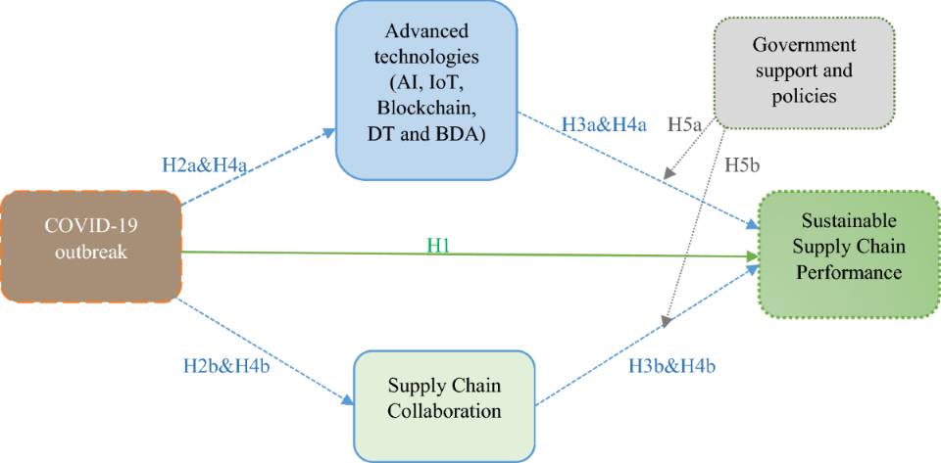
Figure 5: The impact of the pandemic over the Supply Chain Performance
Source: Javed et al. (2024)
Create Alternative Ways to Reduce Waste
Resource-efficient solutions need to be put into practice in order to eradicate waste. Collaborations on waste reduction, digital supply chain technologies, and circular economy might help reach this aim. These methods increase efficiency, lessen waste, and enhance the environment (Dainty and Brooke, 2004). Peiris et al. (2023) claim that waste reduction can reduce a company's operating expenses and environmental effect.

Assess and Improve Own Supply Chain
Finding inefficiencies and improving efficiency need supply chain modifications and internal assessments. Internal evaluations are important. Regular supply chain evaluation may help businesses reduce expenses, improve performance, and streamline operations. The optimisation of supply chain operations may be enhanced by contemporary technology and ongoing observation (Mohammadi et al., 2018; Ben-Tzur and Ward, 2010). This guarantees that the business can adjust to setbacks.

Work with Suppliers to Reduce Price
Negotiating better terms with suppliers is an effective strategy for reducing costs. Establishing strong relationships and collaborative partnerships can lead to mutually beneficial agreements, lower prices, and enhanced supply chain efficiency. Open communication and regular negotiations help in aligning goals and improving the overall supply chain network (Hussain Soomro et al., 2021; Cherrett et al., 2010).
Keep Stakeholders Informed and Up to Date
Transparent communication with all stakeholders is vital for effective supply chain management. Keeping stakeholders informed about changes, challenges, and strategies ensures alignment and fosters trust. Regular updates and open dialogue help in addressing issues promptly and maintaining a resilient supply chain (B. Nagarjuna et al., 2023). Effective stakeholder communication enhances collaboration and supports the implementation of sustainable practices.

The Importance of Supply and Demand Chain
Pricing Strategy
Adjustments to pricing strategies are essential to manage demand and supply pressures effectively. Implementing dynamic pricing models, such as incremental discounts, can attract customers while controlling inventory levels. This approach helps balance demand fluctuations and maintain profitability, ensuring a competitive edge in the market (Gheydari and Nazari, 2022).
Competition and Price Reduction
Competition drives prices down by encouraging businesses to offer better value to consumers. Market sharing and price leadership strategies enable firms to compete by setting the lowest market prices, increasing market share and profits. This competitive pricing helps stimulate demand and promotes efficient resource allocation within the market (Farm, 2009).
Business Productivity Expansion
Businesses can enhance productivity through strategic use of online platforms. For example, Amazon's comprehensive platform management integrates supply chain operations, inventory management, and customer service. This approach streamlines processes, reduces costs, and increases efficiency, enabling businesses to scale operations and meet growing demand effectively (Ma et al., 2010).
Marketing Strategy
Effective marketing strategies are crucial for promoting business concepts and engaging consumers. Understanding customer purchasing behaviour and market trends allows businesses to tailor their marketing efforts, increase competitiveness, and stabilize their market position. Well-planned marketing strategies help in building brand loyalty and driving sales.

Inventory Management Strategy
Implementing just-in-time inventory systems and other strategies optimizes stock levels and reduces waste. Efficient inventory management ensures that businesses can meet demand without overstocking, thus lowering costs and improving cash flow. Advanced demand forecasting and real-time inventory tracking are critical components of effective inventory management (Limansyah and Lesmono, 2020).
Finance Attraction Through Investments
IPOs are a highly effective means for companies to draw in significant investors. IPOs give companies the money they need to expand, embark on new initiatives, and take a stronger position in the market. According to Aktas et al. (2016), public investor funds support business expansion and financial stability.
Greater Worker Retention and Satisfaction
A generous salary is crucial for maintaining employee happiness and contentment. Attractive compensation packages attract highly skilled individuals and reduce employee attrition, leading to a steady and committed team. In order to sustain productivity and foster loyalty, employees must experience a sense of appreciation and get equitable remuneration (Babina et al., 2015).
Risk Management
Ensuring a balance between supply and demand issues is essential for sustaining solid continuation through effective risk management. Organisations may mitigate disruptions by employing real-time market monitoring, diversity, and contingency planning. Proactive risk management allows organisations to adjust to changing market conditions while ensuring operational stability (Inderst and Mueller, 2002).

Management of Shortage and Supply
There are a number of factors that might aid in adapting to changes in market demand, including advanced forecasting tools, flexible supply chains, and strong ties with suppliers. By utilising these strategies, businesses are able to forecast shifts in demand and adjust the processes involved in the supply chain. By effectively managing gaps, businesses are able to rapidly meet the requirements of their customers (Mohammadi et al., 2018).

The Difference Between Elasticity and Inelasticity

Definitions
The term "elasticity of demand" refers to the degree to which the amount of a product or service that is sought shifts in response to a market variable, such as the value of the product or the demand for it. When prices change, high-elasticity products cause considerable fluctuations in demand. This is the case because of the characteristics of the items. Whenever there is a change in the price of something, this takes place (Beckman and Smith, 2014). However, inelasticity of demand occurs when the amount of an item or service that is desired does not change significantly regardless of the price of the good or service. Since people continue to purchase pharmaceuticals and utilities despite price rises, the demand for these products is inelastic. The pharmaceutical industry and utility items are two examples of commodities (Kumari et al., 2020).
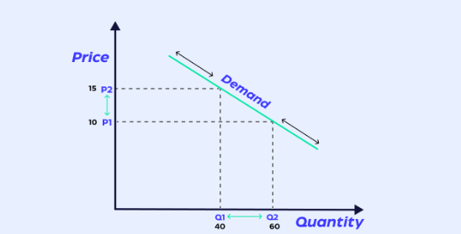
Figure 6: Explanation Chart

Comparison with Examples
Every time there is a change in the pricing of the items, there is a possibility that the elastic commodity demand for such goods. These goods are consumer goods that are neither needs nor luxury items. They fall within the category of commodities. As prices continue to grow sales of high-end gadgets continue to decrease (Buer,2016). This happens anytime there is an increase in pricing. Nevertheless, despite the fact that prices have increased, inelastic items such as gasoline and electricity, as well as essentials such as food, continue to be in demand. Considering that customers buy these things because they are required to do so, it may be deduced that price fluctuations have less of an impact on the decisions they make regarding their purchases (Kumari et al., 2020).
Advantages and Disadvantages
Elasticity of demand provides several advantages, including the ability to set optimal pricing strategies that can maximize revenue during periods of high demand. Lower taxes and increased sales can result from accurately predicting consumer responses to price changes. However, the need for constant market monitoring and the short-term effectiveness of price adjustments pose significant challenges. Additionally, businesses may struggle to maintain stability in volatile markets where demand is highly elastic (Buer, 2016).
Inelasticity of demand offers the advantage of stable revenue, as businesses can increase prices without significantly losing customers. This stability allows for more predictable financial planning and can lead to higher profit margins during economic fluctuations (Beckman and Smith, 2014). However, the main disadvantage is the potential for consumer dissatisfaction and decreased affordability, particularly when prices for essential goods are raised. Additionally, companies relying on inelastic demand may face public backlash and regulatory scrutiny if price increases are perceived as exploitative (Kinnucan and Zheng, 2004).

Supply and Demand Laws

Increased Demand, Unchanged Supply
This scenario typically occurs when a product becomes more popular or a population's income increases, enhancing their purchasing power. The higher demand pressures the market, causing prices to rise until supply can be adjusted to meet the new demand levels.
Decreased Demand, Unchanged Supply
This situation can occur due to a decline in consumer interest, economic downturns, or changes in preferences. As demand drops, suppliers may reduce prices to encourage sales and clear excess inventory, leading to a decrease in market prices and quantities sold (Aiming, 1991).
Increased Supply, Unchanged Demand
This may occur as a result of new companies joining the market or as a result of established producers raising their output levels. The surplus supply exerts downward pressure on prices as sellers compete to attract buyers, resulting in reduced prices and increased availability of goods.
Decreased Supply, Unchanged Demand
This scenario may occur due to production disruptions, resource shortages, or supply chain issues. The limited supply forces price up as consumers compete for the available goods, leading to higher prices and reduced quantities in the market (Chen et al., 2017).

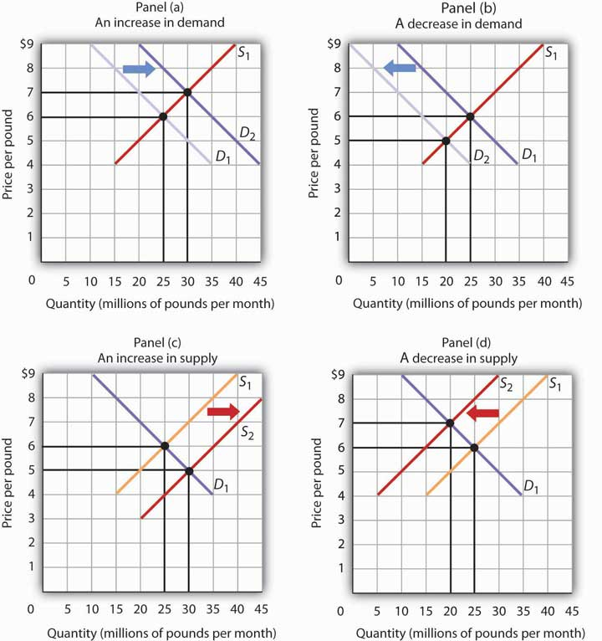
Figure 7: Supply and Demand Laws Chart
Source: University of Minnesota (2016)

Conclusion

In the future, resolving such challenges requires initiative. Achieving long-term economic stability will require promoting innovation, strengthening supply chains, and getting ready for any future crises. Businesses and governments may work towards a more adaptable and flexible economic system that is better suited to manage unforeseen circumstances in the future and promote sustainable growth by putting these methods into practice.

References:

- Abutabenjeh, S., Anguelov, L., Brunjes, B.M., Dimand, A.-M. and Rodriguez-Plesa, E. (2020). Supplying the pandemic response: The importance of public procurement. Journal of Emergency Management, 18(7), pp.189–208. doi: 10.5055/jem.0549.
- Ahmed, M. (2023). Effects of fuel prices on economic activity: Evidence from Sudan. International Journal of Advanced and Applied Sciences, 10(6), pp.164–179. doi: 10.21833/ijaas.2023.06.020.
- Aktas, N. and Croci, E. (2016). The Financing Role of IPOs in Acquisitions: Market- Versus Bank-Based Economies. SSRN Electronic Journal. doi: 10.2139/ssrn.2835972.
- Al Fajrin, B.F.R., Jinan, A.Z., Auliyah, P.S., Wulandari, A.F. and Tambunan, N. (2023). The Impact of the Drastic Increase in Fuel Oil (Bbm) Prices. Journal of Social Research, 2(3), pp.640–645. doi: 10.55324/josr.v2i3.709.
- Aiming, H. (1991). Shortage and Coupons. Chinese Economic Studies, 24(4), pp.69–75. doi: 10.2753/ces1097-1475240469.
- Babina, T., Ouimet, P.P. and Zarutskie, R. (2015). Going Entrepreneurial? IPOs and New Firm Creation. SSRN Electronic Journal. doi: 10.2139/ssrn.2692845.
- Beckman, S. and Smith, J.W. (2014). An Essential Guide to Demand. SSRN Electronic Journal. doi: 10.2139/ssrn.2380777.
- Ben-Tzur, I. and Ward, G. (2010). Systems Approach to Reducing Waste in the Fresh Produce Supply Chain. Acta Horticulturae, (880), pp.125–136. doi: 10.17660/actahortic.2010.880.13.
- Bloom, N., Bunn, P., Chen, S., Mizen, P., Smietanka, P., Thwaites, G. and Young, G. (2019). Brexit and Uncertainty: insights from the Decision Maker Panel. SSRN Electronic Journal. doi: 10.2139/ssrn.3335270.
- Buer, M.C. (2016). Elasticity of Demand. pp.36–39. doi: 10.4324/9781315270081-13.
- Cherrett, T., Maynard, S., McLeod, F. and Hickford, A. (2010). Reverse logistics for the management of waste. Green Logistics: Improving the environmental sustainability of logistics, pp.242-262.
- Murrison, P. (2021). Lorry driver shortage: Charts reveal shocking decline in HGV drivers. [online] Express.co.uk. Available at: https://www.express.co.uk/news/uk/1497384/lorry-driver-shortage-fuel-HGV-drivers-charts-evg.
- Dainty, A.R.J. and Brooke, R.J. (2004). Towards improved construction waste minimisation: a need for improved supply chain integration? Structural Survey, 22(1), pp.20–29. doi: 10.1108/02630800410533285.
- Farm, A. (2009). Market Sharing and Price Leadership.
- Gheydari, S. and Nazari, L. (2022). Inventory Model and Pricing in the Supply Chain Approach VMI Considering Incremental Discount. doi: 10.47176/tdass/2022.33.
- Ghafour, K.M. and Aljanabi, A.R.A. (2022). The role of forecasting in preventing supply chain disruptions during the COVID-19 pandemic: a distributor-retailer perspective. Operations Management Research. doi: 10.1007/s12063-022-00327-y.
- Hussain Soomro, A., Shaikh, N., Fatima Miano, T., Marri, A., Gul Khaskheli, S. and Kumar, D. (2021). Food Waste Management Strategies in Food Supply Chain. International Journal of Ecosystems and Ecology Science (IJEES), 11(4), pp.759–766. doi: 10.31407/ijees11.413.
- Inderst, R. and Mueller, H.M. (2002). Venture Capital Contracts and Market Structure. [online] Ssrn.com. Available at: https://ssrn.com/abstract=302402 [Accessed 22 Jul. 2024].
- Ivanov, D. and Dolgui, A. (2022). The shortage economy and its implications for supply chain and operations management. International Journal of Production Research, 60(24), pp.1–14. doi: 10.1080/00207543.2022.2118889.
- Kopishynska, K. and Umaieva, D. (2022). POST‐COVID‐19 SUPPLY CHAINS: CHALLENGES AND PROSPECTS. Zeszyty Naukowe Politechniki Częstochowskiej. Zarządzanie, 45(1), pp.38–47. doi: 10.17512/znpcz.2022.1.03.
- Kumari, S.M.M., Maheepala, J., Koswatte, K.R.D. and Perera, S. (2020). Import Demand Elasticities of Sri Lanka from January 2010 to March 2021 and the Change in Elasticities during the COVID-19 Pandemic. Staff Studies, 50(2), p.115. doi: 10.4038/ss.v50i2.4726.
- Limansyah, T. and Lesmono, J.D. (2020). A Mathematical Model for Inventory and Price-Dependent Demand with All-Units Discount. Journal of Physics: Conference Series, 1490, p.012051. doi: 10.1088/1742-6596/1490/1/012051.
- Luan, Y. (2021). Review on the Prices of Shipment Keep Rising in Perspective of Global Shipping Supply Chain Disruption. BCP Business & Management, 13, pp.92–100. doi: 10.54691/bcpbm.v13i.57.
- Ma, C., He, H. and Louyue Xun (2010). Inventory Management Strategy of Retail Trade on Revenue Management. doi: 10.1061/41139(387)119.
- Mohammadi, M., Jämsä-Jounela, S.-L. and Harjunkoski, I. (2018). Sustainable supply chain network design for the optimal utilization of municipal solid waste. AIChE Journal. doi: 10.1002/aic.16464.
- Najmulmunir, N. (2008). Dampak kebijakan harga minyak terhadap daya beli masyarakat. Jurnal Madani. Edisi II, Nopember.
- Nagarjuna, B., Ramachandran, K.K., Ajay Nautiyal, Sardar Parminder Singh, Bijaya Bijeta Nayak and Ganguly, P. (2023). Sustainability in the field of Supply Chain Using Technology: A deep review. doi: 10.1109/icacite57410.2023.10183000.
- Peiris, M., Isuru Gamlath and Saman Bandara (2023). Optimum Route Plan for Effective Collection of an Industry Level By Product/Waste. Proceedings of the SLIIT International Conference on Engineering and Technology. doi: 10.54389/bcoc8887.
- Rahim, N.Abd. and Yusoff, Y.S. (2019). Household income prediction model due to fuel price fluctuation: A review. Journal of Physics: Conference Series, 1358(1), p.012077. doi: 10.1088/1742-6596/1358/1/012077.
- Salah, M., Reason, D.M., Ncube, M. and Al Kaabi, S. (2021). The Impact of Post-Covid-19 Container Shortage Crisis on Global Supply Chains. doi: 10.46254/ap01.20210211.
- Setiawan, R. and Rosita (2023). Dampak Kenaikan Harga Bahan Bakar Minyak (BBM) Tahun 2022 terhadap Tingkat Pendapatan Pedagang di Pasar Cakranegara Kota Mataram. Nusantara Hasana Journal (Online), 2(10), pp.44–49. doi: 10.59003/nhj.v2i10.797.
- Tregear, M. (2023). Public policies and financing for Mexican SMEs in the face of the Covid19 pandemic. Panorama Económico, 31(1). doi: 10.32997/pe-2023-4151.
- University of Minnesota (2016). 3.3 Demand, Supply, and Equilibrium. [online] open.lib.umn.edu. Available at: https://open.lib.umn.edu/principleseconomics/chapter/3-3-demand-supply-and-equilibrium/.
- Widiantari, A., Neki, E., Kiftiah, M. and Martha, S. (2023). The Effect of Increasing Fuel Prices on the Components of Household Consumption Expenditures in PDRB According to Expenditure Case Study of West Kalimantan Province 2015-2022. Jurnal Forum Analisis Statistik (FORMASI), 2(2), pp.104–117. doi: 10.57059/formasi.v2i2.34.
- webapps.ilo.org. (n.d.). The effects of COVID-19 on businesses: key versus non-key firms. [online] Available at: https://webapps.ilo.org/static/english/intserv/working-papers/wp077/index.html.
- Zhu, L., Zhao, B., Liu, H., Zhou, R. and Li, X. (2023). Research on policy options to improve the controllability of strategic material supply chain. doi: 10.1109/ictis60134.2023.10243919.

