Developing Creative Project Self Reflection
Word count: 1313

With my creative project I wanted to be able to use the knowledge and skills I have gained over the last two years, while studying to achieve a Batcheler of Arts in Film and Visual Culture.
In my second year the topic of film genre was studied, we looked at the genre of film noir, and an area that I had never even considered or looked at in depth before. While looking at this very interesting and sometimes confusing genre, it began to intrigue me, so much so I choose to write an essay concerning the films Kiss Me Deadly (Aldrich, 1955) and Touch of Evil (Welles, 1958).

Before starting my final year, I had no idea what I was going to do concerning my main project, until it was discussed in class. At the back of my mind I had considered a concept that concerned the film actor Gareth Hughes, but writing a script had not been at the top of my agenda. I had thought about possibly creating a photographic portfolio, or maybe a dissertation regarding Gareth Hughes, but never a script.
I had started writing a script around 14-years ago, but back then I had no idea how to format the script correctly. However, since I started studying and researching script writing, I now have a better understanding of how to format and lay out a script out correctly.
I still have a long way to go, but with guidance and the implementation of further research I am confident I will be able to achieve a strong and workable script.
However, before I can achieve this I need to carry out extensive research, exploring formatting the script correctly and also building the world in which my script is set.
Through this process I now know why it is important to develop a story world and the characters that live within it, before even considering starting to write the script.

My script is based on a historical event that happened in Hollywood during the 1920s, concerning the murder of the prominent film director and producer William D Taylor. At the time it was a scandal, which a relative of mine, the aforementioned Gareth Hughes, was caught up in. At the time Hughes was a very successful film actor in Hollywood and allegedly had had an affair, or liaison, with Taylor. Hughes was one of many suspects brought in for questioning, because a certain brand of cigarette that only a few could afford to smoke, was found at the murder scene of Taylor.
I hope by writing a well-researched and stimulating script, it will be able to be developed further and possibly made into a film.
I believe I do have the knowledge and ability to write a workable script, which is based on both factual and fictional events concerning Hughes and Taylor.
Since I have been developing this portfolio, I have discovered even more interesting facts about this event. This has helped to build upon the knowledge I already have concerning Hughes.

Over the last three years I believe my research and writing skills have improved considerably, which will help me to develop the script. I also believe I am able to work well under my own direction. Creating and developing this portfolio has also helped me to think about how I would like the film to look and feel, if it were to be made. Included in the portfolio are colour palettes of the different scenes, which include the opening scene of Hughes in Nixon, Nevada and of the murder scene in Los Angeles. Below is an example from the portfolio (fig.1).

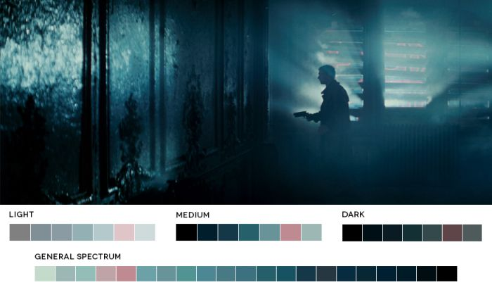
Fig.1 - Colour Palette from a scene in Blade Runner (Scott, 1982)

Producing this portfolio has also helped me to think about who I would like to play the different characters in the film, which again will help me when comes to writing the script.
By having actors in mind to play the various parts will help me when it comes to developing the characters in the script and writing their back stories, whether they be factual or fictional.
Frensham (1996) explains that, ‘Sometimes you will find your characters changing the direction or thrust or your original story. Don’t be afraid of it.’ This statement taken from Frensham’s book ‘Teach Yourself Screenwriting’ is one that I need to refer back to while writing, because this will inform me when thinking about and developing my characters and my story. I also think I need to be flexible while writing and to be open to advice and criticism. Additionally, I think while writing the script I need to keep reflecting on the story I want to tell, and if necessary, move the story in a different direction than first intended.
Thinking about all the elements I need to bring together for the script has been a daunting process at times, but at the same time exciting. For example, using a beat sheet to help me plan the pace of the script, this is something I had never considered using before.
Furthermore, thinking about the word count and having to stay within 40 to 48 pages will be challenging, because there is so much happening within the narrative. Within the script writing process I also need to consider the predicament of what do I include and what do I leave out? Designing a poster for the proposed film has also helped me to focus on the many elements of the script and the world that my characters inhabit.

Preparing this portfolio has definitely helped me to think about the story I want to tell and to include the following elements: murder, sex, Freemasonry, religion and possibly police corruption; and how they all may influence the outcome of the narrative.
The process of making this portfolio has helped me to improve my research and design skills and expanded my knowledge about Gareth Hughes and his possible involvement in the murder of William D Taylor. The portfolio has also helped me to create what I believe is a solid foundation and body of research for my script. The other elements of this portfolio, which include a Gantt chart (fig.2), will help me when it comes to planning the best use of my time, while not only writing, but addressing a work-life balance. Plus, most importantly, the planning of the 9th Carmarthen Bay Film Festival in May 2020.

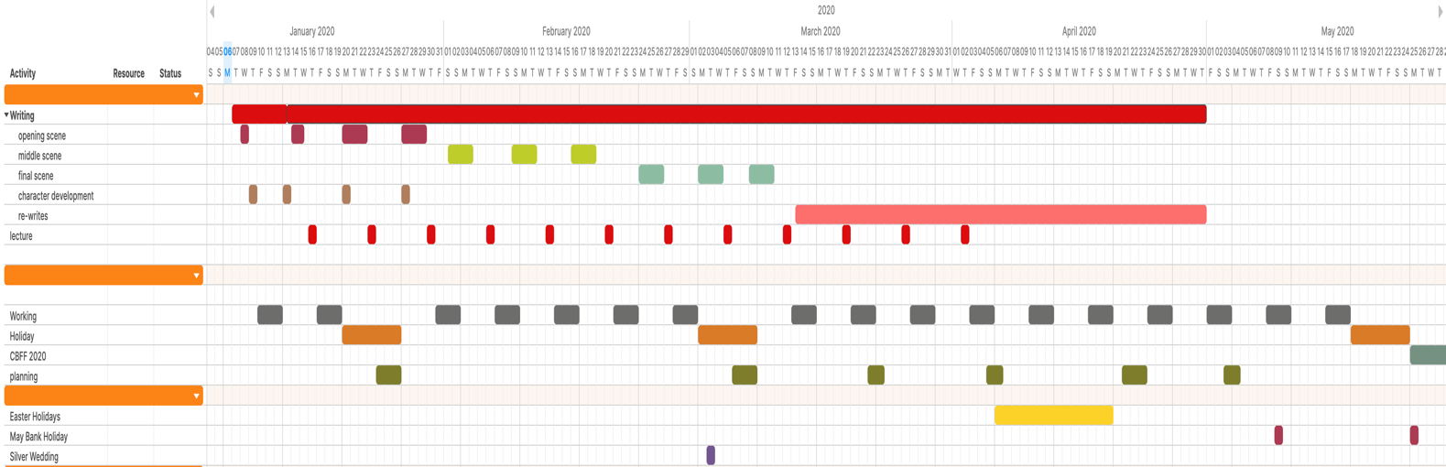
Fig.2 - Gantt Chart for planning personal time usage and script development

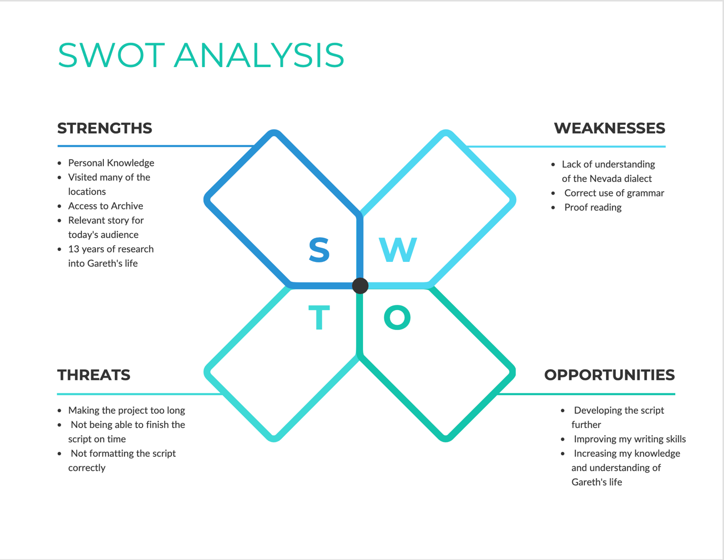

Fig.3 – SWOT analysis

When considering the SWOT analysis (fig.3), I believe that I have built upon the strengths I already have concerning the personal knowledge and Gareth Hughes’ alleged involvement with the murder of William D Taylor. This is strengthened by local knowledge of Nixon, Nevada and information sourced at the Special Collections Department within the University of Nevada, Reno. To improve my knowledge and understanding of the Nevada dialect, I need to research and watch local news programmes (via the Internet) and liaise with native speakers of the Paiute language – this will help to make the script more authentic. I will also engage in the process of reading past scripts and literature on script writing skills, to help improve my work. I will utilise the Gantt chart to plan my time and help me keep within the set timeframe and word count. I have created a mind map (fig.4) to help me visualise the different processes needed to produce the script.

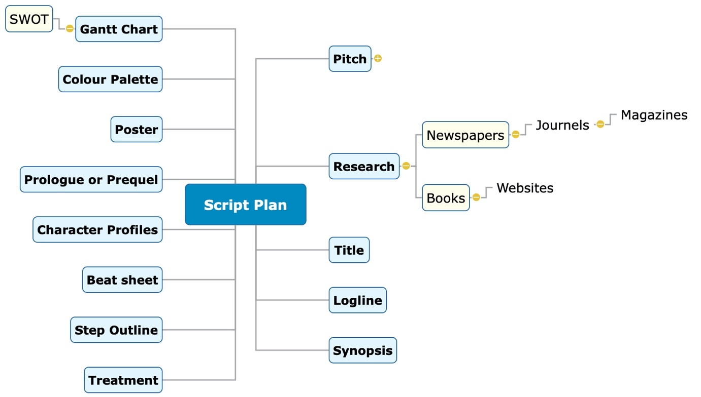

Fig.4 – Mind map for script plan research and development using Mindview software

Creating this portfolio has helped me to consider pursuing a career in research and possibly script writing. It has been an enjoyable process and has got me to think about and review all the information and artefacts I have collected over the years, concerning Gareth Hughes, and to put them to good use.

Reference List
Frensham, R. (1996) Teach Yourself Screenwriting. London: Hodder Arnold

