SUSTAINABLE HOSPITALITY & TOURISM
MANAGEMENT
Assessment 1

NAME AND STUDENT NUMBER:
Marius-Ionut Hurmuzache
2125248
LECTURER’S NAME:
Huw Thomas

Introduction
This Essay investigates the transition toward sustainability in the hospitality and tourist industries, focusing on well-known businesses such as Marriott Hotel and their use of circular economy principles within the corporate social responsibility (CSR) framework. It investigates sustainability's social, environmental, and economic elements, tourist impacts, and policy papers, focusing on Wales, to better comprehend the changing landscape of sustainable development. Sustainable hotels seek to lower their carbon footprint by incorporating environmentally friendly methods into their services, maintenance and distribution chains. Contemporary Tourism provides a unique worldwide viewpoint on tourism, addressing the shifting global order, destination marketing, tourist ethics, and pro-poor tourism. These hotels use automation and software to cut energy use, eliminate food and recyclables, conserve water, and modernise the client experience. However, it is critical to prevent greenwashing and be upfront about eco-friendly measures. To become an ecologically conscious hotel, start small and progressively implement green measures to draw environmentally aware tourists. This essay investigates the transition toward sustainability in the hospitality and tourist industries, concentrating on Marriott Hotel's circular economics implementation as part of its CSR strategy. Tourism, especially hospitality, is a vital growing sector that contributes considerably to the economy and societal development, accounting for 4.4% of GDP, 6.9% of employment, and 21.5% of service-related exports (Costa and Costa, 2022). It investigates the industry's historical evolution, economic trends, consumer lifestyles, the effects of supply and demand, and social inclusion. The article intends to provide future leaders with a critical awareness of sustainability and to promote environmentally friendly activities.

Main body
Tourism is an important component of global culture since it allows individuals to explore, meet others, and learn about new cultures. In a circular economy, producers develop items that can be reused. For example, electrical gadgets are built to be repairable. Goods and ingredients are recycled as much as feasible. Plastic may be reprocessed into pellets to make new plastic items. However, the business is transforming in response to climate change risks and the need to cut emissions. Environmentally friendly tourism concentrates on providing travel possibilities with little environmental effect while also benefiting locations and people. It entails safeguarding the environment, giving socioeconomic advantages, preserving cultural legacy, bringing visitors and local people together, and developing inclusive possibilities. Ecotourism, on the other hand, aims to educate visitors about nature and the natural world while also engaging them in preservation and cultural activities. Both forms of tourism have benefits and drawbacks, and sustainable tourism may provide a solution to existing issues. The tourist business provides several social and cultural advantages, including community building, infrastructure improvement, job creation and the preservation of local traditions. However, it also has adverse ecological consequences, such as developing nature green spaces, decreasing wildlife poaching, increasing water quality, and raising money for nature conservation. Staged authenticity, uniformity, and commercialization represent a few of the adverse socio-cultural consequences that might arise. Staged authenticity occurs when events or cultures are fabricated for tourism and profit, resulting in unfavourable sentiments among tourists and locals. Standardization, when tourists seek familiarity, might result in a loss of cultural uniqueness. Commodification, in which cultural events are tailored to tourists' time constraints, can leave local people feeling exploited. The detrimental environmental effects of tourism may be evident via development.
CSR refers to corporations accepting responsibility for their influence on society and the environment. Including a circular economy in CSR projects can result in environmentally friendly operations that are beneficial to both the firm and the community. The hospitality industry in the UK has experienced transformations and is influenced by economic changes as well as customer preferences (Inkson and Minnaert, 2018). The Marriott hotel is a significant player in the UK tourism industry. Corporate growth in the UK shows the tourism industry's detectability in the global dynamics. Technology advancement has become a significant player in the expansion of the tourism sector. Marriott Hotel is aligning technological advancement as well as globalisation with quality accommodation. The accommodation style is changing day by day and the hospitality as well as tourism sector must develop their ideas along with the changing pattern. The historical context helps to understand that the Marriott Hotel has experienced the UK's economic changes as well as shifts in growth opportunities and customer behaviour. The contemporary growth rate indicates that the Marriott Hotel has experienced a complex journey in the tourism industry in the UK.
Marriott International unveiled its three-year business plan for 2025, which includes the debut of a new midscale company, the Four Points Airport by Sheraton, for Europe, the Middle East, and Africa (EMEA). The business intends to add a total of 2 to 270,000 net beds over the next three years, bringing its worldwide portfolio to approximately 1.8 million net rooms by the end of the year 2025. Marriott's goal is to offer the finest products and experiences for customers, attract and keep its most loyal visitors, and be in more locations throughout the world. Given the assumptions made in its three-year framework, the corporation might achieve results such as gross fee revenues of 18 per cent YoY in 2023 and a two-year CAGR of 6.5% to 9.5% to attain $5.4 billion in total revenues to $5.8 billion by 2025. Marriott also focuses on luxury and leisure products, with almost 500 open premium rooms and 17% of the total market. Conversions, especially multi-unit conversions, are an important aspect of the business's overall growth plan (Hotelbusiness.com, 2022). Marriott intends to maintain its conservative approach to deploying money in overtime value-enhancing projects that generate cash flow growth.
The Marriott hotel in the UK follows a framework of sustainable development which shapes their practices with the UK and its national policies. Marriott Hotel follows sustainable standards as well as guidelines which are recognised globally. International frameworks like GSTC or UNWTO initiatives are followed by the hotel Marriott. The compliance-regulated activities by the Marriott Hotel are faster a standardised aspect of this hotel for the global environment as well as social changes. DCMS regulates the tourism industry in the UK and the Marriott Hotel follows the documents for digital media and support (Cooper, 2021). The sustainability agenda in Wales for tourism is influenced by the regional sustainability guidelines and rules mentioned in the tourism board from Visit Wales.
To be eligible for the plan, the hotel must satisfy specific requirements. These include keeping public liability insurance, following legislative requirements, and conforming to municipal planning and licensing rules. Owners additionally have to register with their local Health and Safety Department, maintain hygiene and food safety standards, and keep visitor registers. They must also abide by the Hotel Owners and Proprietors Act and the Data Protection Act. The hotel must also follow the Equality Act of 2010 and provide clean, sanitary, safe, and well-maintained accommodations. The basic admission criteria include being on-site 24 hours a day, seven days a week, offering bilingual emergency procedures, and keeping the facility looking well (Gov.wales.com, 2020). The hotel's hygiene as well as amenities are all important criteria for earning a high star rating. Cleanliness entails keeping the inside sound and clean, as well as servicing electrical or gas systems. Cleaning standards should be high, with cleaning chemicals that are low-impact and chlorine-free. Physical quality entails offering sufficient durability and comfort, with an emphasis on cleanliness and convenience. Hospitality comprises polite, efficient, and courteous treatment that is tailored to each guest. Services include a simple menu of options, timely and courteous service, and exceptional social skills.
In the coaster areas, the hotel Marriott can align their initiative with the Marine ecosystem which will promote bitch tourism as well as activities which are focused on the biodiversity of coasters. the initiatives can be taken from the Marriott hotels like beach clean-up and Marine conservation projects. These programs can support waste management programs. In rural areas, the Marriott Hotel can speed up sustainable tourism with the help of local farmers and producers. Local and organic products can be used in Marriott Hotel's restaurants for this sustainable tourism planning (Haski-Leventhal, 2018). The agritourism activities and eco-friendly practices can decrease the ecological footprint of the Marriott hotel. In the organic areas, the Marriott Hotel can sustain its urban development by implementing energy-efficient technology and public transport options. The Marriott Hotel also can support local cultural events and community engagement programs to encourage engagement. Collaborating with local business partners will increase the sustainability practice in the urban tourism sector. The Marriott Hotel has taken some initiatives to promote eco-friendly tourism and development life in Cornwall. The rural area of Lake District has been significantly influenced by the partnership with Marriott Hotel as the farmers, as well as producers, become introduced to the concept of sustainable agriculture practices. London is an urban location and the Marriott Hotel emphasizes the concept of energy-efficient building features and cultural engagement programs.
Marriott International was formed in 1927 and has been a global hotel industry leader since then. The company's key asset is its capacity to welcome diversity and provide possibilities for workers, visitors, owners, franchise owners, and suppliers. Marriott International, with over 3,800 hotels in 72 countries across the world, continues to set the standard for the industry in terms of inclusion, diversity, accessibility, and a people-focused culture. Marriott fosters a strong sense of belonging by treating workers like family and delivering a world of opportunities. The firm also provides accessible accommodations for those with impairments, allowing them to schedule stays at any of its facilities worldwide. the hotel's "spirit to serve" extends to caring for the neighbourhoods in which it works, as seen within its Pathways from Education to Work initiative, which was launched in 1989 (Levelaccess.com, 2022).
The Marriott Hotel in the United Kingdom works in an ever-changing setting driven by environmental legislation and self-regulatory norms, which shape tourist sector behaviour. Marriott Hotel uses cutting-edge technology to plan, implement, measure and share responsible operations, lowering waste to landfills by 45% and waste from food by 50%, benefitting both companies and communities. Marriott Hotel is committed to incorporating top environmental and ethical standards into its supply chain and collaborating with like-minded vendors (Marriott.com, 2020). It strives to limit the adverse social and environmental effects of our company operations by emphasizing sustainable, responsible, and local sourcing.
Marriott's advertising plan is built on a four-point approach that includes a diverse product offering, competitive price, openness to market adaptability, and distribution strategy. The organization caters to a wide range of consumers with varying budgets and travel demands, including luxury, cost, select, and extended stays. Marriott's distinguishing features include great services, exceptional service to customers, and a diverse portfolio with various rates. The firm intends to open 35 new luxurious lodging properties by 2023, with important brands such as Carlton or EDITION driving commercial development. Marriott's distribution strategy involves deliberately selecting properties near supermarkets, roads, and airports, and the company teamed with Expedia in 2019 (Wickham et al., 2021). The hotel incorporates ecological, market, and self-regulatory considerations into its everyday operations and works with industry colleagues to push for collective sustainability efforts.
Greening tourism business necessitates ongoing enhancements with a sustainable mentality guiding every decision. Small modifications, such as cutting back, reusing, or reusing and recycling, can have a significant impact. In the long run, aim to get recognized by a globally recognized green accreditation program. Green travel companies in developing nations may profit from long-term operating cost reductions, improved reputation, distinct selling features, investment prospects, European trade collaborators, and a good influence on employees. Consumer demand for environmentally friendly practices is increasing, including 84% of UK customers prepared to pay more for an environmentally responsible brand. To enter this burgeoning market, enterprises ought to promote their green efforts, draw inspiration from European campaigns, and communicate boldly. Green company in poor nations confronts several problems, including an absence of assets, reluctance to change, market competitiveness, limited government backing, a scarcity of environmentally conscious suppliers, and customer views. These characteristics may restrict demand for sustainable tourist choices and reduce profitability, particularly during a cost-of-living crisis. The EU Green Deal aspires to make Europe the continent's first climate-neutral nation by 2050, affecting SMEs in developing nations. Certification is necessary, but integrating sustainability is critical. To accommodate client demand, online tour operators are incorporating sustainability into their systems and partnerships. Marriott Hotel in the UK is implementing "Greening Your Business" practices, focusing on energy efficiency, water conservation, sustainable sourcing, employee training and regular monitoring. The hotel is implementing energy-efficient lighting systems, smart HVAC systems, waste reduction initiatives, water conservation technologies, community engagement, employee training, guest education, and regular monitoring to promote environmental responsibility and social consciousness.
Marketing is an aspect of business planning and making choices, with sustainability as a critical component. Critics contend that CSR is incompatible with commercial business capitalism as well as that there's a conflict between CSR projects and caring for individuals outside of the firm's regular operations. Firms, on the other hand, engage in CSR projects for a variety of reasons other than legal mandates. Sustainable marketing is a market-driven requirement for sustainable company behaviour, although the economic motivation is restricted. A study is needed to figure out how to inspire customers to embrace more responsible lives and behaviours, as well as build and promote goods that are progressively more sustainable for the overall market.
Marriott Hotel understands the importance of sustainable transport oration for environmental responsibility and it has engaged in sustainable transportation at National as well as international levels. The Marriott hotel may have established a good inter-relationship with the local transportation providers to maintain the eco-friendly aspects or they could implement some bicycle-friendly programs and offer bicycles for rent (Edgell, 2020). EV charging stations are nowadays become a good technological invention for charging hybrid vehicles. This hotel could implement this kind of charging station in its parking lot. Carbon offset programs can be offered by the hotel to access more sustainable travel options.
Marriott Hotel utilizes worldwide instances to promote sustainable practices in the hotel business, offering unique insights into new techniques for incorporating sustainability into operations. Banff National Park, Canada, promotes sustainability in the country's national parks through strategies for management, animal bridges, environmental plans, and sustainability pledges. Banff National Park has cut highway wildlife crashes by more than 80%, and the town intends to lower emissions of greenhouse gases and human-big animal conflict events. Public transportation and excursions are encouraged to avoid traffic and greenhouse gas emissions, and SkiBig3 provides complimentary transportation for winter guests.
Wales Coast Path can be considered as a nature-based tourist place and it has collaborated with conservation organisations to ensure decreasing the environmental impact also it has implemented educational programs for our guests about the importance of sustainable tourism. National Trust Properties is a heritage preservation and it has taken some influential initiatives to reduce carbon emissions and consumption. Piran, Slovenia is known for its cultural heritage and it has initiated some active environment in the local community projects. The Marriott hotel can adopt as well as implement the practices of this tourist spot of the UK to increase its sustainable programs.

Conclusion
This essay delivers a thorough investigation of the journey to sustainability within the tourism sector in the UK by using Marriott Hotel. This explanation is aligned with social as well as environmental considerations and it has also provided highlights to the challenges and perspectives for the tourism landscape. The Marriotts hotel has been used for scrutinising its adaptation to understand the circular economy principles and historical evolution. This essay also covers the authentic commitment to die environmental practices of Marriott Hotel and also advocates for future programs for sustainable practices in the ever-evolving hospitality and tourism.

Reference List
Cooper, C. (2021) Essentials of tourism. Third edition. London: SAGE.
Costa, V. and Costa, C., (2022). Challenges in Times of Crisis and Pandemics in the Hospitality Industry: A Systematic Literature Review. Sustainability and Competitiveness in the Hospitality Industry, pp.1-22.
Edgell. (2020). Managing sustainable tourism: a legacy for the future (Third edition). Routledge.
Gov.wales.com, (2020). Hotel Owners and Proprietors Act. Accessed 29 January 2024 from: https://businesswales.gov.wales/sites/business-wales/files/tourism/Serviced%20Hotel%20Guidance.pdf
Haski-Leventhal, D. (2018) Strategic corporate social responsibility: tools & theories for responsible management. London: SAGE.
Hotelbusiness.com, (2022). Marriott-outlines-three-year-growth-plan. Accessed 29 January 2024 from: https://hotelbusiness.com/marriott-outlines-three-year-growth-plan/#:~:text=Marriott%20will%20outline%20its%20plan,of%205%25%20to%205.5%25.
Inkson, C. and Minnaert, L. (2018) Tourism management: an introduction. 2nd ed. London: SAGE.
Levelaccess.com, (2022). Global hotel Industry leader. Accessed 29 January 2024 from:https://www.levelaccess.com/a/marriott/#:~:text=Marriott%20offers%20people%20with%20disabilities,their%20properties%20around%20the%20world.
Marriott.com, (2020). Marine ecosystem. Accessed 29 January 2024 from: https://serve360.marriott.com/sustain/#:~:text=Reduce%20Environmental%20Impacts,-We%20minimize%20our&text=We%20employ%20innovative%20technologies%20to,communities%20in%20which%20we%20operate.&text=Waste%3A,Reduce%20food%20waste%20by%2050%25
Researchgate.net, (2020). CSR research in Hotel Industry Publications by Year. Accessed 29 January 2024 from: https://www.researchgate.net/figure/CSR-research-in-Hotel-Industry-Publications-by-Year_fig1_326158776
Skift.com, (2020). Marriott on Track for Emissions Goal. Accessed 29 January 2024 from:
https://skift.com/2023/09/14/marriott-on-track-for-emissions-goal-but-trending-in-wrong-direction/
Wickham, Donnelly, T., & French, L. (2021). Strategic Sustainability Management in the Event Sector. Event Management, 25(3), 279–296.

Appendices
Appendix 1: Emissions Goal

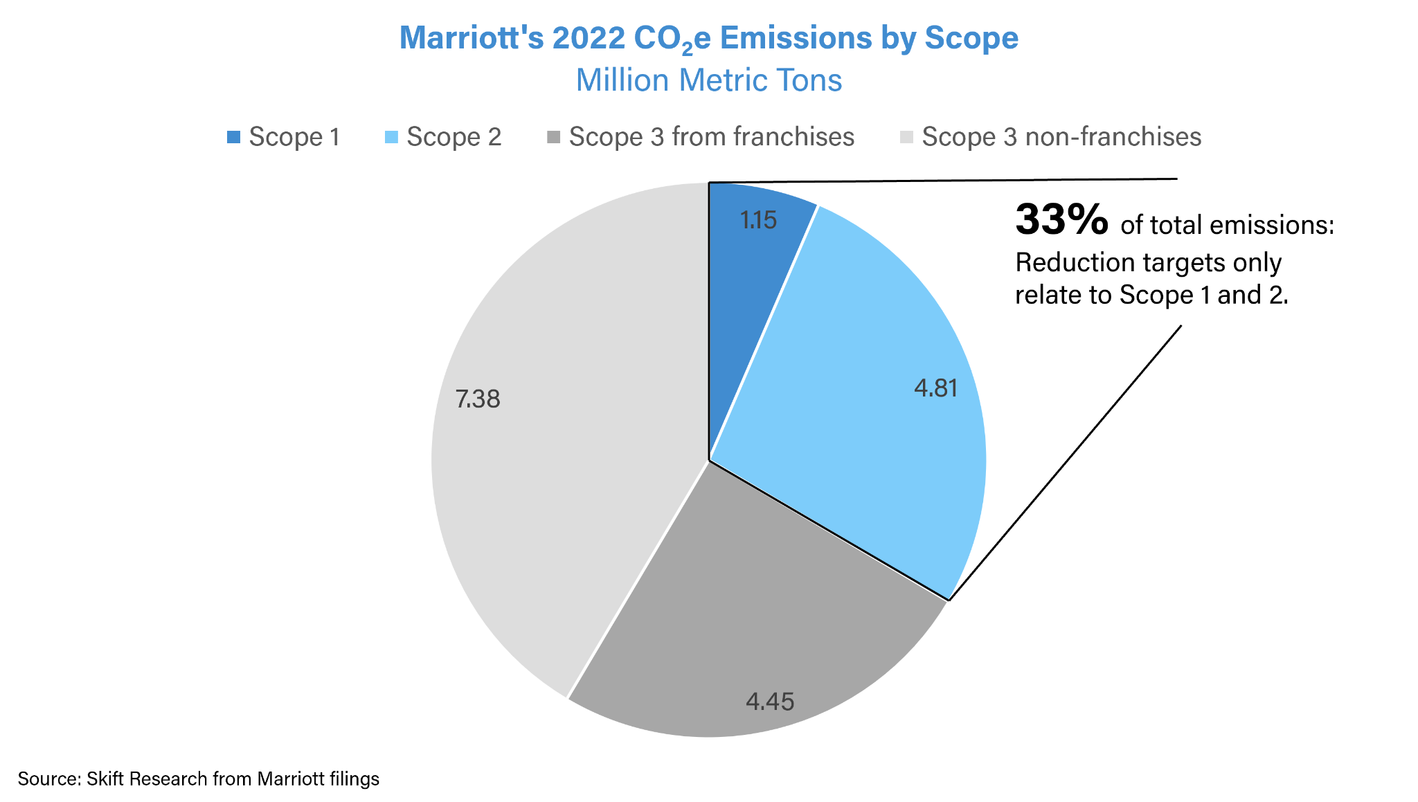
Figure: Marriott on Track for Emissions Goal
(Source: Skift.com, 2020)

Appendix 2: CSR Research in Hotel Industry

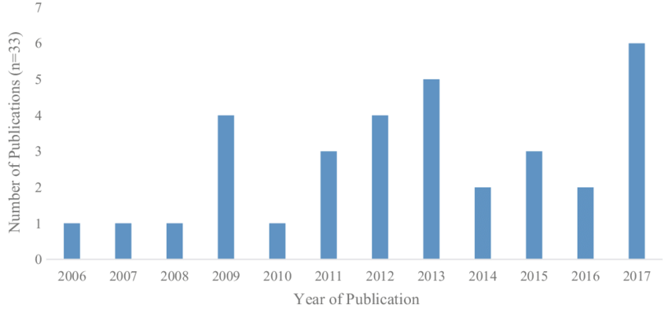
Figure: CSR Research in Hotel Industry Publications by Year
(Source: Researchgate.net, 2020)

