Academic and Employability Skills

Argentina Anica Sonoc 1906235

Academic and Employability Skills (BMSW4001_LON)

Lecturer: Sylvia Hoffmann

May 2020

Table of Contents
Introduction 3
Reflecting on my learning from this module 3
Topics learnt from each term along with their usefulness 5
Most interesting topics learnt in first term and their usefulness 5
Topics learnt in second term and their usefulness 8
Conclusion 9
Reference list 10

Introduction
This report is based on a reflection on my learning from both the terms. There are many things that I have learnt from both terms. This report has explained the beneficial aspects that I have learnt from academic and employability skills. In this report, it has been reflected about the time management skill and employment skill that I have learnt from this module. Moreover, self-evaluation skill and skill of gathering relevant information that I have learnt from the first term have been discussed in this report. Furthermore, my learning about writing style, presentation techniques and styles, referencing skill and technological support has been discussed in this report.

Reflecting on my learning from this module
According to Schon’s theory, reflection can be categorised in two types, one during the activity and the other one after activity. The types of reflection can also be defined by reflection in action and reflection on action (Hébert, 2015). Reflection in action is based on learning during lessons. On the other hand, reflection on action is based on doing assignments after the lessons.
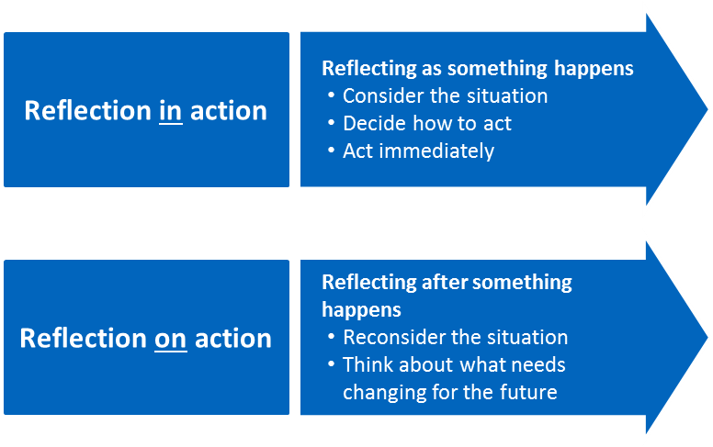
Figure1: Schon’s Model of reflection
(Source: Hébert, 2015)
The module academic and employability skills helped me to gather knowledge about various academic skills. I have gathered base knowledge regarding this module from class lessons. Before lessons, I did not have any knowledge of academic and employment skills. This initial learning is the reflection in action as per Schon’s model. It is not possible to remember all the lessons after class. Therefore, I had to research on the module and try to remember lessons by reading notes; this is called reflection on action. This module helped me to gain skills like time management, employment skill and many other skills. Self-evaluation helped me a lot in this assignment. Through this skill, I was able to learn more by gathering in-depth knowledge from other sources. Time management skill is one of the best skills that I have ever learnt. This skill mostly helped me to make a proper schedule for every task. With the help of this skill, I was able to submit every assignment within time. I can manage my daily routine and activities through time management.
Driscoll model of reflection focuses on three essential stem questions. They are such as what, so what and now what. 'What' can be defined with a few questions such as what is the purpose of the activity, what the reaction was, and what the critical aspects of that situation are. ‘So what’ can be defined with few questions such as how the student feels that time, how the student feels now and any trouble that the student faced (Hampshireonlinelearning.co.uk, 2020). 'Now what' is based on future outcomes such as what are the key learning points of the experience and what will happen if a student decided something to do.
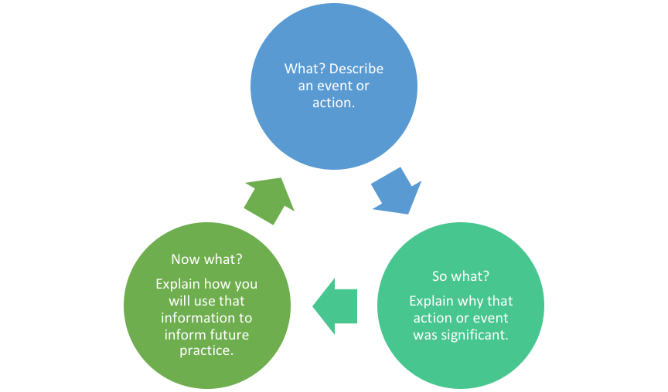
Figure2: Driscoll Model of reflection
(Source: Hampshireonlinelearning.co.uk, 2020)
As per the model, the purpose of the module is to learn more academic and employment skills. I have done the research, including all the aspects related to this module. Therefore, I have learnt many things from this module. I have found myself with a lack of knowledge regarding these academic and employment skills. Nothing troubled me except time of activities. I was not able to manage timing for all the activities. However, this skill I have learnt efficiently. Therefore, through this module, I got the opportunity to learn useful writing style presentation techniques, references skill and digital learning. Writing skill is very useful for me in my daily life. When I do any presentation in future, then this presentation skill will be effective for me. All the skills are very important in their specific way. All these skills have helped me to complete the module effectively even these will help me in future for more several pieces of research.

Topics learnt from each term along with their usefulness

Most interesting topics learnt in first term and their usefulness

Self-evaluation skill
Self-evaluation or self-assessment skill is the essential skill that I have learnt from the module. I have noticed that this skill helps to identify the gap of knowledge that I or any student have regarding an aspect. It is necessary to encourage myself in order to learn more on a topic. Therefore, it will help to assess the areas of improvement (Cetin, 2015). Hence, I can learn more to gather in-depth knowledge or complete knowledge of an aspect. As I have learnt, self-evaluation would also make confident based on my knowledge and capabilities. While making the assignments, I had to search more in order to gather data from the literature. When I was searching, I have found many other similar articles. Therefore, various articles helped me to clear my thoughts on academic and employment skills. If I have been asked to answer such questions related to this topic, then I can answer confidently because I have depth knowledge of it.
Employment skill
While completing the first term, I have learnt deeply about employment skills. I have noticed that what are the essential elements required in an employee. Communication and behaviour are the most important aspects for me. I have learnt that having better communication and behaviour towards people help to build a healthy relationship with others. For an employee, teamwork is crucial in order to get success (Cush, 2016). In a team, every individual has its own thoughts and different point of view for the same aspect. If an employee is not able to understand other's point of view or listen to them, then there might be many issues raised in a team. Another thing is the problem-solving ability that I think every employee should have. In the professional field, many challenges will come regarding work. Therefore, it is crucial to analyse the problem and make a permanent solution to it. That is the more significant skill that I have learnt.
Time Management Skill
Time management skill possesses a variety of skill that has helped me to manage my time well and these skills play an important role in accomplishing my goals. Therefore, some of the most time management skills have been discussed as follows
Organisation: Being organized has helped me in maintaining a transparent picture of what I need to complete and when I get the accomplishment. Therefore, I have been able to maintain a calender through which I can comfortably locate important documents having a tranquil environment (Sainz et al., 2019).
Goal-setting: Through this skill, I have been able to establish my goals and makes me determined in achieving it with a lot of dedication and hardwork. Therefore, in this respect, I can utilise my time by brooding over the matter of my goal and as a result, I have focused on my goal attentively (Janeslätt et al., 2018).
Planning: After setting up a goal, I have made a planning in order to accomplish it. In this respect, I have maintained a schedule that helps me to do the proper work at a proper time and it is required for the accomplishment of the task.
Communication: Strong communication has supported me to work with the persons comfortably. Developing a good communication skill, I have become very much confident and clear in presenting my point of view and it has helped me to make my goals clear with the people I have been working with (Shchetynina et al., 2019).
Skills of gathering relevant information
Primary and secondary resources: In order to gather relevant information, I have selected the primary and secondary resources. Among the primary resources, I have searched about various research articles and important texts based on literature (Late et al., 2019). As a result, I have fortunately able to gather a lot of information about various aspects. For the secondary resources, I have made a research on some magazine articles and biographical books. As a result, I have been able to collect effective note.
Benefits of Library and internet: There are innumerable books in library from a wide range of authors of literature. Therefore, I have gathered relevant information from the perspective view with the help of library (Kamau and Adika, 2018). Besides library, Internet has also been a convenient way to find the relevant information by searching articles, blogs of famous author, philosophers and economists. Therefore, library and internet have been beneficial for me to gather relevant information. By making a reflection on my experience, I have gained information and learnt a lot of lessons.
Analysing literature, researching and presenting findings: In the term 1, I have analysed the literature and in this respect, I have got the opportunity to brood over the matter and to think over that critically. Therefore, I have enhanced critical thinking skills that have developed my learning skill. Through the process of researching, I am able to experience some learning outcomes. For example, I have gathered an accurate knowledge about the aims and objectives of the research. I have learnt different methods of collecting data and analysing them. It affects on me very much by making me more disciplined and interested (Wickramasinghe, 2019).

Topics learnt in second term and their usefulness

Writing style: There are many varieties of writing style. For example, the writing style of essays and the writing style of report are completely different from each other. The essay writing has contained some features that present the ideas and motives of the essay and provide a great deal of information. The report writing is simply based on the accuracy of the facts and unbiased recommendation. Therefore, these skills have helped me in order to develop my writing style. In this respect, I have developed some ideas in order to write the essays and the reports with well-structured. In this second term, I have learnt about various opinions and arguments regarding the style and as a result, I have developed a good understanding about the writing style (Pryzant et al., 2018).
Presentation techniques and styles: There are many presentation techniques and styles that provides help to communicate with others and present information to them. The skills are passion, determination, transparency and knowledgeable. Therefore, I have developed a good learning from these information presentation skills. I have learnt that I have to be very passionate in order to present my information confidently to the listeners. In this respect, I also need to know about their requirements that are related to the information (Ajayi et al., 2017). Then, I have become determined in delivering a good speech to the listeners in order to make them more informative about the information. Without transparency in the data, none can be able to think over the information. Therefore, I have collected a lot of relevant information that possess transparency and as a result, I have become knowledgeable. Through these skills, I have learnt these lessons in second term.
Referencing skills: In this second term, I have learnt about the significance of referencing. Referencing means to provide a source of information by searching about some journals, articles, and books. In the same light, the significance of the citation plays a crucial role. These referencing skills have earned me a great knowledge. I have learnt that in order to find the reference, Google Scholar plays the most significant role. I have learnt that I need to write the name of the journal or the article on the Google Scholar. After that, I am able to find such valid information and then cite the Harvard reference system in order to justify my explanation (Baranova, 2016). Therefore, I have developed a clear understanding and significance of referencing skill that has helped me in doing my work with perfection.
Using digital technologies to support learnings: Digital technologies are social-media, online games, multi-media, mobile phones and also digital television. These technologies have been become very much beneficial in order to develop my learning. Apart from searching the books, the benefits of digital technology are convulsive. Through social-media, I have developed a good communication and also learnt about various aspects about such subjects. It has increased my basic knowledge. Through the digital television, I have learnt the benefits of audio-visual learning. Therefore, these digital technologies have benefitted me to gain learning about each and every part of the world (Flyverbom et al., 2019).

Conclusion
This report reflects the learning elements that I have learnt while completing the module of academic and employability skills. Through this report, it has been found that how learning is beneficial for me in my daily day-to-day life and my work as well. It has also been found from this report that the use of self-evaluation skill and employment skill for me. Moreover, the usefulness of time management skill, the skill of gathering relevant information has also been found from this report. I have learnt many essential aspects of the term assignments, and these will help me in my future personal life as well as professional life.

Reference list
Ajayi, K.F., Friedman, W.H. and Lucas, A.M., 2017. The importance of information targeting for school choice. American Economic Review, 107(5), pp.638-43.
Baranova, J., 2016. Harvard Referencing System and Its Use by the Students of the TTI. B. Misnevs, p.63.
Cetin, B., 2015. Academic Motivation and Self-Regulated Learning in Predicting Academic Achievement in College. Journal of International Education Research, 11(2), pp.95-106.
Cush, M., 2016. Report to the Minister for Education and Skills of the chairperson of the expert group on fixed-term and part-time employment in lecturing in third level education in Ireland. Retrieved May, 30, p.2016.
Flyverbom, M., Deibert, R. and Matten, D., 2019. The governance of digital technology, big data, and the internet: new roles and responsibilities for business. Business & Society, 58(1), pp.3-19.
Hampshireonlinelearning.co.uk. 2020. [online] Available at: <https://www.hampshireonlinelearning.co.uk/pluginfile.php/4368/mod_resource/content/6/What%2C%20So%20What%2C%20Now%20What.pdf> [Accessed 20 April 2020].
Hébert, C., 2015. Knowing and/or experiencing: a critical examination of the reflective models of John Dewey and Donald Schön. Reflective Practice, 16(3), pp.361-371.
Janeslätt, G.K., Holmqvist, K.L., White, S. and Holmefur, M., 2018. Assessment of time management skills: psychometric properties of the Swedish version. Scandinavian journal of occupational therapy, 25(3), pp.153-161.
Kamau, G.W. and Adika, F.O., 2018. Collaboration between the Faculty and Librarians to Improve Students’ Information Literacy Skills at Strathmore University. Regional Journal of Information and Knowledge Management, 3(2), pp.1-19.
Late, E., Tenopir, C., Talja, S. and Christian, L., 2019. Reading practices in scholarly work: from articles and books to blogs. Journal of Documentation.
Pryzant, R., Basu, S. and Sone, K., 2018, November. Interpretable neural architectures for attributing an ad’s performance to its writing style. In Proceedings of the 2018 EMNLP Workshop BlackboxNLP: Analyzing and Interpreting Neural Networks for NLP (pp. 125-135).
Sainz, M.A., Ferrero, A.M. and Ugidos, A., 2019. Time management: skills to learn and put into practice. Education+ Training.
Shchetynina, O., Horbatiuk, L., Alieksieieva, H. and Kravchenko, N., 2019. Project Management Systems as Means of Development Students Time Management Skills. Archived Volume, p.370.
Wickramasinghe, D.M.J., 2019. Literature Review of Importance of Knowledge Management to Developing Nations. GSJ, 7(6).

