DS 1

My Screenshots/Photos
- Please add 4–6 screenshots or photos of your digital life.
- You can use your phone or laptop.
- For each screenshot, write one or two sentences explaining what it shows.

Screenshot/Photo 1
[Insert Photo/Screenshot below]
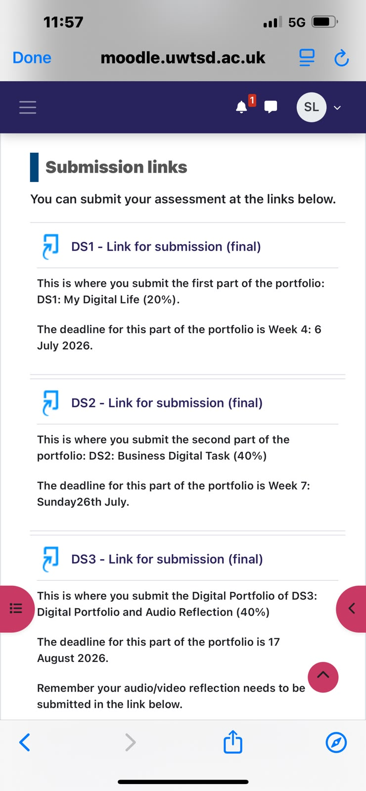
This screenshot shows the Moodle submission area where I upload my coursework and check assignment deadlines. Using Moodle has helped me become more organised because I can easily monitor my progress and make sure that all my work is submitted before the deadline.

Screenshot/Photo 2
[Insert Photo/Screenshot below]
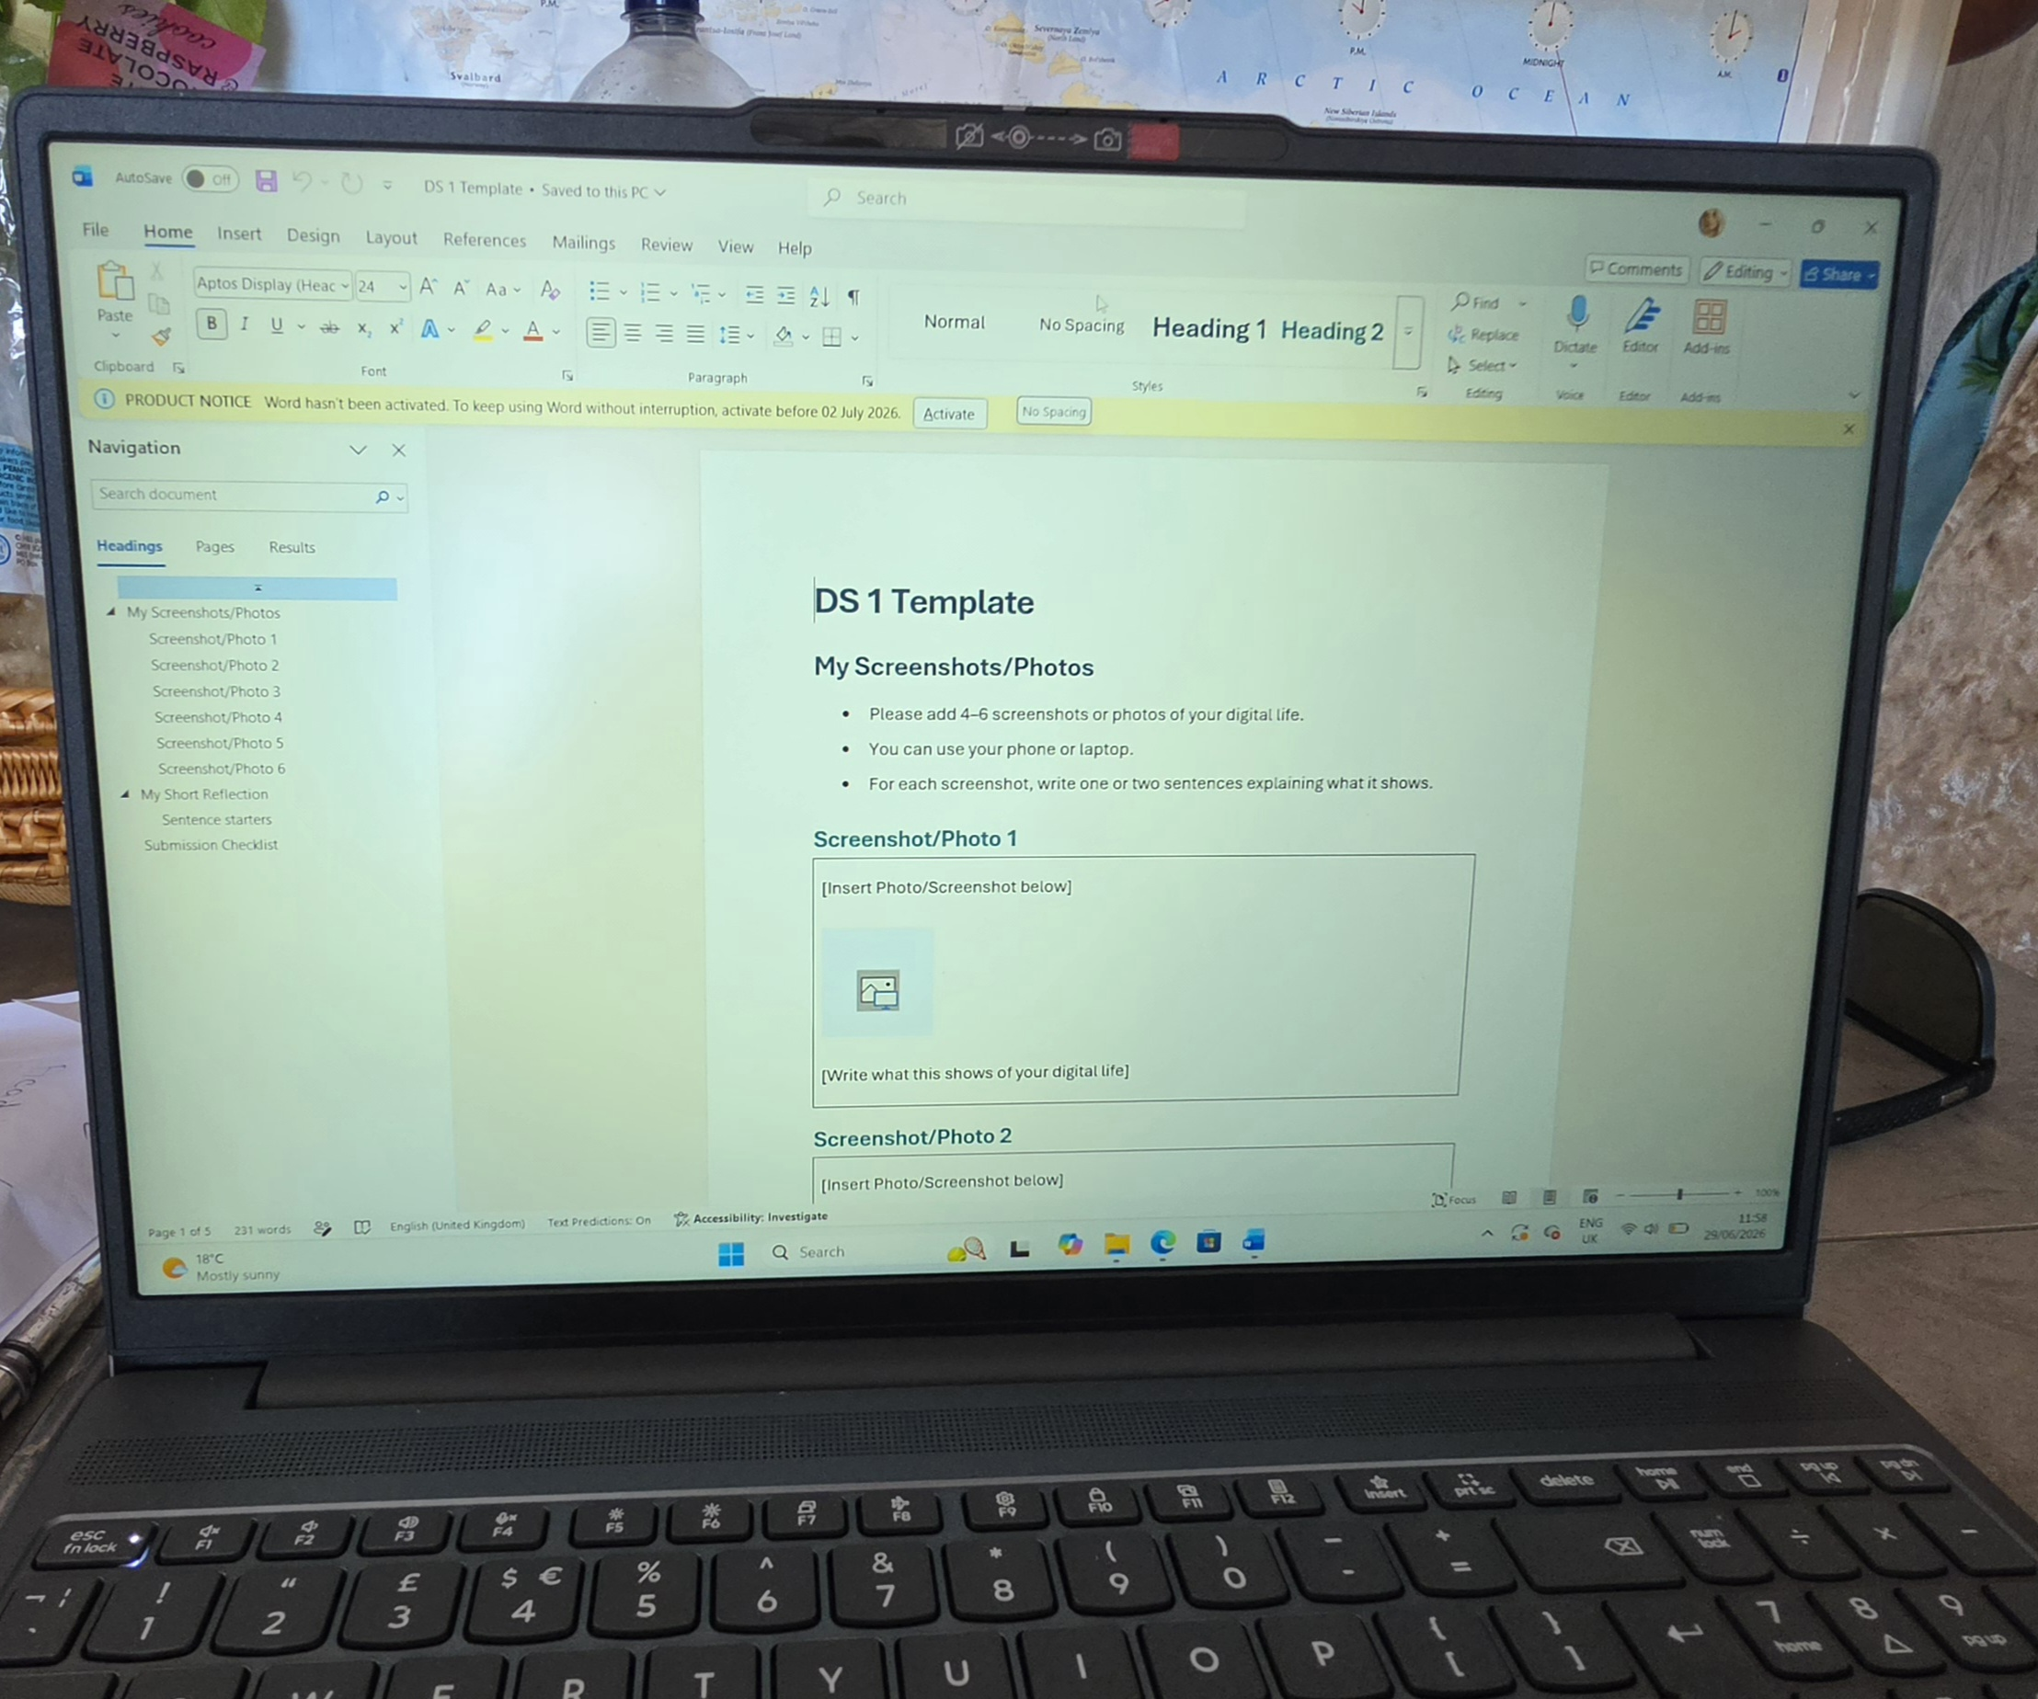
This screenshot shows Microsoft Word, which I use to prepare and edit my university assignments. The software allows me to structure my work clearly, check spelling and grammar, and present my assignments in a professional format.

Screenshot/Photo 3
[Insert Photo/Screenshot below]
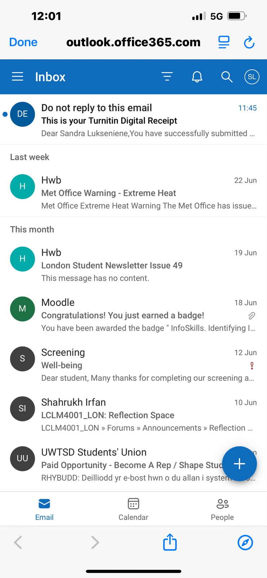
This screenshot shows my university email account in Outlook. I use it every day to receive important messages from lecturers, submission confirmations and course announcements. Regularly checking my email helps me stay informed and avoid missing important information.

Screenshot/Photo 4
[Insert Photo/Screenshot below]
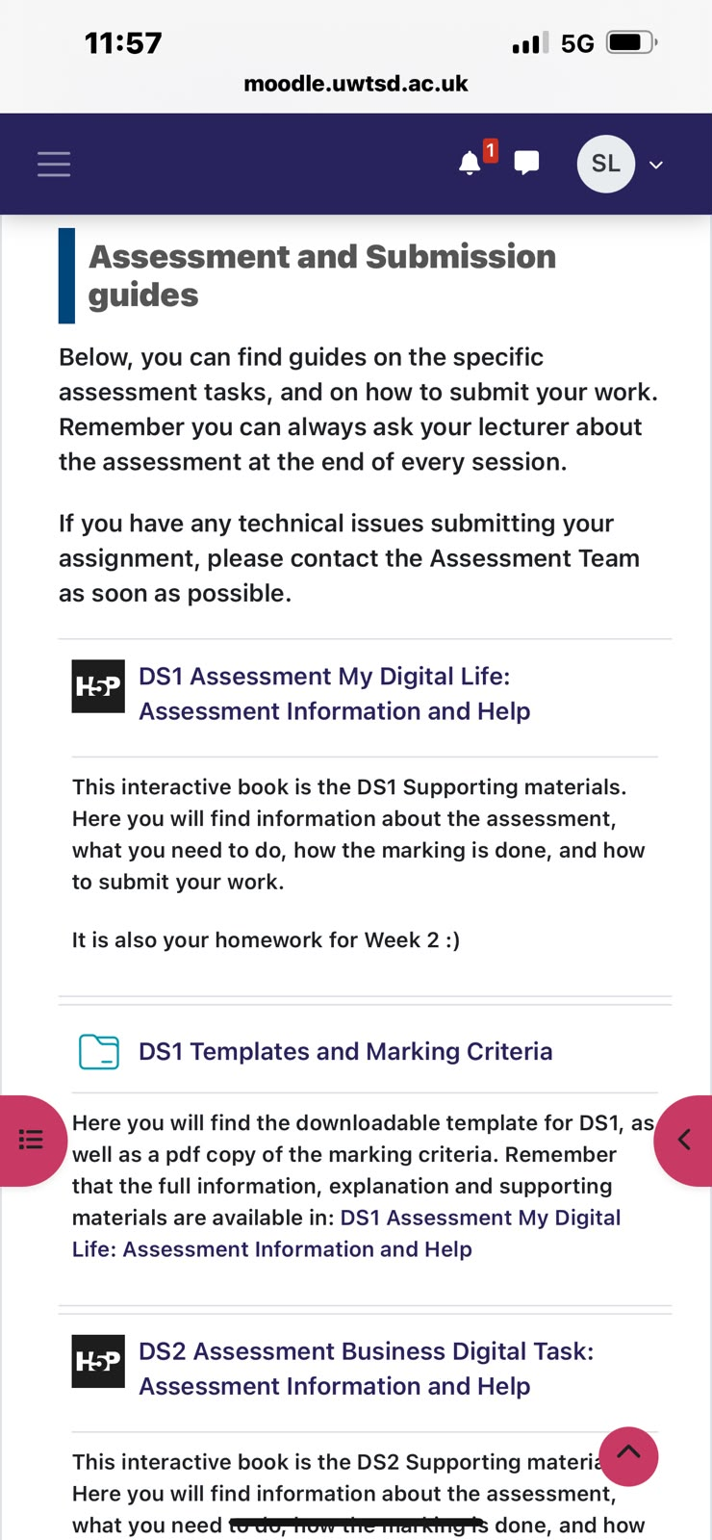
This screenshot shows how I organise my university documents using the Files application. Keeping my assignments and templates in one place allows me to access them from different devices and makes my study routine more efficient.

Screenshot/Photo 5
[Insert Photo/Screenshot below]
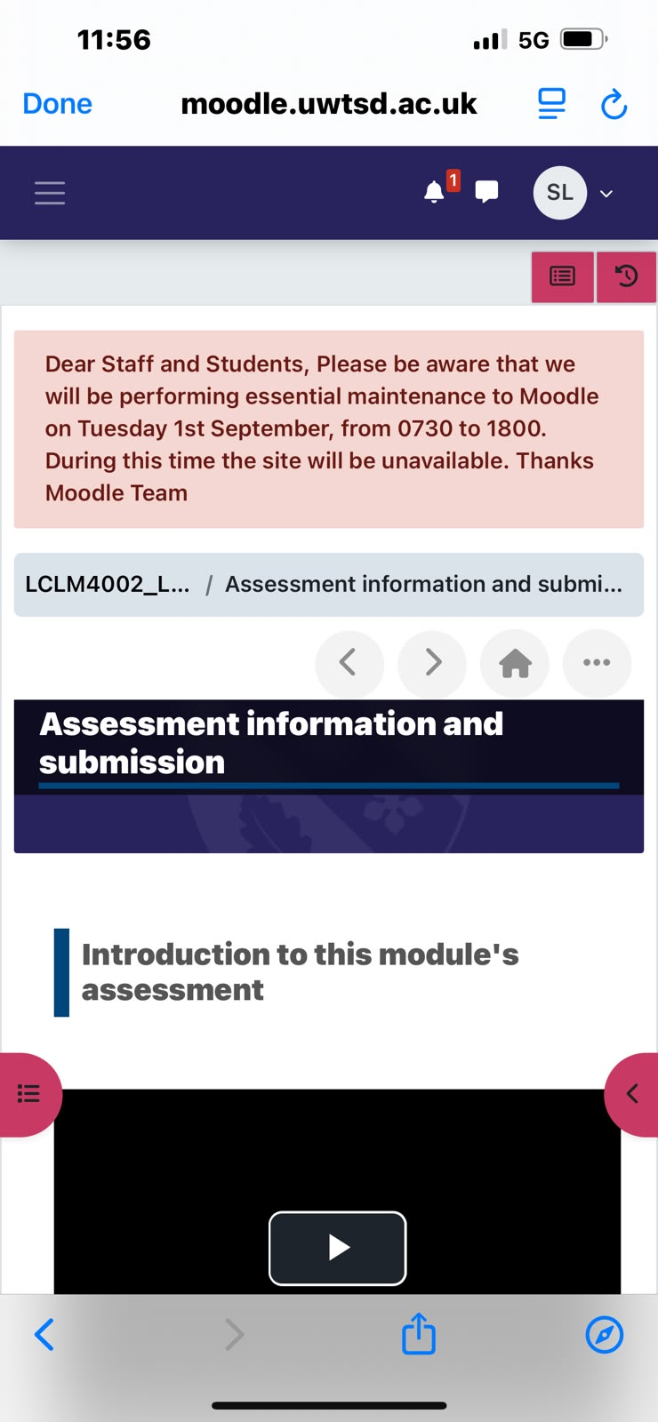
This screenshot shows my Digital Skills module on Moodle. I use this page to access learning resources, assessment guidance and templates before starting my coursework. It helps me prepare my assignments and understand what is expected for each task.

Screenshot/Photo 6
[Insert Photo/Screenshot below]
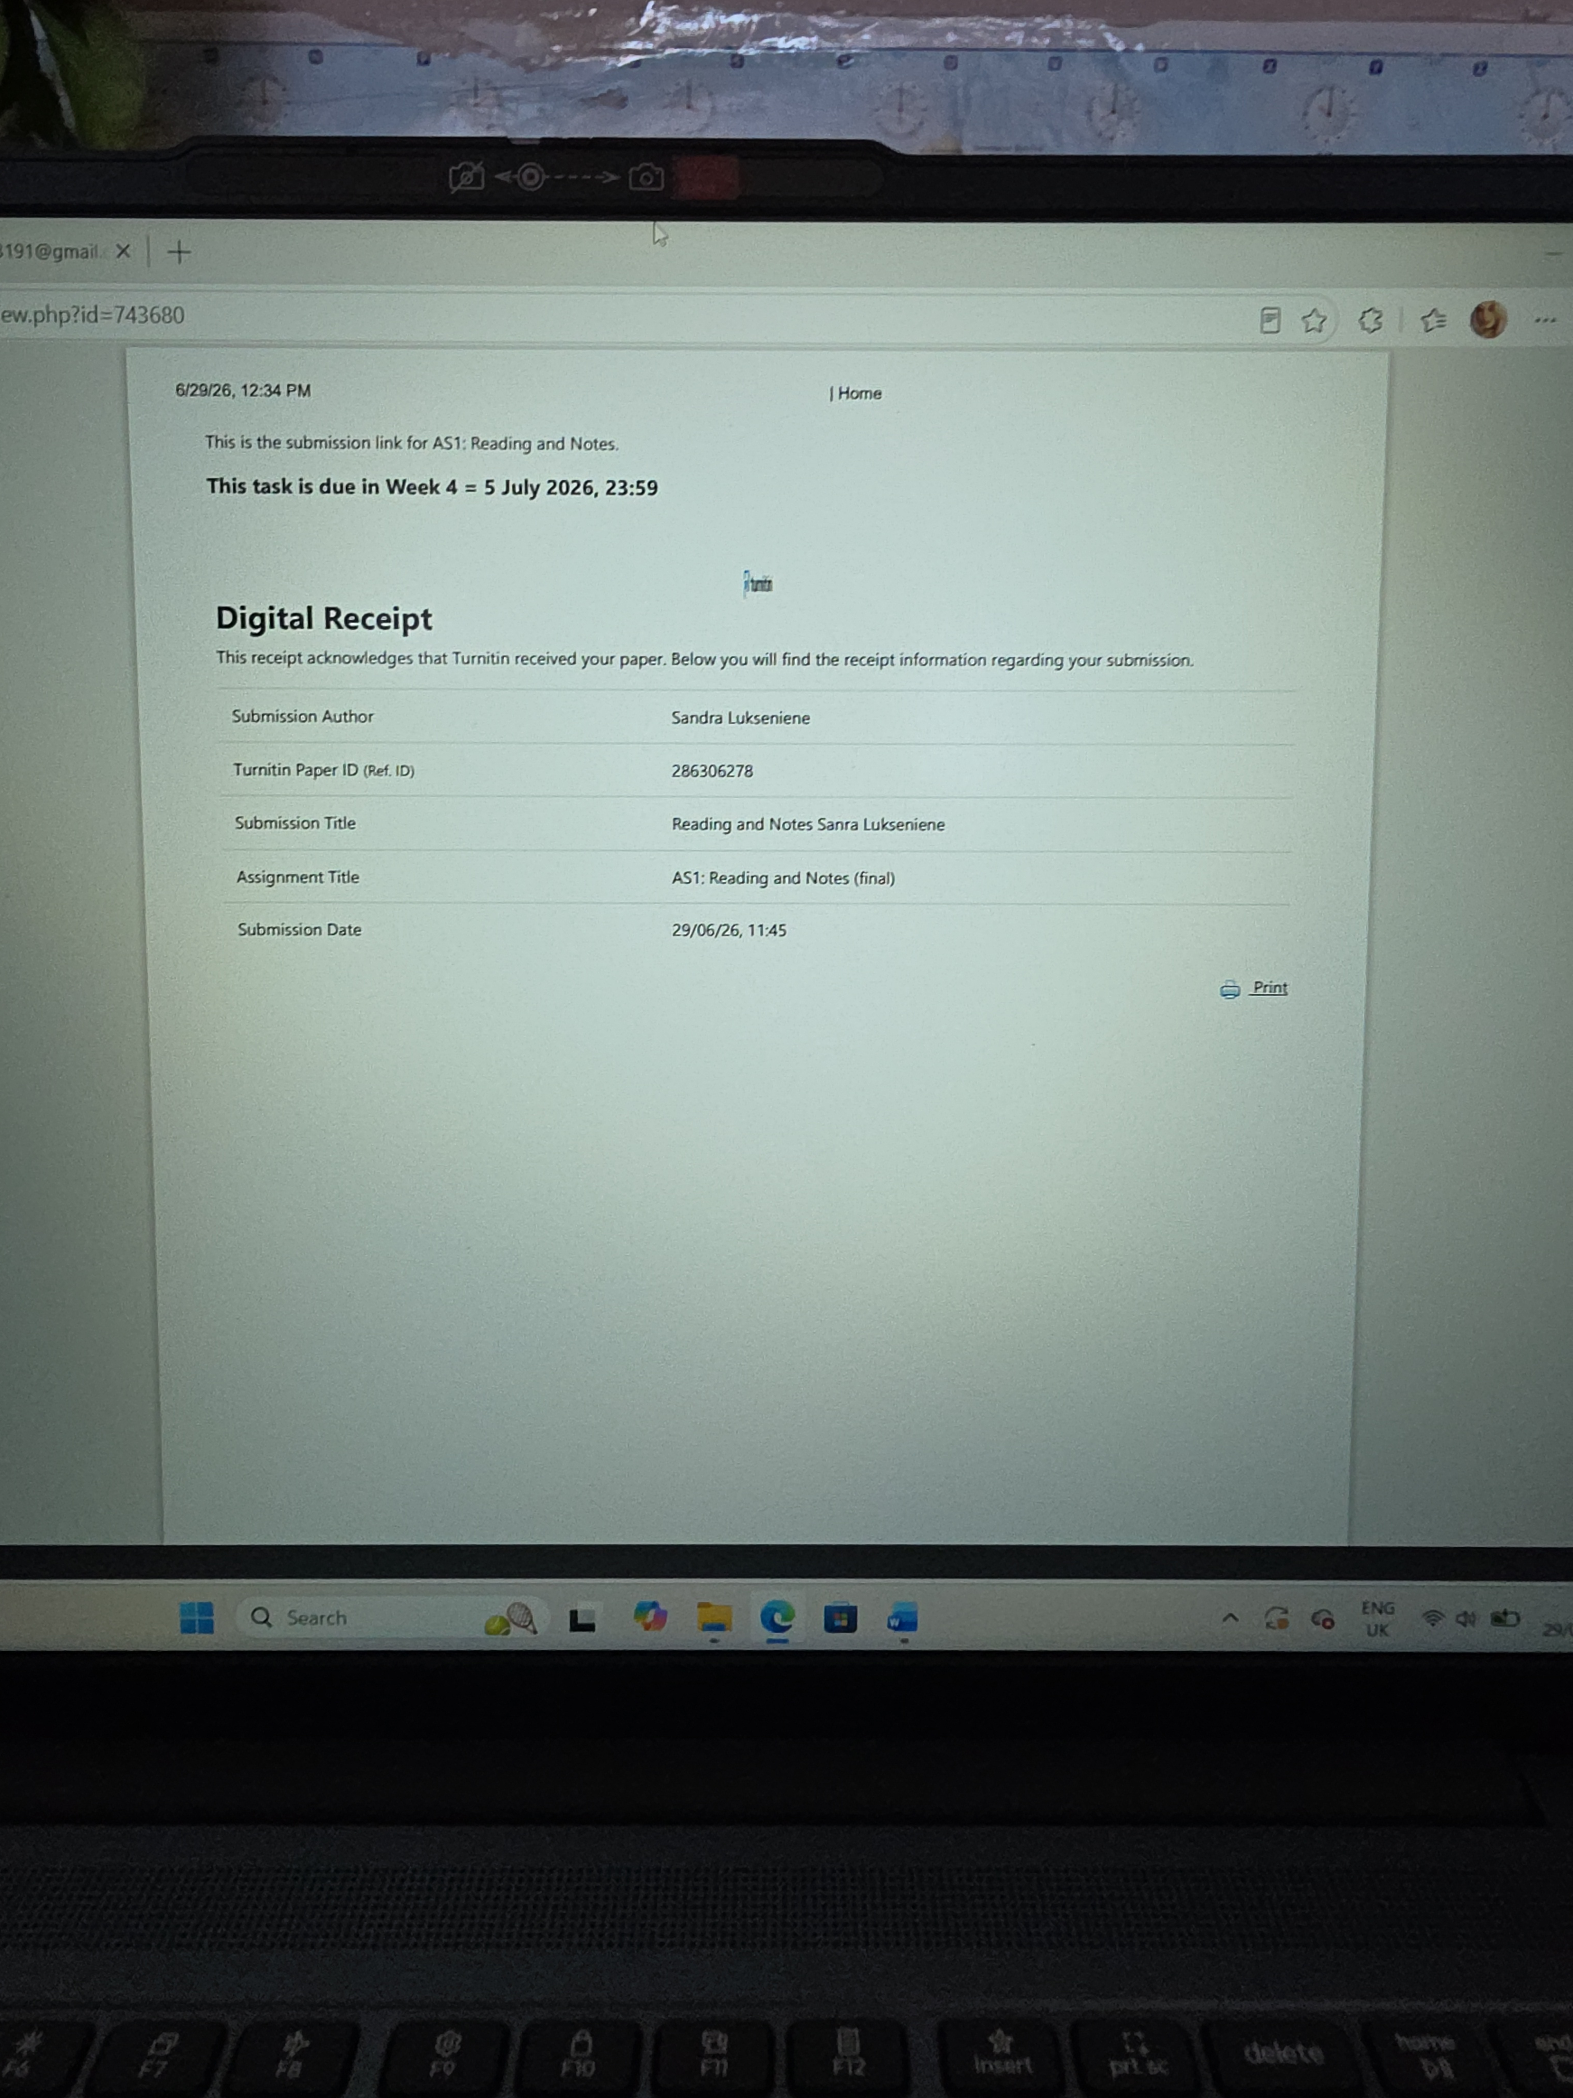
This screenshot shows the digital receipt that I received after submitting my assignment through Turnitin. It confirms that my work was uploaded successfully and provides the submission details. I always check the receipt to make sure my coursework has been submitted correctly and on time.

My Short Reflection
- Write 5–8 simple sentences about your digital life.
- You can use the sentence starters below if helpful.
My Short Reflection
I use digital tools every day for my university studies and personal life. Moodle, Microsoft Word and Outlook help me organise my coursework and communicate with my lecturers. I feel more confident using these tools than I did at the beginning of the course. I still want to improve my digital skills, especially when using new software and online learning systems. Sometimes I feel nervous when I submit assignments because I want to make sure everything is uploaded correctly. This module is helping me become more organised and confident when working online. I believe good digital skills will help me succeed at university and in my future career.

Sentence starters
- I use digital tools to …
- I feel confident when I …
- I want to improve …
- I often use these tools: …
- I sometimes feel nervous about …
- I hope this module will help me …
- Digital skills are important for me because …
You can write more if you want.

Submission Checklist
Before you submit, please check:
​​​ ☒ I added 4–6 screenshots
☒ I wrote short sentences for each screenshot
☒ I wrote my short reflection
☒ My work is my own
☒ My file opens correctly
​​☒ My file opens correctly

