[Date]
Mark Price (1501759)
SBUS6104
Contemporary Themes in e-Business
Assignment 1

Contents

Introduction……………………………………………………………………………………………..3

Strategic Formulation Framework……………………………………………………………………...4

Applying SFF to Netflix
Phase 1 CPM……………………………………………………………………………………………6
EFE…………………………………………………………………………………………… 6
IFE …………………………………………………………………………………………….7

Phase 2 TOWS 9
Space Matrix …………………………………………………………………………………10
Grand Strategy Matrix ……………………………………………………………………….11

Phase 3 QSPM ………………………………………………………………………………………..12

What Has Changed…………………………………………………………………………………….14

Conclusion ……………………………………………………………………………………………15

References/Bibliography ……………………………………………………………………………..16

Introduction
This report will be assessing the Strategic Formulation Framework in relation to the online streaming service, Netflix. Netflix is a subscription-based, movie and T.V network that is available on most devices. Since its birth in 1997, Netflix has since amassed over 117 million subscribers and is available in over 190 countries. The company has continued to innovate, staying at the forefront of television and movie streaming services; becoming an international cultural icon. As of the end of 2017, Netflix has a revenue of $11.69 billion (US) and invests billions a year into content, both original and non-original content. This report will be investigating the concepts of Strategic Formulation Framework. Using this knowledge, Strategic formulation will then be applied to Netflix. This will then be used to assess what has changed in the 11 years since a previous assessment. This information will then be used to determine the strategic positioning that Netflix has achieved.
It is important first of all to establish what strategy is. ‘Strategy is the overarching decisions that determine the fundamental direction of a company. (Jelassi et al, 2008, p34). Lynch (2000, cited in Chaffey 2007, p202) describes strategy as an organisations purpose, but that purpose alone is not strategy, plans and actions are also needed.

Strategic Framework Formulation
In terms of strategy formulation with an e-business such as Netflix, the overall goal of developing an e-business strategy is to succeed in using the internet as an enabler for achieving competitive advantage. (Jelassi et al, 2008, p35).
Various methods and models are discussed in business literature; however, this report will be centred around Fred David’s Strategic Framework Formulation. SFF ‘helps analyst in understanding the methodology and techniques to determine most appropriate alternative strategy(s) for the organisation.’ (Torlak and Sanal, 2007). Fred David’s model is broken into three phases consisting of:
- Phase 1 – Input Stage
- Phase 2 – The Matchmaking Stage
- Phase 3 – The Evaluation Stage
Phase 1
According to Persaud et al (2016) phase 1 is essentially the planning phase and consists of five activities. Its first two activities begin with the conceptualisation of vision and mission. In doing this, a company establishes the foundation for the strategic management process.
The third activity to be completed in phase 1 is an External Factor Evaluation (EFE) Matrix; which evaluates how factors such as economic, social, cultural, environmental, political and competitive factors to name a few that may present threats and opportunities to an organisation.
The next step is to conduct a Competitive Profile Matrix (CPM). A CPM identifies an organisation’s major competitors and their strengths and weaknesses in relation to an organisations strategic position. ‘Different from EFE, critical success factors in a CPM are broader; they do not include specific or factual data and even may focus on internal issues’ (Torlak and Sanal, 2007)
Next, is the Internal Factor Evaluation (IFE) Matrix. Every organization has its own weaknesses and strengths in its job activities. Internal weaknesses and strengths are the one which can be controlled. Some of internal factors are: management, marketing, accounting/financial affairs, production/operation, research and development and intelligent services' management and so on (David, 2011, cited in Sarfaraz et al, 2015).
Finally, is strategy formulation, in which ‘strategy formulation phase concludes with the generation, evaluation, and selection of strategies that the company should pursue.’ (David, 2013 cited in Persaud et al, 2016).

Phase 2
Phase 2 ‘focuses on generating feasible alternative strategies by aligning key external and internal factors.’ Torlak and Sanal (2007). ‘It also entails full employee mobilization and creation of a conducive supportive work environment which motivates employees to optimize work performance so that the organization's desired outcomes can be realized.’ (Persaud et al, 2016).
Phase 3
Finally comes the Evaluation Phase Persaud et al (2016) state that this phase is especially essential as it triggers a review of objectives, values and strategy. Phase 3 comes with the use of a Quantitative Strategic Planning Matrix (QSPM). ‘A QSPM reveals the relative attractiveness of alternative strategies and thus provides objective basis for selecting specific strategies.’ (Torlak and Sanal, 2007)

Applying SFF to Netflix
Stage 1- CPM
 | Netflix | Amazon | Time Warner
Critical Success Factors Weight | Rating Score | Rating Score | Rating Score
Market Share 0.12 | 3 0.36 | 4 0.48 | 3 0.36
Financial Position 0.08 | 2 0.16 | 4 0.32 | 3 0.24
Product Quality 0.10 | 4 0.40 | 3 0.30 | 1 0.10
Customer Loyalty 0.03 | 4 0.12 | 3 0.09 | 1 0.03
Global Expansion 0.09 | 4 0.36 | 2 0.18 | 1 0.09
Advertising 0.10 | 4 0.40 | 4 0.40 | 2 0.20
E-Commerce 0.15 | 4 0.60 | 4 0.60 | 3 0.45
Customer Service 0.07 | 3 0.21 | 4 0.28 | 2 0.14
Price Competitiveness 0.10 | 3 0.30 | 4 0.40 | 1 0.10
Management Effectiveness 0.03 | 3 0.09 | 3 0.09 | 4 0.12
Total 1 | 3 | 3.14 | 1.83

The competition from the previous SFF has since been outdated; Redbox has now been replaced with amazon, a company that is much closer in terms of competition. Hulu was to be used as a third competitor, however Hulu is owned by a multitude of other companies, one of which is Time Warner. It is interesting to see the difference between a company that is still reliant on traditional TV viewers as opposed to Netflix and Amazon. Netflix is notably better in terms of product quality, global expansion and advertising. It is worth noting that though Time Warner and Amazon have a larger score, these numbers are taken from the company as a whole.
EFE Matrix
Opportunities | Weight | Rating | Weighted Score
- Internet users have risen from 28.8% in 2010 to 54.4% in 2017. | 0.06 | 3 | 0.18
- Netflix is available worldwide as of 2016. | 0.08 | 3 | 0.24
- As of 2013, Netflix began producing its own movies and T.V shows. Has since created emmy/nominated shows like Stranger Things | 0.10 | 4 | 0.40
- Netflix is now pre-installed on a number of T. Vs and other devices. | 0.07 | 2 | 0.14
- Netflix has perfected its content marketing strategies. | 0.08 | 4 | 0.32
- Netflix has 3 different payment plans, varying in price. | 0.05 | 2 | 0.10
- Is one of a group of large companies for net neutrality. | 0.05 | 2 | 0.10
- Netflix has over 117 million subscribers; from 2017, 62.8 million of which are now international subscribers | 0.08 | 3 | 0.24
- Expanding into new technology such as 4K and VR. | 0.06 | 2 | 0.12
- As of 21/03/18, Netflix released the ‘bug bounty’ program allowing public to hunt Netflix bugs for money. | 0.04 | 1 | 0.04

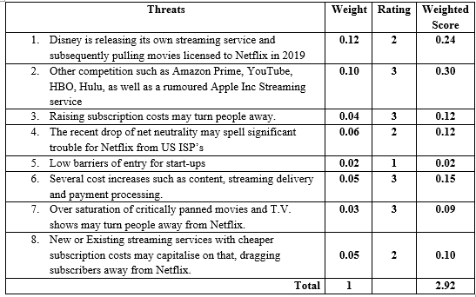

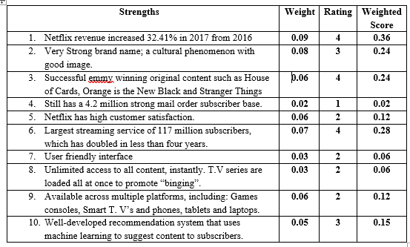
IFE

Weaknesses | Weight | Rating | Weighted Score
- Still relies heavily on Amazon cloud computing. | 0.02 | 1 | 0.02
- Netflix is currently one of the more expensive streaming services available. | 0.05 | 3 | 0.15
- Despite immensely increasing original content, Netflix is heavily dependent on its partners for content. | 0.05 | 3 | 0.15
- Has come under fire for gender inequality in regards to payment. | 0.06 | 3 | 0.18
- Non-original movies and shows are taken off Netflix quickly and without warning. | 0.03 | 1 | 0.03
- Some subscribers prefer the old “star” rating system which could have been integrated with the recommendation system. | 0.02 | 1 | 0.02
- Unlike traditional studios, Netflix does not own the rights to its original content and can appear on other media after expiration. | 0.06 | 3 | 0.18
- Has low ranking in terms of environmental awareness in comparison to rivals. | 0.05 | 2 | 0.10
- Though China is one of Netflix’s biggest achievements in terms of country integration, strict regulation as well as Chinese competition inhibit progress. | 0.08 | 4 | 0.32
- Original Content varies greatly in quality. | 0.03 | 2 | 0.06
Total | 1 |  | 2.86

Phase 2 – Matching Stage
TOWS Matrix
Similar to a SWOT Matrix, a TOWS Matrix also identifies the same criteria; however, ‘although the sets of variables in the matrix are not new, matching them in a systematic fashion is.’ (Weihrich, 1982) it is further stated by Weihrich (1982) that it “forces” managers into developing strategies, tactics and actions by analysing the situation of their company.
SO
- Integrate gamification elements onto Netflix by allowing subscribers on multiple Devices find and “kill” bugs for cash and achievements. (S9, O10, S1, S2).
- Allow Subscribers to create playlists that ca be ranked and shared with other subscribers and social media. (O4, S7, S10).
- Use the increasing prestige and revenue to attract more A-list actors and directors for original content. (O3, O8, S1, S2, S3) (Strategy 1)
WO
- Introduce further payment plans with lower costs in return for less original/non-original content for lower income households and poorer countries. (O6, O2, O3, S2, S3)
- Netflix has shown forms of corporate responsibility with the defence for Net Neutrality, further campaigns must be committed in terms of equality and sustainability to increase public image. (O7, W4, W8)
ST
- Introduce a “Netflix rating system” or “Netflix best Picks” system as part of the recommendation system to allow customers to assess movies they may not enjoy. (T7, S2, S7, S10)
- Use the brand name of Netflix to form some sort of partnership with Disney so that films and TV shows can be shared. (T1, S2)
WT
- China has a population of 1.3 billion. Invest more money and build the brand name in China. Complying with laws and regulations, tailor original content for the Chinese population, using Chinese film studios and celebrities. (T5, T8, W9) (Strategy 2)
- Potential to form partnership with rivals such as Amazon on some level, despite being rivals. (T2, W1, W3, W7)

Space Matrix
Financial Position
Gross Margin | 5
Debt to Equity | 3
Current Ratio | 4
ROE | 3
ROA | 3
Total | 3.6
Industry Position
Growth Potential | 4
Financial Stability | 2
EOEiM | 2
Resource Utilisation | 3
Profit Potential | 4
Total | 3

Stability Position
Rate of Inflation | -2
Tech Changes | -2
PEoD | -2
Competitive Pressure | -4
BoEiM | -5
Total | -3

Competitive Position
Market Share | -2
Product Quality | -1
Customer Loyalty | -1
Tech Know-how | -2
Control over Supp & Dist | -3
 | -1.8

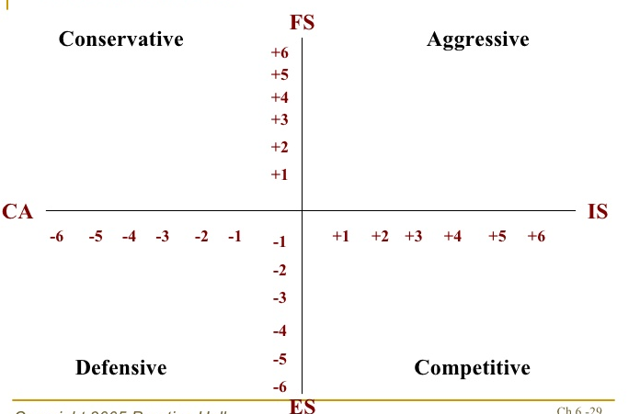

Grand Strategy Matrix

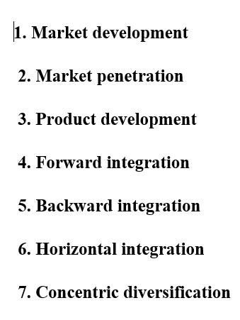
RMP
NETFLIX
Quadrant II Quadrant I

WCP SCP

Quadrant III Quadrant IV

SMP

It is evident from the previous matrices that Netflix has risen to becoming a market leader within this industry and has thus had to constantly evolve and innovate to stay ahead of the competition. This is evident from its heavy investments into content, which is to be in the region of $8 billion in 2018. This indicates a level of heightened competition amongst a clearly still rapidly growing market. To add to this, money.cnn.com (2017) states that as early as 2019, Disney could be launching its own channel, leading Netflix to possibly spend up to $16 billion over the next few years on content.

Strategy 1  Use the increasing prestige and revenue to attract more A-list actors and directors for original content. | Strategy 2  Invest More money and build brand name in china. Tailor original content, using Chinese film studios and celebrities.
Stage 3 – Decision Stage
 | Weight | AS1 | TAS | AS2 | TAS
1 | 0.06 | 3 | 0.18 | 3 | 0.18
2 | 0.08 | 4 | 0.32 | 3 | 0.24
3 | 0.10 | 3 | 0.30 | 4 | 0.40
4 | 0.07 | 1 | 0.07 | 0 | 0.00
5 | 0.08 | 3 | 0.24 | 4 | 0.32
6 | 0.05 | 2 | 0.10 | 3 | 0.15
7 | 0.05 | 1 | 0.05 | 2 | 0.10
8 | 0.08 | 3 | 0.24 | 3 | 0.24
9 | 0.06 | 0 | 0.00 | 0 | 0.00
10 | 0.04 | 0 | 0.00 | 0 | 0.00
 | Weight | AS | TAS | AS | TAS
1 | 0.12 | 3 | 0.36 | 1 | 0.12
2 | 0.10 | 3 | 0.30 | 2 | 0.20
3 | 0.04 | 2 | 0.08 | 3 | 0.12
4 | 0.06 | 2 | 0.12 | 0 | 0.00
5 | 0.02 | 0 | 0.00 | 4 | 0.08
6 | 0.05 | 2 | 0.10 | 2 | 0.10
7 | 0.03 | 2 | 0.06 | 1 | 0.06
8 | 0.05 | 3 | 0.15 | 4 | 0.20
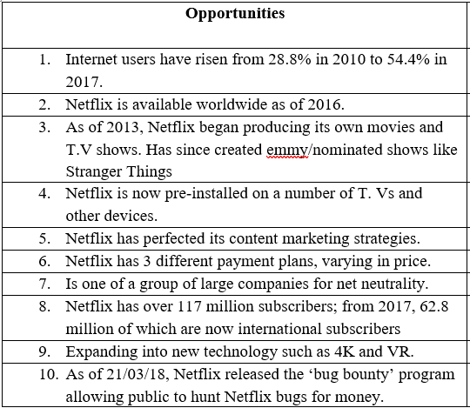
QSPM
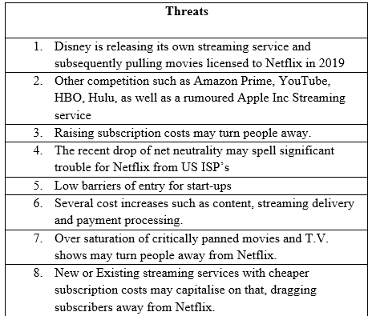
Total | 4.53 4.74
 | Weight | AS | TAS | AS | TAS
1 | 0.09 | 3 | 0.21 | 4 | 0.28
2 | 0.08 | 4 | 0.32 | 3 | 0.24
3 | 0.06 | 4 | 0.24 | 4 | 0.24
4 | 0.02 | 0 | 0.00 | 0 | 0.00
5 | 0.06 | 2 | 0.12 | 3 | 0.18
6 | 0.07 | 3 | 0.21 | 3 | 0.21
7 | 0.03 | 0 | 0.00 | 0 | 0.00
8 | 0.03 | 0 | 0.00 | 0 | 0.00
9 | 0.06 | 2 | 0.12 | 2 | 0.12
10 | 0.03 | 0 | 0.00 | 1 | 0.03
 | Weight | AS | TAS | AS | TAS
1 | 0.02 | 0 | 0.00 | 2 | 0.04
2 | 0.05 | 2 | 0.10 | 3 | 0.15
3 | 0.05 | 2 | 0.10 | 2 | 0.10
4 | 0.06 | 3 | 0.18 | 1 | 0.06
5 | 0.03 | 0 | 0.00 | 0 | 0.00
6 | 0.02 | 0 | 0.00 | 0 | 0.00
7 | 0.06 | 2 | 0.12 | 3 | 0.18
8 | 0.05 | 0 | 0.00 | 1 | 0.05
9 | 0.08 | 1 | 0.08 | 4 | 0.32
10 | 0.03 | 2 | 0.06 | 1 | 0.03
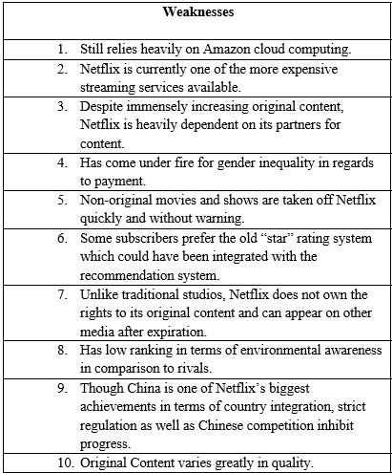
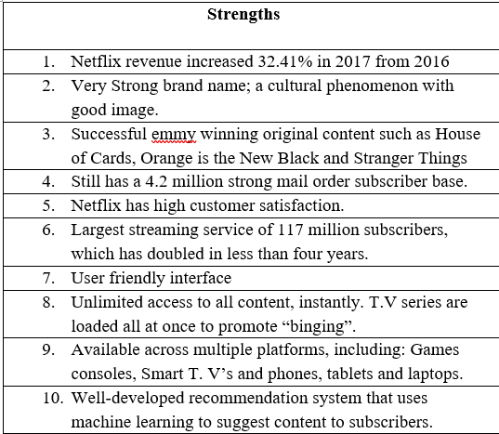
What Has Changed?
Between 2011 and now, a lot has changed in regards to Netflix. In the last few years, Netflix has grown and expanded immensely, both in reach and in capabilities, constantly evolving and innovating its service. This constant evolution resulted in certain aspects such as that which would have been threats or opportunities to be irrelevant. From observation, there are several major differences between 2011 and now that have impacted Netflix in a major way and thus its strategy:
What would have been one of the biggest moves was the move away from mail-order DVD’s to concentrate on streaming, a factor that along with a previous well implemented mail-order service, contributed to the end of Blockbuster, previously one of its biggest rivals.
Another big change to consider is Netflix’s direction to invest heavily in producing its own, as well as licensed content. According to statista.com (2018) despite the increase in subscription price, its heavy investment continues to pay off, with an estimated 8.3 million subscribers between October 1st and December 31st 2017, bringing its count 20 117 million.
By far, one of the biggest developments in the growth of Netflix its world dominating expansion, putting it in a clear first of its main competition, namely streaming services such as Amazon and Hulu. Though China does not officially allow Netflix, Netflix has recently made licencing deals with its top streaming portal, iQyi. This as least puts Netflix presence within the country which could lead to further progress in future.
In the time since the previous SFF, it is worth noting the mass migration of media from traditional mediums such as television to the internet has reduced the threat from previous rivals, such as Time Warner. However, new threats loom on the horizon for Netflix. By far, the most threatening rival to Netflix will be Disney’s own streaming service. Not only will Disney have numerable resources to compete with Netflix, but it will also be slowly removing property from Netflix for its own service as licences end.
Netflix has evidently become a lot more aggressive in its strategy. Since 2011, it has evidently utilised vertical integration ‘where a company expands its business operations into different steps on the same production path, such as when a manufacturer owns its supplier and/or distributor’. (Investopedia.com). This is obviously evident from its acquisition of content and distribution.
This is also demonstrated by the GS Matrix, in which over time, the market has grown extremely rapidly and Netflix’s position is evidently extremely competitive.
It could be suggested that Netflix may exercise caution in the coming times not to spend more than it can make back in revenue, such as its billions of dollars in investment; especially with the possibility of Disney as a disruption.
Conclusion
SFF is evidently a good tool for mapping out and visualising an organisation’s strategy. Strategies can be simultaneously evaluated. The eventual development of a QSPM is by far one of the largest advantages of SFF. Matthews (2012) suggests that A QSPM makes internal and external factors less likely to be overlooked as well as being able to draw attention to relationships that affect strategy decisions. However, evidently there are certain limitations that come with Strategy Formulation Framework. Torlak and Sanal, (2007) suggest that SFF requires judgements and assumptions from a practitioner/ strategist; if SFF is carried out by in-house personnel, Persaud et al (2016) suggests that this carries the limitation of bias, resulting in the compromise of credibility in the process. This is backed up by Torlak and Sanal (2007), stating ‘the practitioner as a hired consultant may be serving to the interests of top managers or owners of the firm and may disregard the interests of disadvantaged (silenced and marginalised) groups, this may bring about deleterious consequences for the firm’. Overall, SFF is an appropriate guidance tool for allowing strategists to generate and evaluate alternatives and choose a course of action, however it is important to note that many of the numerical inputs are subjective and should thus be subject to 3rd party strategists.

References
Butler, B. (2016). Netflix is (not really) all in on Amazon’s cloud. [online] Network World. Available at: https://www.networkworld.com/article/3037428/cloud-computing/netflix-is-not-really-all-in-on-amazon-s-cloud.html [Accessed 24 Mar. 2018].
Csimarket.com. (2018). Netflix Inc (NFLX) Annual Revenue Annual Growth Rates, Year by Year, Research Fundamentals - CSIMarket. [online] Available at: https://csimarket.com/stocks/singleY_growth_rates.php?code=NFLX&rev [Accessed 24 Mar. 2018].
Csimarket.com. (2018). Netflix Inc Competition Data by Company - CSIMarket. [online] Available at: https://csimarket.com/stocks/competitionNO9.php?&code=NFLX [Accessed 24 Mar. 2018].
Ft.com. (2017). Netflix’s rivals take aim at its stream of success. [online] Available at: https://www.ft.com/content/04ffc136-7e79-11e7-9108-edda0bcbc928 [Accessed 21 Mar. 2018].
HuffPost UK. (2018). The Secret Magic Behind Netflix Customer Service. [online] Available at: https://www.huffingtonpost.co.uk/entry/netflix-customer-service_n_4178662 [Accessed 24 Mar. 2018].
Internetworldstats.com. (2018). Internet Growth Statistics 1995 to 2017 - the Global Village Online. [online] Available at: https://www.internetworldstats.com/emarketing.htm [Accessed 21 Mar. 2018].
Ltd, A. (2018). Netflix SWOT Analysis | Business Teacher. [online] Businessteacher.org.uk. Available at: https://businessteacher.org.uk/swot/netflix.php [Accessed 24 Mar. 2018].
McAlone, N. (2018). This stat shows how much Netflix crushes Hulu and Amazon Prime in subscriber loyalty. [online] Business Insider. Available at: http://uk.businessinsider.com/netflixs-subscribers-most-loyal-of-its-competitors-2016-4 [Accessed 24 Mar. 2018].
Monica, P. (2017). Netflix plans to spend nearly $16 billion on content. [online] CNNMoney. Available at: http://money.cnn.com/2017/08/14/investing/netflix-disney-content-costs/index.html [Accessed 29 Mar. 2018].
Moskowitz, D. (n.d.). The Biggest Threats to Netflix. [online] Investopedia. Available at: https://www.investopedia.com/articles/investing/040815/biggest-threats-netflix-nflx.asp [Accessed 23 Mar. 2018].
Netflix Inc. (n.d.). Netflix Inc.. [online] Available at: https://netflixcompanyprofile.weebly.com/ [Accessed 23 Mar. 2018].
Netflix Media Center. (2018). About Netflix. [online] Available at: https://media.netflix.com/en/about-netflix [Accessed 20 Mar. 2018].
Persaud, N., Woodhouse, M. and Scriven, M. (2016). Enhancing the Strategic Management Process Through the Use of Professional Evaluation Methods and the Logic of Evaluation. Journal of Multi Disciplinary Evaluation, 12(26), pp.1-11.
Richter, F. (2018). Infographic: Netflix Adds a Record 8.3 Million Subscribers in Q4 2017. [online] Statista Infographics. Available at: https://www.statista.com/chart/10311/netflix-subscriptions-usa-international/ [Accessed 21 Mar. 2018].
Richter, F. (2018). Infographic: Netflix Adds a Record 8.3 Million Subscribers in Q4 2017. [online] Statista Infographics. Available at: https://www.statista.com/chart/10311/netflix-subscriptions-usa-international/ [Accessed 27 Mar. 2018].
Richter, F. (2018). Infographic: Netflix Surpasses Major Cable Providers in the U.S.. [online] Statista Infographics. Available at: https://www.statista.com/chart/9799/netflix-vs-cable-pay-tv-subscribers/ [Accessed 21 Mar. 2018].
Sarfaraz, A., Taheri, S., Vatandoost, R. and Dastani, R. (2015). Strategy Planning for Joint-stock Companies, Case Study: Software Development and Production in DIDGAH RAYANEH SAMA. Procedia - Social and Behavioral Sciences, 181, pp.303-312.
SEITZ, P. (2017). Netflix Stock Retreats On Disney Competitive Threat | Stock News & Stock Market Analysis - IBD. [online] Investor's Business Daily. Available at: https://www.investors.com/news/technology/click/netflix-stock-retreats-on-disney-competitive-threat/ [Accessed 21 Mar. 2018].
Staff, I. (n.d.). Vertical Integration. [online] Investopedia. Available at: https://www.investopedia.com/terms/v/verticalintegration.asp [Accessed 27 Mar. 2018].
TechCrunch. (2017). Netflix enters China via licensing deal with top video streaming service iQiyi. [online] Available at: https://techcrunch.com/2017/04/25/netflix-china-iqiyi/ [Accessed 27 Mar. 2018].
TechCrunch. (2018). A sneak peek at Disney’s streaming service lineup. [online] Available at: https://techcrunch.com/2018/02/09/disneys-streaming-service-wont-have-r-rated-films/ [Accessed 21 Mar. 2018].
The Verge. (2018). Netflix changes course and says it’ll ‘never outgrow the fight for net neutrality’. [online] Available at: https://www.theverge.com/2017/6/15/15811192/netflix-declares-support-for-net-neutrality-after-backing-off [Accessed 21 Mar. 2018].
The Verge. (2018). Netflix opens its bug bounty program to the public. [online] Available at: https://www.theverge.com/2018/3/21/17147652/netflix-bug-bounty-program-15000 [Accessed 21 Mar. 2018].
The Verge. (2018). Netflix plans to spend $8 billion to make its library 50 percent original by 2018. [online] Available at: https://www.theverge.com/2017/10/16/16486436/netflix-original-content-8-billion-dollars-anime-films [Accessed 29 Mar. 2018].
TORLAK, N. and ŞANAL, M. (2007). DAVID’S STRATEGY FORMULATION FRAMEWORK IN ACTION: THE EXAMPLE OF TURKISH AIRLINES ON DOMESTIC AIR TRANSPORTATION. İstanbul Ticaret Üniversitesi Fen Bilimleri Dergisi, 6(12).
Vena, D. (2017). Netflix Found a Way Into China, but It's No Game-Changer. [online] The Motley Fool. Available at: https://www.fool.com/investing/2017/05/03/netflix-found-a-way-into-china-but-its-no-gamechan.aspx [Accessed 24 Mar. 2018].
weakness, N. (2017). Netflix has one big weakness. [online] Business Insider. Available at: http://uk.businessinsider.com/netflix-has-one-big-weakness-2017-10?r=US&IR=T [Accessed 24 Mar. 2018].
Weihrich, H. (1982). The TOWS matrix—A tool for situational analysis. Long Range Planning, 15(2), pp.54-66.

