Web Development: ASP.NET
  - Lecture 2 Lab Tutorial Exercise

Getting Started: Building the Models

Objectives
For the remainder of the tutorial exercises for this module you will be building the web application required for the cinema company case study. In today’s exercise, you will set up the project, add it to source control and create the data models.

Exercise 1: Creating the Project
- Open up Visual Studio 2015
- Create a New Project
  - Go to File New Project …
  - Under templates, make sure the Visual C# is selected and select an ASP.NET Web Application template.
  - Give your project a name of your choice and save it to your preferred location.
  - Select the option to Create new Git repository
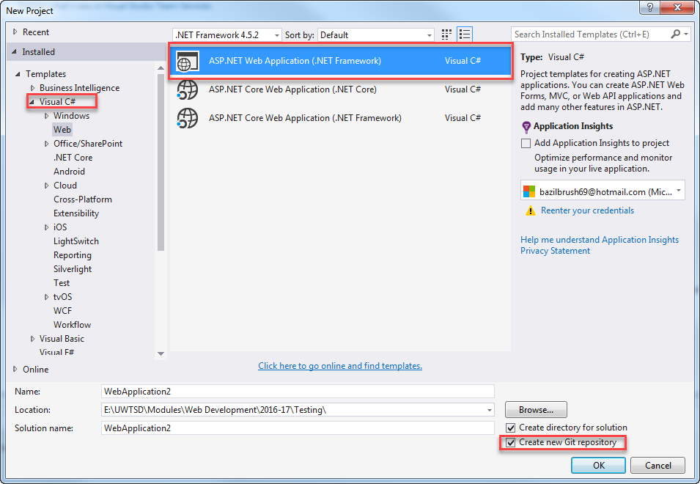

- In the next window, select the following:
  - Template: MVC
  - Check “Add Unit Tests”
  - Authentication: Individual User Accounts
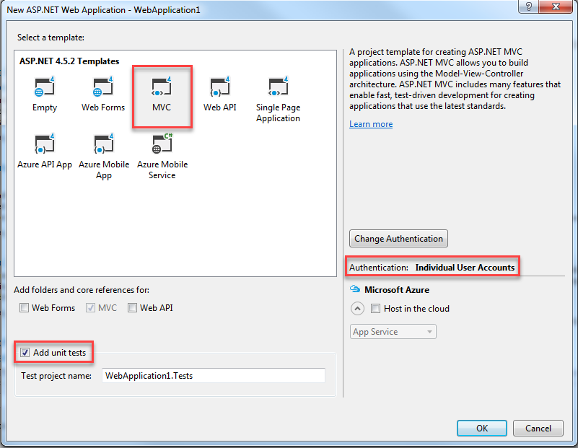
- Be patient it takes a while to load.

Exercise 2: Adding Project to Source Control
It is good practice to use version control on your software development projects. You do not have to do this, it is just a suggestion. The instructions provided here are for Bit Bucket, but you are free to use anything else.
You can skip to the next exercise if you know how to do this already or you do not wish to use source control or if you wish to use a different tool.
- Go to https://bitbucket.org/ and create an account using your university email address if you do not already have one.
- As you are working in pairs, you will need to create a team.
  - Add your partner and me to your team.
- Create a new repository and make note of the URL address.
  - Simply go to Repositories Create Repository and follow the instructions – the defaults are fine.
- In Visual Studio, from the menu, go to View Team Explorer. You can also switch to it using the Team Explorer tab in the solution explorer area.
- Click the little arrow as shown below to bring up the menu and select Sync from the menu options.
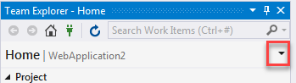
- Next scroll down and look for the Publish to Remote Repository section.
  - Click the Publish Git Repo button
  - You should get a text field prompting for the URL address of your repository. Paste in the URL of the repository you created earlier on BitBucket.
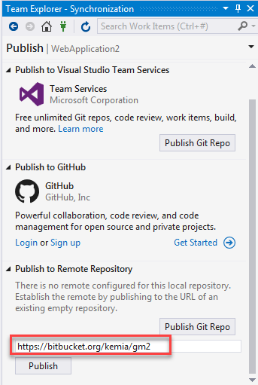
- You can go back to Bitbucket to confirm that it has published your new project.

Exercise 3: Creating the Data Models
- Using the data descriptions for each of the entities for the cinema application, create data model classes for each of the entities.

Defining Data Properties
- You use Data Annotations: https://msdn.microsoft.com/en-us/library/jj591583(v=vs.113).aspx
- Import the Data Annotations library into your data class.
- Use data annotations to add data attributes to the properties (see Lecture 1, slide 20). Some examples are shown below:
  - To define a field as a primary key. Note: if the key field is an integer, EF will automatically make it an auto-increment field when creating the database table unless otherwise specified.
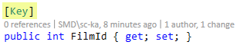
  - To specify a required field
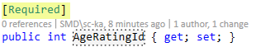
  - To specify a maximum string length for a field
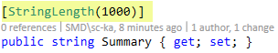
  - To specify a required field as well as a maximum string length
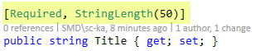

Extending the ASP.NET Application Users Class
- For user accounts, you will use the already tried and tested ASP.NET Identity. The user profile, however, contains just the basic properties for managing a user account. In this exercise, you will extend it by adding a few more user profile data properties.
- Open up the IdentityModels.cs file in the Models folder.
- You will need to import the Data Annotations library so that you can annotate the fields.
- By default, it contains two classes, ApplicationUser and ApplicationDbContext. The class you want is the ApplicationUser which represents the user account.
- Locate the end on the ApplicationUser class and just before its ending (the end curly “}” bracket), insert the additional properties for:
  - First name
  - Last name
  - Created (the date the account was created). Note: you are not likely to find the DateTime data type. You can either:
    - Use System.DateTime
    - Import the System library into the file.
  - Last login (the last date and time the user logged in)

Composite Primary Keys
- A composite primary key is a primary key made up of more than one column. There are two composite keys defined in the cinema application database design in the following entities.
  - TicketTypeAgeRating
  - BookingTicket
- Open up the TicketTypeAgeRating class.
- To define composite keys, you need to import the additional database schema library. Add the following additional highlighted import statement.
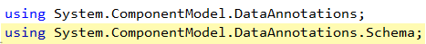
- The composite primary key for the TicketTypeAgeRating entity is made up of the following two columns:
  - TicketTypeId
  - AgeRatingId
- Mark both fields as Key fields, by adding the “Key” data annotation.
- You also need to tell EF the order of the columns making up the composite key. Add the following highlighted column order definitions.
// Has a composite primary key
// Made up of TicketTypeId, AgeRatingId
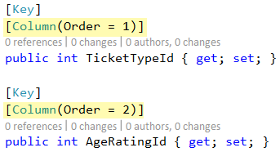
- Configure the composite primary key in the BookingTicket class.

Using Enums
Enums provide a simple way to limit values for a field to a small set of allowed values. You will use an enum to restrict the viewing experience type of a film showing to either 2D, 3D or iMax. Enums evaluate to integer values.
- Create a new code file: Add New Item … Code File
- Call the file ViewingExperienceTypes
- Add the following to it to define the enum and its allowed values:
// Enumeration of a small set of values allowed for
// a Film Showing Viewing Experience Type
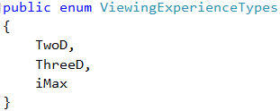
- Open up the FilmShowTime class.
- You will use the enum you have just created as the data type for the ViewingExperienceType field. Add the following:
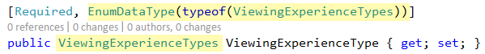

Exercise 3: Checking in your Changes
- As you are using version control, it is good to check in changes frequently.
- Go to the TeamExplorer window. If the changes to commit are not visible, click the little arrow to bring up the menu and select changes
  - You can also right-click on the Project node in solution explorer and select Source Control Commit…
- You should see a list of any pending changes.
- You will also be asked for a commit message. It is good practice to identify your commits (a group of changes). Give your changes a name, for example:
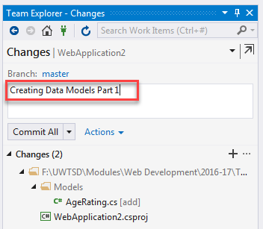
- For the Commit All button, you have three choices (click the little arrow to see them). You probably want the second option (Commit and Push) at the minimum.
  - Commit will simply make record of your changes that you have made on your local machine. It will not mark the change in the remote repository.
  - Commit and Push will do the above and push it to the remote repository. This means that any changes you have made will be saved to the remote repository as well.
  - Commit and Sync does three things. First, it will commit. Second, it will perform a pull (grabs the updated information from the remote repo). Finally, it will push.
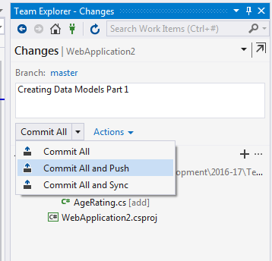
- Click the Commit All button with the right choice to save the changes and upload them to bitbucket.
- You can go to Bitbucket to confirm that the changes were saved.
- That’s all for today.

