Name: Group 8
Business Plan for: TranquilTerra Retreats

Lecturer: | Charlotte Joyner
Date: | 28.02.2024
Team members: | Traian Roibu (2215953)  Roxana Maria Burlacu (2014302)  Nerea Juaristi (2212615)  Vlad Danceanu (2212616)
Business plan contents
Executive Summary…………………………………………………………………………………………………………….3
1 Executive summary 3
2 Business details 4
3 Key personnel 5
Vision 6
4 The business idea 6
5 Business goals 6
6 What the business does 7
7 What makes the business different 8
8 Legal requirements 8
Marketing 9
9 Market research 9
10 Profiling customers 9
11 Profiling competitors 10
12 Managing market risks 11
13 Pricing 11
14 Promotion and advertising 12
Running the business 13
15 Staff 13
16 Premises 14
17 Suppliers 14
18 Equipment 15
19 Managing operational risks 15
Finance 16
20 Start-up costs 16
21 Cash flow forecast 17
22 References……………………………………………………………………………………………………………………………………………………………18
23 Appendix………………………………………………………………………………………………………………………………………………………………19

1 Executive summary
Historical and Scenic Significance:
Sarmisegetusa, situated in the southwestern Romanian mountains, has a rich history dating back to the Dacian civilization. Once the capital of the Dacian Kingdom, its UNESCO World Heritage Site status and echoes of ancient resilience make it an idyllic setting for TranquilTerra Retreats.
Strategic Resources and Partnerships:
TranquilTerra strategically utilizes Sarmisegetusa's historical and scenic qualities, emphasizing the significance of land selection in leveraging the area's allure. The integrated farm, operated by skilled personnel using sustainable techniques, adds allure to the retreat, emphasizing environmental conservation. Core Activities and Sustainable Practices: The retreat's core activities encompass managing an integrated farm, creating accommodations, organizing guided tours, and implementing sustainable practices. The integrated farm transcends mere revenue generation, committing to sustainable agriculture and providing guests with an authentic farm-to-table experience. Accommodations, designed for comfort and eco-friendliness, and guided tours enhance the cultural and historical experiences. Unique Value Proposition: TranquilTerra Retreats caters to nature enthusiasts and eco-conscious travelers, offering a haven to disconnect from urban life and reconnect with nature. The emphasis on sustainable and responsible tourism aligns with global trends, attracting a discerning customer base. Collaborations with local farmers provide immersive cultural experiences, forging a deeper connection with local culture. Target Audience and Marketing Strategy: Nature enthusiasts, eco-conscious travelers, families seeking a peaceful getaway, and educational groups are identified as specific customer segments. Leveraging online platforms, travel agencies, social media, and local partnerships, TranquilTerra ensures a broad reach and engages with its target audience effectively. Customer Relationship Strategy: TranquilTerra's customer relationship strategy revolves around personalized service and consistent communication. Personalized experiences cater to individual guest needs, while regular communication through newsletters and social media fosters a sense of community. Gathering feedback ensures continuous improvement and responsiveness to evolving customer needs. Revenue Streams and Cost Structure: Diverse revenue streams, including accommodation fees, guided tour fees, farm produce sales, merchandise, and collaborative promotions, contribute to financial sustainability. The cost structure is designed for a balance between financial viability and sustainable practices, encompassing land acquisition, staff salaries, construction, marketing, and investments in sustainable farming. Key Metrics for Success: Key success metrics include occupancy rates, visitor satisfaction, farm production and sales, social media engagement, online reviews, and environmental impact metrics. These metrics provide insights into popularity, guest experience, and the retreat's commitment to sustainable practices and responsible tourism.

2 Business details

Company name:
TranquilTerra Retreats

Address:

Sarmisegetusa

Primary contact method
tranquilterra@gmail.com
(+4) 0727362234

The business will:

TranquilTerra Retreats offers a holistic eco-tourism experience, including eco-friendly accommodations (cabins and camping facilities), an integrated farm for farm-to-table experiences, guided tours, and educational programs. The retreat strives to create a balance between modern comfort, cultural immersion, and environmental sustainability.

3 Key personnel

Details of owner(s):
Name: Traian Roibulescu
Position/main responsibilities: Project manager
Experience and knowledge of our industry: 5 years
Previous employment: Hospitality
Key skills brought to the business: Management skills
Academic/professional qualifications: Degree in Hospitality Management or Business Management
Salary expectations £ 11.000

Vision

4 The business idea

Sum up your business idea:

- Establish and manage an integrated farm with local produce
- Develop and maintain accommodations, including cabins and camping facilities
- Organise guided tours and activities within the reservation park
- Implement sustainable and eco-friendly practices in all operations

5 Business goals
- What do you want to achieve in your first year of business?
TranquilTerra Retreats will achieve an occupancy rate of 60%
- Where do you see your business in 3-5 years’ time?
TranquilTerra will increase its integrated farm by 50% and the rate of occupancy by 80%

6 What the business does

Product/service | Features | Benefits
- Eco-Friendly Accommodations | - Sustainable design, eco-friendly materials | - Guests enjoy a comfortable stay while minimizing their environmental footprint.
- Integrated Farm Experience | - Organic, locally sourced produce, farm-to-table concept | - Visitors participate in sustainable agriculture, relishing fresh and authentic farm produce.
- Guided Cultural Tours | - Local insights, historical exploration | - Guests gain a deeper understanding of Sarmisegetusa's culture and history through engaging guided tours.
- Nature Fascinating Activities | - Scenic trails, wildlife observation | - Nature enthusiasts reconnect with the natural world, enjoying serene landscapes and diverse wildlife.
- Educational Workshops | - Sustainable farming practices, cultural immersion | - Educational groups benefit from hands-on learning experiences, fostering environmental and cultural awareness.
- Community Collaborations | - Partnerships with local farmers, businesses | - Enhances the local community by supporting regional agriculture and promoting economic sustainability.
- Environmental Conservation Initiatives | - Sustainable practices, waste reduction | - Demonstrates a commitment to responsible tourism, attracting eco-conscious travelers.

7 What makes the business different (Value Proposition)
Your product/service is unique or different compared with the competition because:
- Nature Escape: Unlike other retreats, we seamlessly blend nature, agriculture, and comfy stays, offering a unique escape into the beauty of Sarmisegetusa, Romania.
- Local Culture Dive: Guests actively participate in traditional farming with local farmers, creating a deep bond with the area's rich heritage.
- Eco-Friendly Focus: We're not just about a place to stay – we're committed to sustainable agriculture and green accommodations, appealing to environmentally conscious travelers.
- Personal Touch: Our personalized service ensures each guest's unique needs are met, fostering a sense of community and creating lasting memories.
- Historical Charm: Set in the UNESCO World Heritage Site of Sarmisegetusa, our retreat combines historical significance with scenic beauty, offering a one-of-a-kind backdrop.

8 Legal requirements (including regulations and licences particular to your business)
The legal and insurance requirements that apply in your business are:
TranquilTerra will adhere to legal requirements and obtain necessary permits for business registration, land use, and construction in Sarmisegetusa. The business will comply with environmental regulations, ensure food safety certifications, and obtain licenses for accommodations and guided tours. Additionally, TranquilTerra Retreats will secure liability insurance, follow employment regulations, and implement data protection measures. These steps aim to ensure legal compliance, safety, and protection for both the business and its guests.
You will meet your legal and insurance requirements by:
- Business Registration: Complete the formalities for business registration in compliance with local laws.
- Land Use and Construction Permits: Obtain necessary permits for land use and construction, ensuring adherence to regulations.
- Environmental Compliance: Adhere to environmental regulations, implementing sustainable practices for conservation.
- Certifications: Obtain required certifications for food safety, especially concerning the integrated farm's produce.
- Accommodation and Tour Licenses: Acquire licenses for accommodations and guided tours to operate within legal parameters.
- Insurance Policies: Secure liability insurance to protect the business and its guests, ensuring financial security.
- Employment Regulations: Comply with employment regulations, covering staff salaries, benefits, and working conditions.
- Data Protection Measures: Implement measures to protect customer data, ensuring compliance with privacy laws.

Marketing

9 Market research

Trends in your chosen market are:
- Sustainability of the business model, which focus on responsible resourcing for operations and services, agreeing key partnerships with sustainable local providers of food, drinks, services suppliers, tourism boards, environmental organizations, and governmental institutions which support and finance enhancing business sustainability.
- Marketing strategies focus on including the United Nation’s 17 Sustainable Development Goals to demonstrate Corporate Social Responsibility
- Supporting local communities and the society through effective Corporate Social Responsibility strategies enhance the brand awareness and the reputation of the hospitality brand.
- Marketing strategies become more effective by embedding digital strategies such as e-commerce, website and mobile applications, big data management, data analytics, Artificial Intelligence, social media practices, digital advertising, Internet of Things, etc.
- Multiple payment alternatives and an e-booking system are offered to improve the consumer experience.
- Loyalty programmes and customer support services are part of the current customer relationship.
- The multichannel strategy includes traditional and online sales channels, which are crucial for a new hospitality brand, word-of-mouth and customer recommendations on specialised websites and social media, as well as advertising in outdoor, print, TV, and online media, communications via online and traditional mass media, and social media marketing practices on platforms such as Facebook, LinkedIn, YouTube, Instagram, TikTok, etc.
- Online travel giants like Expedia and Booking.com are crucial for promoting online accommodation services.

How you know this: (Provide examples with references)
- Sustainability of the business model: Ibis Hotels (Ibis Accor, 2020).
- Hilton Hotels prioritises environmentally friendly hospitality methods, such as waste minimization, community involvement, and energy efficiency (Levitsky, 2023)
- CSR performance can increase consumers' affinity for a brand (Tingchi Liu et al., 2014)
- Marketing strategies become more effective by embedding digital strategies (Ward et al., 2023)
- Multiple payment alternatives and an e-booking system are offered to improve the consumer experience: Airbnb (Ravindran, 2023)
- Loyalty programmes and customer support services: Ibis Hotels (Nuseir, 2021)
- The multichannel strategy: Chevalier and Mayzlin (2006)

10 Profiling customers

The customer groups you will be selling to are: (4 x Customer profiles minimum)
- Nature enthusiasts travellers
- Eco-conscious travellers
- Tourists interested in culture and history
- Tourists interested in relaxation

Your customer research has shown what your customers want is:
Travellers who are environmentally responsible and passionate about the outdoors look for opportunities to get away from city life and re-connect with nature. A sophisticated consumer base is drawn to the focus on sustainable and responsible tourism, which is in line with the expanding global trend towards eco-friendly travel (BBC.com, 2024).
In order to develop a stronger bond with the local way of life, tourists hope to have the opportunity to find a tranquil haven for people and families looking to get away from the rush of modern life.
The customers are interested in culture and history, and also in relaxation.

How you know this:
- The expanding worldwide trend of environmentally conscious travel, drawing in a premium clientele (BBC.com, 2024).
- Nature enthusiasts travellers: Haukeland et al. (2014)
- Tourists interested in culture and history: O'Leary et al. (1998)
- Tourists interested in relaxation: Pesonen and Komppula (2010).

Number of customers you expect to win in each group and what they might pay:
Group | Number of customers | Price they might pay per unit
Nature enthusiasts travellers | 1000 | £35
Eco-conscious travellers | 1000 | £35
Tourists interested in culture and history | 700 | £35
Tourists interested in relaxation | 2000 | £35

11 Profiling competitors (Source: Booking.com, 2024)

Competitor name | Strengths | Weaknesses
- Pensiunea Sarmis | - Excellent services and amenities | - Only accommodation
- Casa Britonia | - Excellent services and amenities | - Only accommodation
- Pensiunea Agroturistica Romana Sarmizegetusa | - Excellent services and amenities  - Sustainability | - Only accommodation

How you can improve on their offer and/or price(s) unique offerings:
Situated at the intersection of nature, agriculture, and cosy lodging, TranquilTerra Retreats presents a distinctive value proposition. The retreat offers eco-aware tourists and nature lovers a safe sanctuary where they may detach from city life and re-establish a connection with the natural world.

12 Managing market risks

Write down the risks you have identified:
- Competition
- Inflation and increasing cost of living
- Human resources shortages

How will you manage these risks so that they become less of a threat:
- Diversification strategy
- Attracting larger customer pools
- Effective remuneration and incentive schemes

13 Pricing

How you can calculate your prices:
- Based on prices on the same location

How your prices compare with the competition:
Product/service | Your price(s) | Range of competitor prices (per unit)
Accommodation | £35 | £34.35-80.00
Pensiunea Sarmis | £35 | £39.00
Casa Britonia | £35 | £60.00
Pensiune Agroturistica Romana | £35 | £38.00

Reasons for the difference between your price(s) and your competitors’ price(s):
- Startup’s accommodation prices are a the lowest level of the range considering that the amenities are not luxurious.

14 Promotion and advertising

How and where will you promote your product/service?
- Google SEO
- Google ads
- Facebook
- LinkedIn
- YouTube
- Instagram
- TikTok
- Company’s website and app
- specialised websites
- advertising in outdoor, print, TV, and online media
- communications via online and traditional mass media, and social media marketing practices on platforms.

Running the business

15 Staff

Role | Total cost | Necessary experience | Specialist skills and/or qualifications
- Venue Manager | £10,000 | - 3 – 5 years in managing hospitality venues | - Degree in Hospitality  - Degree in Business Management  - Good communication skills  - Teamwork  - Complaint handling
- Assistant manager | £7,200 | - 1 - 3 years team leader or in hospitality management | - Degree in Hospitality  - Experience in team leader.  - Good communication skills  - Fluent English and good customer service  - Complaint handling
- Front of house (4 people) | £21,600 | - Front of house experience | - High school diploma  - Good communication  - High costumer Service  - Problem solving
- Back house (4 people) | £12,000 | - 1 year experience | - High school graduation  - Multitasking  - Cleaning
- Guide (part-time/ weekend only) | £3,000 | - 2 years’ experience | - Professional tour guide skills  - Public speaking  - Multilingualism  - Time management

16 Premises

 | Cost £
Premises required at start-up: Owned Land | £ 0
Premises required in the future (if different): No | £ 0

17 Suppliers

Your key suppliers and their credit terms
Supplier | What you’ll buy from them | Number of days’ credit
- Case de lemn Bernard (www.caselemnbernard.ro) | - 10 Build Wood Accommodation | - 6 months
- Ikea | - Furniture (beds, sofa, tables, pillow, wardrobes) | - 6 moths to 1 year
- Pernod Ricard | - Alchool / Spirit/ Wine | - 30 days
- Parma Food | - Groceries | - 30 days
- Harghita – Holding | - Cleaning products and hygiene supplier | - 30 days
- Coca-Cola Hbc Romania | - Soft drinks / water | - 30 days
- Espresso Concept Romania | - Coffee/ Tea/ Hot drinks | - 1 day
- Spalatorie Germana Sarmisegetuza | - Professional washing and cleaning company. | - 1 day

18 Equipment
Resource | When | How funded | Cost £ per unit
- Houses | - From start | - Company investment | £21,280
- Cars | - From start | - Company investment | £5,500
- Laptop and IT | - From start | - Company investment | £560
- Furniture for rooms | - From start | - Company investment | £500
- Restaurant furniture | - From start | - Company investment | £100

19 Managing operational risks

Risk | Solution
Staff  - Work and safety accidents.  - Language barrier with some of the costumers  - Costumer support and problem solving | - To be sure that everybody is following the Health and Safety rules.  - Trying to be sure on hiring that the staff they have good language skills and, in the future, to help them to improve their knowledge in other languages.  - Keeping the staff involved in all the problem-solving resolution
Suppliers  - Late time of delivery or non-delivery dates  - Payment agreement  - Missing items from the invoice/ delivery | - To be sure that the Manager and Assistant they are up to date with the stocks in the business and to be ready with the orders on time.  - To be sure the payment for all the invoices from suppliers to be paid on time, if not they will add interest and that will affect our cash flow.  - All the order or invoices to be verified with attention to be sure all the product they are delivered for our venue.

Finance

20 Start-up costs
IT and computers | £2,800
Telephones and broadband | £780
Equipment | £212,800
Stock | £4,000
Tools | £1,500
Vehicles | £11,000
Insurance | £600
Stationery | £900
Marketing | £4,000
Consumables | £1,100
Licences | £1,000
Training | £500
Wages/recruitment | £4,483
Security/health and safety equipment | £2,000
Market research costs | £1,000
Total | £248,463

21 Cash flow forecast (Click on the tabs within the Microsoft Excel sheet to view the second 6 months and summary)

22 References
Levytskyi, A. (2023) Aligning marketing strategy with the Sustainable Development Goals (SDGs). Available at: https://antonlevytskyi.com/insights/aligning-marketing-strategy-with-the-sustainable-development-goals-sdgs (Accessed: 20 February 2024)
Ibis Accor (2020) With Planet 21, Accor aims to provide a positive hospitality experience. Available at: https://ibis.accor.com/sustainable-development/index.en.shtml (Accessed: 20 February 2024)
Tingchi Liu, M., Anthony Wong, I., Shi, G., Chu, R. and L. Brock, J. (2014) ‘The impact of corporate social responsibility (CSR) performance and perceived brand quality on customer-based brand preference’. Journal of Services Marketing, 28(3), pp. 181-194. https://doi.org/10.1108/JSM-09-2012-0171
Ward, A.F., Marmol, M., Lopez-Lopez, D., Carracedo, P. and Juan, A.A. (2023) ‘Data analytics and artificial intelligence in e-marketing: techniques, best practices and trends’. International Journal of Data Analysis Techniques and Strategies, 15(3), pp. 147-178. https://doi.org/10.1504/IJDATS.2023.133019
Ravindran, S. (2023) The Power of Online Booking Systems: How It Can Streamline Your Business Operation. Available at: https://news.simplybook.me/the-power-of-online-booking-systems/ (Accessed: 20 February 2024)
Nuseir, M.T. (2021) ‘Assessing the impact of brand equity and customer experience on brand loyalty in the United Arab Emirates' hotel industry’. International Journal of Business Excellence, 25(4), pp. 459-473. DOI https://doi.org/10.1504/IJBEX.2021.119753
Chevalier, J. A., and Mayzlin, D. (2006) ‘The Effect of Word of Mouth on Sales: Online Book Reviews’. Journal of Marketing Research, 43(3), pp. 345-354. https://doi.org/10.1509/jmkr.43.3.345
Haukeland, J.V., Grue, B. and Veisten, K. (2014) ‘Turning national parks into tourist attractions: Nature orientation and quest for facilities’. In Frontiers in nature-based tourism (pp. 76-99). London: Routledge.
O'Leary, J.T., Morrison, A.M. and Alzua, A. (1998) ‘Cultural and heritage tourism: Identifying niches for international travellers’. Journal of tourism studies, 9(2), pp. 2-13. https://search.informit.org/doi/10.3316/ielapa.990807825
Pesonen, J. and Komppula, R. (2010) ‘Rural wellbeing tourism: Motivations and expectations’. Journal of Hospitality and Tourism Management, 17(1), pp. 150-157. https://doi.org/10.1375/jhtm.17.1.150
Booking.com (2024) Search hotels in Sarmizegetusa. Available at: https://www.booking.com/city/ro/sarmizegetusa.en-gb.html (Accessed: 20 February 2024)
BBC.com (2024) BBC Travel. Available at: https://www.bbc.com/travel/article/20240103-the-secret-meaning-behind-the-world-tree-hugging-championships (Accessed: 20 February 2024)
https://www.ikea.com/ro/ro/
(Accessed: 23 February 2024)
www.caselemnbernard.ro
(Accessed: 23 February 2024)
https://www.pernod-ricard.com/en
(Accessed: 20 February 2024)

23 Appendix
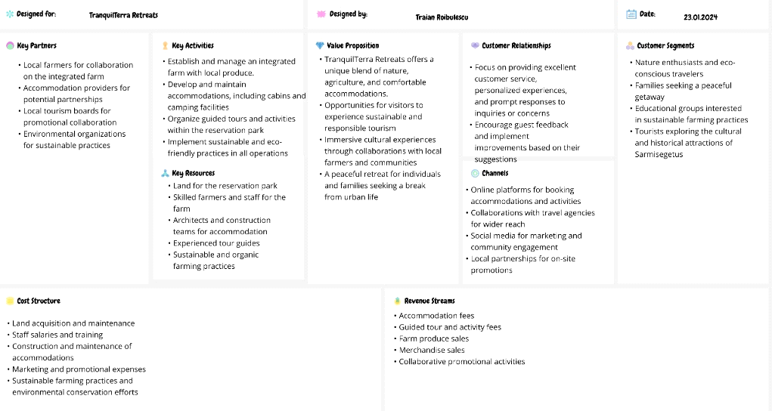
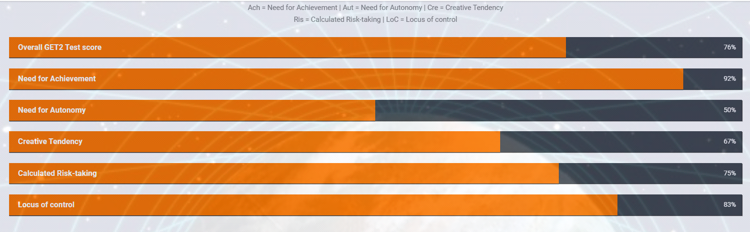

Sarmisegetusa Land
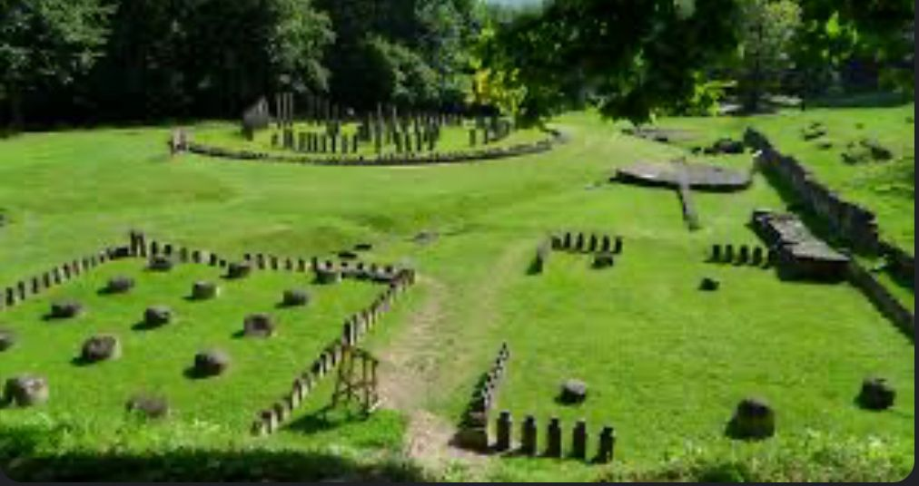

Case lemn Bernard Project





