
Volume 1

University of Wales trinity saint david Journal
Theory and Practice of Environmental Impact Assessments: Case Studies

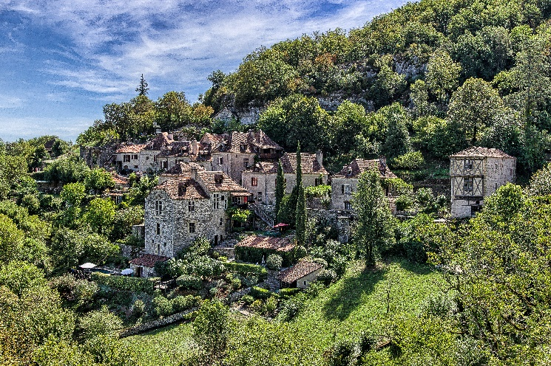
Aim and Scope of Journal


The Theory and Practice of Environmental Impact Assessments (EIA): Case Studies is a journal that examines cases of developments that have produced EIA’s. This Journal is for an audience of various people from different walks of life, whom have an interest in this field. An Impact assessment is a study carried out that will/should identify the possible consequences of a current or proposed action/development. When carrying out a EIA, an impact assessment process is done to consider the effects on or of the environment. An EIA review is carried out to evaluate impacts of projects, policies, processes and products, and how to the make the most informed decision which will allow the best management actions to be taken.
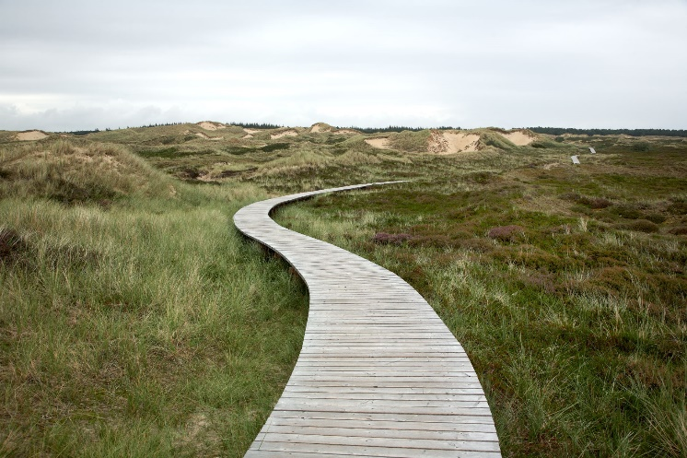
This is the first volume produced by the University of Wales Trinity Saint David. This issue will comprise of a collection of varying case studies examining the theory and practice of EIA’s, by a group of Postgraduate students within the Natural Built Environmental department.

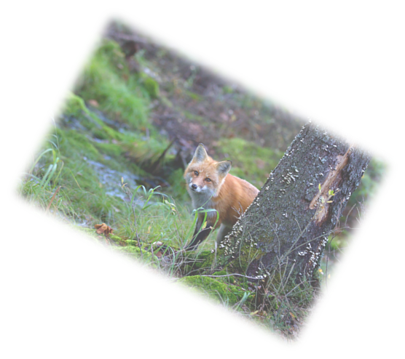



Editorial and Board Members

Chief Editor:
Marie West

Assistance Editor:
Matt Morga

Line Editors:
Joseph Blackmore
Laura Davies
Tracy King
Dylan Morgan
Bethan Stroud

Chief Board Members:
Professor Chris House
Professor Rhian Jenkins

Acknowledgements
The Authors of this Journal would like to say a thank you to all of their Professors; who gave their support and encouragement throughout the last 8 months which has enable all of us to take the next step in our education. Not only have they, themselves been trying to make it through the pandemic, they have done so while learning new methods to deliver lectures and still provided a great level of education. Thank You.

Table of Contents
Blackmore, J. : Discussion of Good Practice Within the Environmental Impact Assessment Process and Evaluation of The Environmental Assessment of Mynydd Y Gwrhyd Solar Farm 1
Davies, L. : Environmental Impact Assessment and The Penderi Solar Park 15
King, T. : Newgale Road Relocation EIA Analysis………………………………….28
Morga, M. : Upper Ogmore Windfarm Environmental Impact Assessment (EIA) Report………………………………………….37
Morgan, D. : A Critical Assessment of EIA Process and Theory: A Swansea Inner West Pier Marine Works Case Study……………………………………………49
Stroud, B. : Environmental Impact Assessment and Trimsaran Housing Development……………………………….61
West, M. : Environmental Impact Assessment and The Cleve Hill Solar Park……………………………………………..68

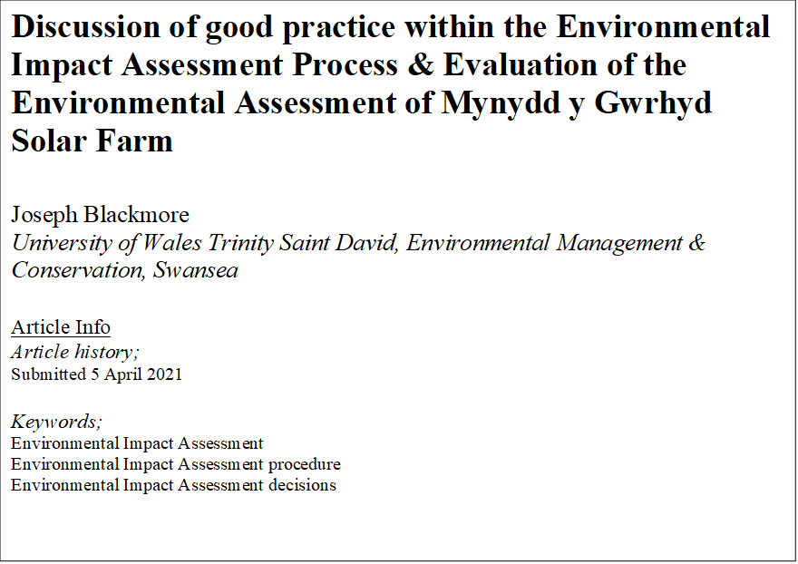

- Introduction
Within the planning and policy surrounding built developments, there are a wide array of potential impacts that must be considered in order to facilitate the mitigation of negative environmental and anthropogenic impacts. The environmental impact assessment (EIA) process should involve a holistic approach to gathering knowledge surrounding the scope of the development and the potential ways in which the environment may be affected by it. Each development will have unique characteristics and potential for environmental impacts dependant on the type of development, along with the scale, purpose, and the location. Whilst the EIA process itself should have a common goal of identifying the environmental risks associated with a development, the variety of proposed developments that EIA’s can be applied to results in a wide variation in how individual EIA’s can be structured. There remains debate whether the EIA process can be considered as a scientifically objective approach to identifying the associated environmental impacts of a development, this is perhaps as a result of the variation between EIA’s and the inevitable political influence in the granting of permission for large scale developments in particular (Cashmore & Richardson, 2013). Nevertheless, good practice within an EIA can be established in regards to how thoroughly the specific environmental risks associated with the development in question have been identified, along with the manner in which mitigation options have been presented. A systematic and thorough approach to considering the relationship between the development in question with the natural environment, human health and the surrounding areas can have a tangible effect on the success of planning and construction. The completion of a high quality EIA can increase the likelihood of developments meeting legal environmental requirements whilst maintaining a positive impact for the communities that they are designed to serve.
The regulations that an EIA will be expected to consider can vary depending on the type of development under consideration and the national significance of the project. In this report an EIA of a Welsh solar farm proposal will be evaluated, considering examples of both good and bad practise, in order to discuss both the positive attributes and limitations of the specific EIA in question. The influence of policy and regulation in relation to EIA’s will be discussed, including a consideration of political and legal developments historically and within a more contemporary context. Recent developments within EIA guidelines and policy will be evaluated in order to determine the potential for improvements in conducting an EIA.
2.Environmental Impact Assessments The Fundamental Purpose of Completing an EIA
Environmental impact assessments can be considered to be linked to both sustainable development and planning practise. In essence, an EIA can be considered as a planning tool that when implemented effectively, encourages developments in infrastructure to become more sustainable in their utilisation of the natural environment (Steiner, 1995). Within the planning of a development a goal of either of no net loss (NNL) or net gain of biodiversity can be set relative to a predetermined baseline in order to encourage the developer to consider the environmental footprint of their project as a guiding principle throughout its design, planning, construction and use.
By establishing the potential environmental risks that are posed by a development proposal this can inform the relevant authority whether permission for the development should be permitted, perhaps under the condition of required mitigation or enhancement, or refused outright. Following the completion of the EIA, and environmental impact statement (EIS) can be published publicly so that the environmental risks associated with the development are presented and available to all relevant stakeholders in a transparent manner (Sheate, 2014). The broad purpose of an EIA should be to exchange information, techniques and methods, which are of value for environmental management. EIAs involve individual assessments of all aspects of the environment, such as the potential health implications to human populations in addition to the landscape, heritage, air, climate, soil, water, fauna, and flora likely to be significantly affected by a proposed project. This process should require developers to consider the environmental, social and economic impacts of their projects, thereby discouraging developments that are severely damaging to the environment and surrounding communities. Some of the principle purposes of an EIA can be considered as follows:

- To produce a statement guiding relevant decision makers.
- To publish a clear statement of identified impacts with an indication of their significance (especially if any are irreversible).
- To advise on problem mitigation, gather data, feed into future impact assessment, improve damage control and discourage over exploitation of the natural environment.
- To systematically evaluate all environmental impacts associated with the development whilst considering their relationship between social and economic impacts.
- To increase the accountability of the developer.
- To facilitate an objective and independent review of any results collated.
- To facilitate public participation.
- To identify the legal responsibilities of the developer and consider regulatory boundaries and environmental law in recommendations made.
(Barrow, 1999).
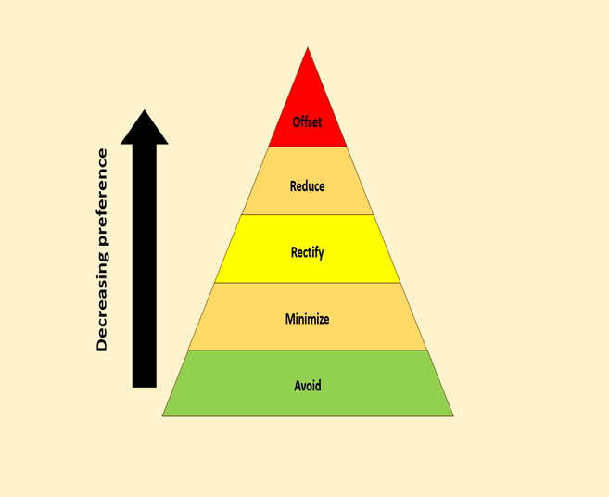
A hierarchy of environmental mitigation measures can also be applied to the EIA, so that the environmental impact of the proposed development is considered as a fundamental area of concern when producing a guide for the developer and relevant authority. A proposed mitigation hierarchy may be considered as in the following diagram:
Figure 1: A 5 step mitigation hierarchy for environmental impacts.
(Babu, 2016).

The hierarchy begins with the most beneficial form of mitigation through to the least beneficial from the perspective of environmental conservation, or in some cases potential for biodiversity improvement, in the following order;
- Avoidance- This can be considered the preferred form of mitigation as this can prevent any environmental harm from occurring in the first place. This could include avoiding impacts on biodiversity by screening potential risks prior to project design and selecting an alternate development site.
- Minimise- The second step of the hierarchy requires that prior to and during development, impacts are minimised, such as by using more environmentally friendly construction methods as an example. This approach recognises that environmental impact cannot be completely prevented, however provisions can be put in place to reduce the environmental impact as much as feasibly possible.
- Rectify- This implies that an environmental impact has already occurred in some capacity, therefore efforts to rectify any damage caused should be considered. This can include actions such as requirements that biodiversity loss is remediated within the footprint of the development, which could include actions such as reseeding affected land or developing a breeding program for affected species during and after project completion.
- Reduction- In a scenario where environmental damage cannot be completely rectified, suggestions for impact reduction should be presented. This can include changes to the operation of a site in order to reduce emissions or putting provisions in place to reduce the risk posed to the surrounding eco-systems.
- Offset- This stage requires that any residual impacts not captured by the first four steps of the hierarchy are offset elsewhere, such as by contributing funding or time to contributing to conservation efforts such as wetland restoration schemes or by supporting the removal of invasive species from ecologically important areas. This can be considered as a
form of compensation in order to contribute to achieving no net loss or even a net gain in biodiversity. This form of mitigation is surrounded in controversy as some argue that large developers can use this as a method of ‘buying their way out’ of environmental responsibility by causing environmental harm in their projects, but using their wealth to meet the loose definition of ‘no net environmental loss’. It is desirable for offsets to fund new protected areas and their management as this can be used as a catalyst to fund practical actions that have the potential to contribute significantly towards efforts in conservation. However, unless these offset-funded protected areas are tallied separately — and alongside the losses that trigger them, the proliferation of using offsets as a form of environmental impact mitigation can pose a significant threat to biodiversity, particularly in the presence of corporate and governmental corruption (Maron, et al., 2015). (Arlidge, et al., 2018).
Additionally, a hierarchy amongst the perceived potential environmental impacts themselves can be produced by applying the definition of impact as;
Impact = Effect x Sensitivity (Boughton, et al., 1999).
Where effect is considered as the pressure placed on the ecosystem in question and sensitivity is the ability of the ecosystem to withstand the pressure. The accuracy of grading impacts utilising this approach will be dependent on the quality of both quantitative and qualitative data recorded in the EIA, along with the judgement and level of knowledge surrounding the specific site in question held by the person responsible for grading the perceived threat of the potential environmental impacts (Jacob, et al., 2016). By highlighting the most threatening environmental risks posed by a development, such as a risk of damaging the habitat of a European protected species (EPS) for example, this can more clearly inform the developer and relevant authority about the most significant legal and moral responsibilities that must be considered. The potential effect of any environmental impacts can also be contextualised from a local, national and global perspective. By considering the scale of the environmental impact, along with moral and legal requirements from local, national and international authorities, this can allow for a better understanding of how to present and plan mitigation for the issues raised.
2.1 Structure of the EIA Process
Each individual development proposal will have unique characteristics and present different challenges from the perspective of constructing an EIA and EIS, however, a common structure for completing an environmental assessment can be considered as follows:
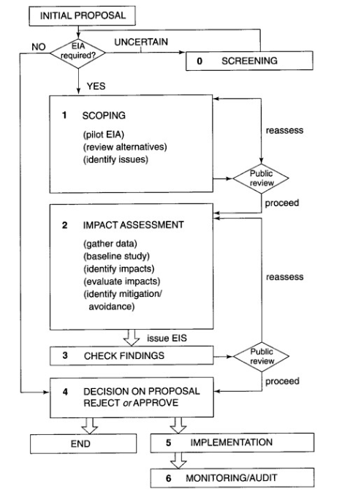

Figure 2: A diagram of the typical stages involved in completing an EIA and EIS. Phases 0-6 are presented in an idealised order. (Barrow, 1999)

In order for an environmental assessment to be considered systematic and thorough, it is vital that the relevant phases are completed in an appropriate order, however, some processes may require continuous adjustment as a more detailed appraisal is achieved progressively throughout the assessment process. Where the requirement for an EIA has been established following the identification of possible significant environmental impacts in the screening of the initial proposal, the key procedures to consider are as follows;

Scoping & Baseline Studies

This can be considered as the essential first step in assessing the development in question as the scoping phase defines the potential environmental impacts before identifying the most important impacts and their key receptors. Any obvious legal barriers can be discussed with the developer in this early stage of the development in order to reduce complications later in the planning process. A line of communication can also be established between developers, consultants and any other relevant interest groups in order to encourage sharing of information relevant to the project in terms of environmental concerns.
The scoping exercise should provide a base plan for subsequent steps by making a preliminary assessment of:

- The potential impacts on component receptors, estimated from the project description (including size, construction requirements, operational features and secondary developments such as access roads) and the nature of components and receptors
- The impact area/zone where impacts are likely occur, estimated from the impact types and the nature of the surrounding area and environmental components, e.g. impacts on air quality from particulate pollution may occur at distances of up to 2 miles from the project site
- Possible mitigation measures
- Is there potential for monitoring?
- The methods and levels of study required to gather reliable baseline data that can be used to evaluate the baseline conditions, produce accurate impact predictions, and formulate appropriate mitigation measures and monitoring procedures.
- Effective methods for collecting, analysing and presenting information
- The resource requirements and timing considerations for activities such as field surveys.
- Limitations such as available time and monetary resources.

(Morris & Therivel, 2009).

The baseline study can be considered as the continuation of the scoping process, where relevant information is collected firstly from a desk study in order to collect any relevant data that has previously been collected, before investing resources in collecting necessary primary data. The evaluation of the baseline study should include a clear presentation of the methods used and the results gained, indications of limitations and uncertainties relating to the accuracy of data gathered and an assessment of key receptors to the environmental impacts and their sensitivity.

Impact Assessment

Impacts can be categorised as the following;
- Direct/primary
- Indirect/Secondary
- Cumulative

Some impacts may be deemed as beneficiary or neutral whilst other can be negative. The interaction between impacts should be considered along with their severity, spatial extension and timescale. Some impacts may be deemed as having a temporary influence, such as during the construction phase, whereas others may have a long term or even irreversible influence on the environment (Beanlands & Duinker, 1983). It is important to consider that the measurements of some impacts may rely on qualitative data, whereas other impacts such as greenhouse gas emissions may be able to be recorded and presented in a quantitative form, e.g. tonnes of CO2 emitted per year (quantitative), a high risk of interference with bat behaviour (qualitative).
A well informed impact prediction and evaluation can produce more focussed suggestions for mitigation.

Environmental Impact Statement (EIS)

Following the impact assessment, an EIS should be produced in a manner that clearly illustrates to stakeholders and decision makers what the most relevant impacts are, particularly any that may be considered severe enough to consider condemning permission for the project to commence within an ecological risk assessment (ERA) (Claassen, 1999). In order to carry out this process, the significance of assessed impacts should be determined, then clearly presented. Significance determination is presented in the following infographic;

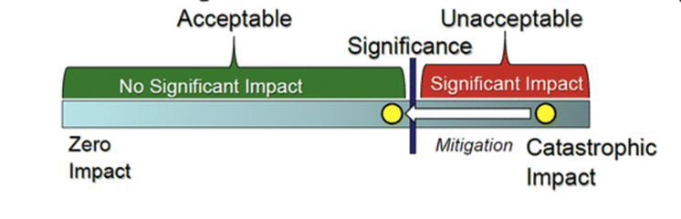
Figure 3: The significance determiner decides where on the spectrum a predicted impact (shown as the yellow circle) falls, and weighs the effect of mitigation measures (shown as the arrow) on impact significance. (Ehrlich & Ross, 2015).
Presenting the significance of impacts and determining whether their perceived risk can be considered “acceptable” is considered by some academics to be the guiding principle in the construction and presentation of the EIS as this is the basis for granting approval (Lawrence, 2007). The potential for mitigation measures to present new impacts must also not be ignored, whether or not they are considered to be of reduced significance. The following diagram represents how significance determination is central to the EIS process in addition to the presence of feedback loops in updating and further informing the mitigation and enhancement proposals;

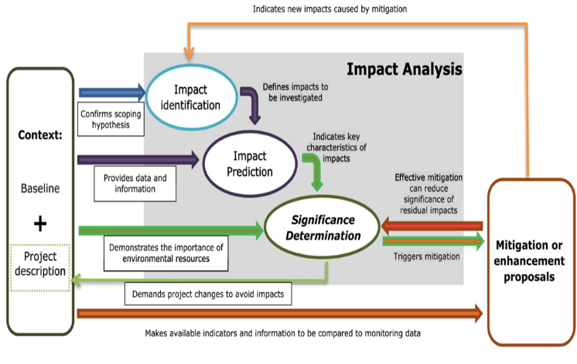
Figure 4: The centrality of significance determination in the EIS process
(Duarte & Sánchez, 2020).

The determination of impact significance should be presented coherently by providing the information relating to each impact within clearly defined sections. The significance of impacts are merely presumed in the scoping process, however the determination of the significance should be confidently confirmed within the EIS in order for the mitigation and enhancement proposals to be deemed compelling. (Perdicoulis & Glasson, 2009). Limitations in presenting the significance of impacts can result from the subjective nature of the term ‘significance’, particularly in reference to environmental impacts that rely on qualitative information in their determination. One person’s significant impact could be perceived as negligible to another, especially in the absence of measurable and compatible data sets.

Authors Quivy & van Campenhoudt suggested seven steps for completing qualitative research, by following this guide the significance of impacts can be presented more clearly, hence reducing the risk of misunderstanding surrounding the significance of impacts given that the steps are carried out in detail and presented coherently;
(1) set the initial research questions, (2) explore the related literature, (3) specify the problems within the context of the development, (4) build a model of analysis, (5) collect data, (6) analyse data and information, and (7) set the conclusions.
(Quivy & Van Campenhoudt, 2008)
2.2 Policy Guiding EIA standards and Legal Requirements in Wales
As the EIA that is being evaluated in this report is for a proposed solar farm development in Wales, it is important to understand the expected standard and legal requirements for such a development in wales specifically. The origins of the EIA process can be traced back to 1969 in the USA, with the passing of the National Environmental Policy Act (NEPA), which mandated assessment of the environmental outcomes of development projects. The EIA process was quickly adopted by governments and legislatures across the globe, including in Japan (1972), Hong Kong (1972), Canada (1973), Australia (1974), the Philippines (1977), Taiwan (1979) and the People's Republic of China (1979) to name a few (Tullos, 2009). EIA’s were formally introduced in the UK in 1988 through inclusion in the Town and Country Planning Regulations for England and Wales (UK Government , 1990) and in Environmental Assessment Regulations for Scotland and Northern Ireland, based on European Directive 85/337/EC (Jha-Thakur & Fischer, 2016). Prior to the UK leaving the European Union, policy surrounding EIA’s have been influenced significantly by European directives. The European EIA Directive (85/337/EEC) amended three times in 1997, 2003 and 2009 and consolidated in 2011 formed the basis of EIA practice in the UK (Arts, et al., 2012). In 2014, a new Directive was published which required implementation by 2017. This represents how pivotal the EIA Directive has been in influencing EIA guidance in the UK. Following the more recent amendments made to the EIA Directive, climate change has been required to be explicitly addressed both, in terms of carbon dioxide emissions associated with the proposed project (mitigation), as well as adaptation to a changing climate. The consideration of heritage aspects, both historical and cultural was strengthened from a UK perspective following the 2014 EIA Directive amendment.
Based on voluntary accreditation provided through the UK Institute of Environmental Management and Assessment's (IEMA's) EIA quality mark, rigorous and continuous examinations are made to EIA’s in order for them to acquire gain accreditation. The EIA Quality Mark is built on seven commitments (referred to as COMs). These are formally signed up to by a senior figure responsible for each registrant's EIA practice. The commitments focus on EIA-management; team capabilities; legal compliance; EIA context and
influence; EIA content; EIA presentation; and improvement of EIA practice. The EIA Quality Panel consists of independent experts that evaluate the submitted EIA’s in each of the aforementioned commitments in order to conclude whether the EIA is worthy of accreditation. Within the UK it is considered good practice for an EIA to attain IEMA accreditation as this is considered as evidence of regulatory compliance and procedural competence.

The required standards of individual EIA’s can be influenced by numerous bodies of control, some examples of authorities that can influence EIA implementation and their expected standard are represented in the following table;

Table 1: Control mechanisms influencing EIA standards. (Bond, et al., 2017)
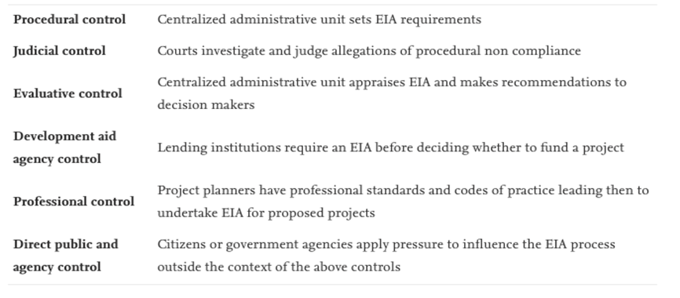
Particular consideration must be made if a project is within, or likely to have an impact on a European protected site. The European Union (EU) Habitats Directive protects certain species of plants and animals that are considered particularly vulnerable. The Directive specifically relates to Special Protection Areas (SPAs), Special Areas of Conservation (SACs) and ‘Ramsar’ sites, also referred to as Natura 2000 sites. If this is the case there may be a legal requirement to complete a Habitats Regulations Assessment (HRA) as set out within Article 6 of the EC Habitats Directive 1992, and interpreted into British law by the Conservation of Habitats & Species Regulations (Amended in 2017) ( East Hampshire District Council and South Downs National Park Authority, 2012).

A Habitats Regulations Assessment (HRA) refers to the several distinct stages of Assessment which must be undertaken to determine if a plan or project may affect the protected features of a habitats site before deciding whether to undertake, permit or authorise it. European Sites and European Offshore Marine Sites identified under these regulations are referred to as ‘habitats sites’ in the ‘National Policy Planning Framework’. A ‘Habitats Regulations Assessment screening’ should be completed in order to take into account the potential impacts both of the plan/project itself and in combination with other plans or projects on protected species (Ministry of Housing; Communities and Local Government, 2019). Despite the UK leaving the European Union in 2020, legislation protecting European sites has been maintained within the Conservation of Habitats and Species Regulations (2017).

If a HRA is required to be completed for a project located within Wales, Natural Resources Wales (NRW) should be consulted and any relevant advice offered by NRW should be included within the HRA itself.

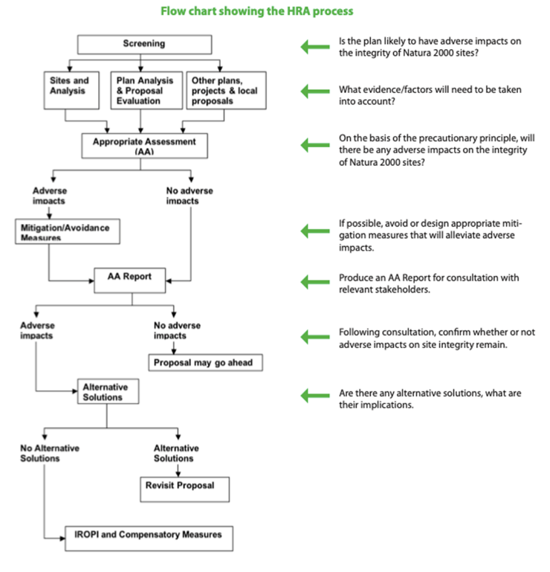
Figure 5: A diagram of the typical stages within the HRA process
( East Hampshire District Council and South Downs National Park Authority, 2012)

3.Mynydd y Gwrhyd Solar Farm
As prescribed in ‘The Town and Country Planning (Environmental Impact Assessment) Regulations 2017’, for all schedule 1 large scale projects an EIA is compulsory. Schedule 2 sites can include smaller scale projects where an EIA may be required at the discretion of the Lasting Power of Attorney (LPA). Within the aforementioned regulation, developments applicable to the definition of ‘schedule 2’ include any industrial installation for the production of electricity where the
area of construction exceeds 0.5 hectares (UK Government , 2017). The proposed development in question comprises a ground-mounted photovoltaic (PV) solar farm located on approximately 4 hectares (ha) of agricultural grazing and semi-improved land, therefore the development can be defined as a schedule 2 project.
3.1 Location
The Environmental assessment in question accompanies a planning application for a solar farm, including battery storage, electrical and associated civil infrastructure, that is up to 2.23 Megawatts (MW) in capacity on land known as Mynydd Gwyrhyd. The land in question is a moorland area situated between the villages of Tairgwaith/Gwaun Cae-Gurwen and Cwm-twrch Uchaf within Neath Port Talbot county, South Wales. The site is marked by two operational community wind turbines, owned and operated by Awel Aman Tawe (AAT). The proposed development site is not located within any recognised national area protected for landscape, ecology, hydrology or archaeology. The Welsh Government’s predictive Agricultural Land Quality tool indicates that the Site is covered by Grade 5 very poor quality agricultural land. The EIA shows clear consideration of the geographical features of the site, this is good practise as this can be used to inform mitigation suggestions that are suitable for the sites specific characteristics.
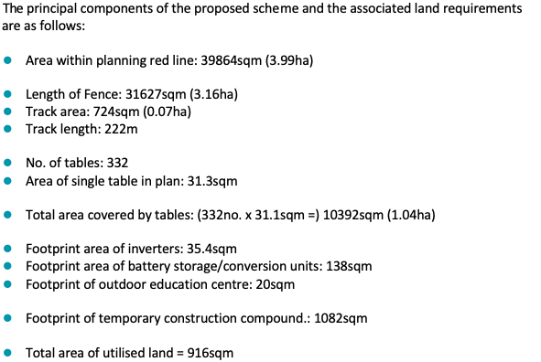
Table 2: List of land use required (Dulas Ltd., 2019).

A map of the proposed site can be found on the following page-
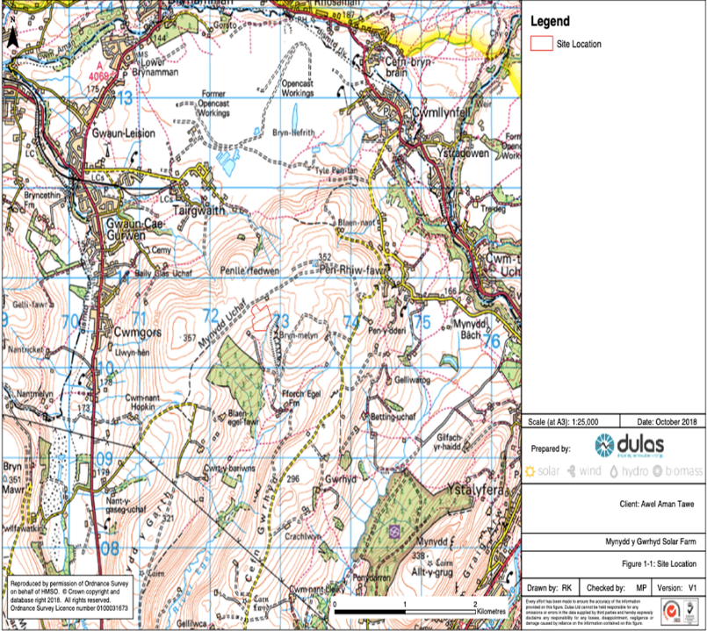
Figure 6: The proposed area of the development is outlined in red near the centre of the map.
(Dulas Renewable Energy, 2018).

3.2 Solar Array
The plan proposes that high quality poly-crystalline silicon photovoltaic modules would be installed at the solar farm, harnessing the diffuse nature of light and direct sunlight. Each of the approximately 6972 panels are expected to measure 1m x 1.67m. The solar cells are expected to be dark blue/black in colour and the panels would have an anti-reflective coating to maximise light absorption and minimise glare or reflection. The mounting frames are likely to be fabricated from extruded aluminium, installed on galvanised steel piles driven approximately 1.5 metres into the ground. The development proposal includes the incorporation of battery storage units at the site, measuring approximately (6.1m long x 2.9m high x 2.4m wide) and a single inverter/transformer station.

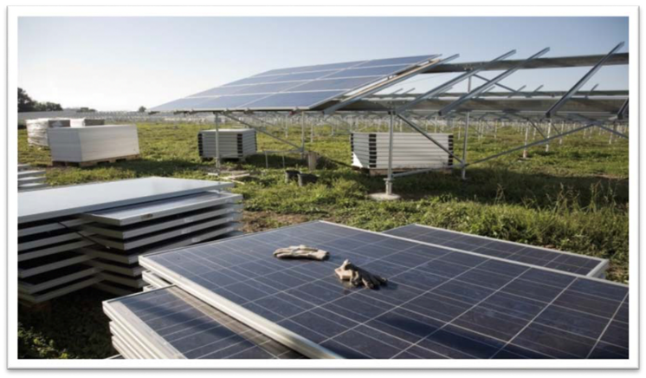
Figure 7: Aluminium frame photovoltaic cells (Dulas Ltd., 2019)

4.The Environmental Assessment for Mynydd Y Gwrhyd Solar Farm
The Assessment of environmental impacts for the proposed solar farm was completed by Dulas Ltd, A Welsh renewable energy installer and consultancy agency. The version evaluated in this section was published on the 9th of January 2019. The key sections of the report include;
- Introduction
- Planning Policy Context
- Description of Proposed Development
- Landscape and Visual Assessment
- Preliminary Ecological Appraisal
- Archaeology and Cultural Heritage Assessment
- Hydrology and Hydrogeology
- Traffic and Transport
- Glint and Glare
- Noise
The report will be evaluated in the following section in order to discuss the quality and methods of environmental assessment with a principle focus on chapter 5.
4.1 Considerations Made For the Construction Phase
The potential for environmental impacts during the construction phase of a project, even if they are considered temporary, are important to consider. The construction phase is estimated to last 12 weeks (weather permitting). Reference is made to some construction phase impacts and control measures Within the description of the proposed development:

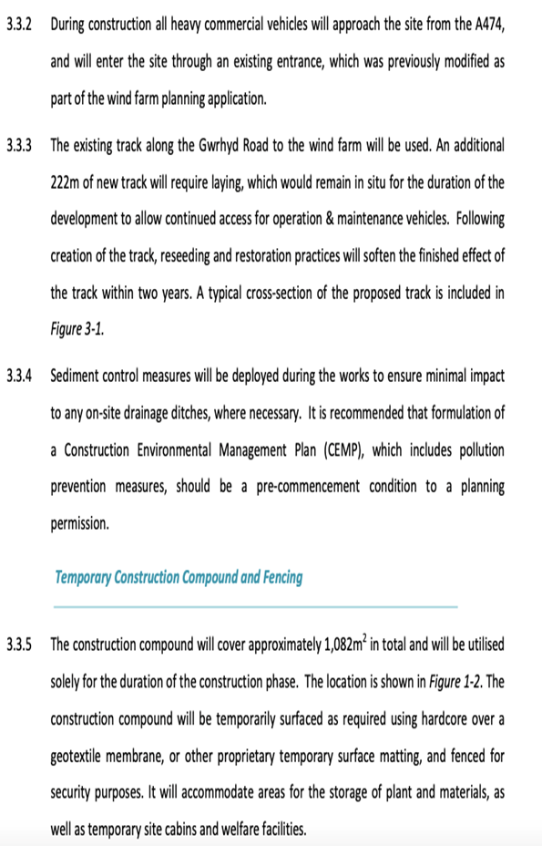
Within this section reference is also made to incorporating gaps underneath temporary fencing to allow for small mammals to enter and exit the site area, this is in addition to the following considerations made;
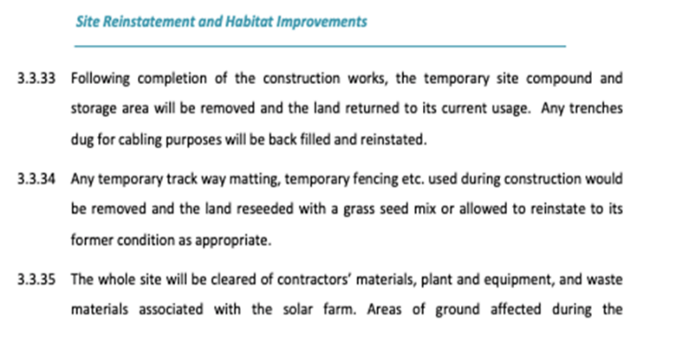
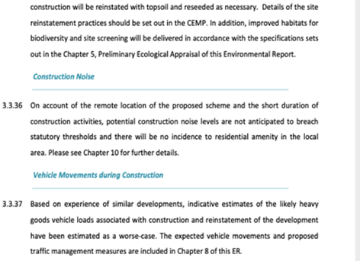
(Dulas Ltd., 2019)
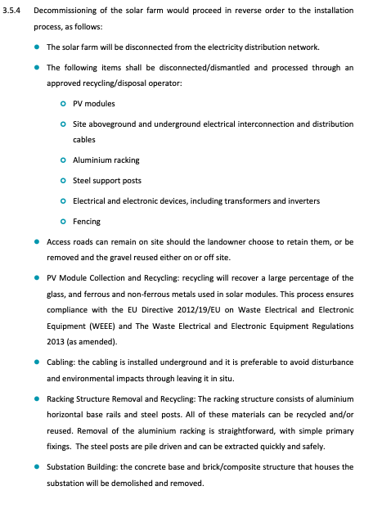
The reference made to the requirement of a Construction Environmental Management Plan (CEMP) presents a commitment to mitigating environmental impacts throughout the construction phase of the project. Following the construction, plans to reinstate the site back to its natural state through reseeding and refilling of ditches illustrates intentions to consider mitigation, even in response to arguably low risk environmental impacts. Estimations of expected heavy goods vehicle loads in a worse-case scenario represents a positive consideration of the precautionary principle in the planning of the project (Josimović, et al., 2021).

On the opposite end of the project life cycle, consideration for decommissioning and the environmental impact of the solar farm after the cells have surpassed their usable life has also been demonstrated in the report. Whilst PV cells typically have a life of around 30 years, they contain numerous recyclable materials such as glass, semiconductor material, steel, aluminium and copper. When the solar plant reaches the end of its operational life, these component parts can be dismantled and recycled. Reference is made to the Waste Electrical & Electronic Equipment (WEEE) EU Directive, illustrating a considered approach to the life cycle environmental impact of the scheme;

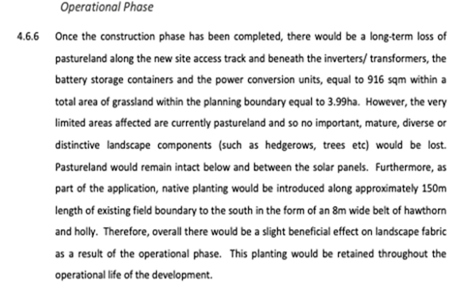
4.2 Landscape & Visual Impact
A summary of the landscape and visual impacts and their determined magnitude are clearly presented in a table within the report. Due to the location and nature of the project the visual and environmental impact on the landscape itself was determined to be relatively minimal. This section of the assessment also utilised Natural Resources Wales landscape character area (LCA) maps in order to determine the types of landscape found at the proposed site and the potential impacts of the project on them. Discussion around significant landscapes surrounding the proposed site was also presented, showing that the surveyor has considered the potential impact not only of the site in question, but of surrounding areas.

Table 3: (Dulas Ltd., 2019)
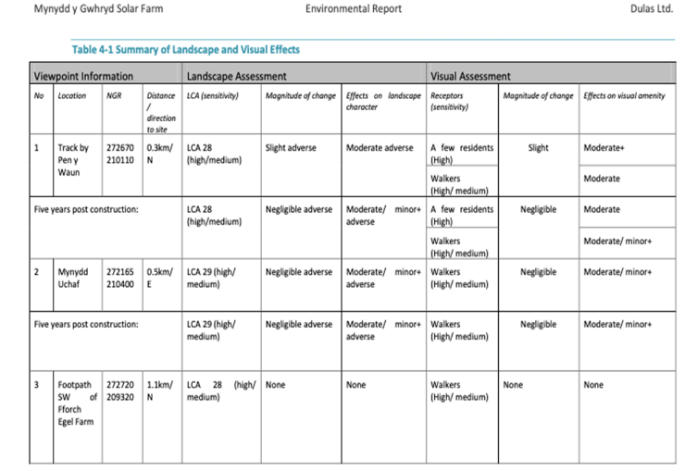

4.3 Phase 1 Habitat Survey
A desk study was completed in order to compile background information on the site and its immediate surroundings. As suggested previously in this report, this can be considered good practise in environmental assessments as this can save resources on completing unnecessary field studies whilst utilising expert knowledge relating to the area in question. All habitats present on the site were searched for signs of faunal activity to determine any presence of badger setts, mammal tracks, bat roosts, herpetofauna basking and any water bodies suitable for amphibians. South East Wales Biodiversity Record Centre (SEWBReC) information relating to protected species and sites of statutory designation were used in order to plan for any mitigations required in relation to preservation of biodiversity. SEWBReC identified a local Site of Interest for Nature Conservation (SINC) within a 1km radius of the site known as Tiroedd Comin Cwm Amman Uchaf. SEWBReC also returned a record of 44 protected and priority species in the area, the majority being birds such as Lesser Redpoll, Skylark, Golden Plover, Cuckoo, Linnet, Dunnock and Song Thrush with one record for Common Lizard 500+ meters from the site. There were 6 records of species of local conservation concern, the nearest being 160m from the site, all of which were bryophytes except for one vascular plant. Survey information on UK protected species should be provided, prior to the determination of a planning application, although there may be certain circumstances where some surveys may be undertaken as a condition of a planning approval. For any European Protected Species, however, sufficient information must be provided before the application is determined.
European Protected Species include (EPS):

- Bats (all species)
- Dormice
- Great Crested Newts
- Otters
- Shore Dock
- Fen Orchid

When completing species surveys an important aspect to consider is the influence of seasonality, some species have optimum periods for surveying as outlined by the
Glamorgan Biodiversity Advisory Group & Gwent Biodiversity Action group:

Table 4: Optimum times for surveying species in Wales (Glamorgan Biodiversity Advisory Group; Gwent Biodiversity Action Group, 2010)
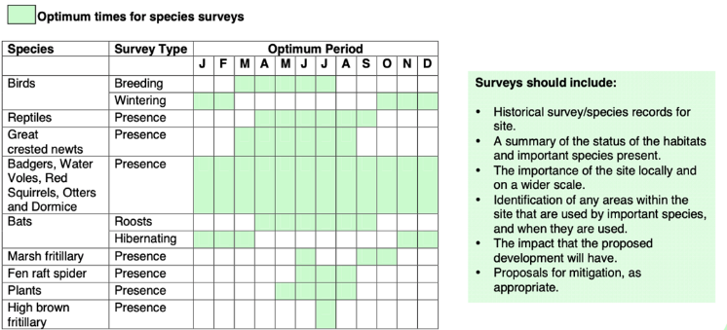
The results of the ecological survey suggest that no EPS are present at the site, however impact significance was assessed for the sites features using a 3 stage process consisting of an assessment of ecological value, magnitude of likely impacts and a determination of impact significance based on a combination of ecological value and magnitude of impact. The criteria for determining significance used the following table:
Table 5: Criteria for determining significance of impacts (Dulas Ltd., 2019).
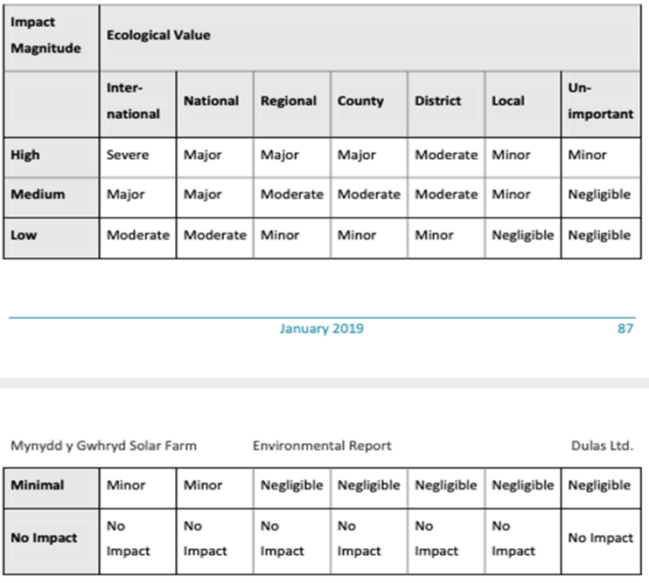
The determined impact significance on specific species was then assigned following a brief statement such as in the following examples:

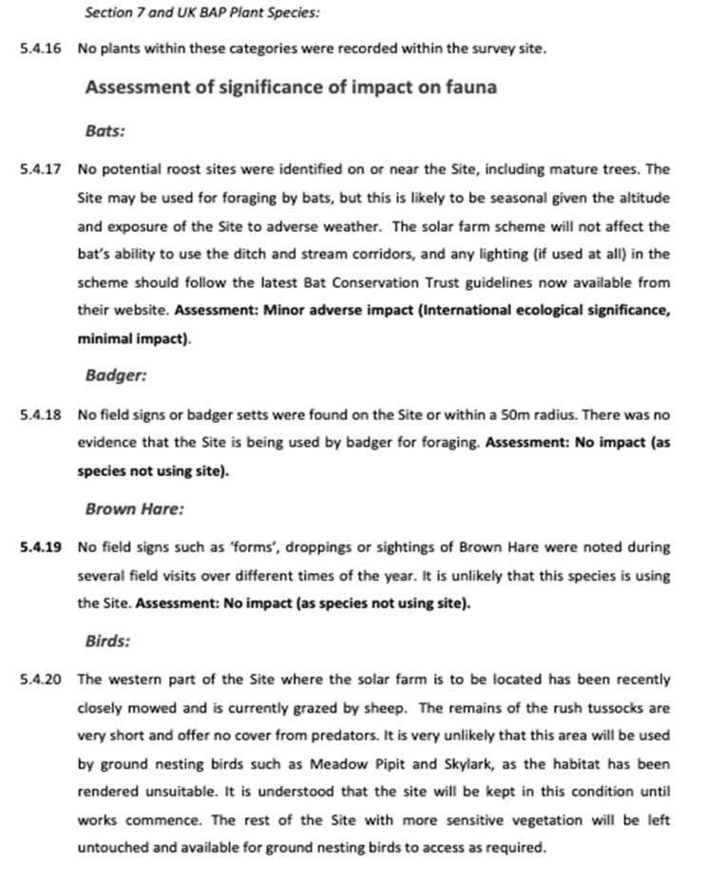(Dulas Ltd., 2019)
Within the impact significance assessment, consideration is made towards the potential of surface runoff at the site to enter the drainage system that feeds the hydrological cycle at Bury Inlet, a Site of Special Scientific Interest 17km to the south-west. Control and regulation of potential spillages of hazardous waste and/or sediment runoff during any construction phase is suggested in order to mitigate the risk of adverse impacts. This is an example of good practise as the assessment is considering the potential impacts on the wider locality, and acknowledgment of the interdependencies of different areas in regards to natural processes such as water runoff. The impact determination is clearly presented and justified and practical solutions for mitigation are presented. However, there are some weaknesses within the methodology of the impact determination of this site as potential impacts are not presented in order of significance and the consideration of seasonality within the habitat survey is not clearly presented. As the habitat survey is collected from a respected third party as part of the desk study, it is likely that seasonality was considered within the survey of EPS, however, this is not clearly demonstrated within the report itself. However, despite the determination of the project having a relatively low impact on flora and fauna, some precautionary mitigation measures including all construction works taking place when amphibians and reptiles are active i.e. April to September rather than in the hibernation period and all lighting fixtures following the latest Bat Conservation Trust guidelines located on their website are commendable efforts to mitigate environmental impacts.
5. Conclusion
The EIA in question contains multiple examples of good practise in assessing potential impacts and presenting practical mitigation solutions. The potential impacts on flora and fauna are investigated in detail utilising appropriate historical data from the desk study and flood risks are considered using a Digital Terrain Model (DTM). This approach also demonstrated clear consideration on the impact on surrounding sites of ecological importance within the habitat survey. The report presented a variety of potential impacts and mitigation measures throughout the construction, operation and eventual decommission of the solar farm. The mitigation measures presented also followed the hierarchy of mitigation measures as the measures suggested aim to avoid environmental impact where possible. Some fundamental processes that are indicative of a high quality EIA as suggested in the academic literature were not present however. The EIA did not demonstrate consideration of seasonality in the habitat survey, there was no accreditation from an independent body such as IEMA, and no public participation such as surveys or meetings were discussed (Roque De Oliveira & Partidario, 2020). Considering these findings, determining the quality of
the Mynydd Y Gwhyrd Solar Farm EIA is a discussion that is subjective. Using some of the key principles demonstrated in academic literature can be used as a basis to judge the quality of an EIA, however, as illustrated by the example used in this report, each EIA must be considered on an individual basis due to the variability in development proposals. By judging the example used in this report by the standards discussed previously, this may present as an EIA of limited detail. However, when the relatively low environmental risk posed by the project is put into context, the efforts of the assessors can be regarded as sufficiently considered and detailed in approach.

6.References
East Hampshire District Council and South Downs National Park Authority, 2012. A quick guide to the Habitats Regulations Assessment. [Online]
Available at: https://cdn.easthants.gov.uk/public/documents/HRA%20guidance.pdf
[Accessed 31 March 2021].
Arlidge, W. N. S. et al., 2018. A Global Mitigation Hierarchy for Nature Conservation. Bioscience, 68(5), pp. 336-347.
Arts, J. et al., 2012. The Effectiveness of EIA as an Instrument for Environmental Governance: Reflecting on 25 Years of EIA Practice in the Netherlands and the UK. Journal of Environmental Assessment Policy and Management, 14(1), p. 1250025.
Babu, S., 2016. Mitigation Hierarchy: Levels of mitigation in Environmental Impact Assessment. [Online]
Available at: https://eco-intelligent.com/2016/12/11/levels-of-mitigation-in-environmental-impact-assessment/
[Accessed 24 March 2021].
Barrow, C. J., 1999. Environmental management principles and practice. London : Routledge .
Beanlands, G. E. & Duinker, P. N., 1983. An Ecological Framework for Environmental Impact Assessment in Canada , Dalhousie: Institute for Resource and Environmental Studies Dalhousie University, Federal Environmental Assessment Review Office.
Bond, A., Fischer, T. B. & Fothergill, J., 2017. Progressing quality control in environmental impact assessment beyond legislative compliance: An evaluation of the IEMA EIA Quality Mark certification scheme. Environmental Impact Assessment Review, 63(1), pp. 160-171.
Boughton, D. A., Smith, E. R. & O'neill, R. V., 1999. Regional Vulnerability: A Conceptual Framework. Ecosystem Loss, 5(4), pp. 312-322.
Cashmore, M. & Richardson, T., 2013. Power and environmental assessment: Introduction to the special issue. Environmental Impact Assessment Review, 39(1), pp. 1-4.
Claassen, M., 1999. Ecological risk assessment as a framework for environmental impact assessments. Water science and technology, 39(10), pp. 151-154.
Duarte, C. G. & Sánchez, L. E., 2020. Addressing significant impacts coherently in environmental impact statements. Environmental Impact Assessment Review, 82(1), p. 106373.
Dulas Ltd., 2019. Mynydd y Gwhryd Solar Farm Environmental Report, Machynlleth : Dulas Ltd..
Dulas Renewable Energy, 2018. Site Location. [Online]
Available at: http://awel.coop/wp-content/uploads/2018/11/E05419-DWP-Figure-1-1-Site-Location-v1.pdf
[Accessed 31 March 2021].
Ehrlich, A. & Ross, W., 2015. The significance spectrum and EIA significance determinations. Impact Assessment & Project Appraisal, 33(2), pp. 87-97.
Glamorgan Biodiversity Advisory Group; Gwent Biodiversity Action Group, 2010. Quick Reference Guide for Planning Officers. [Online]
Available at: https://www.merthyr.gov.uk/media/1244/think-wildlife-think-protected-species.pdf
[Accessed 1 April 2021].
Hanover Conservancy, 2020. Hanover Conservancy Annual Meeting featuring Prof. Rich Howarth. [Online]
Available at: https://www.hanoverconservancy.org/event/environment-society-hanover-conservancy-annual-meeting/
[Accessed 25 March 2021].
Jacob, C., Pioch, S. & Thorin, S., 2016. The effectiveness of the mitigation hierarchy in environmental impact studies on marine ecosystems: A case study in France. Environmental impact assessment review, 60(1), pp. 83-98.
Jha-Thakur, U. & Fischer, T. B., 2016. 25years of the UK EIA System: Strengths, weaknesses, opportunities and threats. Environmental Impact Assessment Review, 61(1), pp. 19-26.
Josimović, B., Cvjetić, A. & Furundžić, D., 2021. Strategic Environmental Assessment and the precautionary principle in the spatial planning of wind farms. Renewable & sustainable energy reviews, Volume 136.
Lawrence, D. P., 2007. Impact significance determination—Back to basics. Environmental impact assessment review,, 27(8), pp. 755-769.
Maron, M. et al., 2015. Conservation: Stop misuse of biodiversity offsets. Nature, 523(7561), pp. 401-403.
Ministry of Housing; Communties and Local Government, 2019. Guidance on the use of Habitats Regulations Assessment. [Online]
Available at: https://www.gov.uk/guidance/appropriate-assessment
[Accessed 31 March 2021].
Morris, P. & Therivel, R., 2009. Methods of environmental impact assessment. 3rd Edition ed. London: Routledge .
Perdicoulis, A. & Glasson, J., 2009. The causality premise of EIA in practice. Impact Assessment & Project Appraisal, 27(3), pp. 247-250.
Quivy, R. & Van Campenhoudt, L., 2008. Manual de Investigação em Ciências Sociais. 5th ed. s.l.:Lisboa Gradiva.
Roque De Oliveira, A. & Partidario, M., 2020. You see what I mean? – A review of visual tools for inclusive public participation in EIA decision-making
Environmental Impact Assessment and The Penderi Solar Park
Laura Davies
University of Wales Trinity Saint David, MSc Environmental Conservation and Management

ABSTRACT
Solar energy generation in the form of photovoltaic (PV) installations is the one of the fastest expanding energy technologies globally. There are significant environmental impacts from the development of large-scale PV developments. This research evaluates the EIA process applied to the Penderi Solar Farm and analyses the extent to which the Development of National Significance (DNS) process within Wales assesses and mitigates for these impacts. The study found comprehensive scoping and consultation led to design improvements and mitigation through management plans but the process prioritised visual impact above addressing cumulative effects on habitats and species.

1.Introduction
The Paris Agreement has set an ambitious target of limiting global warming below 2⁰C, preferably to 1.5⁰C (United Nations, 2015). The energy sector has an essential contribution to make in the achievement of net-zero greenhouse gas (GHG) emissions. As requested by the COP26 Presidency, on 18th May 2021 the International Energy Agency (IEA) will publish its road map for the energy sector to reach net-zero GHG emissions by 2050, ahead of the Glasgow hosted COP26 in November 2021 (IEA, 2021). The IEA is anticipating that to meet this target, investment in renewables will need to rise from $370bn to more than $1.6 trillion per year by 2030 (Birol, 2021).
Solar energy generation in the form of photovoltaic (PV) installations is the one of the fastest expanding energy technologies globally and accounts for over 50% of the green energy market (REN21, 2020). The Climate Change Act 2008 committed the UK to GHG emissions reduction of 34% by 2020 from 1990 levels and the resulting UK Renewable Energy Roadmap proposed 20 GW of PV could be installed by 2020 (UK Government, 2011). By the end of December 2020, the UK has the solar generational capacity of approximately 13.5GW (Figure 1), 44% of that coming from large scale installations of greater than 5MW capacity (UK Government, 2021), however according

to the Solar Trade Association, there are currently a further 13GW worth of projects at various stages in the planning process (Solar Energy UK, 2021).

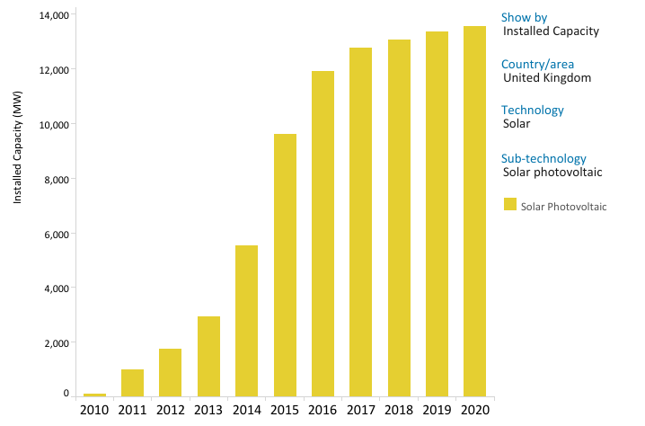
Figure 1: Installed Capacity Trends (IRENA, 2021)

Analysis by the UK Department for Business, Energy and Industrial Strategy calculates that between 2025-2040, solar parks will provide the cheapest electricity ahead of offshore or onshore wind, gas, and nuclear (BEIS, 2020). In September 2017, Cabinet Secretary for the Environment, Lesley Griffiths, announced new energy generation targets to continue carbon reduction efforts and for the benefits to be shared within Wales. The targets included Wales generating 70% of its electricity consumption by 2030; 1 Gigawatt of renewable energy capacity to be locally owned by 2030 and all new renewable energy projects to have an element of local ownership (Welsh Government, 2017).
The case for a massive expansion in this cheap, low maintenance and clean energy seems overwhelming, however there are drawbacks to large scale PV installations; most obviously the significant use of land, estimated at 2 hectares per MW of capacity (NFU, 2013); the visual impact of the installation; and the potential loss of or impact on agricultural land or habitats. This report will evaluate the current process by which planning authorities use Environmental Impact Assessments (EIAs) to balance the need for large new energy generation schemes against the effects on communities and biodiversity using the proposed Penderi Solar Farm as a case study.

2. Literature Review of the EIA
2.1. Legal Framework

Although the first European Union directive on EIAs was enacted in 1985, EIA Directive (85/337/EEC), it has been amended several times since to increase the types of projects covered, establish minimum information requirements, and improve public participation. The current EIA Directive (2014/52/EU) includes amendments to introduce timeframes for the different stages of the process, simplify the screening process, make the EIA reports more understandable to the layperson, increase the transparency of decision-making and ensure the monitoring of mitigation measures (European Commission, 2014).
In Wales, this most recent EU directive was implemented via the Town and Country Planning (Environmental Impact Assessment) (Wales) Regulations 2017. Although, the directive also required member states to set up an easily accessible portal for registering all EIAs (Jha-Thakur and Fischer, 2016) there is no evidence that this is yet up and running in Wales.
An EIA is required for projects likely to have significant environmental effects on account of their scale, type or location (Orford and Henderson, 2017) and is compulsory for all Schedule 1 and some Schedule 2 developments (dependent on scale) as listed in the 2017 Regulations.

2.1.1 Habitat Regulations Assessment (HRA)

The status of protected/conservation areas within the planning process are further enhanced by EU Nature Directive 92/43/EEC (the Habitats Directive) transposed into UK legislation by the Conservation of Habitats and Species Regulations 2017 and the Conservation of Marine Habitats and Species Regulations 2017 (the Habitat Regulations), included within this are Sites of Community Importance (SCIs), Special Areas of Conservation (SACs), candidate SACs, Special Protection Areas (SPAs) and also Ramsar wetland sites, possible SACs (pSACs) and potential SPAs (pSPAs), commonly known as Natura 2000 or European sites (Davies and Dodds, 2017). Habitat Regulations Assessments (HRAs) are carried out to minimise or avoid a proposed development having an impact on one of these sites. The developer provides the ‘competent authority’ (usually the local authority) with sufficient information to firstly determine whether a HRA is required and then to make an ‘appropriate assessment’ (AA) (Planning Inspectorate, 2017). During the assessment process the ‘statutory nature conservation body (SNCB)’, in Wales, Natural Resources Wales (NRW), must be consulted (The Planning Inspectorate, 2019). According to 2017 Habitat Regulations 63 (5-6) only projects that have been assessed as not having an adverse impact on a Natura 2000 site can be approved. However, under certain circumstances, a derogation, (Article 6(4)) in the Habitats Directive, allows a development to still be approved even if it affects a Natura 2000 site for reasons of over-riding public interest, no feasible alternatives, etc. In this case, the responsibility for the final decision rests with Welsh Government Ministers.

2.1.2 Development of National Significance (DNS)

In 2015, the Planning (Wales) Act 2015 created a new category of project known as Developments of National Significance (DNS). These include large infrastructure projects of national importance such as power stations, airports, etc. The consent for projects that qualify as DNS are considered by the Planning Inspectorate (PI) rather than the local planning authority (LPA). The PI writes to the Welsh Minister, responsible for the final decision, recommending planning permission be granted or not. The process is prescriptive with time limits for each stage which gives a certainty to the timescale for both the developer, stakeholders and residents. The DNS thresholds were
extended in 2019 to include all energy generation developments between 10MW and
350 MW of capacity (The Planning Inspectorate, 2019), as a result, the Penderi Solar Farm, at up to 38 MW capacity, qualified as a DNS and the planning application went through the Planning Inspectorate. DNS application differ from a standard EIA in that there is an extensive pre-application consultation period as shown in Figure 2. This is submitted as a Consultation Report with the DNS application. This “front-loading” enables issues to be raised and resolved before the application is submitted (Warren-Thomas and Henderson, 2016).

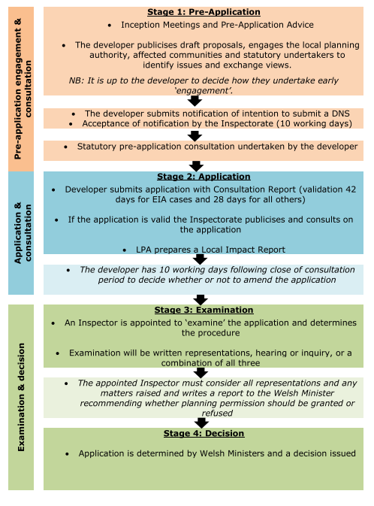
Figure 2: Developments of National Significance (DNS) (Planning Inspectorate 2019; p.5)

2.2 How the EIA operates in practice.

The Environmental Impact Assessment (EIA) is the process by which a planning authority considers the potential positive and negative environmental impacts of a proposed development. In addition to being an aid to decision-making for planners, according to (Glasson and Therivel, 2019), the EIA is also an opportunity for engagement with stakeholders, an aid to the development of project actions and a framework for sustainable development. Since their inception, EIAs have been viewed as a policy tool that, by identifying and mitigating environmental threats and impacts in proposed developments, can enhance environmental protection, particularly of protected areas (Alberts et al., 2021), despite being regarded by critics as an expensive and time-consuming burden for businesses (Morrison-Saunders et al., 2015). The EIA process is vulnerable in times of economic downturn and can be a scapegoat for a lack of investment (Enríquez-de-Salamanca, 2021). Government guidance describes the purpose of the EIA as to ensuring that the planning authority knows the full extent of the likely significant impacts of a project on the environment and to take these into account, but that EIA should not be a barrier to growth (UK Government, 2020). Some of the criticisms of the EIA process are that it is inherently a political system and contains value judgements that are not always based on good quality data simply because of time constraints (Glasson and Therivel, 2019). (Enríquez-de-Salamanca, 2021) suggests that the system can be particularly weak when the developer is a government agency or department (compared to a private company) and when there is political pressure on the EIA agency from within the same government or politicians to approve a project and is concerned that the EIA can be used as a political tool to justify projects. As the world attempts to economically recover from the COVID_19 pandemic, there is a chance than even greater pressure will be placed on EIAs to support development ahead of environmental impacts (Enríquez-de-Salamanca, 2021). The EIA is not about whether a project is required but whether there is an alternative location or approach; can it be made more sustainable; and can the worst impacts be mitigated against? It provides the decision maker with a level of discretion during the decision process (Retief et al., 2020). Ultimately, the EIA is a decision-support tool, not the decision maker.

2.3 The EIA Framework

It is the responsibility of the developer to complete the EIA process, as shown in Figure 3, the results of which are submitted to the planning authority with the planning application in the form of an Environmental Statement (ES).

2.3.1 Screening and Scoping

Screening is the process by which the planning authority determines whether a proposed development needs an EIA. If an EIA is required, the developer can request from the planning authority formal direction of what needs to be included in the
EIA (known as scoping). (Banhalmi-Zakar et al., 2018) highlights inadequate scoping as a cause of impact assessments that are too lengthy, lacking focus and do not address the key issues. The preparation of a scoping report should involve all stakeholders and highlight the resources or concerns, such as, the ecological data that needs to be collected and assessed, for a decision on the development to be made (Canter and Ross, 2014). The required contents of the scoping report are listed in Regulation 33 of the 2017 Regulations, scoping reports submitted to the planning inspectorate result in a formal scoping direction document, for which the inspectorate consults with such statutory bodies as the LPA, NRW, CADW, etc. (Planning Inspectorate, 2019) Effective and focused scoping can also save the developer time and money by avoiding unnecessary impact assessment of less relevant issues (Morrison-Saunders et al., 2015).

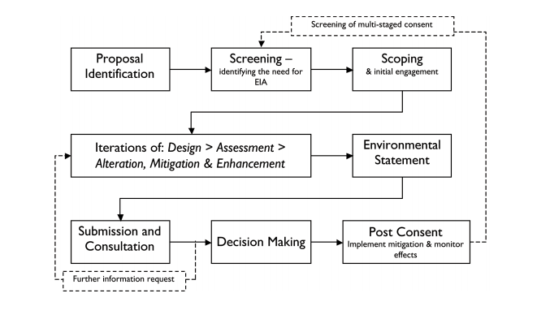
Figure 3: The EIA Process (IEMA, 2011; p.20)

2.3.2 Consultation

There are two types of consultation within the planning process, the pre-application engagement during scoping and the formal consultation period. Unlike onshore wind, there is no obligation for solar project developers to consult the public prior to submitting a planning application during a typical planning process, however, the solar industry bodies highly recommend it (BRE, 2015). Their reasons include reducing opposition, identifying issues, local knowledge, meeting the expectations of local councils, building relationships with those who will potentially neighbours for over 25 years. It can be the periods of consultation during which designs can be refined and concerns answered through engagement with statutory bodies, NGOs and the public, that can really benefit a project. These are most at risk by those that want to streamline the process and reduce timeframes (Alberts et al., 2021).

2.3.3 Mitigation and Monitoring

(IEMA, 2011) identifies three types of mitigation; inputs during the EIA process which influence the design; practices during construction which reduce or avoid impacts; these might be stated in a separate Construction Environmental Management Plan (CEMP) and actions to be taken following consent and completion, e.g., measures to improve habitats; these will often be included in a Landscape & Ecological Management Plan (LEMP).
Monitoring the impacts of developments and compliance with conditions has arguably been the weak link in the EIA and there has been little research done on the follow-up of EIAs (Jones and Fischer, 2016) and it is often difficult to establish direct causes between a development and a resulting effect within a dynamic environment. Often once a project is completed, the team involved moves on; there is then a lack of knowledge accumulation as to whether mitigation measures are successful or not (Wood, 2000). Responses collated by (Jha-Thakur and Fischer, 2016) suggest that both EIA consultants and academics felt that more importance should be placed on the monitoring which was often weakened by changes in the project teams over time or by simply not being a priority for the developer post-construction, who may have passed responsibility for the project on to a client. Practitioners often focus on mitigation measures that can be completed during construction rather than measures that need managing over time which reduces the opportunity for monitoring (IEMA, 2011). There is a sense that as more businesses wish to highlight their green credentials, monitoring can be used as a way of demonstrating environmental progress but members of IEMA surveyed believe that legislation is the key to increasing emphasis on monitoring (IEMA, 2011). The most recent European EIA Directive (2014/52/EU) indeed obliges member states to monitor projects that have significant environmental impacts and their mitigation responses.

3. Environmental impacts of solar farms
A review by (Lovich and Ennen, 2011) highlights multiple effects on wildlife during the development and operation of solar farms, the loss and fragmentation of habitat; increase in invasive species; noise; mortality due to collisions; physical barriers to movement and therefore gene flow; impacts on the microclimate. There is also the impact on soil, such as
increased erosion following the removal of vegetation; soil-shading and sealing; impacts on soil carbon cycling and seedbanks (Agha et al., 2020; Delfanti et al., 2016). Depending on the species, solar farms can attract or deter and they can be imperceptible or mistaken for a habitat, such as a waterbody, causing death, injury or stranding (Kagan et al., 2014; Smith and Dwyer, 2016). Migratory birds seem to be disproportionately impacted by solar farms which highlights the potential impact of siting solar farms near to breeding or over-wintering sites (Walston et al., 2016). Studies also show that renewable energy facilities can have a negative impact on species diversity, richness and distribution within their boundaries with increased non-indigenous or invasive plants and less rare species (Agha et al., 2020).

The primary mitigation strategy to reduce impacts on wildlife population is using data to support the siting of developments and this decision making could be improved by ensuring suitable monitoring and data collection, both pre and post construction (Conkling et al., 2020). (Beck et al., 2012) suggested restricting solar farms to low-quality land, such as brownfield sites or near major roads and railway lines or degraded and contaminated land (Weinzettel et al., 2013). (Rehbein et al., 2020) estimates that so far 17.4% of large renewable energy farms (larger than 10 MW) have already been built in conservation areas and that this is set to expand to 42% when facilities in the pipeline are included. Different regions have developed models using GIS to identify suitable locations for solar sites using factors such as slope of the land, proximity to electrical connections and good access whilst avoiding protected areas, sites of species richness, historical landscapes, etc., (Palmer et al., 2019; Thomas et al., 2018) This can be an attempt to overcome the fact that energy and conservation policies and frameworks are often not integrated leading to conflicts (Kim et al., 2021). The Welsh Government is currently developing an Energy Atlas for Wales to identify the most suitable locations for siting both onshore wind and solar energy sites considering a range of constraints such as European protected sites, National Parks, urban areas, high quality agricultural land, etc (Ove Arup & Partners, 2019). The aim is to assist regional and cross-authority planning, the development of local development plans (LDPs) and the coordination of investment with the National Grid and local distribution network operators. This will also help with mitigation of the cumulative effect of the development of several small or medium sized solar farms within areas of agricultural or natural habitats that may have the same environmental impact, or even greater in terms of habitat fragmentation and visual impact, as the development of one very large solar farm which may face a more challenging approval process ((Kim et al., 2021).
Despite the scale of the expansion in solar farm development, there is limited understanding of the direct impacts on wildlife and changes to wildlife behaviour (Chock et al., 2020) with a surprisingly low number of studies. This suggests there is a lack of monitoring of sites following completion and little assessment of the effectiveness of mitigation strategies such as the design of the development. There are concerns that the relentless expansion without ongoing research into environmental impacts could lead the industry vulnerable to some of the legal and environmental problems that beset the early days of the wind industry (Bailey et al., 2014; Brown and Escobar, 2007)
(Semeraro et al., 2018) are much more positive about the potential of solar farms as green infrastructure that can create a conservation gain, particularly when built on previously intensively managed farmland. They suggest that actively managed solar farms can become a site of enhanced biodiversity by developing wild-flower meadows between panel arrays, creation of ponds and micro-habitats, imposing bans on pesticide use and becoming a source of pollinators for surrounding farmland. Their project in Italy demonstrated that solar farms could be used to introduce “phot-ecological gardens” with educational, recreational and economic, as well as environmental benefits as green infrastructure in urban areas. In the UK, (Montag et al., 2016) survey of 11 solar farms showed that wildlife-focused management regimes improve biodiversity compared to surrounding farmland. Where plant biodiversity is improved using species rich seed mixes when reseeding the site and conservation grazing regimes, there is an increase in insect biodiversity providing pollinators for surrounding farmland and that solar sites can be particularly important for birds of conservation concern. They suggest that there are few higher value crops (in this case, solar power) that a landowner can supply, earning a significant income whilst leaving most of the land available for biodiversity and habitat creation. Cleve Hill, what will be the UK’s biggest solar farm, providing 350MW from a 900-acre site, is due to start construction in 2021. Approved by the UK Minister for Business, Energy & Industrial Strategy against objections from conservation bodies (the site is surrounded on three sides by a Ramsar, a SPA and a SSSI); it has included or had to include a dedicated Habitat Management Area of 138 acres for lapwing
brent geese, golden plover and marsh harrier. The company are advertising an estimated net biodiversity uplift of 65% to mitigate against the environmental impact (Cleve Hill Solar Park, n.d.; Wright, 2021).

4. Review of the Penderi Solar Farm EIA
The Penderi Solar Farm development is located at Blaenhiraeth Farm, Llangennech, Llanelli, SA14 8PX. The development covers approximately 143.6 hectares (ha) in size, of which 79ha will be used for the siting of the arrays of photovoltaic panels and associated infrastructure.

4.1 Scoping

As the Penderi Solar Farm (PSF) is a DNS application, the developer summitted a scoping report to the Planning Inspectorate, including all the information require by the 2017 Regulations. Of the listed factors likely to be affected by the development, in their report PSF ‘scoped in’ biodiversity & nature; landscape & visual; human beings and ‘scoped out’ with justifications, agriculture; air quality; cultural heritage & archaeology; traffic & transport; hydrology & ground conditions. The resulting scoping direction, containing responses from statutory consultees, largely agreed with the scoping decisions, except for hydrology & ground conditions which were required to be ‘scoped in’ based on the hydrological link afforded by the Afon Morlais and Afon Dafen tributaries which directly links the development to European sites as shown by the location map (Appendix 1). The applicant was corrected in their assumption that there was only one European site affected (the Carmarthen Bay and Estuaries SAC) and was required to additionally reference European sites, the Burry Inlet SPA and Ramsar and the Burry Inlet and Loughor Estuary SSSI. Although PSF had proposed substantial buffer zones around the tributaries, including hydrology in the ES would enable pollution risks to be highlighted and mitigated against. The PI also suggested the applicant consider input into the ecology chapter from non-statutory consultees, reference the cumulative effects of this development together with others locally and requested several additional reports to be submitted with the application that although outside the scope of the ES (which should focus on significant effects) provide evidence to support the EIA or mitigation of the development. These included a Landscape and Ecological Management Plan (LEMP), Glint and Glare Assessment, Detailed Landscape Design Statement, Transport Statement and Construction Ecological Management Plan (CEMP).

This scoping exercise was thorough and detailed. It streamlines the ES to the specific information that the planning authority and statutory consultees require to assess the significance of the project’s environmental impacts whilst preventing unnecessary work. The PSF has clear guidance of what exactly what information they are expected to provide within the ES which is a benefit of this formal process of scoping direction but relies on well-funded and staffed public bodies who have a clear understanding of the potential impacts of different types of development and comprehensive knowledge of the sensitivities within their spatial area.

4.2 The Consultation Process

During the PSF application process there were several statutory and non-statutory consultation periods as shown in Table 1. The original non-statutory phase included consultation with the local community, Carmarthen County Council, including an EIA screening request prior to the project’s later capture within DNS legislation. Community consultation included meetings with affected community councils, leaflet drop to surrounding homes and businesses and two public presentations/exhibitions advertised in the local press, over 40 people attended the presentations which considering the location of the development is surrounded by farmland and isolated houses, suggests that a significant proportion of potentially affected residents took part or were aware of the development and had the opportunity to take part.

The Statutory Pre-application consultation met all the requirements of the Article 8 of The Developments of National Significance (Procedure) (Wales) Order 2016 (Appendix 2) and exceeded the minimum length of the consultation period by 9 days. All the relevant application documents were and still are available on the development’s website https://www.penderisolarfarm.co.uk/ with contact details.

As a result of the consultation phase and in response to feedback from both the public and consultees, the plan of the development went through several design iterations mainly to reduce the visual impact of the development from local roads, a public footpath, individual dwellings and to enhance biodiversity. These design refinements suggest that the consultation phase worked as it should with the
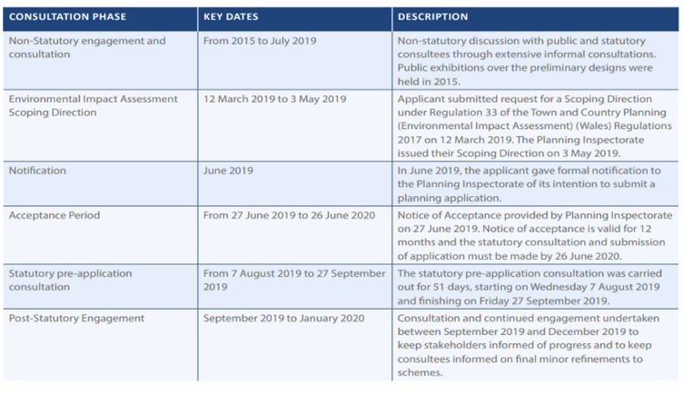
Table 1: Penderi Solar Farm consultation process (Voltalia Ltd, 2020a)

developer taking on board suggestions and criticisms. The process showed that solar farms in rural areas
tend to have a very significant visual impact on a small number of individuals who have the misfortune to have properties in a direct sight-line due to their position or elevation, unlike other developments for example, which may impact on air or noise quality and where the impact is potentially shared more evenly through a community. The concerns of these residents were taken seriously, demonstrated by responses by the LPA and resulted in additional research and reporting on the visual impact of the development later in the process.
4.3 Environmental Statement (ES)
The submitted ES contained the following chapters and a Non-Technical Summary: -
- Introduction
- Assessment Scope and Methodology
- The Development Site and its Environs
- The Development
- Climate Change, Energy, Planning Policy & Guidance
- Landscape and Visual
- Ecology and Nature Conservation
- Hydrology and Ground Conditions
The full contents listing detailing included plans, surveys, reports and management plans are included as Appendix 3.
This report will focus on chapters 6 & 7 which form the main assessments of the potential negative environmental impacts, the key environmental hydrological links to the European sites are covered within the Ecology chapter and with mitigation measures during construction addressed in the CEMP.

4.3.1 Landscape and Visual
There is minimal impact on the landscape elements because there will be no significant excavation or soil displacement at the site, field pattern and existing trees will remain in place and when the solar arrays are removed in 30 years’ time the physical landscape will be largely unaltered.
The solar arrays will have a significant impact on visual amenity of the landscape. There are several locations such as from a public footpath where the impact will be noticed and others where due to the undulating landscape the site will be hidden. The mitigation measures such as planting new sections of hedgerows and managing existing hedgerows to increased heights will go some way to disguising the site but these measures will take time to establish. The developer has also attempted to mitigate the visual impact by taking on board comments from consultees and the design of the site has changed several times with the removal of arrays from the prominent areas of the site and from proximity to a sensitive area of fen. Because of the particular impact on a number of residential properties and objections both formal and informal by residents, a Residential Visual Amenity Assessment was undertaken which further refined the design. The consideration of the visual impact on residents within the vicinity of the farm does not appear to be fully resolved and it will be ultimately a value judgement by the Inspectorate as to how the impacts on them are balanced against the viability of the development needed for cheap, clean energy.
It is within this chapter that the cumulative effects are discussed but only in relation to the visual amenity effects of further solar farms within the landscape not in relation to, for instance, the behavioural impact on bird species as discussed previously. This seems a very narrow interpretation of the term cumulative effects but is reflected in a recent report commissioned by Carmarthenshire County Council on Solar Farms (Anthony Jellard Associates LLP, 2019).

4.3.2 Ecology and Nature Conservation

The development’s appointed ecologists undertook a series of habitat, bird and species surveys as shown in Table 2, undertaken over a range of months within each season.
Table 2: Penderi Solar Farm Ecological Surveys (Voltalia Ltd, 2020b)
Date of Survey | Type of Survey
2014 - 20th October updated 26th April 2018 | Extended Phase 1 Habitat survey
2015 - 13th & 28th January, 3rd & 12th February  2017/18 - 28th November, 18th December, 16th January, 27th February | Wintering Birds survey
2018 13th & 28th January, 4th July | Dormouse survey
2015 – 16th & 24th April, 19th May, 5th June  2018 – 26th April, 9th May, 31st May, 4th July | Breeding Birds survey

Data was acquired from the West Wales Biodiversity Information Centre, including data on protected and red data book species, Species of Principle Importance, LBAP species and invasive species within 1 Km radius of the site. The surveys and data identified a number of ecological features of the site and assessed their importance. (Table 3).

The majority of significant impacts were anticipated to occur during the construction phase with some habitat loss and fragmentation due to the removal of some sections of hedgerows to allow access, disturbance and mortality due to construction activities; degradation of habitats due to pollution and dust from construction activities. It is expected that during the operational phase impacts will be minimal apart from uncertainty over the impact of the arrays on ground nesting birds. Following mitigation measures described in the Construction Ecological Management Plan and Landscape and Ecological Management Plan (LEMP), the ES concluded that adverse impacts of the development are largely non-significant and that from a baseline of relatively low existing ecological value the solar farm would actually enhance biodiversity on the site and in the surrounding area.

The Welsh Government advises planning authorities to look for biodiversity enhancement or net benefit within new developments (Welsh Assembly Government, 2009). The Penderi LEMP attempts to deliver this through mitigation and enhancement measures, for example, by creating new habitats through planting appropriate local native species within new and existing hedgerows and re-seeding of bare ground with appropriate wildflower mixes with species added to benefit moth Species of Principal Concern. The plan will also create habitats and shelters, by way of the installation of a variety of bird, dormouse and bat boxes, the creation of scrapes for snipe and hibernacula for invertebrates, reptiles and amphibians. The grasslands will be subject to conservation management with sheep grazing and late summer hay cuts with field margins managed as for rough tussocks and hedgerows will be managed on a three-year rotation to increase their height to 3m to increase biodiversity and provide visual screening of the solar arrays. The site will also be subject to a monitoring strategy with botanical surveys in June/July in years 1, 5, 10, 15 & 20, breeding and over-wintering bird surveys in years 2, 5 & 20 with inspections of bird, bat and dormouse boxes at each survey visit. Reports will be sent to the LPA following each visit and the LEMP will be reviewed annually by a steering group. Whilst this generic type of monitoring will assess changes in populations, it does not address, as neither does the EIA as a whole, the specific impacts of solar arrays on bird behaviour and mortality as discussed in Chapter 3 and its mitigation.

Due to the distances of the hydrological link from the development site to the European sites 5.1km and 10km and the resulting unlikelihood of sediment or pollution reaching that far before being deposited; the lack of disturbance at this distance; the lack of shared habitat type and resulting habitat fragmentation or degradation associated with the European sites; the Habitats Regulation Assessment Screening Matrix also concluded that there would be no significant effect.
The conclusion of the ecologists is in line with research from other solar farms, in that even moderate management of these sites for biodiversity quickly improves the ecological value of the site to above that of the surrounding conventionally managed land (Montag et al., 2016). The comprehensive monitoring planned will go some way

Table 3: Penderi Solar Farm Ecological Features
to addressing the concerns within the academic literature, as discussed previously, regarding the lack of knowledge accumulation of the success of mitigation measures within EIAs.

4.3.3 Community Benefits

Designated sites | Habitats | Species
Burry Inlet SPA and Ramsar | Hedgerow | Badger Meles
Burry Inlet and Loughor Estuary SSSI | Semi-improved grassland | Bat Chiroptera Spp.
Carmarthen Bay and Estuaries SAC | Fen | Dormice Muscardinus avellanarius
Rhos Cefn Bryn Wildife Trust Reserve | Streams/rivers | Otter Lutra
 | Woodland | Breeding birds – open habitat
 | Marshy grassland | Breeding birds – boundary habitat
 | Improved grassland | Wintering birds – open habitat
 | Wet ditches | Wintering birds – boundary habitats
 |  | Reptiles
 |  | Polecat Mustela putorius
 |  | Common toad Bufo
Key: Important ecological feature (included in further assessment and mitigation)
Not important ecological feature
Not important ecological feature (Included due to legal protection)
Community Benefit Arrangement (CBAs) describes the arrangement between a developer and host community as an attempt to rectify the disproportionate impact on local communities of particularly, energy developments which are deemed in the national interest (Glasson, 2017). The developer can provide new community infrastructure or financial support in recognition of the impact. Potential community benefits were mention briefly by Carmarthen County Council within the scoping document as something that PSF might consider but was not referenced within the application documents, including the economic benefit report. A CBA is now under discussion with the 3 affected community council prompted by Policy 17 of the Future Wales plan which states “Proposals should describe the net
benefits the scheme will bring in terms of social, economic, environmental and cultural improvements to local communities” (Welsh Government, 2020) . A sum of £100,000 over 10 years has been proposed but is felt by the county council to be insufficient and does not compare with the going rate of £5000 per MW per year for recent wind power projects or the £1000 per MW per year used as a minimum benchmark for solar farms in Dorset (Glasson, 2017)At the Dorset rate the communities local to PSF would be in line for benefits of £38,000 per year for reparations.

5. Conclusion
The Penderi Solar Farm EIA highlights some good practice within the EIA process and in theory the formal process surrounding scoping should ensure that all the relevant information is made available to the planning authority and that the decision-making process is concluded in a timely manner. However, this has not been the case and post application there have been delays due to the COVID19 pandemic, amendments to the original planning application, resulting in a further consultation period, a need to consider a new Welsh Government policy document (Welsh Government, 2020) and a series of hearings in March 2021 to address remaining areas of concern (Carmarthenshire County Council, 2021). The final decision is now due (April 2021). This extended process is either the EIA system working as it should with a resulting decision that can be trusted to have weighed up all the evidence available or it is a costly process that holds up much needed green energy projects, depending on which side of the fence you are viewing the project from.

6. References
Agha, M., Lovich, J.E., Ennen, J.R., Todd, B.D., 2020. Wind, sun, and wildlife: Do wind and solar energy development “short-circuit” conservation in the western United States? Environmental Research Letters 15, 075004. https://doi.org/10.1088/1748-9326/ab8846
Alberts, R.C., Retief, F.P., Cilliers, D.P., Roos, C., Hauptfleisch, M., 2021. Environmental impact assessment (EIA) effectiveness in protected areas. Impact Assessment and Project Appraisal
1–14. https://doi.org/10.1080/14615517.2021.1904377
Anthony Jellard Associates LLP, 2019. Carmarthenshire Solar PV Development: Landscape Sensitivity and Capacity Study. Carmarthenshire County Council.
Bailey, H., Brookes, K.L., Thompson, P.M., 2014. Assessing environmental impacts of offshore wind farms: Lessons learned and recommendations for the future. Aquatic Biosystems. https://doi.org/10.1186/2046-9063-10-8
Banhalmi-Zakar, Z., Gronow, C., Wilkinson, L., Jenkins, B., Pope, J., Squires, G., Witt, K., Williams, G., Womersley, J., 2018. Evolution or revolution: Where next for impact assessment? Impact Assessment and Project Appraisal 36, 506–515. https://doi.org/10.1080/14615517.2018.1516846
Beck, M., Bopp, G., Goetzberger, A., Obergfell, T., Reise, C., Schindele, S., 2012. Combining pv and food crops to agrophotovoltaic – Optimization of orientation and harvest. 27th European Photovoltaic Solar Energy Conference and Exhibition 4096–4100. https://doi.org/10.4229/27THEUPVSEC2012-5AV.2.25
BEIS, 2020. Electricity Energy Costs 2020.
Birol, F., 2021. IEA chief: Net zero by 2050 plan for energy sector is coming | Financial Times [WWW Document]. Financial Times. URL https://www.ft.com/content/6c5e29e1-283e-4df8-a402-ce09fcec3bda (accessed 4.12.21).
BRE, 2015. Community engagement good practice guidance for solar farms. BRE National Solar Centre. https://www.bre.co.uk/filelibrary/pdf/Brochures/BRE-NSC_Good-Practice-Guide.pdf
Brown, B., Escobar, B., 2007. Wind Power: Generating Electricity and Lawsuits. Energy Law Journal 28, 489.
Canter, L., Ross, B., 2014. A basic need for integration - bringing focus to the scoping process. Impact Assessment and Project Appraisal 32, 21–22. https://doi.org/10.1080/14615517.2013.872848
Carmarthenshire County Council, 2021. Response to Future Wales and Planning Policy Wales Edition 11. https://dns.planninginspectorate.gov.uk/wp-content/ipc/uploads/projects/DNS/3213164/DNS-3213164-000223-REP13%20Carmarthenshire%20CC%20PPW%20Future%20Wales%20Review.pdf Accessed 1/5/2021
Chock, R.Y., Clucas, B., Peterson, E.K., Blackwell, B.F., Blumstein, D.T., Church, K., Fernández‐Juricic, E., Francescoli, G., Greggor, A.L., Kemp, P., Pinho, G.M., Sanzenbacher, P.M., Schulte, B.A., Toni, P., 2020. Evaluating potential effects of solar power facilities on wildlife from an animal behavior perspective. Conservation Science and Practice. https://doi.org/10.1111/csp2.319
Cleve Hill Solar Park, n.d. https://www.clevehillsolar.com Accessed 12/4/2021.
Conkling, T.J., Loss, S.R., Diffendorfer, J.E., Duerr, A.E., Katzner, T.E., 2020. Limitations, lack of standardization, and recommended best practices in studies of renewable energy effects on birds and bats. Conservation Biology. https://doi.org/10.1111/cobi.13457
Davies, H., Dodds, W., 2017. The Planning Series: 16-Habitats Regulations Assessment National Assembly for Wales Research Service.
Delfanti, L., Colantoni, A., Recanatesi, F., Bencardino, M., Sateriano, A., Zambon, I., Salvati, L., 2016. Solar plants, environmental degradation and local socioeconomic contexts: A case study in a Mediterranean country. Environmental Impact Assessment Review. https://doi.org/10.1016/j.eiar.2016.07.003
Enríquez-de-Salamanca, Á., 2021. Project justification and EIA: Anything goes? Environmental Impact Assessment Review 87. https://doi.org/10.1016/j.eiar.2020.106540
European Commission, 2014. Review of the Environmental Impact Assessment (EIA) Directive Environment [WWW Document]. European Commission. URL https://ec.europa.eu/environment/eia/review.htm (accessed 4.7.21).
Glasson, J., 2017. Large Energy Projects and Community Benefits Agreements - Some experience from the UK. Environmental Impact Assessment Review 65, 12–20. https://doi.org/10.1016/j.eiar.2017.03.009
Glasson, J., Therivel, R., 2019. Introduction to environmental impact assessment, Introduction to Environmental Impact Assessment. https://doi.org/10.4324/9780429470738
IEA, 2021. Energy and climate leaders from around the world pledge clean energy action at the IEA-COP26 Net Zero Summit - News - IEA [WWW Document]. International Energy Agency. URL https://www.iea.org/news/energy-and-climate-leaders-from-around-the-world-pledge-clean-energy-action-at-the-iea-cop26-net-zero-summit (accessed 4.12.21).
IEMA, 2011. The State of Environmental Impact Assessment Practice in the UK.
IRENA, 2021. Solar Data Energy - Installed Capacity Trends [WWW Document]. URL https://www.irena.org/solar (accessed 4.12.21).
Jha-Thakur, U., Fischer, T.B., 2016. 25 years of the UK EIA System: Strengths, weaknesses, opportunities and threats. Environmental Impact Assessment Review 61, 19–26. https://doi.org/10.1016/j.eiar.2016.06.005
Jones, R., Fischer, T.B., 2016. EIA Follow-Up in the UK-A 2015 Update. Journal of Environmental Assessment Policy and Management 18. https://doi.org/10.1142/S146433321650006X
Kagan, R.A., Viner, T.C., Trail, P.W., Espinoza, E.O., 2014. Avian Mortality at Solar Energy Facilities in Southern California: a Preliminary Analysis, Unpublished report to US National Fish and Wildlife Forensic Laboratory.
Kim, J.Y., Koide, D., Ishihama, F., Kadoya, T., Nishihiro, J., 2021. Current site planning of medium to large solar power systems accelerates the loss of the remaining semi-natural and agricultural habitats. Science of The Total Environment 779, 146475. https://doi.org/10.1016/j.scitotenv.2021.146475
Lovich, J.E., Ennen, J.R., 2011. Articles Wildlife Conservation and Solar Energy Development in the Desert Southwest, United States. BioScience 61. https://doi.org/10.1525/bio.2011.61.12.8
Montag, H., Parker, G., Clarkson, T., 2016. The Effects of Solar Farms on Local Biodiversity: A Comparative Sudy.
Morrison-Saunders, A., Bond, A., Pope, J., Retief, F., 2015. Demonstrating the benefits of impact assessment for proponents. Impact Assessment and Project Appraisal 33, 108–115. https://doi.org/10.1080/14615517.2014.981049
NFU, 2013. Solar photovoltaic electricity in agriculture-on your roofs and in your fields.
Orford, K., Henderson, E., 2017. The Planning Series: 10-Environmental Impact Assessment.
Ove Arup & Partners, 2019. Welsh Government Assessment of onshore wind and solar energy potential in Wales Stage 1 - Development of Priority Areas for Wind and Solar Energy.
Palmer, D., Gottschalg, R., Betts, T., 2019. The future scope of large-scale solar in the UK: Site suitability and target analysis. Renewable Energy 1136–1146. https://doi.org/10.1016/j.renene.2018.08.109
Planning Inspectorate, 2019. Developments of National Significance: Procedural Guidance. Cardiff.
Planning Inspectorate, 2017. Advice note 10: Habitats Regulations Assessment relevant to nationally significant infrastructure projects.
Rehbein, J.A., Watson, J.E.M., Lane, J.L., Sonter, L.J., Venter, O., Atkinson, S.C., Allan, J.R., 2020. Renewable energy development threatens many globally important biodiversity areas. Global Change Biology 26, 3040–3051. https://doi.org/10.1111/gcb.15067
REN21, 2020. Renewables 2020 Global Status Report. REN Secretariat 36.
Retief, F.P., Fischer, T.B., Alberts, R.C., Roos, C., Cilliers, D.P., 2020. An administrative justice perspective on improving EIA effectiveness. Impact Assessment and Project Appraisal. https://doi.org/10.1080/14615517.2019.1680042
Semeraro, T., Pomes, A., del Giudice, C., Negro, D., Aretano, R., 2018. Planning ground based utility scale solar energy as green infrastructure to enhance ecosystem services. Energy Policy 117, 218–227. https://doi.org/10.1016/j.enpol.2018.01.050
Smith, J.A., Dwyer, J.F., 2016. Avian interactions with renewable energy infrastructure: An update. Condor 118, 411–423. https://doi.org/10.1650/CONDOR-15-61.1
Solar Energy UK, 2021. A new dawn for UK solar. London.
The Planning Inspectorate, 2019. Developments of National Significance Procedural Guidance.
Thomas, K.A., Jarchow, C.J., Arundel, T.R., Jamwal, P., Borens, A., Drost, C.A., 2018. Landscape-scale wildlife species richness metrics to inform wind and solar energy facility siting: An Arizona case study. Energy Policy 116, 145–152. https://doi.org/10.1016/j.enpol.2018.01.052
UK Government, 2021. Solar photovoltaics deployment - GOV.UK [WWW Document]. URL https://www.gov.uk/government/statistics/solar-photovoltaics-deployment (accessed 4.12.21).
UK Government, 2020. Guidance: Environmental impact assessment [WWW Document]. UK Government website. https://doi.org/10.4324/9781315600789
UK Government, 2011. UK Renewable Energy Roadmap.
United Nations, 2015. Framework Convention on Climate Change (2015) Adoption of the Paris Agreement, in: 21st Conference of the Parties, Paris. Paris.
Voltalia Ltd, 2020a. Consultation report.
Voltalia Ltd, 2020b. Penderi Solar Farm, EIA Chapter 7 Ecology and Nature.
Walston, L.J., Rollins, K.E., LaGory, K.E., Smith, K.P., Meyers, S.A., 2016. A preliminary assessment of avian mortality at utility-scale solar energy facilities in the United States. Renewable Energy
92, 405–414. https://doi.org/10.1016/j.renene.2016.02.041
Warren-Thomas, E., Henderson, E., 2016. The Planning Series: 14-Developments of National Significance.
Weinzettel, J., Hertwich, E.G., Peters, G.P., Steen-Olsen, K., Galli, A., 2013. Affluence drives the global displacement of land use. Global Environmental Change 23, 433–438. https://doi.org/10.1016/j.gloenvcha.2012.12.010
Welsh Assembly Government, 2009. Planning Policy Wales Technical Advice Note 5: NATURE CONSERVATION AND PLANNING. Cardiff.
Welsh Government, 2020. Future Wales - The National Plan 2040.
Welsh Government, 2017. Lesley Griffiths high on ambition for clean energy [WWW Document]. 28 september. URL https://gov.wales/lesley-griffiths-high-ambition-clean-energy (accessed 4.7.21).
Wood, G., 2000. Is what you see what you get? Post-development auditing of methods used for predicting the zone of visual influence in EIA. Environmental Impact Assessment Review 20, 537–556. https://doi.org/10.1016/S0195-9255(00)00055-X
Wright, J., 2021. Construction at Cleve Hill Solar Park, between Faversham and Whitstable, set to begin this year [WWW Document]. Kent Online. URL https://www.kentonline.co.uk/faversham/news/construction-of-uks-biggest-solar-farm-to-begin-this-year-240598/ (accessed 4.8.21).

7.Appendeces

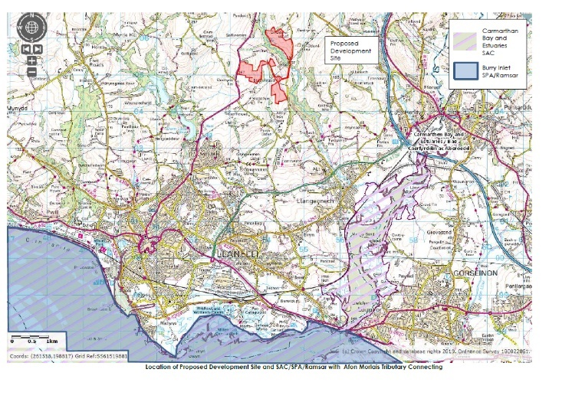
Appendix 1:Location of development and European sites

Appendix 2 : Article 8 of the Developments of National Significance (Procedure) (Wales) Order 2016

Publicity before applying for planning permission.

(1) The applicant must publicise the proposed application by—

(a)giving requisite notice—

(i)by site display in at least one place on or near the land to which the proposed application relates for not less than 42 days;

(ii)in writing to any owner or occupier of any land adjoining the land to which the proposed application relates: and

(iii)by publication of the notice in a newspaper circulating in the locality in which the land to which the proposed application relates is situated; and

(b)publishing the following information on a website maintained by the applicant, for not less than 42 days beginning with each day on which each of the notices referred to in subparagraph (a) or article 9(2) are given—

(i)the draft application form published by the Welsh Ministers under article 12(1)(a) (or a form substantially

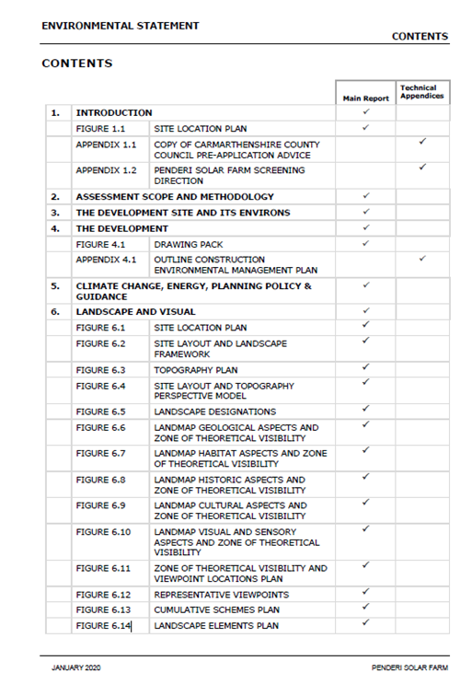
to the like effect), including the particulars specified in or referred to in the form;

(ii)a plan which identifies the land to which the proposed application relates;

(iii)any other plans, drawings and information necessary to describe the development which is the subject of the proposed application;

(iv)a copy of the notice required by article 6 which has not lapsed under paragraph (3) of that article;

(v)the design and access statement required by article 14;

(vi)subject to article 12(3), the particulars or evidence required by the Welsh Ministers under section 62(3) of the 1990 Act (applications for planning permission);

(vii)where applicable, a statement referred to as the environmental statement for the proposed development;

(viii)a written statement about any secondary consent connected with the proposed application in respect of which the applicant considers a decision on that consent is to be made or should be made by the Welsh Ministers, together with the draft application form and documents associated with such consents

(ix)in the case of development within regulation 3(1)(ab) of the Criteria Regulations, a written statement about the length of the proposed line and its nominal voltage.
Appendix 3. Environmental Statement Contents

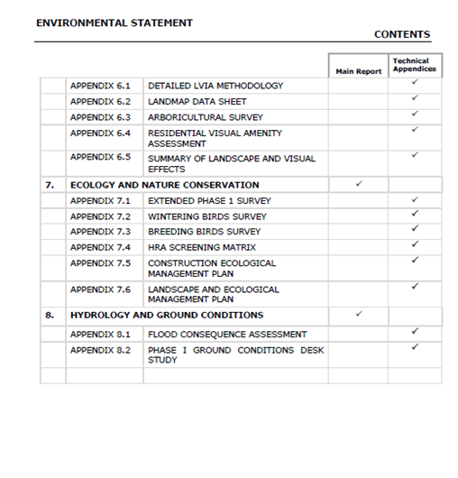

Newgale Road Relocation EIA Analysis
Trace King
University of Wales Trinity Saint David, MSc Sustainable Construction

ABSTRACT
Newgale beach is predicted to be encroaching on the existing road within the next 20 years. Atkins and Pembrokeshire County Council have developed proposals to mitigate this. This report analyses the depth of the report and highlights the issues that creating a new road would cause. The protection of residents, wildlife and the levels of CO2 that this new road would cause are potential causes for concern.

1.Introduction
The purpose of this report is to define an Environmental Impact Assessment (EIA) and to explain how they are used in conjunction with planning applications to local government bodies. In addition, it will be used to highlight when an EIA is required and the stages of the assessment process, both prior to and between planning applications. A case study will also be used to evaluate the EIA's overall effectiveness and to determine whether the EIA addressed all the potential environmental impacts associated with the project in question, as well as to critique the assessment and identify key areas for improvement. A comprehensive evaluation will then be conducted to determine whether the Environmental Impact Assessment was thorough and effective, or ineffective and lacking in required information. After evaluating the case study, recommendations will be made regarding the EIA and how it can be improved.
2.What is an Environmental Impact Assessment?
EIA is a comprehensive information gathering exercise carried out by the developer that allows a local planning authority to understand the environmental effects of a development before deciding whether the project can go ahead or not.

The emphasis on using the best available sources of objective information and for developers to compile information in a systematic, holistic, and robust manner is crucial to EIA. In theory, a well-researched and objective EIA submission should enable the entire community to fully comprehend the true impact of the proposed development.
An EIA should result in higher development standards and, in some cases, no development at all. EIA also aids in determining the effectiveness of mitigation measures proposed for a development and whether they will ensure that no significant impact occurs.
EIA should be a methodical process that results in a final written product, known as the Environmental Statement.
To ensure the validity of the EIA, they should be conducted over an extended period to observe seasonal animal migration habits, as short-term observational studies frequently produce skewed data and miss species occupation.
In the United Kingdom, EIA is mandated by the European Union's EIA Directive. The Town and Country Planning (Environmental Impact Assessment) Regulations 2017 in England implement the Directive. Wales, Scotland, and Northern Ireland all have similar
regulations. Official guidance on the interpretation of Regulations and the procedures for evaluating ESs is available online.
Separate legislation governs EIA for development not covered by town and country planning laws, such as highways, power plants, water resources, land drainage, forestry, pipelines, and harbour works. Several of these will be classified as nationally significant infrastructure projects, which the Planning Inspectorate will oversee on behalf of the Secretary of State under the 2008 Planning Act.
To determine whether an Environmental Impact Assessment is required, a project is classified into Schedule 1 or Schedule 2.
Schedule 1 developments or projects are generally those with the potential for the greatest environmental impact, coastal flood defenses, new roads, large industry, power generation. This scale of development always requires an EIA, and if one is not completed, the project will be automatically denied planning permission.
Schedule 2 developments do not always require an EIA; this is dependent on factors such as the size and location of the project. Wind farms, small industrial developments, golf courses, and larger housing proposals are all examples of Schedule 2 development. Other examples include vacation villages and other tourism-related items. If your development falls under Schedule 2, it is recommended that it be screened to determine whether an EIA is required. This would be handled by the local government.
2.1 Stages of EIA
The government specifies five stages that must be completed in order to complete an Environmental Impact Assessment.
2.1.1 Screening
Determining whether a proposed project falls within the scope of the Schedule 1 or 2 Regulations and whether it is likely to have a significant environmental impact, necessitating an assessment.
2.1.2 Scoping
Identifying the scope of issues that should be considered during the assessment and reported in the Environmental Statement. The applicant may request a scoping opinion from the local planning authority regarding the information that should be included (this is referred to as a 'scoping opinion').
The Town and Country Planning Regulations 2017 require that copies of an EIA scoping opinion for a project be made available for public inspection. This will enable members of the local community to voice their concerns about a development and to inspect the assessment conducted by the Local Authorities, as well as their final opinion on whether an EIA will be completed.
2.1.3 Environmental Statement Preparation
If an assessment is determined to be necessary, the applicant must prepare and submit an Environmental Statement. The Environmental Statement must include at a minimum the information reasonably necessary to assess the development's likely significant environmental effects and to comply with regulation 18(3). (4).
To ensure the Environmental Statement's completeness and quality, the developer must ensure that it is prepared by competent experts. The Environmental Statement must be accompanied by a statement from the developer describing the developer's expertise or qualifications in relation to the subject matter.
2.1.4 Consultation and submission of a Planning Application
The Environmental Statement (along with the development application to which it pertains) must be made available electronically and via public notice. The statutory ‘consultation bodies' and the general public must be consulted on the proposed development and the Environmental Statement. “The Environmental Statement must be placed on Part I of the planning register, as should any related screening or scoping opinion or direction as soon as possible after publication” (Gov.uk, 2020)
2.1.5 Decision Making
The Environmental Statement, along with any other relevant information and any comments or representations made on it, must be considered by the local planning authority and/or the Secretary of State when determining whether to grant consent for the development. The public must be notified
electronically and via public notice of the decision and the primary reasons for it.
2.2 Legislation of EIA (UK)
The Town and Country Planning Act of 1990, “An Act to consolidate certain enactments relating to town and country planning (excluding special controls in respect of buildings and areas of special architectural or historic interest and hazardous substances) with amendments to give effect to Law Commission recommendations,” is a significant law (Town and Country Planning Act, 1990). This Act establishes policies for development and land use changes in an area, considering the area's appearance, physicality, and environmental impact as a result. The Act establishes guidelines for local planning and granting permission to construct or develop projects of all types. Additional revisions have been made to this Act to ensure that the legislation is current and to provide a framework for new uses that may have an environmental impact. Although the Town and Country Planning Act 1990 contains a substantial amount of framework, the decision-making process is highly variable depending on the location, nature of the project, anticipated environmental impact, and opinion of stakeholders and the Local Authority, which can be significantly influenced by biased and personal opinions, and restrictions on construction in areas such as national parks.
The UK's regulations have been criticised for not fully interpreting the EIA Directive's spirit. Individual cases involving large-scale development proposals have sparked contentious debates about the quality of the EIA conducted. Third parties have also complained to the European Commission about the UK government's failure to fully implement the EU Directive on environmental impact assessment. Such issues are still being litigated in the courts.
The UK left EU on 31 January 2020. A transition period ended on 31 December 2020, during which the UK continued to be treated as an EU member state and subject to EU law. The EIA Directive has been transposed into UK law through the EIA Regulations, which will remain in force until they are revised.
2.3 EIA Case Study
Our case study in this report is one which EIA data is exceptionally important both to monitor current damages being caused to the area, residents, and wildlife, as well as the proposed development to alleviate the inconvenience of those effected by the current frequent storm and flood damages.
We will critique the EIA submitted to Pembrokeshire County Council for the development of a new road to bypass Newgale beach which will result in fewer road closures, and inconvenience to the residents. Several options were presented in order to provide the most suitable solution for an alternative to the current A487. (Atkins, 2017)
3.0 The Proposed Development
A route redirection removing through access at the point of Newgale village to mitigate future modelled issues with the loss of road along the beach front behind the shingle bank. A choice of proposals were presented for discussion from raising the current road height, to bolstering existing flood defences.
This will provide residents with an alternative route when the road floods, and a permanent road when the existing road is inundated by the forecasted sea level rise, high tides, and storm surges.
3.1 Why Is the Project Proposed
Inundation flood models are showing countries all over the world are going to lose many miles of coastline by the year 2050, the Paris Agreement 2015 has set carbon emissions targets to attempt to minimize the sea temperature increase, this could potentially slow the melting of the glaciers and the rising sea levels. If this is not addressed like many climate control agreements previously then the modelled data shows many areas in west Wales would cease to exist. (UNFCCC, 2015)
As one such low lying sea front village the road is currently protected by an inadequate shingle bank. This regularly gets toppled over, and in recent years this has become more regular occurrence with sea flood waters reaching further back into the nearby Brandy Brook River. Without considerable investment required to implement highly developed robust the flood defenses the most suitable method for the short term would be to reroute the existing road preventing on-going continued road closures which has the repercussion of creating excessive traffic on alternative routes. Many of these alternative routes are single track roads, unsuitable for traffic other than the agricultural vehicles that use them most.
The Residential area of Newgale is safely above sea level and rising on a hill to further higher altitudes,
however much of the local tourist activities and retail area are positioned squarely in the area which is most prone to flood damage from rising sea waters.
This proposal is a mediatory measure and with predicted sea level rises by 2050 it is entirely feasible that there may not be a viable beach front area unless action is taken to relocate all the road level service.
The shingle bank at Newgale, Pembrokeshire Coast National Park, protects the A487 and the village of Newgale from the sea. The shingle bank was overtopped and the A487 was flooded during the winter storms of 2013/14. Numerous times since that winter storm the shingle bank has been breached.
This results in road closures, and with sea levels predicted to rise, this type of event is expected to become more and more frequent and severe. When the road is closed, a 6.2-kilometer detour via single-lane rural roads through Roch and Penycwm is used. This route is incapable of carrying a high volume of traffic, necessitating the provision of a transportation solution.
3.2 Impact on Local Community
As a small immediate community, the loss of the main road to Haverfordwest could result in transport connection issues via bus services, reduced passing trade, logistics issues delivering goods to residents and retailors alike and as time passes those businesses will be left to the mercy of the sea without sufficient construction proposals to hold back the sea.
As a wider community of Newgale, Roch, Pen Y Cwm, St Davids, Solva improved roads would greatly benefit the local area, helping to prevent long detours, with less through traffic having to take the beach front road through Newgale noise and pollution levels would be significantly reduced vastly improving the quality of life for the residents.
The new road could also provide access to areas currently inaccessible and provide long term future areas for development of new towns and villages along its route.
3.3 Future Risks and Health Implications
The adjacent Brandy Brook River flows directly onto Newgale beach, future loss of the road, and failure to adequately address and maintain the failings of the current shingle bank may well result in relocation of the shale. The shale relocation could well cause a whole host of further problems and issues if it were to have a dam like effect upon the river. With the natural flow of the river being disturbed this may cause serious flooding issues further upriver, and dramatically expanding modelled flood plain and disturbing other villages and rural areas. Flooding can have the two-tier effect of overloading sewerage transport systems which can result in waste matter making its way into solid and potentially onto the beach, into the sea. This would create very unhealthy and unsanitary conditions, which would have a severe detrimental effect on the local tourism economy for which much of the area is reliant but may well also extend out to the houses in the area leaving residents without adequate sanitation.
The public house and surf shop directly adjacent to the road which have already suffered water damage on several occasions in the past are predicted to be completely under water at low tide by 2050 estimations of up to 8ft water level increase.
4.0 Evaluation of EIA
To critically evaluate the Environmental Impact Assessment, we will be comparing the report to the main issues highlighted in Section 3. We will also consider problems and solutions identified by the developer prior to the project's design.
We will discuss the strength and weaknesses of the depth of testing, and the accuracy of the produced results, providing recommendations for improvement, while developing a greater knowledge of the intricacies of EIA. It is critical to assess the threats, risks, sustainability, and social impact that a proposal of this scale will have on the local community, and to critique the developer's strategy for avoiding, eliminating, or mitigating negative impacts on the area, their plans for compensatory measures, as well as their methods for overcoming issues such as national park construction limitations. However, the definitions of strength, weakness, and effectiveness are subjective to the stakeholder, who may have divergent interests and opinions, values, or even morals. To evaluate an Environmental Impact Assessment, it is critical to maintain objectivity in order to make clear recommendations and conclusions.
By using critical analysis post submission, we improve our knowledge for future proposals and inform ourselves of missed opportunities to develop better proposals, better projects, and new ways to protect the countryside.
4.1 Strengths
This report is extremely in depth. At 160 pages from a brief skim read of the paper it appears to be well constructed, and aimed at providing clear, concise and complete knowledge of the proposals from the very beginning. It highlights its aims to help to contribute to the Well-Being Wales act 2015.
The EIA explains its requirement for public funds at the beginning of the report, and how using 2 appraisals would provide the most suitable list of possible proposal. When a project of this nature includes the use of public funds, full disclosure must be given; if not a project can be halted if details are found to being withheld at any point. The writer highlights the current ongoing issues faced by councils maintaining the Newgale road to an adequate and sufficient standard, which leads clearly into the reasoning for developing a proposal to best combat it. The report introduces the legislation, regulations and Welsh Transport Planning and Appraisal Guidance (WelTAG) as its guidance in a clear manner to ensure the reader can easily understand it and conduct their own research to clarify what it means.
By producing traffic forecasts for a range of difference scenarios they presented high levels of information from no change to minimum change to extensive change, as a forecast this is only an estimation but the level of their observations and testing areas shows they aim for the success of this project on a social, economic and environmental front.
The assessment also presents the masterplan strategy for Newgale, without going into further detail but it does give an idea that further works to protect the area may be put in place in the future.
It presents all the initial options as highlighted in the list below. To anyone not from the local area this would not make sense, but to residents who are used to using many of these routes when the beach is closed, they can easily visualize how the proposals would affect the area.
The Planning Stage Report recommended the following route alternatives for further consideration:
Option 2b: bolstering sea defenses.
Option 2c: putting the existing road on an embankment (either behind the shingle ridge or possibly as a defence).
Option 2d: putting the existing road on a bridge, viaduct, or culverted causeway.
Option 3b: building a bridge, viaduct, or culverted causeway behind the Duke of Edinburgh Inn.
Option 4: Newgale Farm to Wood Farm
Option 5: Southwood Farm to Newgale Farm
Option 7: partially on existing road and track: 'Penycwm – Llethr – (Site of) Brawdy Mill' – new road including Brandy Brook crossing.
Option 8: an embankment or viaduct further inland to connect to the existing A487.
Option 9: departing from Roch, skirting the marshy land, crossing Brandy Brook at its eastern terminus, and rejoining the A487 at Penycwm.
Option 11: Maintain existing route but upgrade Diversion Route (C3062-C3063-C3010) over time to accommodate increased traffic.

The proposals considered every possible method to cross Newgale seafront as well as routes much further back from the area. Which were then narrowed down by an environmentally based TPO.
‘TPO2 - To conserve and enhance the natural beauty, wildlife and cultural heritage of the Pembrokeshire Coast National Park avoiding, or at least minimising, adverse effects on the natural environment caused by traffic and associated infrastructure’.
Figure 1 shows the proposed alternative route the council has considered the most plausible course of action, over a variety of developments including a viaduct directly over the valley of Newgale.
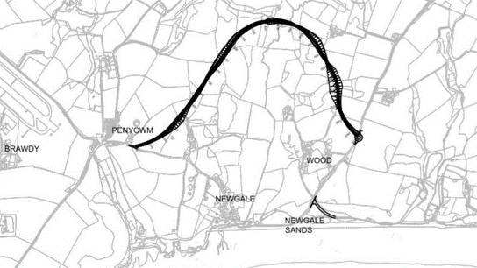
Figure 1 Proposed New Road (BBC, 2018)

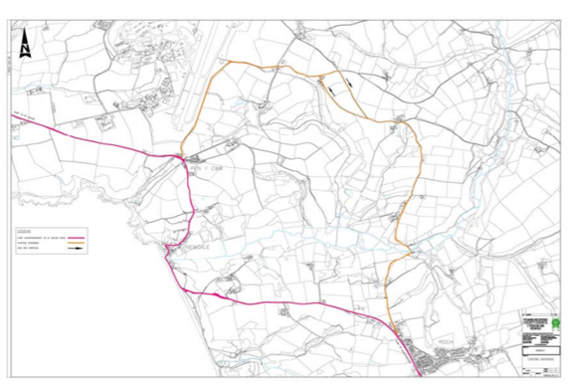
Figure 2 highlights the current diversion road that residents and commuters must take when the shingle is displaced over the road due to sea water tidal flood surges. The route itself is time consuming and drivers are often not made aware of diversions until they reach Newgale itself.
Figure 2 Current Road Diversion
4.1.1 Noise Levels
As with all road expansion projects there are some considerations to be made. First, there is the initial increase in noise as a direct result of road construction and then there is the everyday operational noise of having motor vehicle traffic in an area where there once was none in small towns and villages where houses front onto roads very closely some without the protection of even a pavement or planting. Increasing heavy freight traffic through areas like this I more than likely to cause high levels of noise disturbance, many of the existing roads in the area are single track roads and are often occupied by slow moving agricultural traffic.
Tables 1-3 highlight a range of data collected by Atkins to determine the most effective proposal with the least effect on the residents and wildlife through noise pollution. Increases in noise are a major contributing factor in resident refusal to accept new proposals, they may be willing to accept short term construction noise but increased noise pollution and vibration from traffic can be detrimental to the residents in the immediate area and may even be a cause of long-term health issues. With such highly detailed levels of transparency in the preliminary testing process residents can see how much impact the project will have on their lives going forward from start of construction, completion, and long-term use.

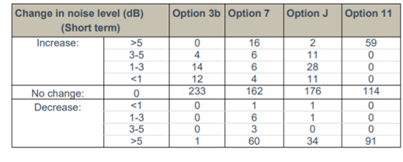
Table 1 Short Term Noise Change
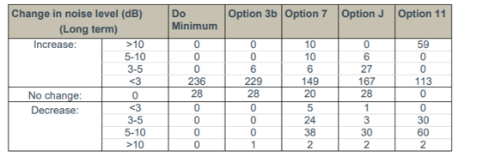
Table 2 Long Term Noise Change
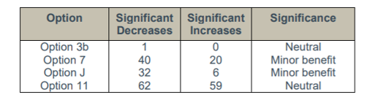
Table 3 Significant Changes to Areas

As the proposals were concentrated down to 4 the requirement for testing zones was also reduced, but enough data was collected to demonstrate to the residents, local authority, wildlife agencies that overall, the noise levels upon completion would be demonstrably neutral or beneficial.
The noise results indicate that Option 3b would produce the most similar noise climate to the current one. Options J and 7 have more noise benefits than drawbacks, and it is believed that the number of negative impacts associated with these options could be reduced using implementation of noise mitigation strategies. Option 11 has the most negative consequences and is the most difficult to mitigate.
The level of testing is sufficient; however, I believe using testing at all locations for all options would have given a far greater insight, resulting in possible further options for expansion in the area.
4.1.2. Air Quality
As an area of outstanding natural beauty and a much sought-after area for getting away into fresh air, clean air is a large part of the attraction to Newgale, Solva, St. Davids. Any new development cannot interfere with that too much or risk reducing the areas income as
incoming tourism plays a significant part in theses' areas local economy.
With carbon emissions currently at the forefront of much legislation and the driving force behind many construction projects, improving air quality is seen as a vital component to any new proposals. When that proposal involves increasing traffic through previously quiet towns, villages, and hamlets it is especially vital that as much is done as possible to mitigate any increased air pollution that comes from the increased number of motor vehicle through traffic. As the through traffic that will be diverted from Newgale will be largely commuters, tourists, and traffic that would be diverted should other roads be closed due to accidents which happen frequently on some roads in the area.
Each option had their vehicle emissions calculated using the DMRB21 method, detailed emission functions for various vehicle types and pollutants were used that were dependent on average traffic speed, road type, and composition (percentage heavy duty vehicles [HDV]). The proposed options and the surrounding local road network were assessed using traffic data. For the opening year, the data included annual average daily traffic (AADT) flows, average daily speed, and percentage HDV for four options (Option 3b, Option 7, Option 11, and Option J) (2022).
As shown in Table 4 enough data was recorded to formulate a substantial level change both positive and negative.
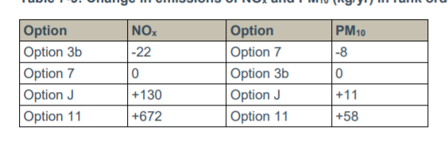
Table 4 Gas Emissions Changes for Each Option

Highlighting the increased air quality due to less traffic at the existing road would have been beneficial, and their chart is incorrectly formatted. Is this a mistake? It would appear so. This may have resulted in decisions being made incorrectly if it was not highlighted at consultation stage meetings.
4.1.3 Greenhouse Gas Emissions
The assessment was carried out in accordance with WelTAG guidance (June 2008)20. There is a requirement to assess changes in CO2 emissions over a 60-year appraisal period beginning in 2022 and ending in 2081, and to calculate a Net Present Value (NPV) for this period. Traffic data for four different scenarios (Option 3b, Option 7, Option 11, Option J, and a 'Do Minimum' (DM) scenario) were provided for the years 2022 and 2037.
Outside of construction, transport is the second highest contributor to c carbon emissions, 15% of the greenhouse gases in the atmosphere are from road vehicular transport (H, 2020), and in small villages with no industry, this is often the only source of pollution they encounter. The Climate Change Act of 2008 lays out a strict legally binding contract to its commitment to reduce greenhouse gas emissions by 2050.
The Atkins EIA emphasises the additional mileage that the new routes would result in for residents over a 60-year period. As shown in Table 5, the extra mileage increases CO2 emissions; however, only Option 3b benefits those residents and road users.

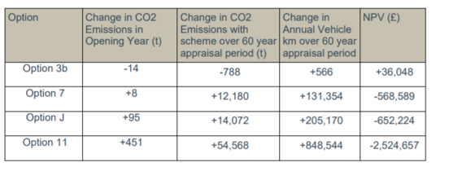
Table 5 CO2 Emissions and milage changes

As a county with higher levels of poverty than the national average, this data is extremely important to the public in order to make the best possible decision that will have the least impact on their already limited incomes, and with more people becoming aware of their carbon footprint, the increase in CO2 emissions will also drive many decisions, 14,000 miles extra per year would seem untenable to many people.
4.1.4 Landscape and Townscape
With much legislation required for construction seeing a report highlight that they have used methods created via using multiple sources and guidelines, to develop a proposal that was usable and inclusive for all.
By giving a short explanation of the short-term immediate effects of the project, and again highlighting that if no change were to take place, the report shows that the contractor is willing to absorb the loss of
hedgerow and amount of cut and fill work associated with any of the options for development.
In the long term the effects are much greater and indicating they may possibly move the existing hedgerow to new roadside locations to fulfil compensatory measures is a clear benefit as the wildlife that use those hedges would return soon after construction activity ceased.
Seemingly careful thought to the visual impact a new road would have on the extensively rural area, and its level of mitigation shows the contractor aims to provide a transport link that is in keeping with the existing roads in the area.

4.2 Weakness
While the report makes it abundantly clear that the primary objective, aside from providing a new futureproof transportation link, is to preserve the rural aesthetic, it falls short of adequately considering how to construct more robust flood defences that would largely prevent flooding and develop a sustainable, safe recreational area and through road for residents and commuters alike. The road will be impassable by 2036, and the public house, as well as the surf shop, are on the same level as it. Permanent flooding of that road would also result in the closure of the buildings adjacent to it, resulting in a loss of tourist revenue each year. Saltwater inundation will eventually force its way upriver and have a severely detrimental effect on the local eco system, harming fragile wildlife habitats, altering soil PH levels and dramatically altering the size and mapping of the current floodplain.
The proposed road is too long, it winds out too far to then return on itself, and while we understand that is how local roads are built, it will result in excessive extra miles and unacceptable increases of levels of excess CO2 emissions at a time when the UK is committed to drastically reducing them. The longer road would increase both construction time and cost, as well as cause additional and unwanted traffic congestion on the existing narrow roads used by many logistics vehicles to deliver supplies and materials to local businesses and farming industry
The new roads also border on an active military base, which has its own artillery traffic on a regular basis.
No mention is made of any inclusion of cycle paths, and options to decrease the number of cars on the road by increasing other clean transport options. As an area now long standing with the triathlon community the inclusion or development of safe places to cycle to and from the surrounding areas would seem to be a major oversight.
Their CO2 testing did not allow for the shift we are seeing from combustion engines to electric vehicles which the government are now actively seeking legislation to gradually eliminate combustion engines. As the report was in 2017 before the recent spearhead toward carbon neutrality this may have been less prevalent at the time, but some mention toward the decline of the combustion engine may have shown a marked reduction in the CO2 measures.

5.Conclusion
With rising sea levels an ongoing concern, I do not believe that a new road away from Newgale is the answer. The UK is surround by towns and village like Newgale, and we cannot justify moving a road every time the water gets close. What happens to the people who live there, the livelihoods of the people who own businesses there? There must be another way to defend places like Newgale from a watery fate, because one road moved today are waves lapping at the doors of the people the new road is designed to help. If no one lives there, no one benefits from the new road. Once the council stop maintaining the shingle bank there will be no lower Newgale, and with a 4-8ft predicted sea rise by 2050 homes that are currently out of reach of the tides, will not be out of reach of the storms.
This would result in the expensive mediation of moving a whole village of people away from a decaying coastline, in an area with excessive homelessness. If this happened all over the UK, we would soon increase the housing crisis and give up miles of land to the sea. Whatever option is chosen for the Newgale road will be an example to the rest of the UK and World of how to address the global warming crisis.
6.References

Atkins. (2017, July). Newgale WelTAG Stage 1 Assessment Report. Retrieved May 1, 2021, from Pembrokeshire.gov.uk: https://www.pembrokeshire.gov.uk/objview.asp?object_id=3835&language=
BBC. (2018, September 25). Newgale A487: £30m new route for storm-ravaged road. Retrieved from BBC.CO.UK: https://www.bbc.co.uk/news/uk-wales-45641147
Gov.uk. (2020, May 13). https://www.gov.uk/guidance/environmental-impact-assessment. Retrieved from Gov.uk: https://www.gov.uk/guidance/environmental-impact-assessment
H, R. (2020, October 6). Cars, planes, trains: where do CO2 emissions from transport come from? Retrieved from Our world in data: https://ourworldindata.org/co2-emissions-from-transport
UNFCCC. (2015). The Paris Agreement. Retrieved from unfccc.int: https://unfccc.int/process-and-meetings/the-paris-agreement/the-paris-agreement

Upper Ogmore Windfarm Environmental Impact Assessment (EIA) Report
Mateusz A. Morga
University of Wales Trinity Saint David, MSc Environmental Conservation and Management

ABSTRACT
The global population numbers are rising, and human-induced climate change drives demand for large-scale, renewable energy projects to meet the increasing global clean energy demand. Nationally significant developments (DNS) like wind farms (WF) can impose tremendous environmental implications, and thanks to the highly regulated process of Environmental Impact Assessment (EIA), their environmental impact can be mitigated. The Upper Ogmore onshore WF EIA evaluation aimed to analyse the effectiveness of EIA underpinning legislation and identify gaps between the theory, law, and practice. Research revealed that investigated EIA mainly focused on the most significant impacts from the WF construction phase. They include project design, site location and visual, including aspects of hydrology and ecology. Also, the pre-application consultation with local authorities and the local community was very good, and mitigation was introduced, although lacking specific details in many areas. Unfortunately, the post-construction monitoring and potential enhancement of the affected environment were omitted by the WF proposer.

1.Introduction
With the rapid growth of the global population and rising life quality and standards due to smart technology, the demand for electric energy is also increasing. Combining with human-induced ‘climate change’, they drive a global push for more sustainable development solutions, including alternative renewable energy production sources.
Wind-generated energy is one of the favourites amongst many counties, and it often comes in the form of gigantic onshore/offshore wind farm (WF) infrastructures. Almost all new WF development creates unavoidable pressure in the broader environment causing habitat loss and fragmentation. Air pollution increases during the construction phase, and many post-construction long-term effects of noise pollution and shadow flickering are present, causing visual and economic impacts on tourism, not to mention the decommissioning phase impacts.
Nonetheless, the highly evolving wind technology fits many essential strategies, including the elimination of burning of fossil fuels to reduce the global warming

effect below 1.5- 2 degrees Celsius in line with the 2015 Paris Agreement, followed by the UK impressive 68% reductions in greenhouse gas emissions reductions by the end of 2030, announced by the UK Government in a recent Climate Ambitions Summit letter. Also, Boris Johnsons’ ‘Built Back Better, and Greener’ plans to increase investment in more renewable energy (primarily wind-generated) in the post-pandemic recovery plans favour renewables.
The assessed Upper Ogmore WF proposed in Bridgend County, like most WF projects, is a large-scale development often located within a specific, upland environment in Wales. The title project is to be erected in South Wales, a post-industrial, highly devastated (but slowly recovering) upland region that forms a cluster of multiple operational wind farm developments. Therefore, to support the successful planning application, a rigorous and system Environmental Impact Assessment (EIA) procedure was requested as various environmental effects are ‘most

likely to arise’ from the project realisation (The Planning Inspectorate, 2019a).
Therefore, this report aims to assess if the theory and the law regarding EIA’s are put in practice and their effectiveness in identifying negative and positive environmental effects of the proposed WF with the inclusion of adequate mitigation measures and stakeholder’s consultation.
2.0 EIA Methods in General
An EIA is a highly regulated, consistent, and methodological information gathering process conducted by the project developer. It aims to present the highest quality, up to date information concerning the proposed development in the form of an Environmental Statement (ES). It should highlight the most significant environmental effects of the project, including mitigation for the planning authority to facilitate an informed decision to accept or reject the planning proposal. EIA also ensures early public participation in all stages of the decision-making process, albeit it should not be perceived as a ‘barrier to growth’ (Friends of the Earth, 2020; Ministry of Housing Communities & Local Government, 2020).
2.1 Underpinning Legislation
EIA was formerly introduced in the UK through the European Union ‘EIA Directive’ (85/337/EEC) in 1985, then updated in 2014 (Directive 2014/52/EU) to be finally transposed into all EU members legislation by 2017. The amendments aimed to incorporate climate change into ES and decision-making processes and make EIA reports more transparent and more accessible for the public (e.g. through Technical Summaries) while involving more competent experts (European Commission, no date; IEMA, 2015).
In Wales, the EIA is legally regulated by Town and Country Planning (EIA) (Wales) Regulations 2017, giving Welsh Ministers powers to declare what projects qualify as EIA development. The inclusion of relatively big energy projects (e.g. wind farms below 50MW) under the Town and Country Planning Act (TCPA 2017) was aimed at allowing for the involvement of local communities in the application processes of proposed WF projects in their local areas (Department for Business, Energy & Industrial energy, 2013).
2.2 Determinants of an ‘EIA Development’?

Not all developments require an ES, and therefore, the ‘screening’ step is essential to be conducted at the beginning of the planning permission process. It helps to define if the project is a Schedule1 with mandatory EIA (e.g., railway, major road schemes, chemical or power plants except for national/military defence) or a Schedule2 that is “likely to have significant effects on the environment under factors such as its nature, size or location” but must be ‘screened out’ before the EIA decision is made (Welsh Government, 2018, p:6). The latter can be very tricky to assess and often cause disputes between local authorities, developers and concerned stakeholders. Example projects are golf courses, open cast mines, smaller energy plants (e.g. onshore WF, brewing, and even holiday villages) (Welsh Government, 2018; Friends of the Earth, 2020).
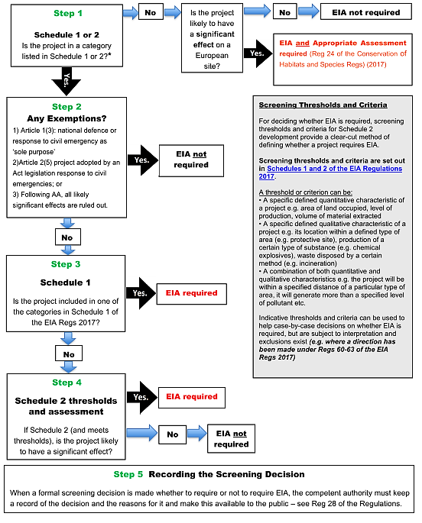
Figure 1 below shows a flow chart that breaks down the screening procedure. The process is guided by clear flow charts and threshold tables, which makes it very systematic. However, the Planning Practice Guidance warns that consenting EIA decisions are never ‘black and white’ and project falling below the ‘screening thresholds’ can still be located in environmentally sensitive areas and cause unforeseen impacts (Friends of the Earth, 2020).
Figure 1 Screening Flowchart (Friends of the Earth, 2020)
Regarding the ‘likely significant environmental effects’ (Fig.1, Step 2), the Institute of Environmental Management & Assessment (IEMA) recommends the involvement of early mitigation measures engaging project designers, decisive authorities and local community very early (possibly at the screening stage)
to ensure the most significant effects are forwarded into EIA assessment (IEMA, 2016).
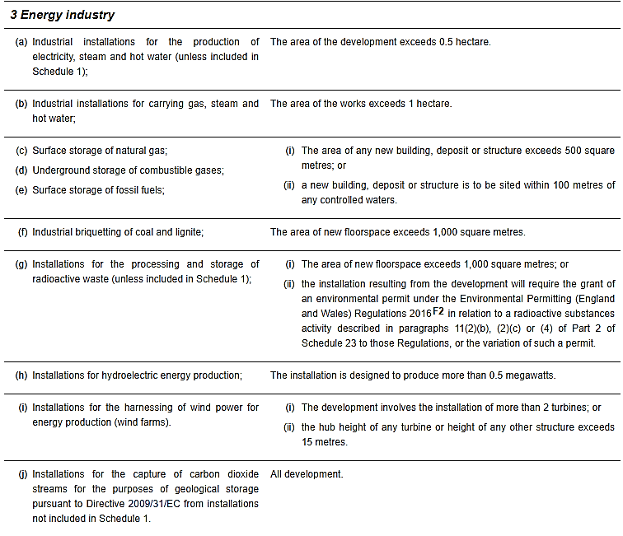
Table 1 presents example ‘thresholds and criteria’ applicable for the energy industry that local planning authority must adhere to when declaring an EIA development according to The Town and Country Planning (EIA) Regulations 2017 (Description of Development, Schehdule2, p.24) (UK Government, 2017; Welsh Government, 2018).
Table 1 ES Relevant Thresholds and Criteria for Energy Industry (UK Government, 2017).

The relevant thresholds and criteria regarding the WF projects are highlighted in point ‘(i)’ (Table 2). It is worth mentioning that most criteria are either qualitative, quantitative or the combination of both and are subject to interpretation. On some occasions, they can be excluded under the EIA 2017 regulations, e.g. “projects serving national defence purposes in Wales” (Reg 61) (Part 11, Exemptions) (Welsh Government, 2018).
2.3 Development of National Significance (DNS)
Declaring proposals as DNS projects ensures that planning applications with potentially more significant influence on Wales receive more attention from statutory, specialist consultees and all decisions are timely and maximally benefit the Welsh community/environment (The Planning Inspectorate, 2019b). Also, the DNS (Wales) Regulations 2016 appoints The Local Planning Authority (LPA) together with the NRW and Cadw a ‘specialist consultees’ in the EIA application process that must be consulted before submitting to Welsh Ministers (Natural Resources Wales, 2017; The Planning Inspectorate, 2019b).
The DNS has a statutory basis in Wales provided by the Planning (Wales) Act 2015 (amending the TCPA 2017) as well as the Developments of National Significance (Wales) Regulations 2016 (as amended) (The Planning Inspectorate, 2019a). In line with the 2016 Regulations, most of the energy generation projects (like proposed WF) “must be applied directly to the Welsh Ministers with the support of Planning Inspectorate Wales (Section 62D, TCPA 2017) with the inclusion of special DNS list of relevant secondary consents (e.g. Commons Act 2006-Section 38: Works on Common Land) (Department for Natural Resources, 2016; The Planning Inspectorate, 2019b).
Regulation 4 in the DNS (Wales) Regulations 2016 states that generating stations with installed generating capacity between 10-50 MW (like the Upper Ogmore WF project) are DNS development (Welsh Government, 2016).
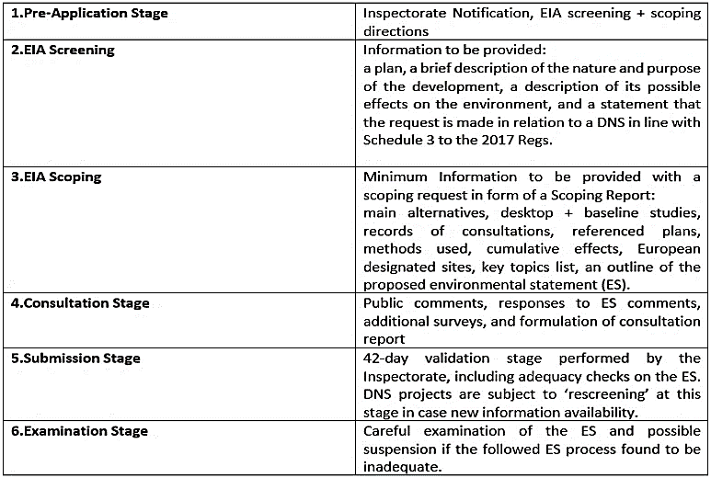
2.4 Standard EIA Steps (DNS Projects) (Table 2)
Table 2 EIA Stages Included in DNS Projects (The Planning Inspectorate, 2019a).

When the initial screening unlocks the EIA requirement for the planning application process, applicants are encouraged to engage with the Planning Inspectorate (PINS) at the scoping stage very early for the fluent DNS application examination to avoid later rejection. The screening direction must be issued within 21 days by the PINS providing all the minimum required
information included in the screening request (in line with the Schedule 3, 2017 TCPA Regulations) (Table 2., 2). It is vital to ensure that “all aspects of the development likely to be significantly affecting the environment were considered” (Welsh Government, 2018, p:71). Similarly, the formal scoping direction request should be included at an early stage in the form of a ‘scoping report’. The PINS can only issue a scoping direction with ‘high-level comments’ within the statutory five weeks, providing all-sufficient and extensive information concerning the significant environmental effects (including the ES proposal) were present (Table 2., 3). It is advised that ‘the worst-case scenario’ is assumed, although PINS can always request additional information and suspend the process (The Planning Inspectorate, 2019a).
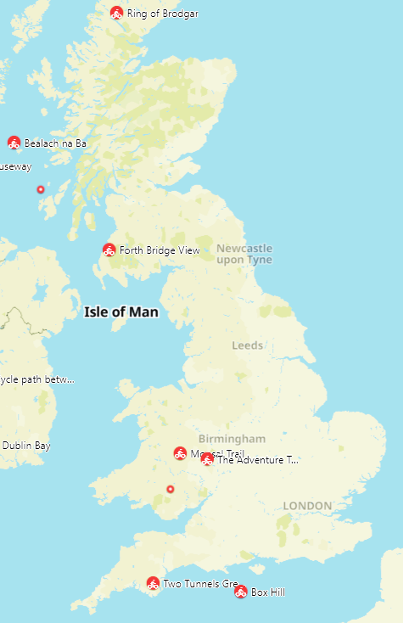
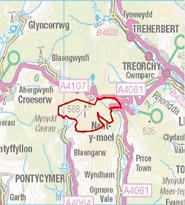

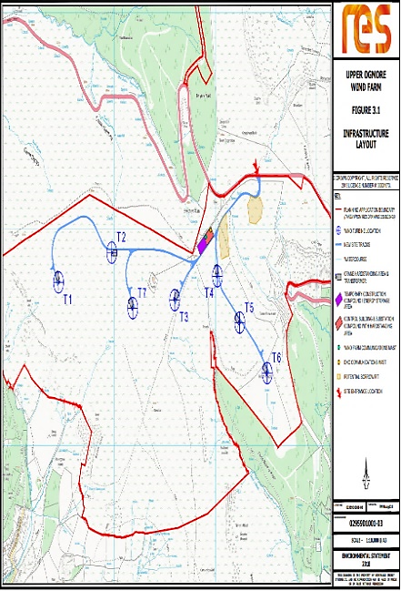
The consultation stage should be long enough to collect the consultees comments (including the proposed ES feedback), and they should be handed in as a Consultation Report. Some additional surveys are often performed. The submission stage is used to validate the DNS project, and its ES is checked extensively for its adequacy. Sometimes ‘rescreening’ process is commissioned in case new information is available. Lastly, a detailed examination is performed to check the followed ES process was sound and in case of infringements, the whole process can be suspended, and more information requested.
Figure 2 Location of Upper Ogmore Windfarm (RES, 2020).
2.5 Available Guidance

It is vital to mention many professional bodies issue valuable guidance and updates to help to incorporate the constantly evolving EIA requirements into the DSA application process. Examples are the Welsh Government, The PINS, Natural Resources Wales (NRW), the Institute of Environmental Management and Assessment (IEMA), including relevant NGOs like Friends of the Earth.
3.0. Proposed Development Outline

The Upper Ogomre WF development was proposed by Renewable Energy Systems Limited (RES) company in March 2018. The company is considered one of the world’s leading renewable energy developer, with over 17 thousand MW of renewable energy is installed worldwide.
The chosen site location is in Bridgend County near three mid-size villages (Nantymoel, Blaengarw and Blaengwynfi) located south of the A4107 (Grid ref: E29150 N19450) (Fig.2), centred on the summit of Werfa (568m). The proposed WF will occupy 16.81 ha of private agriculture land near small watercourses present to the south east and west. The land is an upland moorland consisted of acid and marshy upland grassland mainly used for grazing. Also, mosaics of dwarf shrub heath scatter across, and some adjoining larch (Larix decidua) plantations to the ease and west are present. Several public rights of way (i.e., footpaths and bridleways) are located on-site, including enclosed pastures in easternmost sectors (RES Limited, 2020f).
The wind farm will consist of “seven three-bladed, horizontal axis wind turbines” of maximum heights of 130m to 149.9m and a total installed energy capacity of 25MW supplying 25000 homes in the area (RES Limited, 2020a, p:1). It will also require “new access tracks with improved site entrance, hard crane standings, control building and substation compound, electricity transformers, underground cabling, energy storage containers, drainage works and upgrades to a
forestry track and associated tree felling, and a possible short diversion of the forestry track’’ (all contributing to substantial land transformation ) (RES Limited, 2020b, p:1). Through the screening and scoping exercises the project was declared a DNS development and it was classified Schedule 2 (EIA regs.) as an “installation for the harnessing of wind power for energy production (wind farm)” with likely significant environmental impacts (RES Limited, 2020a, p:1). Therefore, an EIA process involving number of legislations and regulations was implemented which will be assessed in the Chapter 4 (Analysis).
4.0. Evaluation of Upper Ogmore WF EIA Findings

Description of a Development

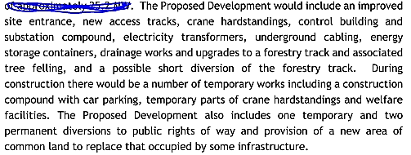
EIA guidance recommends starting an ES evaluation at the description stage (Friends of the Earth, 2020). According to Schedule 4 TCPA 2017 Regulations as well as the Planning Inspectorate Guidance (Point 9), a good description needs to include the location type, relevant land-use requirements with demolition work coverage, expected resources use for the operational phase (e.g. energy, water, land, soil) as well as estimations of the expected pollution types caused (Welsh Government, 2018; The Planning Inspectorate, 2021). In Chapter 3 of (ES), the proposed development includes an excellent description of the location, including grid references, location map (red line boundary) followed by all relevant requisite demolition involved in the construction phase (Fig.3).
Figure 3 Requisite Demolition and Land Alteration Works During Construction Phase (RES Limited, 2020c).

There are much fewer details on the type of the location as only referring to it being an "agriculture land". The project required 16.81 ha of the agriculture land to be acquired through the Commons Act 2006 procedures (in line with the DNS relevant secondary consents) (The Planning Inspectorate, 2019b; RES Limited, 2020d). All the necessary actions, including access track widening (3.6 km long section), route diversions and access alterations, has been provided, including lengths and widths (all numbers included in the 'Figures' attachment). Regarding the materials and quantities, ES states that there is no watercourse crossing involved and borrow pits were suggested at two locations as a source of 'won rock' used for road construction. Nevertheless, the required quantity and geological data are not included at this stage. ES vaguely states that "it is not anticipated that these areas would be fully exploited" (RES Limited, 2020, p:6).
Similarly, regarding the prevention of pollution caused by the borrow pits construction involving stone blasting (2-5 times a week), erection of turbines and crane hardstandings, it is mentioned vaguely stating that the working area will always be minimised and "appropriate dust suppression at the borrow pits and any materials storage areas will be provided as required" (RES Limited, 2020, p:10). In turn, water quality monitoring and pollution prevention received more attention. The Construction & Decommissioning Method Statement (CDMS) created by RES Limited limits all excavation activities during substantial rainfalls, designating refuelling points and no unapproved discharges of processed, contaminated water within the site. Also, the water buffer zones and surface run-off controls to protect watercourses and groundwater will be implemented in line with the Sustainable Drainage Systems (SuDs) guidance. Lastly, emergency response procedures in the unlikely pollution event, a Hotline number and immediate notification of NRW are advised. Consultations with specialist consultees (public bodies like NRW) are in line with the DNS ES steps guidance provided by the Welsh Government (The Planning Inspectorate, 2019b).
Surprisingly, there is no information on water sourcing for the construction phase, and detailed quantification of the materials used and the expected residual pollution are also not included.
4.1 Design Evolution & Reasonable Alternatives

According to EIA 2017 Regulations (Schedule 4., 2), a description of the good reasonable site and design alternatives should give sufficient reasons on why a particular site was chosen for the project. It is required in the context of other sites and their potential environmental effects to consult all stakeholders to avoid further third-party objections and potential legal challenges (Welsh Government, 2018; Friends of the Earth, 2020). Moreover, they should be included early in the scoping request and the ES (The Planning Inspectorate, 2019b). According to RES Limited, the proposed site location and WF design are specified to balance the factors influencing maximisation of the energy produced (e.g., wind speed, topography or access) against the overall environmental, economic, and technical criteria which determine the viability of WF.
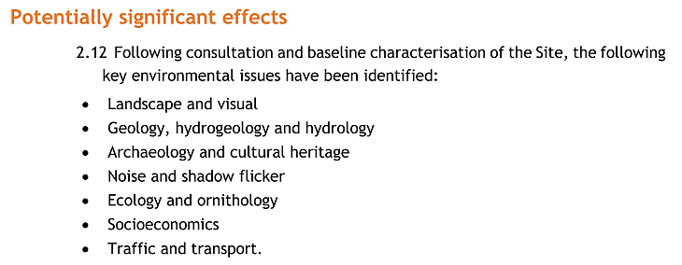
The most significant 'environmental constraints to the proposed development, according to RES Limited, were identified through series of environmental surveys presented in Fig.4. Those will be addressed in the following' Impacts Assessment' subheading. The proposer states that he aimed to "design out those significant effects" during the "iterative design process" (Res Limited, 2020).
Figure 4 Potential Significant Effect Resulted From the Environmental Surveys (Res Limited, 2020).
The public consultations were commenced in 2017 so almost three years before the planning application submission, to make sure the consultation process was effective and constructive and addressed all concerns (Res Limited, 2020). It shows a 'good-practice example' of initiating an early discussion on alternatives (in line with the DNS Procedural Guidance, Appendix 7) (The Planning Inspectorate, 2019b). Nevertheless, this report does not summarise the public comments and avoids commenting on the overall public attitude to the project. Concerning the site design options and alternatives, the prosper informs he used a GIS system as a key tool in choosing the exact site boundaries to eliminate the potential constraints. There are no other alternatives proposed elsewhere as the most effective method of site selection available, according to RES Limited, are the GIS systems (Res Limited, 2020). Additionally, Several modifications of the WF infrastructure and turbine layout were tested. According to RES Limited, the best environmental mitigation was obtained through technological design influenced by feedback from consultees, including policy and technical recommendations (In line with the TCPA 2017 guidance).
The 'Alternatives' Chapter does not elaborate much on the site selection or comparison with other potential sites, neither it provides specific reasons justifying the chosen shape of the WF site. In turn, it informs on multiple efforts to relocate the site's main entrance due to the near located scheduled monument highlighted at Cultural Heritage Consultation. As before, the GIS software assessment tool was the only factor determining the shape and size of the proposed WF. Moreover, the ES focuses in this chapter more on eliminating design constraints resulting from the baseline environmental study (e.g., removing Turbine T8 including reducing turbine tip height being adjusted I line with local Landscape Consultant) rather than looking for more appropriate alternative site locations.

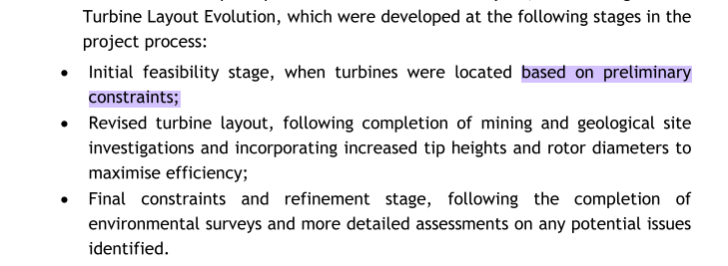
The overall impression when assessing the 'Alternatives’ chapter is that methods used to find the most feasible WF site used by the applicant are “the best”, and the process of locating suitable sites is based on the eliminations of ‘environmental constraints’ like potential geological instability that may affect the turbines themselves rather than prioritising of minimalisation of the environmental impacts (example, Figure 5).
Figure 5 Turbine Layout Design Evolution (Upper Ogmore WF) (Res Limited, 2020).
Interestingly, no project layout constraints were resulted from the Ecological Consultant feedback according to the Upper Ogmore ES (Res Limited, 2020). It might suggest that sizeable DNS energy projects are favoured and receive some form of leniency towards them.
4.2 Upper Ogmore WF Impacts Significance & Mitigation

IEMA reminds that in line with the Directive 2014/52/EU, all EIA’s should deliver more proportionate assessments of impacts solely focusing on significant impacts specific of the development based on the scientific evidence available aimed to simplify ES for more straightforward interpretation. Also, to ensure that the latest climate change trends (DNS projects to be carbon-capture ready) and population health and well-being are addressed (IEMA, 2015; The Planning Inspectorate, 2019b)
The TCPA 2017 EIA Regulations in Schedule 4 emphasise the need to include factors that influence the environment, social and economic aspects,
including cumulative effects and their significance (Welsh Government, 2018).
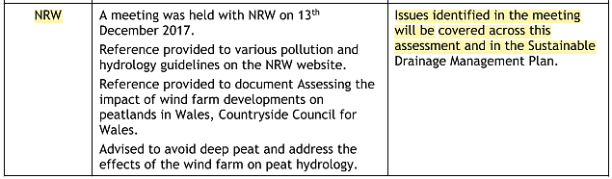
The initial ES analysis shows that a large part of the ES focuses on impacts from the construction phase in almost all chapters (1,2 3 and 5-12). Chapters 1-3 indicate that the most likely significant effects during the construction will be the excavation of borrow pits, construction of access and transportation routes including noise, extensive excavation, turbine foundations and erection of turbines using cranes, all causing disturbance to the sensitive peat bog habitats including water quality and affecting visual aspects.
Figure 6 Developer Responses to NRW Meeting Concerning Hydrology and Water Quality (Res Limited, 2020c).

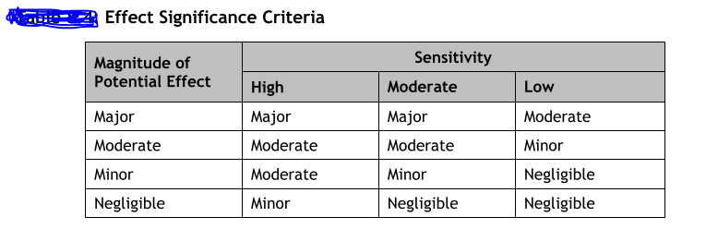
The matrix explaining the ‘sensitivity criteria’ categorisation used to assess the likely significant effects in the Upper Ogmore ES is presented in Fig.6. It combines the magnitude and the environmental sensitivity to assess the site(RES Limited, 2020d).
Figure 7 Sensitivity Criteria Matrix Categorisation for Upper Ogmore WF (RES Limited, 2020d).
Thanks to the water surveys and extensive peat probing, it was established that turbines should be positioned a minimum of 50 metres away from the watercourses. Additionally, watercourse buffer zones should be applied to reduce sudden increases of flow and encourage filtration and a unique silt control system to promote permeability of stock-pile materials (in line with SuDS guidance and climate change trends). Moreover, digging where peat depths exceeded 0.5m was prohibited and ‘floated construction methods’ were used (in line with the carbon storage and climate change inclusion guidance). Importantly, NRW was part of the consultation to assist the decision-making process and facilitate adequate licencing (in line with the IEMA guidance), which shows a good consultation practice example (Res Limited, 2020).
Chapter 8 informed on potential significant effects on water quality and hydrology of the peatland. Also, human health was mentioned as one of the potential sensitive receptors. However, it was only associated with potential accidents or injuries of the work crew crossing the river in case of a flood event (RES Limited, 2020c). Despite consultations with Bridgend County Borough Council (BCBC) and NRW, the explanations of exact mitigation methods were formulated into ‘SuDS Management Plan’, but no detailed description was provided at this stage. The ES statement was rather vague and unclear concerning the exact mitigation steps (example, Figure 7).

Regarding the potential chemical spillages, NRW Guidance for Pollution Prevention was applied so things like refiling away from watercourses and using risk assessments (RES Limited, 2020g). The overall level of consultation on water quality aspects is satisfying, although, like before, the mitigation lacks specific details.
Chapters 5, 8 and 11 (in line with EIA guidance) highlighted the issues of potential cumulative significant effects arising from the WF development (including construction phase, shadow flickering, affected hydrology and visual aspects). They confirm
all impacts to be assessed within a 15 km study area (visual amenity radius) using desktop studies (e.g., LANDMAP database) and field-based assessments (e.g., all inhabited properties assessed within 1100m diameter in line with a 2011 legislative Update to Shadow Flicker Evidence Base). Most of the suggested impacts were ruled out due to the secluded location (2km from the nearest housing development) (RES Limited, 2020b). Surprisingly, the assessment does not mention the effect on the adjacent A4107 road and the passing-by commuters.
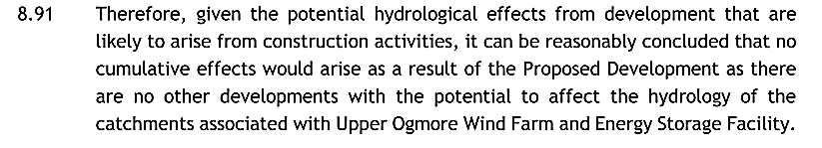
Similarly, regarding the hydrological effects, the local authority and the PINS consultations suggest no other ongoing or planned significant development within 10km of the Upper Ogmore site. Therefore, potential significant cumulative effects are ruled out (reasoning in Fig.8). Moreover, the already operational WF (Fig.9) were not taken into account.
Figure 8 Reasoning for the ruling out of Cumulative effects caused by the Upper Ogmore Development (RES Limited, 2020f).

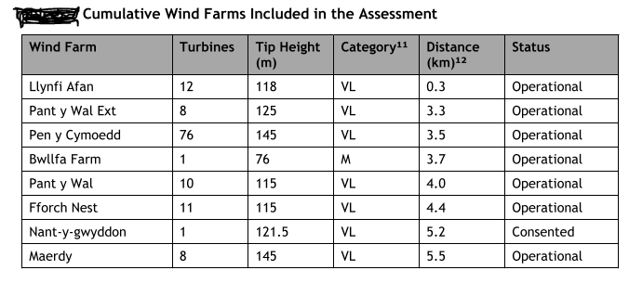
It is unclear why cumulative effects (e.g., disturbed hydrology and visual effects) were only accounted for ongoing projects in the construction phase. For some reason, other adjacent WF developments, including llynfi Afan (12 turbines only 0.3 km away) (Fig. 9), were not considered to be adding to the cumulative impacts (RES Limited, 2020e).
Figure 9 Other Wind Farm Locations Found within 3 Miles Frome the proposed WF Development (RES Limited, 2020d).
Socioeconomics is another aspect influenced by the WF that was included in the ES in Chapter 12. The potential benefits and impacts were estimated based on the information relevant to the project description, including evidence-based assumption methods used, including the quantitative method of Oxford Economics (i.e., Economic Impact Inputs-Outputs Model). The overwhelming part of this chapter was focusing on the benefits, therefore suggesting that the location of the WF in a highly deprived region was convenient to everyone. The main benefits, according to the ES, are £22.49 capital investment spent on the proposed project resulting in “110 job-years of employment” (£3.44 million of created directional wages) during the construction phase only (RES Limited, 2020c, p:25). Furthermore, WF would provide renewable energy for 22,000 homes every year, which was estimated to reduce Wales yearly CO2 emissions by 38,5 tonnes (in line with climate change commitments).
Regarding tourism, the report suggests that based on the scientific research, including analysis of impacts in Scotland ((e.g., Wind Farms and Tourism Trends in Scotland (2016) and 2016 BiGGAR Economics (2017)) there is currently no clear evidence of significant impacts on tourism in the UK. Interestingly, the report also points out “ a lack of literature focussing on the WF impacts on tourism in Wales” (RES Limited, 2020c, p:21). This somewhat optimistic chapter, although based on some scientific research, it omits the harmful effects of onshore WF highlighted in various other studies suggesting some negative effects on tourism (e.g., on frequency and duration of local visits) (Welsh Government, 2015; Brudermann, Zaman and Posch, 2019). Lastly, the humans stress management issues resulting from the long term WF effects suggested in research (e.g., potential post-construction cumulative impacts linked to long-term health effects) (van Kamp and van den Berg, 2018). Lastly, no post-construction checks, or long-term monitoring management plans were considered or suggested by the project proposer.

4.3 Ecology & Biodiversity Assessment

Chapter 6 (Ecology and Biodiversity) was assessed separately due to being the most extensively covered subject of the DNS ES Report. The 2017 TCPA EIA Regulations (as amended) require the preparation of ES only by competent experts (Regulation 18(5)(a)) (Friends of the Earth, 2020). Moreover, the Planning Inspectorate and IEMA guidance remind the latest EIA updates, especially regarding DNS projects that require demonstration of not just mitigation/compensation but also post-construction long-term maintenance plans (i.e. Environmental Management Plans) aimed to enhance the affected environment (IEMA, 2016; Planning Dirrectorate, 2019). Another relevant EIA guidance stresses that “The potential for significant effects to protected species should be a principal consideration for an EIA” (Friends of the Earth, 2020, p:20).
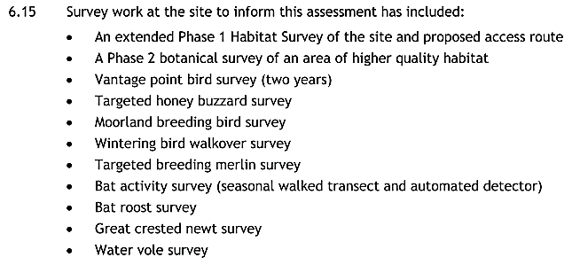
Firstly, ES informs on project supervision by senior ecologist Gareth Lang (ACIEEM, BSG Ecology) and the NRW expertise. It was clarified that specialist experts
Figure 11 Fig 11 Extensive List of Surveys Conducted in the Ecology Biodiversity Assessment (RES Limited, 2020e).

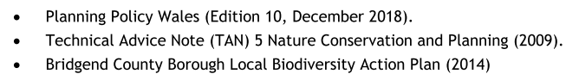
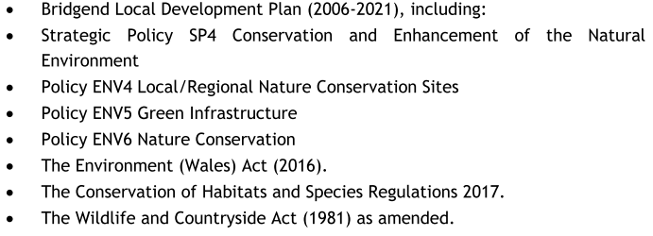
with licences were involved, which is in line with the legislation. Additionally, an extensive list of national/regional planning policies relevant to Chapter 6 was presented (Fig. 10), proving the site’s ecology was taken seriously (RES Limited, 2020f).
Figure 10 List of Environment Relevant National, Regional and Local Planning Policies (RES Limited, 2020e).
The initial response from the NRW at the pre-application and screening stage was crucial for the ES ecology assessment as the Special Site of Scientific Interest (SSSI) was located downhill, right below the proposed WF. Although it is not an EU protected site (therefore, no statutory Habitat Regulation Assessment as per 2017 EIA Regulation 27/Part5 required), the Planning Inspectorate and NRW insisted
that Environment Management Plans, including biodiversity management, was designed for the duration of the project (with post-construction monitoring inclusion). Despite some resistance from RES Limited, it was declared “essential for granting the planning permission”, which shows the critical role of Regional/Local Authorities consultations in large scale DNS projects, especially concerning environmental protection (Jones, 2021, p:21).

Extensive, seasonal ecological surveys were conducted, including Phase 1 extended habitat surveys (Fig.11) (e.g. bird, bat and water vole surveys, some lasting even two years showing adhering to seasonality check), resulting in the location of some protected species on-site (e.g. kestrels, bats and water voles). The involvement of BSG Ecology licenced ecologists combined with the NRW expertise and PINS guidance shows good practice example of collaboration between the developer, scientist, and the overseeing local authority ((in line with the 2017 EIA Regulations (Regulation 18(5)(a)).

Ecological Management Plan (EMP) was introduced ((in line with The Conservation of Habitats and Species Regulations 2017 (as amended) including Planning Inspectorate and IEMA guidance). It included critical Collision Risk Analysis V2 (in Appendix 06, ES Report) concerning birds and the modelling with clear conclusions, which were very good according to NRW examinations (Jones, 2021). Mitigation was offered in line with the Wildlife and Countryside Act 1981 (as amended, updated in March 2016) to protect specific birds and nests during the breeding season (March-August). However, like previously, it was rather vague and lacking specific details. Also, some EMP mitigation proposed in Chapter 13 (Fig. 12) (RES Limited, 2020c) may prove counterproductive, opposite the Friends of the Earth guidance on “using the development as an opportunity to enhance the biodiversity” (Friends of the Earth, 2020, p:20).
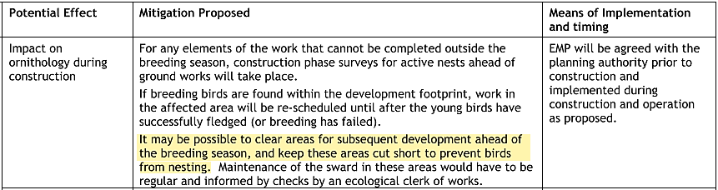
Figure 12 Mitigation proposed in Chapter 13 Concerning Breeding Birds (RES Limited, 2020b).
Additionally, kestrel’s habitat loss ( kestrel is conservation species under WCA 1981, Section 1) (Association of Drainage Authorities, 2017), including water voles (WCA 1981, Schedule 5) (as amended),
were declared significant at ‘local to district level’ due to the cumulative effect of multiple turbine development in the area’. Unfortunately, the mitigation efforts proposed during the construction phase were “financial contribution to local initiatives focussed on the management of moorland habitats” (RES Limited, 2020e, p:86) which shows the responsibility of habitat mitigation/enhancement being passed onto someone else and difficult to trace in post-construction phase.
It can be noted that the primary EMP focus was only on the short-term protection of species and habitats during the construction phase. Also, habitat ‘no net loss’ requested by the Welsh Government (since 2019 updates), including habitat enhancement, according to the proposer, was deemed impossible “due to the isolated nature of the site” (RES Limited, 2020e, p:80). Therefore, no pinpointing of exact water voles’ locations was performed, neither loss of crucial moorland/wetland habitat concerning the long term (post-construction) phase was addressed (in line with habitat enhancement also required by the Environment Wales ACT 2016). Once again, the only mitigation offered was through ‘’contribution to local habitat restorations initiatives’’(RES Limited, 2020e, p:80).
4.4 Public Consultation and Non-technical Summary

Legislation regarding the ES formal consultations points out the importance of local advertisements and publicity of any new or updated decisions made regarding the proposed development, including the full ES report as required by the updated 2017 TCPA Regulations (Schedule 2) (Welsh Government, 2018). In line with the regulations, the PINS office requested notice in a local newspaper and article on the public website) (The Planning Inspectorate, 2019b).
In response, a detailed index of issues concerning the ES consulted with PINS were attached in ES (Appendix 1.3). Moreover, the project was presented for stakeholders’ consultations since the pre-application stage, starting in 2017, 33 months before the final ES submission. All essential details concerning the project design and extent were presented in several public exhibitions to engage with the local community, address all significant issues, and collect feedback (in line with the 2017 TCP Regulations). The Pre-Application Community Consultation Report presenting all the received feedback was also drawn up to facilitate project decisions. In line with the legislation, the news on the plans of erecting a new 25MW Welsh wind and storage facility by RES Limited was published in an online newspaper article in December 2020 (reNEWS.BIZ, 2020). Additionally, the official website sharing all the information regarding WF development was also created (RES Limited, 2021).
It is worth mentioning that the recently updated Welsh Government EIA guidance has also included the Covid-19 pandemic restrictions asking local planning authorities and proposers not to produce hard copies of any ES related documents and create their electronic form making them available online (Ministry of Housing Communities & Local Government, 2020).
It was confirmed that all ES chapters were presented online on RES Limited website in great detail of 13 separate chapters for everyone to read and comment on. The Non-technical summary was also provided in line with the 2017 TCPA Regulations (as amended) (Part5, 18e) in an electronic file form (Volume1, six whole chapters) in more cognised and more accessible to rad form, including Introduction, description, and significant impacts of the proposed development. On the negative side, no location maps or any plans and drawing were included, and most significant impacts were usually declared ‘acceptable’, ‘minimal’ or ‘negligible’ and the information on impacts mitigation were minimal (RES Limited, 2020h).
5.0 Conclusion

The EIA assessments produced for DNS developments are complex documents full of many legal and procedural guidance that involve a high number of different expertise to be completed. Many impacts are interrelated and covered under various themes and subheadings, which creates extra difficulty. Perhaps focusing on the most significant ones, in line with the guidance, especially in large-scale development, simplifies the EIA assessment process and makes it more effective. Through this assessment, it can be concluded that EIA is a powerful tool, and with the engagement of specialist, licenced experts, local authorities, and public participation, they can be very effective in eliminating severe environmental threats imposed by new structures. Government bodies like NRW and ecological surveyors helping in WF projects are essential to achieve an excellent overall level of protection/mitigation throughout the consecutive steps of the EIA process. On the negative side, it was observed that big energy projects like Upper Ogmore WF, of national strategic status, may be treated with priority by statutory bodies, and therefore a form of leniency in terms of mitigation and enhancement requirements is present. It was especially noticeable within the habitat mitigation and post-construction enhancements chapters surrounded with some
ambiguity. Many impacts were easily neglected, and proposed mitigations were missing essential details. It can also be observed that there is a high level of personal interpretation involved in examining the proposed actions, which can cause potential issues in the long run. Lastly, it can be stated that modern EIAs, although far from perfect, do very well on incorporating climate change and human health, including public participation, and they will be indispensable when dealing with those issues in a near, post-pandemic world.
6.0 References
Association of Drainage Authorities (2017) Kestrel Action Plan for Incorporation Within Internal Drainage Board BAPs.
Brudermann, T., Zaman, R. and Posch, A. (2019) ‘Not in my hiking trail? Acceptance of wind farms in the Austrian Alps’, Clean Technologies and Environmental Policy. Springer Berlin Heidelberg, 21(8), pp. 1603–1616. doi: 10.1007/s10098-019-01734-9.
Department for Business, E. & I. energy (2013) Consents and planning applications for national energy infrastructure projects -, GOV.UK. Available at: https://www.gov.uk/guidance/consents-and-planning-applications-for-national-energy-infrastructure-projects#history (Accessed: 10 April 2021).
Department for Natural Resources (2016) DEVELOPMENTS OF NATIONAL SIGNIFICANCE. Available at: http://gov.wales/topics/planning/developcontrol/developments-of-national- (Accessed: 10 April 2021).
European Commission (no date) Review of the Environmental Impact Assessment (EIA) Directive. Available at: https://ec.europa.eu/environment/eia/review.htm (Accessed: 10 April 2021).
Friends of the Earth (2020) Environmental Impact Assessment (EIA).
Hoare, D. (2019) ‘Impact Assessment Outlook Journal Perspectives upon Nationally Significant Infrastructure Projects and Development Consent Orders Thought pieces from UK practice’, IEMA, 2(April), p. 22.
IEMA (2015) ‘Environmental Impact Assessment Guide To Climate Change Resilience and Adaptation’, (November), p. 32. Available at: https://www.iema.net/assets/templates/documents/iema_guidance_documents_eia_climate_change_resilience_and_adaptation (1).pdf.
IEMA (2016) ‘Environmental Impact Assessment Gide to Delivering Quality Development’, pp. 1–20. Available at: https://www.iema.net/assets/newbuild/documents/Delivering Quality Development.pdf.
Jones, L. (2021) Upper Ogmore - Wind Turbines.
van Kamp, I. and van den Berg, F. (2018) ‘Health Effects Related to Wind Turbine Sound, Including Low-Frequency Sound and Infrasound’, Acoustics Australia. Springer Singapore, pp. 31–57. doi: 10.1007/s40857-017-0115-6.
Ministry of Housing Communities & Local Government (2020) Environmental Impact Assessment, GOV.UK. Available at: https://www.gov.uk/guidance/environmental-impact-assessment#history (Accessed: 9 April 2021).
Natural Resources Wales (2017) Developments of National Significance - Guidance for Applicants. Available at: www.naturalresourceswales.gov.ukwww.naturalresourceswales.gov.ukwww.naturalresourceswales.gov.uk (Accessed: 10 April 2021).
Planning Dirrectorate (2019) Securing Biodiversity Enhancements.
reNEWS.BIZ (2020) RES submits 25MW Welsh wind and storage plans. Available at: https://renews.biz/65148/res-submits-25mw-welsh-wind-and-storage-plans/ (Accessed: 16 April 2021).
Res Limited (2020) Chapter 2 Design Evolution & Alternatives Environmental Statement.
RES Limited (2020a) Chapter 1 Upper Ogmore Wind Farm & Energy Storage Facility Introduction Environmental Statement.
RES Limited (2020b) Chapter 11 Shadow Flicker & Reflected Light Background Information.
RES Limited (2020c) Chapter 13 Upper Ogmore Wind Farm- Schedule of Mitigation.
RES Limited (2020d) Chapter 3 Upper Ogmore Wind Farm & Energy Storage Facility Proposed Development Environmental Statement.
RES Limited (2020e) Chapter 5 Landscape and Visual.
RES Limited (2020f) Chapter 6 : Ecology and Biodiversity.
RES Limited (2020g) Chapter 8 Hydrology & Hydrogeology ES.
RES Limited (2020h) Upper Ogmore Wind Farm and Energy Storage Facility Non-Technical Summary.
Available at: www.upperogmore-windfarm.co.uk (Accessed: 16 April 2021).
RES Limited (2021) Upper Ogmore Wind Farm | DNS APPLICATION. Available at: http://www.upperogmore-windfarm.co.uk/dns-application/ (Accessed: 16 April 2021).
The Planning Inspectorate (2019a) Developments of National Significance Appendix 3: Environmental Impact Assessment.
The Planning Inspectorate (2019b) Developments of National Significance Procedural Guidance.
The Planning Inspectorate (2021) EIA: Process, Preliminary, Environmental Information, and Environmental Statements. Available at: http://infrastructure.planninginspectorate.gov.uk/legislation-and-advice/advice- (Accessed: 13 April 2021).
UK Government (2017) The Town and Country Planning (Environmental Impact Assessment) Regulations 2017. Available at: https://www.legislation.gov.uk/uksi/2017/571/schedule/4 (Accessed: 8 April 2021).
Welsh Government (2015) Study into the Potential Economic Impact of Wind Farms and Associated Grid Infrastructure on the Welsh Tourism Sector. Available at: www.regeneris.co.uk (Accessed: 22 February 2021).
Welsh Government (2016) The Developments of National Significance (Specified Criteria and Prescribed Secondary Consents) (Wales) Regulations 2016. Available at: https://www.legislation.gov.uk/wsi/2016/53/regulation/4/made (Accessed: 10 April 2021).
Welsh Government (2018) ‘Preparation of an Environmental Statement’, National Infrastructure Planning Handbook 2018, (571), p. 76. doi: 10.5040/9781526508126.ch-061.

A Critical Assessment of EIA Process and Theory: A Swansea Inner West Pier Marine Works Case Study
Dylan Morgan
University of Wales Trinity Saint David, MSc Environmental Conservation and Management

ABSTRACT

This report begins by outlining the contextual background for Environmental Impact Assessments (EIA), the stages of EIA and also the policies and legislations underpinning EIA. Secondly, it will evaluate the EIA process and EIA theory from a UK perspective and also from the viewpoint of an existing EIA document; Swansea Inner West Pier Marine Works. Evaluations of the Swansea Inner West Pier Marine Works pertaining to a new retaining wall from the use of piling is undertaken in the SWOT analysis (Strength, Weaknesses, Opportunities and Threats) format. Final applications of the EIA are presented in a future context whilst offering recommendations to better improve the EIA process for similar developments to Swansea Inner West Pier.

1.Introduction

This aim of this report is to critically evaluate the process and theory behind Environmental Impact Assessments (EIA) using Swansea West Pier Inner Marine Works as a case study to substantiate the evaluation process. As of May 2018, and October 2018, The Association of British Ports (ABP) respectively published a Screening and Scoping Report and an Environmental Appraisal document pertaining to the reparation of the timber retaining wall within the inner confines of Swansea West Pier. This report will firstly outline the EIA process and the rationale behind EIA. Secondly, there will be a critical assessment of the UK EIA process and EIA theory. Thirdly, a general overview of the environmental impacts associated with pier developments and maintenance. Fourthly, a comprehensive evaluation of the Swansea West Pier Inner Marine Works EIA document using the SWOT analysis approach. Fifthly, an insight to the future of EIA and the future implications of the Swansea West Pier Inner Marine Works. Before drawing to conclusions, this report will

finally offer recommendations based on existing academic literature and the SWOT analysis of Swansea West Pier Inner Marine Works.

According to Beder (2013) there are several key interdisciplinary principles included in environmental policy making; each must adhere to the following factors; participation, equity, consensus orientated, transparency, effectivity, efficiency, accountability, responsivity, inclusivity and following the rule(s) of law. As a result, the implementation of EIA in proposed developments in the natural environment must adhere with the factors aforementioned.

2. Environmental Impact Assessment (EIA)

Environmental Impact Assessments (EIA) arose in the USA in the late 1960s with definitions existing in a multitude of various forms (Glasson, 1999). However, the primary objective of an EIA is to gauge, forecast and appraise whether the undertaking of a project, program, plan, or the making and promotion of
merchandise or provisions has the potential to incur substantial environmental impacts (biological, physical or socio-economic) and as a result cultivate countermeasures to evade, reduce, mitigate or counteract the mentioned environmental impacts in the EIA document(s) (Senécal et al., 1999; Sadler and McCabe, 2002).

In further terms, EIA is a sequence of practises where data is gathered to establish, gauge, forecast and communicate the implications of a future development, plan or policy on the natural environment and society as a whole. One such definition of EIA agreed upon by the United Nations Department of Economic and Social Affairs (UNESC), Division of Sustainable Development is:
“A structured approach for obtaining and evaluating environmental information prior to its use in decision-making in the planning and development process. EIA includes predictions of how the environment is expected to change if certain alternative actions are implemented and advice on how best to manage environmental changes if one alternative is selected and implemented. As used here environment includes the physical, biological, economic, health, and socio- cultural context of human activities. The relevant concepts are well developed and are described in a variety of publications on the subject”.
The main practices or phases present in most EIAs are (Carroll et al., 2002; Sadler and McCabe, 2002; Morris, 2009):
• Screening: the process determining the necessity for an EIA or not. Also intended to outline the depth of detail that needs to be researched.

• Scoping: the process responsible for recognising the key subjects and implications to be focussed on throughout the EIA and disregarding those of no relevance or concern. During the scoping process, spatial and temporal confines to the EIA are outlined and realistic replacements are recognised.

• Baseline Studies: the process of gathering contextual data to illustrate the existent conditions of the components of the environment and society that are liable to be impacted by the proposed development; to symbolise the pre-development conditions.

• Impact Analysis: the process used to classify and scrutinise the principal impacts and forecast their implication. This process involves a comprehensive investigation of the impacts and their consequences. Undertaken in three stages: identification, extrapolation and assessment.

• Mitigation and Impact Management: the process deciding the methods required to counteract, curtail or counteract, or answer noteworthy negative impacts. These methods are integrated into a management strategy or management scheme.

• Presentation of Findings and Proposals in the EIA: the Environmental Impact Statement is a text stipulating all the compulsory data acquired from the EIA for decision making purposes. It assembles data concerning developments’ purpose, the demand for proposal, implications, mitigation methods and supervision, environmental impacts that cannot be evaded, and depictions of substitutes to the future plan.

• Implementation and Follow-up: the process covering all the management activities to supervise the alterations in the environment and social components throughout the application and operative stages of the development. Activities accomplished in this phase incorporate: identifying impacts, confirmation that the impacts are within the anticipated levels, evaluation of the alleviation processes, application of restorative actions, and application of response procedures to progress prospected actions.
Through incorporating impact investigations to a proposed development, all of the various activities that lead to adverse environmental and societal impacts can be clearly acknowledged, forecasted and evaluated (Modak and Biswas, 1999). Furthermore, EIA is a data assembling (Sikoyo, 1999) and choice making apparatus (USEPA, 1998) that compiles the relevant information for project supervising teams to comprehend:
- All conceivable environmental consequences of the proposed development and to establish urgencies that will aid the environment at primary phases of the development (UNEP, 1990).
- Foremost advantages and disadvantages of the various actions that will be implemented in terms of their advantageous and disadvantageous impacts to the environment (DOC, 2008).
Amidst the various procedures that formulate the EIA, impact investigations, and extenuation and impact management are widely regarded as the key components to EIA procedures (Sadler and McCabe, 2002). Impact investigation methods are used to recognise primary impacts to the environment from projected activities, developments, plans, forecast their core features and appraise their implications. Extenuation and impact managing is a procedure
utilised to establish methods to elude, eradicate, alleviate or counteract the impacts (USEPA, 1998).

3. Critical Assessment of EIA
In the UK the EIA process is most recently legislatively outlined in the Town and Country Planning (Environmental Impact Assessment) Regulations 2017, which was amended from section 3 of the Town and Country Planning Act 1990. This legislation is applied through European Union EIA directives.
There are other terms corresponding to EIA documents such as, Environmental Statements and Environmental Appraisals to name but a few. Consequently, in short, EIA is a methodical and consolidative method of contemplating likely impacts preceding the decision-making process to determine the status of a proposed development, undertaken by an individual, organisation(s) or company (Wood, 2008). Larger scale developments, plans or policies where government facilitation is mandatory and environmental and societal implications are forecasted to wider scales, necessitate a Strategic Environmental Assessment (SEA) (Sadler, 1996).

3.1.Strengths

The EU EIA Directive has been revised thrice; 1997, 2003 and 2009, whilst in 2011 it was merged to form the foundation of UK EIA custom (EC, 2009; IEMA 2011a). 2014 saw the publishing of a novel Directive to be introduced in 2017 – Town and Country Planning Regulations 2017. This EIA Directive resumes its key role in developing the UK’s EIA advancement (Arts et al., 2012). EIA consultants in the UK hold the EIA Directive in high regard for stimulation to develop practices (IEMA, 2011a; Tinker et al., 2005). Contributors to a workshop in Liverpool emphasised that in the contemporary governmental climate the Directive has safeguarded the UK EIA method from additional weakening or even its total eradication. However, in general, the Directive is considered a strength, despite its accompanying risks; stemming from the perception of the EU becoming ‘politically difficult’ in light of the 2016 Brexit referendum result (Jha-Thakur and Fischer, 2016).
An additional praise acknowledged by Glasson (1999) concluded that the UK EIA method was not excessively procedural. Nevertheless, in the following 25 years since the research, hints of adjustment have become apparent. Contributors to the 2013 Liverpool workshop alleged that EIA was prone to ‘technical obesity’ implying that EIA is excessively technical (Jha-Thakur and Fischer, 2016). Moreover, the workshop concluded that the UK EIA system includes documentation of excessive length which is somewhat due to the practiced planning framework (Arts et al., 2012).
Thirdly, Glasson (1999) recognised an asset in ‘capacity building, guidance documents and training programmes.’ A federalised Government has contributed diminutive exertion to progressing EIA and as such botched a renovation in leadership, the provision of counsel and capacity assembling. Conversely, the Institute of Environmental Management and Assessment (IEMA) and the Environment Agency have assumed vital functions in the expansion of the EIA tool (Bond and Stewart, 2002; IEMA, 2011b; Fischer et al., 2015). Results from the 2011 study specify that 43% of contributors did not consider that present supervision was stringent enough; just 36% believing it was. Contributors in the 2013 Liverpool workshop additionally insinuated that existing supervision was in fact restrictive and limiting advancement, due to a ‘stick to what we know attitude’ (Jha-Thakur and Fischer, 2016). Furthermore, the evaluated literature proposes that supervision may be perceived as excessively dogmatic, despite it not being its intention (Bond and Stewart, 2002).
In terms of EIA guidance and capability building, the Liverpool workshop contributors proposed that a decline in finance by the Government as a limitation. Yet, they also contemplated that this allowed prospects for evolution between consultants who were evolving EIA associated education (Jha-Thakur and Fischer, 2016). In 2014, the IEMA contained an estimated 15,000 associates and was vigorously involved in progressing specialised criteria; a voluntary recognition structure for professional advisors - EIA Quality Mark - and expert instruction (Fischer and Fothergill, 2015).
Generally, the Liverpool workshop outcomes indicate that EIA is currently broadly acknowledged as a tool that enriches environmental mindfulness (Jha-Thakur and Fischer, 2016). Additionally, it is observed as a tool to encourage decision-making procedures to become increasingly environmentally sustainable. The Liverpool workshop contributors’ insights were as a result reinforced, specifically by the consultants. Advocations were created and stated that EIA was gradually effective in prompting development strategies (Jha-Thakur and Fischer, 2016). Though, literature indications insinuate a ‘culture of resistance and disownment’ between those accountable for applying EIA methods (Weston, 2011, p.97; Gray and Edward-Jones, 2003). The development planning
framework for EIA purposes in the UK is not alleged to be understanding of the tool, with planners perceiving EIA as an affliction (Weston, 2011; Tinker et al., 2005). As a result, it is important that in the UK, Environmental Statements are tendered accordingly, with planning requests purely obliging as substantial evidence. Besides, EIA subsidised a 0.1% total of UK planning requests (Tinker et al., 2005). Likewise, in 2015, the UK Government concentrated EIA obligations by increasing the area size limit beyond which EIA is mandatory. Hence, the present setting that EIA is being utilised within is deflating its assets (Jha-Thakur and Fischer, 2016).
In the subsequent time from Glasson’s 1999 evaluation, SEA was presented in the UK via the EU SEA Directive for plans and procedures. Nevertheless, contributors from the 2013 Liverpool workshop hinted that the elimination of provincial planning in 2010 held adverse effects on the aptitude to contemplate environmental effects (Jha-Thakur and Fischer, 2016). EIA’s extent has widened in the sum of topics mentioned. Upon the questioning if ‘EIA is focussing on too many different themes’ 33% of the contributors established this reason, whilst 40% diverged from the assertion and a comparable proportion was ambivalent (Jha-Thakur and Fischer, 2016).
3.2. Weaknesses
Glasson (1999) proposed that the governing context that EIA was applied to in the UK was intricate and that several people professed the process as perplexing. The procedures set in 2011 initiated in Scotland and subsequently in England and Wales, aided in confirming and modernising the EIA routine (Arts et al., 2012). Still, there is in excess of 20 applicable items of legislature for EIA, indicating that the process is not a simple one. Liverpool workshop contributors approved that the abundant quantity of diverse sorts of licences and legislature made the EIA process complicated (Jha-Thakur and Fischer, 2016). Although, it was also implied that this was not essentially a limitation; a proposition was stated that ‘EIA acts as a catchall for anything that doesn’t fit elsewhere’ (Jha-Thakur and Fischer, 2016). For instance, EIA is progressively necessitated to comprise supplementary themes like carbon emissions and the environmental implications of materials used in a proposed development (Jha-Thakur and Fischer, 2016).
EIA practitioners in Jha-Thakur and Fischer’s (2016) research outlined that EIA regulations are deficient in transparency. Furthermore, this is no revelation as EIA practitioners must ensure licit requests are adhered to in their prepared EIA documents (Arts et al., 2012). Generally, founded on the verdicts of Jha-Thakur and Fischer (2016) and as outlined by previous data in expert and academic texts (Petts, 2003; Badr et al., 2004), it is assumed that the breaking-up of principles persists as a limitation for the UK’s EIA process.
An additional limitation proclaimed by Glasson (1999) was the deficient concern of EIA substitutes. In the present, this has endured (Badr et al., 2004; Bassi et al., 2012). Conversely, as recommended by the 2013 Liverpool workshop contributors, the advent of SEA, some substitutes are now contemplated at premeditated levels; As a result, the value of contemplating substitute processes during EIA was examined by the workshop contributors, concluding that site-specific results are typically previously considered when EIA processes are implemented (Jha-Thakur and Fischer, 2016). The Planning Acts additionally undermined this EIA phase.
In addition, monitoring was deemed a limitation by Glasson (1999) and the requirement to better it was later highlighted via numerous researchers (Wood, 2000b; Marshall, 2001; Gray and Edward-Jones, 2003; Tinker et al., 2005; Jones and Fischer, 2016). EIA texts initiated the monitoring process, stressing the responsibility of environmental management plans to provide alleviation and control of unsolicited environmental effects (Marshall 2002; Tinker et al., 2005).
Jha-Thakur and Fischer (2016) employed SWOT analysis at their Liverpool workshop, contributors advocated that SWOT persists as a limitation; correlating the tendency for development teams to temporally vary, leading to monitoring methods eluding their permanence. In total, workshop contributors alluded that planning commitments and habitat guidelines are required to accentuate the significance of monitoring processes.
Restricted concerns to socio-economic and incremental impacts were branded as extra limitation in EIAs by Glasson (1999), additionally verified by Pritchard (1993), Fuller and Sadler (1999) and Cooper and Sheate (2002). Existing journals insinuate this continuation to be a limitation (Jarvis and Younger, 2000; Glasson and Cozens, 2011; Coleby et al., 2012). In 1999, environmental paradigms alluded to bio-physical viewpoints and as such at the core of EIA, presently existing data proposes this remains the same (Jha-Thakur and Fischer, 2016). Nonetheless, Badr et al., (2004) proposed that in the confines of certain topics like water administration, impact appraisal
‘practices are not as problematic as research indicates…for ecological, socio-economic and cumulative impact assessments.’ The contributors to the Liverpool workshop believed that novel philosophies like ecosystem services can be anticipated as a remedy for progress (Jha-Thakur and Fischer, 2016).
The significance of fortifying public involvement in EIA processes has been emphasised by several authors, most notably Glasson (1999) and Jarvis and Younger (2000). However, contributors to Jha-Thakur and Fischer’s (2016) Liverpool workshop accounted for improvements yet remained sporadic. The Aarhus Convention fortified the UK’s EIA public involvement process, but this enhancement was compromised by how premature and successful public involvement was construed (Hartley and Wood, 2005).
Jha-Thakur and Fischer’s (2016) workshop contributors alluded that the 2008 Planning Act further bolstered public involvement in the UK EIA process. Despite being a limitation, this has been observed to progressive refinement (Bassi et al., 2012), somewhat resulting from demands of worldwide and nationwide legal compulsions and somewhat resulting from the expanding extent of socio-economic effects in the UK’s EIA process (Glasson and Cozens, 2011).
The outcomes from Jha-Thakur and Fischer (2016) research suggest that core elements (such as advantages and disadvantages) of the EIA method have not undergone much change in the years after Glasson’s (1999) research. Fluctuations are additionally evident for the peripheral elements, particularly with respect to opportunities. Nevertheless, EIA is argued to be experiencing a ‘mid-life crisis’ at present and can be predominantly attributed to views concerning EIA which may be prejudiced and contrarywise associated to the duration of expertise in EIA (Jha-Thakur and Fischer, 2016). As a result, pathways for future studies in EIA have become apparent.
4. Environmental Impacts of Piers and Marine Works
Smaller scale docks and piers in coastal waters, reinforced by piles, are not capable of causing considerable environmental impacts to quantities of dissolved oxygen or water temperature (Bliven and Kelty, 2003). Docks and piers are often lacking in size and, excluding the most secluded of coastal waterways, tidal and riverine movements adequately aid to elude environmental implications (Bliven and Kelty, 2003). The prevailing pollutant regarding coastal dock/pier structures is the discharge of additive coatings from pilings in locations that come into regular contact with water. Wendt et al., (1996) state that petroleum-based additives including creosote and/or pentachlorophenol, painted on the exterior of wooden pilings, seep freely and have verified toxic effects, consequently their use in waterways is prohibited. Laboratory findings via Weis et al., (1991, 1992) indicate that discharge from chromated copper arsenate (CCA) -painted timber can be noxious to estuarine species. Noting that discharge rates lower by roughly 50% everyday once the timber has been subjected to seawater. An estimated 99% of the discharge happens in the initial 3-month period (Cooper, 1990, Brooks 1990; in Sanger and Holland, 2002).

Seaworthy vessels whether recreational or commercial can cause possible environmental effects particularly when diverted due to maintenance or construction. Crawford et al., (1998) concisely reviewed possible sea vessel-related environmental impacts; however, their research concluded a lack of quantifiable evidence at a scale large enough to attribute to coastal-environmental decision making. In spite of this, Crawford et al., (1998) results found that leisure vessels, whilst impacting the marine environment at a lesser scale than larger commercial vessels, their accumulative impacts to the marine environment are far from nonthreatening. At a conference in 2002, Kennish concluded that diverting sea vessels due to marine work/construction in shallower waterways impacted the environment in 4 ways. Firstly, to underwater bottom-dwelling flora through boat propellors damaging habitats and disrupting sediment banks (Thayer et al., 1975; Kruer, 1998; Burdick and Short, 1999). Secondly, through fuel discharge pollution from motors (Milliken and Lee, 1990); which amasses in sea floor deposits (Sanger et al., 1999) and are liable to agitation from vessel traffic (Albers, 2002). Thirdly, countless findings have associated vessel backwashes with coastline erosion (Zabawa et al., 1980; Camfield et al., 1980; Hagerty et al., 1981). Mostly concerning vessels travelling at or close to hull speeds over waterways. In the academic literature there is little indication regarding the impacts of vessels turning near docks and shoreline areas. Finally, the hull and bow backwash waves from vessels travelling through shallower, narrower waterways can impact seafloor habitats (Crawford, 1998). Vessels travelling at slower speeds in shallower waterways above less-coarse sediment will incur turbidity however this is acknowledged as a brief temporal occurrence (Crawford, 1998). Seagrasses and seaweeds’ adequate ambient light for survival is restored 10 minutes after the passing of a boat (Crawford, 1998). Vessels docked via ‘prop dredging’
may cause disruptions to nearby seagrass communities through disturbance and sediment interment (Burdick and Short, 1999).
Wooden piles may instigate amplified flow rates in the proximity of the pier structure. The adjustments in water movement can generate scour and erosion or amplified depositional processes of sediment according to the status of the structure. Each of the aforementioned can disturb shellfish or wildlife habitats (Bliven and Kelty, 2003). Research surrounding the implications on sedimentation from pile reinforced structures. The completed research exists in oceanic settings rather than physical fluctuations to neighbouring shorelines and sea floor(s) (Bliven and Kelty, 2003). Noble (1978) established that pilings “had a negligible effect” on deposits and the erosion of neighbouring shorelines. Also illustrated is that Noble’s (1978) results concur with the existing knowledge of Johnson (1973) and Evert and DeWall (1975) in the field.
Acoustics produced through impact pile-driving comprise extreme source sound pressure intensities in excess of 250 dB re 1µPa (OSPAR 2009). The impacts of pile-driving acoustics on coastal cetaceans, like harbour porpoises have been the topic of preliminary investigations, little evidence has been identified if there are effects on fish populations (OSPAR 2009; Popper & Hastings 2009a; Thomsen et al., 2006). Findings to date indicate that pile-driving sound could eradicate or harm fish in close proximity of the construction location and it appears credible that provisional hearing damage may happen at greater distances, dependent on the likelihood of fish moving in reaction to the sound(s) (OSPAR 2009; Popper & Hastings 2009a). However, the sum of fish intensely disturbed in whichever instance may be slight, particularly after relating to the quantities caught in the fishing industry (Thomsen et al., 2006).

The biological concerns of social disruption owing to pile-driving may be somewhat distinctive. Studies indicate strong interactive responses of fish a multitude of sounds, on occasions at comparatively subdued sound pressure quantities (Hastings & Popper 2005; Popper & Hastings 2009b; Thomsen et al., 2006; Mueller-Blenkle et al., l 2010). Thomsen et al., (2006) approximates that even fish with inferior audio sensitivity such as salmonids and flatfish may perceive pile-driving acoustics at extensive ranges. Thomsen et al., (2006) further proposes that fish reactions to pile-driving sound may possibly avert migratory fish, in particular, from accessing upstream reproductive and hatching locations, locating food, and acoustically discovering possible mates.

5. Swansea Inner West Pier Marine Works

Swansea West Pier is positioned in Swansea Bay, within close proximity of Swansea Barrage on the River Tawe. It is owned and operated by the Association of British Ports (ABP). The existing timber retaining inner wall experienced damage (illustrated below in Figure 1), and as a result a need for immediate temporary repair the wall. ABP set out a Screening & Scoping Report (2018) before publishing an Environmental Appraisal (2018) illustrating plans to build a new retaining wall to the inner section. The chosen option being a ‘driven combination pile wall’ due to environmental considerations that will be discussed next, mostly relating to migratory fish episodes (ABP, 2018). However, as outlined in the EIA document other topics were discussed; water and sediment quality, marine ecology, terrestrial ecology, commercial and recreational navigation, coastal and flood protection, noise, visual assessments and transport and access (ABP, 2018). Important to mention is the fact that no international conservation site margins overlap with the work proposed at Swansea Inner West Pier. However, the site is in relatively close proximity to Blackpill and Crymlyn Burrows SSSI.

The overall aim to enable long-term coastal defence for navigational purposes and in order to stabilise the wall’s surrounding coastal areas; shoreline and dune environment (ABP, 2018). All activities outlined in both documents align with current relevant legislations; Marine and Coastal Access Act 2009, Marine Works (EIA) Regulations 2007, Well-being of Future Generations Act 2015 and the Swansea Harbour Act 1864 (ABP, 2018). The structure of ABP’s EIA process aligns with the previously stated procedural process mentioned by Carroll et al., 2002; Sadler and McCabe, 2002; Morris, 2009.
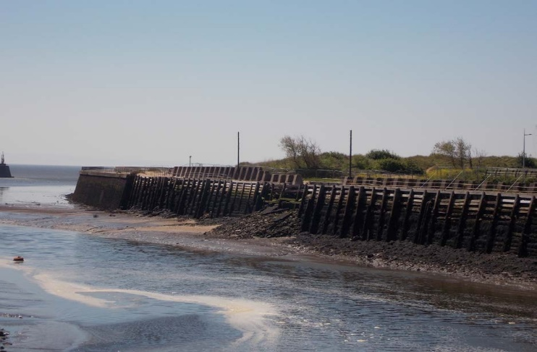
Figure 1. Damage to Swansea Inner West Pier retaining wall (ABP, 2018)

5.1. Water and Sediment Quality

Impacts were proposed to water and sediment quality resulting during the construction phase at Swansea Inner West Pier. Listed were likely changes to; suspended sediment concentrations, dissolved oxygen concentrations and water pollutant quantities (incorporating unintended leakages). However, these impacts were listed as low-risk and not requiring further assessments. Conversely, likely impacts during the work are anticipated from sediment-chemical rearrangement. Further assessment was required via collecting and analysing sediment samples for pollutants. This approach to water and sediment quality ensures the omission of needlessly polluting the water during construction. However, more stringent approaches towards chemical leaching (Wendt et al., 1996) considering the close proximity to SSSI locations and migratory fish corridors would be beneficial. Collecting sediment-chemical samples may provide other institutions/organisations with the opportunity to incorporate the samples to their research. Ongoing marine-vessel activity may threaten water quality.

5.2. Marine Ecology

Direct habitat losses for fish, marine mammals and birds are not anticipated. Neither were further assessments recognised as mandatory during construction in the changes to water quality and seabed habitats. Underwater noise effects on benthic habitats were also considered to be negligible. However, underwater noise modelling was undertaken in order to gauge the sound pressure, noise and vibration effects from piling on fish and marine mammals. Similarly, airborne sound and visual disruptions impacts on coastal birds was further considered and caution to minimise impacts employed during the construction process. Due to the nature of the work undertaken, no further assessment was required with regard to marine mammals’ collisions and visual disruptions. Furthermore, a biosecurity plan was prepared in order to eliminate any likelihood of introducing non-native invasive species to the project area. As evidenced in the EIA document, the direct impacts of the work towards marine ecology have been carefully contemplated according to migratory fish/bird patterns and breeding/mating seasons. But due to the wall piling process some form of excessive noise and vibration is going to occur and as such the safeguarding of marine mammals, fish and birds is somewhat restricted. Further opportunities may arise to research the limited field of the effects of sound and vibration on marine ecology.

5.3. Terrestrial Ecology

No further assessment was deemed necessary with regard to direct habitat impacts. This includes; disturbance/damage to dune habitats, maintenance of dune habitats and affecting the status of nearby and surrounding conservation areas such as Swansea SINC and Blackpill SSSI. Again, biosecurity plans were compiled in order to diminish the dispersal of invasive non-native species and protect priority plant species. Due to the nature and location of the piling process, no further assessments were required to investigate the impacts on invertebrates, reptiles, terrestrial birds, bats and otters from lighting, disturbance, damage, noise and vibration sources. Future rising sea levels and biodiversity loss may inhibit the development/formation of diverse ecosystems in the locality of the inner wall. With sections of the wall backing onto the Swansea Bay dune environment I was surprised to not see any mention of possible impacts from the construction materials, process and future implications of the wall on dune habitats and morphology. However, attention has been paid to protected species such as bats despite not being commonly found in such locations. Again, as previously mentioned in the marine ecology section, further opportunities may arise to research the limited field of the effects of sound and vibration on terrestrial ecology in coastal structure-settings.
5.4. Coastal and Flood Protection

Flood risk assessments were deemed mandatory especially considering exacerbated natural processes from climate change and subsequently rising sea levels. The surrounding areas local to the inner wall may be prone to flooding from storm events, spring tides and high river discharge rates. However future climate change was deemed inconsequential to maritime operations in the Swansea West Pier area. Coastal and flood defences were regarded as unaffected and not in requirement of further assessment. The consideration of the new retaining wall also providing coastal and flooding defence is viewed as a strength and aligns with shoreline management plans in the area. However, little mention to future rising sea levels and coastal flooding events is made with rationale for the height of the new retaining wall. However, the process of constructing piled retaining pier walls is costly, therefore financial reasons may be attributed to this.
5.5. Airborne Noise and Vibration
In order to counteract construction noise and vibration, further assessments were undertaken and used to gauge the potential impacts of airborne noises and vibration. Marine and terrestrial species susceptible to excessive noise and vibration from construction processes and the transportation of construction materials were also further assessed for their impact. The outcome was that airborne noise and vibration will be considerate to species’ seasonal biological patterns of migration, mating, breeding and feeding. However, the impacts were deemed mostly inconsequential even to the dune environment that backs sections of the inner pier wall. In addition, careful consideration was given to nearby human residents and visitors. Acknowledging that airborne noise and vibration is not only endemically affects other fauna. Again, as mentioned in earlier sections, further opportunities may arise to research the limited field of the effects of sound and vibration from piling in coastal structure-settings.

5.6. Landscape Visual Assessment
A landscape and visual impact assessment were undertaken as well as a field survey in order to establish environmental-visual impacts. The findings concluded that replacing the retaining wall bared little to no visual impacts on the landscape. However, temporary adverse impacts to the landscape and views were also considered during the construction phase. The new, repaired inner pier wall was attributed to everlasting beneficial impacts towards natural vistas and the landscape upon the completion of the construction phase. Settling a compromise for the duration of the construction process. The inclusion of visual/landscape assessments attributes that ABP is mindful of environmental appearance beyond industrial and commercial purposes. Nevertheless, no mention of blending/camouflaging the new inner pier wall to its surroundings was made in order to incentivise natural appearances on coastal developments. However, this may present itself as an opportunity for future improvements to employ a blended appearance approach. Finally, an immediate threat stands out from the eventual wear-and-tear of pier walls and therefore its visual status as beneficial to the public realm, no reference of future maintenance in the visual-landscape setting addresses this.

6. Recommendations & Conclusions
The EIA compiled by ABP contemplated and evaluated the possible environmental implications related to the construction of a new retaining inner wall at Swansea West Pier by considering all environmental topics related to the project. As outlined in the EIA, discussions with main stakeholders took place preceding and during the EIA process; debating environmental matters. This was a top priority to ensure minimal environmental impacts.
The bulk of impacts recognised in the EIA were assessed to be of little to no adverse consequence. The fundamental environmental issues were established to be those relating to increased noise and vibration intensities through the construction phase, affecting marine fauna and nearby human residents. In addition to the dislocation of vessels and the possibility of a disaster/incident concerning vessels during construction of the wall. Following the implementation of apt preventative measures, ABP states that the remaining effects are aimed to be lessened at negligibly adverse at very worst. Once the retaining inner wall of Swansea West Pier has been erected, ABP anticipates no substantial effects to be expected following the construction phase as outlined in the EIA (ABP, 2018).
The construction of a new retaining inner wall at Swansea West Pier has commenced and is in compliance with current EIA theory and UK process in addition to the aforementioned current government EIA legislations (Town and Country Planning Act 2017, Marine and Coastal Access Act 2009, Marine Works (EIA) Regulations 2007, Well-being of Future Generations Act 2015 and the Swansea Harbour Act 1864 (ABP, 2018), however the build is not yet completed thus proving difficult to fully substantiate the extent of environmental impacts and the success of the work. A separate comprehensive Health Impact Assessment document may prove useful in the future for similar works in order to holistically consider the health status of residents and visitors to the site and nearby conservation sites when undertaking invasive works or new developments in/near the coastal-residential zone. Additional comprehensive studies into atmospheric impacts from greenhouse gas emissions from construction machinery would further facilitate a widespread EIA text.
As previously alluded to in existing literature, public participation in the EIA and construction processes, particularly at Swansea West Pier may prove counter-intuitive to the motives and operation of ABP (Bassi et al., 2012). Despite the previous postulation, should ABP employ some form of public perception survey technique(s)they may discover that their organisational transparency, efficiency, effectivity,
accountability and governance increases and further abides to the key interdisciplinary principles included in environmental decision making (Beder, 2013). The Swansea Inner West Pier Marine Works EIA compiled by ABP is 170 pages long, containing a multitude of intricate and technical information, making it a laborious and time-consuming document to comprehend especially considering the extent of the proposed work. As stated by Jha-Thakur and Fischer (2016) cutting down on ‘technical obesity’ would lead to the creation of an informed, concise yet comprehensive EIA document.
To conclude this report, future monitoring is recommended in order to fully understand and appraise the environmental impacts at Swansea West Pier and at similar proposed plans in the future.
7. References
Arts J, Runhaar HAC, Fischer TB, Jha-Thakur U, Laerhoven FV, Driessen PPJ, Onyango V. The effectiveness of EIA as an instrument for environmental governance reflecting on 25 years of EIA practice in the Netherlands and the UK, Journal of Environmental Assessment Policy and Management, 2012; 14:1250025.
Badr ESA, Cashmore M, Cobb D. The consideration of impacts upon the aquatic environment in environmental impact statement in England and Wales, Journal of Environmental Assessment Policy and Management, 2004; 6: 19-49.
Bassi A, Howard R, Geneletti D, Ferrari S. UK and Italian EIA Systems: A comparative study on management practice and performance in the construction industry, Environmental Impact Assessment Review, 2012; 34:1-11.
Beder, S. (2013) Environmental principles and policies: An interdisciplinary introduction. (Environmental Principles and Policies: An Interdisciplinary Introduction). doi: 10.4324/9781315065908.
Bond A, Palerm J, Haigh P. Public participation in EIA of nuclear power plant decommissioning projects: a case study analysis, Environmental Impact Assessment Review, 2004; 24: 617-641.
Bond A, Stewart G. Environment agency scoping guidance on the environmental impact assessment of projects, Impact Assessment and Project Appraisal, 2002; 20:135-142.
Brooks, K.M. 1996. “Evaluating the environmental risks associated with the use of chromated copper arsenate-treated wood products in aquatic environments.” Estuaries 19(2A):296–305.
Burdick, D. M. and F. T. Short. 1999. “The Effects of Boat Docks on Eelgrass Beds in Coastal Waters of Massachusetts.” Environmental Management, 23(2): 231–240.
Caroll B.; Pearson, N. and Turpin T. 2002. Environmental Impact Assessment Handbook: A Practical Guide for Planners, Developers, and Communities. London: Telford, Thomas Limited.
Cooper LM, Sheate WR. Cumulative effects assessment: A review of UK environmental impact statements, Environmental Impact Assessment Review, 2002; 22:415-439.
Cooper, P.A. 1990. “Leaching of CCA from Treated Wood.” Proc. Canadian Wood Preservation Association II: 144–169.
Crawford, R. 1998. “Measuring Boating Effects of Turbidity in a Shallow Coastal Lagoon”. In “The Environmental Impacts of Boating: Proceedings of a workshop held at Woods Hole Oceanographic Insititution, Woods Hole, MA December 7–9 1994.” Technical Report WHOI-98-03. R. Crawford, N. Stolpe and M.Moore. Eds.
Crawford, R. N.Stolpe and M. Moore, Eds. 1998. “The Environmental Impacts of Boating: Proceedings of a workshop held at Woods Hole Oceanographic Insititution, Woods Hole, MA December 7–9 1994.” Technical Report WHOI-98-03
DOC (Department of Conservation). 2008. The guide to preparing your environmental impact assessment (EIA) for concessions applications. OLDDM-540455 - EIA version 4. New Zealand, Wellington: Department of Conservation.
European Commission, Impact Assessment Guidelines, http://ec.europa.eu/smart- regulation/impact/commission_guidelines/docs/iag_2009_en.pdf, 2009.
Fischer T, Sykes O. The TEN-T: an environmental pitch. Town and Country Planning. p. 2, 2009.
Fischer TB, Fothergill J. Das IEMA UVP Gütezeichen (EIA quality mark) im Vereinigten Königreich: Ein Beispiel freiwilliger Akkreditierung. UVP Report, 2015.
Fischer TB, Gazzola P, Jha-Thakur U, Belcakova I, Aschemann R. Environmental Assessment Lecturers’ Handbook, Road Bratislava, www.twoeam-eu.net, 2008.
Fischer TB, Gazzola P, Jha-Thakur U, Kidd S, Peel D. Learning through EC Directive based SEA in spatial planning? Evidence from the Brunswick Region in Germany, EIA Review, 2009; 29:421-428.
Fischer TB, Jha-Thakur U, Environmental assessment and management related master level degree programmes in the EU: baseline, trends, challenges and opportunities, Journal of Environmental Assessment Policy and Management, 2013; 15:1350020.
Fischer TB, Jha-Thakur U, Hayes S. Environmental impact assessment and strategic environmental assessment research in the UK, Journal of Environmental Assessment Policy and Management, 2015; 17:1550016.
Fischer TB, Potter K, Donaldson S, Scott T. Municipal waste management strategies, strategic environmental assessment and the consideration of climate change in England. Journal of Environmental Assessment Policy and Management, 2011; 13: 541–565.
Fuller K, Sadler B. EC guidance on cumulative effects and assessment Environmental Assessment, 1999; 7:33-35.
Glasson J, Cozens P. Making communities safer from crime: An undervalued element in impact assessment, Environmental Impact Assessment Review, 2011; 31:25-35.
Glasson J. The First 10 years of the UK EIA System: Strengths, Weaknesses, Opportunities and Threats, Planning Practice & Research, 1999; 14: 363-375.
Glasson, J. (1999) ‘The first 10 years of the UK EIA system: Strengths, weaknesses, opportunities and threats’, Planning Practice and Research, 14(3). doi: 10.1080/02697459915652.
Gray I, Edwards-Jones G. A review of environmental statements in the British Forest sector, Impact Assessment and Project Appraisal, 2003; 21:303-312.
Hagerty, D. J., M.F. Spoor and C.R. Ullrich. 1981. “Bank Failure and Erosion on the Ohio River.” Engineering Geology, 17:141–158.
Hartge, P. 1998. “Boating Induced Turbidity.” In “The Environmental Impacts of Boating: Proceedings of a workshop held at Woods Hole Oceanographic Insititution, Woods Hole, MA December 7–9 1994.” Technical Report WHOI-98-03. R. Crawford, N. Stolpe and M.Moore. Eds.
Hartley N, Wood C. Public participation in environmental impact assessment-implementing the Aarhus Convention, Environmental Impact Assessment Review, 2005; 25:319-340.
Jarvis AP, Younger PL. Broadening the scope of mine water environmental impact assessment: a UK perspective, Environmental Impact Assessment Review, 2000; 20: 85-96.
Jha-Thakur, U. and Fischer, T. B. (2016) ‘25 years of the UK EIA System: Strengths, weaknesses, opportunities and threats’, Environmental Impact Assessment Review, 61. doi: 10.1016/j.eiar.2016.06.005.
Kelty, R.A. and S. Bliven. 2003. Environmental and Aesthetic Impacts of Small Docks and Piers, Workshop Report: Developing a Science-Based Decision Support Tool for Small Dock Management, Phase 1: Status of the Science. NOAA Coastal Ocean Program Decision Analysis Series No. 22. National Centers for Coastal Ocean Science, Silver Spring, MD. 69 pp.
Kennish, Michael J., (Editor). 2002. “Impacts of Motorized Watercraft on Shallow Estuarine and Coastal Marine Environments.” Journal of Coastal Research Special Issue 37.
Marshal R. Application of mitigation and its resolution within environmental impact assessment: an industrial perspective, Impact Assessment and Project Appraisal, 2001; 19:95- 204.
Marshall R. Developing environmental management systems to deliver mitigation and protect the EIA process during follow-up, Impact Assessment and Project Appraisal, 2002; 20:286- 292.
Milliken, A. S., and V. Lee. 1990. Pollution impacts from recreational boating: A bibliography and summary review. Rhode Island Sea Grant. P 1134. RIU-G-90-002. 26 pp.
Modak, P. and Biswas, A.K. 1999. Conducting environmental impact assessment for developing countries. New York: United Nations University Press.
Morris, Peter. 2009. Methods of Environmental Impact Assessment. 3er Edition. London: Taylor & Francis.
Mueller-Blenkle C, Jones EG, Thomsen F, Elepfandt A, Lüdemann K, Kafemann R, Johnstone ADF, Reid DG (2010) Behavioural reactions of cod (Gadus morhua) to low frequency sound and implications for marine environmental management. ICES Journal of Marine Science
Noble, Ronald. 1978. “Coastal Structures’ Effects on Shorelines.” In Proceedings of the Sixteenth Coastal Engineering Conference, v. III. American Society of Civil Engineers. New York, NY.
OSPAR (2009) Overview of the impacts of anthropogenic underwater sound in the marine environment, OSPAR Convention for the Protection of the Marine Environment of the North-East Atlantic (www.ospar.org)
Petts J. Barriers to deliberative participation in EIA: learning from waste policies, plans and projects, Journal of Environmental Assessment Policy and Management, 2003; 5:269-293.
Planning Act. http://www.legislation.gov.uk/ukpga/2008/29/contents, 2008.
Planning Act. http://www.legislation.gov.uk/ukpga/2017, 2017
Popper AN, Hastings MC (2009a) The effects of athropogenic sources of sound on fishes. Journal of Fish Biology 75:455-489
Pritchard D, Towards sustainability in the planning process: the role of EIA, ECOS, 1993; 14: 10-5
Sadler, B. 1996. Environmental Assessment in a Changing World: Evaluating Practice to Improve Performance. Final Report of the International Study of the Effectiveness of Environmental Assessment. Ottawa, Canada: IAIA and Canadian Environmental Assessment Agency, Ministry of Supply and Services.
Sadler, B. and McCabe, M. (Eds). 2002. Environmental impact assessment training resource manual. 2nd ed. Genevea: Economics and Trade Branch-Division of Technology, Industry and Economics-United Nations Environment Programme.
Sadler, B. and McCabe, M. (Eds). 2002. Environmental impact assessment training resource manual. 2nd ed. Genevea: Economics and Trade Branch-Division of Technology, Industry and Economics-United Nations Environment Programme.
Sanger, D.M. and A.F. Holland. 2002. “Evaluation of the Impacts of Dock Structures on South Carolina Estuarine Environments.” SC Department of Natural Resources, Marine Resources Division Technical Report Number 99. Charleston, SC.
Sanger, D.M., A.F. Holland and G.I. Scott. 1999. “Tidal creek and salt marsh sediments in South Carolina Coastal Estuaries. I. Distribution of trace metals.” Archives of Environmental Contamination and Toxicology 37:936–943.
Sanger, DM and AF Holland. 2002. “Evaluation of the Impacts of Dock Structures on South Carolina Estuarine Environments.” SC Department of Natural Resources, Marine Resources Division Technical Report Number 99. Charleston, SC.
Senécal, P.; Goldsmith, B.; Conover, S.; Sadler, B. and Brown, K. 1999. Principles of environmental impact assessment best practice. North Dakota, USA: International Association for Impact Assessment.
Sikoyo, G. 1999.Environmental Impact Assessment of Biodiversity. In Okot-Uma R., Odiachi R.R. (Eds), Biodiversity and gender for sustainable development, pp.132-137. London: Commonwealth Secretariat.
Smart DE, Stojanovic TA, Warren CR. Is EIA part of the wind power planning problem? Environmental Impact Assessment Review, 2014; 49:13-23.
Swansea Inner West Pier Marine Works, Environmental Appraisal, ABPmer Report No. R.3080. A report produced by ABPmer for Associated British Ports, October 2018.
Swansea Inner West Pier Works, Screening and Scoping Report, ABPmer Report No. R.2985. A report produced by ABPmer for ABP, May 2018.
Thayer, G.W., D.A. Wolff and R. B. Williams. 1975. “The Impact of Man on Seagrass.” American Scientist 63:288–296.
Thomsen F, Lüdemann K, Kafemann R, Piper W (2006) Effects of offshore wind farm noise on marine mammals and fish, biola, Hamburg, Germany on behalf of COWRIE Ltd, Newbury, UK
UNEP (United Nations Environmental Programme). 1990. An approach to environmental impacts assessment for project affecting the coastal and marine environment. Regional Seas Reports and Studies No. 122. Washington, DC: United Nations Environmental Programme. http://www.unep.org/regionalseas/publications/reports/RSRS/pdfs/rsrs122.pdf
United Nations Department of Economic and Social Affairs, Division of Sustainable Development. Chapter 8: Integrating Environment and Development in Decision- Making. http://www.un.org/esa/sustdev/natlinfo/indicators/indisd/english/chapt8e.htm
USEPA (United States Environmental Protection Agency). 1998. Principles of Environmental Impact Assessment: An International Training Course. EPA/315B98001. Washington, DC: United States Environmental Protection Agency.
Weis, P., J.S. Weis, A. Greenberg, and T.J. Nosker. 1992 “Toxicity of Construction Materials in the Marine Environment: A Comparison of Chromated-Copper-arsenate-Treated Wood and Recycled Plastic.” Archives of Environmental Contamination and Toxicology. 22: 99–106.
Weis, P., J.S. Weis, and L.M. Coohill. 1991. “Toxicity to Estuarine Organisms of Leachates from Chromated Copper Arsenate Treated Wood.” Archives of. Environmental Contamination and Toxicology. 20: 118–124.
Wendt, P.H., R.F. Van Dolah, M.Y. Bobo, T.D. Mathews, and M.V. Levisen. 1996. “Wood Preservative Leachates from Docks in an Estuarine Environment.” Archives of Environmental Contamination and Toxicology, 31:71–79.
Weston J. From Poole to Fulham: a changing culture in UK environmental impact assessment decision-making? Journal of Environmental Planning and Management, 2002; 45:425-443.
Weston J. Screening for environmental impact assessment projects in Enland: what screening? Impact Assessment and Project Appraisal, 2011; 29:90-98.
Wood G. Is what you see what you get? Post-development auditing of methods used for predicting the zone of visual influence in EIA, Environmental Impact Assessment Review, 2000b; 20:537-556.
Wood G. Ten Years On: An empirical analysis of UK Environmental statement submissions since the implementation of Directive 85/337/EEC, Journal of Environmental Planning and Management, 2000a; 43:721-747.
Wood, G. 2008. Thresholds and criteria for evaluating and communicating impact significance in environmental statements: ‘See no evil, hear no evil, speak no evil’?. Environmental Impact Assessment Review 28 (1):22-38.

Environmental Impact Assessment and Trimsaran Housing Development
Bethan Stroud
University of Wales Trinity Saint David, MSc Sustainable Construction

1.0 Introduction

The aim of the report is to explore what an Environmental Impact Assessment (EIA) is and how they accompany planning applications to Local Authorities. It will also be highlighted when an EIA will be required and the stages of an assessment, prior and among planning applications. A case study will also be used to assess the effectiveness of the EIA and and whether the EIA has covered all potential environmental impacts which the project could cause, as well as critiquing the assessment and where improvements can be made. A full evaluation will be completed to identify whether the Environmental Impact Assessment was a good, thorough assessment, or whether it was ineffective and lacking information. Once the case study has been assessed, recommendations will be made on the EIA and how improvements can be made.

2.0 What is an Environmental Impact Assessment?

An Environmental Impact Assessment (EIA), is the procedure of judging the impacts a planned development or project will have on the environment. This will consider the potential negative health impact on humans or wildlife within an area, as well as the economic and social impact which can however provide a positive impact. It will assist with the decision making of a project and aims to foresee potential environmental impacts prior to the project taking place, which can allow negative aspects to be possibly be designed out, adjust plans and result in a reduced harmful impact on the surrounding environment.
The Ministry of Housing, Communities and Local Government defines the purpose and aim of an
Environmental Impact Assessment to “protect the environment by ensuring that a local planning
authority when deciding whether to grant planning permission for a project, which is likely to have significant effects on the environment”, and “is also to ensure that the public are given early and effective opportunities to participate in the decision making procedures” (Ministry of Housing, Communities and Local Government, 2014).
The EIA will also encourage projects to be designed around the local environment, integrating the possible wildlife or potential for an economic or social advantage as a result of the project. An example of an economic advantage would be the reduced costs of a project, as well as the time to reach completion. Within the assessment, this will be reflected in a lessened disturbance to the locality, clean-up costs and potential health and safety risks which are open to the public.
2.1. When is an EIA Required?

To understand whether an Environment Impact Assessment would be required, the project will be categorised in to either Schedule 1, or Schedule 2. Schedule 1 developments or projects would “tend to be larger developments or those with potentially the most significant environmental effects, such as airports, oil refineries, or motorways” (East Lothian Council, 2021). This category of developments would always need an EIA completed and without doing so, the project would not be granted planning permission. Other examples of a Schedule 1 development would be a nuclear power station, waste disposal, dams, overhead power lines and any road which would have four or more lanes.
Schedule 2 developments will not always require an EIA and will depend on aspects such as the projects size and location. “Schedule 2 development can include things such as wind turbines, certain industrial developments, golf courses, larger housing proposals, and a wide range of other types of development” (East Lothian Council, 2021). Other examples will include ski-runs, holiday villages and other tourism items. If your project falls in to the Schedule 2 of developments, it is advised that it undergoes screening for opinion and whether an EIA is required. This would be carried out by the Local Authority and is stage one of the five stages to completing an Environmental Impact Assessment.
2.2. Stages of EIA

The Government outline five stages which must be undergone to complete an Environmental Impact Assessment. The first stage would be Screening, which as mentioned in section 2.1, if a development meets the conditions of Schedule 2, requires a member of the Local Authority to assess the likelihood of the project creating a significant impact on the environment and if so, would require an EIA. Screening would take place at the beginning of the design stages of a project, to avoid the project being submitted for planning permission and the possibility of it being rejected due to the impact on the environment, thus saving time and providing the ability to make design amendments to lessen the potential negative impact.

Scoping is the next stage, which is “Determining the extent of issues to be considered in the assessment and reported in the Environmental Statement. The applicant can ask the local planning authority for its opinion on what information needs to be included (which is called a ‘scoping opinion’)”, “The applicant is responsible for the preparation of the Environmental Statement. In order to ensure the completeness and quality of the Environmental Statement, the applicant must ensure that it is prepared by competent experts and that it is accompanied by a statement from the developer outlining the relevant expertise, or qualifications of such experts, sufficient to demonstrate that this is the case” (Ministry of Housing, Communities and Local Government, 2017). Under the Town and Country Planning Regulations 2017, it is required to make copies of a projects EIA scoping opinions available for public inspection. This will allow the local public to raise concerns regarding a development and to inspect the assessment which has been carried out by the Local Authorities and their final opinion to whether an EIA will be completed.
If it is decided by the Local Authorities that an EIA must be completed, the next stage would be to submit an Environmental Statement. “The Environmental Statement must include at least the information reasonably required to assess the likely significant environmental effects of the development” (Ministry of Housing, Communities and Local Government, 2017). The statement should include detailed and genuine descriptions of the development and the main environmental effects should be discussed. This will be to present data, knowledge and the potential science behind the environmental impact the project will create. Within the statement, if there are possible amendments which can be made to differ the impact and effect of the project, these should be compared and discussed within the statement.
Once the previous stages have been completed, the developer can then make an application, which must be publicly accessible. This allows stakeholders to raise issues on the development with potential disagreements of opinions. This will accompany the planning application sent to the Local Authority. The application must include the Environmental Statement, location of the project, where further documents and information is available, as well as date stamps. “The Environmental Statement must be placed on Part I of the planning register, as should any related screening or scoping opinion or direction as soon as possible after publication” (Ministry of Housing, Communities and Local Housing, 2017).
The fifth stage is the decision making stage. This is where the Local Authority or Secretary of State (for major developments) will assess the information provided from the Environmental Impact Assessment and Statement, along with the planning application. After reviewing the package, it will be decided whether the project has been granted permission to proceed and the decision will need to be publicised. Although this is not the topic of the report, it is important to highlight this process to show the significance an EIA and how it influences the final decision making. “The local planning authority must take into account the information in the Environmental Statement, the responses to consultation and any other relevant information when determining a planning application.” (Ministry of Housing, Communities and Local Government, 2017).
2.3. Legislation in the UK
A significant law is the Town and Country Planning Act 1990, “An Act to consolidate certain enactments relating to town and country planning (excluding special controls in respect of buildings and areas of
special architectural or historic interest and in respect of hazardous substances) with amendments to give effect to recommendations of the Law Commission” (Town and Country Planning Act, 1990). This Act states policies for development and altering the use of land in an area, which will take in to account the appearance within the surrounding area, physicality and environmental impact as a result. The Act provides guidelines for providing local planning and granting permission to construct or develop for all different natured projects. From this Act, further revisions have been implemented to ensure the legislation is up to date and provide framework for new usage which can have an environmental impact. Although there is a substantial amount of framework around the Town and Country Planning Act 1990, the decision making process is highly variable with location, nature of the project, predicted environmental impact, opinion of stakeholders and the Local Authority, which can be significantly dependant on biased and personal opinions.
3.0. The Proposal
The proposed project is a large housing development within Trimsaran, West Wales. The development is to be consisting of 139 homes and 29 garages, ranging from two bedroom terraced houses to four bedroom detached homes. Eight of these homes will be built to be sold to housing associations or to be ‘affordable’ homes. The project will be constructed by a large housing developer who have previously built three other developments within this area, the one in discussion being phase four. The project has views of Ffos Las Race Course opposite, with a small stream, road and a plot of land which is between the homes and the course. Within the development, an area for open space has been designated which will include sitting benches and a small number of children’s playing blocks. The build timescale is aimed for May 2019 - September 2021.

3.1. Why is the Project Required?

Housing projects are required to be constructed to keep up with the housing demand in the UK. According to the UK Parliament “Estimates have put the number of new homes needed in England at up to 345,000 per year, accounting for new household formation and a backlog of existing need for suitable housing.”, “The White Paper identified a threefold problem of “not enough local authorities planning for the homes they need; housebuilding that is simply too slow; and a construction industry that is too reliant on a small number of big players” (Barton and Wilson, 2021). Due to the nature of the developer, it is likely that the project will be completed relatively quickly to ensure the availability of the homes. The location of the development is also not heavily built, with no surrounding shops, garages and not many homes. The homes are affordable for the surrounding areas, with short commutes to the M4 and city centre which is desirable for first time buyers, young families and commuters. These requirements are sought after within this area, emphasising the need for the project. The area is overseen by Carmarthenshire Country Council, who have issued an Affordable Homes Delivery Plan by 2020. “The purpose of this plan is to provide the detail on how and where we will deliver more affordable homes. The initial programme will deliver over 1000 additional affordable homes over the next five years, with a total investment exceeding £60m. The plan will also explain how we could deliver an ambitious new build programme by looking at the delivery options. This will further increase the number of homes delivered and provide additional investment” (Carmarthenshire County Council, 2016). It would be in the local councils interest to grant permission to the housing developer to help achieve their plan in action, adding to the local requirements for the project.
3.2. How Does it Impact the Local Community?
The project will impact the local community in many positive and negative ways. Some negative impacts would be the increased traffic resulting in more carbon monoxide fumes, noise, lack of parking with newly built homes resulting in many cars on roads, and in some people’s opinions, the homes allocated to social housing. Where the area was once a smaller ‘village type’ community, will begin to grow in to a loud and busier location. With the development of more homes, it will attract more construction of shops and other attractions which will further increase the footfall in the area. During the construction process it will also impact the community due to the noise of building, deliveries, logistics and lack of privacy with the quantities of trades peoples around homes. Many of these negative examples are of social impact, which are still an important feature to the Environmental Impact Assessment.
The local community can also benefit from the project in this area, with positive impacts such as creating much needed homes, homes which are affordable, ability to commute, Section 106 works which will improve items such as roads, kerbs and planting of trees and attraction to the area which can create result in jobs in local shops.
In the short term, the community will experience some disturbance due to construction and increased traffic, however the project will be providing much needed homes in the area and affordable rates. It creates a positive social impact in the long run for the purchaser, as well as additional open space allocated for the whole local community.
“Those affected by a specific development have a right to comment and to have their concerns about the development’s impact taken into account. Importantly the issues that can be taken into account do not include the possibility that local house prices may be adversely affected, although it is often argued that this possibility lies behind many of the objections which are put in terms of negative externalities” (Whitehead et al. 2015). This is why it is important that the Environmental Impact Assessment is available for public access, as many people will be effected differently by a new housing development in their area.
3.3. Potential Risks and Health Factors

A potential risk which could occur is the pollution of the small stream adjacent to the development. The result of this could disrupt any wildlife living in the stream by materials being dumped in to the water. This would include items such as contaminated soil, insulation, concrete, metals, petroleum or emulsion. Another risk in the area is the ground conditions. It was known that an area on the development had severely unstable ground, with testing resulting in piled foundations and large capping layers on the roads. A potential risk to this area, which has occurred previously in the West Wales area of Machynys, is the possibility of the ground sinking around the foundations. This will damage the property and create a hazard for the home owner. If this was to happen outside the purchasers warranty, then the costs would be for them to wholly cover. The weak ground is due to the coal mining which took place in the area in the 1800’s.
Human health could also be impacted by radon in the ground, which can result in increased risk of lung cancer. Although there are radon barriers in place to protect, this is still a high risk to human health if not correctly installed. According to McColl “If we breath in high levels of radon over long periods of time this exposure can lead to damage to the sensitive cells of our lungs which increases the risk of lung cancer. Radon causes about 1,000 lung cancer deaths in the UK every year”, “Every building contains radon but the levels are usually low. In some parts of the country homes may have higher levels, and the chances of a higher level depend on the type of ground” (McColl, 2015). Below is an image provided by McColl showing the areas of high radon. It is noticeable that Wales in general is high for radon, however we can see that the further West you travel, the radon is higher. Homes need extra care before and post construction to ensure radon barrier are in place and further protection is provided post construction.
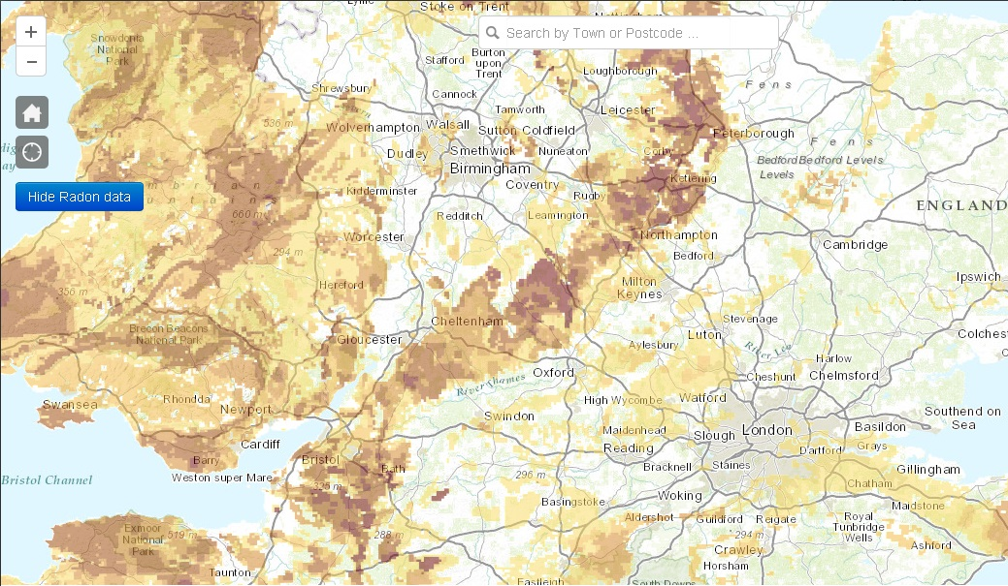
Image 1 - Neil McColl, 2015
According to Whitehead et al, many people believe that new residential developments reduce physical wellbeing. “The initial response of many people to the possibility of new residential development nearby is that it will reduce their wellbeing, notably with respect to access to local services, their own immediate environment and simply because of the impact of increased population in the area.”, “More generally households can be resistant to change and uncertainty concerning their neighbourhood and neighbours. Economically, residents may be worried about whether the market might respond to development by reducing the prices of existing dwellings as a result of increased supply, or whether demand might decrease as a result of the degradation of local attributes. These issues are core to the longer-term acceptability of new development.” (Whitehead et al, 2015). This is another risk/impact which the new housing development can have on the local community.
4.0. Evaluation of the EIA

To evaluate the Environmental Impact Assessment, the document will be compared to to the highlighted issues within section 3.2 and section 3.3, and what considerations the developer has identified prior to design of the project. The strengths and weaknesses of the EIA will be evaluated, along with recommendations on how it could be improved. It is important to evaluate the threats, risk, sustainability and social impact which the development will cause to the local community and how the developer is aiming to avoid such issues, eliminate or reduce negative impacts to the area. Strength, weakness and effectiveness can however be subjective to the stakeholder, with differing interests
and opinions, values or even morals. To evaluate the Environmental Impact Assessment, remaining unbiased is key to draw clear recommendations and conclusion.
4.1. Strengths
Upon first glance of the Environmental Impact Assessment, it is clear that many aspects have been considered at the design stage. Firstly, there is a detailed explanation of the area’s history and location. This is important due to the issues with the ground conditions in the area. The EIA discusses the prior use of coal mining in the area of Trimsaran in the late 1800’s to early 1900’s. This includes multiple coal pits. The EIA also highlights further previous usage of brickworks and queries nearby, another possible factor in having weak ground in the area. The Environmental Impact Assessment goes in to detail regarding previous land usage and physical setting. It is noted that the area have been significantly backfilled, changing the land and valley’s features.
An identified strength to the Environmental Impact Assessment is the detailed information on the stratigraphy and structural geology. “Stratigraphy, scientific discipline concerned with the description of rock successions and their interpretation in terms of a general time scale. It provides a basis for historical geology, and its principles and methods have found application in such fields as petroleum geology and archeology” (Britannica, 2021). This detailed information can assist with engineering requirements and the environmental impact the works will cause, as well as the significance of the impact.
Another strength would be the mention of radon, as previously mentioned in section 3.3. it was indicated that no radon protection would be required at the development, therefore not resulting in an environmental impact or human health risk.
The Environmental Impact Assessment also highlights the risk of flooding in the area. This is important for environmental impact as the homes will be built in the center of a water run-off.
“About 5.5 million homes in the UK are in danger of being flooded. That’s approximately 15% of properties built near to rivers, the sea or areas of extreme surface water run-off caused by local ground conditions – the latter of which are often in places that aren’t actually near to open water” (Owen, 2018).
4.2. Weaknesses
A weakness of the Environmental Impact Assessment is the lack of further information on the local coal mining and the position of entries or exact locations. “The position and recorded treatment details for the mine entry will be revealed in any future coal mining report produced for prospective purchasers of the property. Consequently it is necessary for the landowner and/or developer to undertake any work precisely in accordance with the agreed scheme and provide detailed information to The Coal Authority for inclusion within its records for future reference and disclosure.” (The Coal Authority, 2012). Within the EIA, another weakness would be the lack of location of the previous quarries and brickworks in the area.
Regarding the detail of radon within the Environmental Impact Assessment, a weakness identified would be the lack of science or data behind their conclusion. Due to the human health risk radon causes, it would be important to provide numerical information or figures from different locations at the development.
Another weakness to the Environmental Impact Assessment is the lack of information regarding social impact within the local community. The EIA or developer does not mention the positive or negative impact the project could have to the area, local people or businesses. A key aspect to the EIA is the social impact, however the main topics which are highlighted are the physical aspects and compositions which will negatively affect construction and increase costs for the developer, rather than negatively effecting the environment or people. Throughout the Environment Impact Assessment, human risk or health has not been mentioned.
Furthermore, the Environmental Impact Assessment has not discussed potential risk of contamination of the stream adjacent to the development. It would have been important to include possible negative environmental impact due to construction. This would also include the potential pollution, fumes, increased traffic and carbon monoxide. The EIA has shown a biased and one sided assessment, rather than gaining data from all aspects of an Environment Impact Assessment.
The Environmental Impact Assessment can also be criticised due to the general lack of information. The assessment was very short, one sided and biased. It was written in the view of the developer, missing regard for the local community, environment or people who would be living in the homes.
5.0. Recommendations
It would be recommended that the Environmental Impact Assessment should increase information on the location of the coal mines and specific areas which may have been at risk. This information could reduce building risks, or even risk of injury. This would also be applicable to the location of the quarries and brickworks within the area and how it would effect construction in the local area.
It would also be recommended that the Environmental Impact Assessment should include discussion on human risk and health, as well as the social impact the development would cause as this has not been highlighted throughout the assessment. As the site is going to be built for human use, it would be necessary to discuss the end user and the impact that it will have on them and the environment. In addition to this, the EIA is recommended to note the positive impact the development can have on people, by providing homes, open space areas, additional trees, affordable homes and improved roads due to the Section 106 works in the area. This would emphasises the positive social impact which has been completely missed within the EIA.
6.0. Conclusion
To conclude, if effectively carried out, an Environmental Impact Assessment can be an eye-opener to the public and stakeholders to a project. Although this would already be necessary to complete for a large housing development to accompany a planning application, it could correctly inform the community and how the developer will design out or alter aspects of the project to ensure a limited environmental impact and positive impact socially. A result of going this would also result in localities possibly being more accepting of a large residential project in their area. It was found that this particular Environmental Impact Assessment was not well rounded and lacked in diversity in regard to the environment, social and economic impact. The EIA was very biased to the developer was only discussed aspects which would result in major issues to construction or which would result in significant costs. The issues of previous coal mining would agreeably need to be discussed, but should not have been the only topic to be reviewed on the EIA. With the recommendations completed and weaknesses eliminated, the Environmental Impact Assessment would ensure a well-rounded, unbiased and true view on the environmental and positive social impact of constructing this housing development in this community.
7.0. References
Britannica, 2021, Stratigraphy, www.britannica.com/science/stratigraphy-geology [Last visited 6/4/21].
Carmarthenshire County Council, 2016, Affordable Homes Delivery Plan 2016-20, www.carmarthenshire.gov.wales/home/council-democracy/strategies-and-plans/affordable- homes-delivery-plan-2016-20/ [Last visited 3/4/21].
Cassie Barton, Wendy Wilson, 2021, Tackling the under-supply of housing in England, www.commonslibrary.parliament.uk/research-briefings/cbp-7671/ [Last visited 3/4/21].
Christine Whitehead et al, 2015, Understanding the Local Impact of New Residential Development: a Pilot Study, http://eprints.lse.ac.uk/63390/1/ Understanding_the_Local_Impact_of_New_Residential_Development.pdf [Last visited 7/4/21].
East Lothian Council, 2021, What is an EIA and when is it needed?, www.eastlothian.gov.uk/ info/210547/planning_and_building_standards/12270/environmental_impact_assessment_eia [Last visited 1/4/21].
Julian Owen, 2018, Building a House in a Flood Zone, www.self-build.co.uk/building-a-house- in-a-flood-zone/ [Last visited 6/4/21].
Ministry of Housing, Communities and Local Government, 2014, Environmental Impact Assessment, www.gov.uk/guidance/environmental-impact-assessment [Last visited 1/4/21].
Neil McColl, 2015, Five facts every home owner should know about radon, www.publichealthmatters.blog.gov.uk/2015/03/20/five-facts-every-home-owner-should-know- about-radon/ [Last visited 5/4/21].
Town and Country Planning Act, 1990, Chapter 8, www.legislation.gov.uk/ukpga/1990/8/ introduction [Last visited 1/4/21].
The Coal Authority, 2012, Policy For Building Over Or Within The Influencing Distance Of A Mine Entry, www.assets.publishing.service.gov.uk/government/uploads/system/uploads/ attachment_data/file/363064/policy-for-building-over-or-within-the-influencing.pdf [Last visited 6/4/21].

Environmental Impact Assessment and The Cleve Hill Solar Park
Marie A. West
University of Wales Trinity Saint David, MSc Environmental Conservation and Management

ABSTRACT
The Built and Natural Environment sector has had to change their view on the environment as the public and governments over the world start a journey to improve environmental conditions, this is where Environmental Impact Assessments (EIA) and new legislation have been put into place. The case study being review in this report is Cleve Hill Solar Park, Faversham. The report examines how the case study carried out their EIA, focusing on Ecology, mitigation and monitoring. The report found that extensive surveys where carried to establish what type of habitats and wildlife could be found in the possible site, however, little details was given on what plans were in place to mitigate the impact to the habitat and wildlife, and no monitoring methods were given.

1.Introduction

The topic of the environment has become a subject that is important to talk about due to the increased decline. With the pressure of climate change many sectors in the United Kingdom (UK) Have had to change the way they do things; the UK Government are devoted to having a net-zero carbon emission by the 2050 (Harvey, 2021). Although the built environment has been taking large steps to become more environmentally friendly, they still account for 45 percent (%) of the UK’s carbon emissions (Harvey, 2021). A large percentage of carbon emissions can be attributed to the built environment, 32% of land field waste comes from construction and demolition, and 58% comes from water consumption (Sexton et al., 2011). The UK Government has continued to make strides in policies to improve the environment and to make the built environment industry more friendly towards habitats, biodiversity, wildlife and be more sustainable (Sexton et al., 2011).

This report will examine the Environmental Impact Assessment (EIA), what the process entails and discussions on the progress toward the effectiveness and execution of such policies. For this report a case study of Cleve Hill Solar Park, Faversham will be used as an example to represent the theories and how policies can be put into practice. The report will also consider any changes in policies and the industries views on current changes.

2.What is an Environmental Impact Assessment?

An Environmental Impact Assessment (EIA) was first considered when concerns for the environment from the public and the world in general, became more increasing in regard to development projects and the impacts (Croner-i Ltd, 2021). The EIA process was first established in the United Stated (US) in 1969 and in the years to come over 100 countries adapted a similar process (Croner-I Ltd, 2021). In 1988, the European Union (EU) and its member states made it a legal requirement to participate in the EIA process, called A European Directive EIA (85/337/EC) (Croner-I Ltd, 2021).

Over the years the EU have amended the European Directive EIA (85/337/EC), the last time in 2014 (Croner-I Ltd, 2021); but in 2001 they introduced more criteria to the Directive and called it Strategic Environmental Impacts. This new criteria was to
enhance understanding of the environment at a strategic scale and help to influence the decisions of potential types of developments of where and when they will proceeded (Croner-I Ltd, 2021).

Although the UK has left the EU there are other polices and strategies in place that each UK country follows, or each country has built upon to make the polices more accommodating to fit their own country (Croner-I Ltd, 2021).

The EIA process for this case study, Cleve Hill Solar Park, will be using England’s process as its locations is in England. The development is considered a ‘Nationally Significant Infrastructure Project’ (NSIP) (Arcus Consultancy Services Ltd, 2017). This falls under the Planning Act 2008 in section 14(1)(a) and 15(2) due to the new generator having a capacity of more the 50 Megawatt (MW) (Arcus Consultancy Services Ltd, 2017). The development has to follow a number of legislation but another main one is the Town and Country Planning Act 1990 (Arcus Consultancy Services Ltd, 2017).

An EIA is carried out to gather data and information, then to compile it into a format that is understandable, such as a report (Croner-I Ltd, 2021); this data and information will establish what impacts to the environment could be expected if the development were to go ahead, this will then allow the consulting authority to make a decision on whether to allow the planning to go ahead or to deny permission to develop (Croner-I Ltd, 2021). There are a number of steps to follow when carrying out an EIA (Figure 1) that will allow a developer to gain a response and communicate between the different stages, making sure that the Environment Statement (ES) contains all of the information that it should (CBD Secretariat, 2021).
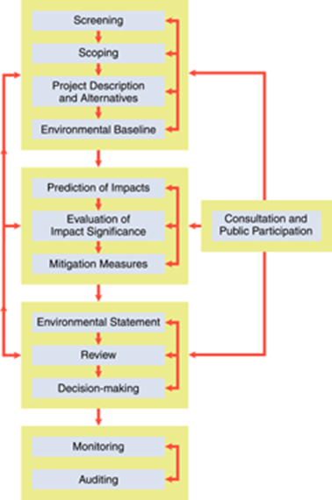

Figure 1. The Environment Impact Assessment Process (Croner-I Ltd, 2021)

Although an EIA is important not all developments will be subjected or required to carry one out. There are different layers, for example, a Schedule 1 will be such developments as airports, motorways and energy stations, these will require an EIA to be conducted, while a Schedule 2 will differ depending on the development hoping to take place, the consulting authority will need to examine the Screening process, which will determine if the development will need to be conduct an EIA (Exam Chum, 2021).

The Screening process is a step that indicates if a development could have a possible impact on the environment and if so, would require an EIA to take place (Exam Chum, 2021). Once the decision has been reached the developer can move to the next step. If an EIA is required then the next step would be for the developer to request a scoping report (Sexton et al., 2011).

The Scoping report is an important step in the EIA process as it allows the impacts, alternatives to cause less of an impact to be suggested and what methods could be used or will be used in the different stages (Harvey, 2021). This stage also allows for other information such as what type of surveys will be used, what type of monitoring measures will be put in place, what possible impacts there could be and what areas in and surrounding the location could be influenced by the development (CBD Secretariat, 2021).

All of the information gathered is then compiled into an Environmental Statement (ES) which is then given to either the local authority or secretary of state (Exam Chum, 2021); the authority of body presiding over the development will then give or not give permission for the development to continue (Croner-I Ltd, 2021). This decision will be concluded by the information given in the Environmental Statement, this approval or refusal will then have to be made public along with any justifications for this decision (Harvey, 2021).

3.Cleve Hill Solar Park Background Project

Cleve Hill Solar Park is located on the Coast of North Kent, residing in close proximity to the Village of Graveney, approximately 1 mile northeast of Faversham and 3 miles west from Whitstable (Kent Wildlife Trust, 2021).

The surrounding area of the Solar Park consist of a wide range of habitats, along with special sites. For Example, (Figure 2) shows the designated areas with valuable wildlife both at a National and International level, The Swale has three designations, Site of Special Interest
(SSSI), the National designation of a Special Protection Area and European designation of a Ramsar Site (Kent Wildlife Trust, 2021); not only does The Swale have these three different designations but it also has a Marine Conservation Zone which is another national designation (Kent Wildlife Trust, 2021).
This development is considered a Schedule 2 under Part 3 (a) of the Environmental Impact Assessment Regulations as its development would consist of ‘industrial installation for the production of electricity, steam and hot water’ (Arcus Consulting Services Ltd, 2017. P: 8). Although this general means that it is not obligatory for Schedule 2 developments to carry out an ES the developers, knowing the background of the site, decided that one should be carried out without request from the presiding body (Arcus Consulting Services Ltd, 2017). As stated before, this development is defined as a National Significant Infrastructure so this means that the Secretary of State was the person who read the ES and made a decision on whether the development was to go ahead or not (Arcus Consulting Services Ltd, 2017). The development was given permission to continue by the Secretary of State for Business, Energy and Industrial Strategy (Kent Wildlife Trust, 2021). This means that 800,000 solar panels will be placed, comprising of roughly 890 acres (360 hectares) of former grazing marsh (Kent Wildlife Trust, 2021).
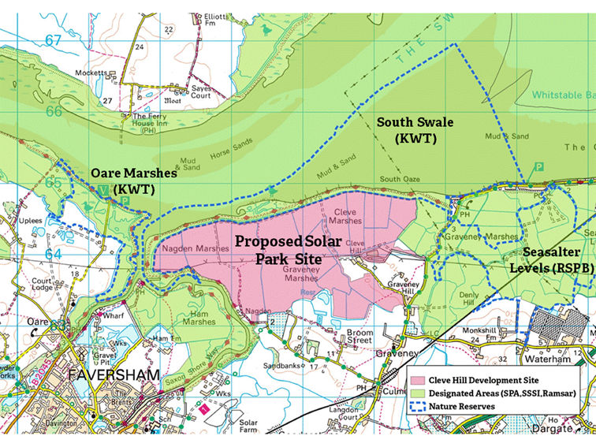

Figure 2. The Proposed Solar Park Site with Designated Areas Highlighted (Natural England, 2020)

The developers of Cleve Hill Solar Park are two separate companies who specialise in solar parks but joined forces for this development (Cleve Hill Solar, 2021).

One of the companies is Hive Energy, which was first founded in 2010, and focus on providing energy by using Photovoltaic (PV) power; this is done by installing solar panels on commercial rooftops, building, solar farms and solar parks (Hive Energy Ltd, 2021). They also work international in such countries as, Africa, Middle East and Central America (Hive Energy Ltd, 2021). Their technology and vision of a clean future is what has made them the leading developers in Solar PV energy in the UK and given the title of ‘Pure Play Developer’ by Bloomberg (Hive Energy Ltd, 2021).

The second company is Wirsol, first founded in 2013, and they focus on large scale projects in renewable energy such as, wind and photovoltaic (Wirsol Energy Ltd, 2021). They primarily work in the German market for renewables but are located in Spain, Italy, Belgium, UK, Switzerland, Canada, the United States, Brazil, Japan, China, Malaysia and the Maldives (Wirsol Energy Ltd, 2021).

Due to the different designated sites surrounding and within the proposed development site different organisations and government bodies had decided to make their voices herd on the project, with some not reviewing the scoring report before voicing their disdain for the project.

Kent Wildlife Trust, Kent Country Council, Swale Borough Council and the Royal Society for the Protection of Birds (RSPB) were some of the few organisations and government bodies that voice their issues with having this development on the proposed site. Although the government bodies were unable to contest this development and had to stop with their protests, they still made it clear they were unhappy. The organisations, such as the Kent Wildlife Trust, stated

“Kent Wildlife Trust is not opposed to solar parks and is supportive of initiatives to reduce reliance on fossil fuels - but this must not be at the expense of other aspects of the natural environment. As with many development issues, it is as much about ‘where’ as ‘what’ and in this case the development site is ‘functionally linked’ to the surrounding habitats and plays a vital role in supporting the species for which the area has been designated. In particular, significant numbers of Brent geese, lapwing and golden plover use the farmland. Marsh harrier breed and feed in the area and may be displaced by the presence of the solar panels.” (Kent Wildlife Trust, 2021. P. 1).

The developers say that they did try to keep the public informed about their plans (Community Consultation Leaflet, 2017). This was done by presenting the communities with information in meetings when phase 2 of construction started, while also providing community news leaflets every few months (Community Consultation Leaflet, 2017). These leaflets could be found around the communities and on
the developer’s website (Community Consultation Leaflet, 2017).
There are many parts to their Scoping report for Cleve Hill Solar Park and the chapters are layout out as shown below:

- Introduction
- Environmental Impact Assessment
- Consultation
- Site Selection and Consideration of Alternatives
- Project Description
- Legislative and Planning Policy Context
- Landscape and Visual Impact Assessment
- Ecology
- Ornithology
- Hydrology, Hydrogeology, Flood Risk and Ground Conditions
- Cultural Heritage and Archaeology
- Noise and Vibration
- Socio-Economics, Tourism, Recreation and Land-use
- Access and Traffic
- Climate Change
- Miscellaneous Issues, including glint and glare, human health and telecoms and waste
- Interaction and accumulation of effects
- Supporting Figures and Drawings
- Technical Appendices (e.g., baseline survey reports)

The report does contain many subheads breaking the report down further with more information, with a 5-page content table. These are just the main headings.
This project is placed in an area that has many different designated sites which contains a variation of different habitats, and the development is a large scale project, that conducted a lot of information gathering to be able to give a well-informed Environmental Statement. However, for this report the main section that will be focused on will be the Ecology as the Scoping report is too long to examine all of it.

3.1 Ecology
There are a number of different designated sites within the area, either at a local, national or international area (Arcus Consulting Services Ltd., 2017). The Scoping report has listed all of the different designated site within the area, in a 5 kilometre (km) distance of the development site. The location contains, one Marine Conservation Zone (MCZ), four Local Nature Reserves (LNR), two Sites of Special Scientific Interest (SSSI), one Special Area of Conservation and three National Nature Reserve (NNR), however, one area located within this site has three different designated site status with a Site of Special Scientific, a Ramsar site and a Special Protection Areas (SPA) (Arcus Consulting Services Ltd., 2017).

There are a few sites that sit close to the development site. Two of the designated sites are situated adjacent in The Swale is, which sits to the north, east and west of the site, and has a designated site status of SSSI, Ramsar and SPA (Arcus Consulting Services Ltd., 2017). The other adjacent site is situated in to the north and west of the development site, and its names is South Bank of the Swale and has a designated status of LNR (Arcus Consulting Services Ltd., 2017). Both these sites were given these statues due to having habitats such as mudflats, salt marshes, grazing marshes and wildlife such as, notable international gatherings of certain invertebrates, plants and birds (Arcus Consulting Services Ltd., 2017).

The next closest designated site sits just 10 metres (m) to the west of the proposed site, with a MCZ status, which it gained due to intertidal aspects, subtidal aspects, high biodiversity, spawning and nursery site for different fish species and permanent home for marine invertebrates, this site is The Swale Estuary (Arcus Consulting Services Ltd., 2017).

The Oare Marshes, which is at a distance of 300m from the development site, has a LNR designated status due to containing traditional grazing marsh, reedbeds, saltmarsh with freshwater and brackish dykes found in little streams running through the habitats (Arcus Consulting Services Ltd., 2017). This site also contains important international migration, overwintering and breeding wetland birds, the saltmarshes sustain unique plants such as golden samphire, sea lavender, sea purslane, sea clover and thrift, while the freshwater dykes have plants such as frog bit, reedmace and water plantain (Arcus Consulting Services Ltd., 2017). A common visitor to Swale is the Common Seals that like to swim there too (Arcus Consulting Services Ltd., 2017).

The remaining 8 designated site range in distances from 1.4 km to 4.4 km (Arcus Consulting Services Ltd., 2017). The remaining designated sites are The Swale with a NNR, Seasalter Levels with a LNR, Foxes Cross Bottom with a LNR, Ellenden Woods with a SSSI, Blean Complex with a SAC, Elmley with a NNR, Blean Woods with a NNR and Church Woods Blean with a SSSI (Arcus Consulting Services Ltd., 2017). With this information in hand the developers carried out a range of different surveys and site visits. The surveys found that in three of the ponds, not located on site, had the presents of crested newts, many of the surrounding bodies of
water did show signs of the presents of water voles, the area is sustainable for bats but little bat activity was seen, in the ditches with water atypical insects where present and, the flora in the surrounding area showed no signs of rare or important vegetation (Arcus Consulting Services Ltd., 2017).
The conclusion made from these surveys found that the project will ‘limit likely ecological effects’ due to the infrastructure being located in arable land, which was found to have ‘limited ecological value’ (Arcus Consulting Services Ltd., 2017). However, they did state that there would be

“Loss of, and disturbance to, terrestrial habitats due to land take by the infrastructure; Loss of habitat important for the maintenance of species’ conservation statuses; Direct disturbance of, and harm to, animals, including the displacement of species from the proximity of the Development; and Potential legal offences, even when significant adverse ecological effects are unlikely.”(Arcus Consulting Services Ltd., 2017. P. 51-52).

A desk assessment was also carried out which was done to gather information on the site that would be of use to their EIA. The information gathered was historical and regional; for example, the Kent and Medway Biological Records Centre and National Biodiversity Network was contacted to obtain records of any notable or protected species that could be found in the location, whether they were there at present or in the past (Arcus Consulting Services Ltd., 2017).

4.Review of Academic Literature
The literature on EIA should be noted as it shows an insight into the how the process should work and how it does work in practice. The goal of an EIA is to help protect the environment, by have this task carried out it allows the presider to make a decision on whether the effects of the development will be significant (Government, 2017) and encourages the industry to be more sustainable.

4.1 The Screening and Scoping
The screening step is the first phase towards the EIA process (International Institute for Sustainable Development, 2021).The purpose of a screening process is establish whether an EIA is required for the project being examined (European Commission, 2001). For example, should the assessment be performed, will there be a considerable impact, or there is no need for the assessment to be performed due an anticipated lack of considerable impacts (International Institute for Sustainable Development, 2021). The Screening process is essential as it will reveal the amount of impact expected from the short term and long term of the development or project (International Institute for Sustainable Development, 2021).

Although many smaller developments appear to not need one, or might only have to consider if an EIA is needed due to the proposed site have a designation (The Town and Country Planning Regulations, 2011). However, in regards to Cleve Hill Solar Park the developers did considers the sites around them while also considering how they could continue to support the habitats and wildlife within the vicinity.

The scoping stage is performed in preparation to accomplish an EIA, this step will distinguish any issues that have the possibility to have the highest consequence while allowing one with little or less consequences to be excluded (International Institute for Sustainable Development, 2021). The scoping report helps to establish the limits of an EIA in regards to the development, what the EIA will include and how the EIA was assembled using terms of references (International Institute for Sustainable Development, 2021).

However, while researching the government EIA guidelines there seemed to be no guidance on what would be consider to have the highest consequence, in regards to what would impact the environment more and what would be detrimental to the wildlife. Due to this lack of guidance on what would be considered to have the highest consequence, it could be the reason behind having such large scoping reports as the developer is including everything to make sure there are no delays in the presider giving permission or not.
This is clear to see in the scoping report for Cleve Hill Solar Park and the ES, the consulting services used made sure to include ever last little bit of detail including such things as what a scoping report is; which means it is of no surprise that the scoping report is 109 pages long, they have covered the necessary information while providing more details to ensure that every possible question that the presider might asked is already answered.

4.2 Public Participation

The Publics participation in EIA is not necessary but if included will allow the development to progress with little hindrance. In regards to EIA’s and government policy making the public participation can be beneficial, as seen in the Water and flood management
policy making (Wood, 2003). There is also this mentality that if a development will affected the local people that they have a right to be included in the process and have the chance to contribute (Pahl-Wostl et al., 2007).

The reason for having public participation in EIA’s is that it could allow more insight and the public/locals will feel listen to, for example, it will protect individuals right while bring acceptance to the development when transparency and information is given (Cuppen et al., 2012). However, this does not mean that public participation will secure acceptance within the community (Innes and Booher, 2007).
To be more engaging with the public there is a Non-Technical Summary (NTS) which is meant to be enticing to read and understandable to the general public (Murphy, 2012).

The Cleve Hill Solar Park project did have some public participation but still did not lead to acceptance by organisations and many of the local people. The developers held 4 meeting within the surrounding areas that would be most affected and 3 meeting were held in the evening allowing the public to attend (Community Consultation leaflet, 2017).

Such distain for the project was present that the community and organisations reach out to a group called Graveney Rural Environment Action Team (GREAT) This group is a collection of people who bring together the views and voices of local, regional and national organisations and communities that are against such developments as the Cleve Hill Solar Park (Save Graveney Marshes, 2019). A web site was made called ‘Save Graveney Marshes’, the site explains why they are against the development and what organisations are in agreements that the development should not be given permission and proceed with building (Save Graveney Marshes, 2019). Although not necessarily needed but the list of organisations against the development also contained government bodies, the list is : (Save Graveney Marshes, 2019)

• RSPB
- Kent Wildlife Trust
- Graveney Community
- GREAT
- Member of Parliament (MP) Helen Whately of Faversham
- Swale Green Party
- Swale Borough Council
- Faversham Liberal Democrat Party
- The Faversham Society
- Ramblers Association

As stated above, this list might not be important but the author thinks that it is of interest that a few government bodies had an issue with this development proceeding.
4.3 Ecology, Mitigation and Monitoring

The purpose of ecology, mitigation and monitoring is to ensure the EIA are considering, informing and continually maintaining the surrounding environment. In 1993 a study carried out on 37 developments of roads found that 49% failed to provide information on mitigation methods and only 8% had given a detailed plan on proposed mitigation methods (Thompson et al., 2015). The same study then visited seven different sites with a combined 202 proposed or required by law mitigation methods, some of the methods had to be excluded as they would have or were carried out during construction, such as time of year that construction would begin (Thompson et al., 2015).
These site visit found that 65.3% had been completed implemented, 18.8% had to some extent by implemented and 15.8% had not been implemented at all (Thompson et al., 2015).

This is just one of many studies that show many developments will implement the plans completely but some development will not deliver what they agree to and was given permission to build on some of these plans.

With the project only just being given permission in May of 2020, construction of the project has yet to have started; any mitigation and monitoring that has been proposed has yet to be put into action. However, they did disclose what they found and what they plan to do to mitigate the loss of possible habitats.

With a large area to examine there are a lot of surveys and notes to consider. The findings of the extended phase 1 habitat survey will be discussed, examining what was found instead of what was not found. Another thing to note is that the scoping report was put together in 2017, however, the habitat survey was carried out between August and September of 2015.
In regards to terrestrial and aquatic invertebrates the survey only found 172 species, some common but also atypical one, for example, three different species of water beetles, and boatman bugs that were found in the water ditches bordering the development site (Arcus Consulting Services Ltd, 2017).

The amphibians survey was carried out between April and June 2015, the survey found no crested newt but did find smooth newt, common frog and marsh frog
(Arcus Consulting Services Ltd, 2017). The reptile survey was carried out in the beginning of September 2015, a high population of common lizard and a low population of grass snakes were found (Arcus Consulting Services Ltd, 2017). The bat survey was carried out between June and September 2015, which found that 9 species of bats used the site, Common Pipistrelle and Soprano Pipistrelle were found in high numbers, Noctule and Serotine bats were found in moderate numbers, Myotis bats (Daubenton bats), Leisler bats, Brown Long-Eared bats and Nathusius bats were found on the site but in small numbers (Arcus Consulting Services Ltd, 2017). No signs of Badgers on the development site was found (Arcus Consulting Services Ltd, 2017). A survey for Water Voles was carried out in September 2015, 22 ditches were examines and in 10 of them large amounts of Water Voles were present along with other species, such as, Bank Voles and Brown Rats (Arcus Consulting Services Ltd, 2017).

There are also a number of different bird species that can be found in or surrounding this site. Such species as, European White-fronted and Dark-bellied brent goose, Shelduck, Wigeon, Teal, Pintail, Shoveler, Little Egret, Avocet, Oystercather, Grey and Golden Plover, Lapwing, Curlew, Black-tailed and Bar-tailed godwit, Knot, Sanderling, Dunlin, Green Sandpiper and Greenshank (Arcus Consulting Services Ltd, 2017)- this are just the noteworthy species.

The main response to what mitigation and monitoring will be done to ensure that these habitat will remain in good condition or will not be impacted is:

“The change in habitats as a result of the Development will offer opportunities to manage habitats around the solar panels in a way that may improve conditions for (whatever animal is being discussed)” (Arcus Consulting Services Ltd, 2017. P. 43).

Although a great deal of surveys were carried out to examine what species are on this site the underwhelming plans for what steps will be taken to mitigate and monitor these habitats and species is disappointing.

5.Changes in Legislation

Considering that this report was published in 2017 the EIA, ES and Scoping report should have been carried out to the standard of the most up-to-date legislation. However, there have been a few amendments in some legislation.

The Town and Country Planning (Environmental Impact Assessment) Regulations 2017 has had a total of 61 amendments, which led to changes in other legislation such as, The Conservation of Habitats and Species Regulation 2017, The Town and Country Planning (Permission in Principle) Order 2017, The Environmental Assessment and Miscellaneous Planning (EU Exit) Regulations 2018, The Environmental Food and Rural Affairs (England) Regulations 2018, The Nuclear Reactors (Environmental Impact Assessment of Decommissioning) Regulations 2018, and The Town and Country Planning and Infrastructure Planning (Environmental Impact Assessment) Regulations 2018 (Nicholas Pearson Associates, 2019).

The changes in The Town and Country Planning (Environment Impact Assessment) Regulations 2017 are the Terminology, instead of ES it is referred to EIA; Mitigation, there should be emphasis, and detailed information on what the plans are for mitigation and monitoring; Appropriate Assessments, EIA reports should also contain assessments under the Habitats and Bird directives (Brodies, 2017).
The Environmental Assessment and Miscellaneous Planning (EU Exit) Regulations 2018 was made to just ensure that developers would still have to undertake EIA’s even once the UK had left the EU (Government, 2020)

There was also temporary changes in The Town and Country Planning (Development Management Procedure, Listed Buildings and Environmental Impact Assessments)(England)(Coronavirus) Regulations 2020, is meant that there was flexibility in how the presider and developer publicise their application for a development; virtual planning committees were allowed to carry out meetings online until May 7th 2021 and also able to take alternate steps to make sure that applications are published and consulted on correctly; Community Infrastructure Levy allowed there to be a certain amount of flexibility on small or medium sized projects, allowing them to defer payments without the fear of suffering more costs; Neighbourhood Plans which meant no elections or referendums were to be held until March 6th 2021; Permitted Development Rights which was to allow temporary changes in use of land or building, for example allowing building to become testing sites or hospitals (Temple, 2020).
6.Conclusion

In Conclusion the legislation does appear to have improve significantly, incorporating many concerns that environmental based organisations and the public had brought attention to. Such changes as allowing more public participation, mitigation and monitoring of ecology. Although these legislation have been made, the theory of them sounds fantastic from an environmental point of view, as we can see in the case study, the legislation in practice is underwhelming in some cases.

The Cleve Hill Solar Park fell within the 2017 regulations and did very well to comply with the legislation, providing a lot of information which shows that they have examined everything; the mitigation and monitoring aspect is lacking, and even with little detail the development was given permission to continue with construction. Considering the development has only just been granted permission in 2020 there is no insight into what their mitigation plans are.

However, the author is wondering how a development with the plans to build on or within a short distance of 14 different designated site, with government bodies and up-standing organisation against the development, was granted permission with only mitigation mention in a report with the underwhelming response of :

“ The change in habitats as a result of the Development will offer opportunities to manage habitats around the solar panels in a way that may improve conditions for (name of whatever species they are discussing)’ (Arcus Consulting Services Ltd, 2017. P. 43).

In this case study it is clear to see that the theory of an EIA was superior than the practice of the EIA. Considering location and size of development perhaps the presider should have requested a more detailed plan on their mitigation and monitoring plans.
7.Reference
Arcus Consulting Services, 2017. Environmental Impact Assessment: Scoping Report Cleve Hill Solar Park. [PDF] North Yorkshire: Arcus Consultancy Services, pp.8, 43, 51 and 52. Available at: <http://file:///C:/Users/Marie/Downloads/EN010085-000027-CHSP%20-%20Scoping%20Report.pdf>.
Brodies, 2017. Changes to Environmental Impact Assessment Regulations. [online] BRODIESllp. Available at: <https://brodies.com/insights/planning-environment-and-climate/changes-to-environmental-impact-assessment-regulations-effective-from-16-may-2017/>
CBD Secretariat, 2021. What is Impact Assessment?. [online] Convention on Biological Diversity. Available at: <https://www.cbd.int/impact/whatis.shtml>
Cleve Hill Solar, 2021. Cleve Hill Solar Park: About us. [online] Cleve Hill Solar Park. Available at: <https://www.clevehillsolar.com/>
Community Consultation Leaflet, 2017. Cleve Hill Solar Park: Community Consultation Leaflet. 2nd ed. [PDF] Available at: <https://ww2.rspb.org.uk/groups/images/17032018092902.pdf>
Croner-i Ltd, 2021. Environmental Impact Assessment: In-depth. [online] Croner-i Audit and Accounting. Available at: <https://app.croneri.co.uk/topics/environmental-impact-assessment/indepth>
Cuppen, M., Broekhans, B. and Enserink, B., 2012. Public Participation in EIA and Attitude Formation. Impact Assessment and Project Appraisal, [online] 30(2), pp.63-74. Available at: <https://www.tandfonline.com/doi/full/10.1080/14615517.2012.660348?scroll=top&needAccess=true>
European Commission, 2001. Guidance on EIA Screening. [PDF] Luxembourg: European Commission. Available at: <https://ec.europa.eu/environment/archives/eia/eia-guidelines/g-screening-full-text.pdf>
Exam Chum, 2021. What is a Screening in EIA?. [online] Exam Chum. Available at: <https://www.examchum.uk/landscape-architecture/screening-in-eia/#:~:text=Screening%20is%20the%20process%20of,the%20design%20of%20the%20project.>
Government, 2017. Environmental Impact Assessment. [online] Gov.uk. Available at: <https://www.gov.uk/guidance/environmental-impact-assessment#:~:text=The%20aim%20of%20Environmental%20Impact,the%20likely%20significant%20effects%2C%20and>
Government, 2020. The Environment Assessments and Miscellaneous Planning (Amendment) (EU Exit) Regulations 2018. [online] Legislation.gov.uk. Available at:
<https://www.legislation.gov.uk/uksi/2018/1232/contents/made>
Harvey, E., 2021. Climate Change and Housing: How the Movement will Impact UK Property. [online] Buy Association. Available at: <https://www.buyassociation.co.uk/2020/02/13/climate-change-and-housing-how-the-movement-will-impact-uk-property/>
Hive Energy Ltd, 2021. Hive Energy: Renewable & Environment. [online] Linkedin. Available at: <https://www.linkedin.com/company/hive-energy-ltd>
Innes, J. and Booher, D., 2007. Reframing Public Participation: Strategies for the 21st Century. Planning Theory and Practice, [online] 5(4), pp.419-436. Available at: <https://www.tandfonline.com/doi/10.1080/1464935042000293170>
International Institute for Sustainable Development, 2021. The 7 Steps to an EIA. [online] IISD. Available at: <https://www.iisd.org/learning/eia/eia-7-steps/step-1-screening/>
Kent Wildlife Trust, 2021. Cleve Hill Solar Park. [online] Kent Wildlife Trust. Available at: <https://www.kentwildlifetrust.org.uk/campaigns/planning-and-development/cleve-hill-solar-park>
Murphy, J., 2012. Effective Non-Technical Summaries for Environmental Impact Assessment. [PDF] eBrief, p.1. Available at: <http://file:///C:/Users/Marie/Downloads/iema_e-briefing_7_jan_12_non-technical_summaries1%20(1).pdf>
Nicholas Pearson Associates, 2019. The EIA Regulations: Two Years On. [online] Nicholas Pearson Associates. Available at: <https://npaconsult.co.uk/articles/the-eia-regulations-two-years-on/>
Pahl-Wostl, C., Craps, M., Dewulf, A., Tabara, D. and Taillieu, T., 2007. Social Learning and Water Resources Management. Ecology and Society, [online] 12(2). Available at: <http://www.ecologyandsociety.org/vol12/iss2/art5/>
Save Graveney Marshes, 2019. Who Are We. [online] Save Graveney Marshes. Available at: <https://savegraveneymarshes.org/who-we-are/>
Sexton, M., Yao, R., Parker, G. and Whyte, J., 2011. Sustainability: the Changing Built Environment. [PDF] Reading.ac.uk. Available at: <https://www.reading.ac.uk/web/files/innovativeconstructionresearchcentre/B02942_Research_Review_Winter_2011_SUSTAIN.pdf>
Temple, 2020. Changes to Planning and EIA Regulation and Guidance. Temple, [online] p.1. Available at: <https://www.templegroup.co.uk/revision-to-the-eia-regulations/>
The Town and Country Planning Regulations, 2011. Environment Impact Assessment EIA. [online] Available at: <https://www.designingbuildings.co.uk/wiki/Environmental_impact_assessment_EIA#:~:text=EIAs%20are%20required%20for%20developments,Refineries>
Thompson, S., Drayson, K. and Policy, M., 2015. Monitoring and Mitigation in EIA Developments. In Practice, [online] 88, pp.9-13. Available at: <https://www.researchgate.net/publication/278023794_Monitoring_Mitigation_in_EIA_Developments>
Wirsol Energy Ltd, 2021. Wirsol. [online] Linkedin. Available at: <https://uk.linkedin.com/in/mark-hogan-14ba311b>
Wood, C., 2003. Environmental Impact Assessment: A Comparative Review. 2nd ed. Harlow: Prentice Hall

