Student name: Rukshana Begum
Student number: 2120527
The assignment title: Planning and Delivering an International Meeting/Event.
The module title: International Meetings Management BMIH6007
Lecturer’s name: Kathryn Flynn

Table of Contents
Introduction 1
The event cycles 2
Event concept 3
Concept of the event 3
Experiences designed for the guests 3
Aim and objectives of the event 5
Event operations 5
Event budget 6
Industry trends and impacts 8
SWOT analysis 8
PESTLE analysis 9
Cultural and situational considerations 10
Conclusion 10
References 12

Introduction
A meeting in the MICE (Meetings, Incentives, Conferences, and Exhibitions) Industry is referred to as a single-day event which is arranged to bring a group of people together to set specific goals, generate awareness or address any challenge (Fox et al., 2014). Therefore, an event is proposed under this MICE Industry of the UK hospitality sector named Tech-Hop which will attract both national and international hospitality industry performers. The report by cbi.eu (2022) said that around 46% of UK hospitality venues expect to increase their technology spending. Thus, the event will be arranged on the theme of ‘Technology and Innovation in the Tourism Industry” so that the importance and associated issues related to the incorporation of technologies and innovative ideas in the tourism sector can be communicated to a wide range of audiences. The event will be arranged in the venue of Canvas - Inspiring Venues, Lasting Connections which is situated at 55 Broadway, London SW1H 0BD, United Kingdom. To accomplish the strategic planning and delivery considerations this report will imply an event cycle along with designing the experiences for the guests. The budgets, resources and skills required for the event will be assessed after the determination of the objectives. There will be also an assessment of industry trends and issues and cultural considerations.

The event cycles
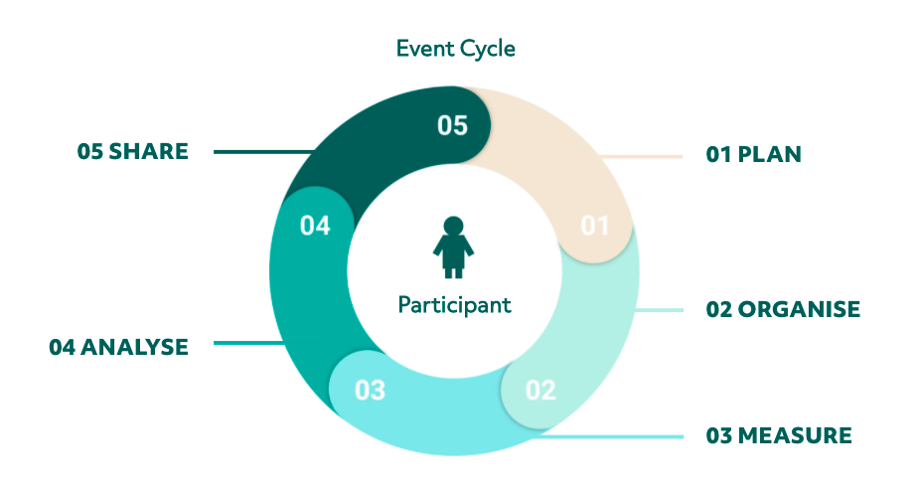
Figure 1: Stages of the event cycle.
Source: (Getz and Page, 2019).
Plan: Planning is the primary stage in event arrangement where there is the determination of goals, target audience, budget consideration, venue and delivery channels (Phi, Dredge and Whitford, 2018). Therefore, the Tech-Hop event will also be arranged with detailed planning where the aim will be to generate awareness about technological innovation in the tourism industry to the audience who work in this industry and have an interest in this area.
Organise: In this step, the lifecycle stages of the event are determined from pre-event arrangement to post-event follow-up (O’Toole, 2011). In the event of Tech-Hop, there will be stages like pre-event marketing to generate awareness, execution of the actual event and post-event follow-up. The actual event is organized in this step.
Measure: It is the step which is considered after the accomplishment of the event (Müller, 2017). Here the experience value is measured in comparison to the perceived value of the event. Therefore, in this stage, the feedback from the participants can be collected to compare them with KPIs (Key Performance Indicators) to measure the success of the event.
Analyse: Analysis of what went well, what went wrong, what could have been performed better and so on are conducted in this step (Meredith, 2022). Thus, to get a more comprehensive view of the performance of the event, a detailed analysis will be conducted. Along with this, plans will be made to solve the issues and perform better in future events.
Share: It is the final stage, where there is documentation of the results and findings as well as action plans for the relevant stakeholders of the event so that the relevant parties can take careful steps in further events (Nolan, 2020). In the case of the Tech-Hop event, there will be digital documentation of the findings so that they can be shared easily and conveniently with different associated parties.

Event concept

Concept of the event
An event concept is defined as the overarching idea or theme that provide guidance for event planning and execution (Smith, 2012). It also guides the purpose or core message of the event or meeting. Here the core concept of the proposed event Tech-Hop will be “Technology and Innovation in the Hospitality Industry”. Thus, there will be arrangements in the event to deliver ideas about the importance of incorporating technologies, innovative techniques, advanced machinery available for the tourism sector, use of AI in tourism, digital communication techniques in tourism and so on. In short, the event is all about technology and innovation in the hospitality business.

Experiences designed for the guests
The following experiences will be arranged for the guests in the Tech-Hop event:
Tech-Hop event
Theme: Technology and Innovation in the Hospitality Industry
Venue  Canvas - Inspiring Venues, Lasting Connections | Address  55 Broadway, London SW1H 0BD, United Kingdom. | Date  15 June, 2024 | Time  10:00 Am to 4:00 PM
Start time | End time | Activity | Location
10:00 AM | 10:45 AM | Arrival and Registration | Entrance to the main hall
10:45 AM | 11:00 AM | Opening speech | Main Hall
11:00 AM | 12:30 PM | Main speech and discussion session | Auditorium
12:30 PM | 01:40 PM | Lunch break | Cafeteria
01:40 PM | 02:50 PM | Workshop | Auditorium
02:50 PM | 03:45 PM | Networking | Main Hall
03:45 PM | 04:00 PM | Closing speech | Main Hall
Arrival and registration: It is the first activity arranged in an event (Stonkutė, 2023). Since the Tech-Hop event will be a significant event and will attract respected professionals in the tourism industry, there will arrangement of seamless attendee experiences. Based on the online registration, the arrival of the guests will be noted.
Opening speech: Upon the arrival of the guests, an opening speech will be delivered to all to introduce them to the theme of the event and activities to be performed throughout the event.
Main speech and discussion session: In the main speech section, there will be visual and vocal presentations on the event topic. Since there are new technology trends, AI tools, digital communication techniques and other facilities that are changing the way of operation in the tourism industry; it is necessary to talk about them (Ormerod and Wood, 2020). After the main speech, there will also be a discussion segment where the guests will be able to ask questions as well as provide their opinions.
Lunch break: A lunch break will be kept. There will also be an arrangement for refreshments.
Workshop: After the lunch break, a workshop will be arranged where the guests will be able to experience the use of AI, Virtual Reality and other digital tools in the hospitality industry. Real-life experience can create a long-lasting and effective impact on the participants (Allen et al., 2022).
Networking: This segment can facilitate communication and networking among the industry performers (Rogers and Wynn-Moylan, 2022).
Closing speech: To end the event a closing speech will be delivered along with thanking the guest.

Aim and objectives of the event
Aim of the event
The aim is to generate awareness about the implications of technology and innovation in the hospitality industry.
Event objectives
- To provide the participants with ideas about technological tools and techniques in the hospitality industry through arranging speeches and discussion sessions on the event day.
- To generate realistic ideas and knowledge about technological use in the tourism industry by delivering speeches and organizing workshops on the event day.
- To ensure increment of sales of sponsorship brands by 10% within 1 month.

Event operations
The skills and resources required for the Tech-Hop event are as follows:
Resources required
Planning and budgeting: Planning and budgeting can be regarded as crucial resources for the success of an event (Dashper and Finkel, 2020). Hence, careful budgeting and effective planning will be required for Tech-Hop. There also can be pre-event research to assess the feasibility, trends and other issues.
Communication network: For the success of the event, another significant thing is a strong communication network that facilitates generating awareness about the event and drawing participants. So, Tech-Hop will require a communication network to contact the clients.
CRM tools: For effective management, an event CRM tool is required that can aid in managing event and client-related data (Phi, Dredge and Whitford, 2018). To help in recording attendees, performing pre-communication, sharing post-event findings and so on; these tools aid greatly.
Skills required
Communication: Among the event management committee and staff, communication skill is a must (Dowson and Bassett, 2022). Without this skill, it can be difficult to interact with the guests and deliver the planned ideas. So, Tech-Hub has to make sure that the event management staff possesses effective communication ability.
Creativity: Creative thinking is required to better engage the participants of the events and ensure effective problem-solving (Getz and Page, 2017).
Time management: In the Tech-Hop event, the staff also should have time management skills. As it will be a single-day event and there will be back-to-back arrangements of activities, proper allocation of time and timely performance will be required.

Event budget
Breakdown of income and expenditure
The following income statement is prepared to express the breakdown of the income and expenditure:
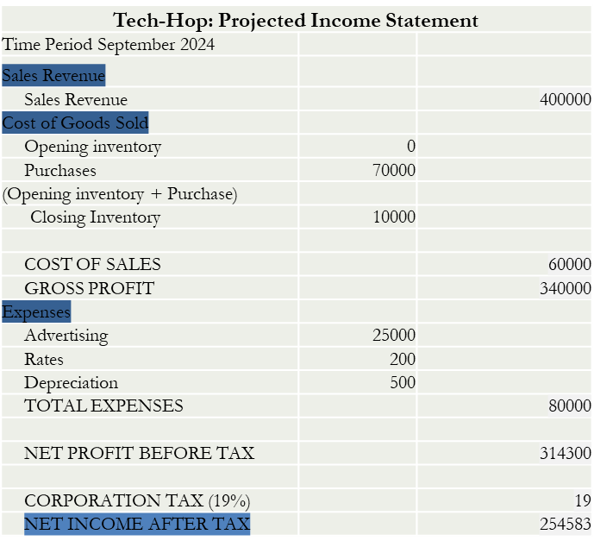
Table 1: Income statement of Tech-Hop.
Source: Own.
Associated costs
There are a lot of costs associated with the events arranged such as rent of the venue, salary of the staff, cost of food, cost of supplies and so on (Hertog, 2020). Hence, for the Tech-Hop event, similar costs will be implied. Since there will be a presentation and workshop arranged on technological and innovative tools used in the hospitality industry, there will be some additional costs related to these supplies.
Income generation
Streams of income generation should be carefully decided as otherwise, it can be difficult to pay the costs and support future events (Stonkutė, 2023). Thus, in Tech-Hop there will be arrangements for diversified income sources rather than a single one. There will be partnerships with sponsorships whose logos and products will be displayed in the event to increase their reach. Along with this, revenue will be generated from the selling of event tickets.
Funding sources
Crowdfunding: It has become a very popular way of raising money for businesses or events through the use of technology (McCartney, 2018). So, for the Tech-Hop event, information can be spread and money can be raised using online platforms. Though it aids in raising popularity and engaging the audience, it is unable to arrange much amount.
Ticket sales: Ticket selling is one of the traditional ways to arrange money for events. Thus, tickets can be offered on both online and offline platforms from one month earlier to the event to raise money (Allen et al., 2022). The purchasers of the tickets will be attendees of the events. Thus, this method has to carefully target the audience.
Sponsorship: Sponsors are also a good source of funds for events. So, the brands of food and beverage, technological items and so on can be eager to invest in the Tech-Hop event as they can target a large audience through this. However, in this funding source, greater responsibilities are associated.
Bank loans: Bank loans can source large amounts of funds for the event. Anyhow, there must be a consideration for increased interest costs (Milohnic, Lesic and Slamar, 2019).

Industry trends and impacts

SWOT analysis
Strength | Weaknesses
Involvement of industry specialists: Increased involvement of industry specialists can enhance the acceptability and success of events (Fox et al., 2014). Since Tech-Hop will bring technology experts and specialists to the event, they will provide much improved insights there.  Adequate planning: Improved planning about activities, costs, venue, time and so on will aid in the successful delegation of the event. | Lack of budget: Budget inefficacy can be faced by the Tech-Hop event. Due to a lack of awareness about technological implementation, many investors are unwilling to invest in such events.  Lack of skilled employees: The arrangement of such top-notch employees requires expert individuals (Getz and Page, 2019). So, the event may face difficulties due to the lack of skilled employees.
Opportunities | Threats
High demand: The demand for technology and innovation in the tourism industry is rising due to the realization of their benefits and the changing demand of the customers. Thus, there is a high chance that professionals in the tourism industry will be interested in the Tech-Hop event.  Minimal competition: There is not much competition in this particular area (Dowson and Bassett, 2022). | External disruptions: Due to political unrest, global war conditions and natural calamities; uncertain situations can occur and disrupt the event.  Funding scarcity: Funding scarcity in the UK due to the increased interest rate can also be a major threat (Cvent, 2024).

PESTLE analysis
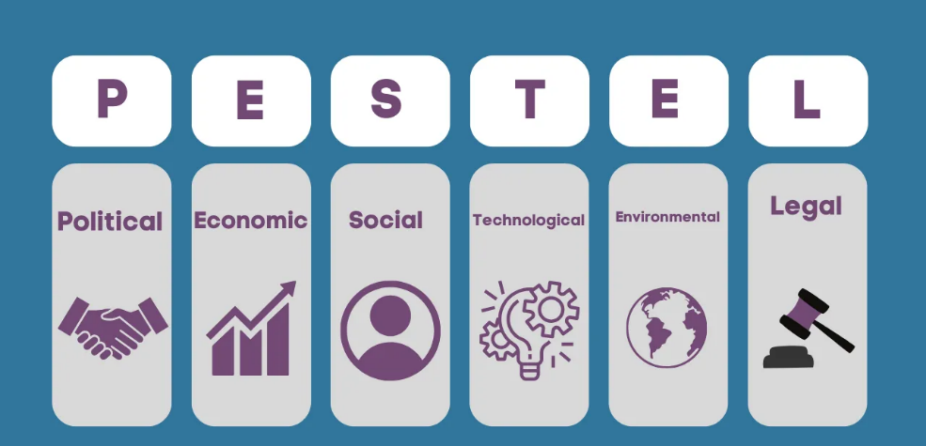
Figure 2: PESTLE analysis.
Source: (Ormerod and Wood, 2020).
Political: Political stability in the UK will be suitable to arrange the event. However, the Brexit decision of the government will create issues. As Brexit has made the immigration policy stricter, employees of EU countries from the hospitality sector will find it difficult to attend the event (Milohnic, Lesic and Slamar, 2019).
Economic: The progression in the economic growth in the UK can support the arrangement of events. As there was 0.4% growth in the first quarter of 2024, it can have a positive impact on the profit generation of the event (Cvent, 2024). Anyhow, the interest rate of 5.2% can be a matter of concern as it can increase the cost of fundraising.
Social: Due to the changes in demand of the customers of the tourism industry, there is increased use of technologies and innovation. This in turn can increase the demand for this event. However, the event may face a cultural barrier as there will be employees attending from various neighbouring countries (Ormerod and Wood, 2020).
Technological: Technological advancement in the UK will be supportive of the arrangement of the event. The use of AI, virtual reality and so on can enhance the experience of the attendees in the event. Anyhow, there must be consideration about cyber security threats so that the personal information about the attendees does not get leaked (Hertog, 2020).
Environmental: Since the Tech-Hop event will be held in physical form, the organizers must have an idea about the weather conditions. Poor weather conditions can disrupt the execution of the event. Nevertheless, the sustainability concern of the event can aid in raising its popularity.
Legal: There must be legal considerations during the arrangement of events. The presence of effective intellectual property rights can be useful for this technology and innovation-based event. However, there must be consideration of the Health and Safety Act (HSW) as otherwise there can be legal consequences (Phi, Dredge and Whitford, 2018).

Cultural and situational considerations
The following cultural and situational considerations will be applicable to the Tech-Hop event:
Cultural diversity: When an international meeting is arranged, guests from different corners of the world attend the event (Dowson and Bassett, 2022). Thus, any kind of ritual, cultural event or other thing cannot be performed that hurts the feelings of people of another culture or community. So, the activities of Tech-Hop will be designed keeping cultural diversity in mind.
Communication style and etiquette: Communication style and etiquette must follow guidance. In the event, a formal communication style will be maintained and use of any kind of slang or signage will be excluded to avoid misunderstanding.
Timekeeping: Irrespective of the culture, there is the importance of timekeeping (Ormerod and Wood, 2020). Thus, there will be proper management of time.
Contingency plan: There can be any kind of uncertain situation in the event (Nolan, 2020). To avoid any unwanted circumstances, there must be a contingency plan to adjust the issues. For instance, the venue will be allocated for an additional hour to avoid uncertainties.

Conclusion
This report has highlighted the strategic planning and delivery consideration of arranging an event in the MICE industry. The event will be named Tech-Hop based on the theme of technology and innovation. The event will follow a clear event cycle. There will be an arrangement of activities like registration, opening speech, discussion, workshop and more for the guests. The major aim of the event will be to raise awareness about the importance of technology and innovation in the hospitality industry. There will be consideration of cultural diversities and situational uncertainties. The event will generate profit from ticket selling and sponsorship. Considering the industry situation, there are minimal threats to the event. However, improved planning and expertise can aid the successful accomplishment of the event.

References
Allen, J., O’Toole, W., Harris, R. and McDonnell, I. (2022). Festival & special event management. 5th ed. Milton, Qld: John Wiley & Sons Australia, Ltd.
cbi.eu (2022). The European market potential for MICE tourism | CBI. [online] www.cbi.eu. Available at: https://www.cbi.eu/market-information/tourism/mice-tourism/market-potential#:~:text=There%20are%20two%20main%20trends%20on%20the [Accessed 9 May 2024].
Cvent (2024). 9 Trends Shaping the Future of MICE Business | Cvent Blog. [online] www.cvent.com. Available at: https://www.cvent.com/sg/blog/hospitality/9-trends-shaping-future-mice-business#:~:text=Now%20with%20the%20pandemic%2C%20this [Accessed 9 May 2024].
Dashper, K. and Finkel, R. (2020). Accessibility, diversity, and inclusion in the UK meetings industry. Journal of Convention & Event Tourism, 21(4), pp.1–25.
Dowson, R. and Bassett, D. (2022). Event planning and management: principles, planning and practice. 2nd ed. London, Uk ; New York: Kogan Page.
Fox, D. et al. (2014). Doing events research: from theory to practice. Routledge: Oxford
Getz, D. and Page, S. (2019). Event studies: theory, research and policy for planned events. 3rd Edition. Routledge: Oxford
Getz, D. and Page, S.J. (2017). Successful event management: a practical handbook. Tourism Management, 26(4), pp.628–630.
Hertog, P. den (2020). Technological Innovation in Tourism and Events industry: A hybrid future of Events. International Journal of Innovation Management, 4(4), pp.491–528.
McCartney, G. (2018). The CAT (Casino Tourism) and the MICE (Meetings, Incentives, Conventions, Exhibitions): Key Development Considerations for the Convention and Exhibition Industry. Journal of Convention & Event Tourism, 9(4), pp.293–308.
Meredith, J. (2022). Project management: a managerial approach
Milohnic, I., Lesic, K.T. and Slamar, T. (2019). Understanding The Motivation For Event Participating – A Prerequisite For Sustainable Event Planning. Marketing Intelligence & Planning, 12(7), p.204.
Müller, M. (2017). The Mega-Event Syndrome: Why so Much Goes Wrong in Mega-Event Planning and What to Do about It. Journal of the American Planning Association, [online] 81(1), pp.6–17.
Nolan, E. (2020). The supply and design of different types of venues for business events. International Journal of Tourism Cities, 6(4).
O’Toole, W. (2011) Events feasibility and development: from strategy to operations. Elsevier: Oxford
Ormerod, N. and Wood, E.H. (2020). Regional Event Tourism Funding Policies: A Strategic-Relational Critique of Current Practice. Journal of Travel Research, 5(2), p.004728752091363.
Phi, G., Dredge, D. and Whitford, M. (2018). Understanding conflicting perspectives in event planning and management using Q method. Tourism Management, 40(4), pp.406–415.
Rogers, T. and Wynn-Moylan, P. (2022). Conferences and conventions: a global industry. 4th Edition. Routledge: Oxford
Smith, A. (2012). Events and urban regeneration: the strategic use of events to revitalise cities. Routledge: Oxford
Stonkutė, E. (2023). Key success factors toward MICE industry: A systematic literature review. Management of Organizations: Systematic Research, 74(4

