  - BSc/HND Motorsport Automotive

Engineering Design & Materials - M4X02194
Subith Joseph || 1902458


(The Psychological Rollercoaster of Motorsport, 2020)

Table of Contents
Design Specification 3
Introduction 4
Dry sump system 4
Wet sump system 5
Research 6
Materials 6
Aluminium 6
Low Carbon Steel 6
Manufacture processes 7
Press Forming 7
Cold Chamber Die Casting 8
CNC (Computer numerical control) Machining 9
List of Figures 10
Bibliography 11

Design Specification
A customer has requested to design a dry sump pan and oil pick up adaptor for a Ford Zetec engine. The Dry sump pan and oil pick up must fit in the factory engine also matching the dimensions and must withstand strains for motorsports application.

Customer requirement | Requirement importance rating (out of 10)
The product should be light weight | 8
The product should be easy to install (initial set-up) | 5
In the event of a roll-over, the engine should not be flooded with lubricant | 9
The product should be low cost | 7
The product should allow easy/fast access for servicing/maintenance | 7
Figure 1 - design specification
(Harrison, 2020)

Light weight – this is done by researching the most appropriate material which is light weight, but at the same time stand high amount of strain
Easy install – this is done by simplifying the design as it is straight forward to install and also having an accurate measurement to ensure a proper fitment
Anti-flood system – this is achieved by designing the sump as if it does tilts upside down then there is a system to compensate the oil from running up the engine causing it to flood the engine
Low cost – This is accomplished by researching the most suitable material and manufacturing process
Easy access - this is done by simplifying the design as it is straight forward to install and also having an accurate measurement to ensure a proper fitment

Introduction
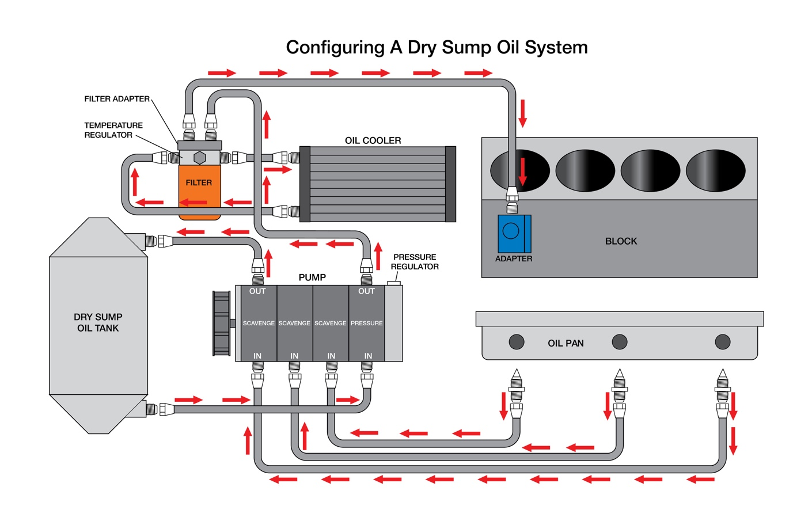
Figure 2 - Dry sump system
(Pros and Cons Of Installing A Dry Sump Engine Oiling System, 2019)

Dry sump system
A generally dry sump oil system mostly is a Performance alternative to the traditional wet sump oil system; generally Dry sump system is used to actually enhance cooling and oil delivery to the engine, which literally is fairly significant, When driving a vehicle around a corner the oil in the sump would move according to how fast and harsh it is turning, definitely due to the gravitational forces this can generally leave the oil pickup taking in air instead of oil, this can cause the vehicle engine to for the most part run sort of dry and leading the pistons to fuse into the cylinder wall due to high temperature which is caused by no lubrication

The downside of having a dry sump system is that there is extra weight of having an oil cooler, piping, oil pump and an oil tank ad also cost in maintenance, parts and development is high.
The downside of having a dry sump system for the most part is that there is extra weight by having an oil cooler, piping, oil mostly pump and an oil tank ad also cost in maintenance, parts and development is actually high in a really major way

Wet sump system
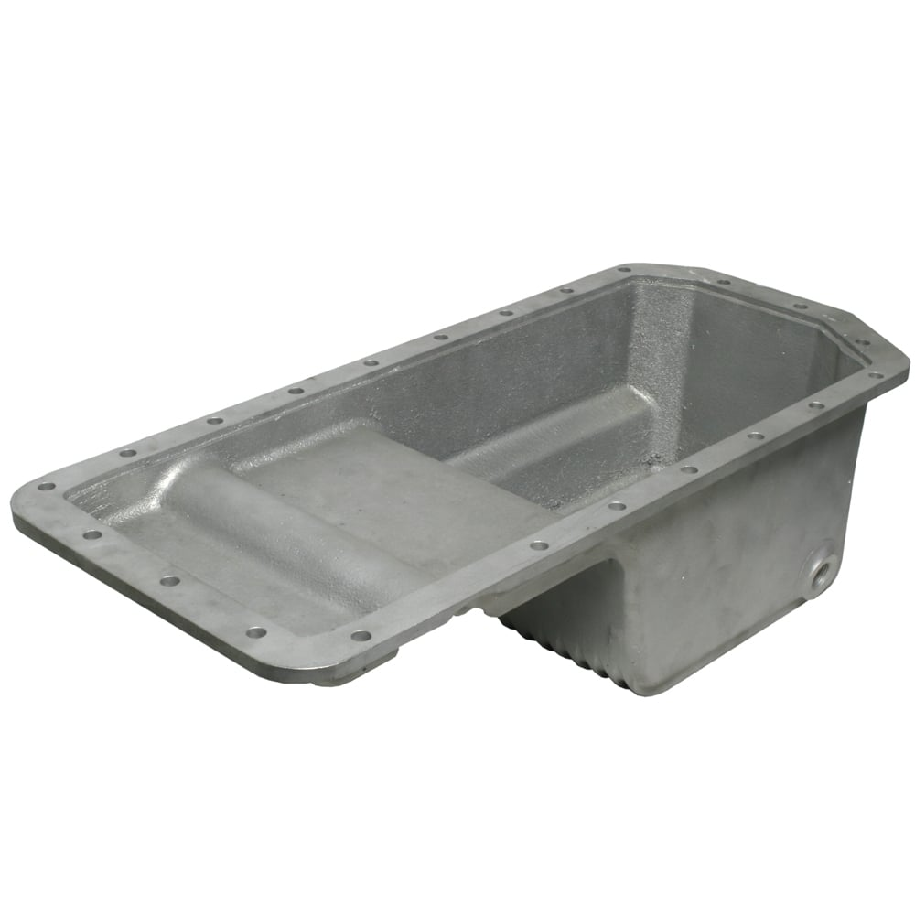
(Racetorations Alloy Finned Oil Sump, 2020)
Figure 3 - wet sump pan

A wet sump system is most sort of common type of engine oil storage, the sump essentially holds the engine oil and also cools passively some using cooling fins. Wet sump system is used to generally due to its reliability as modern oil sump generally are very strong and can withstand high forces if vehicle scrapes the ground, also maintenance is near to minimal and the cost particularly is definitely low compared to a dry sump system.
The downside of having a wet sump system kind of is that the sump generally are fairly big in size, this mostly means the engine would mostly be mounted higher than a dry sump system, and also when cornering at speed all the oil in the sump can move to one side causing the oil pickup feed to feed in air in the system.

Research

Materials
Aluminium
Aluminium basically is a common basically material used for manufacturing, this specifically is because of its sort of low cost and the properties of the material, or so they generally thought.
Aluminium actually is a fairly lightweight material, is useful to keeping the vehicle weight low, having a light weight vehicle increases the handling characteristic and comfort, which definitely is fairly significant.
Aluminium naturally generates a protective oxide coating, making it able to resist many different environments, this is useful for prolonging the life of the product this basically is important for a vehicle since a kind of normal life span of a vehicle really is 10+ years
Aluminium tensile strength increases as temperature drop, this is great for vehicle applications since vehicles particularly are needed to run in kind of many range conditions.
Aluminium essentially is a Ductile material, this actually means that it particularly has a low melting point and density, this is great for manufacturing as therefore not needing heavy machinery, This is great for cost and also creates a wide range of ways to manufacture parts.

(Aluminum - Advantages and Properties of Aluminum, 2002)
Low Carbon Steel
Low Carbon steel really is combination of steel and carbon from 0.05 - 0.25%, due to it being cheap to manufacture this is widely used in modern vehicles.
Low carbon steel does not have corrosion protection, during manufacturing coating the surface in is common this is done to prolonging the longevity of the material.
Steel specifically is a very strong and dense material; when mixed with carbon the hardness of the material and also ductility is enhanced in a major way.

Manufacture processes

Press Forming
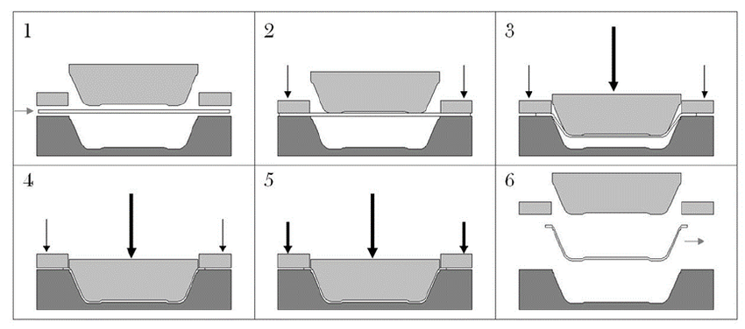
(Press-forming process) Figure 4 - press forming
Press forming also known as stamping is a commonly used manufacture technique, this is used due to its production rate is very high.
A die is used to shape metal, as a press stamps the metal sheet the sheet forms into the shape as the die. This type of production is very quick and also can be done using robots which then cuts down total cost when used for mass production.
Press forming also known as stamping essentially is a commonly used manufacture technique, this basically is used due to its high production rate, which for all intents and purposes is quite significant when it comes to mass production. A die for the most part is used to shape metal, as a press stamps the generally metal sheet the sheet forms into the shape as the die, demonstrating that a die definitely is used to shape metal, as a press stamps the particularly metal sheet the sheet forms into the shape of the die. This type of production is very pretty quick and also is done by using robots which then cuts down sort of total cost when used for mass production.

Cold Chamber Die Casting
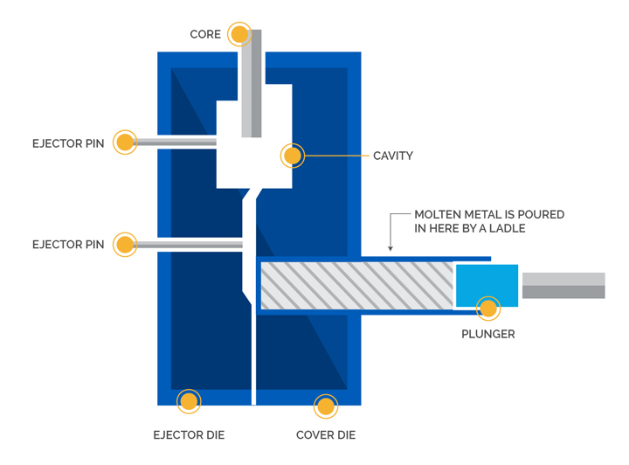

Figure 5 - Cold Chamber Die Casting
(Speciality Die Casting)
‘During cold-chamber die casting, the molten charge, which consists of more material than is required to fill the casting, is ladled from the crucible into a shot sleeve where a hydraulically operated plunger pushes the metal into the die. The extra material is used to force additional metal into the die cavity to compensate for shrinkage, which takes place during solidification.’
(Specialty Die Casting)

CNC (Computer numerical control) Machining
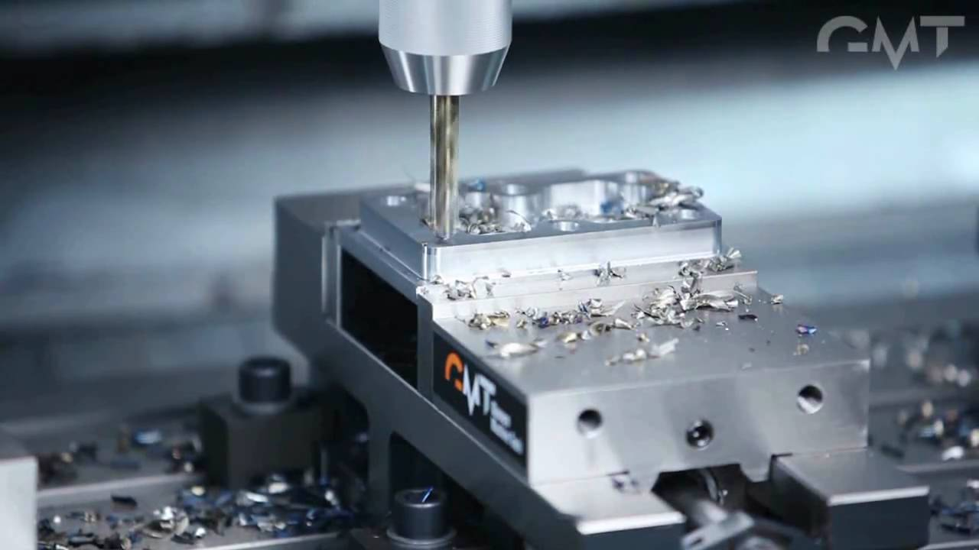
(Glacern Machine Tools) Figure 6 - CNC Milling
CNC machining is very useful in producing for high quality produces, but can be very high time consuming. This is due to having to designing the product using CAD (Computer Aided Design) but the outcome is a high-quality produce which has been milled by a robot. This is commonly used in a one-off or small batch production. Also when choosing a material, it has to be a solid piece of metal, this will effect on the total cost of manufacturing a product.

List of Figures

Figure 1 - design specification 3
Figure 2 - Dry sump system 4
Figure 3 - wet sump pan 5
(Press-forming process) Figure 4 - press forming 7
Figure 5 - Cold Chamber Die Casting 8
(Glacern Machine Tools) Figure 6 - CNC Milling 9

Bibliography
Aluminum - Advantages and Properties of Aluminum. (2002, June 4). Retrieved from Azo Materials: https://www.azom.com/article.aspx?ArticleID=1446
Glacern Machine Tools. (n.d.). Retrieved from Youtube: https://i.ytimg.com/vi/3SUQKGu7F5w/maxresdefault.jpg
Harrison, A. (2020). Design specification .
N/A. (2019, April 18). Pros and Cons Of Installing A Dry Sump Engine Oiling System. Retrieved from Engine Labs: https://www.speednik.com/files/2019/04/pros-and-cons-of-a-dry-sump-engine-oiling-system-2019-04-18_18-08-01_869088.jpg
Press-forming process. (n.d.). Retrieved from Research gate: https://www.researchgate.net/profile/Ville_Leminen/publication/279333324/figure/fig1/AS:294402351222784@1447202398182/Press-forming-process.png
Racetorations Alloy Finned Oil Sump. (2020, January 20). Retrieved from RaceTorations: http://www.racetorations.co.uk/images/racetorations-alloy-finned-oil-sump-gt6-p415-1482_zoom.jpg
Speciality Die Casting. (n.d.). Retrieved from DynaCast: https://www.dynacast.co.uk/stuff/contentmgr/files/0/0090ec6cb0e8171d2c26e89e5caf9982/files/cold_chamber_02.jpg
Specialty Die Casting. (n.d.). Retrieved from DynaCast: https://www.dynacast.co.uk/cold-chamber-die-casting
The Psychological Rollercoaster of Motorsport. (2020, 1 20). Retrieved from Trinerd Blog: https://www.pfaffauto.com/wp-content/uploads/2018/01/pastedImage.png

