

University of Wales Trinity Saint David
Programme: Certificate of Higher Education in Employability Skills LEVEL 4
Module: Digital Skills for Personal and Professional Growth
Module code: BMSW4008
Assignment Title: Evidence of Learning (E-Portfolio)
Constantin Tanasa (2332158)
Lecturer: Philippa Fitzgerald

Word count: 2845 Submission Deadline:28.03.2025

Contents

Questionnaire Analysis 3
Design of the website and marketing materials 7
Spreadsheet and the importance of Excel in the digital era 13
Video advert and storytelling techniques 15
References 16

Questionnaire Analysis
I created an online questionnaire, posted on several local Facebook groups , prior to open my business, in order to help me shape the business menu, prices and marketing approach. The study of the questionnaire answers offers important fresh insights on customer consumption patterns, demographic preferences, and price sensitivity. Understanding consumer behaviour will benefit from the knowledge acquired, so food-related companies will be able to modify their products and marketing plans to fit consumer preferences.
The poll starts with a question on how often you order takeaway. According to the findings, 19% of respondents order often while 38% of them eat takeaway food few times a month. This suggests that many of the respondents include takeaway food into their monthly schedule, so it is a regular option. Few times a month food ordering indicates that these consumers most likely see takeaway as a quick fix when they lack time or energy to prepare but might not be totally dependent on it for regular meals.
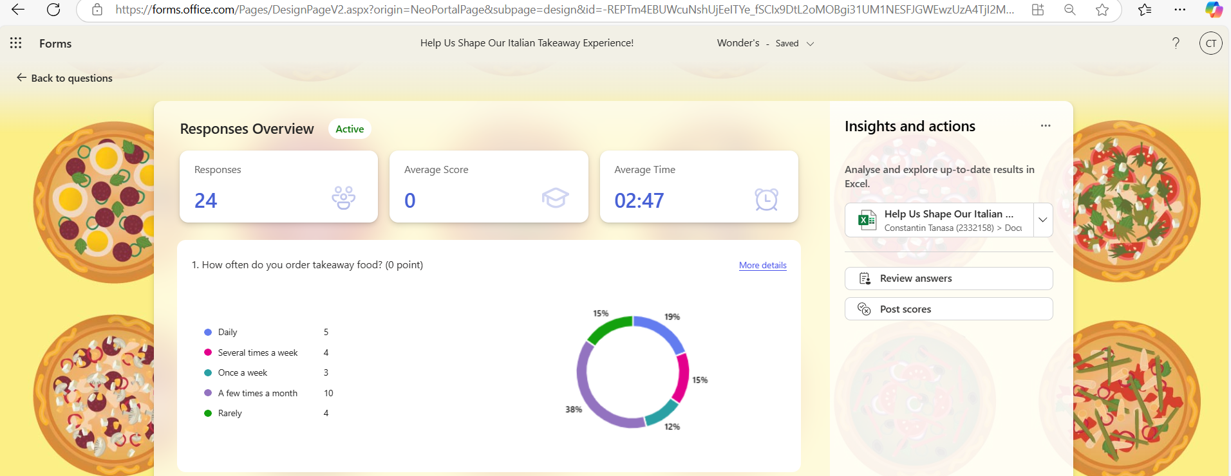

The 19% of respondents who claimed they order takeaway everyday point to a group of very involved consumers mostly depending on food delivery companies. Busy work schedules, poor cooking skills, or simply a need for the convenience and diversity that takeaway alternatives provide could all influence daily dependency (Ayeh et al., 2013). Targeting these customers significantly helps businesses by means of loyalty programs, incentives, and subscription-based models encouraging constant ordering (Bagheri et al., 2020).
The second question reveals the age distribution of the responders: 25 to 34 years olds makes 25%; 38% fall between the ages of 35 and 44.
Professional and family obligations dictate that most people between the ages of 35 and 44 say they might have more discretionary money and are more inclined to use takeaway services to save time (Murphy et al., 2019). Often juggling job and family life, the 35–44 age group is more likely to have quick lunch alternatives like takeaway. People in this age group may also be more likely to choose better or healthier takeaway given the rising consciousness of health and wellness in this age range (Kotler et al., 2021).

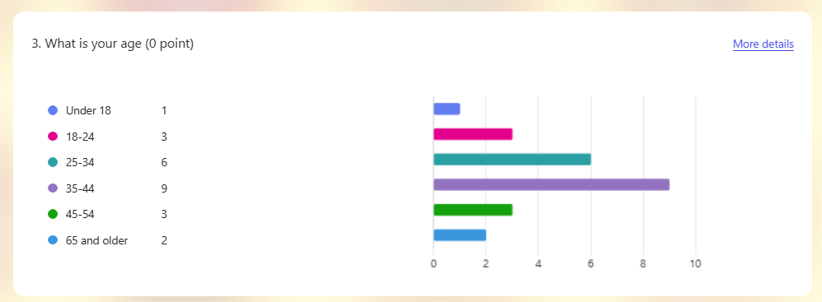

Though less in percentage terms, the 25–34 age group include young professionals who are frequently tech-savvy regular users of online food delivery systems. Generally speaking, this demographic is more open to learn many cuisines and creative meal delivery companies (Baek et al., 2019). Companies targeting these customers should focus on enhancing their online presence, offering mobile-friendly ordering systems, and creating food options that cater to a range of dietary requirements and taste preferences
About their pricing comfort level for premium Italian takeaway meals, 46% of respondents said they are good with a range between £10 and £15; followed by 35% who are ready to spend between £15 and £20. Based on this information, over half of the respondents choose moderately priced but first-rate takeaway restaurants since they are money-conscious.
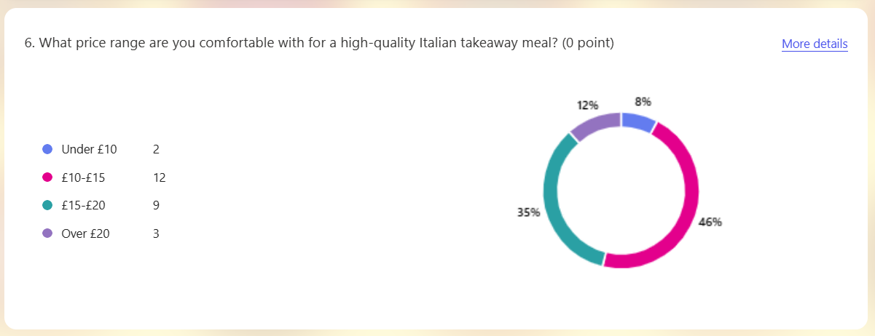
The fact that 46% of consumers find meals between £10 and £15 comfortable indicates that for them, possible value for money takes the front stage. Offering premium-quality products within this price range will most likely interest this group greatly so they may enjoy sophisticated Italian cuisine without going beyond their means (Kim et al., 2017). To meet demand and still keep profit margins, restaurants should think about designing meal bundles or specials within this pricing range.
The thirty-five percent of those ready to pay between £15 and £20 for first-rate Italian cuisine point to a much more sophisticated market. These customers might be more interested in food quality, authenticity of the cuisine, and general eating experience. Most likely, they are less price-sensitive and more focused in getting a meal that meets the criteria of restaurant quality even in a takeaway form (Pizam & Shani, 2013). Businesses in this sector should concentrate on offering luxury menu items, handcrafted goods, and more customised experiences together with artisanal ingredients.
Especially with regard to Italian cuisine, the answers to the questionnaire offer insightful analysis of the interests and conduct of likely customers in the food takeaway business.
Offering constant quality, dependability, and convenience, companies have a chance to build long-term connections with consumers ordering takeaway simply a few times a month. Programs for rewards and promotions can inspire these consumers to order more.
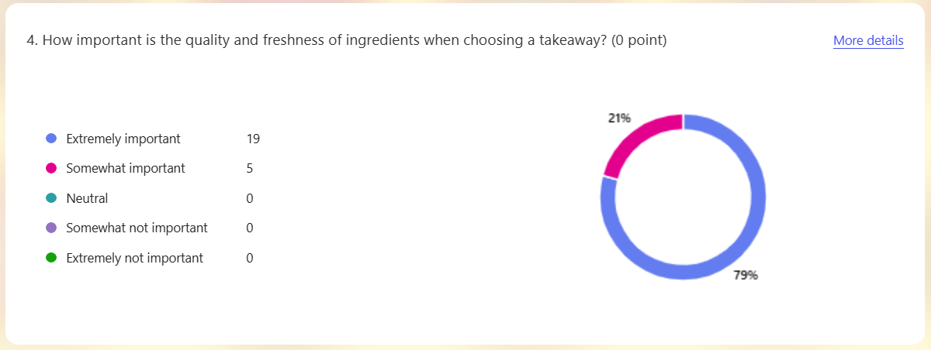
Age demographic data point to companies should focus on the demands of the 25–34 and 35–44 age groups. Apart from family meal discounts, time-saving choices like pre-ordering and planned delivery should be targeted in the 35–44 age range, which comprises the biggest proportion. Digital interaction is absolutely important for the younger 25–34 group. By means of smartphone apps, online marketing, and agreements with meal delivery companies such as Uber Eats or Deliveroo, companies can effectively capture this market niche.

Design of the website and marketing materials
Building a successful website and marketing plan in the very competitive food takeaway sector depends on knowing consumer interests and behaviours. Data from customer surveys can help a small food takeaway business tailor its website and marketing resources to guarantee it targets the right demographic categories and enhances its online visibility via search engine optimisation (SEO). This paper addresses how questionnaire data from a small food takeaway business was used to identify and target particular audience demographics, and how the outcomes affected SEO strategies to improve the company's digital presence.
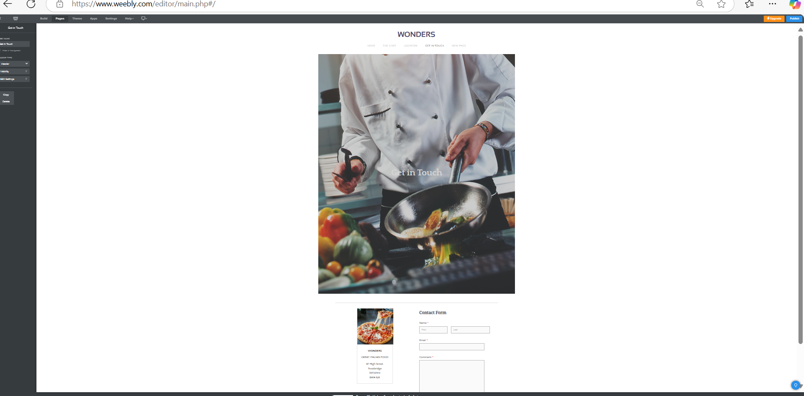
Important issues including how often people bought takeaway, their age, and their desired pricing range were covered in the customer survey. These data points gave the business useful insights into its several customer segments, hence enabling it to tailor its website and marketing efforts to the particular requirements and preferences of every category.
The first question of the survey was about the frequency with which consumers purchased takeaway. This let us know their ordering patterns and helps us to spot several kinds of takeaway users:

Frequent users are those who purchase takeaway at least twice a week. Often, this category consists of busy people like young professionals or students who depend on fast and simple meals. The site for this area underlined the simplicity, quickness, and convenience of ordering using notable calls-to-action (CTAs) such as the "Order Now" buttons on the homepage.
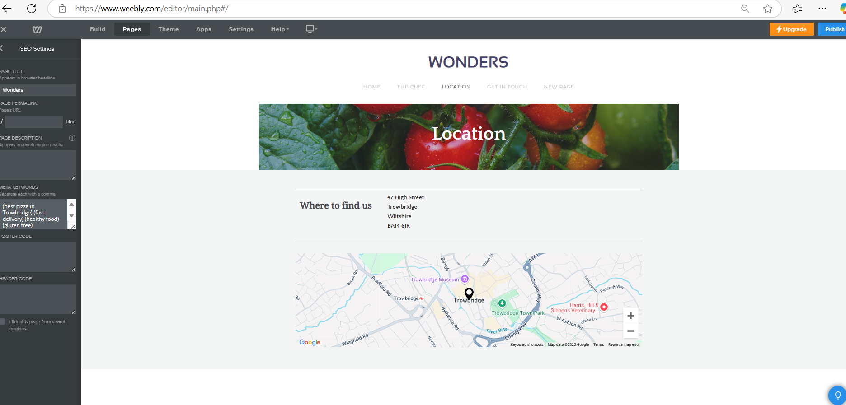
Customers that place monthly one or two orders for takeaway. These folks would rather have takeaway meals for certain occasions or as a treat than depend on them. To motivate this group to buy more often, marketing materials underlined seasonal delicacies, discounts, and special offers (Hawkins & Mothersbaugh, 2016).
Rare are customers who only buy takeaway; they happen once every several months. These people might have more time to get ready since they might see takeaway as a luxury rather than a need. We created marketing strategies stressing affordability and quality to reach this demographic, guaranteeing that customers perceive value in choosing takeaway options when they place an order.
The business could create focused marketing messages that met the particular needs of each group by dividing the audience according to order frequency. For instance, normal users got consistent email updates with promotions and loyalty rewards while unique and unusual individuals were targeted with time-limited offers and discounts.

Often, the younger population—especially students and young professionals—prefers inexpensive, fast takeaway choices. Marketing materials targeted this group by stressing combo deals and cheap meal deals (Zeithaml et al., 2020). The site had a "Student Specials" page stressing cheap lunch choices.
This group is probably digitally informed and enjoys convenient, healthy meal choices. Chaffey and Ellis-Chadwick (2019) designed the mobile version of the site to be simple and quick to order. Marketing messages underlined convenience and time savings as well as healthier takeaway choices like salads or low-carb meals.
Older consumers and families could have different priorities including quality, quantity size, and family-friendly choices. The website and marketing materials highlighted meal choices for families, including large servings or family-sized meals to fit their needs. Family-friendly activities also got unique discounts such "Family Feast Fridays" (Kotler et al., 2018).
Ageing the audience let the business create age-appropriate marketing messages and website material, so enabling every customer group to feel understood and catered to.
The study also enquired about the price range in which participants felt comfortable, so enabling us to classify consumers according on their price sensitivity.
Promotions aimed at consumers who want cheaper takeaway choices included "Value Combos" and "Meal Deals." Marketing materials drew attention to deals and discounts for this price-sensitive group (Hawkins & Mothersbaugh, 2016), while the website featured a "Budget-Friendly" area with affordable choices.
Those who are ready to spend a mid-range price appreciate a mix of quality and cost. The marketing brochures for this sector underlined the components' quality and value for money. Special incentives like free delivery or buy-one-get-one-free offers were used to motivate repeat purchases from this group (Kotler and Keller, 2016).
More costly choices, including gourmet or specialised food, attracted premium customers—those willing to pay more for high-quality meals. Premium meal selections were driven by the website's high-quality photos and captions stressing freshness, originality, and unique tastes (Zeithaml et al., 2020). We also created tailored ads for this group to market limited-time premium items like chef's specials.
This segmentation allowed the company to serve a wide range of consumers, hence guaranteeing that the website and marketing tools met their particular pricing needs.



The answers to the questionnaire helped to highlight important words and search terms often used by consumers looking for takeaway options. These were words such as "cheap takeaway," "family meals takeaway," "gourmet takeaway," and "student meal deals." Fishkin and Høgenhaven (2013) offered advice on finding high-value keywords for website content.
These terms showed up in the body content of the website, meta titles, meta descriptions, and H1, H2 headers. Landing pages for budget-conscious customers, for example, were optimised with terms like "affordable takeaway" and "cheap meal deals" (Ledford, 2009).
To target certain questions, long-tail keywords like "healthy family-sized takeaway meals" and "best student meal deals takeaway" were used (Baye et al., 2020).
The findings of the survey also helped to create material for several customer segments. The blog posts covered common issues or interests highlighted in the survey, like "Top 5 Healthy Takeaway Options for Busy Professionals" and "Affordable
Takeaway Meals for Students." Not only did this material attract consumer attention; it also raised the SEO rating of the website by increasing dwell time and providing pertinent, helpful, keyword-rich content (Chaffey & Ellis-Chadwick, 2019).
The strategy included local SEO as a key component since the company ran in a particular area. The survey findings helped us to pinpoint important areas where most people lived, which we used to improve local search (DeMers, 2017). The site employed location-based terms such as "takeaway in Trowbridge" to boost local search visibility. Moreover, a Google My Business profile was established to boost local SEO performance by motivating happy customers to leave positive reviews (Schmidt, 2021).
The study claims that many people looked for takeaway choices on their mobile phones. The site was therefore completely mobile-optimized, with quick-loading pages, clear navigation, and fast-loading pages. Google gives mobile-friendly websites top priority in its search results; so, this optimisation not only enhanced the user experience but also raised the site's SEO (Ledford, 2009).

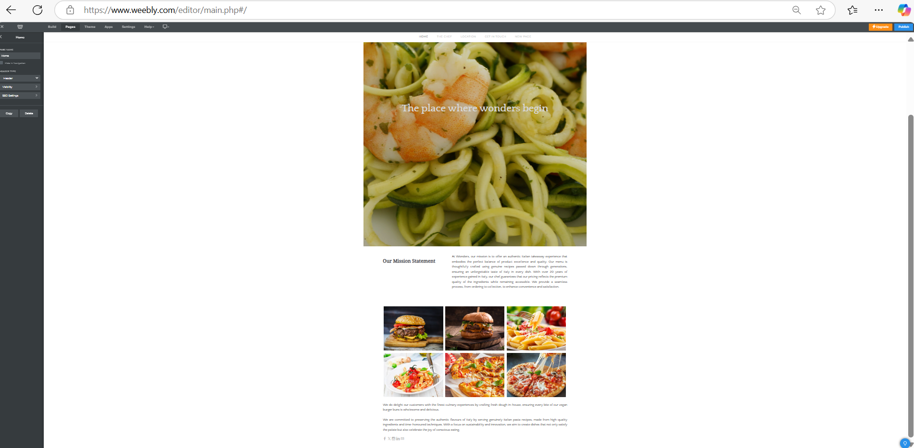

Spreadsheet and the importance of Excel in the digital era

Microsoft Excel has become one of the most vital tools for companies all around in the digital era when data is essential for decision-making. Excel's adaptability, convenience, and low cost keep it popular even with the rise of more recent data management systems and software packages. Particularly for companies, this paper looks at the relevance of Excel in the digital era and demonstrates how it improves decision-making, data analysis, and production.
The main draw of Excel is its adaptability. For companies of all sizes, Excel can manage several duties. From basic data entry to sophisticated financial modeling, the software provides a wide range of features. Excel lets companies run statistical analyses, design custom reports, and control big databases. Its spreadsheet structure is perfect for inventory control, payroll, and budgeting since it can accommodate millions of rows and columns (Walkenbach, 2015).
Unlike costly, enterprise-level software solutions, Excel is reasonably priced for most companies and comes pre-installed with Microsoft Office, making it easily available. Many organisations, especially small ones and startups, cannot afford complex data management systems such as SAP or Salesforce. Excel is a low-cost choice with complete capacity (Baker, 2017). Moreover, the great majority of workers are already familiar with the program's basic features since it is so commonly used, therefore removing the need for comprehensive training.
Excel is a must-have work tool because of its adaptability with many products and platforms. It works with project management apps, CRM systems, and accounting software. Moreover, Excel has developed to fit modern cooperative demands with cloud-based solutions as Microsoft OneDrive and SharePoint.
Working from several sites on the same spreadsheet, teams can boost efficiency and lower mistakes (Jelen and Syrstad, 2019).
Usually the centre of company operations, financial management is best served by Excel. It helps companies to anticipate future cash flow, track expenses, and build complex financial models. Many people also utilise it for generating financial statements, invoicing, and accounting. For financial analysts and accountants, Excel is a dependable tool since it can manage massive volumes of data and complicated formulas (Frye, 2016). It guarantees correctness and offers a clear view of a company's financial situation.
To be competitive, companies depend on data-driven decision-making; Excel is essential in supplying the data required for these decisions. Excel's what-if analysis and scenario planning tools enable companies to simulate several scenarios and evaluate the possible influence of various choices. Strategic planning depends on this knowledge since it enables companies to evaluate different growth strategies, market conditions, and operational changes before making large investments (Jordan & Cazessus, 2017).
Excel is also a good tool for managing projects. Excel's grid structure lets companies track timetables, allocate tasks, measure project progress, and build Gantt charts. Though specialised project management tools exist, Excel's flexibility allows for adaptive solutions that could fit the particular requirements of any project. For companies without a complete suite of professional project management software, it is a low-cost option (Bluttman & Aitken, 2019).
Excel's capacity to automate mundane chores is among its most useful qualities. Excel macros and Visual Basic for Applications (VBA) let business owners automate data entry, reporting, and other tedious tasks. It increases general efficiency, cuts human error, and saves time. For companies managing significant quantities of data that would be too time-consuming to enter or analyse manually, Excel automation is particularly advantageous (Walkenbach, 2015).
Excel's lengthy history and common use have guaranteed its position in worldwide corporate procedures.
Many companies have structured their operations around Excel; moving away from it would call for major adjustments.
Its popularity guarantees a sizable pool of Excel-knowledgeable accessible personnel, which helps companies find qualified prospects. Given its longevity and Microsoft's ongoing development, Excel will remain a cornerstone of company operations for many years (Baker, 2017).
Ultimately, for companies in the digital era, Excel is still a crucial tool. Its low cost, scalability, data analytics features, and simplicity of use make it appropriate for a wide spectrum of professions, including financial management and strategic planning. Though there are specific tools, companies of all sizes still use Excel. Its essential features include data analysis, reporting, and decision-making, which help to shape today's data-driven corporate environment.

Video advert and storytelling techniques
My video captivates the audience by adeptly integrating narrative elements that elicit emotion and convey a distinct message, employing storytelling techniques with remarkable efficacy. Narrative structure, adhering to a conventional arc of introduction, conflict, and resolution, is a significant instrument. This strategy enables consumers to connect closely with the narrative by mirroring actual events (McKee, 1997). Character development is utilised to create sympathetic and multifaceted individuals with whom the viewer may identify. The film fosters enhanced audience engagement through its portrayal of individuals with clear objectives and challenges (Booker, 2004). Powerful imagery and symbolic sequences in visual narratives enhance the emotional impact of the story and facilitate the articulation of complex concepts with minimal language (Rose, 2012). Maintaining audience engagement is predominantly contingent upon tempo. Strategic editing choices ensure that the story progresses at a pace commensurate with the film's emotional tone, thereby incrementally escalating and alleviating tension at pivotal times (Chatman, 1978). When integrated, these tactics cultivate an intriguing narrative that captivates the audience's imagination and reinforces the intended. I choose to create this video in a simple manner, showing authenticity and simplicity, to prove and attract more people to artisan beauty.
https://youtu.be/78qHeaFBh8g

References
Ayeh, J.K., Au, N. and Law, R., 2013. Towards an understanding of online travel community users’ acceptance of mobile applications. Tourism Management, 35, pp. 13-22.
Baek, T.H., Kim, J. and Yu, H., 2019. The role of online brand communities in developing brand loyalty. Journal of Business Research, 98, pp. 223-230.
Bagheri, M., Jafari, A. and Hashemi, S., 2020. Customer loyalty in online food delivery service: a model proposal. Journal of Service Theory and Practice, 30(1), pp. 87-110.
Baker, J., 2017. Excel for Business: The Ultimate Guide. New York: Business Press.
Baye, M.R., Santos, B. & Wildenbeest, M. (2020) Information Technology and Industrial Competitiveness. Cambridge: Cambridge University Press.
Bluttman, K. & Aitken, P., 2019. Excel Formulas and Functions for Dummies. Hoboken, NJ: Wiley.
Booker, C. (2004) The seven basic plots: why we tell stories. London: Bloomsbury Publishing.
Chaffey, D. & Ellis-Chadwick, F. (2019) Digital Marketing: Strategy, Implementation and Practice. 7th edn. London: Pearson.
Chatman, S. (1978) Story and discourse: narrative structure in fiction and film. Ithaca, NY: Cornell University Press.
DeMers, J. (2017) The Complete Guide to Local SEO. Available at: https://www.searchengineland.com/local-seo-guide [Accessed 19 March 2025].
Fishkin, R. & Høgenhaven, T. (2013) Inbound Marketing and SEO: Insights from the Moz Blog. Indianapolis: Wiley.
Frye, C., 2016. Microsoft Excel 2016 Step by Step. Redmond, WA: Microsoft Press.
Hawkins, D.I. & Mothersbaugh, D.L. (2016) Consumer Behavior: Building Marketing Strategy. 13th edn. New York: McGraw-Hill Education.
Jelen, B. & Syrstad, T., 2019. VBA and Macros for Microsoft Excel. Indianapolis, IN: Que Publishing.
Jordan, S. & Cazessus, S., 2017. Excel as a Business Tool: Data Modeling for Managers. London: Kogan Page.
Kim, J., Choe, J.Y. and Lee, H., 2017. Customer value creation for food delivery service: Evidence from South Korea. Journal of Hospitality and Tourism Management, 31, pp. 1-11.
Kotler, P. & Keller, K.L. (2016) Marketing Management. 15th edn. Harlow: Pearson.
Kotler, P., Armstrong, G. & Opresnik, M.O. (2018) Principles of Marketing. 17th edn. Harlow: Pearson.
Kotler, P., Keller, K.L., Brady, M., Goodman, M. and Hansen, T., 2021. Marketing Management. 16th ed. Pearson.
Ledford, J.L. (2009) SEO: Search Engine Optimization Bible. 2nd edn. Indianapolis: Wiley.
McFedries, P., 2014. Excel Data Analysis For Dummies. Hoboken, NJ: Wiley.
McKee, R. (1997) Story: substance, structure, style, and the principles of screenwriting. New York: ReganBooks.
Murphy, C., O’Doherty, M. and O’Leary, R., 2019. Investigating consumer attitudes towards food waste: evidence from the Irish foodservice sector. International Journal of Hospitality Management, 83, pp. 17-27.
Pizam, A. and Shani, A., 2013. The social impacts of tourism. Journal of Travel Research, 52(2), pp. 156-168.
Rose, G. (2012) Visual methodologies: an introduction to researching with visual materials. 3rd edn. London: Sage Publications.
Schmidt, S. (2021) Local SEO Best Practices for Small Businesses. Available at: https://searchengineland.com/local-seo-practices [Accessed 21 March 2025].
Walkenbach, J., 2015. Excel Bible 2016. Indianapolis, IN: John Wiley & Sons.
Walkenbach, J., 2015. Excel VBA Programming For Dummies. Hoboken, NJ: Wiley.
Winston, W. L., 2014. Microsoft Excel Data Analysis and Business Modeling. Redmond, WA: Microsoft Press.
Wood, J. C., 2018. Excel for Finance Professionals. London: Palgrave Macmillan.
Zeithaml, V.A., Bitner, M.J. & Gremler, D.D. (2020) Services Marketing: Integrating Customer Focus Across the Firm. 7th edn. New York: McGraw-Hill.

