Isabel Kate Porch
Student number: 2004147
Course of study: Surface Pattern Design
Word count: 1520
Tutors name: Julia Lockheart

EXHIBITION TITLE: Positive Patterns
Research question: How can we create Positive Patterns in ‘Street’ Art during a pandemic?

Introduction:

Responding to living through a pandemic, this exhibition uses art to create positive messaging in public spaces to increase the wellbeing of audiences. Restricted by the places and spaces we have been able to access, instructed to ‘stay at home’ and use online and digital technologies to communicate and connect with others, this outdoor, Covid friendly exhibition invites you to engage with art in the city of Swansea. Inspired by the positive messaging of colourful drawings, knitted rainbows and words of encouragement for NHS key workers the theme of this exhibition is ‘Positive Patterns’. It includes artworks by Lakwena, Magda Sayeg, Camille Walala and the Craftivist Collective founder Sarah Corbett. Be prepared to see five colourful, vibrant artworks, bold text and patterns on large scale wall murals, textiles and secret messages and even a funky bus that will take you to the park to make your own artworks. The artworks link to Deconstructivism, Affect theory, Situationist theory, Phenonomenology, Positive Design, and Craftivism. This exhibition is all about participation, fun, learning new things and choosing to create positive patterns in your life.

Context:
This exhibition takes place in the streets of Swansea, giving you a fresh experience of this city through the artworks. It is a trail which uses an online map which you can download on your phone and use to guide you through the exhibition. It is a day out, a chance to meet up with families and friends, a bit of exercise, an opportunity to learn, discover new things and explore. This exhibition is accessible to everyone, the event is free but you can make a donation to support the exhibiting artists if you wish through the online app. By each artwork you will find a QR code that you can scan to find out more information about the artwork and the artist. You are invited to use the hashtag #positivepatterns to share your experiences, thoughts and photographs of the exhibition to build a community where people can connect.

Felluga (2003) says, “According to Baudrillard, what has happened in postmodern culture is that our society has become so reliant on models and mats that we have lost all contact with the real world that preceded the map. Reality itself has begun merely to imitate the model, which now precedes and determines the real world.” In the Positive Pattern exhibition, an online hyper real map is used, but through the physical act of walking the streets of Swansea, viewing the artwork in person and making artwork yourself, you are experiencing being present; this first hand, direct experience is called phenomenology (Husserl, 1973).

The exhibition aims to boost positivity and wellbeing which is much needed in the pandemic and is inspired by Polmeyer and Desmet’s idea that there are “three parts to subjective wellbeing: personal significance, virtue and pleasure” (Pohlmeyer A & Desmet P, 2013). People come to the Positive Pattern exhibition to increase their wellbeing and enjoy a day out, discover artworks and learn about them. The feelings of pleasure from experiencing artwork and living in the moment can create positive affect. Affect is a strong emotional and direct experience of art that can change how people think and feel (Clough & Halley, 2007).

Clough, P. T., & Halley, J. (Eds.). (2007). The affective turn: Theorizing the social.
Durham, NC: Duke University Press.

Postmodernity helps us challenge our ideas, values and beliefs about what art is and where we view it. Through walking the streets of Swansea to discover artworks you are not in the traditional gallery or museum space, seeing painting hung on a wall or displayed in cases or on plinths. Situationist theory suggests that people’s behaviour is a result of the situation they are in. In the Positive Pattern exhibition your reaction, meanings and experience of the work will be affected by your walking through the city and it is through your engagement with the artwork, that the artwork is made complete. The space that the artworks occupies only becomes a place once you have given it meaning; you and your conversations construct these meanings, transforming these places into spaces (Relf, 1976).

The street is as valuable as the gallery space for viewing and experiencing art. In the Positive Pattern exhibition walking through the streets, you will hear the noise of the city, chatter, and cars and the smell of food and pollution. The light and time of day will affect how you see colour and experience mood. Your experience will be unique. Derrida says it is unhelpful to see things as opposites and to privilege one thing over the other (The School of Life, 2016). In Deconstructionism, we need to hold things in tension and value both. Public spaces, according to De Certeau (1974) if designed well, should make people feel relaxed and comfortable and encourage sociability. In the Positive Pattern exhibition, the public space allows you to move easily and comfortably between artworks. There are no restrictions on time- you have the flexibility to come and go as you please, stay as long as you want. You can visit with others, make new connections through seeing the artwork in person or sharing a photograph on social media. (The School of Life, 2016).

The five artworks on this trail are all linked to Positive Pattern, Craftism and positive affect.
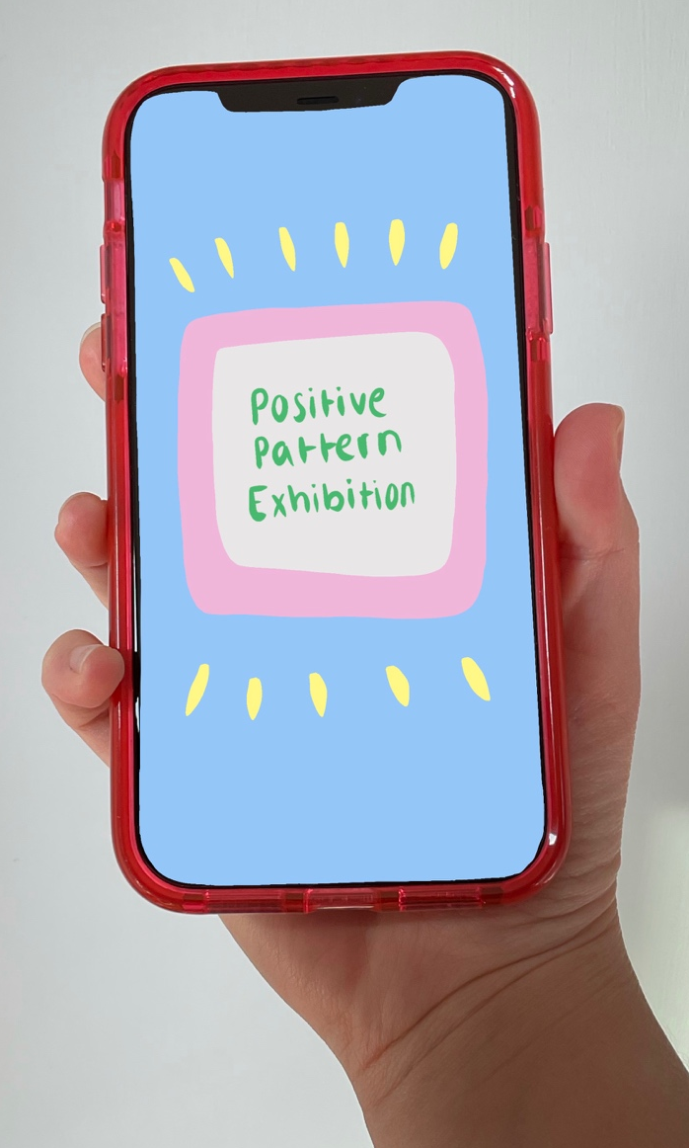
Figure 1: Isabel Porch Positive Pattern Exhibition App 2021

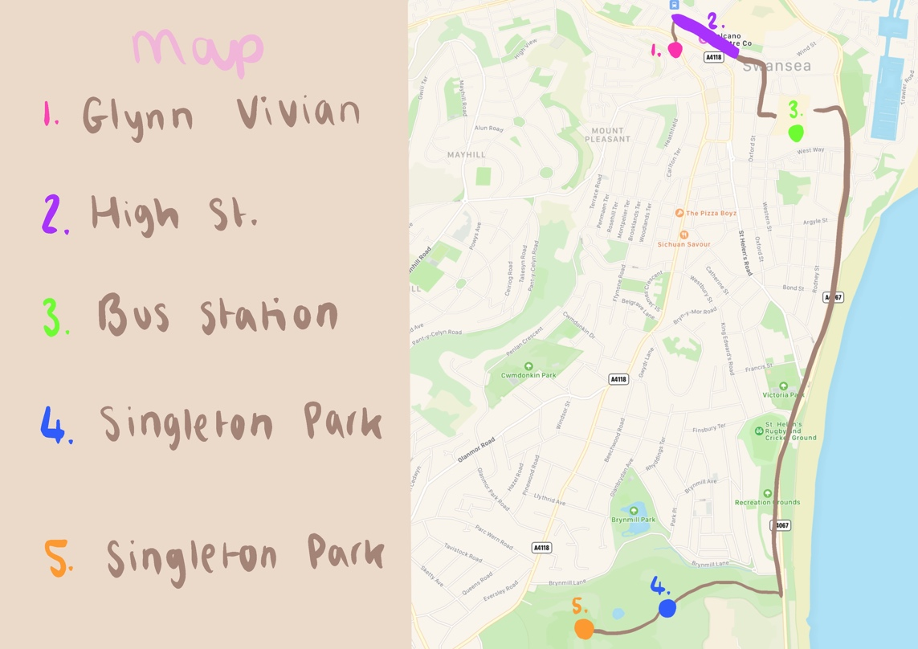
Figure 2: Isabel Porch Map of trail 2021
Artists and Artworks
Lakwena

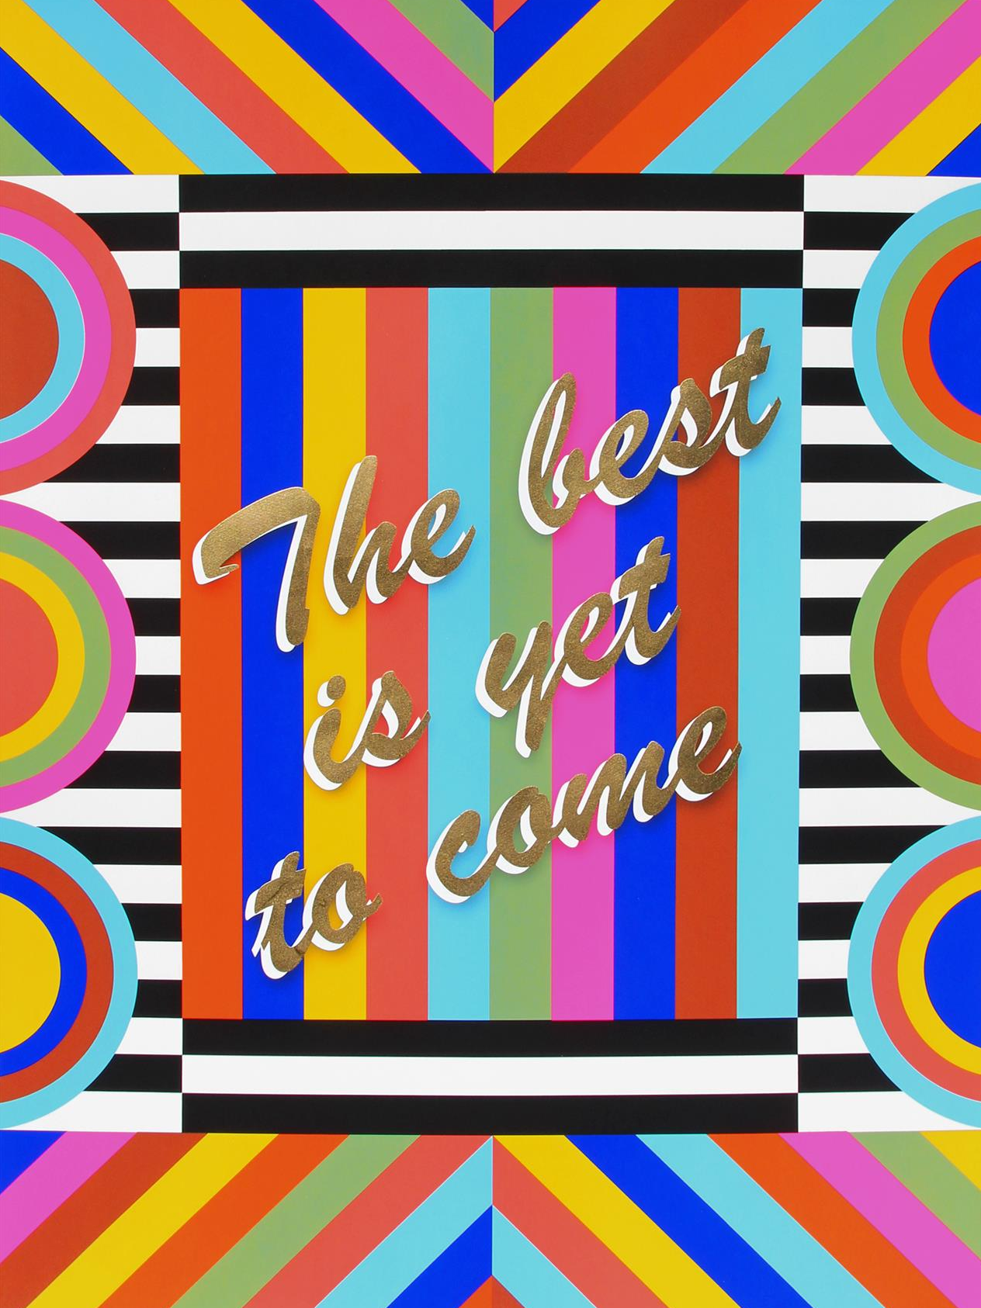
Number 1 on your map is an artwork by Lakwena called The best is yet to come (2018). Originally a limited print poster, the Glynn Vivian commissioned Lakwena to paint a large scale version of this on the front wall of the building. It sends a message of hope to all who see it, through its bright colourful, bold text and positive messaging. Glynn Vivian is the city’s art gallery, a great place to start the exhibition. Even though we can’t go inside, artwork is brought outside. Lakwena believes in the power of text to create positive messages through typography, pattern and colour. The best is yet to come relates to themes of affirmation and empowerment. She is aware of the responsibility and importance of public art, how it can have a positive affect on the viewer.
Figure 3: Lakwena Maciver The best is yet to come 2018

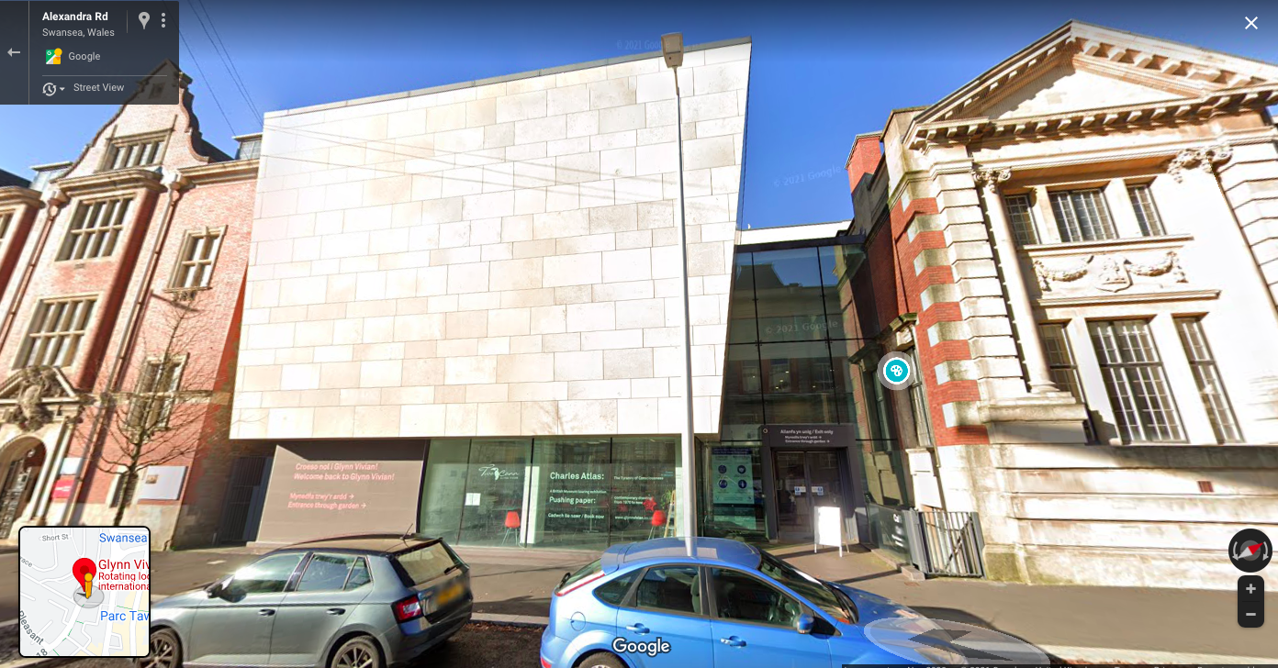
Figure 4: Google Maps Glynn Vivian Art Gallery (n.d)

Camille Walala

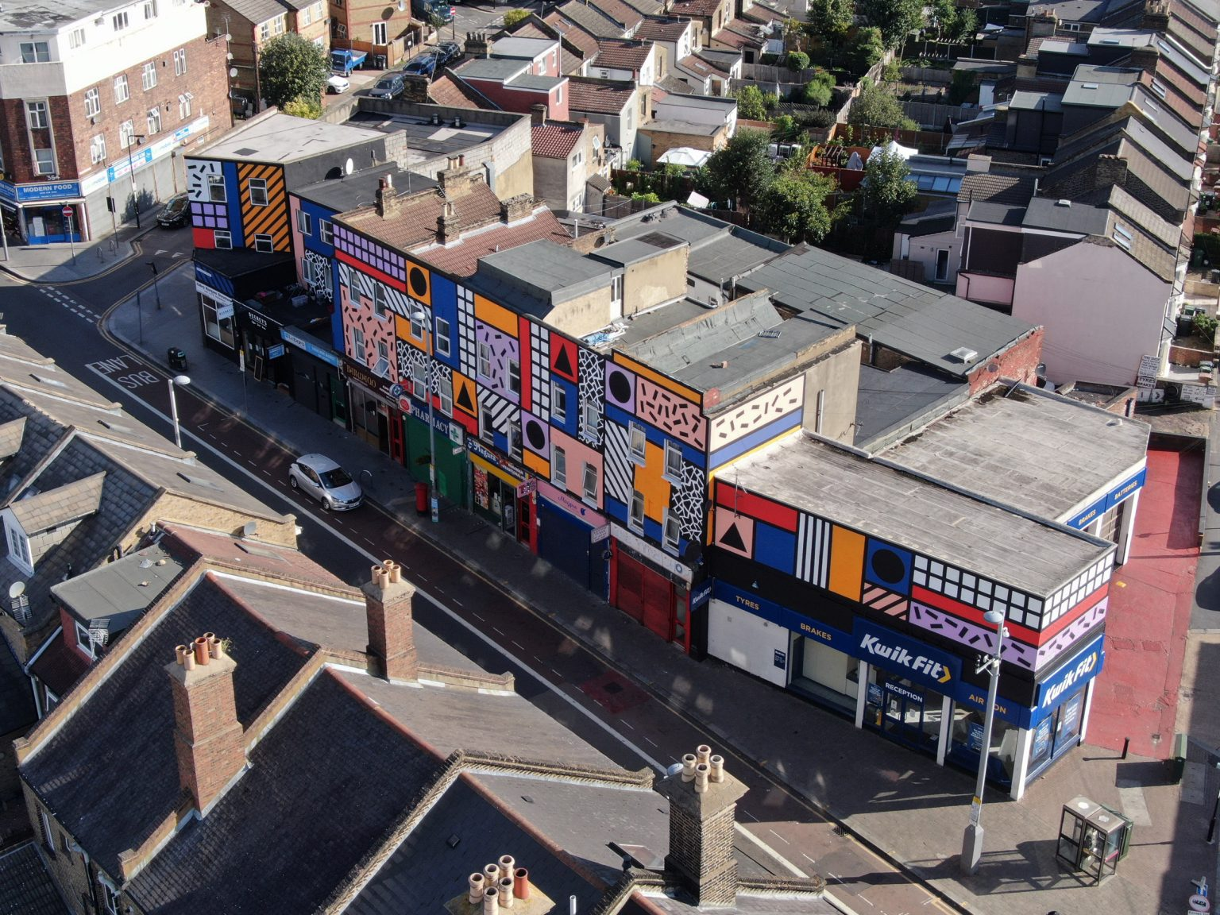
Figure 5: Camille Walala Walala Parade 2020

Number 2 on your map is an artwork by Camille Walala called ‘Walala Parade’ (2020). Originally on Leyton High Street, East London this artwork inspired the local community, shop keepers, businesses, hotels and theatres on a rundown section of High Street (the Grand Hotel to where High Street meets Welcome Lane), to commission Walala to produce a street mural over the buildings along this section, incorporating existing murals and wall art. Many local people do not like this part of Swansea. This street mural could rejuvenise this area and encourage people to visit and enjoy the cultural diversity and independent stores in this part of town. The aim of this street mural is also to bring joy to those who live, work or visit it. To draw attraction to the independent, diverse shops and the beauty of the area. The artwork brings together community and has significance, virtue and pleasure (Pohlmeyer A & Desmet P, 2013)
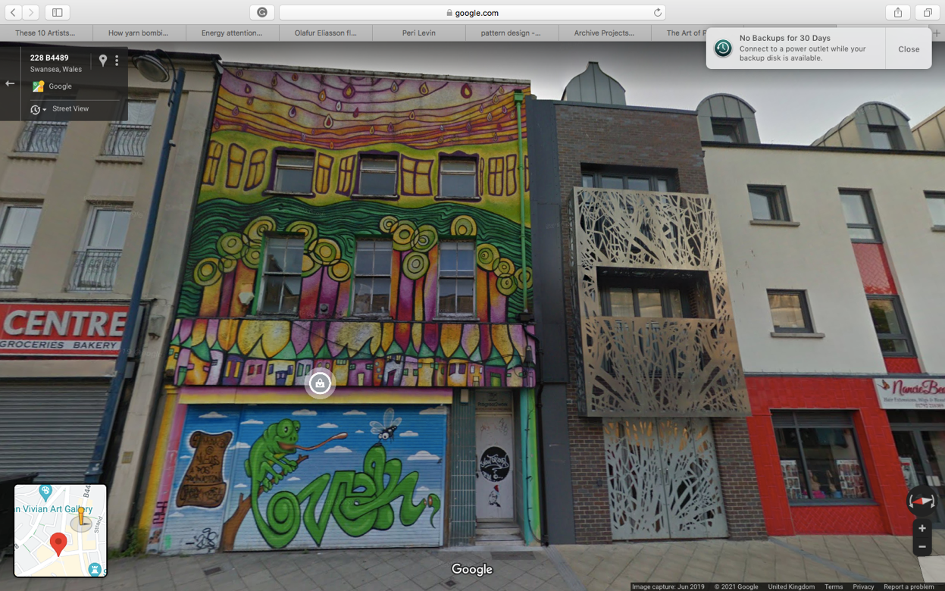
Figure 6: Google Maps High Street (n.d)

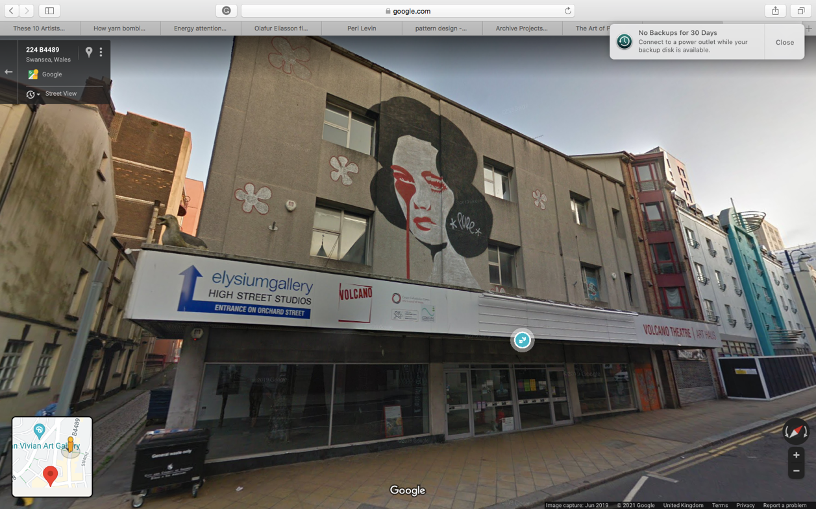
Figure 7: Google Maps High Street (n.d)

Magda Sayeg

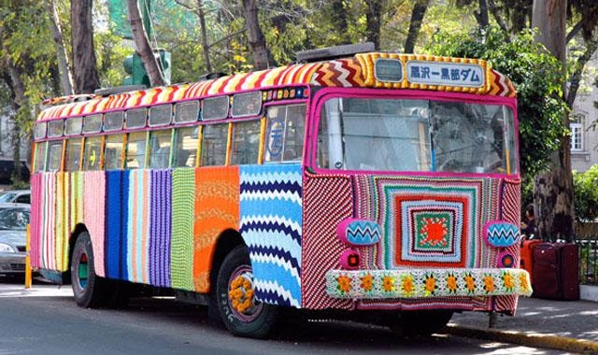
Figure 8: Magda Sayeg Crochet covered bus in Mexico 2015

Number 3 on your map is an artwork by Magda Sayeg and the female knitting group ‘Knitta Please’. It is the original bus that was yarn bombed and covered in bright colourful crochet and knitted patterns inspired by graffiti, first exhibited in Mexico City in 2008. It is part of the Craftivist Movement and as such echoes the theme of Positive Patterning, calling for a better world and future optimism. This piece was made to beat the controversy of graffiti and to show the beauty in all art and stories. Craftivism ensures that all work is positive, has a message and also is not a permanent piece of work which is the reason for the use of crochet and knit. This piece was You will find it in Swansea bus station and you can ride on this artwork to the next destination to see the remaining artworks at Singleton Park. This bus puts a smile on everyone’s face and can be seen and enjoyed as it drives through the city, past the beach.

Figure 9: Robert Melen Swansea Bus Station 2020
Philippa Lawrence


Number 4 on your map is an artwork by Philippa Lawrence called Bound. Originally Lawrence wrapped a dead tree in each county of Wales as part of the Bound project. The tree you see in Singleton Park has been commissioned by the city council, to be bound by Lawrence as part of the Positive Pattern exhibition. Previous comments on Lawrence’s trees have included ‘Joy’ and ‘uplifting of spirit’ (http://news.bbc.co.uk/1/hi/wales/6684199.stm) and as such reflect the aim of the exhibition. This piece unlike the other artworks that use the built environment and vehicles, uses the natural environment as art and makes you appreciate the things you may overlook in everyday life.
Figure: 10 Phillipa Lawrence Bound 2004

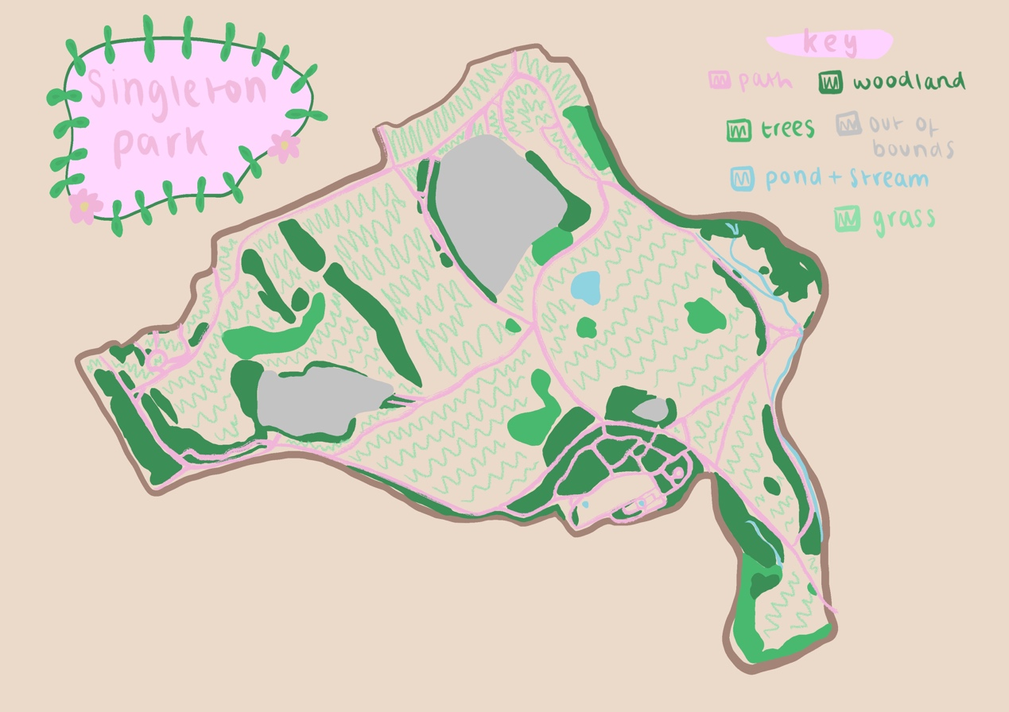
Figure 11: Isabel Porch Map of Singleton Park 2021

Sarah Corbett

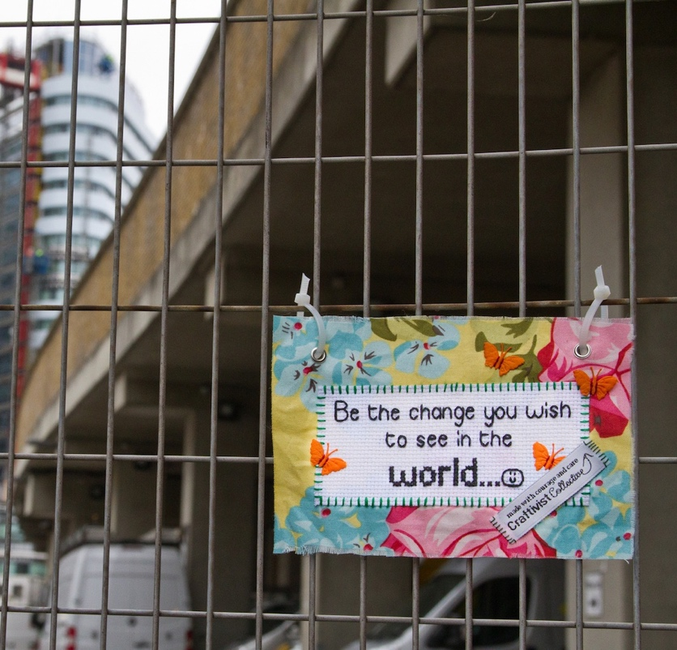
Figure 12: Sarah Corbett Be the change you wish to see in the world 2021

Number 5 on your map and your final destination is the artwork by Sarah Corbett, the founder of Craftivist Collective, called Be the Change you wish to see in the World. Corbett’s work is all about about positive change and through a Craftivist workshop at Singleton Park you are invited to be the artist and contribute to this final exhibit in the Positive Pattern exhibition. The importance of connecting, mending, wellbeing, sharing stories, building community, expressing love and care through craft and making is what this is about. By participating you invest your time and care in making something that will affect and bring hope to others. You can tie your mini banner anywhere in the park and also look for each others. This extends the exhibition, making it into an ongoing community project, where everyone can contribute.
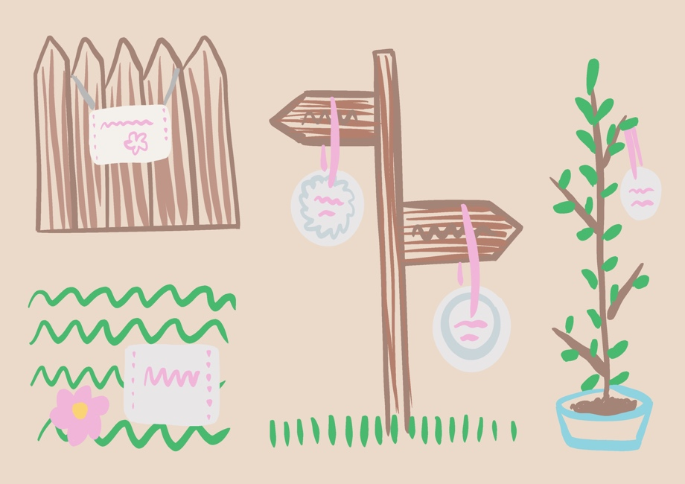
Figure 13: Isabel Porch Craftivist Workshop Exhibition Space Ideas for Singleton Park 2021
List of Illustrations

Figure 1: Porch, I. (2021) Positive Pattern Exhibition App [Digital Drawing] Personal Collection.

Figure 2: Porch, I. (2021) Map of trail [Digital Drawing] Personal Collection.

Figure 3: Lakwena, M. (2018) The best is yet to come [Paint on Wall]. Available at: https://www.jealousgallery.com/artists/lakwena/the-best-is-yet-to-come (Accessed on: 17/04/2021).

Figure 4: Google Maps (n.d) Glynn Vivian Art Gallery [Screenshot]. Available at: https://www.google.com/maps/place/Glynn+Vivian+Art+Gallery/@51.6236151,-3.9467065,17z/data=!3m2!4b1!5s0x486ef53619a492ad:0x543a8fd87779fcc7!4m5!3m4!1s0x486ef549e2186209:0x7603cca533090d5f!8m2!3d51.6236151!4d-3.9445178 (Accessed on: 02/05/21)

Figure 5: Walala, C. (2020) Walala Parade [Wall Mural] Available at: https://www.dezeen.com/2020/09/03/leyton-camille-walala-parade-community-mural/
(Accessed on: 13/04/21).

Figure 6: Google Maps. (n.d) High Street [Screenshot]. Available at: https://www.google.com/maps/@51.6228516,-3.9422152,3a,75y,55.29h,81.34t/data=!3m7!1e1!3m5!1syJEUAOK7AumVySCmC8UVQg!2e0!6shttps:%2F%2Fstreetviewpixels-pa.googleapis.com%2Fv1%2Fthumbnail%3Fpanoid%3DyJEUAOK7AumVySCmC8UVQg%26cb_client%3Dmaps_sv.tactile.gps%26w%3D203%26h%3D100%26yaw%3D106.650185%26pitch%3D0%26thumbfov%3D100!7i13312!8i6656 (Accessed on: 02/05/21)

Figure 7: Google Maps. (n.d) High Street [Screenshot]. Available at: https://www.google.com/maps/@51.6228516,-3.9422152,3a,75y,55.29h,81.34t/data=!3m7!1e1!3m5!1syJEUAOK7AumVySCmC8UVQg!2e0!6shttps:%2F%2Fstreetviewpixels-pa.googleapis.com%2Fv1%2Fthumbnail%3Fpanoid%3DyJEUAOK7AumVySCmC8UVQg%26cb_client%3Dmaps_sv.tactile.gps%26w%3D203%26h%3D100%26yaw%3D106.650185%26pitch%3D0%26thumbfov%3D100!7i13312!8i6656 (Accessed on: 02/05/21)

Figure 8: Sayeg, M. (2015) Crochet covered bus in Mexico [Crochet]. Available at:
http://bestreetart.blogspot.com/2015/12/magda-sayeg.html (Accessed on: 15/04/21)

Figure 9: Melen, R. (photographer for Wales Online) [Photo] Swansea bus station 2020 https://www.walesonline.co.uk/news/wales-news/swansea-quadrant-bus-station-evacuated-19101510 (Accessed on: 1/05/21)

Figure 10: Porch, I. (2021) Map of Singleton Park [Digital Drawing] Personal Collection

Figure 11: Lawrence, P. (2004) Bound [Photo] Available at:
http://news.bbc.co.uk/1/hi/wales/6684199.stm (Accessed on: 10/04/21)

Figure 12: Corbett, S (2020) Be the change you wish to see in the world [Stitch on material]. Available at: https://craftivist-collective.com (Accessed on: 19/04/21).

Figure 13: Porch, I. (2021) Craftivist Workshop Exhibition Space Ideas for Singleton Park [Digital Drawing] Personal Collection.

Bibliography

Certeau, M. D., 2011. The Practise of Everyday Life. 3rd Edition ed. California: University of California Press.

Felluga, D., 2002. Introductory Guide to Critical Theory. [Online]
Available at: <http://www.purdue.edu/guidetotheory/postmodernism/modules/baudrillardsimulation.html>
[Accessed 28. 04. 2021].

Husserl, E., 1973. Cartesian Meditations: An Introduction to Phenomenology. 5th ed. New York: Springer.

Pohlmeyer A & Desmet P, 2013. Positive Design: An Introduction to Design for Subjective Well- Being. International Journal of Design, 7(3), pp. 7-8.

Relph, E., 1976. Place and Placelessnes. 1 ed. London: Pion.

The School of Life, 2016. Philosophy: Jacques Derrida. [Online] Available at: https://www.youtube.com/watch?v=H0tnHr2dqTs
[Accessed 20 04 2021].

