Considerations of explosive trains in artillery rounds during service life and use.

Thomas Austin Diaper-Fox
Student ID: 2022125
Ordnances Munitions and Explosives (OME)
Level 4 Student
Module: ACDA4019 Principles of OME

Abstract
In this report the considerations required while designing large caliber artillery rounds in order to achieve safe storage, transport and use will be discussed. This includes the uses of fuzes and their safety features as well as the rest of the explosive train components. Melt cast TNT as the main fill of the artillery round will be analyzed to identify its benefits, drawbacks and how it compares to alternative explosive fills such as Compound b and IMX-101.

Table of Contents
Abstract 2
Introduction 4
Artillery in Ordnance, Munitions, and Explosives 4
Explosive trains 4
Warhead Fills 5
TNT fill 5
Hexanitrostilbene stabiliser (HNS) 5
Alternative fills 6
Safety Considerations 6
Design features 6
Fuze safety 7
Safe storage 8
Conclusion 8
References 9

Introduction

Artillery in Ordnance, Munitions, and Explosives
Artillery is a system designed to fire a projectile at the target on the battlefield from a safer location behind the front lines. This can be used as a method of attack to weaken the enemy’s defences before attack, a support role for the fighting front or as cover for retreating forces on the battlefield. These units consist of large calibre guns that are mounted on either driven vehicles or mobile platforms.

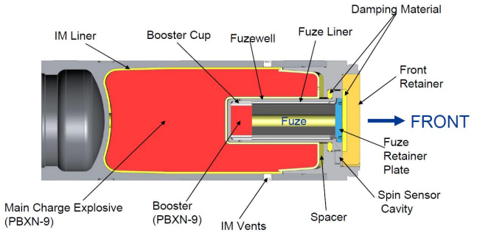
Explosive trains
Figure 1: M982 warhead section showing explosive train components. [16]
An artillery round is comprised of two different explosive trains, one for the propulsion of the round and one for the delivery effect of the round at the target.
An explosive train is the specific arrangement of explosive components that amplifies the input stimulus to achieve a desired outcome. This could be detonation in the case of a TNT filled shell or deflagration which is the desired outcome for propellants to push the artillery shell down the barrel.
The first component in the explosive train is either a primer or detonator, which is dependent on if the train is deflagration or explosive in nature. Primers are used as the initiator of a deflagration train where the primer can be ignited by electrical current, heat, or impact. It outputs a flame onto the next compound to start that burning. Detonation chains involve the compound to decompose at the speed of sound within the material. This resulting massive energy output and gas products cause a shockwave that hits the next compound and continues the explosive train. Some primary explosives just detonate, for example lead azide, or others can deflagrate to detonation, such as mercury fulminate. [1] Materials that deflagrate to detonation have an input stimulus similar to that of a primer, however, the output is a detonation shockwave rather than flame. This can only be achieved by having a greater critical diameter and correct density of the primary compound required to sustain detonation.
Depending on the sensitivity of the main fill, a booster may be needed. This booster is present if the main fill has too high a figure of insensitivity and the energy output from the detonator is below the activation energy of the main fill. For example, a booster would be included if the fill was ammonium nitrate. They are made from secondary explosives, such as RDX.
The next item in the train is the main charge. This is used to create an explosive effect on the target such as to blast or drive metal in the form of a shaped charge or explosively formed projectile (EFP). There are many possible compounds that can be used as a main charge; in a blast shell the main charge will more than likely be TNT, whereas in a shape charge it is more likely to be RDX due to its higher velocity of detonation which will increase the impact penetration.
Incorporated in the explosive trains can be effects such as delay compounds which are used to accurately time the initiation of parts of the train by burning compounds along a known distance to delay the initiation of the next component.

Warhead Fills

TNT fill
Due to TNT’s insensitive nature, its explosive capabilities weren’t discovered until 1891 by Carl Häussermann. TNT was previously the reference point for the Figure of Insensitivity at 100. During WW1, TNT was widely used in artillery shells due to ease of manufacture, reducing production time and costs. [2] TNT ingredients were readily available as toluene is a by-product of coke production as well as being distilled from crude oil. [3] This is then nitrated by being mixed with nitric acid and sulphuric acid to produce 2,4,6-trinitrotoluene (TNT). [4]
TNT is suited to artillery round fillings as its melting temperature is low at 80°C meaning it can be cast into the round with a low risk of auto-ignition. TNT has an ignition temperature of 240°C. [5] Casting enables the simplification of the shell design by eliminating the need for multiple sections.
Diurnal cycling is a problem more apparent with TNT compared to other materials due to its low melting point. This variation in temperature means that TNT will melt and reshape itself before solidifying when the temperature drops. Voids may form from trapped air bubbles or cracks created from the shrinkage during cooling. Voids present a massive risk during the firing process as under set back the air pockets get compressed causing adiabatic heating, leading to premature auto-ignition of the TNT. [6] [7]
Shortcomings of TNT include a slow velocity of detonation and a negative oxygen balance resulting in low power output per kilogram so a larger shell is needed for the same blast effect compared to HMX or RDX. It is toxic and carcinogenic to people.
Hexanitrostilbene stabiliser (HNS):
HNS is added to molten TNT during manufacture in order to further reduce sensitivity. This is achieved by reducing the grain size (Figure 2) and randomising the orientation of TNT needles during cooling. Without HNS, the needles form directionally. Only 0.3% HNS is required for a significant difference. [8]
Longer needles are easier to break. Therefore, by reducing the needle size, detonation is harder to initiate. This results in a safer round that is less prone to accidental initiation.
HNS improves the compressive strength of cast TNT drastically, increasing resilience to the forces applied during launch.

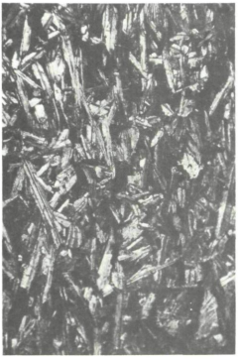
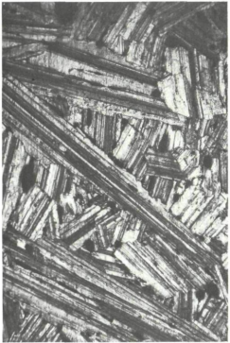
Alternative fills
Figure 2: Image on the left TNT with no HNS, Image on right TNT with 0.6% HNS [8]
As a secondary explosive TNT has desirable properties for use in artillery shells such as insensitive nature and castability, however, ways of improving its low energy output per kilogram has been the focus of research. This resulted in the invention of Comp B which is a 60:40 TNT:RDX mix. The addition of RDX increases the energy output but the retention of TNT keeps the melting point low and means the compound is still insensitive. [9] [6]
Composition H6 improved upon Comp B by altering the chemical makeup:
- 44.0% RDX
- 29.5% TNT
- 21.0% powdered aluminium
- 5.0% paraffin wax
- 0.5% calcium chloride
This Composition H6 mixture was adopted as higher insensitivity and higher energy output than Comp B. [10]
IMX-101 is a high-performance insensitive explosive mixture containing 43.5% 2,3-dinitroanisole, 36.8% nitroguanidine, 19.7% nitrotriazolone. It has a higher figure of insensitivity than TNT, has a melting point of 95°C so is still able to be melt casted, and has a lower thermal expansion coefficient so shrinks less, producing less cracks when cooled. IMX-101 also has a longer shelf life than all the compositions containing TNT as well as being less toxic to both the environment and people. [11] These properties mean it has replaced TNT as the fill in M795 155mm shells. [12] [13]

Safety Considerations

Design features
The fuzes are screwed in individually prior to firing by design – they are kept separate before operation so that the insensitive fill within the shell has no source of initiation. Preventing accidental detonation ensures the round is safer during transportation and storage. By storing the fuze separate, the transportation and storage compatibility group of a TNT filled shell is 1.1D. By including the fuze, the classification will change to 1.1F. [14]
Chemical deterioration is caused by the chemical makeup of the explosive separating. At higher temperatures, the deterioration occurs faster. As a result, the shell should be used before the end of its service life. [15]
The shell is designed so that the base is of thicker material compared to the fuze end. This is so the shell does not collapse on itself when force applied to the base during launch. They make it thinner at the nose end to reduce weight for the crew when loading as this part does not have to be as strong.
Some modern systems use fuze pocket caps – due to TNT being a eutectic mixture, diurnal cycling causes the exudation of lower boiling point isomers, it forms crystals which can aggregate around the fuze screw threads. These crystals are sensitive so by sealing the main fill off with a cap during manufacture it means that screwing the fuze in will not detonate the crystals.
When artillery shells are manufactured the TNT fill is poured in as a liquid and solidifies in the shape of the shell. In this cooling process the TNT fill can shrink up to 11% in size which causes the fill to become detached from the walls of the casing and form cracks in the fill. [2] [16]A flexible liner is put in the shell before the TNT is casted to absorb this shrinkage. As a result, it also reduces friction between the fill and the casing during launch and flight. This friction should be prevented as otherwise it may produce enough heat to accidentally cause premature detonation.

Fuze safety
Fuzes are designed so that the explosive train is only able to be triggered after the fuze receives two inputs. The two most common inputs are centrifugal force and acceleration. The required forces is only possible during launch conditions. If both forces are not present then the explosive train components will not align, resulting in the fuze remaining unarmed.
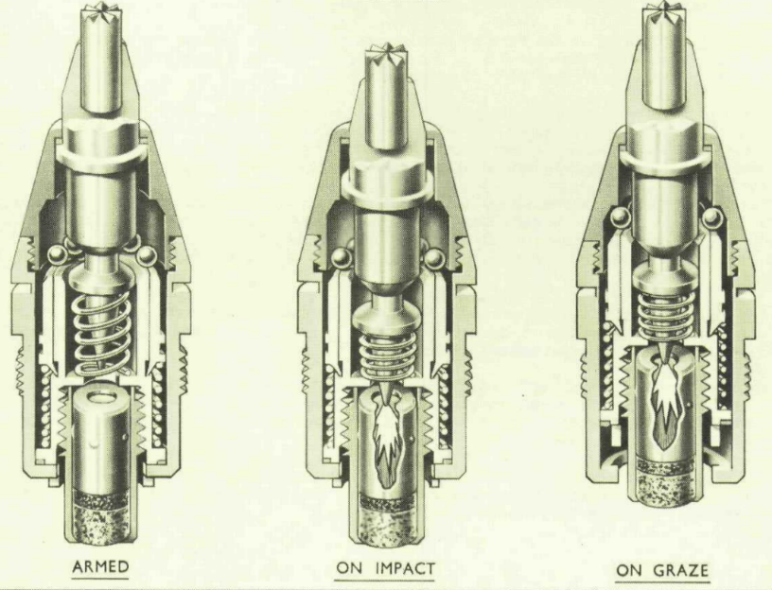
There are two types of fuzes: percussion and airburst. Percussion fuzes generally are initiated by impact upon the target. Airburst fuzes are useful in anti-aircraft and do not physically hit the target, instead bursting in the vicinity of the target. The most prevalent percussion fuze in artillery shells is a graze fuze, where the occurrence of deceleration or sudden change in direction causes the firing pin and detonator to collide, initiating the train as can be seen in Figure 3. Base fuzes are an adaption of the graze fuze where the fuze is enclosed in the base of the shell and has a delay function so the round has time to squash against the target before detonating, rather than detonating immediately at impact. This is used in High Explosive Squash Head (HESH) rounds as a way of defeating armour. [17] [18]
Figure 3: L9A3 Fuze shown in the armed position, direct impact and on a Graze hit [18]
Fuzes have these conditions in order to improve safety during transport, storage and operational use. It should only be possible to initiate the explosive train under the conditions experienced when firing the round. Therefore, accidents within the storage location or transport should not be able to provide sufficient stimuli for unintended detonation.

Safe storage
Safe storage must be considered due to the physical properties of TNT. Standing the shell upright makes operation safer as the diurnal cycling causes the TNT to move inside the shell, potentially unbalancing the round. This can have drastic effects on accuracy when fired from a gun as uneven fill will make the round unstable in flight. Keeping the temperature of the storage location controlled will mitigate the effects of diurnal cycling. Preventing the temperature from rising above TNT’s melting point will reduce the exudation of low boiling point isomers within the TNT mix which will increase the sensitivity of the fill leading to premature detonation.
Where the round is stored must also be humidity controlled. Firstly, a dryer environment will prevent the casing and internal components from rusting. Rusting of the shell may weaken the structural integrity and therefore cause the casing to fail on launch. Diurnal cycling can cause early failure of seals, then the explosive fill may absorb water, reducing the effectiveness. [15]

Conclusion
Large calibre artillery have specific design features to achieve safe storage, transportation, and operation. The explosive train amplifies the initiation source into a deflagration or detonation by using a small amount of highly sensitive explosive in the primer/detonator which sets off a large amount of insensitive material known as the main charge. This is safer because it reduces the amount of sensitive explosives required and parts of the train can be stored separate reducing the risk of a large scale explosion.
Despite TNT’s low power output and the associated effects from diurnal cycling, these weaknesses are overlooked as it’s adequacy in blast and fragmentation as well as cheap and easy manufacturing make it a common fill for artillery shells. Although, many fill mixes have been made to improve upon TNT’s shortcomings. In recent years IMX-101 has eliminated the need for TNT as the base component altogether.

References

[1] | P. M. D. a. J. E. Field, “Initiation and propagation in primary explosives,” Proceedings of the Royal Society, vol. 441, no. 1912, 1993.
[2] | F. L. M. L. Manchee, “PHYSICAL STRUCTURE AND SENSITIVITY - TNT,” Cranfield University, July 2001.
[3] | W. D. J. L. C. L. F. D. Z. Z. T. Y. Q. S. X. C. Juntao Du, “Structural and compositional evolution of coal tar toluene insoluble during slurry-phase hydrocracking,,” Fuel, vol. 203, pp. 352 - 359, 2017.
[4] | W. B. a. I. Dunstan, “Some Properties of TNT Affecting Manufacture and Storage,” MINISTRY OF AVIATION, EXPLOSIVES RESEARCH AND DEVELOPMENT ESTABLISHMENT, WALTHAM ABBEY, ESSEX, 24th November I960.
[5] | K. Walter, “INTRODUCTION TO EXPLOSIVES,” THE ROYAL MILITARY COLLEGE OF SCIENCE, SHRIVENHAM, 1940.
[6] | S. Sadik, “Final Report on a Study of Premature Explosions in Artillery Projectiles Filled with Composition-B,” LAWRENCE LIVERMORE LABORATORY, California, January 12, 1983.
[7] | M. K. &. A. B. Kunz, “An Effect of Hydrostatic Compression on Defects in Energetic Materials,” MRS Online Proceedings Library, pp. 347 - 352, 1998.
[8] | M. P. a. B. Thorpe, “INFLUENCE OF HNS ON THE MICROSTRUCTURE AND PROPERTIES OF CAST TNT,” DEFENCE SCIENCE AND TECHNOLOGY ORGANISATION , MELBOURNE, 1981.
[9] | B. C. Head, “Examination of explosive compositions from new sources, Testing of Comp B and RDX/TNT 60/40 supplied by SNPE of Sorgues,” DERA, Fort Halstead, February 1999.
[10] | B. H. Y. X. Y. S. Q. B. J. J Peng, “The response characteristics of warhead fragment impact on shielded H6 explosive,” International Journal of Multiphysics, vol. 12, no. 2, pp. 89 - 100, 2018.
[11] | W. A. B.-H. A. R. D. S. C. H. P. a. P. J. S. K.E. Lee, “QUALIFICATION TESTING OF THE INSENSITIVE TNT REPLACEMENT EXPLOSIVE IMX-101,” Insensitive Munitions European Manufacturers Group (IMEMG).
[12] | K. Turner, “Trial report – UK element of joint UK /US trials into EOD techniques for insensitive high explosive filled munitions.,” DSTL, Salisbury, September 2017.
[13] | D. Frem, “A Review on IMX-101 and IMX-104 Melt-Cast Explosives: Insensitive Formulations for the Next-Generation Munition Systems,” Propellants, Explosives, Pyrotechnics, vol. 48, no. 1, 2023.
[14] | United Nations Economic Commission For Europe, Agreement Concerning the International Carriage of Dangerous Goods by Road, United Nations, 2023.
[15] | Defence OME Safety Regulator, “DSA 03.OME Part 2 (JSP 482) - Defence Code of Practice (DCOP) and Guidance Notes for In-Service and Operational Safety Management of OME,” Ministry of Defence (MOD), Bristo, Nov 2019.
[16] | E. L. Baker, “LARGE CALIBER PROJECTILE FILL ADHERENCE,” Munitions Safety Information Analysis Center, August 2019.
[17] | D. GILLINGS, “DEVELOPMENT WORK ON FUZES,” Chemical Defence Experimental Establishment, Porton Down, 01/08/1948.
[18] | HANDBOOK OF FUZES USED IN BRITISH LAND SERVICE, WOOLWICH: INSPECTORATE OF ARMAMENTS, 1962.

