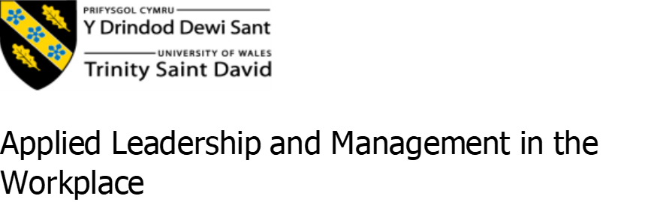

Developing the Learning Organisation: A Case Study of Pullmaflex Ltd.

Author: JOANNA DROZD
Student ID: 2308210
Module Name: BMSK5010
Instructor’s Name: Christine Joy
Submission Date: 09.10.2025

I acknowledge the use of Grammarly (https://www.grammarly.com/) on 09/10/2025 to check my work using the prompt(s):
1. Please check the following text for readability, grammar, and syntax.
I confirm that I have not presented any AI generated text as my own work. I confirm I have copies of my drafts, notes, and other resources I used before, and after the use of AI tools which I may be asked to provide in evidence.

All Polish-to-English translations in this paper were generated using DeepL Translator (version 2024). The translations were reviewed for accuracy and edited for clarity.
Table of Contents

1. Introduction 4
1.1. Purpose and scope 4
1.2. Overview of Pullmaflex 4
2. Aligning People Development with Business Strategy 5
2.1. HR Cycle and Michigan Model 5
2.3. Integration of development into business goals 6
3.The Benefits of Developing Individuals in the Workplace 6
3.1. Organisational benefits (retention, performance, innovation) 6
3.2. Individual benefits (confidence, strategic awareness, skills) 8
4. Managing Expectations in Personal Development 11
4.1. Defining performance expectations: results vs behaviours 11
4.2. Using SMART objectives and goal setting 11
4.3. Addressing conflicts and expectation misalignment 12
5.1. Training, coaching, mentoring 13
5.2. Feedback mechanisms and appraisal tools 13
5.3. Learning styles (Kolb, Honey & Mumford) 14
6. Detailed Development Plan and Performance Management 14
6.1. Designing an individual development plan (PDP) 14
6.2. Performance review strategy and tracking progress. 15
6.4 Continuing Professional Development (CPD) 17
7. Creating a Learning Organisation: Pullmaflex Opportunities 18
7.1. Learning Organisation definition and features 18
7.2. Structural challenges and decentralised decision-making 18
7.3. Embedding continuous improvement culture 19
8. Conclusions and Recommendations 20
8.1. Summary of findings 20
9. References 22
10. Appendices 37
Appendix A. SWOT Analysis 37
Appendix B. GAP Analysis 38
Appendix C. PESTEL Analysis of Pullmaflex Ltd - Developing the Learning Organisation 40
Appendix D. Learning Organisation models in the context of Pullmaplex 41
Appendix E. Structural barriers and tacit knowledge in Pullmaplex 43
Appendix F. Personal Development Plan (PDP) 45
Appendix G. Continuing Professional Development (CPD) Plan for the Author (2025-2030). 52
Appendix H. Key Strategic and Operational Recommendations 55

1. Introduction

1.1. Purpose and scope

The purpose of this report is to reflect upon the concepts of performance support and teamwork through a consideration of employee development at Pullmaflex. This will be done by a consideration of the internal practice of training, the expectations of workers and the place of learning in everyday tasks. The report will provide real-life examples from the author's experience of the potential benefits to individuals and organisations from an approach to developing people at work. Specific consideration will be given to the practical constraints on external training provision.

1.2. Overview of Pullmaflex

Pullmaflex is a manufacturing facility situated in Ammanford, Wales. They specialise in the production of seat support systems and lumbar components for Tier 1 suppliers, including Lear, Adient and Magna. Pullmaflex is a subsidiary of global corporation Leggett & Platt, which achieved a revenue of $4.7 billion in 2023 (Leggett & Platt, 2024). Pullmaflex is known for its high-quality technical production and strong health and safety culture. The Ammanford site has a robust behavioural safety culture, in which employees' actions are observed and modified to reduce risk.
The author of this report is an employee of Pullmaflex, working as a machine operator. This role, in addition to operating production machinery, includes training inexperienced staff, being a certified first aider and acting as a fire marshal. This has given the author a particularly close-up view of the issues relating to learning at work and the development needs of frontline employees. Pullmaflex does not currently have any formal or structured external development programmes in place. Most training is provided in-house, with the primary external focus being on health and safety. The only areas for which employees are externally certified are fire safety and first aid.
The report will examine how this environment affects employee development and identifies potential steps that can be taken to support both workers and business objectives better.

2. Aligning People Development with Business Strategy

2.1. HR Cycle and Michigan Model

At Pullmaflex, the four parts of the Michigan Model are visible: recruitment, appraisal, rewards and development. Recruitment is primarily conducted through agencies, with workers hired and released as orders fluctuate. This weakens team stability and tacit knowledge. Bratton et al. (2021) note that the model is most effective when linked to long-term goals; however, hiring at Pullmaflex is more reactive in nature. Appraisal is based on daily KPIs and Quality Alerts, which secure compliance but do not reward initiative or skills growth. Kaufman et al. (2021) argue that such control creates short-term order but reduces engagement, a pattern seen where output is achieved but skilled operators leave. For example, several agency cohorts completed inductions only to leave within months, making training investment ineffective. Rewards are limited to job security, and training covers only safety and SOPs. The GAP analysis (Appendix B) shows this ensures compliance but weakens capability. The SWOT analysis (Appendix A) also highlights a lack of career planning and succession as a risk. Overall, the model is applied minimally, shaped by audits and client pressure.
2.2. Pullmaflex strategic context
Pullmaflex builds its strategy on quality, delivery, safety and cost (Leggett & Platt, 2024; Internal HR reports, 2024). Aligning HR with these aims should support competitiveness (Dipoatmodjo, 2024); however, training is almost entirely limited to safety. Over 80% of training hours are inductions (HR reports, 2024), with no leadership or technical programmes. This satisfies Tier 1 audits but reduces engagement. Bozhinovska et al. (2023) warn that over-alignment can erode trust. The PEST analysis (Appendix C) reveals that decisions are shaped by audits, while the career expectations of younger staff remain overlooked (CIPD, 2023). Younger operators often request technical skills training but receive only repeat inductions, which causes frustration. The GAP analysis (Appendix B) also confirms that customer priorities dominate workforce development. The result is compliance now, but weak long-term capability (OECD, 2022).

2.3. Integration of development into business goals

Studies show that HR systems are most effective when they support both managers and staff Ferdous et al. (2025). At Pullmaflex, development is primarily focused on compliance, with limited emphasis on skills and innovation. Training is short and functional, while Lean and Kaizen projects are led by engineers, leaving operators excluded. Succession planning is absent, so leadership is unprepared. Ferenhof et al. (2024) argue that knowledge sharing in B2B firms should create value; however, operator tacit knowledge remains unused. Rigamonti et al. (2024) demonstrate that HR analytics can guide training; however, Pullmaflex primarily uses data for compliance purposes. The SWOT analysis (Appendix A) highlights strong audit performance but weak leadership preparation. Without wider training, knowledge gaps emerge during staff absences, highlighting how reliance on compliance can undermine resilience. Broader training in Lean, problem-solving and PDPs could motivate staff and strengthen competitiveness with Tier 1 clients.

3.The Benefits of Developing Individuals in the Workplace

3.1. Organisational benefits (retention, performance, innovation)

Employee development helps companies perform better. Leong et al. (2022) show that training supports retention in manufacturing. Wickramasinghe and Perera (2022) note that Total Productive Maintenance not only increases efficiency but also fosters commitment. Still, training alone is not enough. Chante’ Miller and Banks-Hall (2020) argue that trust and communication must be in place. Venkat et al. (2023) also note that recognising skills through competency management makes employees more likely to stay.
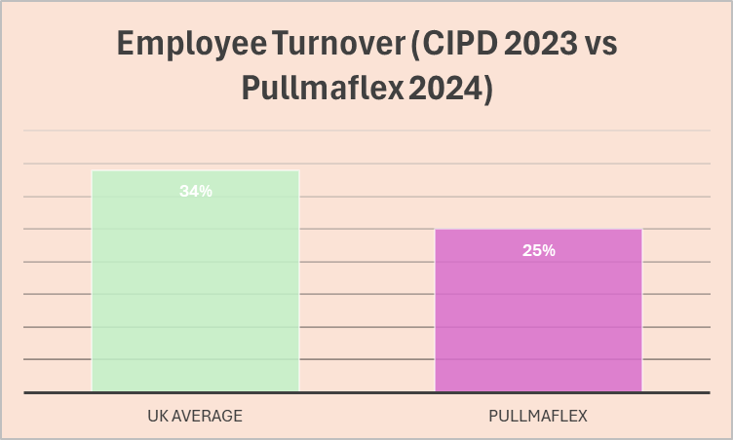
Figure 1. Average employee turnover in the UK vs Pullmaflex.
Note. Created by the author (2025) based on data from CIPD (2023) and Pullmaflex (Internal HR Report, 2024).

At Pullmaflex, the heavy reliance on agency staff creates instability and additional costs. Recruits require repeated inductions, which slows production and reduces tacit knowledge on the shop floor. Figure 1 shows that turnover at Pullmaflex is 25%, which is lower than the UK average of 34% (CIPD, 2023; Pullmaflex, HR Reports, 2024).
At first, this looks good, but it hides weak career development and low engagement, which Macpherson (2024) links to poor innovation. Stronger development policies could help retain skilled workers and reduce waste.
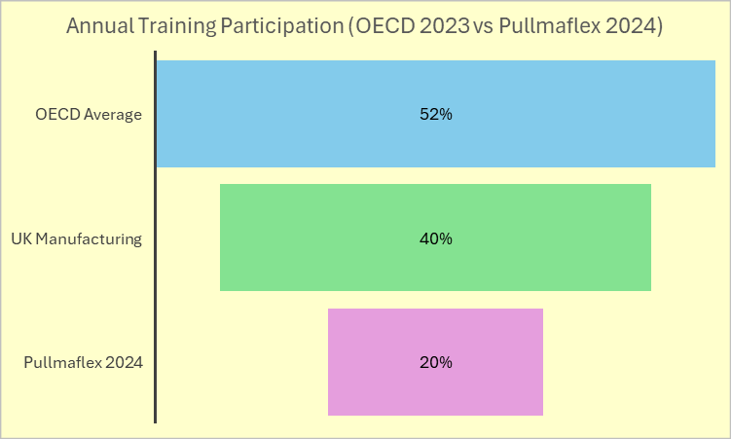
Figure 2. Annual training participation - OECD, UK manufacturing, and Pullmaflex.
Note. Created by the author (2025) based on data from OECD (2023) and Pullmaflex (Internal HR Report, 2024).

Training also supports innovation. Wadhwa et al. (2021) show that learning improves results. Saleh and Ainiah (2024) note that structured training in automotive firms enhances their flexibility. At Pullmaflex, however, training is primarily compliance-based, focusing on health and safety inductions. Figure 2 illustrates that only 20% of staff participated in training in 2024. This is far below the UK manufacturing average of 40% and the OECD average of 52% (OECD, 2023; Pullmaflex, HR Reports, 2024). This gap limits innovation and competitiveness. Macpherson (2024) warns that Industry 4.0 needs digital skills and clear career pathways. Without these, Pullmaflex risks falling behind client expectations even if audit compliance remains strong.

3.2. Individual benefits (confidence, strategic awareness, skills)

For employees, development builds confidence and motivation. Sutarto et al. (2022) found that training boosts performance by increasing confidence, while Coetzee et al. (2022) show that confidence and a sense of purpose encourage initiative. At Pullmaflex, operators often feel judged by QAL alerts rather than supported. This limits confidence and discourages risk-taking.
Strategic awareness is also important. Kataa and Saaed (2024) argue that employees who understand company strategy are more likely to support change. Rashid (2025) emphasises that digital upskilling enables workers to adapt to Industry 4.0, while Leon (2023) demonstrates that reskilling in Industry 5.0 enhances engagement. At Pullmaflex, most operators do not understand how their tasks relate to the broader goals. Training rarely connects shop floor actions to customer satisfaction. As a result, operators lack ownership of change initiatives, weakening their contribution to innovation.

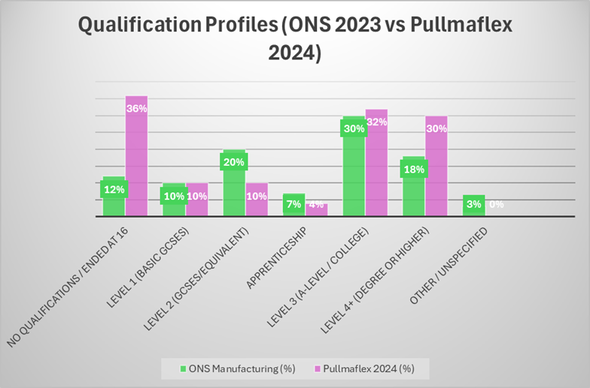
Figure 3. Qualification profiles - ONS Manufacturing vs Pullmaflex.
Note. Created by the author (2025) based on data from ONS (2023) and Pullmaflex (Internal HR Report, 2024).

Skills development is crucial for enhancing employability and fostering career growth. Macpherson (2024) notes that automotive workers now expect chances to upskill. Rashid (2025) and Leon (2023) show that digital skills raise both career prospects and confidence. Pullmaflex, however, lacks structured programmes for technical or digital skills. Younger employees find this frustrating. Figure 3 highlights the imbalance: 36% of Pullmaflex staff left education at 16, compared with 12% of UK manufacturing staff (ONS, 2023). While 30% of staff hold Level 4+ qualifications, these are mainly engineers and office staff, creating a polarised workforce. This structure limits flexibility on the shop floor and makes career growth difficult for operators.
3.3. Statistical evidence and academic sources
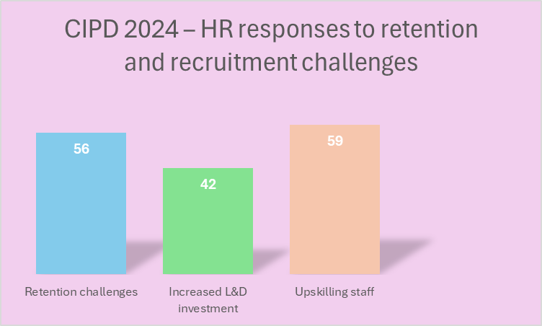
Figure 4. HR responses to retention and recruitment challenges (CIPD, 2024).

CIPD (2024) demonstrates how UK employers address retention and recruitment challenges. According to Figure 4, 56% report retention problems, 42% plan to increase investment in learning and development, and 59% focus on upskilling their staff. Pullmaflex, however, has not followed these trends. Training remains almost fully limited to safety inductions, with little focus on skills growth or career pathways.
Taken together with the earlier data, the picture is clear. Pullmaflex has a lower turnover rate than the UK average, but this is largely due to job security rather than a lack of career opportunities. Training participation is well below national and OECD levels, and qualification data shows a divided workforce. Compared with national patterns, Pullmaflex invests less in upskilling and relies more on compliance. This approach helps audits but weakens flexibility and problem-solving on the shop floor. Addressing this gap by following wider UK practice in learning investment could make the company more resilient and competitive.

4. Managing Expectations in Personal Development

4.1. Defining performance expectations: results vs behaviours

Performance can be measured in two ways: results and behaviours. Results include output, quality issues or KPIs. Behaviours include teamwork, problem-solving, and willingness to follow standards. Armstrong and Taylor (2023) argue that both are important. The CIPD Profession Map (2023) also highlights that technical skills alone are insufficient, as values and behaviours significantly influence real performance.
At Pullmaflex, performance is primarily evaluated by KPIs, quality alerts, and customer audits. This provides clarity but overlooks behaviours such as collaboration or initiative. Agarwal (2021) shows that Balanced Scorecards can measure both results and behaviours, though they may be too complex for the shop floor. Kirkpatrick’s model also emphasises that performance should be evaluated at various levels, from learning to outcomes (Bergamo et al., 2022). In practice, Pullmaflex could utilise simpler methods that strike a balance between efficiency and recognition of staff behaviours and growth.

4.2. Using SMART objectives and goal setting

Clear goals link daily tasks to the company's strategy. Research indicates that performance improves when goals are specific and challenging, and supported by feedback (Vancouver et al.,2022; Niwlikar, 2023). The SMART model makes objectives specific, measurable, achievable, relevant and time bound. At Pullmaflex, goals are often reactive to customer audits. SMART targets could shift this approach. For example, instead of only reacting to a QAL from a Tier 1 client, operators could aim to reduce tube misrouting defects by 20% within three months through targeted training and visual checks. This connects daily work to measurable progress and customer satisfaction.
Fayomi & Akanazu (2024) and Adamik & Sikora-Fernandez (2021) show that clear objectives strengthen competitiveness. Latham (2023) and Ab Rahman (2025) argue that employees are more motivated when they see how their goals are linked to broader outcomes. However, there are risks: rigid goals may reduce creativity and limit growth. Management by Objectives (MBO) mitigates this risk by aligning personal and organisational goals, monitoring progress, and rewarding achievement (Jaworski & Cheung, 2023). For Pullmaflex, combining SMART with MBO could support learning and improvement, but there is also a risk of adding bureaucracy and focusing too much on short term targets instead of innovation.

4.3. Addressing conflicts and expectation misalignment

Conflicts arise when company expectations do not align with employee needs. Ngo et al. (2022) warn that a system can meet technical targets but fail to reflect values. At Pullmaflex, performance is mostly tracked through audits and defect reports, but staff rarely receive positive recognition. Mistakes often result in warning letters, and promotions are frequently based on personal connections rather than skills. This creates a sense of unfairness. Equity theory explains that such treatment leads to frustration and disengagement (Davlembayeva & Alamanos, 2023).
Leadership is crucial to reducing these problems. Responsible leaders can rebuild trust when expectations are not met (Tan et al., 2024; Hargitai & Bencsik, 2023). Herzberg’s theory suggests that a lack of recognition and unfair promotion can lower motivation and job satisfaction (Peramatzis & Galanakis, 2022). Constructive conflict management, such as the Thomas-Kilmann model, promotes cooperation instead of avoidance (Khan et al., 2025). Learning communities also create fairer opportunities for development (Zamiri & Esmaeili, 2024). For Pullmaflex, this means going beyond audits and introducing transparent, fair practices that support both motivation and learning.
Summary
In Pullmaflex, performance is mainly measured through compliance tools, while development and behaviours are often ignored. Research shows that balancing results with behaviours, using SMART and MBO, and ensuring fairness in recognition are essential. Without these steps, expectations remain misaligned and motivation weak. Addressing these gaps could help Pullmaflex transition from an audit-driven control to a more sustainable learning culture.

5. Evaluating Development Vehicles at Pullmaflex

5.1. Training, coaching, mentoring

At Pullmaflex, training is focused on compliance, OSPs and safety. These are important, but they do not prepare staff for Industry 4.0. Plawgo and Ertman (2021) argue that firms must also build digital and problem-solving skills. Short one-off sessions often make staff passive. Tobór-Osadnik et al. (2024) note that this lowers accountability, while Aggarwal (2023) links it to dysfunctions such as low trust and weak commitment.
Structured approaches, such as the ADDIE model, can help. Adeoye et al. (2024) and Crompton et al. (2024) demonstrate that the use of analysis, design, implementation, and evaluation, supported by digital tools, enhances learning. Pullmaflex could use short simulations to track whether errors fall.
However, training alone does not change behaviour. Govender and Adegbite (2022) stress that development should also include coaching and mentoring. At Pullmaflex, line leaders could use situational leadership (Dofinsa et al., 2025), guiding new staff and mentoring experienced ones. Lee (2022) also highlights that trust, constructive conflict and focus on results strengthen teams. Coaching and mentoring could build these behaviours and improve engagement.

5.2. Feedback mechanisms and appraisal tools

Feedback at Pullmaflex is primarily reactive. Errors often bring formal letters instead of constructive advice. With no annual appraisals or reviews, employees lack clarity on performance. Dangol (2021) argues that poor appraisal reduces engagement.
Continuous feedback models (Rivera et al., 2021) suggest that event-based reviews are more effective than retrospective letters. Panadero and Lipnevich (2022) propose clear criteria, quick guidance and dialogue. For Pullmaflex, this could mean short review sessions supported by forms or dashboards, showing both quality metrics and behaviours.
Technology also offers options. AR can log training errors for evaluation (Moghaddam et al., 2021). Digital twins can record operator responses (Opoku et al., 2021). Hybrid modelling can create indicators linked to appraisal systems (Sansana et al., 2021). Pullmaflex could replace warning letters with structured systems that combine KPIs, peer feedback, and digital tools.

5.3. Learning styles (Kolb, Honey & Mumford)

Kolb’s cycle and Honey and Mumford’s styles show that people learn in different ways. At Pullmaflex, training is delivered in one format for all, which reduces engagement. Essa et al. (2023) and Rasheed & Wahid (2021) show that machine learning can adapt materials to individual needs. For example, digital OSPs could provide diagrams, videos or simulations linked to Kolb’s stages. Mourtzis et al. (2023) suggest a “teaching factory” approach, where learning happens on the shop floor.
Ross (2025) and Sood & Sarin (2021) warn that styles should not be applied too rigidly. Zanchi et al. (2023) note that Lean projects are more effective when training employs mixed methods. For Pullmaflex, this means combining models and adaptive tools, giving flexibility while keeping shared standards.

6. Detailed Development Plan and Performance Management

6.1. Designing an individual development plan (PDP)

At Pullmaflex, training is still one-size-fits-all, which reduces engagement and slows adaptation for new operators. A structured PDP can improve this by combining reflection, coaching and measurable goals. Cottrell (2021) emphasises that PDPs enhance employability through self-awareness, while Lejeune et al. (2021) demonstrate that self-directed learning improves performance. Employees should therefore own their development, not just follow a checklist.
Chan (2021) notes that workplace learning should enhance communication, which is crucial in Pullmaflex’s multilingual teams. Wang et al. (2022) highlight that coaching enhances both technical and emotional support, while Mughal (2023) demonstrates that the 70-20-10 model facilitates shop-floor learning. Manyo’e (2025) notes that combining this with ADDIE ensures structure and evaluation. PDPs must also go beyond technical skills. Naqshbandi et al. (2024) link development to engagement, while Xu et al. (2021) and Mourtzis et al. (2022) argue that Industry 5.0 requires digital and collaborative competences. Ilmast (2023) demonstrates that clear PDP templates facilitate the application of theory, while Putra and Putri (2025) link PDPs to fair evaluation.

6.2. Performance review strategy and tracking progress.

At Pullmaflex, performance reviews primarily focus on compliance, including defect counts and audit scores. These measures are practical, but they provide only a partial view of employee growth. Armstrong and Taylor (2023) explain that reviews should also connect personal goals with company strategy. Holbeche (2022) notes that HR must align with the broader business objectives.
The Balanced Scorecard helps expand reviews to cover learning and growth (Kaufman et al., 2021; Agarwal, 2021). For Pullmaflex, this could mean tracking not only reductions in QALs but also operator involvement in Kaizen or progress with digital OSP tools. Kirkpatrick’s model examines four levels of training impact (Andreev, 2022; Bergamo et al., 2022), assessing whether learning changes behaviour.
Goal-setting theory also supports reviews. Latham (2023) and Ab Rahman (2025) demonstrate that SMART goals facilitate measurable progress, whereas Vancouver et al. (2022) caution that excessive rigidity can compromise flexibility. Putra and Putri (2025) argue that competency growth should be linked to fairer evaluation. Rivera et al. (2021) highlight that continuous feedback often works better than yearly reviews.
For Pullmaflex, the best option would be quarterly reviews using SMART goals, combined with ongoing feedback from leaders and quality data linked to development indicators. This frequency aligns with the company’s internal and customer reports, which are also produced quarterly, ensuring consistency between performance evaluation and reporting cycles.

6.3. Succession planning and sustainability.

Succession planning at Pullmaflex is not formalised. Client relationships are stable, but expertise is concentrated among supervisors close to retirement. Armstrong and Taylor (2023) argue that succession planning must also build resilience across the workforce.
Cantarino and de Araujo (2022) stress that leaders must show technical, behavioural and attitudinal competence. At Pullmaflex, this means future leaders should not only manage machines but also solve problems, communicate well and support continuous improvement. Putra and Putri (2025) show that competency-based strategies strengthen both evaluation and leadership pipelines.
The broader context matters too. Xu et al. (2021) and Mourtzis et al. (2022) argue that Industry 5.0 requires both digital and collaborative skills, in addition to technical expertise. Naqshbandi et al. (2024) add that engagement is essential, while hybrid practices demand flexibility.
For Pullmaflex, succession planning should combine mentoring, PDPs and structured reviews. Knowledge transfer through Kaizen and digital OSPs would protect expertise and create a pipeline of skilled leaders, securing long-term sustainability.
A detailed Personal Development Plan, designed by the author to address current training and succession gaps, is provided in Appendix F.
The table below summarises current practices at Pullmaflex and recommended approaches from the literature.
Current vs recommended development practices at Pullmaflex.
Area | Current practice at Pullmaflex | Recommended approach
PDP (Individual Development Plans) | Training is one-size-fits-all, focused on OSPs and safety. No structured PDPs. | PDPs with SMART goals and mentoring to build technical and behavioural competences (Cottrell, 2021).
Performance reviews | Reviews focus on audits, QAL alerts and defect counts. Feedback is mainly letters after errors. | Broader system linking goals to business strategy, using SMART reviews with ongoing feedback (Armstrong & Taylor, 2023).
Succession planning | No formal plan. Key expertise is held by older supervisors. | Structured succession to prepare future leaders with technical and collaborative skills (Mourtzis et al., 2022).

This highlights that Pullmaflex relies on basic compliance systems, while recommended approaches would build long-term capability and resilience.

6.4 Continuing Professional Development (CPD)

Continuous professional development (CPD) helps employees stay employable and adapt to new technologies in a rapidly changing industry. Xu et al. (2021) point out that Industry 5.0 requires not only technical knowledge but also human skills such as creativity, teamwork and problem solving. However, Herjuna et al. (2024) found that in many factories, training still focuses mainly on short-term production goals, which limits long-term growth and innovation.
At Pullmaflex, most training remains compliance-based and rarely includes reflection or future planning. In practice, the 70-20-10 model (Mughal, 2023) and self-directed learning (Lejeune et al., 2021) show that people learn most effectively through experience, mentoring and regular feedback, rather than formal classroom sessions. Cottrell (2021) adds that CPD only works when both employees and managers share responsibility for learning.
While a Personal Development Plan (PDP) sets short-term goals, CPD focuses on continuous growth over time. Combining both can help Pullmaflex move away from audit-driven routines and build a stronger learning culture, where skills are regularly updated and reflection becomes part of everyday work. Time limits, costs, and staff turnover reduce PDP/CPD effectiveness. A detailed CPD plan is provided in Appendix G.

7. Creating a Learning Organisation: Pullmaflex Opportunities

7.1. Learning Organisation definition and features
The idea of a learning organisation (LO) has many interpretations. Hannachi (2021) shows that models are often unclear and complicated to apply. Alerasoul et al. (2022) combine three views: organisational learning, learning organisation, and learning orientation, confirming there is no single model. Still, most authors agree that LOs focus on adaptability, reflection, and knowledge sharing (Kłak, 2021). Senge’s (1990) five disciplines remain influential, but studies note that they are challenging to use in rigid manufacturing contexts (Hannachi, 2021; Alerasoul et al., 2022; Do et al., 2022).
The structure at Pullmaflex is highly centralised and resembles the rigid hierarchies typical of nineteenth-century factories, rather than the flexible systems of a modern learning organisation. This centralisation blocks knowledge sharing and limits reflection. Chen and Cuervo (2022) argue that transformational leadership supports learning organisations, but Pullmaflex relies mainly on supervision and control. Achdiat et al. (2023) link learning culture with innovation, yet production targets are given higher priority.
As a result, Pullmaflex applies only fragments of LO ideas and misses opportunities to build adaptability and shared learning. A fuller discussion of models and frameworks, including Senge’s disciplines, is provided in Appendix D.

7.2. Structural challenges and decentralised decision-making
At Pullmaflex, most decisions are taken by managers and passed down. Operators follow instructions but have little influence on change. This slows response times and prevents knowledge from being shared across teams. Kumar et al. (2021) note that rigid hierarchies hinder the adoption of new technology, while Adana et al. (2024) link decentralisation with stronger resilience. Ozkan-Ozen and Kazancoglu (2022) note that Industry 4.0 necessitates employees who are both flexible and empowered.
Pullmaflex already utilises Lean and Six Sigma, but engineers primarily manage these methodologies. If operators led Kaizen groups, problems could be solved faster and ownership shared more widely. Without this, Lean and Six Sigma risk being reporting tools instead of learning drivers. More on decentralisation and workplace barriers is provided in Appendix E.

7.3. Embedding continuous improvement culture
Continuous improvement is more than projects. Helmold (2024) emphasises that Kaizen should be integrated into daily routines, while Suárez-Barraza and Huerta-Carvajal (2024) demonstrate that reflection enhances employee engagement. Sridhar et al. (2023) argue that rapid change in Industry 4.0 requires improvement every day, not just after problems.
At Pullmaflex, improvement is still reactive. Operators meet targets, but reviews happen only when issues occur. Tacit knowledge, such as early signs of defects or unusual machine sounds, is often not captured. Embedding improvement would mean daily stand-up meetings, simple visual boards for suggestions, and Kaizen sessions with reflections on lessons learned. Okpala et al. (2024) demonstrate that Kaizen is most effective when employees take ownership. For Pullmaflex, this would mean moving from improvement as a tool to improvement as a shared culture.
The table below contrasts current practices at Pullmaflex with the features of a learning organisation.

Pullmaflex today vs Learning Organisation features
Area | Pullmaflex current practice | Learning Organisation approach
Structure | Centralised, top-down decisions | Decentralised, knowledge shared across teams (Adana et al., 2024)
Culture | Focus on meeting production targets | Shared culture of reflection and improvement (Suárez-Barraza & Huerta-Carvajal, 2024)
Use of Lean/Kaizen | Led mainly by engineers and managers | Operators actively lead Kaizen and share tacit knowledge (Okpala et al., 2024)
Learning | Reactive, reviews after problems | Continuous learning embedded in daily routines (Helmold, 2024)

This comparison shows that Pullmaflex remains compliance-driven, while adopting learning organisation practices would require decentralisation, reflection, and stronger operator involvement.

8. Conclusions and Recommendations

8.1. Summary of findings

This report has shown that Pullmaflex places a strong emphasis on compliance with Tier 1 requirements, often at the expense of employee development and long-term adaptability. Training is dominated by health and safety inductions, with little investment in technical, digital, or leadership skills. HR systems, such as recruitment, appraisal, and rewards, are in place but are often reactive and shaped by audits rather than driven by strategic growth. Agency reliance undermines stability, while centralised decision-making restricts knowledge sharing. Lean and Six Sigma tools are utilised, but primarily by managers, which limits opportunities for operator involvement. Continuous improvement exists in form, but not in culture, with problem-solving applied only after defects have arisen. Overall, the company is stable in terms of compliance but weak in developing a learning culture, establishing career pathways, and implementing sustainable succession planning.
This analysis follows the principles of critical reasoning outlined in the RED and Toulmin models, where evidence, assumptions and conclusions are evaluated to ensure balanced and logical judgement in linking theory with Pullmaflex practice.

8.2. Key strategic and operational recommendations

To build long-term capability and continually improve performance, several key actions are recommended. The primary focus should be on enhancing employee development, conducting fair and transparent performance reviews, increasing staff involvement in continuous improvement, and establishing a transparent career path based on merit rather than personal connections.
Detailed recommendations are listed in Appendix H, showing what should be improved to make Pullmaflex a more skilled, motivated, and learning-oriented workplace.

9. References

Ab Rahman, M. R. Z. B. (2025). Why goal setting theory is the most relevant in today’s workforce? Malaysian Journal of Business, Economics and Management, 4(1), 41 - 48. https://doi.org/10.56532/mjbem.v4i1.90
Achdiat, I., Mulyani, S., Azis, Y., & Sukmadilaga, C. (2023). Roles of organizational learning culture in promoting innovation. The Learning Organization, 30(1), 76 - 92. https://doi.org/10.1108/TLO-01-2021-0013
Adamik, A., & Sikora-Fernandez, D. (2021). Smart organizations as a source of competitiveness and sustainable development in the age of Industry 4.0: Integration of micro and macro perspective. Energies, 14(6), 1572. https://doi.org/10.3390/en14061572
Adana, S., Manuj, I., Herburger, M., Cevikparmak, S., Celik, H., & Uvet, H. (2024). Linking decentralization in decision-making to resilience outcomes: A supply chain orientation perspective. The International Journal of Logistics Management, 35(1), 256 - 280. https://doi.org/10.1108/IJLM-07-2022-0308
Adeoye, M. A., Wirawan, K. A. S. I., Pradnyani, M. S. S., & Septiarini, N. I. (2024). Revolutionizing education: Unleashing the power of the ADDIE model for effective teaching and learning. JPI (Jurnal Pendidikan Indonesia), 13(1), 202 - 209. https://doi.org/10.23887/jpiundiksha.v13i1.68624
Agarwal, A. (2021). Investigating design targets for effective performance management system: An application of balance scorecard using QFD. Journal of Advances in Management Research, 18(3), 353-367. https://doi.org/10.1108/JAMR-05-2020-0075
Aggarwal, A. K. (2023). A study of Lencioni’s model of dysfunctional groups. International Journal of E-Collaboration, 19(1), 1 - 19. https://doi.org/10.4018/IJeC.321557
Alerasoul, S. A., Afeltra, G., Hakala, H., Minelli, E., & Strozzi, F. (2022). Organisational learning, learning organisation, and learning orientation: An integrative review and framework. Human Resource Management Review, 32(3), 100854. https://doi.org/10.1016/j.hrmr.2021.100854
Andreev, I. (2022, January 17; updated August 11, 2025). Kirkpatrick evaluation model: Four levels of training evaluation. Valamis. Retrieved from https://www.valamis.com/hub/kirkpatrick-model
Armstrong, M., & Taylor, S. (2023). Armstrong's handbook of human resource management practice: A guide to the theory and practice of people management. Kogan Page Publishers.
Awan, U., Sroufe, R., & Shahbaz, M. (2021). Industry 4.0 and the circular economy: A literature review and recommendations for future research. Business Strategy and the Environment, 30(4), 2038-2060. https://doi.org/10.1002/bse.2731
Bergamo, P. A. D. S., Izart, C., Streng, E. S., Rosenkranz, J., & Ghorbani, Y. (2022). Use of Kirkpatrick evaluation model in simulation-based trainings for the mining industry: A case study for froth flotation. Minerals Engineering, 188, 107825. https://doi.org/10.1016/j.mineng.2022.107825
Bhadu, J., Kumar, P., Bhamu, J., & Singh, D. (2022). Lean production performance indicators for medium and small manufacturing enterprises: Modelling through analytical hierarchy process. International Journal of System Assurance Engineering and Management, 13(2), 978 - 997. https://doi.org/10.1007/s13198-021-01375-6
Bozhinovska, T., Eftimov, L., & Nakov, L. (2023). Contemporary managerial analysis of multi-stakeholder perspective in human resource management: Towards a new conceptual framework. Management: Journal of Contemporary Management Issues, 28(Special Issue), 13 - 27. https://doi.org/10.30924/mjcmi.28.si.2
Bratton, J., Gold, J., Bratton, A., & Steele, L. (2021). Human resource management (7th ed.). Bloomsbury Publishing.
Cantarino, G. P. R., & de Araujo, F. O. (2022). Technical, behavioral and attitudinal competences of leaders/managers: Practical applications based on literature exploratory study. Brazilian Journal of Operations & Production Management, 19(4), 1 - 8. https://doi.org/10.14488/BJOPM.2022.1558
Castanelli, D. J., Weller, J. M., Molloy, E., & Bearman, M. (2022). Trust, power and learning in workplace‐based assessment: The trainee perspective. Medical Education, 56(3), 280 - 291. https://doi.org/10.1111/medu.14631
Chan, C. S. (2021). Helping university students discover their workplace communication needs: An eclectic and interdisciplinary approach to facilitating on-the-job learning of workplace communication. English for Specific Purposes, 64, 55 - 71. https://doi.org/10.1016/j.esp.2021.07.002
Chante’ Miller, O. P., & Banks-Hall, R. (2020). Human capital strategies to reduce employee turnover in the food service and automotive industries. International Journal of Business and Management Research, 8(3), 84 - 90. https://doi.org/10.37391/IJBMR.080304
Chen, S., & Cuervo, J. C. (2022). The influence of transformational leadership on work engagement in the context of learning organization mediated by employees’ motivation. The Learning Organization, 29(5), 567 - 585. https://doi.org/10.1108/TLO-01-2022-0011
CIPD. (2023). Employee turnover and retention benchmarking. Chartered Institute of Personnel and Development. Retrieved from https://www.cipd.org
CIPD. (2023). The Profession Map. Chartered Institute of Personnel and Development. https://www.cipd.org/uk/learn/career/profession-map/
CIPD. (2024). Resourcing and talent planning survey report 2024. Chartered Institute of Personnel and Development. Retrieved from https://www.cipd.org
Coetzee, M., Oosthuizen, R. M., & van Niekerk, A. (2022). Industrial psychologist intern: Professional purpose, skills and practice confidence. Psychology in Society, 48(1), 1 - 22. https://hdl.handle.net/10520/ejc-psyc_v48_i1_a2016
Cottrell, S. (2021). Skills for success: Personal development and employability. Bloomsbury Publishing.
Crompton, H., Jones, M. V., Sendi, Y., Aizaz, M., Nako, K., Randall, R., & Weisel, E. (2024). Examining technology use within the ADDIE framework to develop professional training. European Journal of Training and Development, 48(3/4), 422 - 454. https://doi.org/10.1108/EJTD-12-2022-0137
Dangol, P. (2021). Role of performance appraisal system and its impact on employee’s motivation. Quantitative Economics and Management Studies, 2(1), 13 - 26. https://doi.org/10.35877/454RI.qems119
Davlembayeva, D., & Alamanos, E. (2023). Equity theory. In S. Papagiannidis (Ed.), TheoryHub book (pp. 45 - 58). Newcastle University Business School. Retrieved from https://open.ncl.ac.uk/theoryhub-book/
Dipoatmodjo, T. S. P. (2024). The role of human resource management in enhancing company performance and productivity. Journal Management & Economics Review (JUMPER), 2(2), 83 -90. https://malaqbipublisher.com/index.php/JUMPER/article/view/303
Do, H., Budhwar, P., Shipton, H., Nguyen, H. D., & Nguyen, B. (2022). Building organizational resilience, innovation through resource-based management initiatives, organizational learning and environmental dynamism. Journal of Business Research, 141, 808 - 821. https://doi.org/10.1016/j.jbusres.2021.11.090
Dofinsa, T., Restu, R., & Gistituati, N. I. (2025). Situational leadership in facing digital transformation in the Industrial 4.0 era: In improving teacher performance. Mudir: Jurnal Manajemen Pendidikan, 7(2), 303 - 308. https://doi.org/10.55352/1r8gg147
Essa, S. G., Celik, T., & Human-Hendricks, N. E. (2023). Personalized adaptive learning technologies based on machine learning techniques to identify learning styles: A systematic literature review. IEEE Access, 11, 48392 - 48409. https://doi.org/10.1109/ACCESS.2023.3276439
Fayomi, O., & Akanazu, H. (2024). Strategic goal-setting and organisational effectiveness in selected trading and manufacturing companies. Webology, 21(2), 25 - 39. Retrieved from https://www.proquest.com/scholarly-journals/strategic-goal-setting-organisational/docview/3048155507/se-2
Ferdous, S. (2025). Advanced human resource management: Strategies, theories and concepts for HR practice. Kogan Page Publishers.
Ferenhof, H. A., Bonamigo, A., Rosa, L. G., & Vieira, T. C. (2024). Theoretical B2B knowledge management framework focused on value co-creation. VINE Journal of Information and Knowledge Management Systems, 54(2), 424 - 451. https://doi.org/10.1108/VJIKMS-10-2021-0239
Govender, C. M., & Adegbite, W. M. (2022). Evolving role of learning and development specialists in the 21st century Fourth Industrial Revolution workplace. International Journal of Entrepreneurship, 26(1), 1 - 16. https://hdl.handle.net/10210/501204
Hannachi, Y. (2021). The learning organisation: Choice of a model and study of its empirical modeling. Technology Analysis & Strategic Management, 33(6), 700 - 712. https://doi.org/10.1080/09537325.2020.1839643
Hargitai, D. M., & Bencsik, A. (2023). The role of leadership in digital learning organizations. Emerging Science Journal, 7(Special Issue 2), 111 - 124. https://doi.org/10.28991/ESJ-2023-SIED2-09
Hashemi, A. (2025). Institutional theory and human resource management. Taylor & Francis. https://doi.org/10.4324/9781003513810
Helmold, M. (2024). Kaizen: How to successfully transition into a Lean organization. World Scientific.
Herjuna, S. A. S., Marhaeni, V. F., Alvira, M., Putri, F., & Anastasya, F. (2024). Impact of training and development programs on employee performance in the manufacturing sector. Acta Psychologia, 3(3), 140-151. https://doi.org/10.35335/psychologia.v3i3.68
Holbeche, L. (2022). Aligning human resources and business strategy. Routledge. https://doi.org/10.4324/9781003219996
Ilmast, M. (2023). Developing a work personal development process and personal development plan template for an engineering design company [Master’s thesis, Metropolia University of Applied Sciences]. Theseus. https://www.theseus.fi/handle/10024/796098
Internal HR reports. (2024). Pullmaflex training and development records 2024. Internal company document, Pullmaflex Ltd.
Jaworski, B., & Cheung, V. (2023). Drucker management philosophy and ten principles. In B. Jaworski & V. Cheung, Creating the organization of the future: Building on Drucker and Confucius foundations (Chapter 9). Emerald Publishing Limited. https://doi.org/10.1108/978-1-83753-216-220231009
Kataa, I. A., & Saaed, H. K. (2024). Strategic awareness and its impact on organizational readiness for change: Analytical research into the automotive and equipment manufacturing state company. Journal of Economics and Administrative Sciences, 30(142), 102 - 117. https://doi.org/10.33095/0gbgnk07
Kaufman, B. E., Barry, M., Wilkinson, A., & Gomez, R. (2021). Alternative balanced scorecards built from paradigm models in strategic HRM and employment/industrial relations and used to measure the state of employment relations and HR system performance across US workplaces. Human Resource Management Journal, 31(1), 65 - 92. https://doi.org/10.1111/1748-8583.12271
Khan, S., Bokhari, S. S. A., & Ahmad, B. (2025). Investigating the impact of effective conflict management on organizational performance management using the Thomas-Kilmann Conflict Mode Instrument. Contemporary Journal of Social Science Review, 3(3), 561 - 571. https://doi.org/10.63878/cjssr.v3i3.991
Kłak, M. (2021). Conceptual principles of learning organization. Modern Management Review, 26(4), 47 - 59. https://doi.org/10.7862/rz.2021.mmr.24
Kumar, P., Bhamu, J., & Sangwan, K. S. (2021). Analysis of barriers to Industry 4.0 adoption in manufacturing organizations: An ISM approach. Procedia CIRP, 98, 85 - 90. https://doi.org/10.1016/j.procir.2021.01.010
Latham, G. P. (2023). Motivate employee performance through goal setting. In J. Greenberg (Ed.), Principles of organizational behavior: The handbook of evidence-based management (3rd ed., pp. 83 - 111). Wiley. https://doi.org/10.1002/9781394320769.ch5
Lee, C. (2022). Building blocks of effective teams; Understanding how the Five Behaviors Model impacts team effectiveness (Order No. 29258376). ProQuest Dissertations & Theses Global. https://www.proquest.com/dissertations-theses/building-blocks-effective-teams-understanding-how/docview/2708450641/se-2
Leggett & Platt. (2024). Annual report 2024. Leggett & Platt Automotive.
Leggett & Platt. (2024, February 8). Leggett & Platt reports fourth quarter and full year results. Retrieved from https://leggett.gcs-web.com/news-releases/news-release-details/leggett-platt-reports-fourth-quarter-and-full-year-results-0
Lejeune, C., Beausaert, S., & Raemdonck, I. (2021). The impact on employees’ job performance of exercising self-directed learning within personal development plan practice. The International Journal of Human Resource Management, 32(5), 1086-1112. https://doi.org/10.1080/09585192.2018.1510848
Leon, R. D. (2023). Employees’ reskilling and upskilling for industry 5.0: Selecting the best professional development programmes. Technology in Society, 75, 102393. https://doi.org/10.1016/j.techsoc.2023.102393
Leong, W. K., Ahmad, N., Kamaruddin, N. K., & Mamat, T. N. A. R. (2022). Human resource practices and employee retention in manufacturing industry. Research in Management of Technology and Business, 3(2), 113 - 131. https://penerbit.uthm.edu.my/periodicals/index.php/rmtb/article/view/9726
Macpherson, W. E. (2024). The adoption of talent retention strategies in Industry 4.0 automotive organisations: Employees’ perspective. SA Journal of Human Resource Management, 22(1), 1 -12. https://doi.org/10.4102/sajhrm.v22i0.2789
Manyo’e, E. T. (2025). Model 70-20-10 vs ADDIE: A comparative analysis of learning models for enhancing apparatus competence. Jurnal Administrasi Negara, 31(2), 107-126. https://doi.org/10.33509/jan.v31i2.3468
Moghaddam, M., Wilson, N. C., Modestino, A. S., Jona, K., & Marsella, S. C. (2021). Exploring augmented reality for worker assistance versus training. Advanced Engineering Informatics, 50, 101410. https://doi.org/10.1016/j.aei.2021.101410
Mourtzis, D., Angelopoulos, J., & Panopoulos, N. (2022). A literature review of the challenges and opportunities of the transition from Industry 4.0 to Society 5.0. Energies, 15(17), 6276. https://doi.org/10.3390/en15176276
Mourtzis, D., Panopoulos, N., & Angelopoulos, J. (2023). A hybrid teaching factory model towards personalized education 4.0. International Journal of Computer Integrated Manufacturing, 36(12), 1739 - 1759. https://doi.org/10.1080/0951192X.2022.2145025
Mughal, Z. (2023). Optimizing workplace training transfer: A case study on designing the 70:20:10 training strategy through SME and L&D collaboration (Doctoral dissertation, University of Wisconsin-Stout). University of Wisconsin Digital Collections. http://digital.library.wisc.edu/1793/84881
Myszewski, J. M. (2017). Six Sigma model of transfer of development capability. Business Process Management Journal, 23(4), 857 - 872. https://doi.org/10.1108/BPMJ-02-2017-0026
Naqshbandi, M. M., Kabir, I., Ishak, N. A., & Islam, M. Z. (2024). The future of work: Work engagement and job performance in the hybrid workplace. The Learning Organization, 31(1), 5-26. https://doi.org/10.1108/TLO-08-2022-0097
Ngo, R., Chan, L., & Mindermann, S. (2022). The alignment problem from a deep learning perspective. arXiv preprint arXiv:2209.00626. https://doi.org/10.48550/arXiv.2209.00626
Niwlikar, B. (2023, August 2). Goal setting theory of motivation & its components. Career Shodh. Retrieved from https://www.careershodh.com/goal-setting-theory/
OECD. (2023). Education at a Glance 2023: OECD indicators. Organisation for Economic Co-operation and Development. https://www.oecd.org/en/publications/education-at-a-glance-2023_e13bef63-en.html
Okpala, C., Nwamekwe, C. O., & Ezeanyim, O. C. (2024). The implementation of Kaizen principles in manufacturing processes: A pathway to continuous improvement. International Journal of Engineering Inventions, 13(7), 116-124. https://hal.science/hal-04669397/
ONS. (2023). How qualified are the people in your industry? Office for National Statistics. Retrieved from https://www.ons.gov.uk/peoplepopulationandcommunity/educationandchildcare/articles/howqualifiedarethepeopleinmyindustry/2023-08-14
Opoku, D. G. J., Perera, S., Osei-Kyei, R., & Rashidi, M. (2021). Digital twin application in the construction industry: A literature review. Journal of Building Engineering, 40, 102726. https://doi.org/10.1016/j.jobe.2021.102726
Ozkan-Ozen, Y. D., & Kazancoglu, Y. (2022). Analysing workforce development challenges in the industry 4.0. International Journal of Manpower, 43(2), 310 - 333. https://doi.org/10.1108/IJM-03-2021-0167
Panadero, E., & Lipnevich, A. A. (2022). A review of feedback models and typologies: Towards an integrative model of feedback elements. Educational Research Review, 35, 100416. https://doi.org/10.1016/j.edurev.2021.100416
Peramatzis, G., & Galanakis, M. (2022). Herzberg’s motivation theory in workplace. Psychology, 12(12), 971 - 978. https://doi.org/10.17265/2159-5542/2022.12.009
Plawgo, B., & Ertman, A. (2021). Competency needs of Industry 4.0 companies. Central European Management Journal, 29(4), 172 - 195. https://doi.org/10.7206/cemj.2658-0845.64
Pullmaflex. (2024). Internal HR report: Training and qualifications data. Ammanford: Pullmaflex Ltd.
Pullmaflex. (2024). Internal HR training report 2024. Unpublished internal company document.
Putra, P. S., & Putri, F. F. E. (2025). Competency development strategy as an effort to optimize the performance evaluation of employees of PT PLN (Persero) UPT Padang through literature study. Impact Journal-Management Business and Finance, 2(2), 218-226. https://impactjournal.or.id/index.php/impact/article/view/63/46
Rasheed, F., & Wahid, A. (2021). Learning style detection in E-learning systems using machine learning techniques. Expert Systems with Applications, 174, 114774. https://doi.org/10.1016/j.eswa.2021.114774
Rashid, L. (2025). Industry 4.0 and employee upskilling: How a developing country can bridge the digital skills gap. BRAC University Institutional Repository. http://hdl.handle.net/10361/26632
Rigamonti, E., Gastaldi, L., & Corso, M. (2024). Measuring HR analytics maturity: Supporting the development of a roadmap for data-driven human resources management. Management Decision, 62(13), 243 - 282. https://doi.org/10.1108/MD-11-2023-2087
Rivera, M., Qiu, L., Kumar, S., & Petrucci, T. (2021). Are traditional performance reviews outdated? An empirical analysis on continuous, real-time feedback in the workplace. Information Systems Research, 32(2), 517 - 540. https://doi.org/10.1287/isre.2020.0979
Ross, M. (2025). Learning styles. Publifye AS.
Saleh, H., & Ainiah, S. (2024). Critical factors in employee training for the automotive industry: A systematic review of performance-driven training strategies. International Journal of Academic Research in Business and Social Sciences, 14(12). https://doi.org/10.6007/IJARBSS/v14-i12/23622
Sansana, J., Joswiak, M. N., Castillo, I., Wang, Z., Rendall, R., Chiang, L. H., & Reis, M. S. (2021). Recent trends on hybrid modeling for Industry 4.0. Computers & Chemical Engineering, 151, 107365. https://doi.org/10.1016/j.compchemeng.2021.107365
Senge, P. M. (1990). The fifth discipline: The art and practice of the learning organization. Doubleday/Currency.
Shaturaev, J. (2022). Economies and management as a result of the fourth industrial revolution: An education perspective. Indonesian Journal of Educational Research and Technology, 3(1), 51-58. http://ejournal.upi.edu/index.php/IJERT/
Sood, A., & Sarin, J. (2021). Learning styles: An overview. Indian Journal of Forensic Medicine & Toxicology, 15(3). https://doi.org/10.37506/ijfmt.v15i3.15271
Sridhar, S., Ponniah, V. M., & Sujatha, S. (2023). The need for Kaizen culture for manufacturing industries in Industry 4.0. International Journal of Professional Business Review, 8(5), 9. https://dialnet.unirioja.es/servlet/articulo?codigo=8940018
Suárez-Barraza, M. F., & Huerta-Carvajal, M. I. (2024). Kaizen-mindfulness: A twin continuous improvement approach at workplace. The TQM Journal, 36(6), 1591-1626. https://doi.org/10.1108/TQM-07-2023-0226
Sutarto, S., Setyaningrum, R. P., & Rezeki, F. (2022). The role of self-confidence in mediating the effects of skill practices and training on employees’ performance. Jurnal Aplikasi Manajemen, 20(3), 552-562. https://doi.org/10.21776/ub.jam.2022.020.03.08
Tan, A. J. M., Xiao, S., Jiang, K. K., & Chen, Z. (2024). Buffering negative impact of psychological contract breach on employee voice behavior: The moderating role of globally responsible business leadership. Journal of Global Responsibility, 15(4), 370 - 387. https://doi.org/10.1108/JGR-06-2023-0108
Tetteh, G. A. (2015). Improving learning outcome using Six Sigma methodology. Journal of International Education in Business, 8(1), 18 - 36. https://doi.org/10.1108/JIEB-10-2013-0040
Tobór-Osadnik, K., Bluszcz, A., & Chomiak-Orsa, I. (2024). Dysfunctions in the teamwork of an externally steerable employee in the aspect of P. Lencioni’s theory. Zeszyty Naukowe. Organizacja i Zarządzanie/Politechnika Śląska, 200(41). https://doi.org/10.29119/1641-3466.2024.200.41
University of Huddersfield. (2023). The Performance Management Cycle. Retrieved from https://staff.hud.ac.uk/media/universityofhuddersfield/content/files/hr/staffdevelopment/externaldocs/ThePerformanceManagementCycle-Compressed.pdf
Vancouver, J. B., Ballard, T., & Neal, A. (2022). Goal-setting: Revisiting Locke and Latham’s goal-setting studies. Sage Publications.
Venkat, V. V., Khan, S. R. K., Gorkhe, M. D., Reddy, K. S., & Rao, S. S. P. (2023). Fostering talent stability: A study on evaluating the influence of competency management on employee retention in the automotive industry. Remittances Review, 8(4), 2300 - 2328. https://doi.org/10.33182/rr.v8i4.159
Wadhwa, S., Parimoo, D., & Narayanan, S. (2021). Impact of learning & growth practices on organizational performance: A study of Indian companies. Indian Journal of Training and Development, 51(2), 15 - 20. https://www.researchgate.net/publication/371138438
Wang, Q., Lai, Y. L., Xu, X., & McDowall, A. (2022). The effectiveness of workplace coaching: A meta-analysis of contemporary psychologically informed coaching approaches. Journal of Work-Applied Management, 14(1), 77-101. https://doi.org/10.1108/JWAM-04-2021-0030
Wickramasinghe, G. L. D., & Perera, M. P. A. (2022). Total productive maintenance, affective commitment and employee retention in apparel production. Merits, 2(4), 304 - 313. https://doi.org/10.3390/merits2040021
Xu, X., Lu, Y., Vogel-Heuser, B., & Wang, L. (2021). Industry 4.0 and Industry 5.0 - Inception, conception and perception. Journal of Manufacturing Systems, 61, 530 - 535. https://doi.org/10.1016/j.jmsy.2021.10.006
Zamiri, M., & Esmaeili, A. (2024). Strategies, methods, and supports for developing skills within learning communities: A systematic review of the literature. Administrative Sciences, 14(9), 231. https://doi.org/10.3390/admsci14090231
Zanchi, M., Colombo, B., & Gaiardelli, P. (2023). The influence of learning styles on the perception of Lean implementation effectiveness by employees. In European Lean Educator Conference (pp. 209 - 220). Cham: Springer Nature Switzerland. https://doi.org/10.1007/978-3-031-63265-5_16

10. Appendices

Appendix A. SWOT Analysis

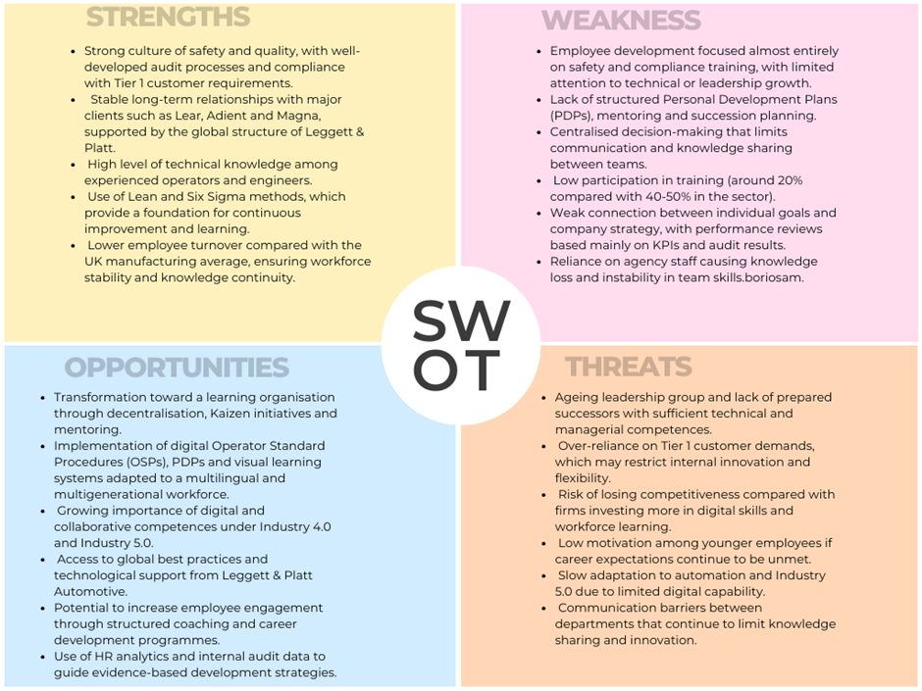
Figure 5. SWOT Analysis of Pullmaflex Ltd (created in Canva by the author, 2025).
The SWOT analysis was developed to provide an overview of Pullmaflex’s internal and external environment in the context of becoming a learning organisation. It identifies the company’s strengths in safety, quality, and long-term customer relationships, but also highlights weaknesses such as limited employee development, lack of structured succession planning, and centralised decision-making. Opportunities arise from the use of digital learning tools, mentoring, and the stronger application of HR analytics, which can support cultural transformation and workforce resilience. At the same time, threats including an ageing leadership group, dependence on Tier 1 audit requirements, and slow adaptation to Industry 4.0 and 5.0 may restrict innovation and long-term competitiveness.

Appendix B. GAP Analysis

The GAP analysis was developed to identify the difference between the current state of employee development at Pullmaflex and the desired state of a learning-oriented organisation. It examines how existing practices meet audit and compliance requirements but fail to address long-term capability, motivation and adaptability.
Currently, the company’s training and performance systems focus on short-term compliance. Most training sessions are limited to health and safety, and employees receive little structured support for technical or leadership growth. There are no formal PDPs or mentoring schemes, and feedback is often reactive, provided only after errors occur. While this ensures that audit standards and customer requirements are met, it restricts the development of creativity, engagement and problem-solving skills.
The desired state, aligned with the principles of a learning organisation, involves decentralised decision-making, regular PDPs, and continuous coaching to transfer tacit knowledge and prepare future leaders. In this model, employees take ownership of their learning and contribute ideas for improvement through Kaizen and Lean initiatives.
Bridging this gap requires a shift from compliance-driven management to a culture driven by development. Structured PDPs, mentoring, and digital learning tools would help to connect technical training with strategic goals. Integrating feedback and recognition into daily routines further supports engagement and retention.
The analysis concludes that while Pullmaflex performs strongly in operational stability and audit compliance, it must expand its focus to include leadership development, knowledge sharing and succession planning to achieve sustainable organisational learning.
The table below summarises the key differences between the current and desired state of employee development at Pullmaflex.

GAP Analysis of Employee Development at Pullmaflex Ltd
Area | Current Practice | Desired Future State
Training and Learning | Focused mainly on compliance and health and safety. Little attention to technical, digital or leadership skills. | Balanced training programme including technical, behavioural and digital skills, linked to company goals and PDPs.
Feedback and Appraisal | Reactive feedback, often in the form of warning letters after errors. No structured performance review system. | Regular feedback through quarterly reviews and coaching sessions. Constructive approach recognising both behaviours and results.
Personal Development Plans (PDPs) | No structured PDPs. Training is one-size-fits-all and updated mainly before audits. | Individual PDPs with SMART objectives and mentoring support, promoting self-directed learning and accountability.
Knowledge Sharing | Tacit knowledge remains with experienced operators. No formal system for capturing or sharing it. | Operators actively involved in Kaizen and training others through mentoring and digital OSP tools.
Succession Planning | No formal process for identifying or preparing future leaders. Reliance on long-serving supervisors. | Clear succession plan integrating technical competence, leadership skills and cross-functional development.
Culture and Engagement | Centralised management focused on meeting Tier 1 audit targets. Limited involvement of operators in decision-making. | Collaborative and decentralised culture where employees contribute ideas and take part in continuous improvement.

Note. Table developed by the author based on internal observations and academic frameworks discussed in the report (Bratton et al., 2021; Cottrell, 2021; Armstrong & Taylor, 2023; Mourtzis et al., 2022).
Overall, the GAP analysis confirms that Pullmaflex must transition from a compliance-focused approach to one that values continuous learning, participation, and leadership development, ensuring long-term capability and resilience within the workforce.

Appendix C. PESTEL Analysis of Pullmaflex Ltd - Developing the Learning Organisation
The PESTEL analysis explores how external factors influence Pullmaflex’s ability to evolve into a learning organisation. It examines the pressures and opportunities created by the political, economic, social, technological, environmental and legal environment that shape the company’s approach to training, leadership and knowledge sharing.
PESTEL Analysis of Pullmaflex Ltd in the Context of Developing the Learning Organisation

Factor | External Drivers | Implications for Developing the Learning Organisation
Political | Government initiatives promoting skills development, safety culture and advanced manufacturing in the UK automotive sector. | Supports investment in workforce learning and continuous improvement, but excessive regulatory focus may reinforce compliance over innovation.
Economic | Inflation, cost reduction pressures and competition among Tier 2 suppliers reduce available training budgets. | Encourages short-term efficiency instead of long-term learning. A learning organisation approach could increase resilience through improved problem-solving and productivity.
Social | Multilingual, multi-generational workforce with different motivation and learning preferences. Younger employees seek visible career pathways and digital learning opportunities. | Requires inclusive PDPs, mentoring and communication strategies that value collaboration and knowledge sharing across generations.
Technological | Rapid development of automation, data analytics and digital production systems under Industry 4.0 and transition toward Industry 5.0. | Creates opportunities to integrate digital OSPs, online learning and AI-based feedback tools that support self-directed and continuous learning.
Environmental | Increasing global focus on sustainability, waste reduction and ethical manufacturing. | Learning culture can drive sustainable behaviour through Kaizen and Lean projects linking operational efficiency with environmental goals.
Legal | Strict audit, safety and data regulations (IATF 16949, GDPR) dominate HR and training systems. | Ensures compliance but may limit creativity. Embedding learning within compliance can promote proactive awareness and responsibility among employees.

The PESTEL analysis shows that the external environment both supports and constrains the development of a learning organisation at Pullmaflex. While political and technological trends promote continuous learning and innovation, economic pressures and audit-driven legal frameworks maintain a compliance-oriented culture. To overcome these limitations, Pullmaflex should align digital transformation, sustainability goals and workforce development within a structured learning strategy that empowers employees to participate in continuous improvement and shared decision-making.

Appendix D. Learning Organisation models in the context of Pullmaplex

Different models explain what a learning organisation (LO) should look like. Hannachi (2021) shows that models are diverse and often challenging to apply in practice. Alerasoul et al. (2022) argue that learning only works when process, structure and mindset are linked. Kłak (2021) highlights fundamental principles, including knowledge sharing and adaptability. Senge (1990) adds five disciplines: personal mastery, mental models, shared vision, team learning and systems thinking.
In Pullmaplex, many of these features are missing. Workers follow strict instructions and have little chance to develop personal mastery. Mental models are fixed, as change is pushed from the top instead of shaped by teams. A shared vision is weak because production targets often dominate learning goals. Team learning is rare, as engineers, rather than operators, typically lead projects. Systems thinking is limited because departments tend to focus on their own tasks rather than collaborating on broader goals. These barriers confirm what Alerasoul et al. (2022) and Do et al. (2022) note: without cultural and structural support, the LO remains an idea rather than a reality.
Pullmaplex already utilises Lean, Six Sigma, and Kaizen, but these methodologies are primarily applied as technical tools. Helmold (2024) and Sridhar et al. (2023) stress that Kaizen should build teamwork and reflection, but here it is reduced to small efficiency projects. Six Sigma is used to solve quality issues, but does not build wider knowledge sharing (Tetteh, 2015; Myszewski, 2017). Lean provides useful indicators, but as Bhadu et al. (2022) argue, data only leads to learning when teams use it together to solve problems.
The company could link these methods with Senge’s five disciplines. Kaizen groups could support team learning. Six Sigma reviews could help staff question and improve mental models. Lean measures could be tied to a shared vision, not only to quotas. Such integration would reduce current barriers and move Pullmaplex closer to becoming a genuine learning organisation.

Appendix E. Structural barriers and tacit knowledge in Pullmaplex

Research shows that rigid hierarchies can prevent organisations from utilising tacit knowledge, which includes the practical skills and insights of employees. Adana et al. (2024) argue that decentralised decision-making enhances the use of tacit knowledge. Kumar et al. (2021) note that centralised structures and silos block knowledge flow, while Ozkan-Ozen and Kazancoglu (2022) emphasise that Industry 4.0 requires empowered workers who act on expertise rather than waiting for managerial approval.
In Pullmaplex, several barriers limit learning and improvement. These can be addressed by linking decision-making more closely to shop-floor experience and recognising the value of tacit knowledge across all levels of the organisation.

Structural Barriers Limiting Organisational Learning at Pullmaplex

Barrier | Example in Pullmaplex | Possible Solution
Centralised decision-making | Managers make most decisions, and operators only follow instructions. | Kaizen groups led by operators to solve local problems (e.g. incorrect cable ties or bladder types).
Siloed departments | Engineering, quality and production rarely share feedback or data directly. | Cross-functional Lean reviews combining data with operator input.
Unused tacit knowledge | Operators identify recurring issues (e.g. unclear OSPs, poor labelling), but their feedback is not collected systematically. | Introduce a digital suggestion platform and include operators in problem-solving meetings.
Manager-led improvement tools | Lean, Six Sigma and Kaizen are driven by engineers, not by the workforce. | Expand Kaizen participation to include operator representatives from each shift.
Language and communication barriers | Multilingual workforce with limited access to translated or visual training materials. | Implement visual and video-based OSPs to overcome language limitations.
Lack of feedback culture | Feedback often occurs only after errors (through warning letters), not during daily work. | Replace reactive feedback with daily coaching sessions and positive reinforcement.
Limited career pathways | No structured development plans or mentoring; younger employees see no progression. | Introduce PDPs and mentoring to retain tacit knowledge and develop future leaders.
Audit-driven priorities | Focus on Tier 1 compliance overshadows internal learning initiatives. | Balance audit goals with continuous improvement targets and operator-led innovation.

Using tacit knowledge in this way would help Pullmaplex respond faster to problems, reduce repeated errors and transform improvement tools into systems for genuine organisational learning.

Appendix F. Personal Development Plan (PDP)

Currently, Pullmaplex does not have a formal Personal Development Plan for its operators. Training and development practices are largely fragmented, and the existing skills matrix is updated mainly before external audits or customer visits. This means that while minimum compliance is achieved, there is no systematic pathway for employee growth, succession planning or long-term workforce sustainability. Similar gaps have been observed in other manufacturing environments where training is driven by audits rather than development (Helmold, 2024; Okpala et al., 2024).
The author has therefore developed the following PDP framework as a conceptual proposal. It is based on recognised academic models such as goal-setting theory (Ab Rahman, 2025; Latham, 2023), the 70-20-10 approach (Mughal, 2023), the ADDIE instructional model (Adeoye et al., 2024) and Kirkpatrick’s four levels of evaluation (Andreev, 2022; Bergamo et al., 2022). The aim is to provide Pullmaplex with a structured approach that supports technical competence, quality performance, employee engagement and sustainability in line with Industry 4.0 and Industry 5.0 requirements (Leon, 2023; Rashid, 2025).
PDP for New Operator (Year 1)

Objective | Actions | Timeline | Support Resources | Success Measure
Technical Competence | Learn bladder cutting, tube trimming, welding and functional test | Months  1 - 3 | Mentor guidance, OSP training | Level 2 (Trained) in 5 processes, validated through skills matrix update and supervisor sign-off.
 | Expand to Baby Williams, pre-assembly and assembly | Months  4 - 6 | Rotation across machines | 12 processes at Level 3 (Experienced), confirmed through audit checklist and supervisor review.
 | Achieve trainer level in 2 processes | By Month 12 | Shadowing expert operators | Level 4 (Trainer) in 2 processes, evidenced by ability to coach new operators and evaluation by team leader.
Quality and Compliance | Perform visual checks and functional tests independently | By Month 6 | Quality and Keyence training | Zero supervision required, measured by quality audit reports and defect-free production logs.
 | Participate in 8D investigations | By Month 9 | Team leader and quality engineer support | Contribution to 2 cases, recorded in 8D documentation and verified by quality engineer
 | Apply IATF and QAL standards across all processes | By Month 12 | OSPs and audits | Correct escalation of defects, evidenced in compliance records and audit trails.
5S and Workplace Organisation | Apply 5S basics | Months  1 - 3 | Mentor support | Audit compliance score of at least 90 percent in initial 5S checks.
 | Maintain and improve 5S standards | By Month 6 | Kaizen workshops | At least 1 improvement idea implemented, confirmed through 5S audit reports.
 | Lead a 5S improvement | By Month 12 | Lean toolbox | 1 documented improvement project, validated through workplace before / after evidence.
Continuous Improvement | Submit Kaizen ideas | By Month 6 | Suggestion system | 3 or more ideas submitted, logged in Kaizen system.
 | Lead a small Kaizen project | By Month 12 | Team leader support | 1 project implemented, evidenced through savings, efficiency or quality improvement.
Personal and Team Skills | Build communication with team | Months  1 - 3 | Feedback sessions | Positive 3-month feedback from supervisor and peers.
 | Adapt to shift rotation | By Month 9 | Cross-training | Independent performance on at least 2 shifts, confirmed by shift supervisors.
 | Mentor a new starter | By Month 12 | Leadership support | Acts as buddy to 1 employee, validated through peer feedback and supervisor confirmation.

30/60/90 Day Structure
The proposed PDP follows a phased 30-, 60-, and 90-day pathway, designed to ensure progressive learning and measurable outcomes. During the first thirty days, the focus is on adaptation, health and safety, observation of production processes and basic technical training. At this stage, the operator is expected to complete initial tasks, such as bladder cutting, tube trimming, welding, and functional testing, at a trained level, while also applying basic 5S principles and building communication skills within the team.
By sixty days, the employee expands their competence to approximately ten to twelve processes, reaching an experienced level in most of them. At this stage, the operator should be able to perform visual and functional quality checks independently, contribute to at least one Kaizen idea, and participate actively in shift rotation. Independence in routine work becomes a key expectation, supported by the skills matrix and supervisor evaluation.
After ninety days, the operator should demonstrate competence in advanced processes such as Baby Williams, pre-assembly and final assembly, as well as customer-specific testing. At this stage, the employee is also expected to support small-scale Kaizen improvements and to adapt fully to workplace organisation standards. Trainer level in specific processes is targeted after one year rather than at the ninety-day stage, ensuring that skills are consolidated before moving into mentoring responsibilities.
This structured progression reflects experiential learning and ensures that development is not only measurable through tools such as the skills matrix and quality audits, but also sustainable in preparing employees for long-term adaptability and innovation (Zanchi et al., 2023; Lejeune et al., 2021).
Integration with the Product Life Cycle
The PDP is designed to align with the Pullmaplex product life cycle, from bladder cutting and tube trimming through welding, functional testing, pre-assembly, final assembly, customer-specific testing, labelling and packing. This integration enables operators to understand the value stream and see how their role contributes to overall customer value. Such alignment reflects the importance of linking training to organisational processes to strengthen quality and continuous improvement (Suárez-Barraza & Huerta-Carvajal, 2024).
Skills Matrix as Current Evidence and Limitations
Pullmaplex currently uses a skills matrix to record employee competence levels across key production processes. It categorises staff from those requiring training to those able to train others. However, this matrix is primarily updated before audits or external visits and does not serve as a continuous development tool. As a result, its potential to guide long-term learning and succession planning is limited. The proposed PDP would transform this tool into a dynamic, regularly updated resource for workforce planning and development.
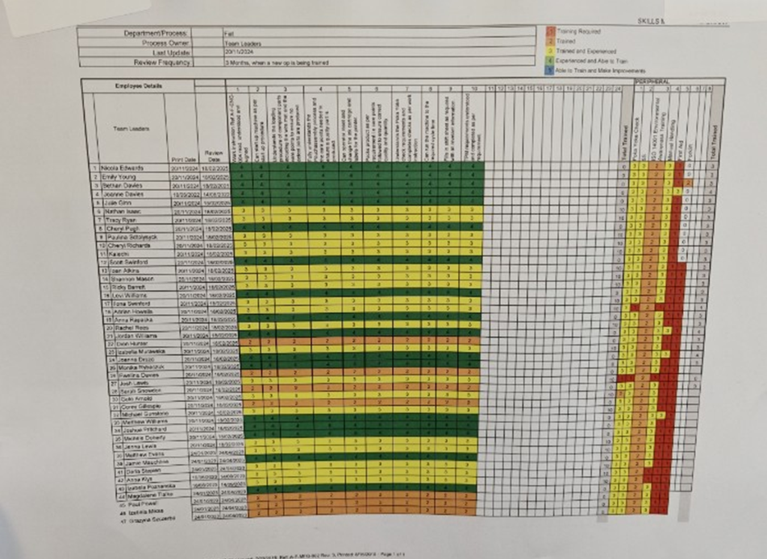
Figure 6. Skills matrix used at Pullmaflex, documented through a workplace photograph taken by the author (2025).
Feedback and Evaluation
The PDP framework incorporates quarterly reviews using SMART goals (Fayomi & Akanazu, 2024), Kirkpatrick’s levels (Andreev, 2022; Bergamo et al., 2022) and Balanced Scorecard alignment (Agarwal, 2021). Coaching and mentoring remain central, as research shows feedback is most effective when based on trust and psychological safety (Castanelli et al., 2022; Govender & Adegbite, 2022).
To strengthen this process, it is proposed that Pullmaplex adopt a structured feedback and evaluation method. Each review should include three elements:
- Skills matrix update: recording progress against defined process levels (trained, experienced, trainer).
- Performance appraisal discussion: a one-to-one meeting focusing on technical competence, quality, teamwork and innovation.
- Self-assessment and reflection: employees complete a short PDP review form, reflecting on their own achievements and areas for improvement.
Different types of feedback should be integrated to ensure a balanced approach. Formal feedback is provided through quarterly reviews, while informal feedback is given daily by team leaders and mentors. Peer feedback is collected when operators work in buddy or trainer roles. This combination reflects good practice models, where multiple feedback channels improve learning transfer and employee engagement (Wang et al., 2022).

Beyond Year 1: Employee Evaluation and Self-Directed Development
Following the initial year, a formal assessment is recommended, encompassing elements such as technical competence, quality, teamwork, innovation, and career goals. This evaluation measures progress based on PDP outcomes, targets, and highlights anticipated development requirements for the future. The employee is then motivated to generate their own PDP, self-driven with their own goals for the next one, two or five years. This has the benefit of increasing ownership and motivation, while also supporting succession planning and workforce resilience (Lejeune et al., 2021).
Proposed Employee Evaluation Framework

Category | Description | Measurement
Technical Competence | Processes mastered, trainer status achieved | Skills matrix levels, audit results
Quality and Compliance | Detecting and escalating defects, involvement in 8D | Audit reports, corrective actions
Teamwork and Communication | Collaboration, mentoring and peer feedback | Supervisor and peer evaluation
Innovation and Improvement | Kaizen ideas, 5S initiatives, small projects | Number and impact of improvements
Career Development | Long-term goals and personal PDP | Self-assessment and supervisor review

Sustainability and Industry 4.0/5.0 Alignment
The proposed PDP contributes to sustainability by embedding succession planning, Kaizen-driven improvement and the future introduction of digital learning tools, such as video-based operator standard procedures, which are not currently in place at Pullmaplex. This forward-looking approach would ensure that employees are not only competent in the short term but also adaptable to technological changes and prepared for Industry 5.0 (Leon, 2023; Rashid, 2025).
Critical reflection on PDP implementation
While PDPs offer clear benefits such as structured learning and self-awareness, their success at Pullmaflex may be limited by several factors. Without sufficient managerial support, PDPs could become bureaucratic exercises instead of meaningful development tools. Supervisors may focus on completing forms to satisfy audits rather than providing constructive feedback. Furthermore, operators with limited English or digital skills may struggle to record or review their goals independently. As Lejeune et al. (2021) and Mughal (2023) indicate, PDPs only improve performance when combined with a supportive culture and coaching. Therefore, for Pullmaflex, implementing PDPs without adjusting workload expectations and mentoring could risk increasing frustration rather than motivation.

Conclusion
This appendix outlines a Personal Development Plan designed by the author to address the lack of structured development at Pullmaplex. At present, there is no formal or informal PDP, no systematic feedback, and no clear career pathway. Training is often limited to preparing for audits, which means employees are treated more as replaceable resources than as individuals with potential for growth and development.
The proposed PDP offers a structured alternative that links training to the product life cycle, sets measurable goals through a 30/60/90-day pathway, and utilises the skills matrix to track competence. Feedback and evaluation are built into the model through quarterly reviews, supported by mentoring and self-assessment, which strengthen employee engagement and ownership of learning.
Although not currently implemented in Pullmaplex, this framework demonstrates how the company could move from a reactive, audit-driven approach to a proactive and sustainable system of workforce development. It highlights the potential to secure not only immediate competence but also long-term adaptability, retention and resilience, positioning Pullmaplex to meet the challenges of Industry 4.0 and the future demands of Industry 5.0.

Appendix G. Continuing Professional Development (CPD) Plan for the Author (2025-2030).
This Continuing Professional Development (CPD) plan has been developed to support the author's long-term professional, academic, and entrepreneurial growth. The plan combines full-time academic study with workplace experience and the ongoing development of a small creative business. It focuses on strengthening leadership capability, health and safety expertise, communication and language skills, and sustainable entrepreneurship aligned with Industry 5.0 principles.
The five-year timeline outlines structured learning goals, professional qualifications, and reflective actions aimed at maintaining continuous learning and enhancing employability. The plan ensures that development remains balanced between the author’s role at Pullmaflex, university studies in Applied Leadership and Management, and the growth of the JD Lumoria Studio brand.

Long-Term Goal
To become a qualified leader and health & safety specialist in the manufacturing industry while developing a sustainable creative business producing handmade cosmetics and décor.

Year 1 (2025-2026): Academic Progress and Business Growth
Area | Development Focus | Actions | Support & Resources | Expected Outcome
Academic | Complete Level 5 (BA) studies successfully | Finish all assignments, improve academic writing and apply workplace examples in reports | UWTSD tutors and feedback | Level 5 completed (January 2026)
Workplace | Continue supporting new operators as a mentor | Conduct short on-the-job training | line manager | Positive feedback and improved training quality
Health & Safety | Start NEBOSH National General Certificate (Level 3) | Attend training and apply health and safety principles at Pullmaflex | NEBOSH accredited provider | Certificate awarded
Entrepreneurship | Expand Lumoria’s online presence and product reach | Improve website SEO, strengthen social media activity and branding | Canva, Shopify, Enterprise Hub Wales | Growing customer base and consistent sales
Language Development | Strengthen English for academic and business use | Continue advanced English lessons and IELTS preparation | Private tutor, online resources | IELTS 6.5-7 achieved

Year 2 (2026-2027): Qualification and Brand Expansion
Area | Development Focus | Actions | Support & Resources | Expected Outcome
Academic | Begin Level 6 and prepare for Master’s entry | Focus on leadership, management and analytical writing skills | UWTSD academic mentor | Level 6 completed (January 2027)
Health & Safety | Apply NEBOSH knowledge to workplace practice | Participate in safety inspections and audits | Pullmaflex H&S Manager | Improved safety awareness and compliance
Entrepreneurship | Launch first certified cosmetic line and improve marketing | Complete CPSR, CLP and GMP training; strengthen online marketing | Cosmetic Safety Consultants UK, CTPA | Certified cosmetics launched
Social media & Marketing | Grow Lumoria’s digital presence | Create structured posting plan across TikTok, Instagram and Facebook | Canva, Meta Business Suite | Stronger engagement and brand visibility

Year 3 (2027-2028): Master’s Study and Product Diversification
Area | Development Focus | Actions | Support & Resources | Expected Outcome
Academic | Complete master’s degree (18 months) | Focus on applied leadership, research and project work | UWTSD faculty | Master’s degree completed (mid-2028)
Health & Safety | Start NEBOSH Diploma (Level 6) | Study part-time while applying knowledge in workplace safety projects | NEBOSH provider | Unit A completed
Workplace | Lead small process improvement projects | Apply Lean and Kaizen tools to production issues | Engineering team, supervisor | Measurable improvements implemented
Entrepreneurship | Diversify Lumoria’s products and improve quality standards | Develop new cosmetics and décor ranges based on customer feedback | Formula Botanica / CTPA | New certified product lines introduced

Year 4 (2028-2029): Professional Development and Business Maturity
Area | Development Focus | Actions | Support & Resources | Expected Outcome
Health & Safety | Continue NEBOSH Diploma (Unit B) | Apply learning through workplace risk assessments and internal audits | H&S department | Improved safety documentation and culture
Professional Growth | Build leadership profile at Pullmaflex | Support training and communication between production teams | HR and management | Recognition for team leadership and initiative
Entrepreneurship | Strengthen Lumoria’s sustainability and branding | Introduce eco-packaging, attend local business fairs and partnerships | Enterprise Hub Wales, Local Business Network | Sustainable certification achieved
Creative Skills | Gain advanced formulation knowledge | Complete Formula Botanica Diploma in Natural Cosmetic Science | Formula Botanica | Diploma achieved and product range upgraded

Year 5 (2029-2030): Professional Achievement and Community Engagement
Area | Development Focus | Actions | Support & Resources | Expected Outcome
Professional | Complete NEBOSH Diploma and apply for Graduate IOSH membership | Pass final module and register with IOSH | NEBOSH / IOSH | Diploma awarded and professional membership obtained
Entrepreneurship | Open Lumoria studio and expand production capacity | Develop local workshop area, retail display and partnerships | Enterprise Hub Wales / Local suppliers | Studio opened and stable collaborations built
Community & Creative Workshops | Share creative skills and promote sustainability | Run candle-making and gypsum casting workshops focused on safe production and eco-friendly materials | Lumoria Studio / Local Enterprise Hub | Workshops delivered and positive feedback recorded

Ongoing Reflection and Evaluation
- Maintain a CPD journal with quarterly reflections on learning progress, obstacles and lessons learned.
- Conduct annual reviews with academic mentors and HR managers.
- Keep records of certificates, qualifications, and key milestones in a digital portfolio.
- Adjust objectives each year based on academic results and business growth.

Summary
This CPD plan presents a clear and achievable five-year development strategy. It integrates academic advancement, workplace learning and regulated cosmetic production training. By combining leadership education, health and safety qualifications, language improvement and entrepreneurial development, the author ensures long-term employability and builds a sustainable business aligned with Industry 5.0 values of innovation, safety, and human-centred progress.

Appendix H. Key Strategic and Operational Recommendations

To build long-term capability and sustain continuous improvement, Pullmaflex should strengthen its approach to people development and learning culture. The following strategic directions are recommended:
- Expand training beyond compliance by including technical, digital, and leadership programmes that prepare staff for Industry 4.0 and 5.0 requirements.
- Introduce structured PDPs and CPD frameworks so employees can plan their learning, track progress, and connect goals with company strategy.
- Reform performance reviews to include SMART goals, regular feedback, and recognition of both results and behaviours, using quarterly reviews aligned with internal and customer reporting cycles.
- Create transparent career pathways to replace informal promotion practices, ensuring fairness, motivation, and long-term retention of skilled workers.
- Establish mentoring and coaching schemes to support new and existing staff, transfer tacit knowledge, and prepare future leaders.
- Increase operator participation in Lean and Kaizen to build shared ownership of improvement and enhance problem-solving on the shop floor.
- Encourage decentralised decision-making by empowering teams to make small operational choices and share ideas through daily stand-ups and suggestion boards.
- Integrate digital learning tools, such as video-based OSPs and feedback dashboards, to overcome language barriers and support different learning styles.
- Strengthen succession planning to ensure continuity of expertise and leadership resilience.
- Together, these actions would help Pullmaflex transition from a compliance-driven system to a genuine learning organisation, where improvement, knowledge sharing, and professional growth are integral to everyday practice.

