Network Operating Systems and Services (ACCA5023)

Tatiana Zaneva (2436814)
University Of Wales Trinity Saint David (London Campus)

Student: Tatiana Zaneva
Student ID: 2436814
Programme: Applied Computing
Lecturer: MD Sadeque Imam Shaikh

Contents
Introduction: 2
Task 1: 2
1(a): Research on Hypervisor: 2
1(b): Research on IP Addressing 3
1(c): Research on Routing: 4
1(d): Research on Network Services: 5
Task 2: 6
2.1. Choose your Hypervisor: 6
2.2 Download and Setup: 6
2.2.1 Evidence of Download and installation. 7
2.2.2 Deploy your network as per the given topology: 8
2.3. Configure IP Addressing: 10
2.3.1. Use appropriate IP addresses to configure your network. 14
2.4 Test and Troubleshoot 17
2.4.1. Perform Connectivity tests 20
2.4 Test and Troubleshoot 22
3.1. Reflect on the following 23
3.1.1. Write a Technical reflection covering network deployment and testing. 23
3.1.2. Write your Personal Reflection 24
Conclusion: 24
References: 25

Introduction:
Virtualisation has become an important technology in modern enterprise networking because it allows organisations to run multiple operating systems on shared physical hardware, improve resource allocation and reduce the need for separate physical machines [1]. This report presents the research, design and implementation of a virtualised enterprise network based on the NOSSLONDON2026 case study. The practical environment includes Windows Server and Debian virtual machines connected through isolated VirtualBox Internal Networks to represent separate organisational network segments [3].
The report evaluates hypervisors, IP addressing, routing and enterprise network services through relevant academic and technical literature. It then documents the practical implementation, including hypervisor selection, virtual machine deployment, network configuration, static IPv4 addressing and connectivity testing. The final section presents technical and personal reflections on the deployment process, the configuration issues encountered and the knowledge developed during the coursework.

Task 1:

1(a): Research on Hypervisor:
The effectiveness of a virtualised environment depends on the selected hypervisor because it influences performance, resource management, system isolation and future scalability [1], [2]. Selecting an appropriate hypervisor therefore requires consideration of the technical requirements, available hardware and intended deployment environment.
Type 1 hypervisors run directly on physical hardware without relying on a host operating system. This architecture offers stronger performance and isolation, making it suitable for production environments where reliability and availability are important. Type 2 hypervisors run as applications within an existing operating system. They introduce additional overhead, although they offer easier installation, lower hardware requirements and greater flexibility for education, software development and network laboratories [1], [2].
For the NOSSLONDON2026 topology, a Type 2 hypervisor is the most suitable choice. The project requires Windows Server and Debian virtual machines to run simultaneously on one workstation. Oracle VirtualBox supports both operating systems, provides isolated Internal Networks, allows hardware resources to be configured for each virtual machine and offers snapshot functions for recovery [3]. These features support installation, testing and troubleshooting while preparing the environment for the BIRMINGHAM.ACCA domain planned for Coursework 2.
Type 1 hypervisors such as VMware ESXi and Microsoft Hyper-V provide stronger performance and scalability for production infrastructure [2]. These benefits are less relevant within the hardware limitations and educational purpose of this coursework. Oracle VirtualBox therefore provides an appropriate balance of compatibility, network control, resource efficiency and ease of administration.

1(b): Research on IP Addressing
Efficient IP addressing supports reliable network communication because each device requires a unique logical address to send and receive data. IP addressing also determines how traffic is forwarded, how networks are divided into logical segments and how communication is maintained between different locations. Poor address planning can create conflicts, waste address space and make routing more difficult [4], [6].
IPv4 uses 32-bit addresses written in dotted-decimal notation, such as 172.16.1.1. A subnet mask or CIDR prefix, such as /24, separates the network portion from the host portion of the address [4], [6]. IPv6 was developed to address the limitations of the IPv4 address space. It uses 128-bit addresses represented in hexadecimal format, such as 2001:db8::1, and provides a far larger number of available addresses [5]. During the transition from IPv4 to IPv6, many organisations operate dual-stack networks so that both protocols can function at the same time [5].
Subnetting divides a larger network into smaller logical networks. This reduces broadcast traffic, improves address organisation and supports more efficient network management [6]. Variable Length Subnet Masking further improves address allocation by assigning subnet sizes according to the number of required hosts rather than applying the same subnet mask to every segment. Figure 1 illustrates the IPv4 structure and the addressing plan applied to the NOSSLONDON2026 environment [6].

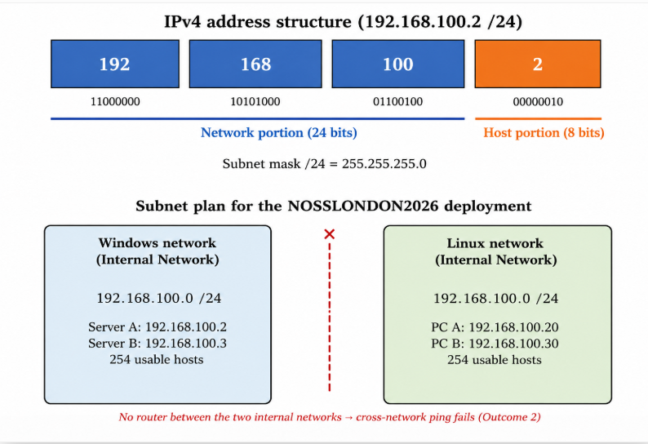
Figure 1: IPv4 address structure and the VLSM subnet plan applied to the NOSSLONDON2026 topology (author’s own work).
For the NOSSLONDON2026 deployment, both virtual segments use addresses from the 192.168.100.0/24 range. The Windows machines are connected to the VirtualBox Internal Network named intnet, while the Linux machines are connected to a separate Internal Network named intnet-linux. Although both segments use addresses from the same IPv4 range, they remain logically isolated because they are attached to different virtual switches and no router or default gateway connects them [3].

1(c): Research on Routing:
Routing enables data to travel between different networks by selecting an appropriate path for packet delivery. Routers examine destination IP addresses and consult routing tables to determine where packets should be forwarded. The selected routing method affects network performance, availability and reliability, particularly in organisations operating across multiple sites [7].
Static and dynamic routing represent two different approaches to route management. Static routing requires an administrator to enter routes manually. This approach provides predictable paths and suits small, stable networks where the topology changes rarely. Dynamic routing protocols such as OSPF and RIP exchange routing information automatically and respond to network changes. Dynamic routing improves scalability and resilience, although it also introduces additional processing requirements and configuration overhead [7].
For the NOSSLONDON2026 topology, static routing is the more suitable approach because the network contains a limited number of devices and follows a predefined structure. Manual routes will make the communication paths easier to control, verify and troubleshoot. In Coursework 2, the Debian server will also support DHCP relay functions by forwarding DHCP messages between clients and a DHCP server located on a different subnet [8], [12].
Dynamic routing is better suited to larger networks with multiple alternative paths and frequent topology changes. Its benefits are limited within this coursework. Static routing therefore matches the size and educational purpose of the NOSSLONDON2026 network and provides a controlled foundation for the services introduced in Coursework 2.

1(d): Research on Network Services:
Enterprise network services provide the foundation for secure communication, centralised administration and efficient resource management. DHCP, AD DS, VPNs and Certificate Authorities support different functions within an enterprise infrastructure, including automated network configuration, identity management, protected remote communication and certificate-based authentication [8], [11].
DHCP automatically assigns IP addresses and other network parameters to devices, reducing manual configuration and limiting addressing errors [8]. AD DS provides centralised authentication, authorisation and policy management, allowing administrators to manage users, computers and security settings across a domain [9].
VPN technologies protect communication between remote users, organisational sites and internal resources across untrusted networks through mechanisms such as IPsec [10]. Certificate Authorities issue and manage digital certificates within a Public Key Infrastructure, supporting identity verification, encryption and digital signatures [11].
For the NOSSLONDON2026 topology, these services will support the enhanced network developed in Coursework 2. AD DS will manage users and devices within the BIRMINGHAM.ACCA domain, while DHCP will automate network configuration and the Debian server will act as a DHCP relay. VPN and certificate services would strengthen remote access and authentication. Deploying these services within the virtual environment will support controlled testing and future expansion of the network.

Task 2:

2.1. Choose your Hypervisor:
Oracle VirtualBox was selected as the Type 2 hypervisor for the implementation of the NOSSLONDON2026 virtual network. The main factors influencing this decision were operating system compatibility, the available hardware, virtual networking options and preparation for the enhanced topology required in Coursework 2.
VirtualBox runs on the existing Windows host operating system and supports the simultaneous deployment of Windows Server and Debian virtual machines. This removes the need for dedicated physical server hardware and makes the environment suitable for the available workstation. Its Internal Network mode allows isolated network segments to be created for the Birmingham and London sites, while configurable virtual network adapters provide control over how each machine connects to the network [3].
VirtualBox also supports snapshots, adjustable processor and memory allocation, virtual disk management and individual machine configuration [3]. These functions assist controlled testing, troubleshooting and recovery following configuration errors. Although a Type 1 hypervisor would provide stronger performance, scalability and isolation in a production data centre, it would require additional hardware and administration. For this coursework, VirtualBox provides an appropriate balance of compatibility, resource efficiency, network control and future expansion.

2.2 Download and Setup:

The required installation media were obtained from official vendor sources to support software authenticity, integrity and security. Oracle VirtualBox was downloaded from the official Oracle website, the Windows Server 2019 Evaluation ISO was obtained from the Microsoft Evaluation Center, and the Debian 13 installation image was downloaded from the official Debian website.
As shown in Figure 2, the files were downloaded on 10 July 2026 before the virtual machines were configured. This demonstrates that the installation and deployment process was planned and completed progressively rather than at the final stage of the coursework.
The installation media were used to create four virtual machines: two Windows Server machines named Server A and Server B, and two Debian machines named PC A and PC B. Each virtual machine was allocated 2048 MB of RAM and between 20 GB and 50 GB of virtual disk storage according to its operating system requirements.
Following installation, all four virtual machines were configured and started successfully. Figure 3 shows Server A, Server B, PC A and PC B running in Oracle VirtualBox on 15 July 2026. Server A and Server B run Windows Server 2019, while PC A and PC B run Debian 13.

2.2.1 Evidence of Download and installation.
Figure 2 provides evidence that the Oracle VirtualBox installer, Windows Server 2019 Evaluation ISO and Debian 13 installation image were downloaded from the relevant official sources. Figure 3 confirms that the four virtual machines were subsequently created and started successfully.

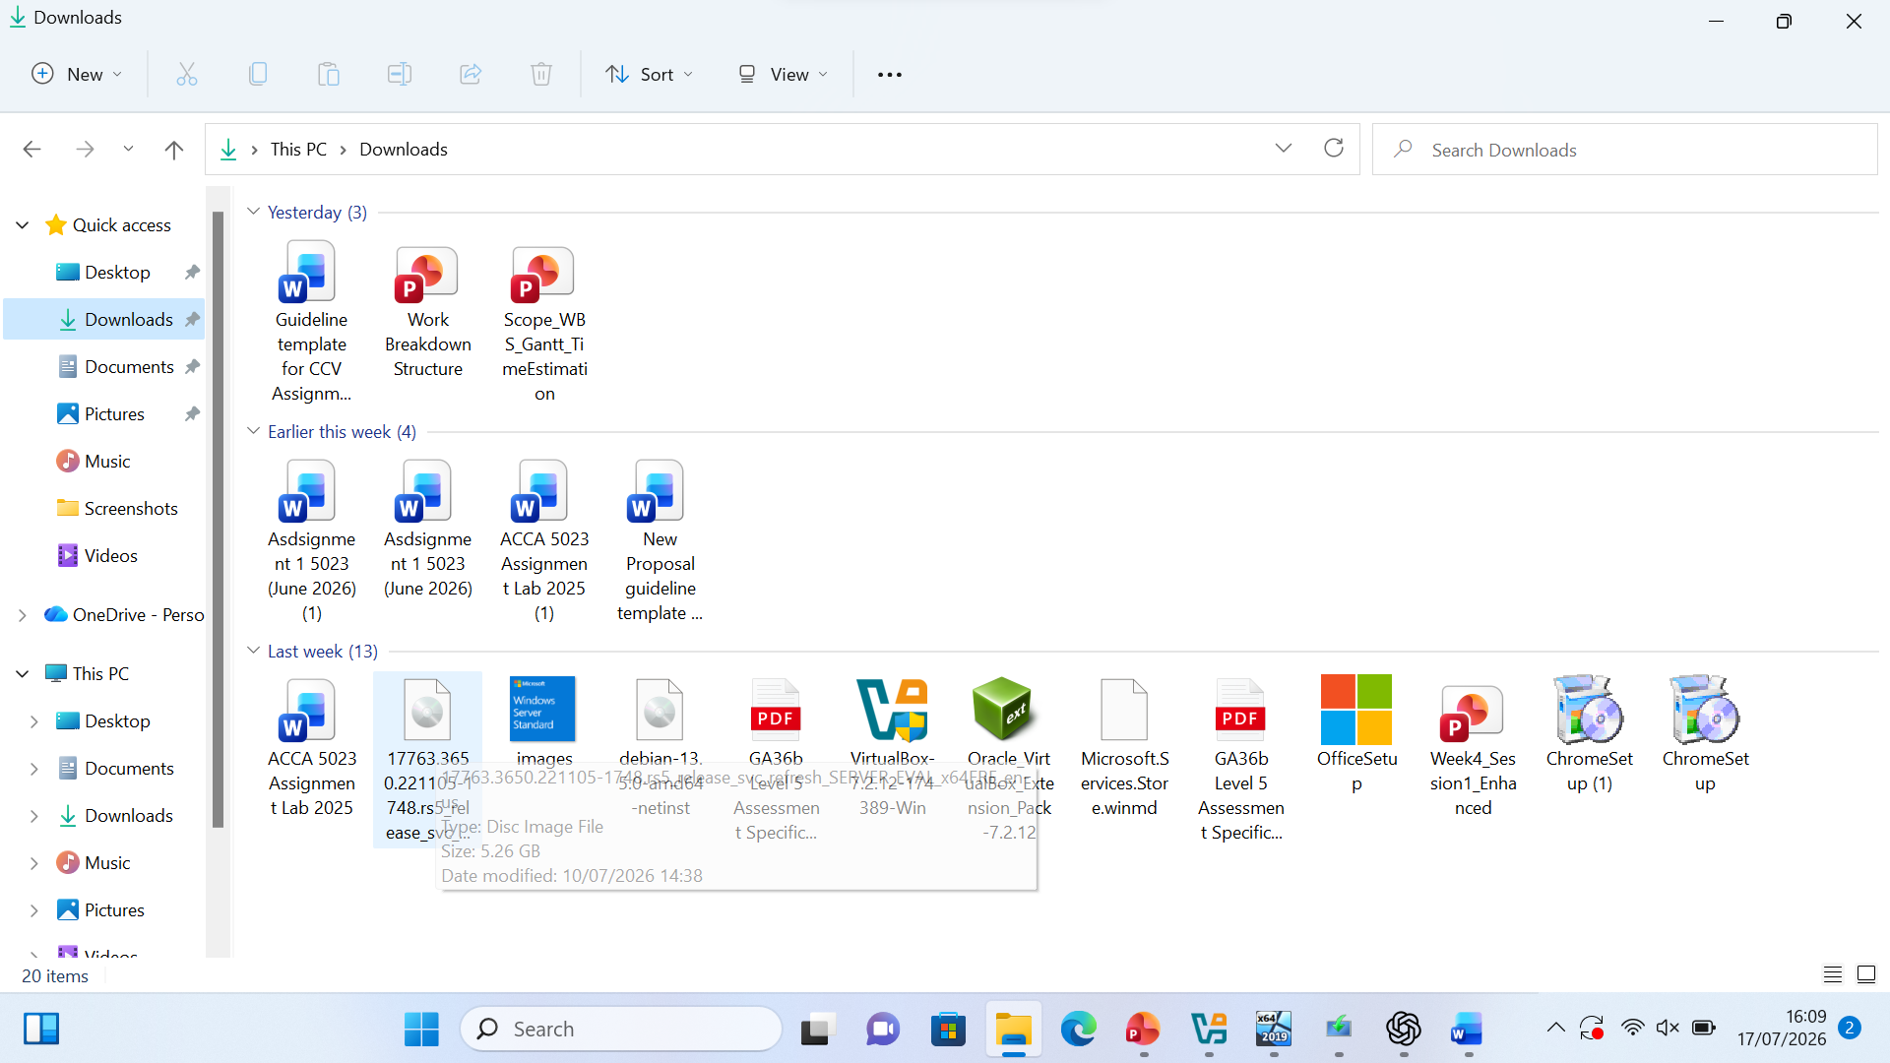
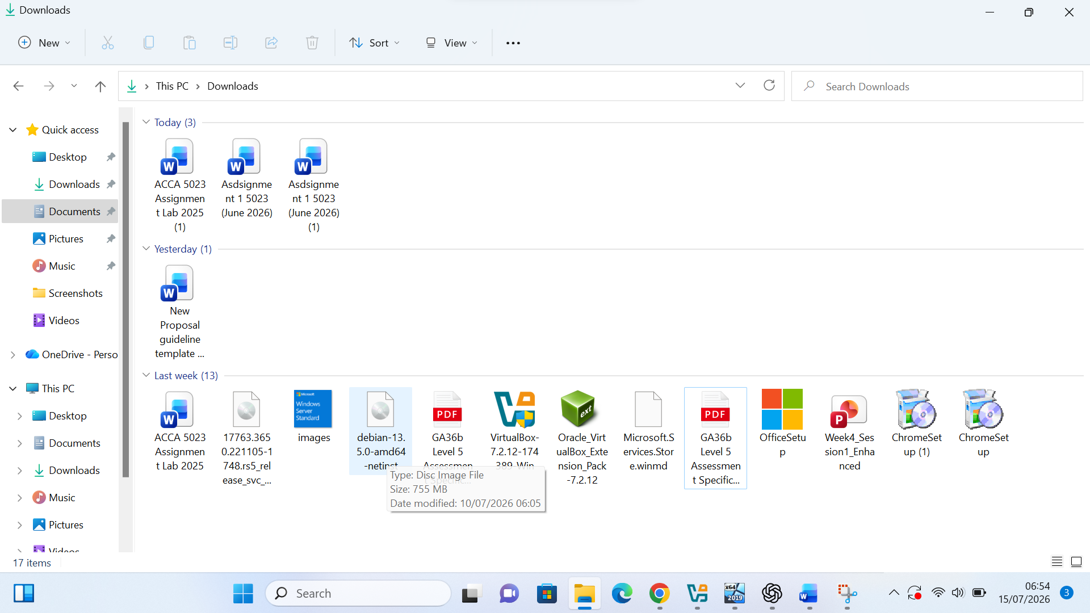

Figure 2. Installation media downloaded for Oracle VirtualBox, Windows Server 2019 and Debian 13 on 10 July 2026

Four virtual machines were created from the downloaded installation media. Figure 3 confirms that Server A, Server B, PC A and PC B were configured and started successfully.

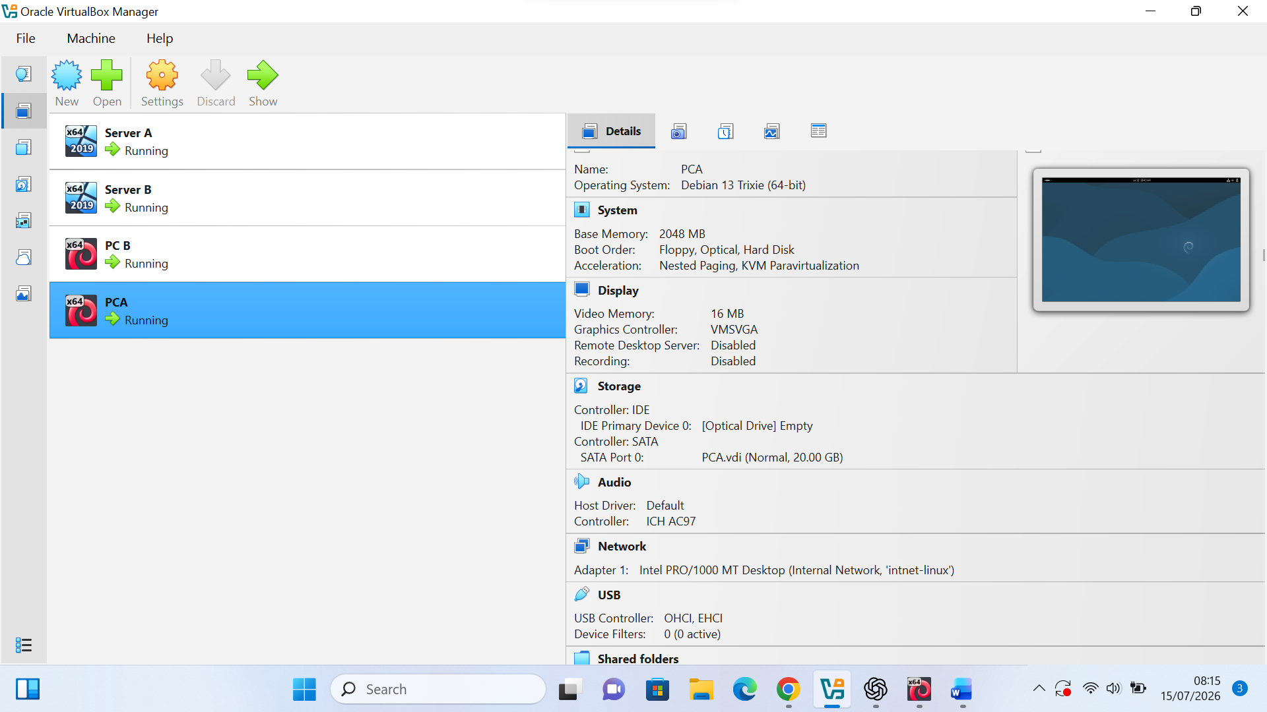

Figure 3. Oracle VirtualBox Manager showing Server A, Server B, PC A and PC B running on 15 July 2026.
Each operating system was then opened individually to verify that the installation had completed successfully. Windows Server 2019 was installed on Server A and Server B, while Debian 13 was installed on PC A and PC B.

2.2.2 Deploy your network as per the given topology:

Server A and Server B were attached to the same VirtualBox Internal Network named intnet. This configuration enables communication between the Windows machines while keeping the segment isolated from the host network.
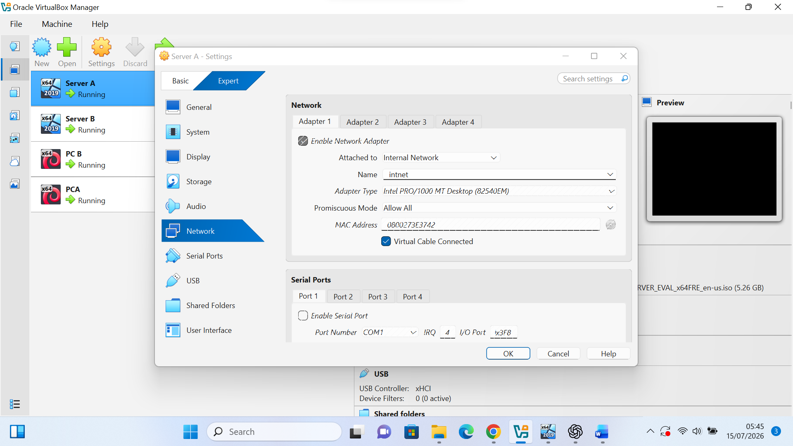
Figure 5(a). Internal Network configuration for Server A.

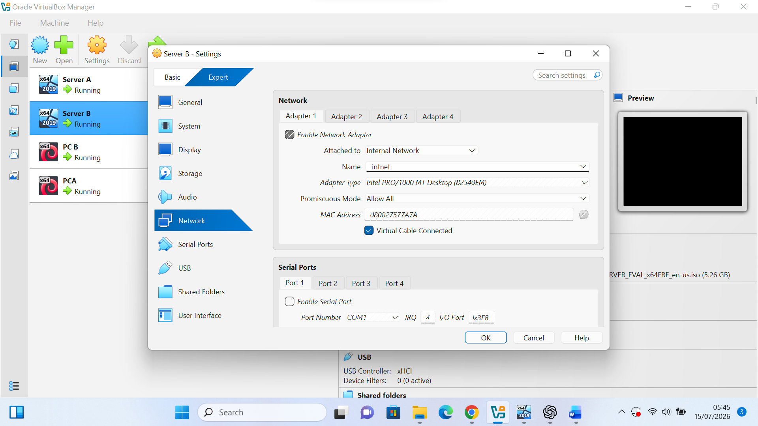
Figure 5(b). Internal Network configuration for Server B
PC A and PC B were attached to a separate VirtualBox Internal Network named intnet-linux. This configuration created an isolated Linux network segment and prevented direct communication with the Windows machines before routing was configured.

Figure 6(a). Internal Network configuration for PC A.
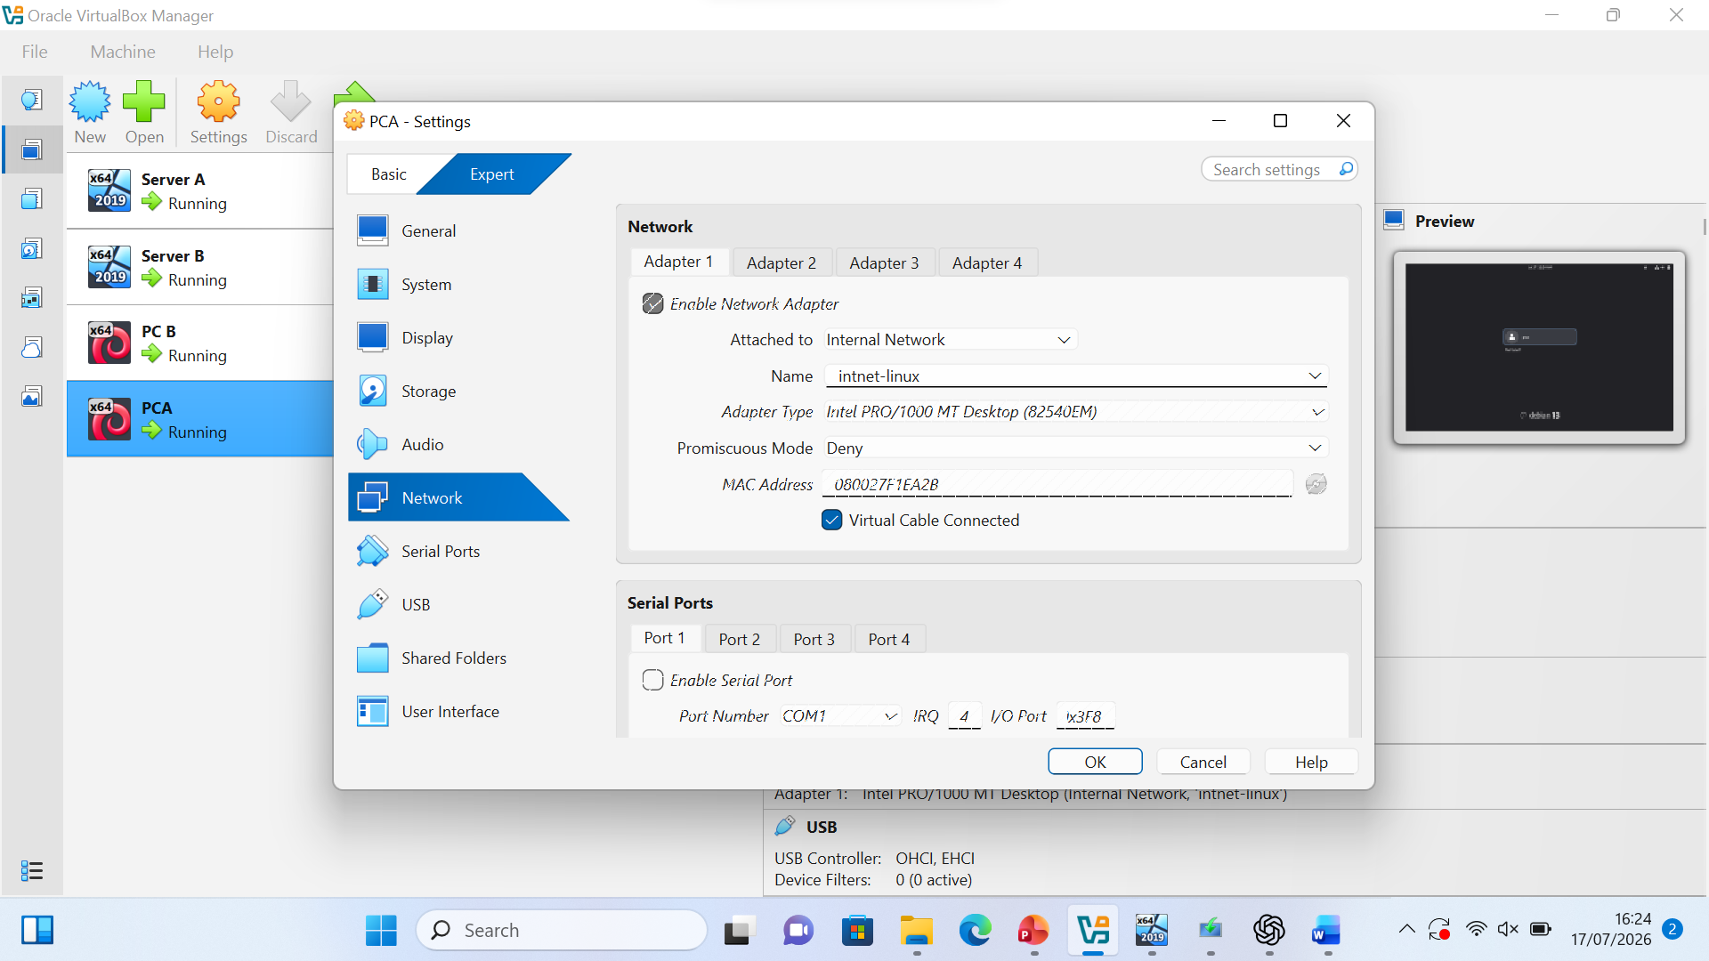

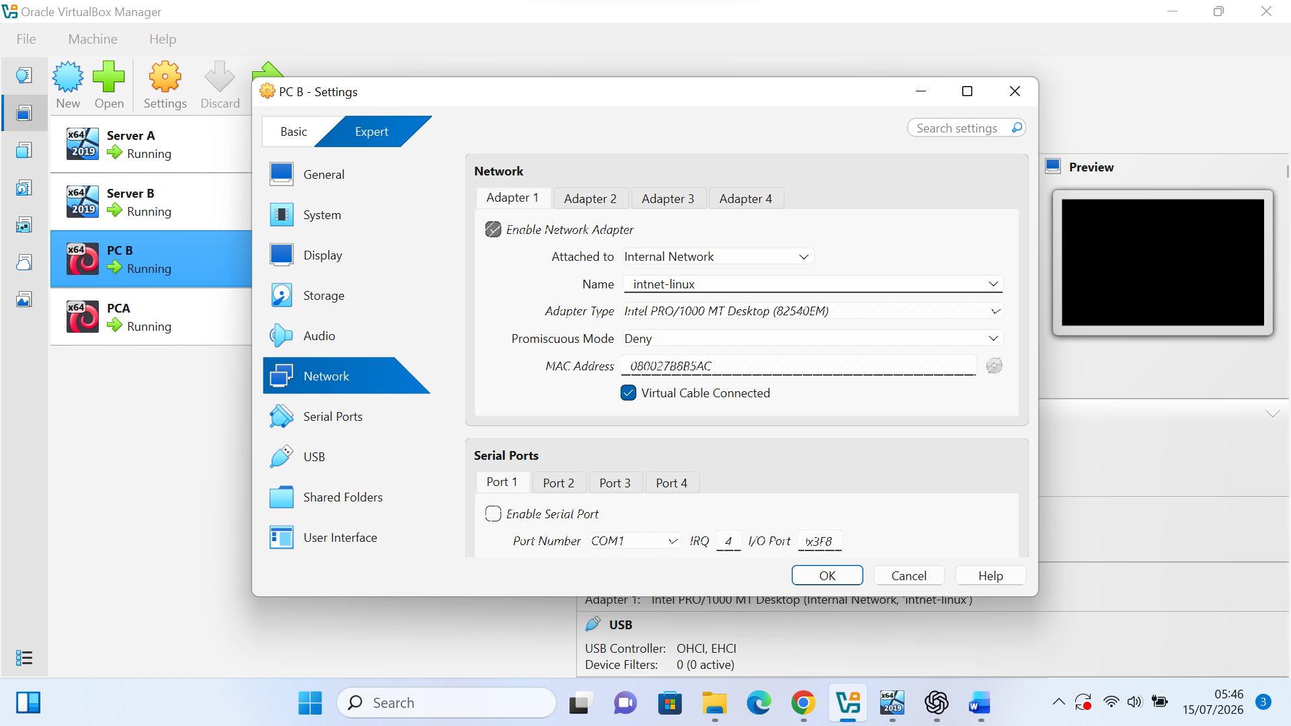
Figure 6(b). Internal Network configuration for PC B.

2.3. Configure IP Addressing:

Static IPv4 addressing was configured manually on Server A. The Server Manager summary confirms that the Ethernet adapter was assigned the address 192.168.100.2.
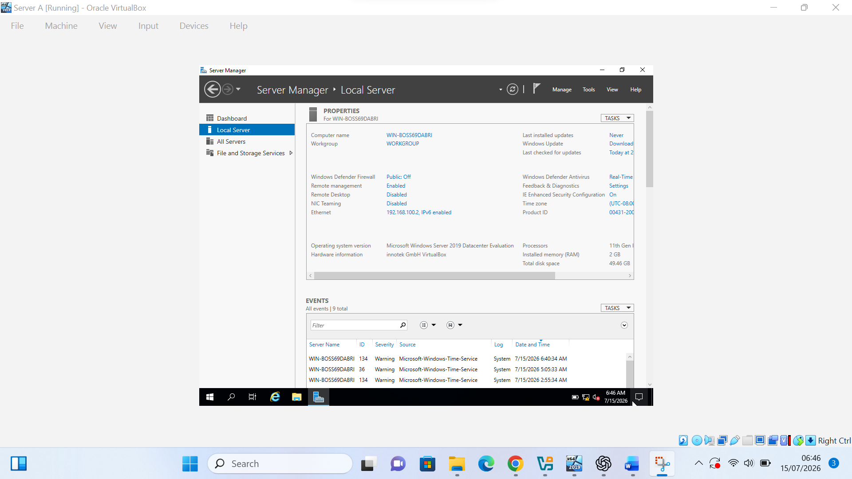
Figure 7. Server Manager showing the static IPv4 address 192.168.100.2 assigned to Server A.

The Ethernet adapter properties were opened through Network Connections to begin the manual IPv4 configuration.
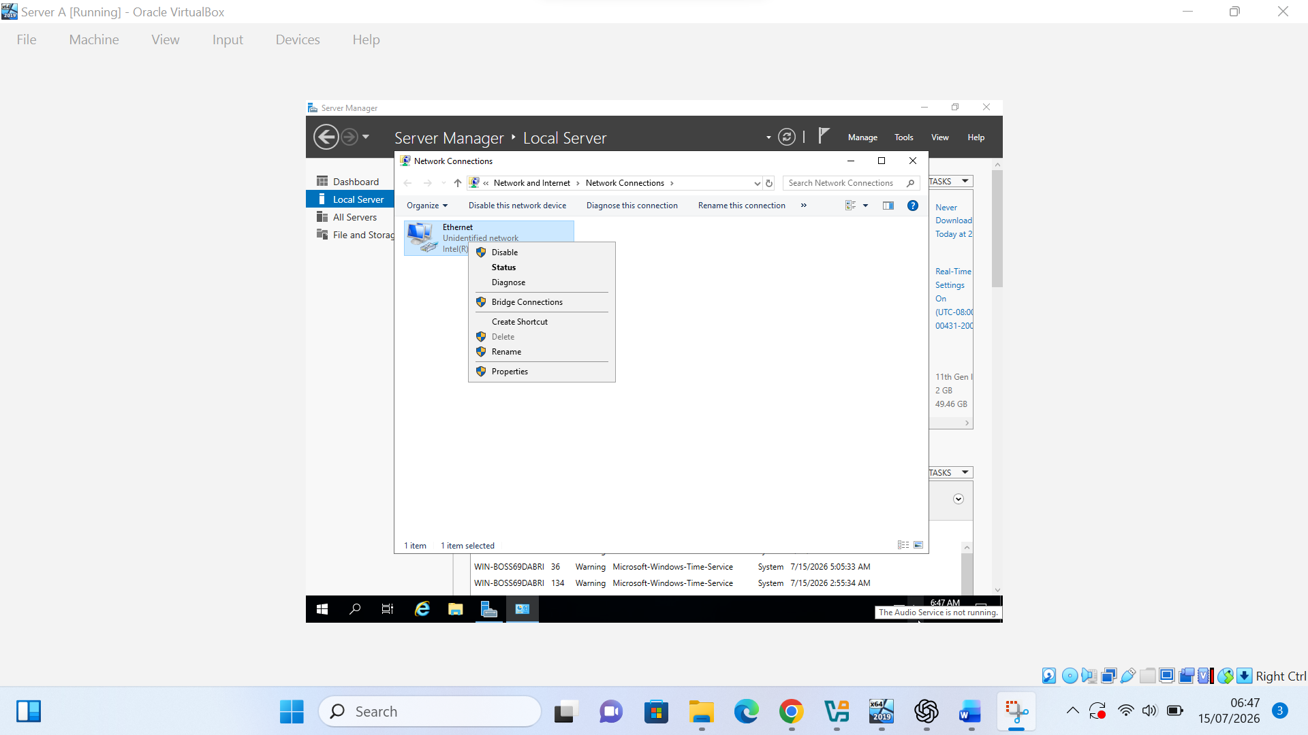
Figure 7(a). Server Manager showing the static IPv4 address 192.168.100.2 assigned to Server A.
Internet Protocol Version 4 (TCP/IPv4) was selected from the Ethernet adapter properties so that a static IPv4 address could be entered manually.

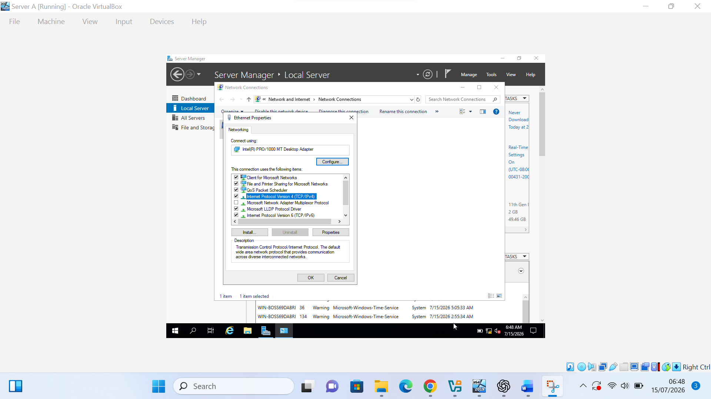
Figure 7(b). Opening the Ethernet adapter properties on Server A.

A static IPv4 address was entered manually for Server A. The address 192.168.100.2 was assigned with the subnet mask 255.255.255.0, while the default gateway and DNS fields were left blank because routing and external name resolution were not required at this stage.
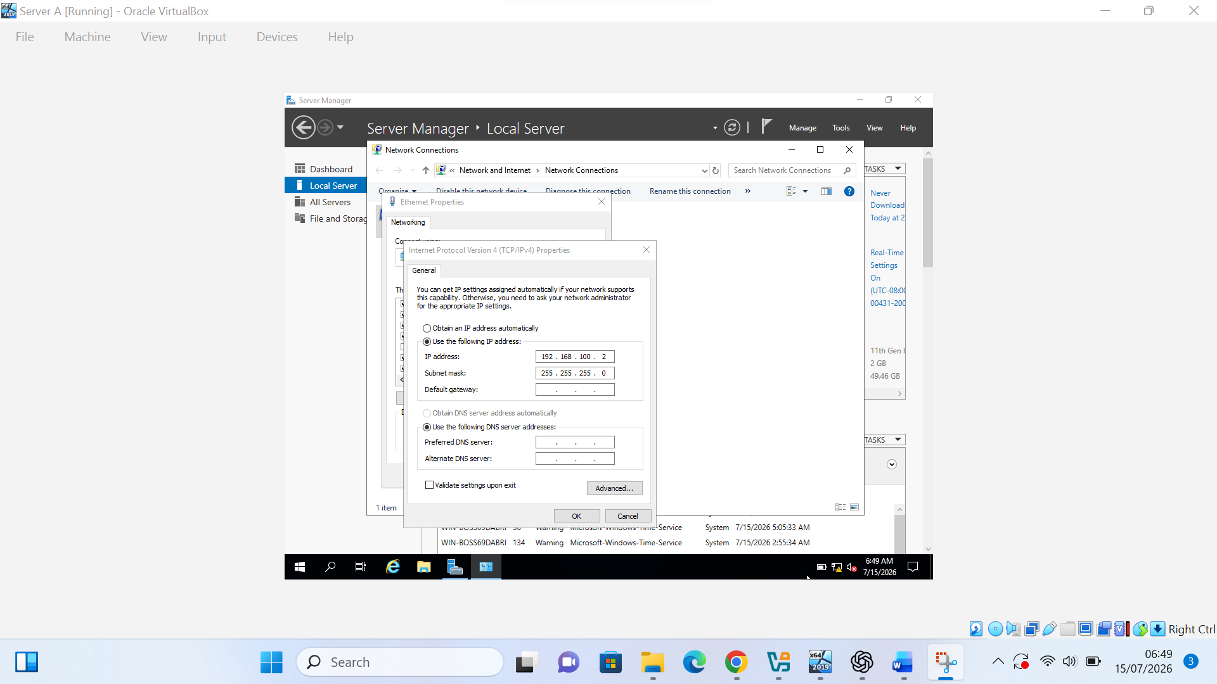
Figure 7(c). Selecting Internet Protocol Version 4 on Server A.
The same manual configuration process was repeated on Server B. Server Manager confirms that the Ethernet adapter was assigned the static IPv4 address 192.168.100.3.
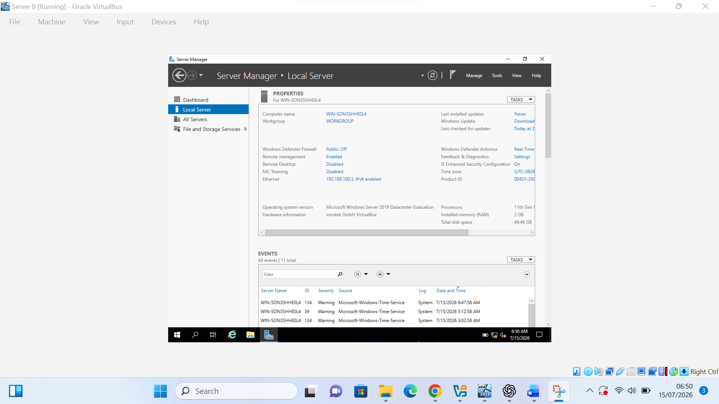
Figure 8. Server Manager showing the static IPv4 address 192.168.100.3 assigned to Server B.

The Ethernet adapter properties were opened on Server B to configure its static IPv4 settings.
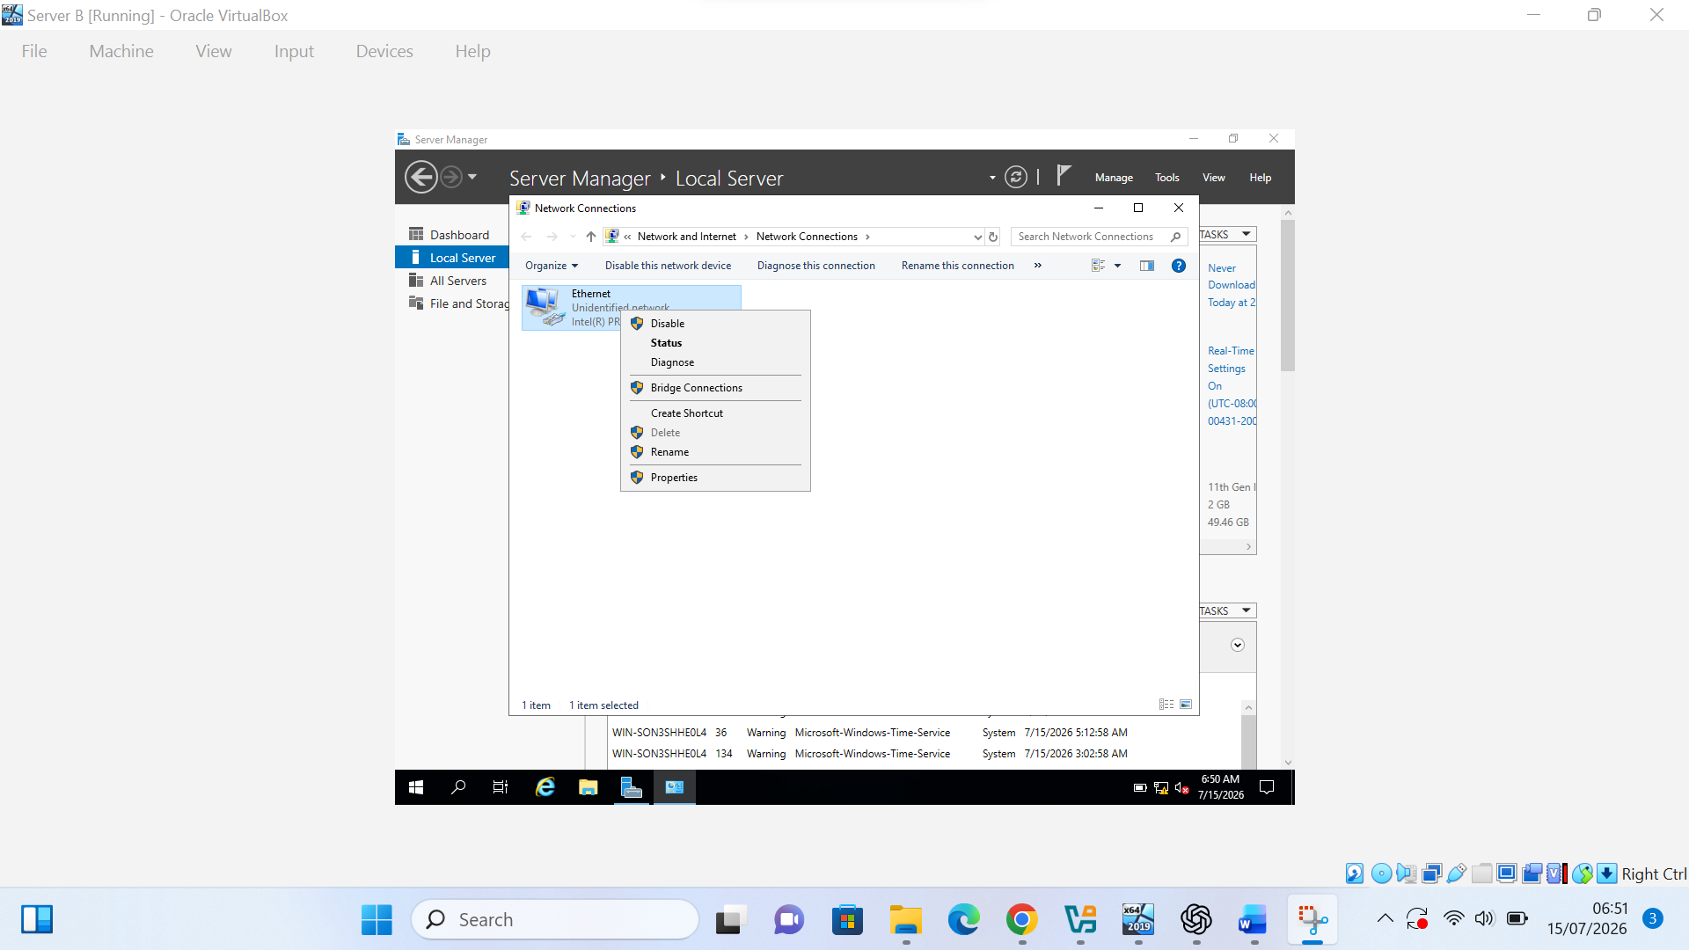
Figure 8(a). Opening the Ethernet adapter properties on Server B.

Internet Protocol Version 4 (TCP/IPv4) was selected on Server B to enter the required static network settings.
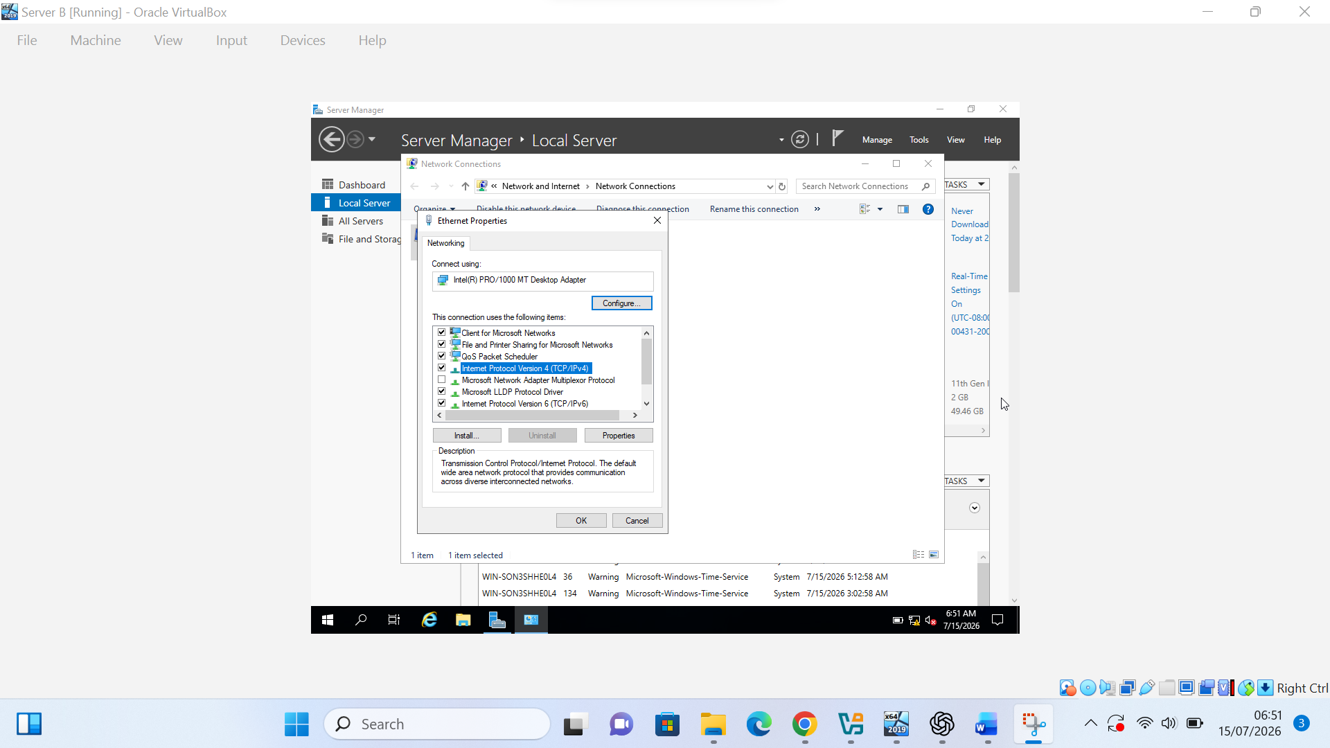
Figure 8(b). Selecting Internet Protocol Version 4 (TCP/IPv4) in the Ethernet adapter properties on Server B.
A static IPv4 address was entered manually for Server B. The address 192.168.100.3 was assigned with the subnet mask 255.255.255.0. The default gateway and DNS fields were left blank because routing and external name resolution were not required during this stage.
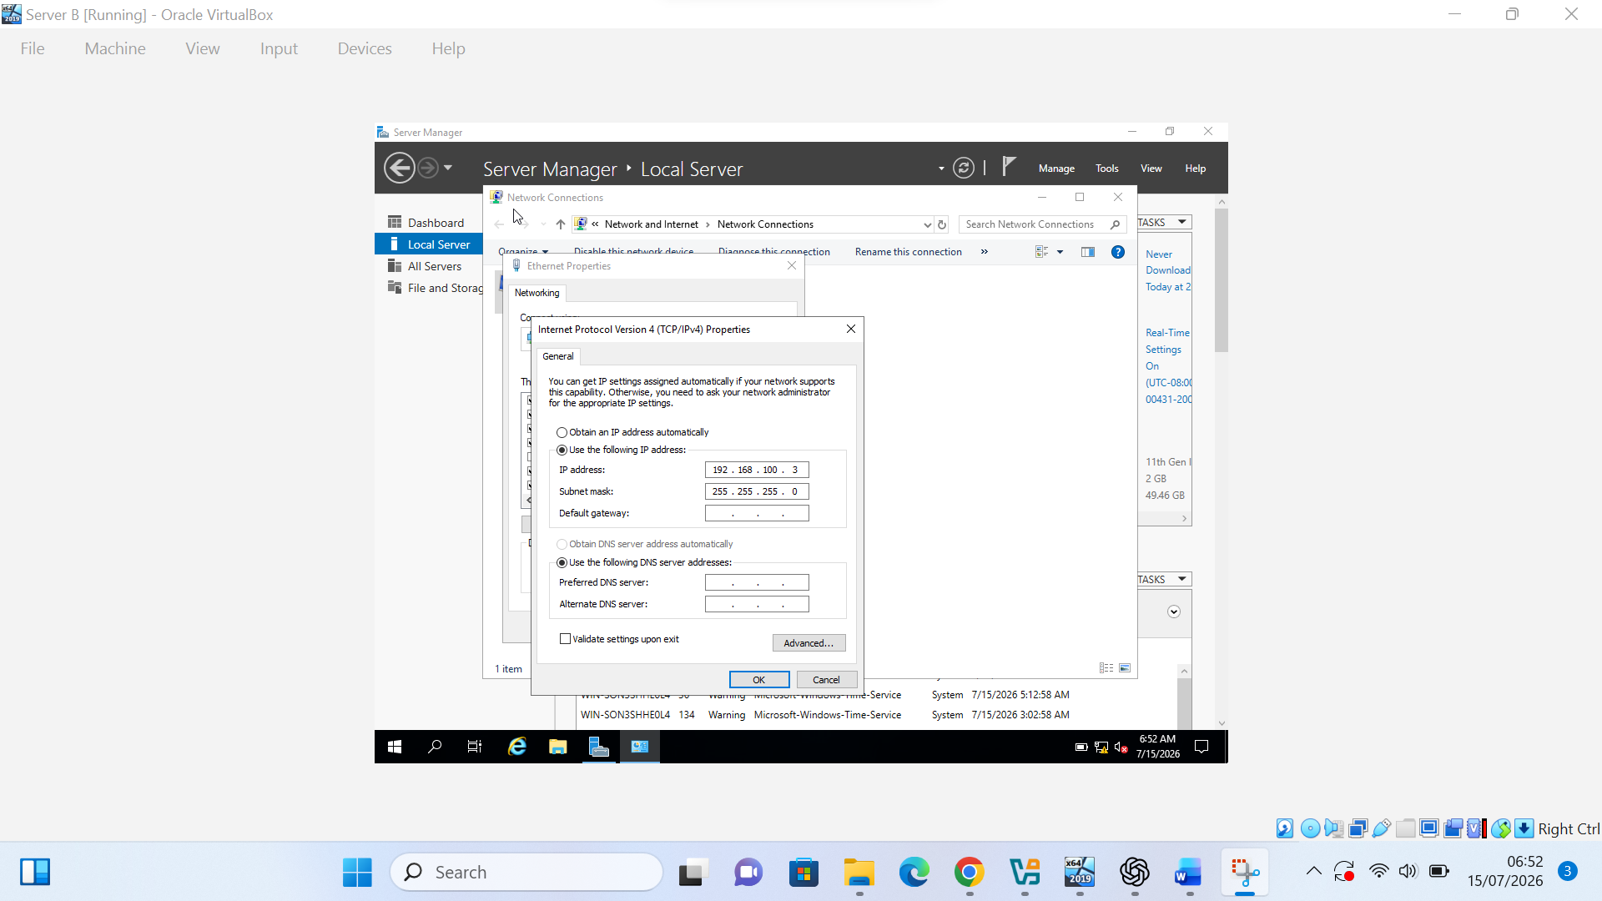
Figure 8(c). Manual IPv4 configuration of Server B using the address 192.168.100.3/24.

2.3.1. Use appropriate IP addresses to configure your network.

The network configuration process on PC B was started by opening the Debian system settings from the desktop context menu.

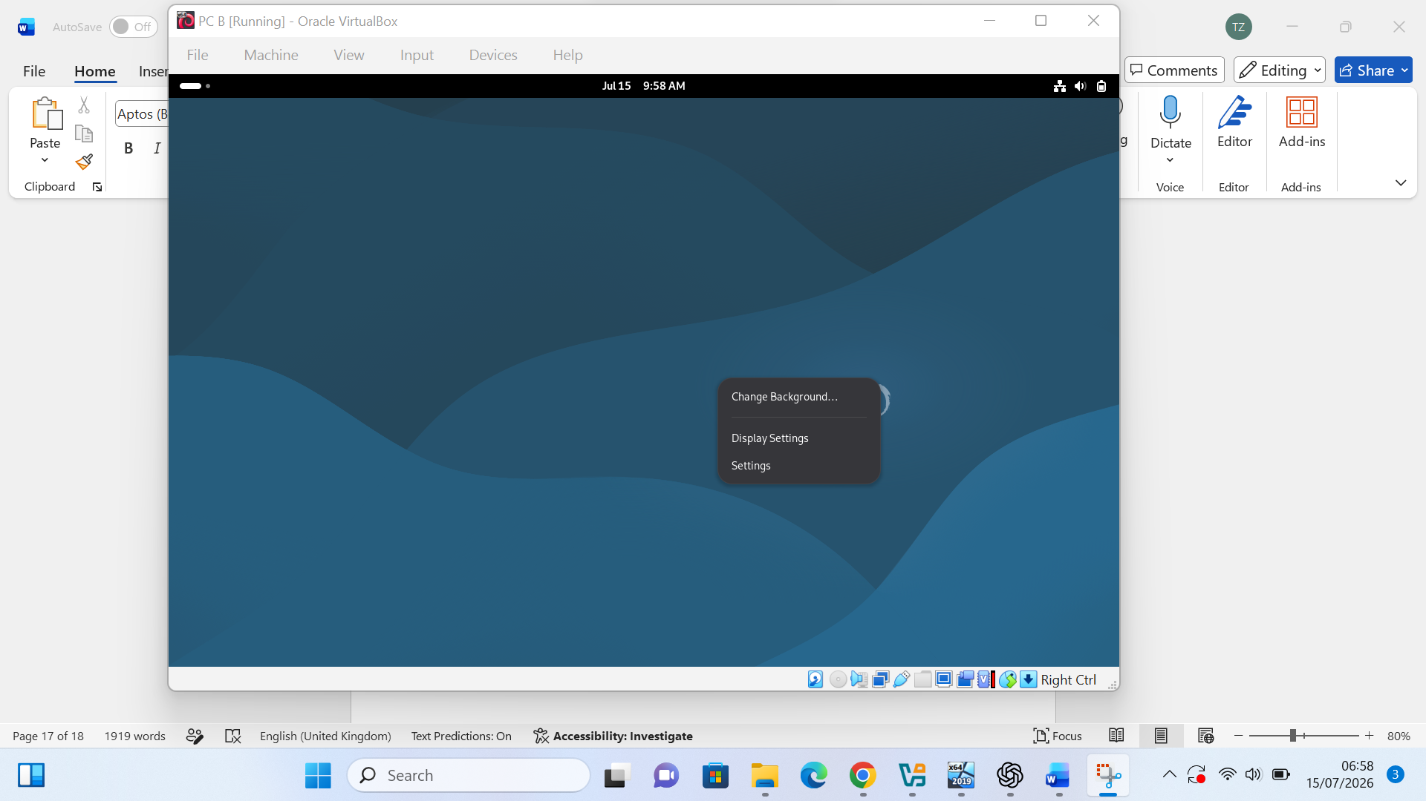
Figure 10(a). Opening the Debian system settings on PC B.

The wired network connection was selected in Debian Settings so that the IPv4 configuration could be changed manually.
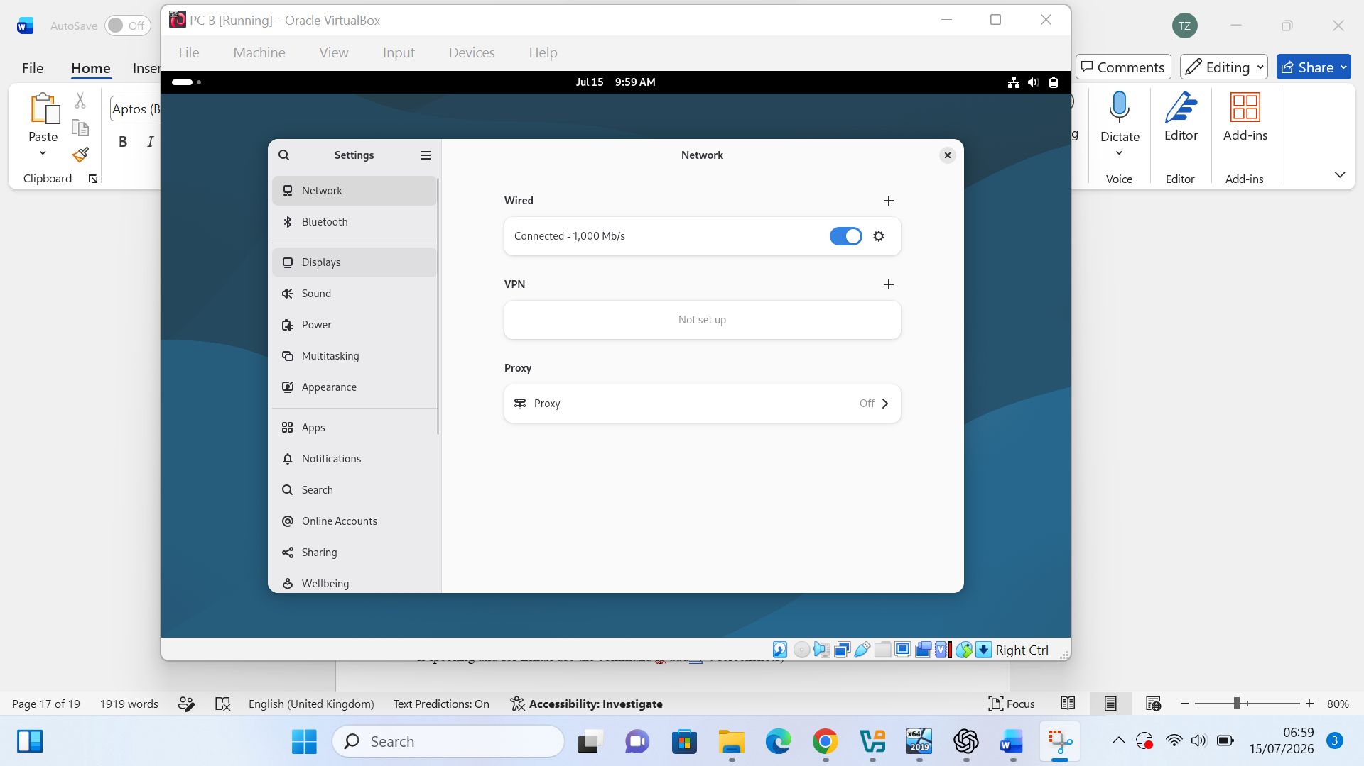

Figure 10(b). Opening the wired network settings on PC B.
A static IPv4 address was entered manually on PC B. The address 192.168.100.30 was assigned with the subnet mask 255.255.255.0, while the gateway field was left blank because no routing device was configured.
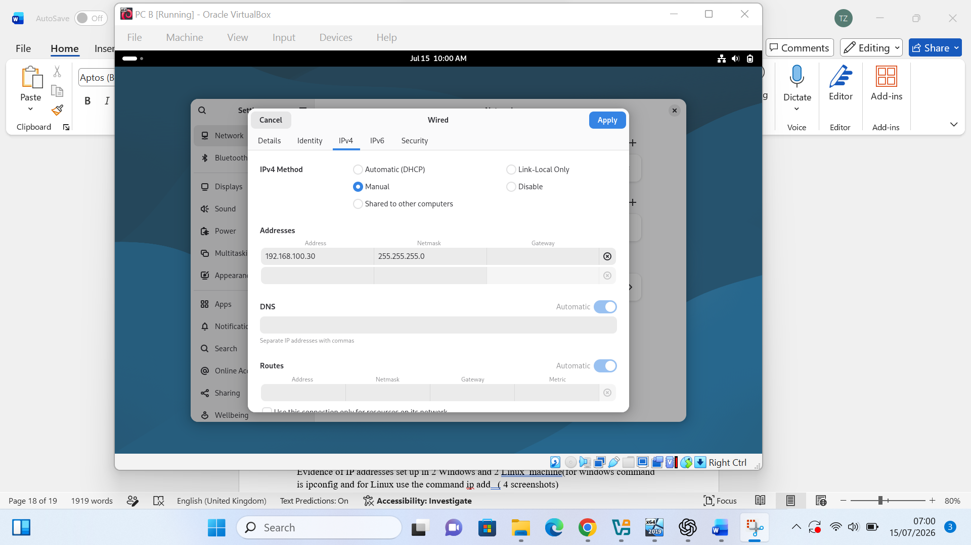
Figure 10(c). Manual IPv4 configuration of PC B using the address 192.168.100.30/24.

The completed network configuration on Server A was reviewed in Server Manager. The Ethernet adapter displayed the assigned static IPv4 address 192.168.100.2.

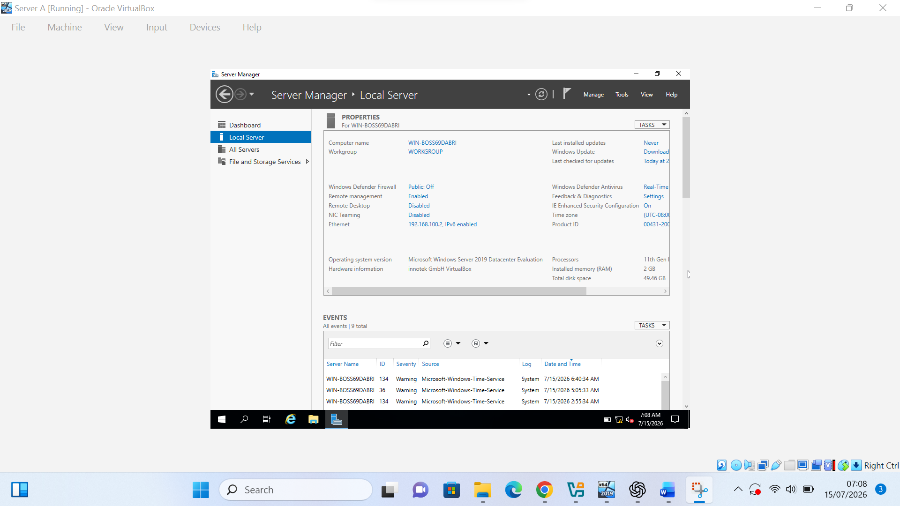
Figure 11(a). Server Manager showing the static IPv4 address 192.168.100.2 on Server A.

The Ethernet adapter properties were opened on Server A to review and confirm the manually assigned IPv4 configuration.
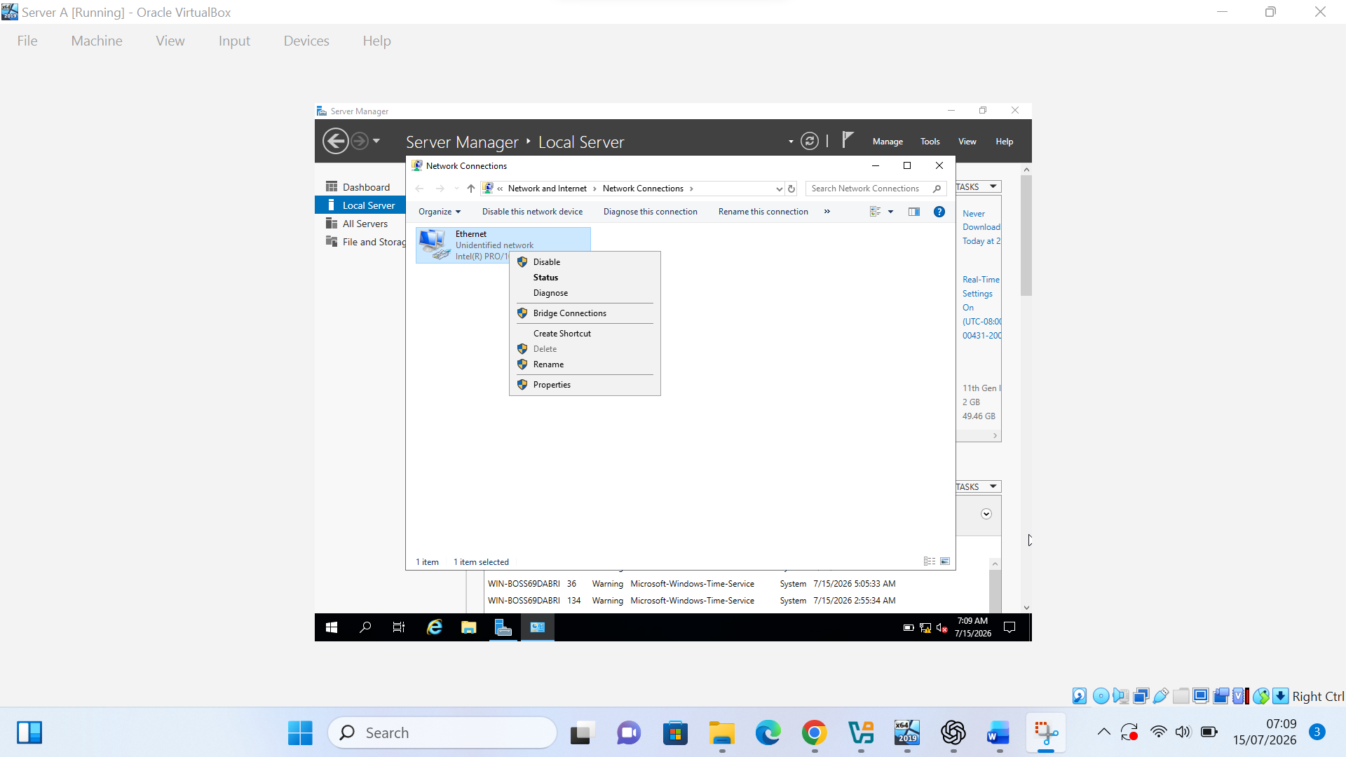
Figure 11(b). Opening the Ethernet adapter properties on Server A.

Internet Protocol Version 4 (TCP/IPv4) was selected in the Ethernet adapter properties to review the static configuration applied to Server A.
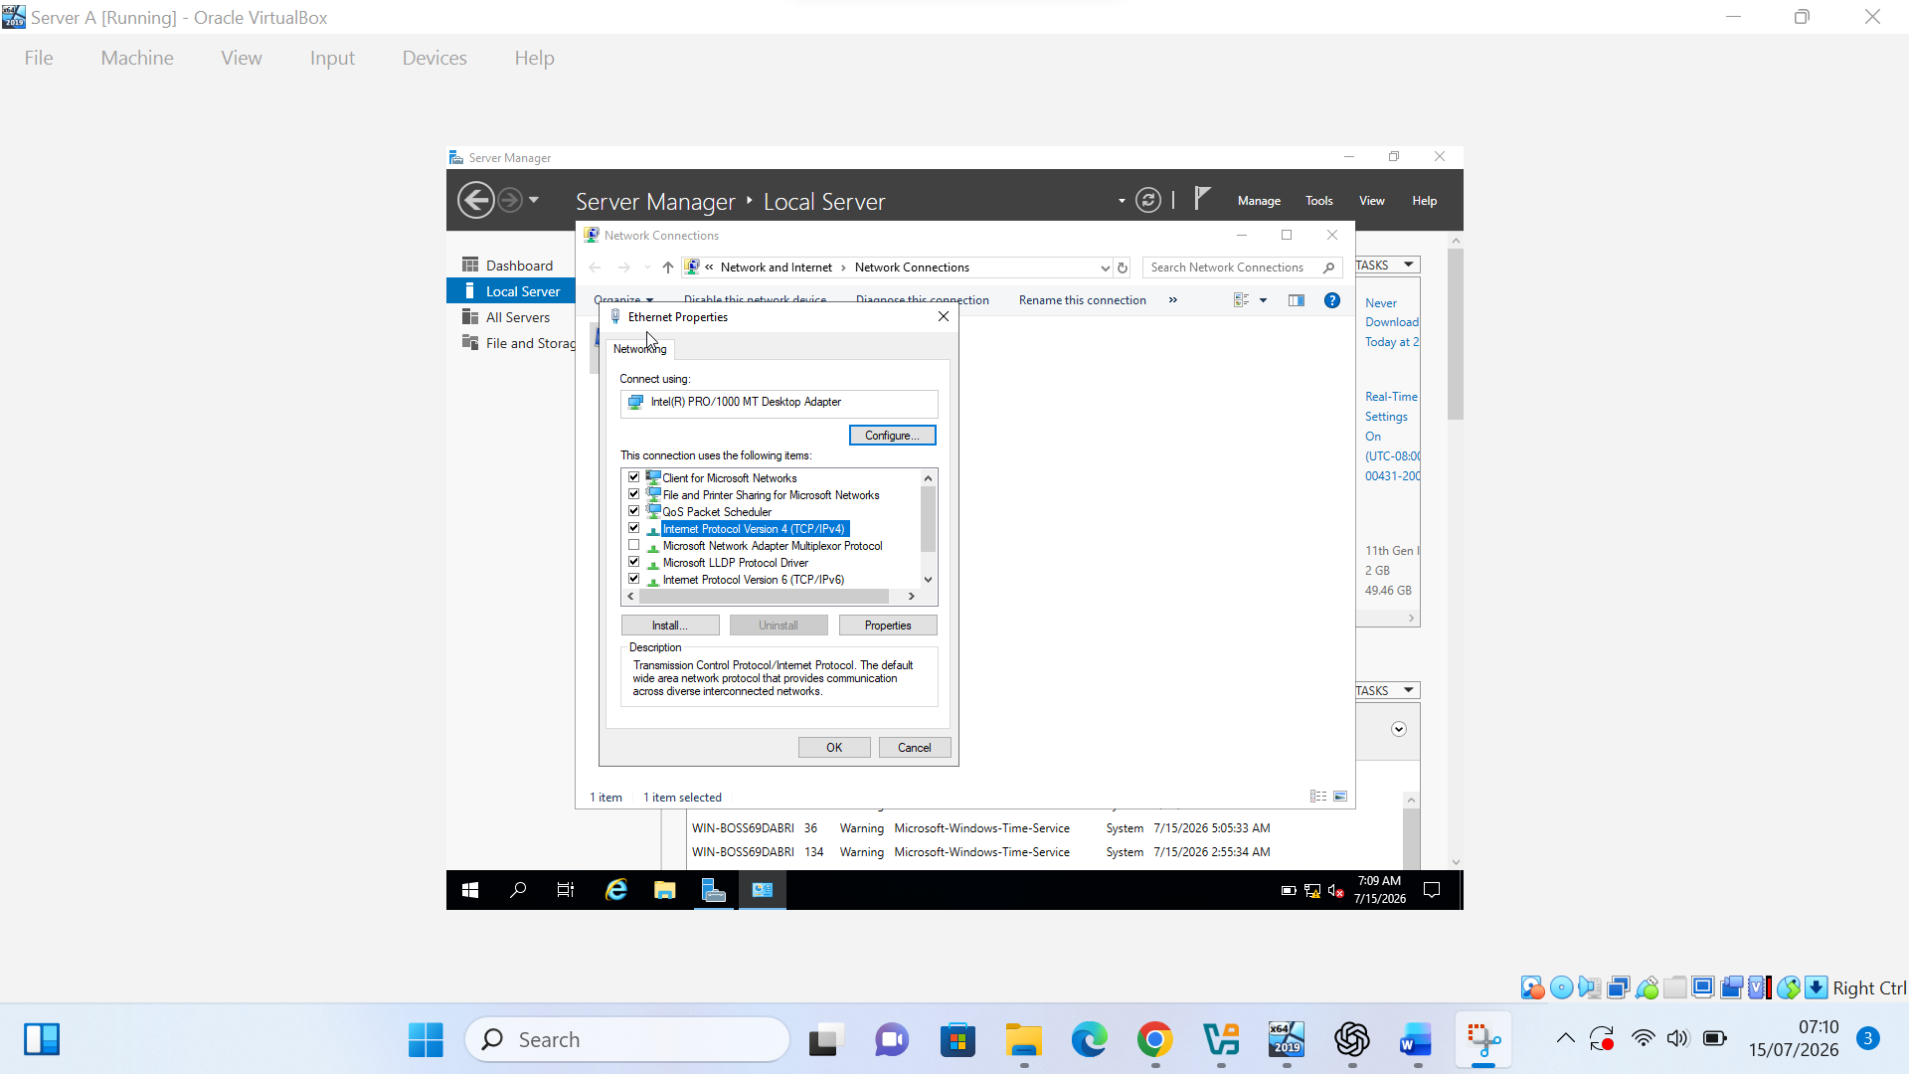
Figure 11(c). Selecting Internet Protocol Version 4 (TCP/IPv4) on Server A.

The static IPv4 settings on Server A were confirmed in the TCP/IPv4 properties window. The address 192.168.100.2 and subnet mask 255.255.255.0 were applied, while the default gateway and DNS fields remained blank because routing and name resolution were outside the scope of this stage.
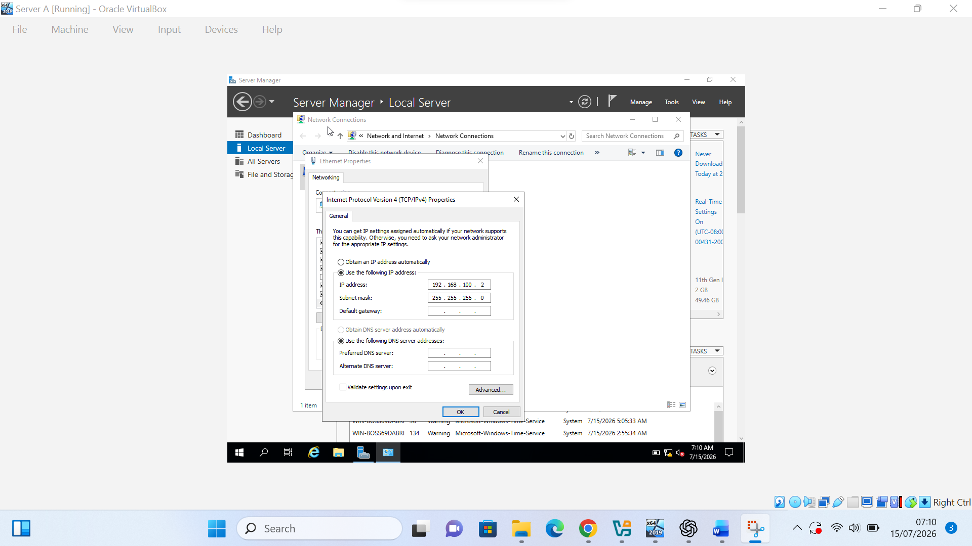
Figure 11(d). Confirmed static IPv4 configuration of Server A using 192.168.100.2/24.

2.4 Test and Troubleshoot

Command Prompt was opened on Server A to begin the connectivity testing process.
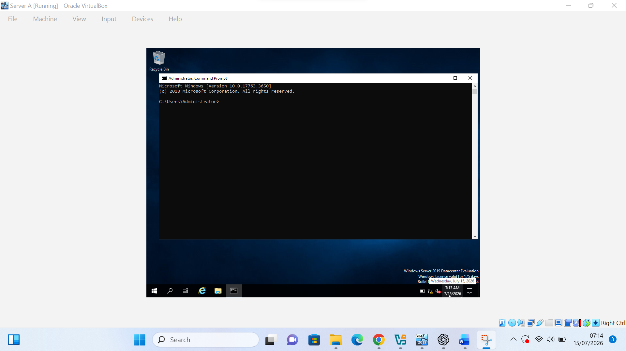
Figure 12(a). Opening Command Prompt on Server A before connectivity testing.

Command Prompt was also opened on Server B to prepare the second Windows machine for connectivity testing.
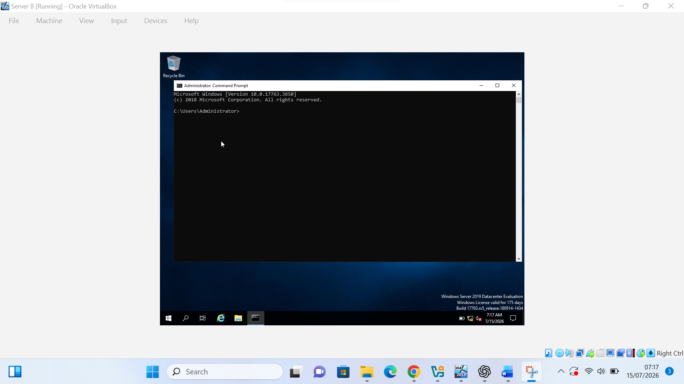
Figure 12(b). Opening Command Prompt on Server B before connectivity testing.

Before testing connectivity, the IPv4 configuration of both Windows servers was checked. The ipconfig results confirmed that Server A used 192.168.100.2 and Server B used 192.168.100.3 with the subnet mask 255.255.255.0.

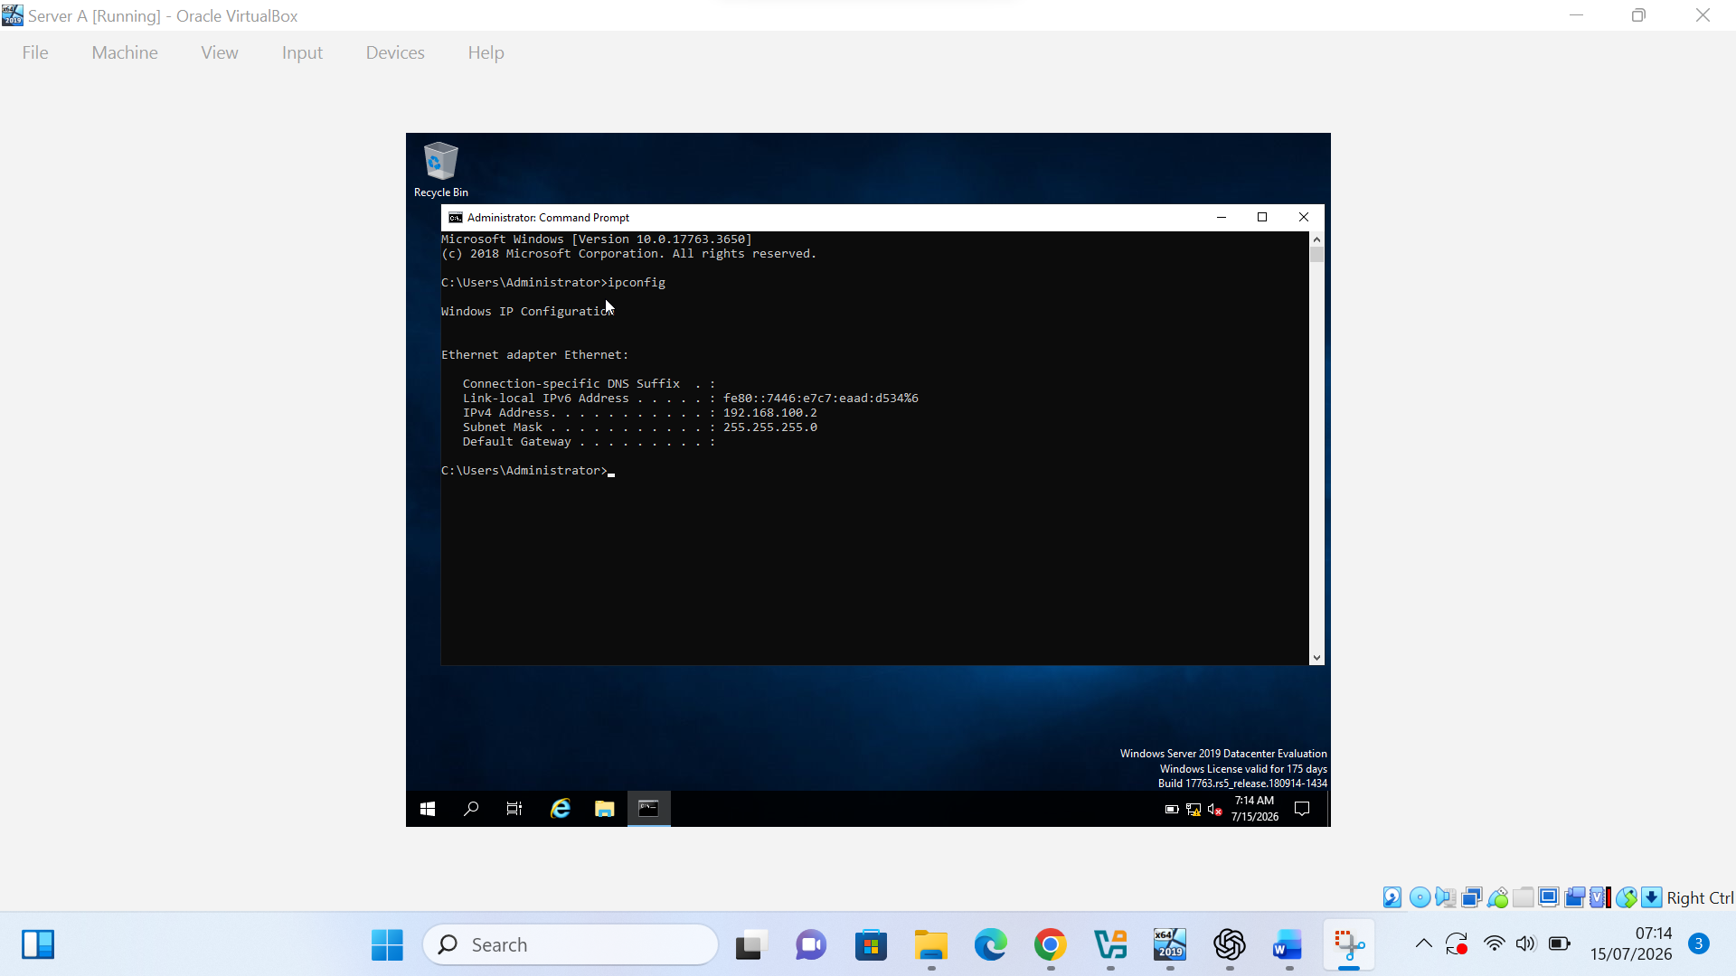
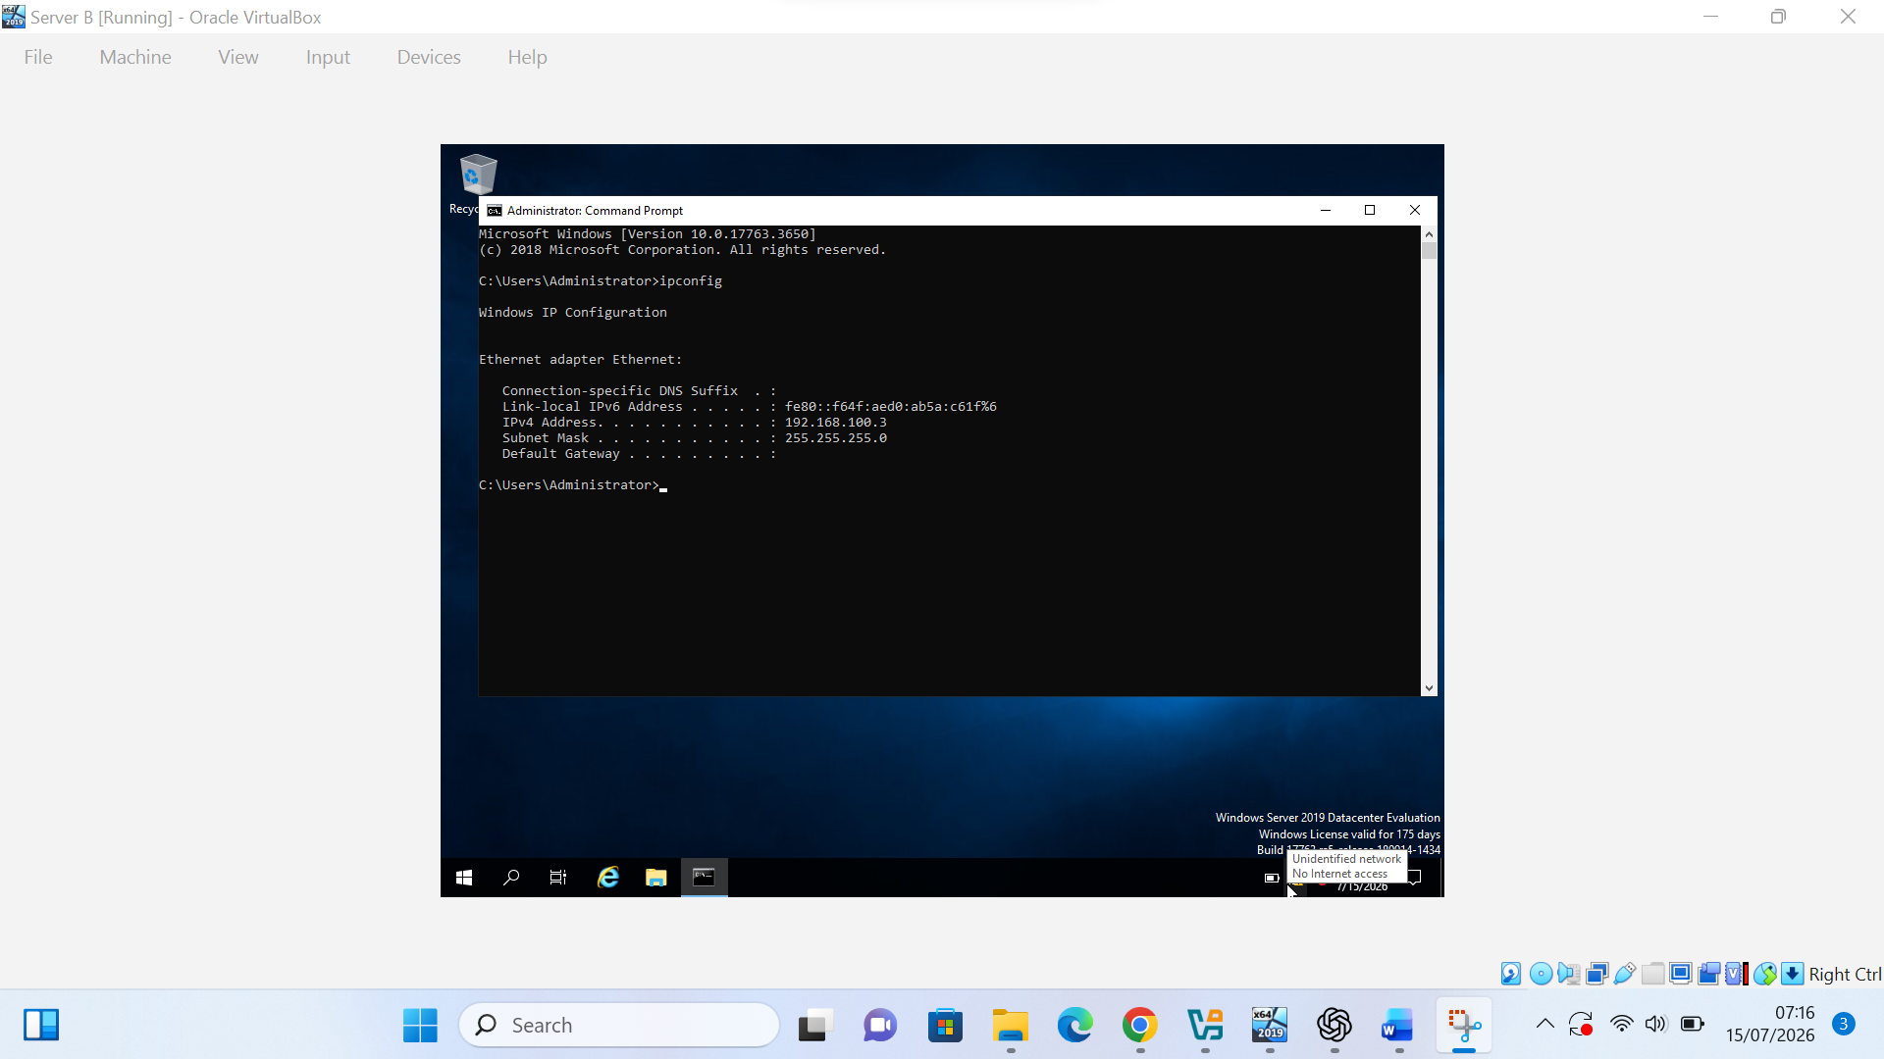
Figure 12(c). IPv4 configuration checked on Server A before connectivity testing.

Server A successfully reached Server B at 192.168.100.3. All four ICMP packets were received with 0% packet loss, confirming successful communication within the Windows Internal Network.

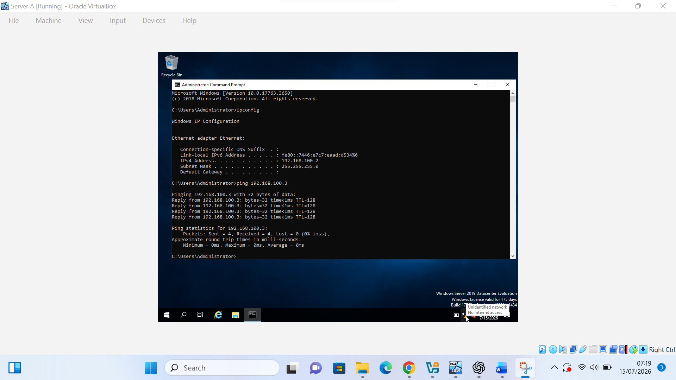
Figure 13(a). Successful ping from Server B to Server A at 192.168.100.2.

Server B successfully reached Server A at 192.168.100.2. All four ICMP packets were received with 0% packet loss, confirming successful communication within the Windows Internal Network.
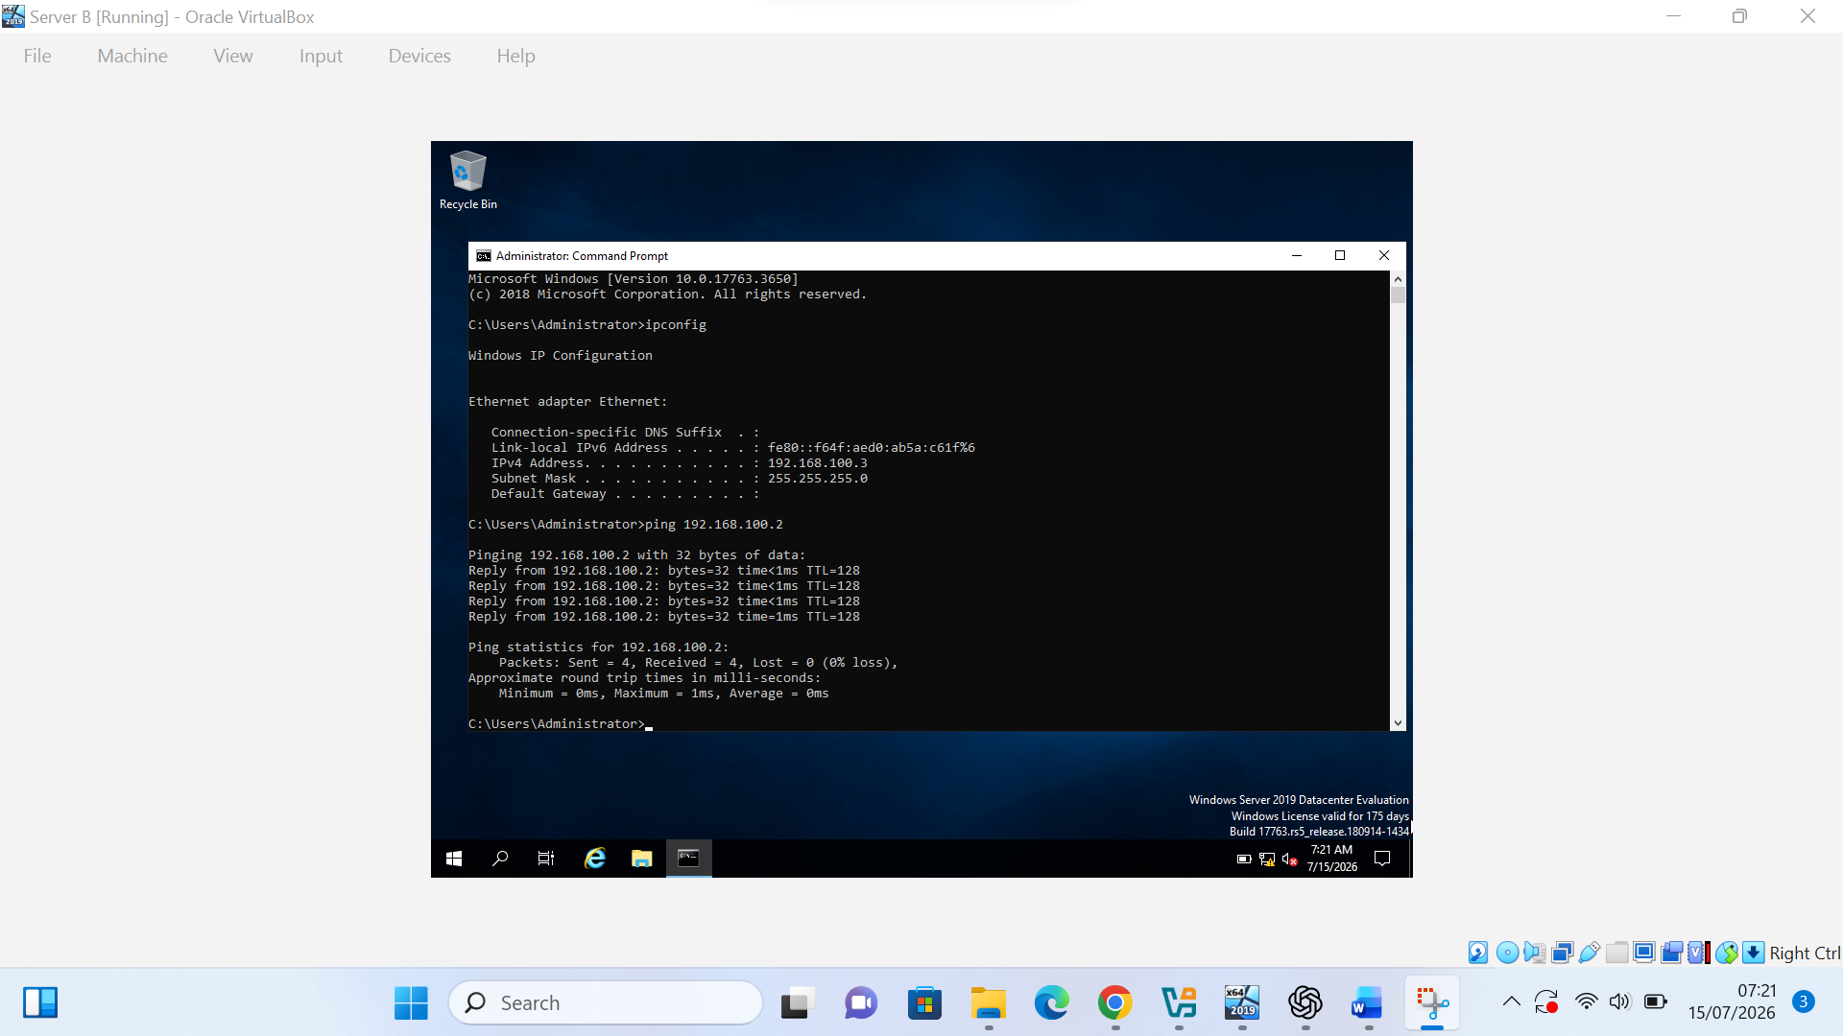
Figure 13(b). Successful ping from Server B to Server A at 192.168.100.2.

2.4.1. Perform Connectivity tests
Before testing connectivity within the Linux network, the IPv4 configuration of PC A and PC B was checked using the ip a command. The results confirmed that PC A used 192.168.100.20 and PC B used 192.168.100.30 with the /24 prefix.
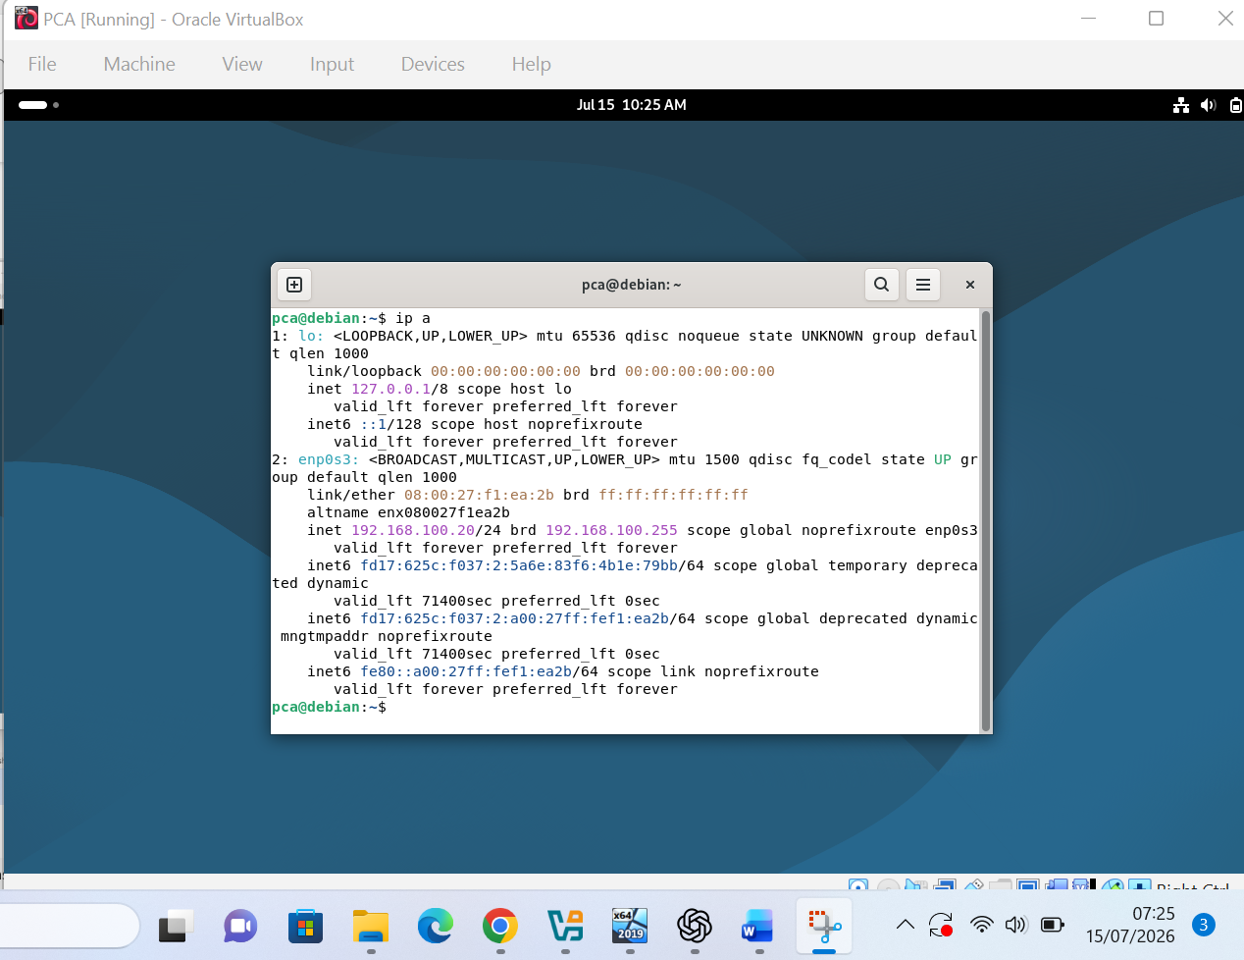
Figure 14(a). IPv4 configuration checked on PC A before connectivity testing.

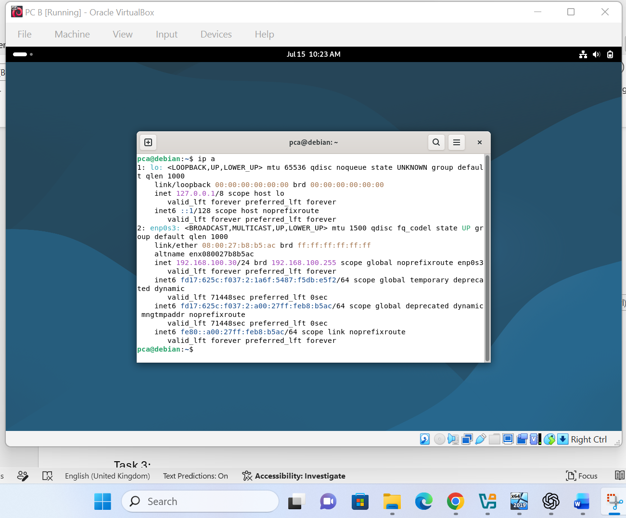
Figure 14(b). IPv4 configuration checked on PC B before connectivity testing.

PC A successfully reached PC B at 192.168.100.30. The replies confirm successful communication within the Linux Internal Network.
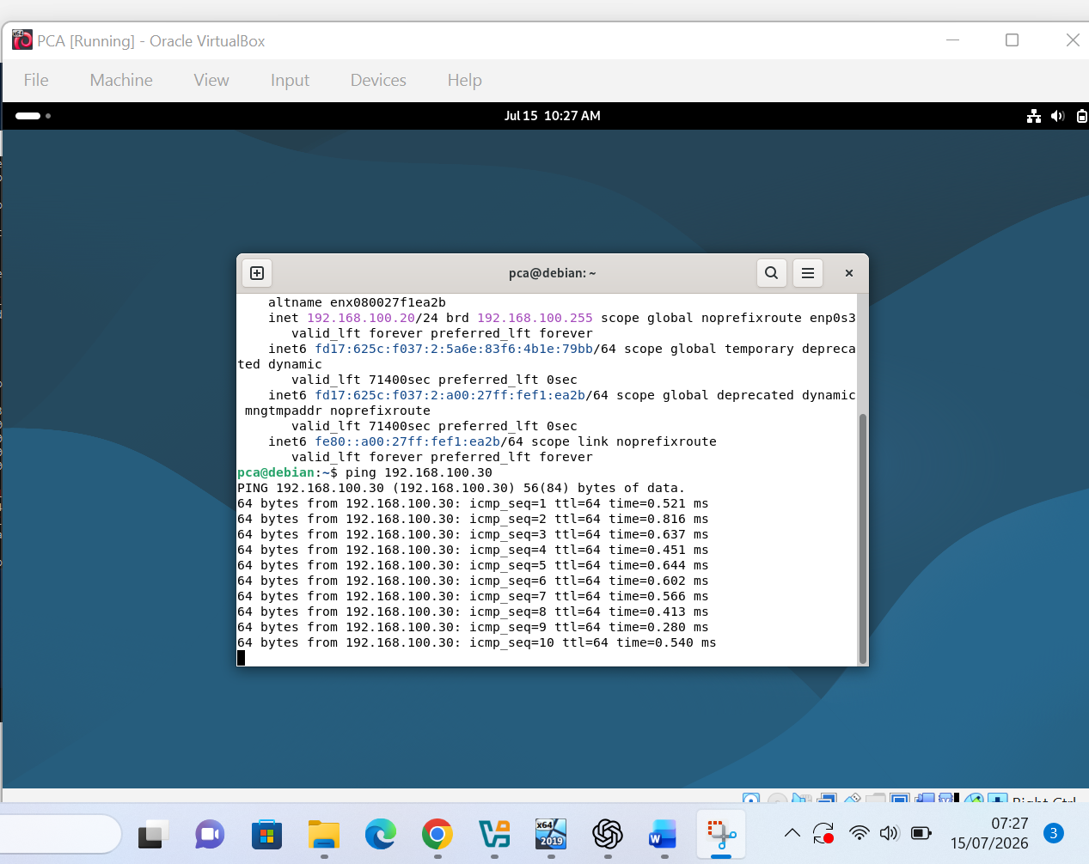
Figure 15(a). Successful ping from PC A to PC B at 192.168.100.30

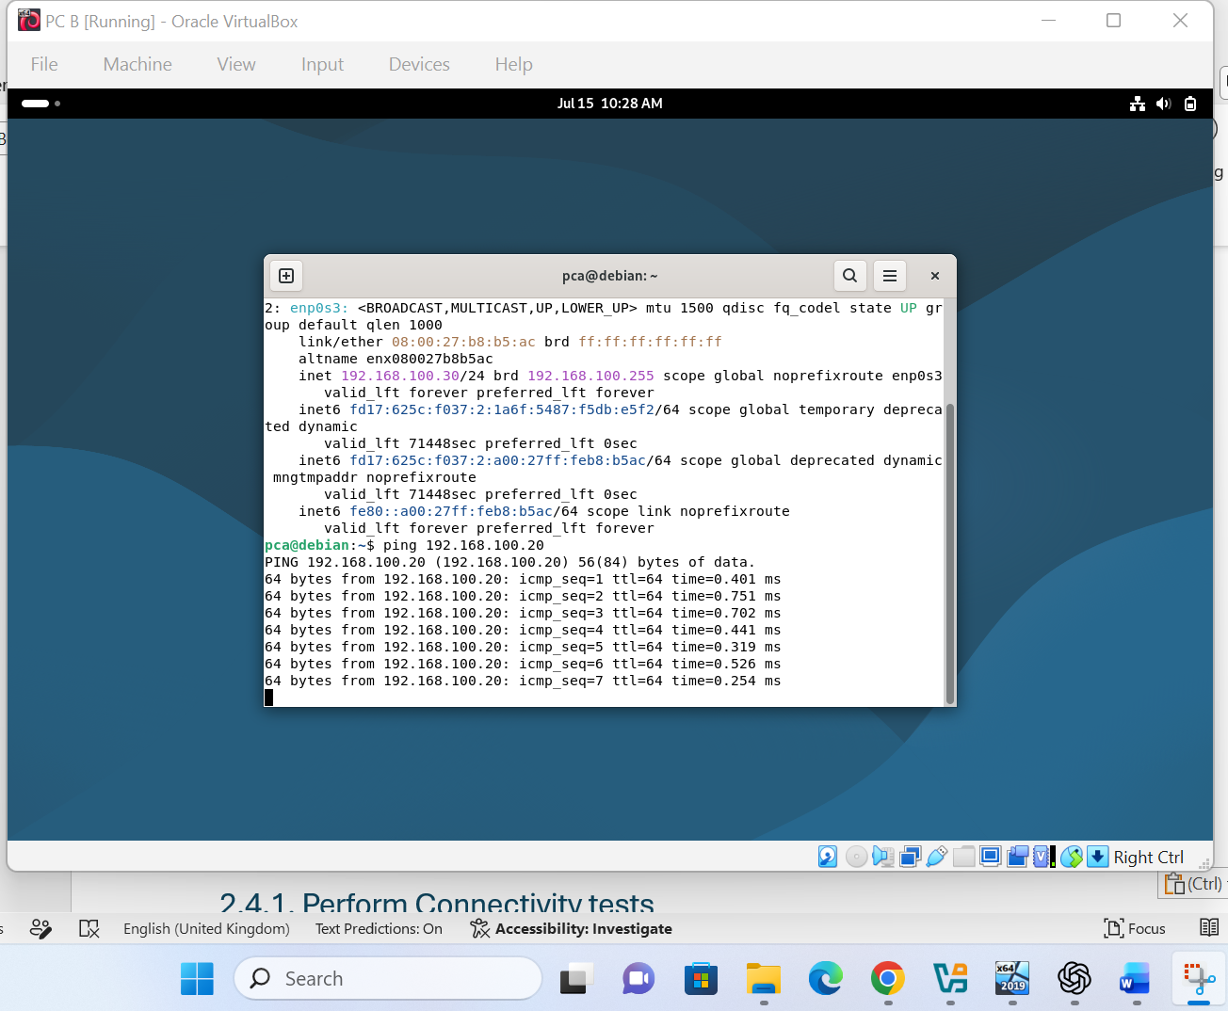
Figure 15(b). Successful ping from PC B to PC A at 192.168.100.20

2.4 Test and Troubleshoot
The Windows Defender Firewall settings were reviewed on both servers before connectivity testing. The firewall configuration was adjusted to allow ICMP traffic between Server A and Server B during the network tests

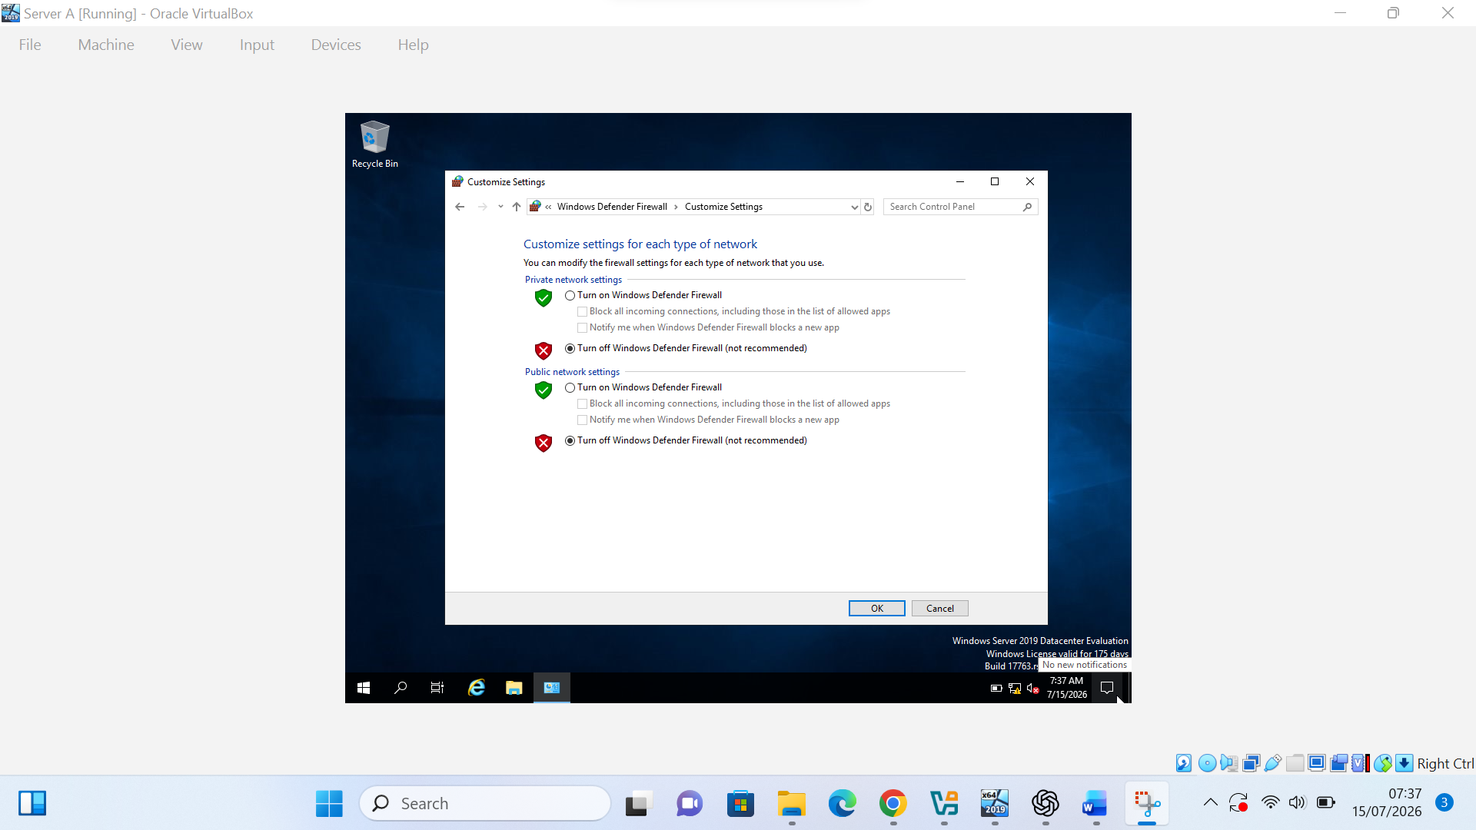
Figure 16(a). Windows Defender Firewall settings reviewed on Server A.

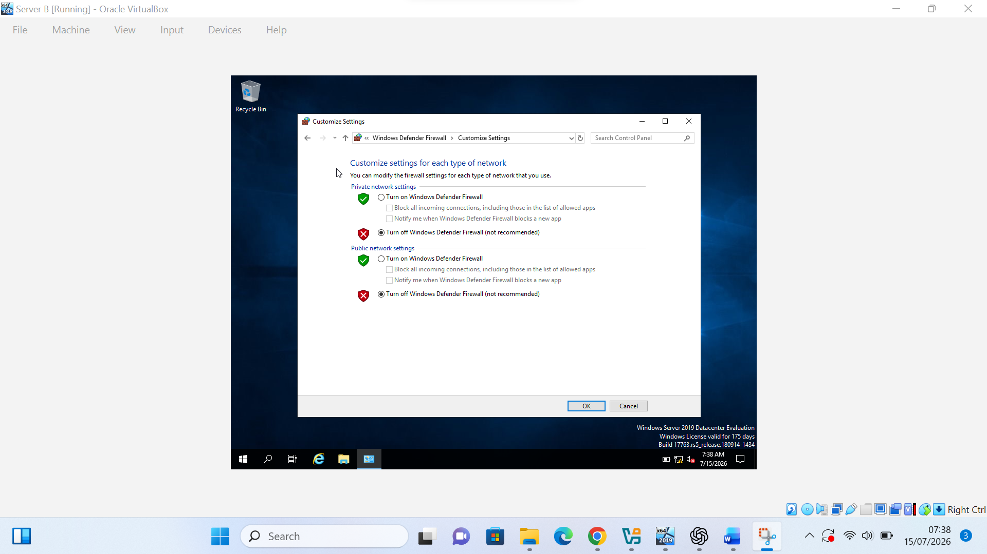
Figure 16(b). Windows Defender Firewall settings reviewed on Server B.

Figure 16. Windows Defender Firewall settings checked before connectivity testing.

Task 3:

3.1. Reflect on the following

3.1.1. Write a Technical reflection covering network deployment and testing.
During the deployment of the NOSSLONDON2026 virtual network, I configured four virtual machines in Oracle VirtualBox and attached them to two separate Internal Networks. The main technical challenge I experienced was ensuring that each machine was connected to the correct virtual network and had the correct static IPv4 address.
I identified the issue by checking the VirtualBox network adapter settings and comparing the assigned addresses through ipconfig on Windows Server and ip a on Debian. I then corrected the configuration by attaching Server A and Server B to intnet and PC A and PC B to intnet-linux. I also verified that the subnet mask was set to 255.255.255.0 on all four machines.
Connectivity testing showed successful communication between Server A and Server B and between PC A and PC B. The cross-network ping tests failed because the machines were connected to separate isolated Internal Networks. This was the expected result because no routing device or default gateway had been configured. This process improved my understanding of virtual network adapters, static IPv4 addressing and structured troubleshooting.

3.1.2. Write your Personal Reflection
Completing this task improved my confidence in creating, configuring and testing virtual machines. At the beginning, I found the network configuration difficult because I needed to manage several machines, IP addresses and VirtualBox network settings at the same time.
I managed my work by completing the installation, network configuration and connectivity testing in separate stages. I also recorded screenshots with visible timestamps to document my progress. The task strengthened my problem-solving and decision-making skills because I had to compare settings, recognise configuration errors and correct them independently. In future deployments, I will prepare the IP addressing plan and machine names before starting the configuration. This experience has prepared me for Coursework 2, where DHCP, Active Directory and routing will be introduced.

Conclusion:
This coursework examined the research, design and deployment of a virtualised enterprise network for the NOSSLONDON2026 scenario. Oracle VirtualBox was selected because it supported the required Windows Server and Debian systems while providing suitable internal networking features for the available hardware. The practical implementation demonstrated the creation of four virtual machines, configuration of isolated internal networks, assignment of static IPv4 addresses and testing of connectivity within each network segment.
The successful ping tests confirmed correct communication between devices connected to the same Internal Network. The unsuccessful cross-network tests also matched the expected outcome because no router or default gateway had been configured between the Windows and Linux segments. The task strengthened the link between theoretical concepts such as virtualisation, IP addressing and routing and their practical application in a controlled network environment. It also provided a reliable foundation for Coursework 2, where services such as DHCP, Active Directory and routing will be added.

References:
[1] N. Regola and J. C. Ducom, “Recommendations for virtualization technologies in high performance computing,” in 2010 IEEE Second International Conference on Cloud Computing Technology and Science, Indianapolis, IN, USA, 2010, pp. 409–416, doi: 10.1109/CloudCom.2010.71.
[2] V. K. Manik and D. Arora, “Performance comparison of commercial VMM: ESXi, Xen, Hyper-V and KVM,” in 2016 3rd International Conference on Computing for Sustainable Global Development, New Delhi, India, 2016, pp. 2628–2631, IEEE Xplore document 7724572.
[3] Oracle Corporation, “Virtual networking,” Oracle VirtualBox User Manual, 2026. [Online]. Available: Oracle VirtualBox Documentation. [Accessed: 22 Jul. 2026].
[4] J. Postel, “Internet Protocol,” RFC 791, Internet Engineering Task Force, Sep. 1981, doi: 10.17487/RFC0791.
[5] S. Deering and R. Hinden, “Internet Protocol, Version 6 (IPv6) Specification,” RFC 8200, Internet Engineering Task Force, Jul. 2017, doi: 10.17487/RFC8200.
[6] V. Fuller and T. Li, “Classless Inter-domain Routing: The Internet Address Assignment and Aggregation Plan,” RFC 4632, Internet Engineering Task Force, Aug. 2006, doi: 10.17487/RFC4632.
[7] G. A. Tizazu, K. H. Kim and A. B. Berhe, “Dynamic routing influence on secure enterprise network based on DMVPN,” in 2017 Ninth International Conference on Ubiquitous and Future Networks, Milan, Italy, 2017, pp. 756–759, doi: 10.1109/ICUFN.2017.7993894.
[8] R. Droms, “Dynamic Host Configuration Protocol,” RFC 2131, Internet Engineering Task Force, Mar. 1997, doi: 10.17487/RFC2131.
[9] Microsoft, “Active Directory Domain Services overview,” Microsoft Learn, 2025. [Online]. Available: Microsoft Learn. [Accessed: 22 Jul. 2026].
[10] S. Kent and K. Seo, “Security Architecture for the Internet Protocol,” RFC 4301, Internet Engineering Task Force, Dec. 2005, doi: 10.17487/RFC4301.
[11] National Institute of Standards and Technology, “Recommendation for Key Management: Part 2, Best Practices for Key Management Organizations,” NIST Special Publication 800-57 Part 2 Rev. 1, 2019, doi: 10.6028/NIST.SP.800-57pt2r1.
[12] K. Kinnear, M. Stapp, R. Johnson and J. Kumarasamy, “Link Selection sub-option for the Relay Agent Information Option for DHCPv4,” RFC 3527, Apr. 2003, doi: 10.17487/RFC3527.

