University of Wales
Trinity Saint David



Birmingham
Student name: Shahzia Ahmed

Student number: 1813330

BA – International Hotel Management

Module: Management and Organizational Behavior

Module code: M5X01924

Assignment Title: Organizational Behavior

Lecturer: Olu Adegbite

Managerial Behavior: A Report on Apple Inc



Table of Contents
Managerial Behavior of Apple Inc 6
Hofstede’s Theory 9
Recommendations 10
Reference 12

Introduction
The purpose of this report is to analyse the turnaround of Apple Inc and how Steve Jobs played a vital role in making this possible. The company’s bold decision to take back Steve Jobs, one is its original founders formally dismissed. The given scenario is “Jobs returned to Apple in 1997 with a daunting mission, to say the least.
The company had lost $1.04 billion in the fiscal year of 1997. Sales plummeted by 30 percent in the last Quarter of 1996. On the product line, it was producing a random array of computers and peripherals, including multiple versions of the same product.
After a few weeks of product review sessions, Jobs had enough. On a product meeting, he decided to reduce the number of products by 70%. Apple was to produce only four products: one desktop and one portable device aimed at both consumers and professionals. The job of his team members was to focus on building four great products, one for each quadrant. All other products should be cancelled. There was a stunned silence…
But by getting Apple to focus on making just four computers, he saved the company” [[Apple.com][accessed 29-03-2020]
Apple Inc is a well-established and highly successful company operating globally, there example is like no other they have earn a global praise in the innovation of marketing and having the customers in anticipation of their newest products, the company's revenue was valued at $110.Billion in the year 2011 earning them the position of the most valuable US companies in the world.
This report will contain an analysis of Steve Jobs return to Apple the strategies deployed by himself and his unique leadership methods to derive the best possible outcome from his employees and the organisational culture, which was being developed for Maximum output.
To evaluate this, I will using four types of the structures which can be applied to Apple Inc, along with the managerial aspects which are implemented (Peng, 2018). It is essentially four dimensions which needs to be consider with respect to the Apple Inc. The major dimensions were those of power distance, the individualism, uncertainty avoidance and masculinity. The managerial factors which would be managed with the help of the Hofstede’s Theory.
Organizational Culture
Apple Inc's. Organizational culture is a key factor in the ongoing success and achievement of the business. An organization's hierarchical or corporate culture sets up and keeps up the business reasoning, qualities, convictions, and related practices among representatives. This report shows that Apple has a corporate culture that empowers HR to attain different key goals. For instance, the organization's social qualities are lined up with the drive for development and innovation, which is a main consideration that decides business importance in the data innovation, online administrations, and purchaser gadgets ventures. In light of the authoritative culture, this business condition encourages the satisfaction of Apple Inc's. corporate crucial vision articulations. Through the administration of Steve Jobs innovative and driven leadership
Through his leadership and effective management quality that helped Apple Inc, to become profitable and one of the largest brands in the world today. Most consider the methods of motivation and strategies undertaken by Steve Jobs was rather different from the other leadership theory (Wang, 2020).

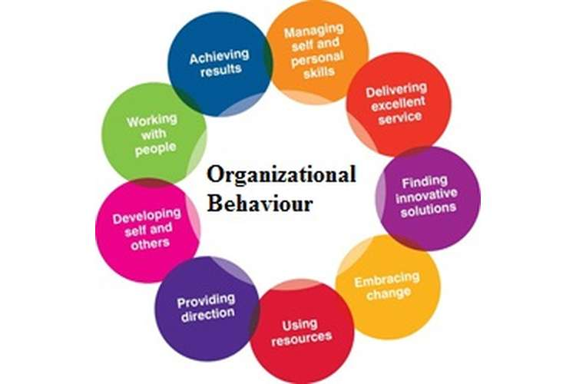

Managerial Behavior of Apple Inc
It has been observed that the incorporation of the management of the managerial structure has been a matter of serious consideration. The study of the micro environment has aided the management of the group analytics along with that of the performance which has enable the growth of the Apple Inc. The managerial behavior of the organization, Apple Inc., would be regulating the organizational culture of the same (Hans and Strese, 2017). The managerial factors of the organization Apple Inc. have been associated with the factors of values, beliefs along with that of the behavior amongst the various employees. It should be taken into consideration that the managerial behavior, which is relative to the company Apple Inc., has been closely associated with the corporate mission and the vision of the company. It has been observed that the Apple Inc, has been centering the issues of the development of the corporate culture around the major factors of the following issues. They are the factors of excellence, creativity, innovation, secrecy and that of the moderate combativeness.
Following are the factors which would be:-
Excellence: One of the means, which was undertaken by the company Apple inc, to exorbitantly increase the profit level of the organization would be that of the recruitment of the highly excellent individuals from the market. One of the methods used within the company was the dismissal of the employees who all did not meet the criteria or new expectation set by Jobs. The excellence of the employees had been regarded as a critical success factors which would be important for the growth and development of the company, which was again important in the establishment of the success from the loss which was incurred in the years previous to 1997 (Laestadius et al., 2019). Creativity: The cultural characteristic would be underpinning the factor of the creativity within Apple which would be important for the management, this helped curb losses which had been previously promoted by the system. It has been decided that the production and promotion of only 4 products, the iPod, iPad, the iMac and the iPhone, even though this was not the first smart phone to be launched, Apple made it seam that it was the best, the “new” buzz word was the Marketing strategy which enabled the system to prevail which eventually led to the success of the establishment in the market place defining new boundaries. The iPod opened new income streams from the new iStore, selling tunes for 99cents thus setting a president in the music industry. 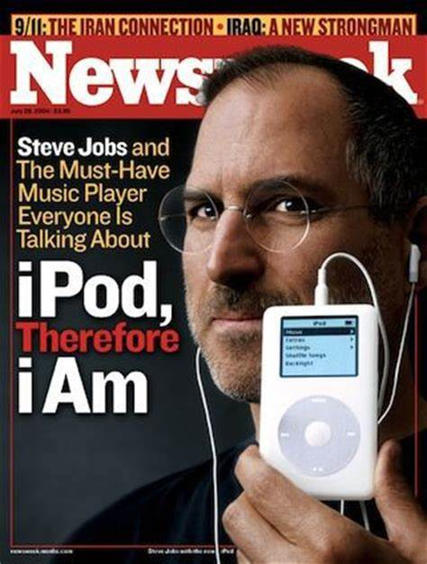

Innovation: For the organization to maintain the level of culture and the proper performance it was highly essential that the steps to be undertaken for the product development process. Steve Jobs had been said to be a perfectionist, he stated on his return “ The products suck they have sex appeal” his pursuit and determination for detail was profound, he was very particular and pushed employees to achieve more than they themselves thought possible. The corporate culture within the system leads to the massive amount of the development of the various characteristic of the growth in the company. It would thus be relative to the company attaining the maximum amount of profitability as well as the productivity of the organization Apple Inc (Pereira, 2019). Furthermore the performances as well as the contribution to the development procedure of the organization would be leading to the eradication of the harmful effects which has been imposed upon Apple Inc previously.
Secrecy: The maintenance of the secrecy has been one of the major factors in which Apple Inc has been able to maintain, the factor of the organizational culture. New innovative marketing strategies to give the consumer the air of expectancy, as with his employees he also sold the “REALITY DISTORTION FIELD” connecting with people, making them believe the impossible, possible, Apple Inc was able to implement the new theory into the organization, which helped to maintain and enhance the corporate culture in which would be eventually ascertaining the factor for the proper development of the matters of the concern which has been relative to the organization (Alexander, 2016). Additionally, this was a managerial behavior which was introduced into the system by the Steve Jobs and it was made to persist within the system by the function which was undertaken.
Moderate Combativeness: This is the manner by which the development of several procedures Apple Inc is facilitated, and which helps in the eradication of the several factors which might exist. The leadership approach which was eventually utilized by the individuals within the Apple has been that of the combativeness. The other matter which should be taken in to account is it has been that of the challenges which would be enhancing the approach to the organization Apple (Bakato and Petrović, 2016). The output of the employees has been found to be improved with the help of the combativeness which has been presented by the employees and the manner in which they would be affected.
It has been observed that the organizational culture within the organization of Apple Inc has been designed to be multifaceted. The ascertainment of the organizational performance has been supposed to be performed by each and every component of the system, which would be eventually helpful in the eradication of the harm which has been imposed by the actions of employees in the organization of Apple. The 4 effective manners in which the managerial behavior has been defined have been by that of the following:
Power Culture: With respect to this mean, to Apple Inc., it has had the function of the dependency on the central character, which would be important for the understanding of the system in the Apple Inc. It is the kind of system which has been exceedingly utilized after it was introduced by Steve Jobs. It would be emphasizing on the final product apart from anything else (Armstrong et al., 2018). Thus, the system which was introduced by Apple Inc wherein the products which was developed was four in number was developed with the help of this system of the organization.
Role Culture: This is the system which follows the bureaucratic mean of Apple Inc. within this system it should that the rules as well as the regulation of the organization would be ascertaining the issue of the formulation of the strong pillars of the organization which is Apple Inc (Ru-na and Ying, 2017). it has been observed that since this was the system, which was followed by Apple Inc, there were certain matters such as that of the management of the secrecy which eventually led to the lack in the product development process. Furthermore, it can be observed that the promotion of the more challenging concept was formulated with the help of this system which eventually promoted the lack of management of the several issues.
Task Culture: The objective and development of the several tasks would be relative to the factor of the several HR regulations along with that of the rules which has been observed to be circulating within the system. The communication which exists within Apple Inc has been found to be in both the manner and mode which tends to the development of the various factors which has been found to be relative to the organization (Zainuddin et al., 2018). It has been furthermore observed that the decision making has not been related to the factor of the rules and information which has been a major issue. One of the issues that has been that of the difficulty which has been relative to be attained with respect to the economies of the sale. Apple Inc, has been thus adopting the style of the operation which would be eventually regulating the manner in which the development could be attained.
Person Culture: This is the manner in which the consideration of the Hofstede’s theory would be taken under the consideration. There are essentially four matters which have to be considered, which would be related to the issue of the following:
Power Distance, Uncertainty Avoidance, the matters of the individualism, and that of the pursuance of the masculinity by the various structure which has been found to be persisting within the organization which is Apple Inc.

Hofstede’s Theory
Power Distance: According to this model, it was observed that the organization follows the top down approach to communication, which has been relative to the organization attaining massive loss during the earlier times. The embracing of competitors in the field, the
Uncertainty Avoidance: It has been referred to Hofstede as the unavoidable and inevitable situation which would be eventually affected by the organization Apple Inc, which would be furthermore inducing the case of the problem and the loss which they would be eventually facing (Duncanson et al., 2016). It was relative to the issue of the secrecy which was found to be a part of the objective of the organization.
Individualism: Apple which states that the organization would be applying the case of the high level of the commitment to individuals, which would be applied related to work which is being conducted within the organization.
Masculinity: This has been one of the reasons which can induce the loss and the incurrence of the issue of the lack in the productivity and sales in Asian markets, pricing according to locations.

Recommendations
My Recommendations for the report conducted are as follows,
- It should be considered that the issue of the communication should be given much importance to combativeness amongst the employees can have negative effect.
- One of the factors which would be inducing a greater amount of the development of Apple Inc, has been that of the promotion of the level of the freedom within the organizational culture. It has been thus observed that the greater level of the transparency would be successful in the promotion of the human resource management.
- Promoting Apple Inc, branch out future a field globally as they are establishes in fifteen countries with just over 360 retail locations across the US, EU and the UK currently, defining price points more suitable to the target market, making products more affordable products for customers in Asia etc..
- Continuous innovation and constant product development keeping the consumer engaged.
- Increase productivity so no delay is passed onto the consumer when purchases are made.
- Continuously strive to forge alliances with the competition as this will help with
- Innovation.

Reference
Alexander, M., 2016. Apple Watch Campaign April 22, 2016 Megan Alexander, Sammi Cowger, Brett Haskell, Kylie Leonard, and Abbey Venable.
Armstrong, G.M., Kotler, P., Harker, M.J. and Brennan, R., 2018. Marketing: an introduction. Pearson UK.
Bakator, M. and Petrović, N., 2016. Correlation between marketing strategy, product quality and promotion on the mobile devices market in Serbia. Journal of Engineering Management and Competitiveness (JEMC), 6(2), pp.67-74.
Duncanson, K.M., Major-Donaldson, B. and Weekes, E., 2016. Hofstede theory and subcultures. In Allied Academies International Conference. Academy of Organizational Culture, Communications and Conflict. Proceedings (Vol. 21, No. 1, p. 11). Jordan Whitney Enterprises, Inc.
Hans, M. and Strese, S., 2017. Rotten Apple Spoils the Barrel? Greenwashing and Trust in Cause-Related Marketing. In Academy of Management Proceedings (Vol. 2017, No. 1, p. 11162). Briarcliff Manor, NY 10510: Academy of Management.
Laestadius, L.I., Wahl, M.M., Pokhrel, P. and Cho, Y.I., 2019. From Apple to Werewolf: A content analysis of marketing for e-liquids on Instagram. Addictive behaviors, 91, pp.119-127.
Peng, X., 2018, January. Study on Apple Marketing Model Based on Modern Aksu Region in Xinjiang. In 2017 5th International Education, Economics, Social Science, Arts, Sports and Management Engineering Conference (IEESASM 2017). Atlantis Press.
Pereira, G., 2019. Apple Memories and automated memory-making: Marketing speak, chip-engineering, and the politics of prediction. In Association of Internet Researchers Conference.
Ru-na, A. and Ying, S., 2017. Analysis on the value and influence of youth values in Inner Mongolia based on Hofstede theory. Journal of Jiamusi Vocational Institute, (4), p.109.
Wang, D., 2020. Nutritional Value of Apple Dry Valley Citrate and E-commerce Marketing of Agricultural Products. Archivos Latinoamericanos de Nutrición, 70(1).
Zainuddin, M., Yasin, I.M., Arif, I., Hamid, A. and Bakar, A., 2018, December. Alternative Cross-Cultural Theories: Why Still Hofstede?. In Proceedings of International Conference on Economics, Management and Social Study (pp. 4-6).

