

PROGRAMME: MASTER OF BUSINESS ADMINISTRATION

MODULE: FINANCIAL MANAGEMENT

MODULE CODE: LCMB7002

ASSIGNMENT TITLE: ASSESSMENT COMPONENT: FINANCIAL PERFORMANCE AND MANAGEMENT
Lecturer: Isaiah Oino
Title: Final Strategic and Financial Conclusion for General Electronics

STUDENT NAME: Ayushkumar Sudhirbhai Savaliya

STUDENT ID: 2509580
Word Count: 5460

Introduction 4
1. Financial Health Check and Strategic Analysis 4
Profitability and Earnings Performance 4
Liquidity and Solvency Evaluation 5
Efficiency and Asset Utilization 5
Cash Flow and Investment Potential 5
Distress Prediction: Altman Z-Score Analysis 6
Strategic SWOT Synthesis 6
2. Working Capital Management Analysis 7
Strategic Assessment of the Cash Operating Cycle 7
Strategies for Liquidity Improvement via Reform 9
Comparative Analysis: Short-term vs Long-term Financing 10
3. Strategic Financial Restructuring Plan 11
Strategic Imperative for Restructuring 11
Divestiture: Unlocking Value from Non-Core Assets 12
Equity Injection: Recapitalizing the Balance Sheet 13
Debt Restructuring: Renegotiating Obligations 14
Operational Flexibility and Shareholder Value 15
International Considerations: Managing Global Risks 16
Ethical Considerations and Corporate Social Responsibility (CSR) 16
4. Investment Appraisal and Capital Budgeting 16
Strategic Context of Capital Allocation 16
Critical Evaluation of Appraisal Methodologies 17
Project-Specific Financial Analysis 18
Capital Rationing and Investment Selection 19
Recommendation 21
Conclusion 21
Reference List 23
Appendices 25
Appendix 1: Financial Health Check – Ratio Analysis (2020–2024) 25
A. Profitability Ratios 25
B. Liquidity Ratios 26
C. Efficiency and Activity Ratios 27
D. Leverage and Solvency Ratios 27
Appendix 2: Corporate Failure Prediction – Altman Z-Score Analysis 28
Z-Score Component Calculation (2024) 28
Total Z-Score (2024): 2.82 28
Five-Year Z-Score Trend 28
Appendix 3: Working Capital Management Analysis 29
Cash Conversion Cycle (CCC) Formula 29
Appendix 4: Investment Appraisal and Capital Budgeting 31
Project A (Initial Investment: £40m) 31
Project B (Initial Investment: £30m) 31
Project C (Initial Investment: £50m) 31
Comparative Investment Summary 32

Introduction
General Electronics is currently facing a severe existential crisis characterized by a consistent decline in revenue and significant erosion of shareholder value since 2020. This report represents a deep financial health analysis of the company with little essential flaws in its profitability and working capital management in particular in terms of acute growth of receivables days. Based on the analysis, strategic intervention is much-needed by using diagnostic measures like the Altman Z-Score, which today has put the company in a distressing grey zone. As a result, the subsequent sections would describe a strong restructuring plan and assess the capital budgeting alternatives to prevent the final fall into insolvency and recover the financial balance.

1. Financial Health Check and Strategic Analysis
General Electronics is sharply in existential crisis. The firm has been terribly outsourcing. There is a five year decline of 35 percent in the revenue. The company now had transformed into massive losses instead of a good profit. Shareholder value has been being eroded significantly since the year 2020. This in fact was devastating the 2023 net loss of PS98.2 billion. Although 2024 has recorded a narrowing down of the losses, when the latter is contrasted with structure, structural issues exist.

Profitability and Earnings Performance
The profitability picture of the company has been destroyed. Comparatively, 614.7 bn net sales, recorded in 2020, had declined to 394.9bn in 2024. This will translate to a decline of approximately 10 per cent annually. The gross profit margins have been maintained at 28 in an unusual standstill way. This is to mean that core product prices will be competitive. The management of the operational cost has however succeeded miserably. In 2024, cost of operation amounted to 32 percent of sales. Consequently, in 2024, the operating margins were negative with 3.87%. It is a drastic attribute of 6.06 that is positive in 2020. Net profit margins reveal a higher structural rot. In the year 2024, a negative net margin of 6.09% was reported at the firm. It was a decrease of 23.36% in the negative in 2023. Nonetheless, it does not yet make it sustainable by the standards of positive 2020 margins. Return on Capital Employed (ROCE) became negative to 9.27. This demonstrates that capital is killing, but not creating value. Return on Equity (ROE) is negative with a value of 15.69. Their losses are also draining their equity base as well as those of their shareholders. The basic Earnings Per Share (EPS) is negative with the figure being i.e. -1.85. This is the complete opposite of the positive 2.78 EPS that the company had had in 2020. The company is even burning the equity to survive.

Liquidity and Solvency Evaluation
On the face of it, liquidity ratios appear fit, nonetheless, they conceal risks. The Current Ratio in the year 2024 stands at 1.53. This is in keeping with the forecast of 1.61 in the coming five years. Ideally, that would mean that assets are sufficient to fund short term liability. However there is a more disturbing tale of the Quick Ratio. It is at a disastrous 1.03. This is an action that does not factor in inventory that cannot be sold easily. The current and the quick ratio have a large gap. It puts into the limelight excessive reliance on unsold inventory to raise liquidity. Going by the solvency indicators, financial distress is increasing. The ratio of Debt to Equity has gone up tremendously with a ratio of 1.11 in 2024.

Efficiency and Asset Utilization
The operational efficiency is now at a very poor state since 2020. It has been boosting the cash conversion cycle (CCC) to 115 days. This is as compared to the 108 days that it was registered in 2020. Money takes more time in the business. Inventory control is one of the bottlenecks. Inventory days stand at 103 days. The inventory is becoming sluggish with regards to the sales volume. This puts it in the wilderness of obsolescence especially in consumer electronics. The control over the receivables is even more difficult to withstand. The receivables days have been increased to 106 days. This would be a massive increase of 77 days in 2020. It is receiving over three months to pay its clients.

Cash Flow and Investment Potential
A cash flow statement puts an indicator of a company that is surviving. Cash of operation constituted a good cash of PS14.8bn in 2024. To a very great extent, this is however blamed on the delay in payables. The net income was a heavy loss in itself. Such operating cash flow is poor in quality. The investing business activities exhibit a withdrawal of increase. Capital allocation on property and equipment is decreased. This declined to mere PS4.6bn in 2024 compared to its PS16.9bn in 2020. This will not augur well in the future in terms of competitiveness due to such under-investment. The reliance on credit lines on financing activities is over-reliant. Later, in 2024, the company borrowed 102bn and repaid the loan in 2024. This is a fast transactions of debt and could also be a sign of challenges in the management of liquidity. There is a half way cash reserve peak. This is a drop of 66.7 to 26.8bn in 2022.

Distress Prediction: Altman Z-Score Analysis
Altman Z-Score creates a compounded view of the risk of bankruptcy. The calculated Z-Score for 2024 is 2.82. This places General Electric in the grey zone. The 3.64 of 2020 has dropped to the risky range. Any mark below 1.8 would be a pointer of failure that would ensue. Though the trend is unfavourable, it does not enter the Distress Zone yet. The decline is caused by three important factors. First of all, EBIT/Total Assets ratio is hampered. This leaves the score dragging to a great extent. Second, the Retained Earnings/Total Assets is on the decline. The cumulative losses are eating up history reserves. Third, Market Value to Liabilities ratio is weakened. The trend in the downward direction is a major problem. A repeat of another year 2025 will cause the firm to enter the distress zone. The immediate restructuring will have to turn this slide upside down.

Strategic SWOT Synthesis
- Strengths: The company has a massive reserve of PS323 billion of assets. The gross margins have been stable with the figures being around 29. This demonstrates that the brand is still to lose its pricing power. It is also a likely possibility that the international presence will be far-reaching despite sales declines. It possesses PS26bn of cash reserves as opposed to a short-term buffer. This will buy some time to take a strategic turnaround.
- Weaknesses: The cost system is too high and it can not be handled to sales downfalls. The company is witnessing working against. Interest coverage does not exist and this brings out risk of default. The degree of gathering of receivables is hazardous. It has a low turnover ratio of inventory and it also is likely to write-downs. Corporate governance is presumed to be weak taking in account the uncontrolled fall.
- Opportunities: Consumer electronics is a market that is evolving at a very high rate. Non core assets sale would lead to an upsurge in short term capital. Optimisation on supply chain would create billions of dollars of working capital. The focus on the emphasis on the high-margin segments can restore profitability. Restructuring of debt would ease the strife on the cash flow in the short term.
- Threats: The sale of the rest would be destroyed by a global recession. Highering the interest rates would make the process of servicing of the debts not possible. General Electronics is not doing any better since chances are that competitors are innovating at an accelerated pace. The result of these credit rating downgrades could result in an immediate liquidity crisis. The losses will go on and end up in insolvency.

2. Working Capital Management Analysis

Strategic Assessment of the Cash Operating Cycle
General Electronics has deteriorated in its competence to work capital management. Cash Operating Cycle (CCC) is a measure of profitability. This is payable within the time period as the difference between the cash expenses on the material as well as cash receivable on the sales (Richards and Laughlin, 1980). The CCC of the firm is 115 days in 2024. This represents a regression of 108 days in 2020. The trend is concerning, though, it is above these 2022, which stands at 140 days. A long cycle is one which entraps important capital that can be utilised in activities or to service debt. The receivables collection period is the most appropriate cause of this inefficiency. The days receivables amuse to 106 days to 2024 against 77 days of 2020. The 37 per cent increase means that credit control policies have seriously failed. This means that their customers are treating General Electronics as an interest free finance option (Shaikh, 2009). This would create a dangerous liquidity shortfall due to such a delay in inflows. Inventory management on the other hand is also quite slow (103 days). Consumer electronics, as an ideal case, require a quicker turnover, so as to avoid exposure to the threat of obsolescence (Supriadi, 2024). Stock can be used to store up cash and store and insurance costs due to stocking more than three months inventory.
One of the ways that the company has attempted to go around them is by late paying the suppliers. The payables days are now at 94 days in 2024 compared to 69 days in the year 2020. This aggressive extension of the payables puts the cash in short term as much as it does though this is a risky practice. It also poses a threat of destroying supplier associations and exception of early payment discounts (Chopra and Sodhi, 2004). To a greater extent, the employment of trade credit as a significant funding tool is a pointer of a dismal condition to the market. The compound effect is too much work capital structure which will not help but drain liquidity.
Table 1: Trade Receivables Trend and Implications
Year | TR Days | Change | Financial Implication
2020 | 77 | Base | Efficient credit control
2021 | 78 | +1 | Stable collections
2022 | 76 | –1 | Temporary improvement
2023 | 98 | +22 | Credit relaxation begins
2024 | 106 | +8 | Severe liquidity drag
The cash conversion cycle (2020-2024) (refer appendix 3) illustrates a sharp post-2022 downward break in Cash Cycle Days, confirming a structural deterioration in credit management rather than short-term volatility.
Table 2: Working Capital Component Analysis (2020-2024)
Metric | 2024 | 2020 | Change | Strategic Implication
Receivables Days | 106 | 77 | +37% | Severe collection inefficiency; high bad debt risk.
Inventory Days | 103 | 100 | +3% | Stagnant turnover; high obsolescence risk.
Payables Days | 94 | 69 | +36% | Aggressive delay; risks supply chain disruption.
Cash Cycle (Days) | 115 | 108 | +6% | Increased capital lock-up; reduced operational agility.

Strategies for Liquidity Improvement via Reform
The pressing issues are to change cash trapping and improve the solvency of the company. The first item to be moved to the top of the list of priorities should be the radical change in the receivables control. The target of 80 days outstanding is practicable and obligatory. The increase of inflows can be achieved by ensuring that there are stricter credit conditions and early settlement discounts (Zhou, 2000). Invoice or factoring might have the ability to also put in place some liquidity in the here and now. This involves selling debtor books in cash to a third party. This will reduce the margins but the liquidity benefit will definitely outweigh the cost when one is in a distress situation. The second pillar of reform is inventory rationalisation. The current 103 day period of staying is unsustainable when it comes to technology products. Installation of the Just-in-time (JIT) inventory system will lead to drastic reduction of any stock (Mazanai, 2012).
On the payables, the negotiation should not be changing strategy, but delay. Unilateral extensions of terms of payment have negative effects on reputation and reliability of the supply chain. Instead, the CFO should provide formal extended conditions to the key strategic partners. This lenders the cash outflow without being untrustworthy. Other potential remedies might be supply chain financing (reverse factoring). This allows the suppliers to receive early payments by a bank since the firm makes late payments. It will create a win-win pattern, which will ensure the liquidity position of the firm (Goyal, 2002).

Comparative Analysis: Short-term vs Long-term Financing
The present situation facing General electronics is that of fund balance. The company has highly relied on the short-term credit facilities which have used the amount of 36.9bn in 2024. The short term financing is easy to liquidate and the interests are likely to be low compared to the long term debt (Diamond and Rajan, 2001). However, it is characterised by a high level of refinancing risk. These lines would be revoked in the event of constriction of the market environment, or a decrease in the credit rating of the company. This is an acute roll over risk on troubled companies (Gormley and Matsa, 2011). The matching principle does not apply in the use of the short run debt in funding the long run asset. This ensures that the firm is exposed to a liquidity crisis in case the firm cannot finance its short-term obligations. Long term financing e.g. bonds or issue of equities is more secure. It invests capital in longer periods of time in a manner that the investment is justified by the life cycle of an asset. This removes the actual payments to repayment and makes the management focus on the turnaround plans. However, long-term debt is now expensive due to the presence of a high-risk profile of the firm. The lenders would demand a high-risk premium which would increase the cost of funds to increase (Vickery, 2008).
Table 3: Strategic Financing Evaluation Matrix
Feature | Short-Term Financing (Current Reliance) | Long-Term Financing (Proposed Shift)
Risk Profile | High (Refinancing & Interest Rate Risk) | Low (Capital locked in; predictable outflow)
Cost | Generally lower, but volatile | Higher initial rate; fixed cost certainty
Flexibility | High; easy to adjust to seasonal needs | Low; often entails restrictive covenants
Suitability | Best for seasonal working capital spikes | Essential for core assets and restructuring
Recommendation | Reduce reliance to mitigate default risk | Increase mix to stabilize the balance sheet

3. Strategic Financial Restructuring Plan

Strategic Imperative for Restructuring
General Electronics is poorly positioned financially which requires a quick organizational makeover. The gradual decrease in the shareholder value demands a radical shift in the paradigm. The negative equity of the firm and the deviating profitability of the firm reveals that the business model of the firm is at its death stage. Restructuring of finances is not an option but a must to the firm so as to survive. The primary objective is to stabilize the books and resume attention of the investors. This entails a multi pronged approach which includes selling assets, generation of capital and restructuring of the debt (Adeniran et al., 2018). Without these measures, the company may end up being under liquidation and leaving the stakeholders with their entire values utterly destroyed. The planned plan will aid in setting up a lean which is more agile organisation.

Divestiture: Unlocking Value from Non-Core Assets
The initial pillar of the restructuring plan is intensive disposal assets that are not core. General Electronics is presently operating an unwieldy portfolio that is taking the form of resources and management attention. Liquidity to sell-off operating divisions that are not performing in order to clear out the toxic debt. The argument has been that firm concentration gives concentrated firms an upper hand over diversified conglomerates during the times of distress (Gopalan and Xie, 2011). The company should aim at acquiring business units with low strategic fit or low margins. These units should be sold to strategic buyers or the firm of the private equity. This is referred to as asset stripping during distress and it is normally obligatory. It helps the firm to trim down to profitable core (Ghosh, 2019). Such sales should have a stringent ring-fencing of their revenue in order to utilize it as a debt reduction. This will straight away drive the gearing ratio and reduction in interest. Divestiture too is a signal to the market that the management is serious about the reforms. It is urgent however that these sales are done in time to prevent fire sale valuation. Liquidating assets below the value erases shareholder value in the long-term (Fried, 2014). The company therefore must create a balance between time and value maximisation. Structured sale of non-core assets through an auction is a good measure.
Table 4: Proposed Divestiture Strategy
Asset Class | Action | Expected Outcome | Risk Factor
Non-Core Divisions | Full Sale | Immediate cash injection; focus on core competency. | Low valuation due to distressed seller status.
Real Estate | Sale-and-Leaseback | Capital release without operational disruption. | Increased long-term operating lease expenses.
Intellectual Property | Licensing/Sale | Monetization of dormant patents and tech. | Potential loss of future competitive advantage.

Equity Injection: Recapitalizing the Balance Sheet
Divestitures will not be sufficient to repair the damages done to the equity base. It requires an extreme infusion of equity in order to enable it to be back on its feet and trim the leverage. The company should have an option of the Right issue, in which the existing shareholders shall be targeted. This will allow the already present investors to purchase fresh shares at reduced prices. It can be a better option over insolvent liquidation but it is not very messy (Goldschmid, 2005). A private placement will have to be done in case the existing shareholders are not willing to take part. It may have capital injection to strategic investors or even sovereign wealth funds. Increased equity base denotes few risks of financial distress therefore cost of debt. It also makes the turnaround strategy be financed by the working capital. However, the impact should be properly managed on the already existing shareholder control. The problem of control or hostile takeover can alter with a massive matter. The management must be clear of the character of such a fundraising which is survival (Sargeant and Shang, 2010). The lack of the new equity will ultimately choke the firm in debt crisis.

Debt Restructuring: Renegotiating Obligations
The company has to restructure its existing debt, in addition to the process of raising equity. The interest will be non sustainable with negative operating cash flows. D/E swap is a functioning mechanism of reducing the leverage simultaneously. Debts represent claims that the creditors relinquish making them ownership interests in the restructured company. This is the equating of the interest of the creditors and the long term prosperity of the company (Hu and Westbrook, 2007). It transforms into fixed interest claim into residual equity claim that improves cash flow. Creditors do not necessarily wish to risk their capital in the reorganisation. This is however normally coupled with the increased interest rates or stricter covenant. The CFO must also be capable of negotiating terms that are advantageous, which would provide a free hand in running operations (Sufi, 2009).
Table 5: Debt Restructuring Impact Analysis
Mechanism | Impact on Debt | Impact on Equity | Operational Impact
Debt-for-Equity Swap | Significant reduction in principal. | Dilution of existing shareholders. | Immediate improvement in cash flow.
Maturity Extension | No change in principal; deferred payment. | None directly; maintains control. | Continued interest burden; buying time.
Covenant Reset | None; avoids technical default. | None; reduces bankruptcy risk. | Improved flexibility for management decisions.

Operational Flexibility and Shareholder Value
The considered restructuring plan will contribute to the enhancement of the flexibility of operations to a substantial degree. The company does this through the balance sheet deleveraging, which reduces the likelihood of breaching covenant. This will give the management freedom to make strategic investment decisions. The low cost of debts will lead to the chance of investing more in research and development. This is the case in the consumer electronics market, which is dynamic, where innovation is the only way of surviving. Along with it, it would reduce the administrative overheads and increase agility through a simplified corporate structure. The shareholder value will be negatively and positively impacted in the short run. Issuing of both equity and debt swaps will result in the dilution of the earnings per share. However, the possible necessity that the long-term value suggests is the savings of the total loss. Restructuring leaves a choice worth of equity of the company (Merton, 1974).

International Considerations: Managing Global Risks
General Electronics is an international company and must confront a complex international financial risk. Currency risk is a major challenge taking into consideration the fluctuation of the global markets. Reorganisation strategy should take into account the exposure to the foreign exchange variations. It has a risk of not being valued the same when the assets being sold in the foreign jurisdictions falls under the same rate as the currency starts weakening there. To offset the value of a divestiture proceeds, the value of the hedging must be used (Allayannis and Weston, 2001). Besides, the company must consider the tax problem of the asset sales. A variety of capital gains tax regimes in various jurisdictions affect the net proceeds. Inflation is another major problem in the contemporary economic reality. Acquired cost dilutes the margins, and contributes to nominal values of debt.

Ethical Considerations and Corporate Social Responsibility (CSR)
The reorganization must be conducted in an ethical establishment that is also good. Mutual separation and downsizing can be followed by huge lay-offs. The moral appeal of the firm is that it should be fair to the employees concerned. These include the provision of the appropriate severance package as well as outbound benefits. Ethical abuses of redundancy can destroy the brand and reputation of the employer in the company. The preservation effect of restructuring has been demonstrated to exist on the morale of survivors (Brockner et al., 1987). One of the intangible capital is the credibility one has with the stakeholders. It might even prove to be suicidal to undermine this trust in the short run (Porter and Kramer, 2006).

4. Investment Appraisal and Capital Budgeting

Strategic Context of Capital Allocation
The Board has proposed three projects, Project A, B and C. These will be benchmarked on a very strict capital limit of 60 million. The appraisal has implemented five most significant measures which incorporate Net Present Value (NPV) and Internal rate of return (IRR). It also has Payback Period (PBP), Accounting rate of Return (ARR) and the Profitability Index (PI). The two methodologies offer distinct insight about value generation and the liquidity risk (Graham and Harvey, 2001). The discount rate is set at 10%. It is an instance of high risk to cost of capital of the firm.

Critical Evaluation of Appraisal Methodologies
Net Present Value (NPV): NPV has been deemed to be the ideal way of investment appraisal. It measures the absolute shareholder equity wealth (Fisher, 1930). It considers time value of money in comparison to ARR or simple Payback. When NPV happens to be positive, then the project is well endowed to generate above the hurdle rate returns. In General Electronics case, maximum NPV is significant so as to reverse the negative equity trend. The researches confirm that NPV is the leading value maximisation tool of firms (Ryan and Ryan, 2002). However it heavily relies on good cash flows forecasts. These estimates in volatile markets can have a severe estimation error (De Reyck et al., 2008).
Internal Rate of Return (IRR): RR is the discount rate, which makes the NPV equal to zero. It provides a percentage of the money, which is easily understandable by the management. It may particularly come in handy when comparing the projects of different scale (Brealey et al., 2011). IRR however has theoretical limitations particularly when common uncharacteristic cash flows are to be used. It makes the assumption that the IRR will be reinvested, which may be highly impractical (then the Modified Internal rate of return is a more suitable approach). It remains, however, a popular instrument of measuring the corporate practise (Pike, 1996). When the IRR is high than the cost of capital, which is 10 percent then the price that a project will be sold at is considerable.
Payback Period (PBP): It can be said that PBP is the period of time that the initial capital outlay can be recouped. It is a very critical indicator to liquidity challenged companies like General Electronics. It equally represents a proxy of project risk (Lefley, 1996). The reduced payback times ensure that they are not highly vulnerable to the long run forecasting errors. PBP fails however to consider the cash flows that follow a cut off point. It also does not take the time value of money in its very simple way. But in the case of distressed situations there of the long term profitability is overridden by liquidity (Graves, Ringuest and Medaglia, 2003).
Accounting Rate of Return (ARR): ARR refers to the calculation of the average profitability with the use of accounting profits compared to cash flows. It may be useful during the assessment of the alterations in the financial statements. Projects with high percentage ARR increases the earnings per share (EPS) earned. This could be important in maintaining the confidence of the investors in the event of a turnaround. However, ARR is flawed since the timing of cash will not be considered. It puts a pound that was earned in-year five equal to that of-year one. Hence, it renders it a secondary screening tool that is often applied (Alkaraan and Northcott, 2006).
Profitability Index (PI): PI is the identification of the value generated on investment unit. It is calculated as, that of the future cash flow/ initial cost $ or present value. This is quite a useful measure in the case that there is capital rationing restriction (Kim and Lee, 1991). It helps in prioritisation of projects where there are limited finances. PI of 1.0 or more are positive signs of value creation. It will ensure that the already limited capital resources are used in the best manner possible.

Project-Specific Financial Analysis
Analysis of Project A: Project A invests an initial capital of £40 million. It creates cash flows which are stable with a peak during year three.
Project B analysis: Project B will need an investment of £30 million and returns of flats.
Project C Analysis: Project C will need a 50 million investment. It has back-loaded cash flows, with a low initial cash flow (£5m) and a high end cash flow (£25m).
Table 6: Comparative Appraisal Summary
Metric | Project A | Project B | Project C | Best Performer
NPV (£m) | 1.32 | (7.26) | 4.23 | Project C
IRR (%) | 11.3% | 0.0% | 12.7% | Project C
Payback (Yrs) | 3.4 | 5.0 | 3.6 | Project A
ARR (%) | 14.0% | 0.0% | 20.0% | Project C
PI Ratio | 1.03 | 0.76 | 1.08 | Project C

Capital Rationing and Investment Selection
The firm is facing a stringent limit of capital rationing of 60m. Such a limitation forces an actions exclusion concession to the viable options. Project B is abandoned when it assumes a negative NPV. Either the project is project A (£40m) or project C (50m). Their combined sum would require the money in the tune of 90million, which the budget cannot afford. Therefore, it is necessary that the CFO selects the most strategic utility of a project.
The Profitability vs. Liquidity Trade-off: As per the conventional finance theory, one would choose the undertaking whose NPV is maximized. Project C will possess a higher wealth creation than Project A of 2.91 million. It is also more efficient in the utilisation of capital as noted by the fact that Profitability Index is greater (1.08 vs 1.03). According to normal sense, Project C is the clear winner. However, General Electronics is a troubled company. The major one is liquidity. Project A is superior in the cash recovery (3.4 years compared to 3.6 years).
Risk Assessment and Cash Flow Volatility: Project C is more volatile with regard to its cash flow structure. It relies on years 3 and 4 to an extent that it builds up value. Future cash flows in case of a delay in the turn around strategy of the company is at risk. Project A has a direct and smooth flow of cash. However, the difference in the payback velocity (0.2 years) is not drastic. It can never suggest the reason of not having the great extra wealth that the Project C will bring. Moreover, the company also needs high returns projects that will enable it to cover the interests. Project A has a low IRR of 11.3% that is at the point of increased attraction of a discount rate of 10 percent. The slight increase in the interest rates would result in the Project A undertaking being a non-profitable venture (Fama and French, 1993). Project C will come in assistance to cushion the fluctuation of discount rates better.
Strategic Fit with Turnaround Objectives: Turnaround plan under consideration incorporates the reorganization of the assets platform and profitability of the company. Project C makes larger contribution to the Accounting Rate of Return (20%). This will improve Return on Capital Employed (ROCE) indicator. Debt covenants have to be substituted as well as entice shareholders with an increased ROCE. Project A is a less appealing project with very low profile of returns that are just able to offset the cost of capital. It is more of a conservation project rather than an addition project. The management must take calculated risks on high value initiatives in order to bail out a failing firm (Damodaran, 1948).
Sensitivity and Scenario Planning: A sensitivity check will be a wise step due to the uncertainty in the economy. In the event of an increase in the cost of capital to 12 per cent following a credit downgrade:
- NPV of Project A would most probably become negative and close to zero.
- The NPV of the project C would be strong as a result of its greater internal return.
- This strength qualifies Project C the less risky strategic choice despite the back-loaded flows. Project C may also have higher the real options embedded in it. The size of it translates to a further market strength or the growth of the capacity (Myers, 1977).
Financial Health Justification: The end result was a liquidity crisis with negative profitability.
- Liquidity Argument: Project A has a pay-back period that is shorter, though minimally (2.4 months). This is not significant statistically to make the decision. To cover this minimal gap, the company has cash reserves worth £26bn.
- Solvency Argument: The company contains negative equity reserves. It is seeking to desperately increase Retained Earnings. Project C contributes to the value of the equity in present values (in present terms) 4.23m. Project A adds only £1.32m. Project C will be three times more effective in repairing the balance sheet.
- Operational Argument: Project C is consistent with the radical restructuring necessity. The returns are high and probably it is a new product line or significant addition of efficiency. Project A does seem to be a low-impact and conservative investment. Failing firms are rarely rescued through conservative investments (Abadleh, 2018).
- Ethical and Stakeholder Implications: Project C is more risky to execute. Failure by it would lead to loss of 50m which would result in insolvency. But, this is not the case as the fiduciary duty of the CFO is to maximize shareholder value. The agency cost involved in optimal decision is to select an inferior project (Project A): to be on the side of safety (Jou and Lee, 2004). It secures the reputation of the management at a cost of the shareholders recovery. The board ethically should take the road to the greatest likelihood of restoring the solvency. Project C is the size and rate of return needed to aid in the greater reorganization strategy.

Recommendation
Final Decision: Invest in Project C.
Project C should be approved by the CFO to invest in the project where capital investment will be the £50 million. The left over 10 million in the budget ought to remain as a buffer fund.

Conclusion
To sum up, financial restructuring General Electronics is not the choice but strategic necessity in order to avoid the complete collapse of the corporation. The discussion establishes the necessity of urgent modification of the working capital and in particular curtailing the Cash Conversion Cycle with a series of non-core asset dispositions to open current liquidity. Concerning the future growth the appraisal is categorical in the recommendation to invest in the Project C since the Project C has a better Net Present Value of PS4.23 million and high Profitability Index, and represents the best way to repair the balance sheet. Using this aggressive turnaround plan, the company will be able to leap out of the distress state and be able to continue creating sustainable values.

Reference List
Adeniran, A.D.E.D.E.J.I., Ekeruche, M.A., Ali, A.A., Ghazi, T. and Bodunrin, O.S., 2018. Managing Africa’s rising debt: Time for a multi-pronged approach. SOUTH AFRICAN INSTITUT E OF INTERNATIONAL AFFAIRS (SAIIA), Johannesburg.
Chopra, S. and Sodhi, M.S., 2004. Supply-chain breakdown. MIT Sloan management review, 46(1), pp.53-61.
Diamond, D.W. and Rajan, R.G., 2001, June. Banks, short-term debt and financial crises: theory, policy implications and applications. In Carnegie-Rochester conference series on public policy (Vol. 54, No. 1, pp. 37-71). North-Holland.
Fried, J.M., 2014. The uneasy case for favoring long-term shareholders. Yale LJ, 124, p.1554.
Ghosh, S., 2019. Corporate distress, troubled debt restructurings and equity stripping: Analyzing corporate debt restructurings in India. South Asian Journal of Business Studies, 8(1), pp.105-126.
Goldschmid, P.M., 2005. More phoenix than vulture: The case for distressed investor presence in the bankrupcty reorganization process. Colum. Bus. L. Rev., p.191.
Gopalan, R. and Xie, K., 2011. Conglomerates and industry distress. The Review of Financial Studies, 24(11), pp.3642-3687.
Gormley, T.A. and Matsa, D.A., 2011. Growing out of trouble? Corporate responses to liability risk. The Review of Financial Studies, 24(8), pp.2781-2821.
Goyal, A., 2002. Reform proposals from developing Asia: Finding a win-win strategy. Debating the global financial architecture, pp.184-212.
Hu, H.T. and Westbrook, J.L., 2007. Abolition of the corporate duty to creditors. Colum. L. Rev., 107, p.1321.
Jou, J.-B. and Lee , T. (2004). The agency problem, investment decision, and optimal financial structure. The European Journal of Finance, 10(6), pp.489–509.
Kumar, A. (2025). Stage-Gate Innovation Process Model for New Ventures. [online] Growthjockey.com.
Mazanai, M., 2012. Impact of just-in-time (JIT) inventory system on efficiency, quality and flexibility among manufacturing sector, small and medium enterprise (SMEs) in South Africa. African Journal of Business Management, 6(17), p.5786.
Sargeant, A. and Shang, J., 2010. Fundraising principles and practice (Vol. 17). John Wiley & Sons.
Shaikh, S., 2009. Corporate finance in an interest free economy: An alternate approach to practiced Islamic Corporate Finance.
Supriadi, I.S.I., 2024, November. Financial strategies to mitigate planned obsolescence risk and its impact on technology product sustainability. In International Management Conference and Progressive Papers (Vol. 2, No. 1, pp. 149-165).
Vickery, J., 2008. How and why do small firms manage interest rate risk?. Journal of financial economics, 87(2), pp.446-470.
Zhou, R., 2000. Understanding intraday credit in large-value payment systems. Federal Reserve Bank of Chicago Economic Perspectives, 24(3), pp.29-44.

Appendices

Appendix 1: Financial Health Check – Ratio Analysis (2020–2024)

A. Profitability Ratios
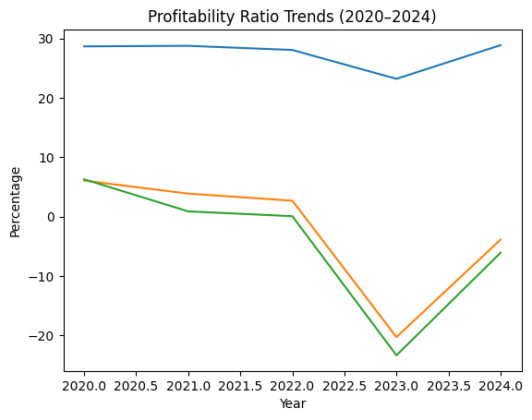
Ratio | Formula | 2024 | 2023 | 2022 | 2021 | 2020
Gross Profit Margin (%) | (Gross Profit / Sales) × 100 | 28.87% | 23.20% | 28.06% | 28.76% | 28.67%
Operating Profit Margin (%) | (EBIT / Sales) × 100 | (3.87%) | (20.29%) | 2.68% | 3.87% | 6.06%
Net Profit Margin (%) | (Net Income / Sales) × 100 | (6.09%) | (23.36%) | 0.07% | 0.88% | 6.28%
ROCE (%) | EBIT / (Total Assets − Current Liabilities) | (9.27%) | (43.81%) | 5.06% | 7.92% | 11.27%
ROE (%) | Net Income / Total Equity | (15.69%) | (54.91%) | 0.15% | 1.92% | 12.31%

B. Liquidity Ratios
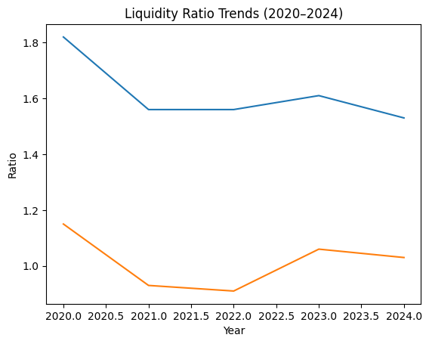
Ratio | Formula | 2024 | 2023 | 2022 | 2021 | 2020
Current Ratio | Current Assets / Current Liabilities | 1.53 | 1.61 | 1.56 | 1.56 | 1.82
Quick Ratio | (Current Assets − Inventory) / Current Liabilities | 1.03 | 1.06 | 0.91 | 0.93 | 1.15

C. Efficiency and Activity Ratios
Ratio | Formula | 2024 | 2023 | 2022 | 2021 | 2020
Inventory Days | (Inventory / COGS) × 365 | 103 | 100 | 131 | 115 | 100
Receivables Days | (Receivables / Sales) × 365 | 106 | 98 | 76 | 78 | 77
Payables Days | (Payables / COGS) × 365 | 94 | 64 | 67 | 79 | 69
Asset Turnover (x) | Sales / Total Assets | 1.22 | 1.18 | 1.08 | 1.18 | 1.20

D. Leverage and Solvency Ratios
Ratio | Formula | 2024 | 2023 | 2022 | 2021 | 2020
Debt-to-Equity | Total Liabilities / Total Equity | 1.11 | 0.99 | 0.88 | 0.85 | 0.63
Interest Coverage | EBIT / Interest Expense | (4.55) | (19.69) | 6.61 | 41.08 | 26.21

Appendix 2: Corporate Failure Prediction – Altman Z-Score Analysis

Z-Score Component Calculation (2024)
Component | Description | Calculation (£m) | Ratio Value | Weight | Weighted Score
X₁ | Working Capital / Total Assets | (242,494 − 158,291) / 323,354 | 0.260 | 1.2 | 0.312
X₂ | Retained Earnings / Total Assets | 208,431 / 323,354 | 0.645 | 1.4 | 0.903
X₃ | EBIT / Total Assets | (15,297) / 323,354 | (0.047) | 3.3 | (0.156)
X₄ | Equity / Total Liabilities | 153,105 / 170,249 | 0.899 | 0.6 | 0.539
X₅ | Sales / Total Assets | 394,879 / 323,354 | 1.221 | 1.0 | 1.221

Total Z-Score (2024): 2.82

Five-Year Z-Score Trend
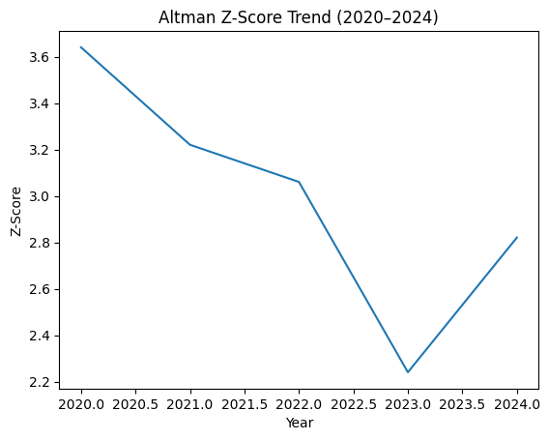
Year | 2020 | 2021 | 2022 | 2023 | 2024
Z-Score | 3.64 | 3.22 | 3.06 | 2.24 | 2.82
Risk Classification | Safe | Safe | Grey | Grey | Grey

Appendix 3: Working Capital Management Analysis

Cash Conversion Cycle (CCC) Formula
CCC=Inventory Days+Receivables Days−Payables DaysCCC = Inventory\ Days + Receivables\ Days − Payables\ DaysCCC=Inventory Days+Receivables Days−Payables Days
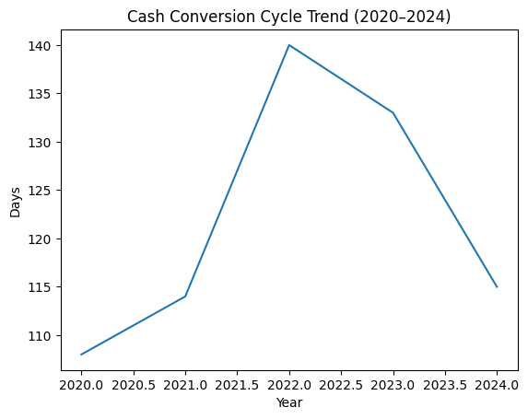
Metric (Days) | 2024 | 2023 | 2022 | 2021 | 2020
Inventory Days | 103 | 100 | 131 | 115 | 100
Receivables Days | 106 | 98 | 76 | 78 | 77
Payables Days | (94) | (64) | (67) | (79) | (69)
Cash Conversion Cycle | 115 | 133 | 140 | 114 | 108
The increase in receivables days materially contributed to liquidity pressure in 2024.

Appendix 4: Investment Appraisal and Capital Budgeting
Discount Rate: 10%
Capital Rationing Constraint: £60 million

Project A (Initial Investment: £40m)
Year | Cash Flow (£m) | Discount Factor | Present Value (£m) | Cumulative PV
0 | (40.00) | 1.000 | (40.00) | (40.00)
1 | 10.00 | 0.909 | 9.09 | (30.91)
2 | 12.00 | 0.826 | 9.91 | (21.00)
3 | 14.00 | 0.751 | 10.51 | (10.49)
4 | 10.00 | 0.683 | 6.83 | (3.66)
5 | 8.00 | 0.621 | 4.97 | 1.32

Project B (Initial Investment: £30m)
Year | Cash Flow (£m) | Discount Factor | Present Value (£m) | Cumulative PV
0 | (30.00) | 1.000 | (30.00) | (30.00)
1–5 | 6.00 each year | — | — | (7.26)

Project C (Initial Investment: £50m)
Year | Cash Flow (£m) | Discount Factor | Present Value (£m) | Cumulative PV
0 | (50.00) | 1.000 | (50.00) | (50.00)
1 | 5.00 | 0.909 | 4.55 | (45.45)
2 | 10.00 | 0.826 | 8.26 | (37.19)
3 | 20.00 | 0.751 | 15.02 | (22.17)
4 | 25.00 | 0.683 | 17.08 | (5.09)
5 | 15.00 | 0.621 | 9.32 | 4.23

Comparative Investment Summary
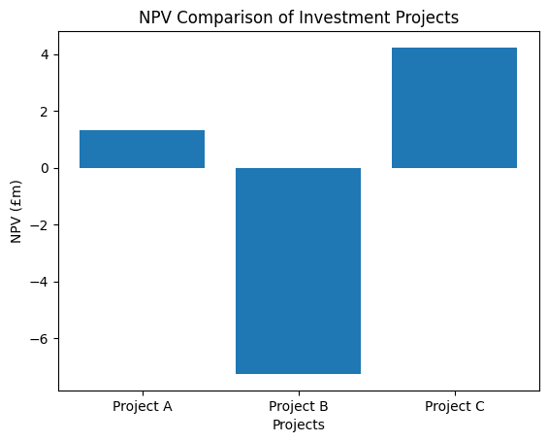
Metric | Project A | Project B | Project C | Preferred
Initial Investment | £40m | £30m | £50m | —
NPV (£m) | 1.32 | (7.26) | 4.23 | Project C
IRR | 11.3% | 0.0% | 12.7% | Project C
Payback Period | 3.4 yrs | 5.0 yrs | 3.6 yrs | Project A
ARR | 14.0% | 0.0% | 20.0% | Project C
Profitability Index | 1.03 | 0.76 | 1.08 | Project C

