
Skills for the Workplace
Module Assignment Submission
Student Name:
Student Number:
Module No: | BMSK4002
Module Title: | Effective Team Working and Communication  Part 2

Statement of Confirmation of Authenticity
By the act of making this submission, the student declares that this is the work of the student named above. The work has not, in whole or in part, been knowingly presented elsewhere for assessment, or where assessment has been built on a previous assessment, this has been identified. Where materials have been used from other sources it has been properly acknowledged. If this statement is untrue, the student acknowledges that an assessment offence has been committed.
Attention is drawn to the plagiarism and unfair practice policies of both the University and of ILM.

Table of Contents
Part 2 Communication 3
1.0 3
Communication Cycle 3
2.0 4
Assessing Own Communication Skills 4
Gap Analysis 4
PDP 5
References 6
Appendix A 6

Part 2 Communication

1.0

Communication Cycle

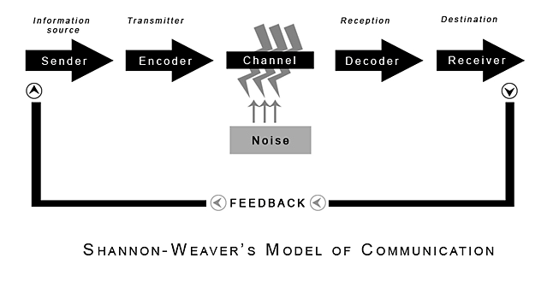
(Shannon and Weaver, 1949)

2.0

Assessing Own Communication Skills

Gap Analysis

Objective | Current Position | Deficiency | Action
What do I want to do? | What can I already do? | What am I lacking? | How do I fix this?

PDP

Objectives | Tasks | Success Criteria | Time Frame | Resources
List your Goals | What do you need to do to achieve these goals? | How will you identify your success? | When do they need to be done by? | Who or what do you need to help you?

References

Blenkinsop, P. (2010) The Communication Cycle. [online] Available at: http://manyana-education.blogspot.com/2010/10/communication-cycle.html Accessed: 22.04.21
MindTools (2021) How good are your communication skills? [online] Available at: https://www.mindtools.com/pages/article/newCS_99.htm Accessed: 22.04.21
Shannon, C. and Weaver, W. (1949) The Mathematical Theory of Communication. Urbana: University of Illinois Press.
Skills You Need (2021) Interpersonal Skills Self-Assessment. [online] Available at: https://www.skillsyouneed.com/ls/index.php/343479 Accessed: 22.04.21

Appendix A

Presentation Feedback and Evaluation goes here

