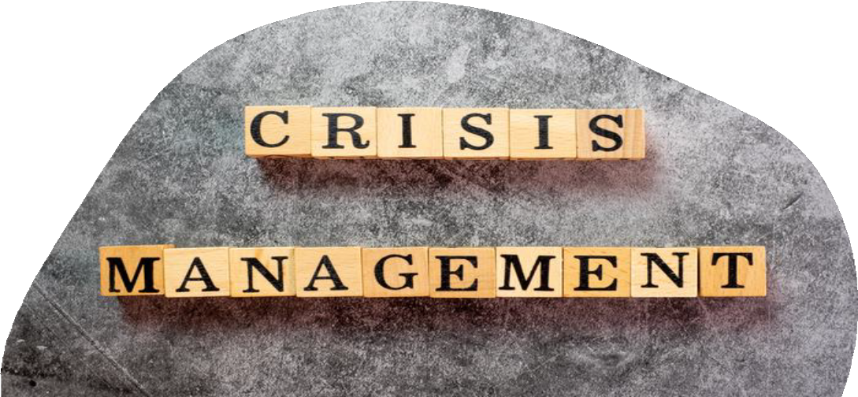

Title: Conference Research Paper Presentation

Theme:
Safety and Crisis Management in the Hotel and Hospitality Sector

N A ME: MO H A MMA D S H A H I D U L I S L A M C H O W D H U R Y S T U D E N T I D N U MB E R: (2 0 2 6 9 6 0 )
L E C T U R E R: D R E R N E S T B A L U T I E W A V E I

B MI H 6 0 0 1 C o n t e m p o r a r y T h e m e s i n t h e H o t e l a n d H o s p i t a l i t y S e c t o r
D a t e: 0 6/ 1 1 / 2 0 2 4

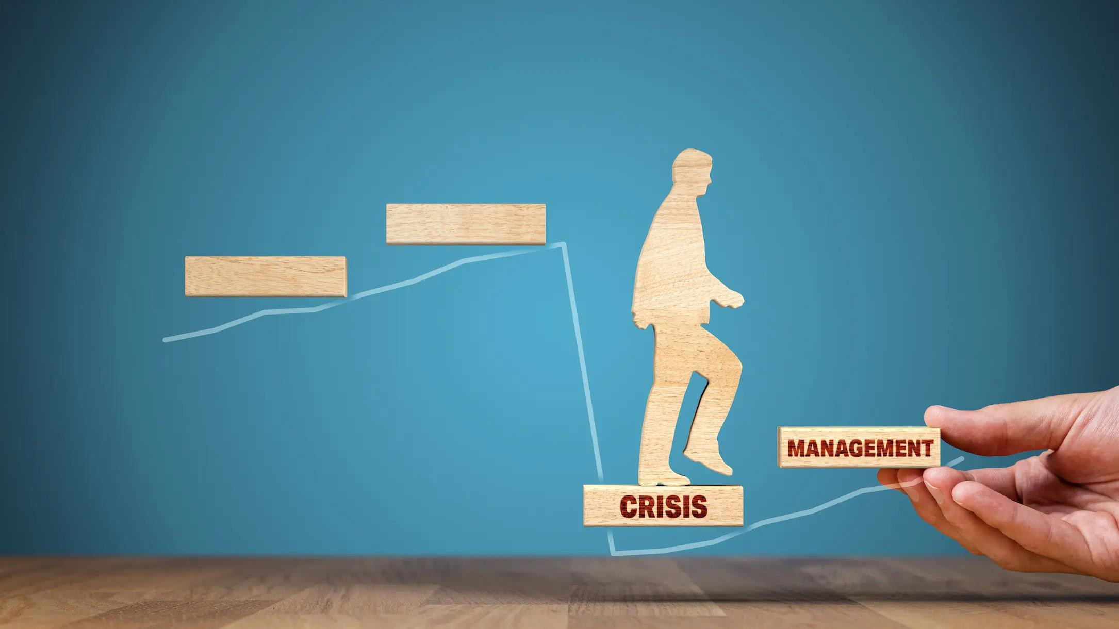Introducing Safety and Crisis Management in the Hospitality Industry

The Hotel guests, staff, and assets must be protected from unexpected threats through safety and crisis management. Health crises, natural disasters, and security threats can be handled effectively with effective strategies. By strengthening resilience, a brand's reputation and continuity can be safeguarded. COVID-19, for example, underscored the need for adaptable safety standards in these areas and others.

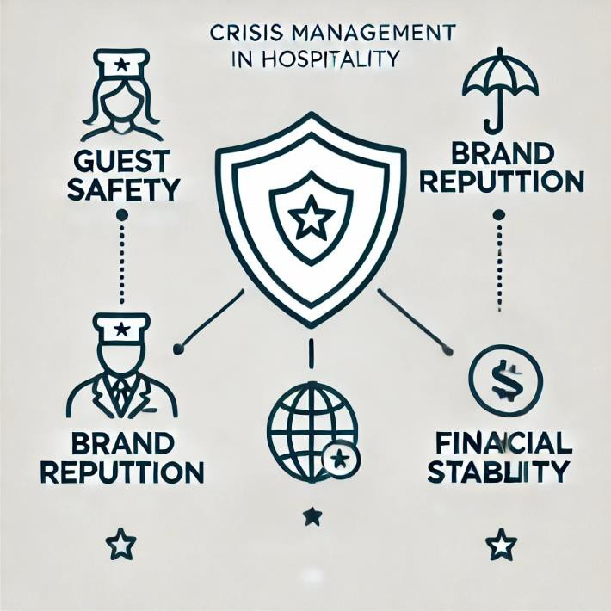

A critical aspect of hospitality is crisis management

A crisis management plan is essential for protecting guests, staff, and the brand's reputation. Considering that this industry is highly affected by global events, crisis management strategies emphasise health protocols, financial stability, and quick response measures. If management is not properly handled, customer confidence is eroded, which impacts occupancy rates and profitability over the long term.

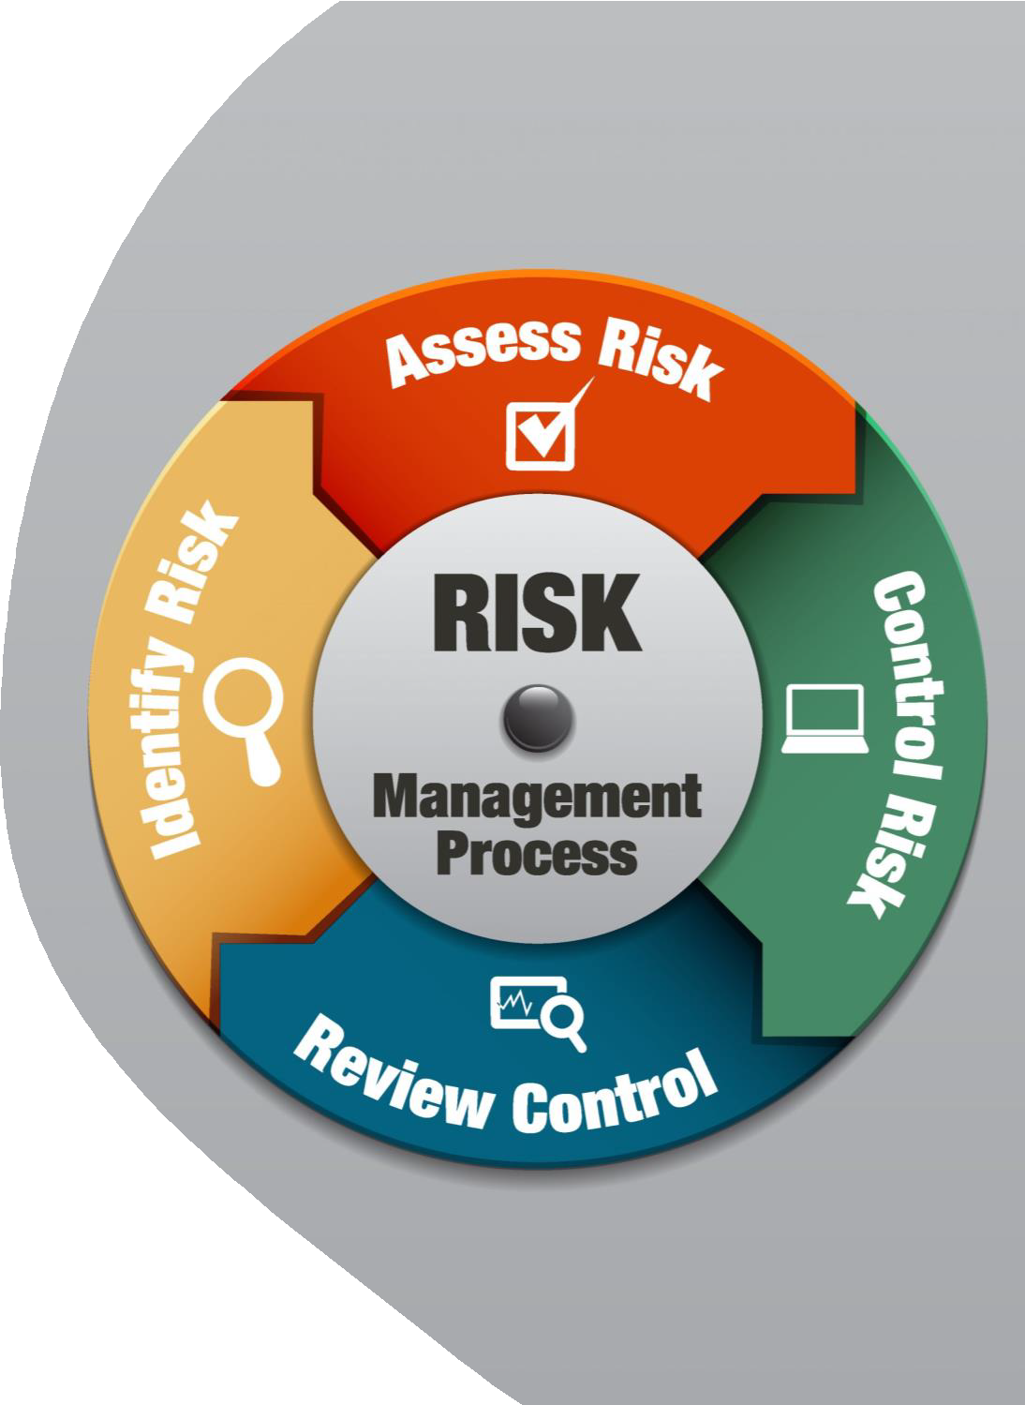

Risk Assessment and Identification in Hospitality

Crisis management in hotels involves identifying risks specific to location and operations, including natural disasters (earthquakes, floods), security threats ( theft, terrorism), health crises such as COVID-19, fire hazards, cybersecurity threats, data privacy, and political instability. Developing effective risk assessment strategies, prioritising safety measures, and ensuring preparedness is imperative for hotels to protect guests and staff from physical and digital threats and sociopolitical ones.


Health-related crisis management
Crisis protocols require strictness. Hotel sanitation, contactless technologies, and health screenings improved because of COVID-19. These measures foster guest trust and safety. Hospitality crisis planning now includes health crisis readiness and hotel preparation.
Political Instability and Its Impact
Tourist occupancy rates are affected by political events such as terrorism.
Minimising financial loss involves diversifying clients and flexible booking policies. When political instability strikes, hotels maintain operations with clear safety protocols.

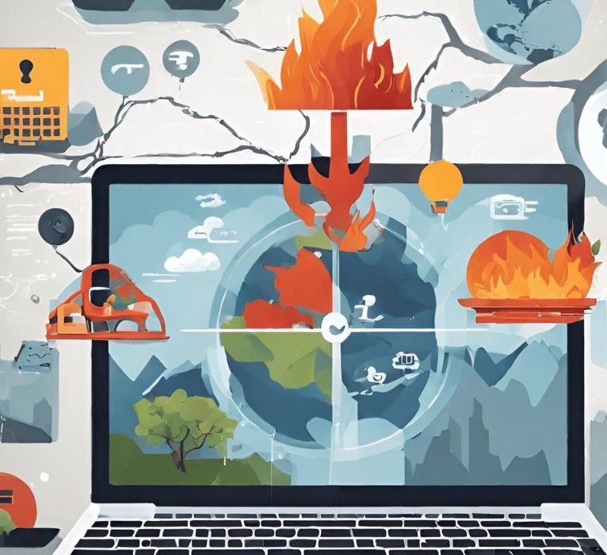



Natural disaster preparedness
A hotel in a high-risk area must be prepared for natural disasters. There are evacuation protocols and insurance coverage. In a climate where disasters are more frequent, disaster preparedness is essential.



Cybersecurity and Data Privacy
As hotels store sensitive guest data, cybersecurity is a crucial element of crisis management. The importance of safeguarding data through secure systems, regular audits, and employee training cannot be overstated. Guests' trust can be eroded by a cyber breach, making proactive cybersecurity essential.

Communication During a Crisis

Communication during crises is crucial. Communication plans provide accurate information to internal and external stakeholders. Transparency, empathy, and regular updates are essential to maintaining trust. Communication officers are more likely to prevent misinformation and rumours.
Post-Crisis Evaluation and Recovery

In evaluating a crisis, we can discover what worked well and what needs to be improved. The hotel should review response strategies, collect feedback, and update policies based on lessons learned. As part of the recovery process, reputational damage may be repaired, affected individuals may be provided support, and business continuity measures may be taken. A revised marketing strategy or financial assistance may be included in these measures.



Future recommendations

- Invest in technology: Contactless services,
secure cybersecurity, and artificial intelligence-driven analytics.
- Flexible Business Models: The ability to adapt booking policies and diversify revenue streams.
- Sustainability practices: Utilizing energy
efficiently, reducing waste, and adapting to
climate change.

- Collaboration: Coordinate with government agencies to respond effectively to crises.


Conclusion

In conclusion, robust crisis management is essential for the hospitality industry to maintain operational continuity, guest trust, and resilience in the face of a variety of challenges. Hotels can be strengthened against future disruptions by combining proactive technological investments with adaptable operational frameworks and sustainable practices. By implementing these strategies, hospitality businesses will be better able to manage crises and protect their reputation as well as their financial standing.
As an example of a well-rounded crisis management plan, the Ibis London Barking case demonstrates how such a plan can safeguard guest well-being, maintain the brand's reputation, and enhance long-term resilience and success.


Reference

American Hotel & Lodging Association ( AHLA) ( 2020 ) Covid- 19 ’s Impact on the Hospitality Industry.
Available at: https://www.ahla.com/covid-19s-impact-hotel-industry

Causevic, S. and Lynch, P. ( 2013 ). Political ( in) stability and i ts influence on tourism development. Tourism Management , 34, pp. 145 – 157. doi https:// doi. org / 10. 1016 / j .tourman. 2012. 04 . 006.
Chin, K., 2023. Cybersecurity in the Hospitality Industry: Challenges and Solutions. [ online] Up Guard.
Available at: https://www.upguard.com/blog /cybersecurity -in-the-hospitality-industry.

Fink, S., 1986. Crisis Management . New York: American Association of Management.

Gössling, S., Scott, D. and Hall, C. M., 2021. Pandemics, tourism and global change: A rapid assessment of COVID- 19. Journal of Sustainable Tourism , 29( 1 ) , pp. 1 - 20.
Hosie, P. and Smith, C. ( 2004 ). Preparing for crises with online security management education. Research and Practice in HRM , [ online] 12( 2), pp. 90 – 127 . Available at: Google Scholar

Kaspersky Lab, 2019. Revenge Hotels: Cybercrime Targeting Hotel Desks Worldwide. Available at: https://usa.kaspersky.com.


Kenny, J . and Dutt, C. S . ( 2021 ) . The long - term Impacts of Hotel’s Strategic Responses to COVID - 19 : the Case of Dubai. Tourism and Hospitality Research , [ online] 22 ( 1 ) , p. 146735842110345 . doi
https://doi .org /10.1177/14673584211034525 .

Marsen, S . ( 2020 ) . Navigating Crisis: The Role of Communication in Organizational Crisis. International Journal of Business Communication , 57 ( 2 ) , pp. 163 – 175 . doi: https:// doi. org / 10 . 1177 / 2329488419882981 .
Myhotelline. com, 2020 . Hotel Management and Crisis Response: Lessons Learned - My Hotel L ine Blog. [ online]
Available at: https://www.myhotell ine.com/blog /hotel -management-and-crisis-response-lessons-learned.

Ritchie, B.W. & J iang, Y. ( 2019 ) ‘A review of research on tourism r i sk, crisis and disaster management: Launching the annals of tourism research curated collection on tourism r i sk, crisis and disaster management ’, Annals of Tourism Research , 79 , 102812 .
Wut, T. M., Xu, J . ( Bill) and Wong, S. ( 2021 ) . Crisis management research ( 1985 – 2020 ) in the hospitality and tourism industry: A review and research agenda. Tourism Management , 85 , p. 104307 . doi https://doi .org /10.1016/j.tourman.2021.104307 .
Valtr, R. ( 2023 ) . The Future Of The Hospitality Industry: 7 Key Trends . [ online] www. mews. com. Available at: https:// www. mews. com/en/ blog / the - future- of- hospitality.

