Introduction
Auto Park Management System is a city-based parking service provider that has multiple parking sites in the city. At present, not only access data to the vehicle but also stores information about the parking availability, the vehicle users and receipts are stored as on paper documents. There are several problems with this manual system, such as low efficiency with parking positions, duplication of data, loss of information, and inaccurate records.
The organisation aims to automate and enhance parking operations and to replace the manual process with a centralised system based on a Microsoft access database.
The purpose of the database system is to:
Keep customer and vehicle data safe.
Keep an eye on parking lot usage.
Handle bookings and car parking issues.
Record payment transactions.
Generate management reports.
Improve operational efficiency.
Eliminate duplicate and duplicate/double data and reduce errors in data.
Task 1
In the scenario, the following entities were identified:
Customer
Attributes:
CustomerID (Primary Key)
CustomerName
ContactNumber
EmailAddress
Purpose: Holds data for the owner of the vehicle.

Vehicle
Attributes:
VehicleID (Primary Key)
RegistrationNumber
VehicleType
CustomerID (Foreign Key
Purpose: Enables the storage of vehicle information associated with customers.

ParkingSite
Attributes:
SiteID (Primary Key)
SiteName
Location
Required: No.Owner: The owner of the record.

ParkingSlot
Attributes:
SlotID (Primary Key)
SlotNumber
SiteID (Foreign Key)
SlotStatus
Use: Used for parking use purpose.

Booking
Attributes:
BookingID (Primary Key)
VehicleID (Foreign Key)
SlotID (Foreign Key)
EntryTime
ExitTime
Objective: To document vehicle parking activity.

Payment
Attributes:
PaymentID (Primary Key)
BookingID (Foreign Key)
Amount
PaymentMethod
PaymentDate
Use: Keeps information about a payment transaction.

Relationships
Customer → Vehicle
Multiple vehicles on a single customer. Multiple cars for a single customer.
One car per customer.
Relationship:
1
Vehicle → Booking
A booking can be fulfilled in one or multiple vehicles.
One booking could be assigned only to a single car type. Individual car type could have only 1 booking.
Relationship:
1
ParkingSite → ParkingSlot
There are multiple parking slots in each parking site
Relationship:
1
ParkingSlot → Booking
A parking space can be rented at several points.
Relationship:
1
Booking → Payment
If you have one booking, you pay one payment. One booking equals one payment.
Relationship:
1:1

Entity Relationship Diagram (ERD)

ERD Structure:
Customer
(PK CustomerID)
|
| 1
|
Vehicle
(PK VehicleID)
(FK CustomerID)
|
| 1
|
Booking
(PK BookingID)
(FK VehicleID)
(FK SlotID)
|
|1:1
|
Payment
(PK PaymentID)
(FK BookingID)

ParkingSite
(PK SiteID)
|
|1
|
ParkingSlot
(PK SlotID)
(FK SiteID)
|
|1
|
Booking
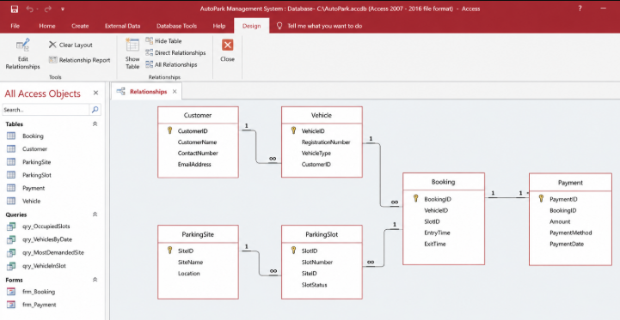

Customer Table
Field Name | Data Type
CustomerID | AutoNumber
CustomerName | Short Text
ContactNumber | Short Text
EmailAddress | Short Text

Vehicle Table
Field Name | Data Type
VehicleID | AutoNumber
RegistrationNumber | Short Text
VehicleType | Short Text
CustomerID | Number

ParkingSite Table
Field Name | Data Type
SiteID | AutoNumber
SiteName | Short Text
Location | Short Text

ParkingSlot Table
Field Name | Data Type
SlotID | AutoNumber
SlotNumber | Short Text
SiteID | Number
SlotStatus | Short Text

Booking Table
Field Name | Data Type
BookingID | AutoNumber
VehicleID | Number
SlotID | Number
EntryTime | Date/Time
ExitTime | Date/Time

Payment Table
Field Name | Data Type
PaymentID | AutoNumber
BookingID | Number
Amount | Currency
PaymentMethod | Short Text
PaymentDate | Date/Time

Integrity Constraints:
- Primary keys uniquely identify records
- Foreign keys establish relationships
- Referential integrity enabled
- Required fields enabled where necessary
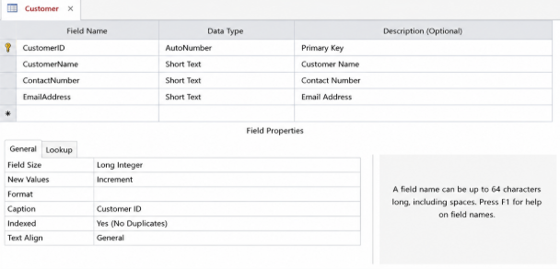
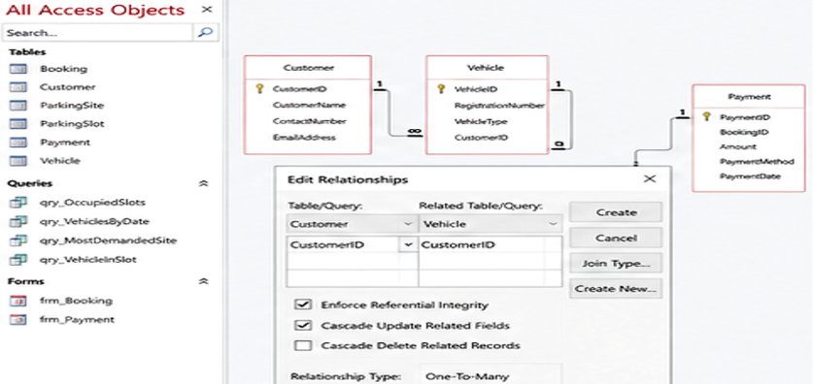
Normalisation Compliance
First Normal Form (1NF)

In all attributes, there are no repeating groups and only atomic values.

Second Normal Form (2NF)

There are no other attributes that are not completely dependent on the primary key.

Third normal form approach (3NF)

There are no transitive dependencies since non key attribute depends on only the primary key.

Hence this data base adheres to 3NF conditions.
Sample Data Population
Customer Table
CustomerID | CustomerName | ContactNumber | EmailAddress
1 | John Smith | 0712345678 | john@gmail.com
2 | Emma Brown | 0723456789 | emma@gmail.com
3 | David Wilson | 0734567890 | david@gmail.com
4 | Sarah Johnson | 0745678901 | sarah@gmail.com
5 | Michael Lee | 0756789012 | michael@gmail.com

Vehicle Table
VehicleID | RegistrationNumber | VehicleType | CustomerID
1 | ABC123 | Car | 1
2 | DEF456 | Bike | 2
3 | GHI789 | Car | 3
4 | JKL321 | Van | 4
5 | MNO654 | Car | 5

ParkingSite Table
SiteID | SiteName | Location
1 | Central Parking | City Centre
2 | North Parking | North City
3 | East Parking | East City
4 | West Parking | West City
5 | South Parking | South City

Booking Table
BookingID | VehicleID | SlotID | EntryTime | ExitTime
1 | 1 | 1 | 01/07/2026 09:00 | 01/07/2026 12:00
2 | 2 | 2 | 01/07/2026 10:00 | 01/07/2026 14:00
3 | 3 | 3 | 02/07/2026 08:00 | 02/07/2026 13:00
4 | 4 | 4 | 02/07/2026 11:00 | 02/07/2026 16:00
5 | 5 | 5 | 03/07/2026 09:30 | 03/07/2026 15:00

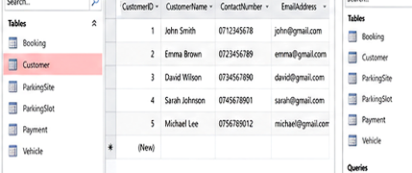
Query Development
Query 1: Parking Slots Currently Occupied
SQL:
SELECT SlotID, SlotStatus
FROM ParkingSlot
WHERE SlotStatus='Occupied';
Purpose:
Displays currently occupied parking spaces.
Query 2: Vehicles Parked at Particular Time
SQL:
SELECT VehicleID, EntryTime
FROM Booking
WHERE EntryTime Between #01/07/2026# And #02/07/2026#;
Purpose:
Displays vehicles parked within a time range.
Query 3: Most Frequently Used Parking Site
SQL:
SELECT SiteID, Count (BookingID) AS TotalBookings
FROM Booking
GROUP BY SiteID
ORDER BY Count (BookingID) DESC;
Purpose:
Identifies the most demanded parking location.
Query 4: Vehicle Details in Specific Slot
SQL:
SELECT Vehicle.RegistrationNumber, Booking.SlotID
FROM Vehicle INNER JOIN Booking
ON Vehicle.VehicleID=Booking.VehicleID
WHERE SlotID=3;
Purpose:
Displays vehicles occupying a specific slot. 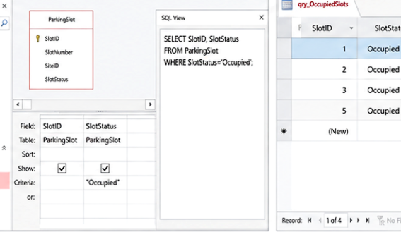
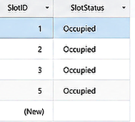
Validation and Testing
Test Case | Expected Result | Actual Result | Status
Add customer record | Record saved successfully | Successful | Pass
Add vehicle with valid customer ID | Vehicle linked correctly | Successful | Pass
Enter duplicate primary key | System rejects entry | Successful | Pass
Create booking | Booking created | Successful | Pass
Generate payment record | Payment generated | Successful | Pass
Run occupancy query | Correct records displayed | Successful | Pass

Testing Process:
Sample records were added to the database and queries were executed to test for database relationships and constraints. Consistency was checked by doing validation rules and referential integrity checks.
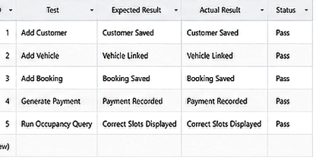
Task 2: Course Work Written Elements

Design Decisions
The database has been designed in the relational approach because, through the connected tables, it is possible to have an efficient organization of the data. Primary keys and foreign keys were employed to assure a correct relationship between entities. To avoid redundancy and enhance consistency, Third Normal Form was used.
It can provide support for the vehicle tracking, management of all customer details, allocation of slots and management of slots and payments.

Challenges Faced
There were a number of developmental challenges. Careful planning was necessary to establish relationships between multiple tables. Referential integrity and no duplication of data needed to be considered for the creation of the database.

Future Improvements
Some future improvements that could be made are:
Availability of parking spaces is monitored in real-time.
Online booking integration
QR code vehicle entry systems
Mobile application support
Automated payment gateways
Use Dashboard Analytics and Visual reports.

References
[1] T. Connolly and C. Begg, Database Systems: A Practical Approach to Design, Implementation and Management, 6th ed. Harlow, United Kingdom: Pearson Education, 2015.
[2] R. Elmasri and S. Navathe, Fundamentals of Database Systems, 7th ed. Boston, MA, USA: Pearson, 2017.
[3] Microsoft Corporation, "Microsoft Access Documentation," Microsoft Learn, Available: https://learn.microsoft.com/
[4] A. Silberschatz, H. Korth and S. Sudarshan, Database System Concepts, 7th ed. New York, USA: McGraw-Hill Education, 2020.

