

University of Wales Trinity Saint David

Applied Computing
Information Engineering
ACCB4013

Student Number 1806547

Rizwan Chishti
Kids Club Cymru Context Diagram
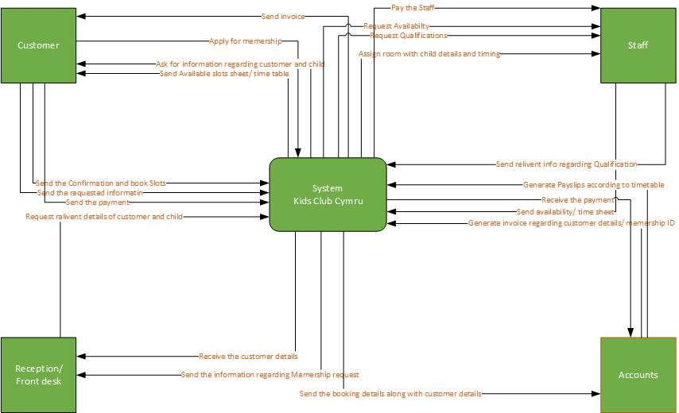

Kids Club Cymru level 0 Diagram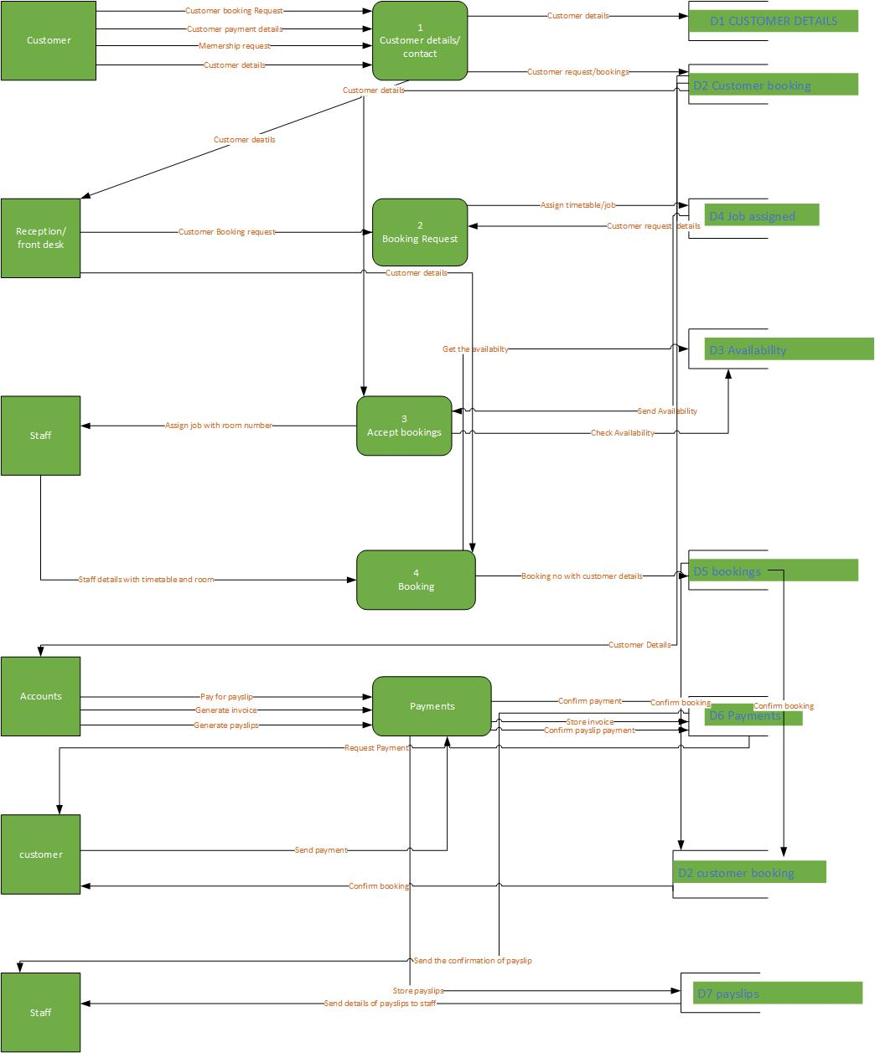
Kids Club Cymru level 1 Diagram 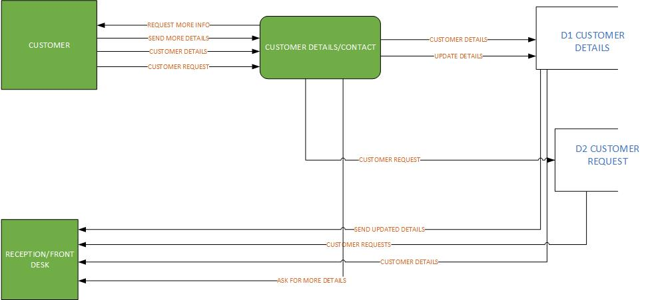

Kids Club Cymru ERD Diagram

