University of Wales Trinity saint David

Managing Enterprise in the 21st Century
AS2

Shamsul Hoque
ID: 1706272

Contents
Introduction: 3
Part 2: Reflective report 4
Learning journey through plan development 4
Development of personal skill set for self-employment 8
Conclusion: 10
References 11

Introduction:
A business plan is the written document of a company that provides direction to develop strategic planning and action to serve the target customers at a profit. All the company needs to develop an attractive and convincing business plan so that it motivates investors to finance the company. Recently I was assigned the task to develop a business plan with a team of several members. During this time I have learned and experienced some entrepreneurial skills and tactics. In this assignment, I will demonstratethis personal development that will add value to my future career.

Part 2: Reflective report

Learning journey through plan development
A business plan is a blueprint that provides a description of some core elements or essentials of new startup from idea generation to idea implementation and all others strategic planning and action plan. Recently I have developed a business plan with my dedicated and cooperative team member and learned a lot of things and gather unique experiences that I want to share through Gibbs reflective cycle.

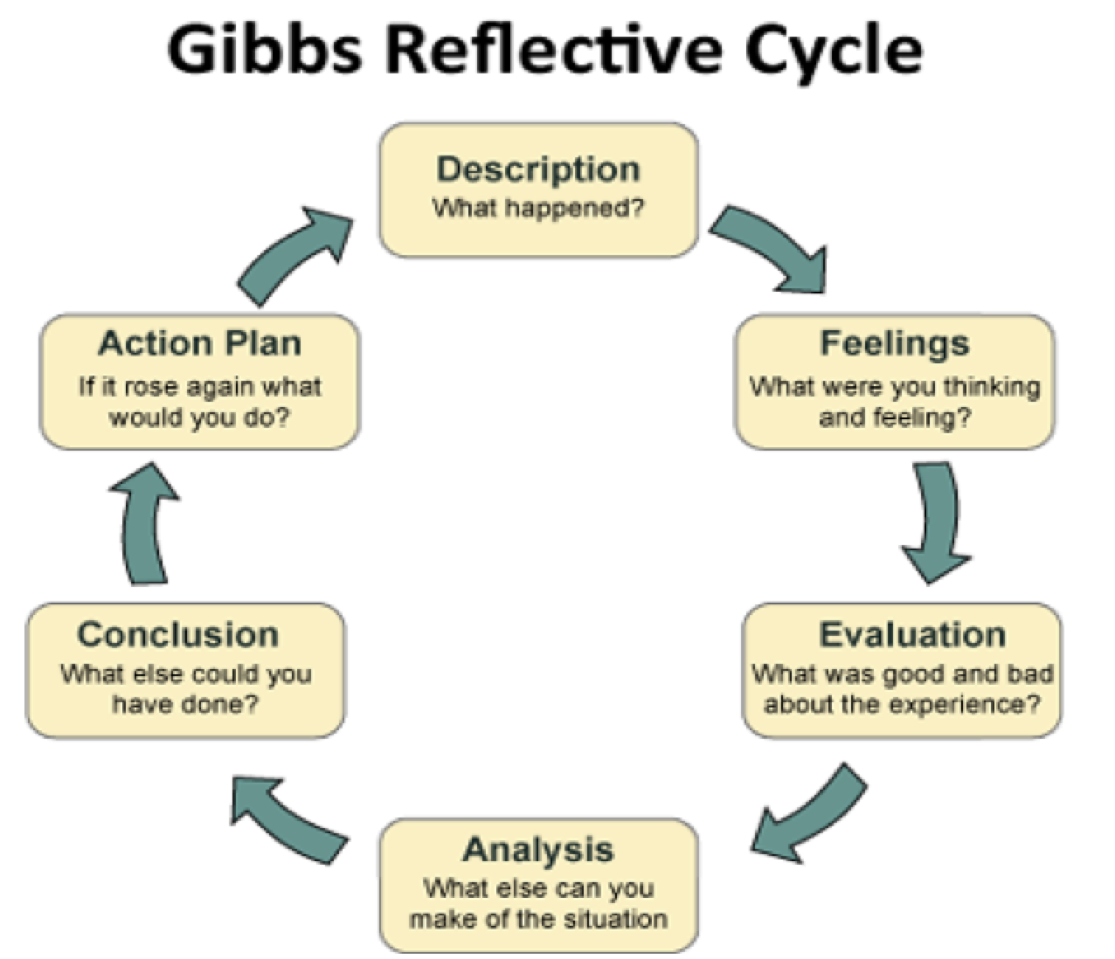

Figure 1:Gibbs reflective cycle.
Source:(Casson, 2016)

Description:
When start our teamwork to develop a winning business plan all the members of our team were a provided different task to be accomplished within a specified period of time and in a systematic and strategic way. In the very beginning of our teamwork, we understood that an effective market analysis and competitor analysis should be run to justify the feasibility and profitability of our business idea. In this regard, Roy ( 2018) stated that to develop a feasible business plan and decide an effective marketing plan company must conduct a value analysis of what it has to offer to the market and competitor analysis helps to identify core competencies of the company. We segmented the total market on the basis of several criteria to identify the target market as new enterprise success mostly depend on determining specific target group of buyers with similar needs and characteristics who will respond differently to different marketing mixes and programs. According to Hisrich et al (2017), market analysis is effective tools to identify the current market trends and development that leads to identifyingthe profitable market segment and competitor analysis suggest an effective way serve the target segment better than competitors. One of the most important things I have learned is that choosing right target segments largely depends on company objective and resources, market attractiveness, market growth and competitor strategies.
Feelings:
From the very beginning of developing our business plan, we are confident that our idea is unique and feasible in the market. And after conducting a successful market and potential competitor analysis, we decided to rethink about our startup before going to implementation stage so that our effort goes in vain and incur a huge cost that is unrecoverable. As Casson(2016) conveyed that idea generation and idea implementation is not same and entrepreneur must not take any decision so quickly without analyzing all the aspects of risks and threats that can arise from the internal or external environment. During the market analysis, we realized that there are a great potentiality and opportunity in the market for a newstartup as the customer always in demanding of new and better ways of meeting their needs to cope with the changing environment. That profitable and attractive market segment boost our self-confidence and entice investors to invest in our new business. One of the most important things, we realized, should be considered during business plan development is time management.Wood(2017) said that equal participation of all the team members and support from top management is also crucial factors in developing an effectivebusiness plan. All the team members were very cooperative and supportive that’s why we completed our business plan in the right manner and within the predetermined period of time.
Evaluation:
We identified all the factors related to our business success and failure to decide whether we should go for implementation or not. We also realized that broad and relevant evaluation of our business plan is needed to convince the investors to collect fund to develop infrastructure and other facilities to conduct our business operation. According to Hisrich et al (2017), future portfolio and product development should be included in the business plan that so that shareholders can easily decide to invest in the new business. One of the focusing points of the business plan is the financial statement or budgeting portion of the business plan because investor mainly focuses on in this section before deciding to invest in a new business. We also realized that profitability and cost analysis should be incorporated on the basis of projected sales because primary goals of every business are to generate money from the market through an effective and efficient business operation. Wood(2017)stated that a business plan without evaluating how it will generate profit cannot be a business plan rather a social or voluntary work. Here we also evaluated different marketing strategy that could be applied in the different market situation on the basis of competitor action and reaction.
Analysis:
When we observed that our business plan is very feasible in the market then we decided to conduct several analysis to identify the strategic opportunities or gap in the marketplace. In this regard Roy(2018) stated that various internal and external factors analysis helps the company to assess market attractiveness and unique competencies that leads to achieve a long-term competitive advantage. We conducted a SWOT analysis to identify strengths, weaknesses, opportunities and threats from which strengths and opportunities have a positive impact on the company that should be exploited and weaknesses and threats will negatively affect the company that should be minimized. The PESTLE analysis evaluates various macro environmental forces that the company cannot control and we did a great job in analyzing these external forces including political, economic, social, technological, legal and environmental factor to measure their impact on market attractiveness and business growth. Another important factor is competitor analysis as Casson (2016) conveyed that competitor analysis provides an insight for determining sources of competitive advantages through developing a new business model, manufacturing quality products and providing unique services that improve customer loyalty and increase profitability of the company.
Conclusion:
As we developed a business plan for the first time, we made some mistakes and faced some difficulties that I want to share now. Frist of all we distributed tasks randomly without discussing among ourselves who are interested and expert in doing a specific task. After the completion of our tasks, we realized that work should be distributed in systematic and effective ways so that members are allowed to do the job in which they are interested and possess expertness. In addition, initially, we tried to identify our target without segmenting the market. Barrow et al ( 2015) stated that in the beginning stage new company don’t have enough resources and capabilities to serve the entire market, rather startup should focus on one or two profitable segments or market niches which are more profitable and ignored by giants. Time management was a big issue as we are asked to submit the plan within very short time.
Action plan:
If I get a chance to implement a business plan, I along with all of my team members will try to apply our learnings and knowledge of the earlier experience of business plan development. I must be careful with proper time management and focus building trust among team members through effective cooperation and communication. Team leaders need to motivate all the members to participate in decision making and involve spontaneously to get the work done. According to Wood(2017), the team leader must assess the strengths and weaknesses of each group team members and will distribute the task on basis of this assessment. I strongly believe I along with my team members will be able to develop a feasible business plan and able to take effective action and measures to implement the plan.

Development of personal skill set for self-employment
I strongly believe, through the development of the business plan I acquired some distinctive skills and knowledge that will help me in my career development. This journey of developing business plan taught me how to work with a team of members with diverse backgrounds. I would like to share some these core personal skills that I have learnt from this journey-

Figure 2:Personal skill set for self-employment
Source:(Roy, 2018)

Communication:
According to Hisrich et al (2017) communication skills refers to someone’s ability to share his or thought, ideas, feelings, opinions, decision or planning with another party effectively so that no misunderstanding occurs between the parties. During developing business plan I worked with different types of people with different cultural background learned how to communicate within better and effective with these people without creating noise or distortion. I recognized that teamwork improved not only my verbal communication but also nonverbal communication like eye contact during conversation, facial expression, gesture, posture and other body movements that also play an important role in effective communication. This skill helps people to build good relationship with people. I think this communication skills will reward me in my future career.
Decision making:
Personal success, as well as business success, largely depends on taking the right decision at the right time and right place. When I had developed a business plan I realized that one of the important aspects if decision making is analyzing relevant data. I along with my team members analyzed various data including market data to decide on market attractiveness, competitive data to decide on competitive advantages. Effective strategy formulation, strategy implementation, work distribution, collecting feedback and all the activities of business mainly depend on making right decision. Roy(2018) stated that one of the key personal characteristics of entrepreneurs is that they can assess the market trends and can take the right decision to grasp the opportunities in charging market environment. So believed I will be able to take the right decision at the right time in my professional life.
Organizing:
In the business plan, I with my team members organized all the financial and human resources. During this time, I observed how company limited resources were planned, managed, organized and control toward achieving organizational goals and objectives. Casson (2016) referred that entrepreneurs are people who organize and integrate all the isolated parts of business operation together in order to earn a profit. Now I have self-confident to organize any program or events in a very effective and efficient way.
Team working:
As I worked with a team to develop the business plan, I know that teamwork is not as much as easy what people thought from the outside. Miscommunication or personal or political view can create internal conflicts among the team members. On the other hand, strong bonding and cooperation among the team members improve efficiency and increase productivity. This experience of communicating with people of different cultural background and personality has improved my team working skills which will add value in my future career.

Conclusion:
In the journey of developing a business plan with my team, I achieved some important professional skills like communication, organizing, group decision making, team working and others functional competencies. I strongly believed that these skills and competencies will contribute to my career development in the future.

References
Barrow, C., Barrow, P. and Brown, R. (2015). The business plan workbook. London [u.a.]: Kogan Page.
Casson, M. (2016). Entrepreneurship. Cheltenham: Edward Elgar.
Hisrich, R., Peters, M. and Shepherd, D. (2017). Entrepreneurship. New York, NY: McGraw-Hill Education.
Hisrich, R., Peters, M. and Shepherd, D. (2017). Entrepreneurship. New York, NY: McGraw-Hill Education.
Roy, R. (2018). Entrepreneurship. Oxford: Oxford University Press.
Wood, M. (2017). The marketing plan handbook. Harlow: Pearson.

