
Master of Business Administration
Student Name: Supria Alam
Student Number: 2435898
Module code: LCMB7026
Assessment: Individual report
Course Name: International Marketing: Principles and Practices
Lecturer: Taonga Kaonga Sobere-Snithers

Submission Deadline: 14th November 2025

Table of Contents
Introduction 1
Brand Overview: BMW in Germany and the USA 2
PESTLE Analysis of BMW in Germany and the USA. 3
Comparison of BMW STP Strategies (Segmentation, Targeting, Positioning) Germany and USA. 6
Comparison of BMW Marketing Mix Strategies (7Ps): Germany vs USA. 9
Evaluation of BMW Marketing Performance 13
Evaluation of BMW Marketing Ethics Practices 15
Recommendations for BMW’s International Marketing Strategies 16
Conclusion 18
References 19
Appendix 22

Introduction
This report examines BMW international marketing strategies with respect to its business within Germany and the United States. It looks at the ways BMW can adjust its branding, market segmentation as well as its marketing mix to various cultural, economic and regulatory contexts. The paper analyses the strategies used by BMW to have a consistent global branding system and at the same time respond to the local market in terms of the global view of the company through detailed PESTLE, STP and 7ps. Moreover, it also analyses the company performance in terms of marketing, ethical performance and offers strategic issues that can improve its competitiveness and sustainability in the fast-changing automotive industry globally.

Brand Overview: BMW in Germany and the USA
Bayerische Motoren Werke AG (BMW) is a Munich-based German multinational auto and motorcycle manufacturer. The company was founded in 1916 and its main product was aircraft engines, which it ventured into in 1928 and then made its way to the automobile industry. During the course of the last hundred years, BMW has grown to be one of the most popular and recognised automotive brands in the world, known as performance, design, and innovation (Encyclopaedia Britannica, 2024).
In Germany, the native market of BMW, the company continues to be at the heart of its operations around the world. The identity of the brand is highly anchored on the German engineering perfection and innovation. The key manufacturing plants of BMW located at Dingolfing, Leipzig, Regensburg, and Munich are strategically placed research and design centres as well as the manufacturing of premium cars (Automade Simply, 2023). Currently, the company is introducing sophisticated Industry 4.0 technologies into their plants located in Germany and it reflects its dedication towards sustainability and quality production (BMW Group, 2024a). Germany takes the role of the corporate nerve centre of the BMW management and the global strategy of innovation as well. Conversely, the United States is the biggest market of BMW outside of Europe and it is one of the pillars of its global growth. In 1994, BMW opened its production plant in Spartanburg, South Carolina, which is a significant milestone in the global plan of the company (BMW Group, 2024b). The Spartanburg plant is now the biggest in the world and it can put together nearly half a million vehicles every year, mostly SUVs including the X3, X5 and X7 (BMW Group Werke, 2025). The plant is also crucial in the United States exports, and BMW is the biggest automotive exporter in value in the United States (BMW Group Werke, 2025). BMW of North America is in charge of marketing, sales, and financial services and makes sure that the brand has a high premium position in the competitive American luxury car market (BMW Group, 2024b).
Conclusion: The combination of operations of the BMW company in Germany and the U.S. displays a compliant global strategy. The brand heritage, leadership in designing, and innovation is based in Germany whereas large-scale manufacturing, market responsiveness, and local adaptation are emphasised in the U.S.

PESTLE Analysis of BMW in Germany and the USA.
Germany
1. Political
Germany has a stable government and strong industrial policy in the EU regime that is assisting the automotive sector. State offers incentive programmes to support sustainable mobility, electric vehicles (EV), and grant innovations to manufacturers like BMW (UKEssays, 2024). Nevertheless, environmental and labour standards that are set by both German and EU laws are also strict, which raises the cost of doing business (Introspective Market Research, 2024).
2. Economic
Germany is also the largest car manufacturer in Europe and produces around six million vehicles every year (PS Market Research, 2024). BMW enjoys the advantage of having a competitive labour force, modern infrastructure and closeness to suppliers. Nevertheless, profit margins have been strained by the increasing labour and energy prices and slow domestic demand since 2023 (Introspective Market Research, 2024). Consumer purchasing behaviour of EVs and hybrids has also been affected by inflation and energy transition.
3. Social
The German customers relate the BMW brand to accuracy in the engineering process, novelty, and dependability (Crowjack, 2024). BMW has a stronger reputation in its home due to its cultural value of quality manufacturing. Nevertheless, shifting the social trends to sustainability, green mobility, and shared transportation would mean that BMW needs to shift its brand identity towards sustainability and digitalisation (Free PESTEL Analysis, 2021).
4. Technological
The technological environment in Germany provides BMW with access to global R&D and robotics. The firm is the pioneer in automotive technology, and the EV technology (BMW i series) has been highly advanced (BMW Group, 2024). Nevertheless, the threat to the technological leadership in battery efficiency is presented by the competition with Tesla and Chinese EV brands (Arxiv, 2025).

5. Legal
BMW has to adhere to the regulation of the European Union emission requirements, laws on product liability, and data protection regulations (GDPR). Although these laws guarantee the quality of the products, they also increase the costs of compliance and generate administrative costs (UKEssays, 2024).
6. Environmental
The green deal in Germany is radically transforming the industry. Manufacturers are under pressure to cut carbon emissions and change to net-zero mobility (Introspective Market Research, 2024). Sustainability activities of BMW, like recycling materials, and minimising lifecycle CO2 emissions, are in line with the national priorities but are expensive to the company.
Conclusion: To put it briefly, Germany provides BMW with technologically developed, sustainability-oriented, yet highly regulated environment that would mind long-term innovation rather than short-term profitability.
United States
1. Political
The political situation in the U.S. is complicated, yet it has a lot of opportunities. The Inflation Reduction Act and federal EV subsidies are incentives to BMW to make an investment in electric production and battery partnerships (Reuters, 2025). Nonetheless, the emission standards and trade tariffs that are state-by-state are a source of uncertainty (Wikipedia, 2024).
2. Economic
As a non-European market, the United States has been the largest market of BMW, with over 15 percent of its sales across the world (Ken Research, 2024). The production facility in Spartanburg, South Carolina, increases cost-efficiency and lessens currency risk due to the local production (BMW Group, 2024). Financing will be impacted and luxury cars will not be in demand since high inflation and increase in interest rates will be experienced even when there is a high consumer expenditure (Reuters, 2025). However, the high-end SUV market in which the X models of BMW are dominant performs well.

3. Social
The American consumers are performance oriented, comfortable and status oriented. BMW brand is associated with aspirational consumption with a specific focus on urban and suburban markets (FinModelsLab, 2024). Nevertheless, the new millennial and Gen Z generations are becoming more focused on eco-friendly and tech-driven cars, and BMW will have to focus on digital experience and sustainability (Pestleanalysis.com, 2024).
4. Technological
U.S. is a pioneer in automotive software, connectivity and autonomy. BMW enjoys the advantages of collaboration in Silicon Valley and research and development partnerships, concerning smart mobility and driver-assistance systems (BMW Group, 2024). However, declines in continuity and profitability have been criticised by supply-chain interruptions and semiconductor deficits since 2020 (Reuters, 2025).
5. Legal
Certain regulatory issues, such as the laws of franchising in states and prohibiting direct sales, make the distribution strategy of BMW through the fragmented system (Wikipedia, 2024). It is required to comply with the standards set by the U.S Environmental Protection Agency (EPA) and National Highway Traffic Safety Administration (NHTSA).
6. Environmental
The government of the U.S. is increasingly focusing on EV adoption although it is uneven at the state level. Such electric models as iX or i4 introduced by BMW are also a reaction to more stringent regulations on emissions and changing consumer trends (Ken Research, 2024). Nevertheless, EV infrastructure and charging networks continue to be a problem.
Conclusion: All in all, U.S. offers BMW with a profitable market and cost benefits with localisation and requires agility in the context of changing consumer, legal, and policy environment. Both Germany and the U.S. are macroenvironments that are vastly different, and therefore, define the strategies that BMW can come up with in both markets. BMW in Germany has a very regulated economy that is sustainability-oriented and has the greatest interest in the environment and technological development. The image of its premium brand is supported with the help of the brand name Made in Germany, which is linked to quality and accuracy, but it puts pressure on the company to become a leader of the EV transition. The U.S. on the other hand, is a more market-oriented and there is massive demand of luxury SUVs, lax labour market and looser regulation.

Comparison of BMW STP Strategies (Segmentation, Targeting, Positioning) Germany and USA.
Segmentation
BMW divides its markets based on a combination of demographic, psychographic, behavioural and geographic variables across the world yet the focus and sub-segments between Germany and the USA vary. In Germany, the emphasis in segmentation is on age/income groups, professionalism, and eco-conscious lives; the main targets are established professionals (35-60 years) in search of engineering quality, performance-seeking buyers, and a growing customer audience (environmentally conscious) with profits in electrified premium vehicles (BMW Group, 2024; Marketing91, 2025). The level of product-knowledge and brand loyalty is also the highest among German customers, and therefore, such psychographic profiles as engineering purists and technology adopters are effective (BMW Group, 2024).
In the United States, BMW focuses on lifestyle, use of the vehicles and area (urban vs suburban), and income. The main segments in the U.S. include wealthy suburban families and professionals, luxury SUV consumers (X-series consumers), millennial clients who are tech friendly when it comes to compact premiums, and performance lovers. The U.S. market includes behavioural segmentation (loves SUVs, long driving range, high-end postsale services) as the significance of such a set of characteristics in the local market is very high due to the popularity of this group of vehicles among buyers (Ken Research, 2024; BusinessModelAnalyst, 2025).
Targeting
BMW applies differentiated and focused targeting strategies that are market-specific. In Germany, the company aims at upper-middle- and upper-income professionals and executives that appreciate precision engineering and a premium badge; the company also focuses more on early adopters of electric cars (BMW i series) as part of its sustainability effort (BMW Group, 2024). BMW targeting is a combination of luxury-brand positioning, technical authority, and environmental status in Germany to maintain a status of prestige and, at the same time, to appeal to EV customers (FT, 2024).
The targeting of BMW in the U.S. is more general but with a premium orientation. The company has high emphasis on the profitable prestige SUV segment, which is aimed at affluent buyers (families and businesspeople) that value space, prestige and performance. The marketing of BMW of North America invests much in 3 Series, i4 and iX models with digital marketing and experience-based campaigns, but vehicles (X3, X5, X7) are positioned to respond to the American driving trends and lifestyles (BMW Group, 2024; Ken Research, 2024). Another idea used by the U.S. strategy is to address younger wealthy customers with the help of lifestyle partnerships, experiential events and digital subscription/mobility services (DigitalAgencyNetwork, 2025).
Positioning
BMW positioning as the Ultimate Driving Machine is the core of their global positioning that is still present in both markets, yet there is a shift in local focus. Positioning in Germany is focused on engineering tradition, precision, and innovation and links the high-end badge with German quality and propulsion technologies (BMW Group, 2024).
U.S. BMW markets itself as a status-symbol luxury car company that provides performance, comfort and lifestyle and focuses on practicality more, including SUVs and driving dynamics which reflect the American roads and consumer tastes. The U.S. strategy balances aspiration and local relevance - the product families will be promoted as localised to American tastes, but the halo of German engineering is preserved (BusinessModelAnalyst, 2025). The latest reports also emphasise technological capabilities and connectivity in order to appeal to younger consumers in cities (DigitalAgencyNetwork, 2025).

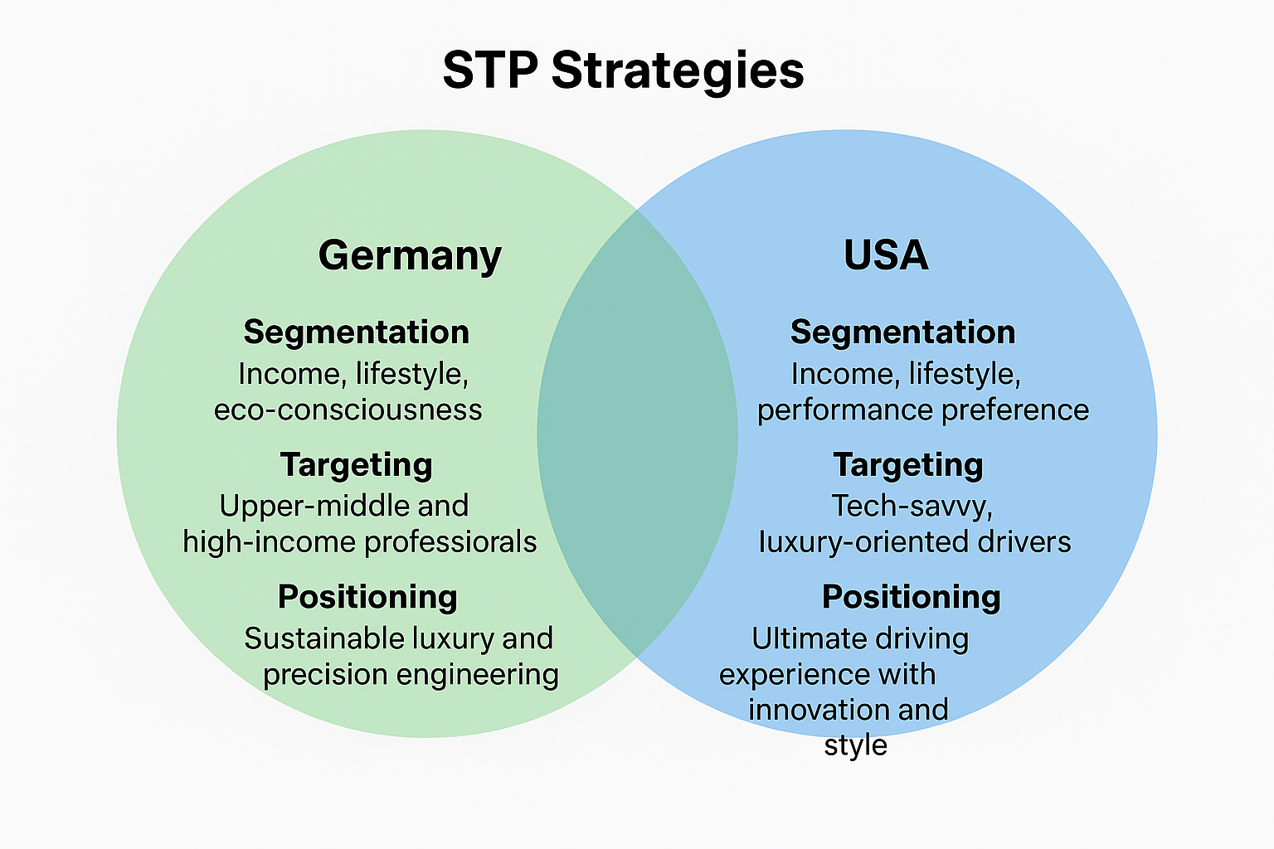
Source: BMW, 2024
Strategic Implications
Although segmentation and targeting vary upon cultural and usage patterns, the positioning strategy of BMW has global brand equity (engineering-led luxury) but has localised product focus and messages. The current problem facing the BMW brand is how to balance these two priorities: to accelerate the electrification (to appease German regulators and the eco-segments) and to deal with demand cycles and tariff/policy risks in the U.S. which impact product mix and pricing (Reuters, 2025).
Conclusion: BMW uses a different approach to sales and promotion in Germany than it does in the U.S. In Germany, BMW focuses on selling to rich experts in engineering who appreciate the company's German background and the joy of driving. In the U.S., the company tries to appeal to a wider audience of rich buyers who want to show off their status and care about performance, technology, and SUVs. This lets BMW keep its worldwide reputation while still meeting the needs of different markets.

Comparison of BMW Marketing Mix Strategies (7Ps): Germany vs USA.
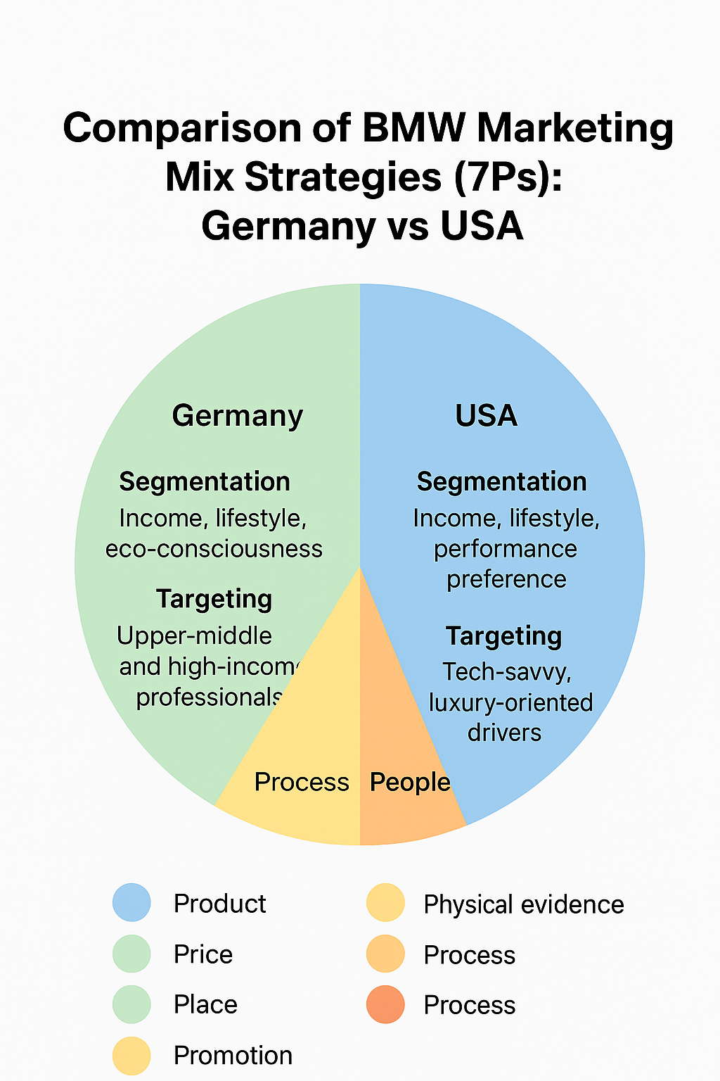
The success of the global marketing of BMW relies on its capacity to harmonise a global premium brand image with the local market variations. The promotional mix of Product, Price, Place, Promotion, People, Process, and Physical Evidence depicts the way BMW realigns its marketing strategies to be in-line with the consumer expectations and the competitive forces in Germany and the United States.
Source: BMW, 2023
1. Product
Engineering excellence, sustainability and innovation are some of the key product strategies of BMW in Germany. The company focuses on the leading-edge car technology, including plug-in hybrids (PHEVs) and electric vehicles (EVs) under the BMW i-series, which correspond with the environmental regulations of the German government and consumer demands of the environmentally friendly transport (BMW Group, 2024a). BMW is perceived as a brand of German consumers as an embodiment of precision engineering, performance, and reliability, which are the main components of the automotive culture of the country. The presence of local R&D and manufacturing plants in Munich, Leipzig, and Dingolfing makes it possible to quickly innovate a product, especially in batteries in EVs and autonomous driving systems (Automade Simply, 2023).
BMW product portfolio serves various consumer tastes in the U.S. The American consumers like larger automobiles particularly the SUVs because of its usefulness, comfort, and prestige. As a result, the plant in Spartanburg, South Carolina, which is the largest production facility of BMW in the world, is oriented on the X-series SUVs, such as the X3, X5, and X7 models (BMW Group Werke, 2025). The firm also customises features of the product including infotainment, connectivity, and luxury interiors to the U.S. market, which is technology-driven lifestyle (BusinessModelAnalyst, 2025).
2. Price
BMW uses a high-end pricing in the two markets, but with subtle variations. In Germany, pricing is indicated by the domestic prestige, excellent craftsmanship and advanced technology of the brand. Consumers are used to the premium price on local luxurious brands such as BMW, Mercedes-Benz, and Audi, which supports the perception of exclusivity and quality (Crowjack, 2024). Also, the company tries to capitalise on government incentives to purchase EV, providing flexible finance and leasing plans that make the entry to sustainable models less expensive.
Competitive price adjustments have been made in the U.S, as the competition with Mercedes-Benz, Lexus and Tesla is intense. BMW uses a value-based pricing strategy and sets prices of models based on perceived performance and lifestyle advantages (Ken Research, 2024). The U.S. consumers are increasingly sensitive to finance and leasing, which makes BMW to focus on leasing opportunities and ownership by subscription (BMW USA, 2025). One of the major elements of its pricing flexibility in the American market is the presence of regular promotional financing and seasonal offers (BusinessModelAnalyst, 2025).
3. Place (Distribution)
BMW has a well-developed and advanced integration of the distribution network. In Germany, BMW targets stores and showrooms that are authorised dealerships, which portray the image of the brand as high-end. Online configuration of the vehicle and the ability to place an order is another aspect of the digital platform employed by the company, providing a smooth experience to the customer (BMW Group, 2024b). The close distance between the production centres and dealerships improves logistics efficiency and decreases the lead times in domestic deliveries.
BMW of North America is a larger network of dealerships and service centres in the U.S. Distribution will be streamlined to the Spartanburg plant and will provide a reasonable supply of high-demand SUVs (BMW Group Werke, 2025). The company has made major investments in online retailing instruments-"BMW online store" and "My BMW" app- to enable customers in the U.S. to customise their preferences in terms of configurations, finance and delivery. Besides, BMW has logistic partners who ensure nationwide transportation of vehicles and export to North and Latin America (BusinessModelAnalyst, 2025).
4. Promotion
In Germany, BMW promotional approach is based on the engineering history, sustainability leadership, and innovation storey. In their marketing campaigns, the focus is put on the innovative technologies, environmentally-friendly mobility and the brand tradition BMW Born in Bavaria, which attracts the sense of national pride and faith in local manufacturing (BMW Group, 2024a). The use of traditional media (print media, television, and on-site events such as the IAA Mobility Show) are still relevant, and they are combined with digital campaigns emphasising the EV developments by BMW (Encyclopaedia Britannica, 2024).
Promotion in the U.S. is based on lifestyle, emotion and experience. The focus in campaigns is on production of pleasure, adventure and contemporary splendour. BMW employs social media, influencer partnerships, and high-profile events, including the commercials during the Super Bowl, to enhance the level of emotional interaction (Business Insider, 2024). In the U.S. more money is invested in digital marketing, with experimental VR test drives, experience-focused pop-ups, and interactive configurators targeting younger and more tech-savvy demographics. It is aimed at the identification of BMW with aspiration and innovation in American pop culture (Deloitte/WSJ, 2024).
5. People
BMW in Germany has workforce and dealership employees who focus on professionalism, technical expertise as well as customer relationship management. The training includes both technical and sustainability literacy training as it is essential to ensure that the staff is able to relay BMWs innovation and environmental objectives (BMW Group, 2024a).
BMW in the U.S. spends vast on customer facing staff training which is based on experience delivery and emotional affiliation. The sales representatives are geared towards giving high-quality customer care with a focus on convenience and lifestyle identification. Diversity and inclusion programmes are also undertaken at BMW of North America in order to represent the wide range of its customers (BusinessModelAnalyst, 2025).
6. Process
At BMW, the processes are focused on the manufacturing excellence and lean production in Germany. Industry 4.0 Dingolfing and Leipzig are the plants that combine the benefits of robotics, data analytics, and sustainability (BMW Group, 2024a). Customer operations, including ordering, financing and servicing, are computerised but with a personalised, consultative touch. The focus of after-sales service is on reliability and maintaining long term relationships.
The U.S. processes are characterised by customer convenience and digital integration. The sales made online, providing a flexible financing and home delivery services have grown after the pandemic (Ken Research, 2024). Dealerships are also oriented to quick buying and on-the-fly booking of service appointments. The service operations of BMW in the United States are directed at Ultimate Care, which provides clear maintenance plans and loyalty reward, which is a consideration of the American taste of convenience and value (BMW USA, 2025).
7. Physical Evidence
Physical evidence supports BMW identity in both markets as high-end. In Germany, minimalist architectural design of showrooms, advanced lighting and digital presentation of BMW technological sophistication are displayed (BMW Group, 2024b). The vehicles themselves are the tangible representations of quality and innovativeness, which are preconditioned by the German production standards.
Showrooms in the U.S. are more of an experience with the inclusion of hospitality areas, digital configurators, and brand merchandise to help customers become more immersed. Sports events (golf, motorsports) and luxury lifestyle tie-ins are also sponsored as an aspect of strengthening the aspirational image of BMW (Business Insider, 2024).
In general, the German marketing mix of BMW is constructed on the principles of the precision, engineering authenticity, and sustainability, whereas its approach to the U.S. market is focused on the emotional, experience-focused, and personalised marketing.
Conclusion: In general, BMW's marketing approach in Germany focuses on accuracy, genuine engineering, and sustainability. In the U.S., the strategy emphasizes emotion, experience, and suiting things to each buyer. Germany is the center for the brand's new ideas and history, while the U.S. is the biggest market, especially for SUVs and spreading its influence on culture. By changing its marketing to fit these situations, BMW keeps a consistent global brand image while still appealing to local customer needs.

Evaluation of BMW Marketing Performance
To measure the success of the marketing of BMW, the analysis needs to determine its market share, sales development, brand equity, and customer interaction in both the United States and Germany. These measures indicate the effectiveness of BMW marketing strategies in respect to consumer behaviour, technological revolution and market competition in worldwide automotive market.
Market Share and Sales Growth
BMW remains a strong player in the premium car market in Germany together with Mercedes-Benz and Audi. As indicated in the 2024 annual report of BMW Group, the brand controlled about 21 percent of the domestic premium market share and this was aided by the fact that the brand was reputed to excel in engineering, not to mention that it had successfully expanded its electric vehicle (EV) lineup (BMW Group, 2024a). In 2023, the company sold more than 250,000 vehicles in Germany and the BMW i4 as well as iX3 and iX are dominating the increases in the EV sales (Statista, 2024).
BMW is also among the most popular luxury cars in terms of sales in the United States. In 2023, almost 15 percent of the vehicles sold by BMW in the world reached the U.S., and more than 395,000 units were sold in the country, which is a 9 percent annual growth (BMW USA, 2025). This success was anchored by the strong SUV brand line-produced within the country in Spartanburg especially the X3, X5 and X7. A globalisation approach combined with American tastes has made BMW more responsive in the market through the localization strategy (BMW Werke Group, 2025). Consequently, in 2023, BMW dethrones Lexus to reach the second largest luxury car brand in the U.S. second only to Mercedes-Benz (Business Insider, 2024).

Customer Perception and Brand Equity
BMW brand equity is one of the strongest across the world and this is because of its image surrounded by sheer driving pleasure and high-level German engineering. The brand is viewed as a quality, performance, and environmental innovation in Germany, especially as the BMW i-series are developed (Crowjack, 2024).
Conversely, the brand image of BMW in the U.S. is more of a lifestyle. It is a symbol of luxury, performance, and prestige and it targets wealthy millennials and families. Emotional engagement has been enhanced by the fact that the brand has consistently featured in the cultural touchpoints, which include high-profile sports sponsorships and entertainment activities (BusinessModelAnalyst, 2025). According to the surveys, a vast majority of the American BMW consumers (more than 70 percent) think of the brand in terms of status and technological advancement, which shows that its differentiated promotional strategy has been successful (Ken Research, 2024).
Customer Response and Online Performance
The digital transformation currently adopted by BMW has greatly improved its interaction with customers in the two markets. Online customised experiences are facilitated by the My BMW App and online configurators, which allow personalised online interaction with the design of the vehicle to financing (BMW Group, 2024b). An augmented reality implementation in showrooms has made BMW in Germany more test-driving conversions, whereas in the U.S., lead generation and retention are better with the help of data-driven marketing and social media campaigns (Deloitte/WSJ, 2024).
Conclusion: BMW's marketing shows a consistent plan with changes made for local areas. Germany is still its center for new ideas and brand history, which keeps its image high-tech and top-class. At the same time, the U.S. market offers growth, lifestyle associations, and varied income. BMW's success in blending these strengths under one worldwide brand shows its ability to keep its marketing strong, even with rivals and rules.

Evaluation of BMW Marketing Ethics Practices
Ethical marketing is important in ensuring the corporate reputation, customer trust and compliance with regulations. BMW has remained focused on the sustainability, transparency and social responsibility as part and parcel of its international marketing and corporate campaign.
Ethical Marketing and Sustainability promise
The sustainability pledge and corporate culture are closely connected to the ethical marketing of BMW in Germany. The company follows the principles of the UN Global Compact and OECD Guidelines on Multinational Enterprises, as they encourage the truthfulness in advertising and responsible product representation (BMW Group, 2024a). Advertising efforts focus on honest description of vehicle performance and environmental efficiency, particularly in series BMW i-series (electric and hybrid vehicles). BMW Sustainability Strategy 2030 emphasises the message of reducing the CO2 emissions of its lifecycle according to green production, renewable energy, and recyclable materials (BMW Group, 2024b).
Transparency is another subject of ethical marketing in the U.S., and it has proven to be problematic because of the divergent expectations of consumers and competition. BMW of North America makes sure to meet the requirements of the Federal Trade Commission (FTC) on the accuracy of advertising and environmental statements (BMW USA, 2025). The company with its campaigns of Drive Electric has transparent information about the range of EVs, battery source, and performance indicators. Nevertheless, BMW has also been challenged in the past, among other automobile manufacturers, on the accusation of not meeting reporting of emissions in the past, a wakeup call of the necessity of maintaining ethical standards (Reuters, 2023).
Corporate Social responsibility and Ethical Conduct
BMW has ethical marketing that is not just restricted to advertising but also wider corporate social responsibility (CSR). BMW invests in road safety, programmes of workforce diversity, and education all over the world. In Germany, the social innovation and climate action are reinforced with the help of the BMW Foundation Herbert Quandt that supports these matters (BMW Foundation, 2024). In the United States, BMW engages in social responsibility activities such as collaborating with UNICEF USA and urban sustainability initiatives that can be explained by the ethical principle of caring about this community (BMW USA, 2025).
Conclusion: Altogether, the marketing ethics of BMW demonstrate strategic orientation of the company toward sustainability, honesty and social responsibility. Although there have been some controversies that have questioned its credibility, the corrective actions that the company has been taking, open communication and alignment of marketing with actual sustainability results have proven that the company has a high ethical level.

Recommendations for BMW’s International Marketing Strategies
BMW needs to use a more integrated, customer-focused, and sustainable global approach to marketing in order to consolidate its image on the international market and adjust to changing conditions in the marketplace.
- To begin with, BMW can become more digitally transformed in marketing by investing in customer analytics based on AI and personalised digital campaigns. This would enable BMW to customise its communication and offers depending on the different consumer preferences in different markets like Germany and the U.S.
- To begin with, BMW can become more digitally transformed in marketing by investing in customer analytics based on AI and personalised digital campaigns. This would enable BMW to customise its communication and offers depending on the different consumer preferences in different markets like Germany and the U.S.
- Third, BMW must pursue the glocalization strategy to keep the global brand image yet adjust the marketing messages, references, and affiliates to suit the values of local consumers.
- Finally, the reinforcement of brand communities by using experiential marketing like digital test drives, virtual showrooms, co-creation platforms will help to create a stronger level of customer interest and loyalty among markets.
Conclusion: Innovation, ethical communication, and local strategies will enable BMW to gain a more powerful and stable position in the global markets. BMW's global marketing success relies on a combination of innovation, ethical practices, and adjusting to different cultures. Using technology, stressing sustainability, and adapting plans for local markets allows BMW to keep its edge and strengthen its image as a top global provider of high-quality, responsible transportation.

Conclusion
To sum up, the global marketing approaches of BMW have high levels of compatibility with premium brand positioning, innovation and sustainability. The analysis of Germany and the United States shows that BMW has managed to adjust its marketing mix, segmentation, as well as ethical activities to different cultural and regulatory contexts. Although the company has achieved a lot in ensuring sustainable mobility and responsible marketing, new challenges that are emerging, like digital transformation, environmental scrutiny, and changing consumer expectations, require the company to keep adapting.

References
Automade Simply (2023) Where are BMW cars manufactured? Production plants around the world. Available at: https://automadesimply.com/cars/where-are-bmw-cars-manufactured/
BMW Deutschland (2024) BMW Deutschland – Produkte, Markenkommunikation und Nachhaltigkeit. Available at: https://www.bmw.de (Accessed: 11 November 2025).
BMW Group (2024a) BMW Group History. Available at: https://www.bmwgroup.com/en/company/history.html
BMW Group (2024b) BMW Manufacturing Co., Spartanburg Plant. Available at: https://www.press.bmwgroup.com/usa/article/attachment/T0448358EN_US/628669
BMW Group Werke (2025) BMW Group Plant Spartanburg – Largest Automotive Exporter. Available at: https://www.bmwgroup-werke.com/spartanburg/en/news/2025/largest-automotive-exporter.html
Encyclopaedia Britannica (2024) BMW: History, Cars, and Facts. Available at: https://www.britannica.com/topic/BMW
Arxiv (2025) Germany’s EV Transition and Automotive Competitiveness. Available at: https://arxiv.org/abs/2501.01781
Crowjack (2024) PESTLE Analysis of BMW. Available at: https://crowjack.com/pestle-analysis/bmw
FinModelsLab (2024) Car Dealership PESTEL Analysis. Available at: https://finmodelslab.com/products/car-dealership-pestel
Free PESTEL Analysis (2021) PESTEL Analysis of BMW. Available at: https://freepestelanalysis.com/pestel-analysis-of-bmw/
Introspective Market Research (2024) Germany Automotive Market Report 2024–2030. Available at: https://introspectivemarketresearch.com/reports/germany-automotive-market/
Ken Research (2024) USA Automobile Market Strategic Growth Report. Available at: https://www.kenresearch.com/industry-reports/usa-automobile-market
PS Market Research (2024) Germany Auto Component Market Size & Trends Report. Available at: https://www.psmarketresearch.com/market-analysis/germany-auto-component-market
Pestleanalysis.com (2024) PESTLE Analysis of the Automotive Industry. Available at: https://pestleanalysis.com/pestle-analysis-of-the-automotive-industry/
Reuters (2025) U.S. Auto Sales Outlook 2025. Available at: https://www.reuters.com/business/autos-transportation/us-auto-sales-set-rise-6-third-quarter-2025-10-01/
UKEssays (2024) A PESTLE Analysis of Germany. Available at: https://www.ukessays.com/essays/economics/a-pestle-analysis-of-germany-economics-essay.php
Wikipedia (2024) Direct-to-Consumer Automobile Selling in the U.S. Available at: https://en.wikipedia.org/wiki/Direct-to-consumer_automobile_selling_in_the_United_States
BMW Group Werke (2025) BMW Group Plant Spartanburg – Largest Automotive Exporter. Available at: https://www.bmwgroup-werke.com/spartanburg/en/news/2025/largest-automotive-exporter.html
BusinessModelAnalyst (2025) BMW Marketing Strategy (2025). Available at: https://businessmodelanalyst.com/bmw-marketing-strategy/
Business Insider / New York Times coverage (2024) BMW North America marketing and Super Bowl campaign. Available at: https://www.businessinsider.com/most-innovative-chief-marketing-officers-2024-6
Crowjack (2024) PESTLE / Brand Perception of BMW. Available at: https://crowjack.com/pestle-analysis/bmw
Deloitte / WSJ (2024) BMW Dealer Coaching Program Helps Drive Consumer EV Interest. Available at: https://www.wsj.com/articles/bmw-dealer-coaching-ev-education-116745 (note: paywalled coverage via Deloitte/WSJ summary)
FinModelsLab (2024) Car Dealership PESTEL Analysis. Available at: https://finmodelslab.com/products/car-dealership-pestel
FreePestelAnalysis (2021) PESTEL Analysis of BMW. Available at: https://freepestelanalysis.com/pestel-analysis-of-bmw/
Ken Research (2024) USA Automobile Market Strategic Growth Report. Available at: https://www.kenresearch.com/industry-reports/usa-automobile-market
Automade Simply (2023) Where are BMW cars manufactured? Production plants around the world. Available at: https://automadesimply.com/cars/where-are-bmw-cars-manufactured/
BMW Group (2024b) BMW Group Sales and Marketing. Available at: https://www.bmwgroup.com/en/sales.html
BMW USA (2025) BMW of North America Official Website. Available at: https://www.bmwusa.com
Business Insider (2024) BMW North America Super Bowl Campaign. Available at: https://www.businessinsider.com/most-innovative-chief-marketing-officers-2024-6
BusinessModelAnalyst (2025) BMW Marketing Strategy (2025). Available at: https://businessmodelanalyst.com/bmw-marketing-strategy/
Crowjack (2024) BMW PESTLE and Market Analysis. Available at: https://crowjack.com/pestle-analysis/bmw
Deloitte/WSJ (2024) BMW Dealer Coaching Program on EV Adoption. Available at: https://www.wsj.com/articles/bmw-dealer-coaching-ev-education-116745
Ken Research (2024) USA Automobile Market Strategic Growth Report. Available at: https://www.kenresearch.com/industry-reports/usa-automobile-market
BMW USA (2025) BMW U.S. Sales Report 2024. Available at: https://www.bmwusa.com/newsroom.html
Business Insider (2024) BMW North America Market Share 2024. Available at: https://www.businessinsider.com/most-innovative-chief-marketing-officers-2024-6
Crowjack (2024) BMW Brand Analysis. Available at: https://crowjack.com/pestle-analysis/bmw
Deloitte/WSJ (2024) BMW Digital Dealer Coaching and EV Adoption. Available at: https://www.wsj.com/articles/bmw-dealer-coaching-ev-education-116745
Statista (2024) BMW Car Sales in Germany 2018–2024. Available at: https://www.statista.com/statistics/416056/bmw-car-sales-germany/
BMW Group (2024a) BMW Group Code of Ethics and Compliance. Available at: https://www.bmwgroup.com/en/responsibility/compliance.html
BMW Group (2024b) Sustainability Strategy 2030. Available at: https://www.bmwgroup.com/en/sustainability.html
BMW USA (2025) Corporate Social Responsibility and Sustainability – BMW of North America. Available at: https://www.bmwusa.com/sustainability.html
Reuters (2023) BMW Tightens Emission Reporting after Industry Review. Available at: https://www.reuters.com/business/autos-transportation/bmw-emission-reporting-2023-07-15/

Appendix
Appendix A: BMW Global Market Overview (2024)
Region |  | Revenue (Billion €) | Market Share (%) | Growth Rate (YoY)
  Sales Volume (Units)
Europe (incl. Germany) | 990,000 | 64.1 | 28.5 | +4.2%
North America (incl. USA) | 410,000 | 34.7 | 16.2 | +3.9%
Asia-Pacific | 1,220,000 | 69.3 | 35.1 | +5.6%
Middle East & Africa | 150,000 | 8.2 | 6.0 | +2.4%
Latin America | 120,000 | 6.4 | 4.2 | +1.8%
Source: BMW Group Annual Report (2024); Statista Automotive Data (2025).
Appendix B: PESTLE Summary Table – BMW in Germany vs. USA
Factor | Germany | USA
Political | Stable EU regulatory framework; strong automotive industry incentives. | Stable democracy; stringent EPA and trade policies.
Economic | High GDP per capita; EV subsidies; strong manufacturing ecosystem. | Large consumer base; fluctuating interest rates; price sensitivity.
Social | Preference for engineering quality and sustainability. | Demand for luxury, innovation, and performance.
Technological | Advanced R&D infrastructure; leader in EV battery tech. | Rapid adoption of digital marketing and AI personalization.
Legal | Strict environmental and labor laws. | FTC advertising regulations; state-level environmental laws.
Environmental | Carbon neutrality goal by 2045; strong recycling mandates. | Growing EV market but slower infrastructure growth.
Source: BMW Sustainability Report (2024); U.S. Department of Commerce (2024).

Appendix C: BMW STP Summary (Germany vs. USA)
Element | Germany | USA
Segmentation | Income, lifestyle, eco-consciousness | Income, lifestyle, performance preference
Segmentation | Upper-middle and high-income professionals | Tech-savvy, luxury-oriented drivers
Positioning | “Sustainable luxury and precision engineering” | “Ultimate driving experience with innovation and style”
Source: BMW Group Marketing Insights (2024)
Appendix D: Marketing Mix Highlights (7Ps)
Component | Germany | USA
Product | Focus on EV models (BMW i series) | Focus on SUVs and performance cars
Price | Premium pricing with eco incentives | Dynamic pricing and flexible financing
Place | Dealership network + online configurator | Strong online retail + experiential showrooms
Promotion | Sustainability-focused campaigns | Lifestyle and digital influencer campaigns
People | Customer-centric culture, technical expertise | Service-oriented staff and digital CRM
Process | Lean production, green logistics | Streamlined digital buying process
Physical Evidence | Futuristic showrooms, EV infrastructure | Luxury-focused retail design

