

Daniel stone
Student ID - 1803523
Assignment 1- Energy Efficiency and sustainable materials
Module – Management of sustainable construction
Module code – ACBA5012
Lecture – Juan Ferriz Papi

In this assignment it is my duty to become responsible for a construction of a detached dwelling, to which there are drawing plans attached in the assignment brief. As I have access to the design before construction work starts, I am able to implement suggestions to improve the energy efficiency in the building and increase on its sustainability.
The suggestions are based on the correct orientation and dwelling, including changes to windows, doors and partitions and a description of U value building regulations. There will also be identification on thermal bridging and solutions preventing heat loss throughout the building also showing and defining renewable solutions for the detached house.
With orientation of a building, it is always best to have it south facing as that’s where most of the sun will begin and stay for most of the day. This would provide natural heat to warm up the detached house making it more economic by using less electricity to heat up the building.
As I have access to the drawing, I will change the orientation of the building so that it faces a more sufficient way. I would also make changes on the exterior positions of windows. This is because of change of position allowing more light into the house and this is done by changing the size of windows in the detached house.
With regards to U values in this house it has to comply too the building regulations. This is based upon the thermal properties off the building which is the thermal conductivity, resistance and the thermal transmittance. The thermal resistance which is also known as the R value is based upon a capacity of materials which prevent heat from being created through it this is measured through thermal resistance (m2k/w). The thermal transmittance being the U value which is the rate of heat transfer through are square meter of the building which is then divided in difference to temperature across the building and is expressed as w/m2k it is compulsory for every dwelling to give a U value certificate such as this detached house.
The current building regulations for a new build just like this household are: (building regulations part L) 2019
Wall – 0.18 w/m2k
Floor – 0.13 w/m2k
Pitched roof – ceiling level – o.13 w/m2k
Pitched roof – rafter level – 0.13 w/m2k
Flat roof – 0.13 w/m2k
Window / door – 1.4 w/m2k
The new build detached dwelling will comply to the U value regulation as insulation to cross section drawings are to be altered and implemented thermal conductivity and resistance.
The thermal insulation material that would be most suitable for this building would be phenolic foam this is because it has a thermal conductivity 0.020 and a thermal resistance of 5.00 this would give a good thermal insulation around of the house which would lead to the U value to the house complying to the building regulations with the U values of a roof being 0.13 w/m2k. I would suggest using the phenolic foam on the pitched rafters and then use the glass fibre wool on the ceiling level which has the thermal conductivity of 0.035 and a thermal resistance of 4.32 at 350 mm. with both solutions of thermal insulation in the roof this would limit the heat loss giving a high U value again complying to the building regulations. With most buildings there can be a case of thermal bridging.
Thermal bridging is a localized element within the building envelope, this is where there is a higher thermal conductivity in a certain area.
You can usually find thermal bridging in structural attachments such as insulation breaks or metal flashings around the building. This works by having heat paths around the house such as stud walls that are attached to an outer skin of a building. This would make the insulation not very effective as there are many ways for the heat to travel through in and out, for example when the weather changes to weather the thermal path is the same as the exterior except its allowing internal heat to escape. , but not only the heat is escaping but it is creating condensation which can connect to corrosion, rust rot in timber in economic household and carbon emissions. The way to solve this problem is to properly insulate the walls covering the stuff works for example on tinder frame stud wall you can use the Celotex insulation on the external frame of the building this would then provide a comfortable thermal mass within the home creating no heat loss through the heat paths. (studs within the partition walls).
Going on with the design of the building and taking that the whole build is a timber frame structure with a concrete basement you would tend to lose a lot of heat through the studs as they are not insulated this is then creating a heat loss to overcome this problem is from working from internally to external you would have you regular plasterboard and Kingspan insulation between the studs in the walls but behind that to cover the studs would be the wood fibre board and a layer of Kingspan around 100mm and then the external brick work which is attached by wall ties there also be a layer of breathable membrane within the wall structure. By doing this this stops the quick allowance of heat loss through the building as the building can warm up and keep the heat in the home.
There are many types of renewable energy’s that can be used in modern and traditional homes these days, a renewable energy means a usage of a source that is not depleted when the energy sources are being used or extracted. For example, some of the main and most common usages of renewable energy in day to day homes are usually solar power (solar panels) and wind power (wind turbines). In this particular building I would suggest on using the solar gains and go with using the photovoltaics panels (solar panels) on the roof structure this works by using the solar power from the sun to exchange it in to electricity by using this solution would benefit the house as it is can rely on a reusable source and remain sufficient this would also work better as the building position has moved to the south to where it will gain more sun light.
Another solution that I would implement of using in this building would be similar to the photovoltaics panels would be solar heating panels this is another way of being substantiable as it turns the solar power to electricity and heats up the water, but again these panels only work if they are facing in the correct orientation to where the most sun light will be, these panels can be fitted on the roof and on any bit of land in the correct position. Using both of these suggestions in the detached house would be a good way to boost the economic value as the both solutions would provide electricity power to the house and water heating from using the suns energy making the building a self-sufficient and sustain able home.
In conclusion to this, the implementations that have been chosen for this particular build are suitable as they make the building more self-sufficient and economic. This is due to both implementations are renewable sources which are being used to produce the electricity and heat power to a reusable source. This is all done with the correct orientation of the building as I placed it in the south facing position to have more solar gains throughout the day.

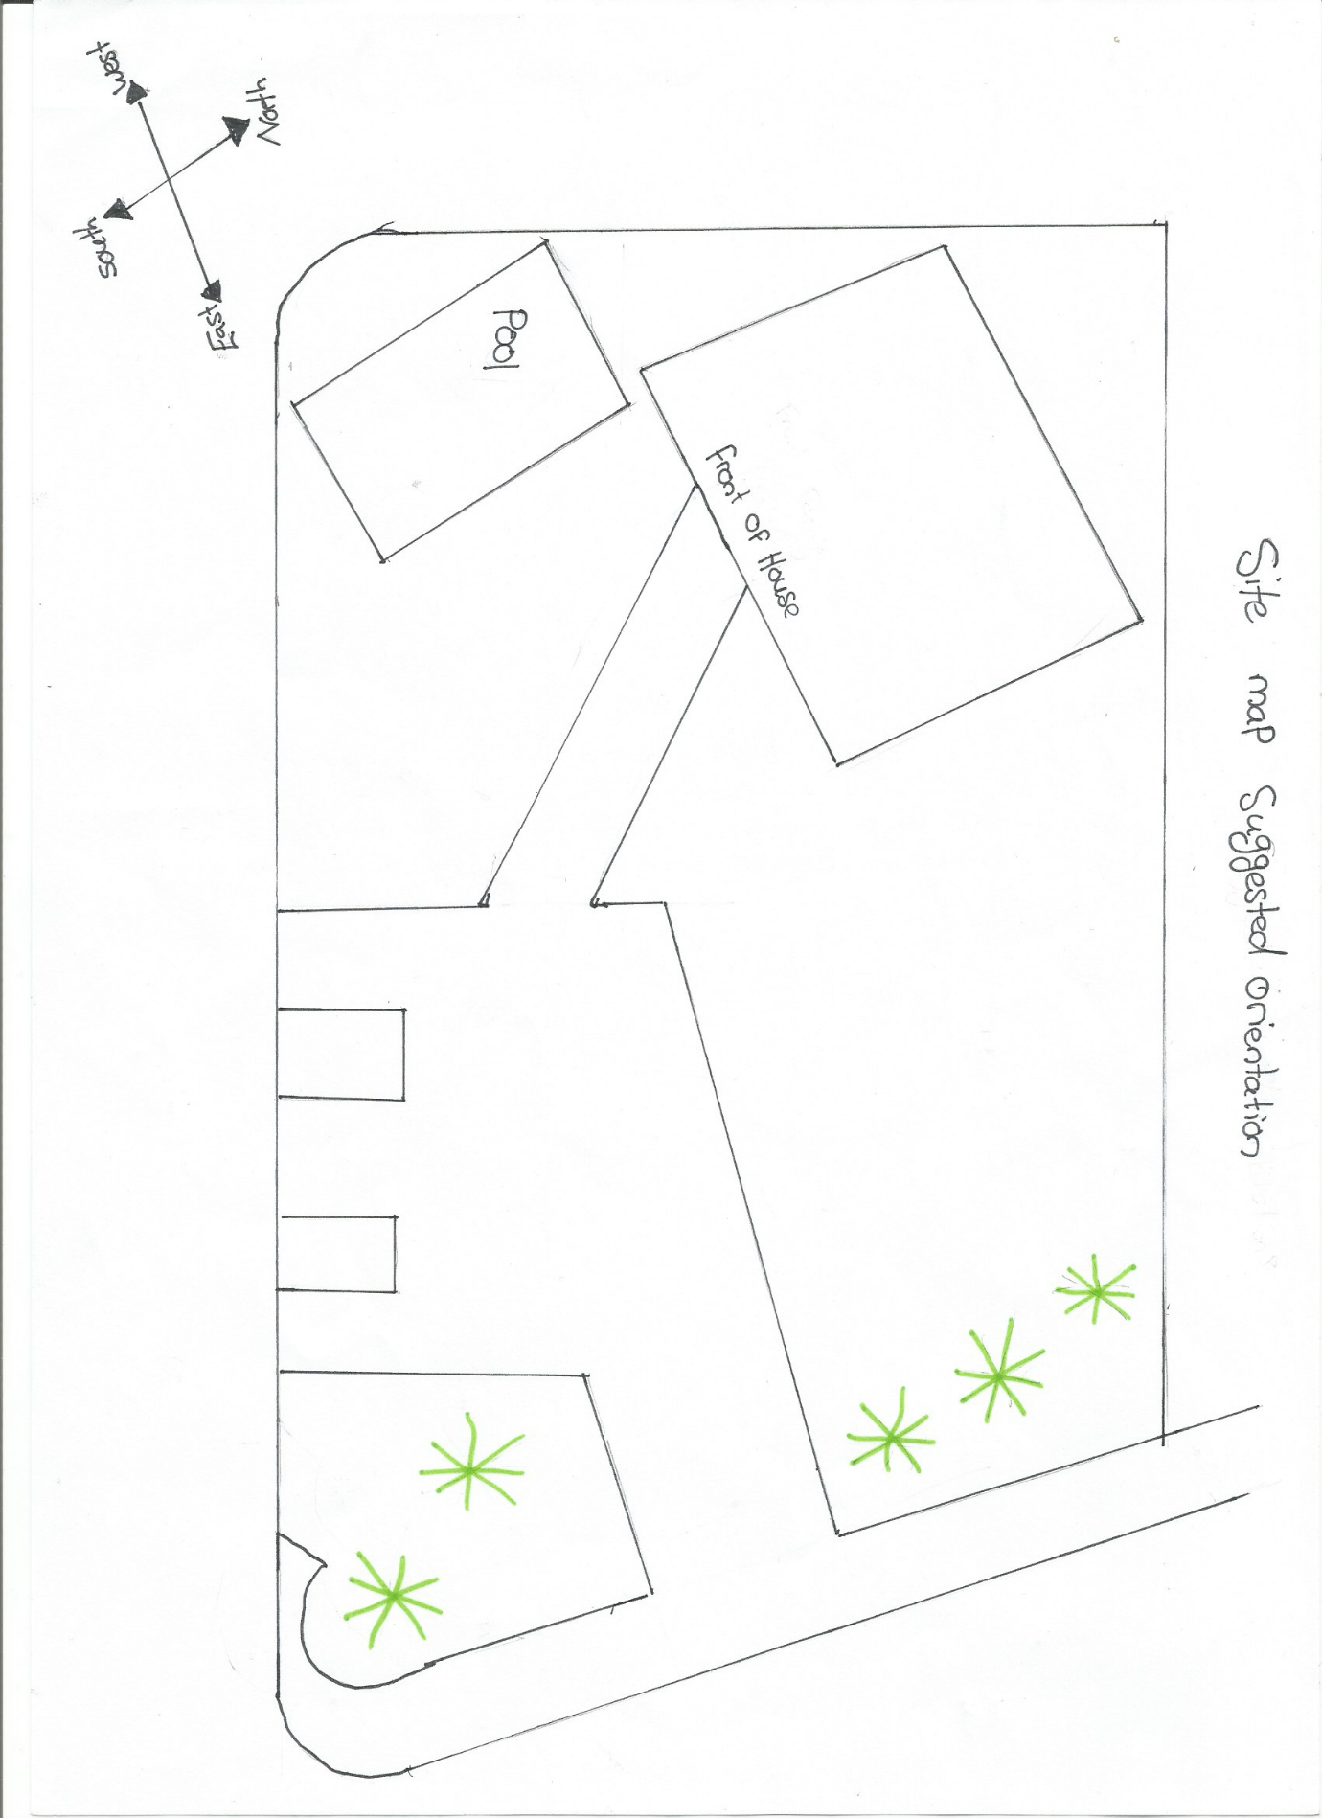

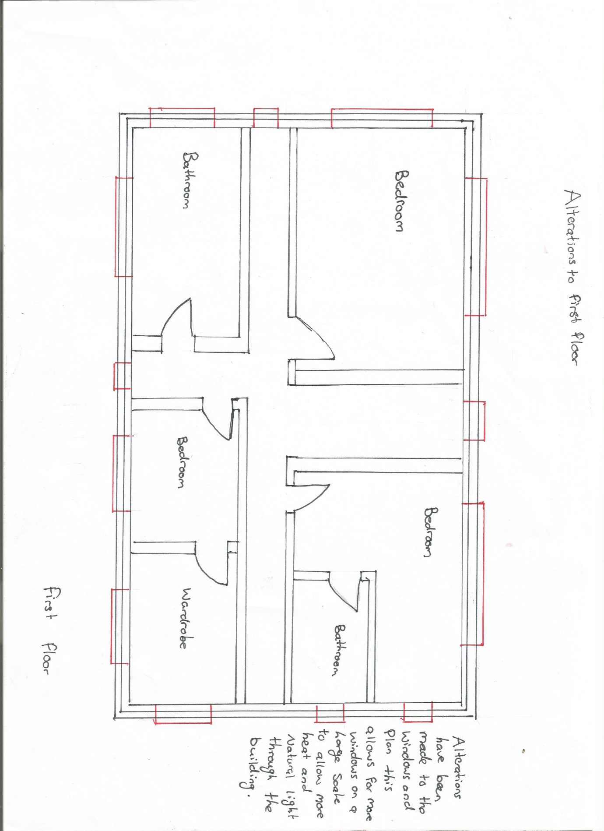

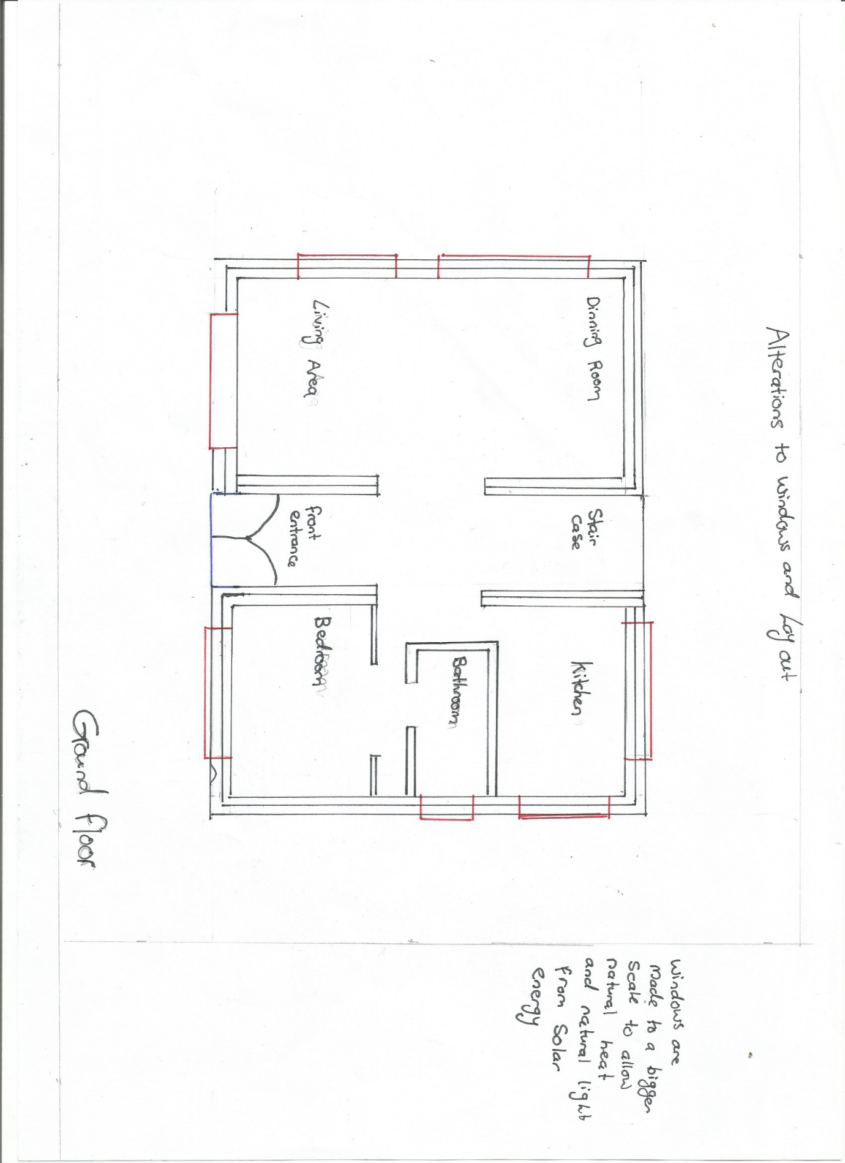

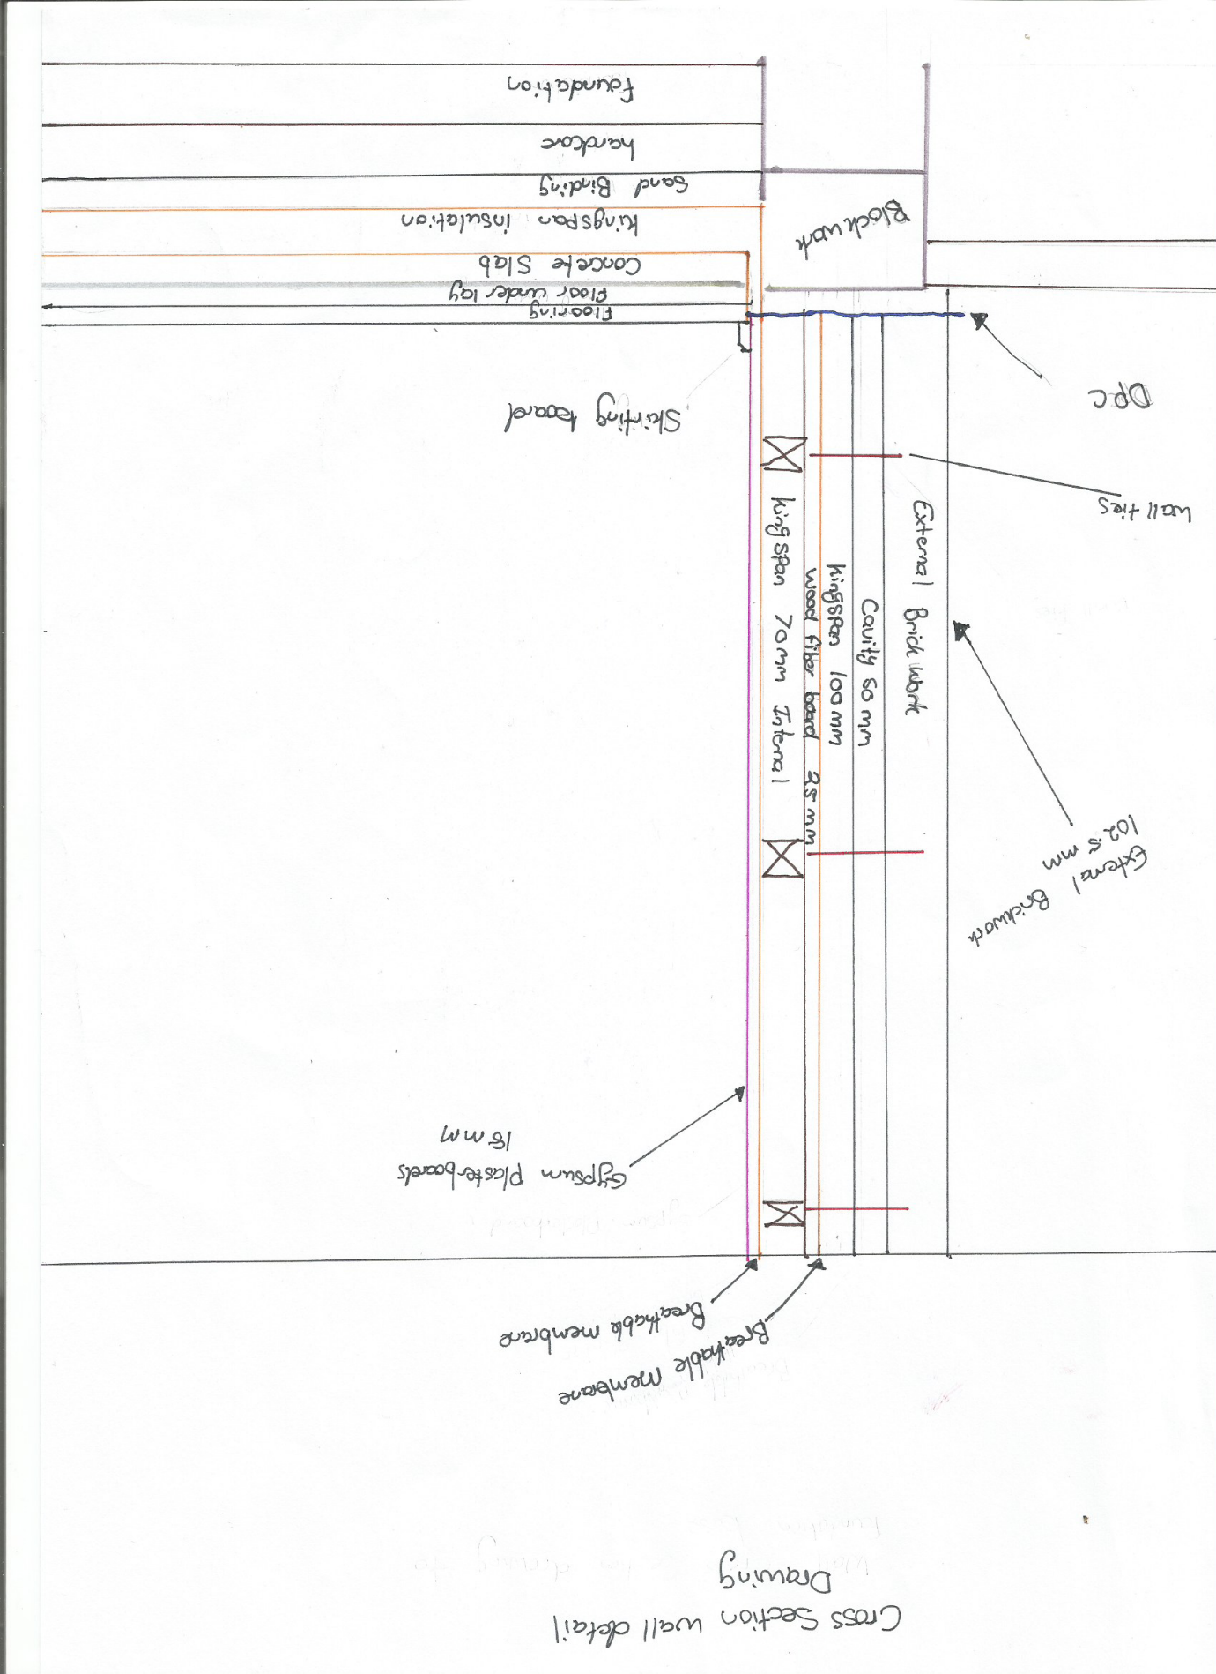

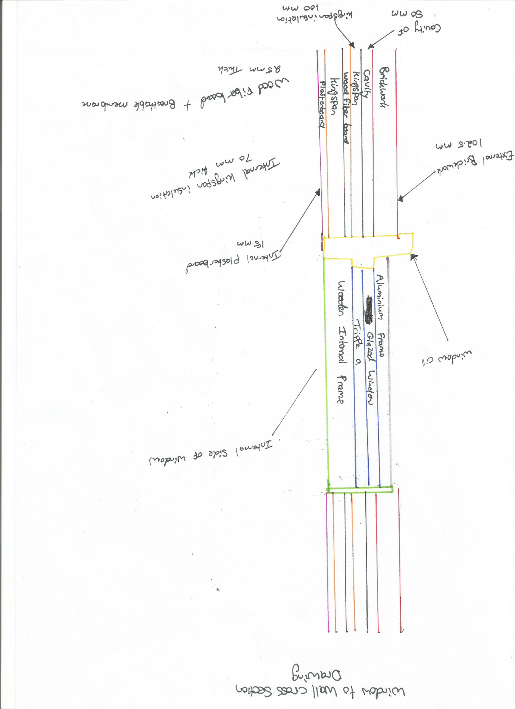

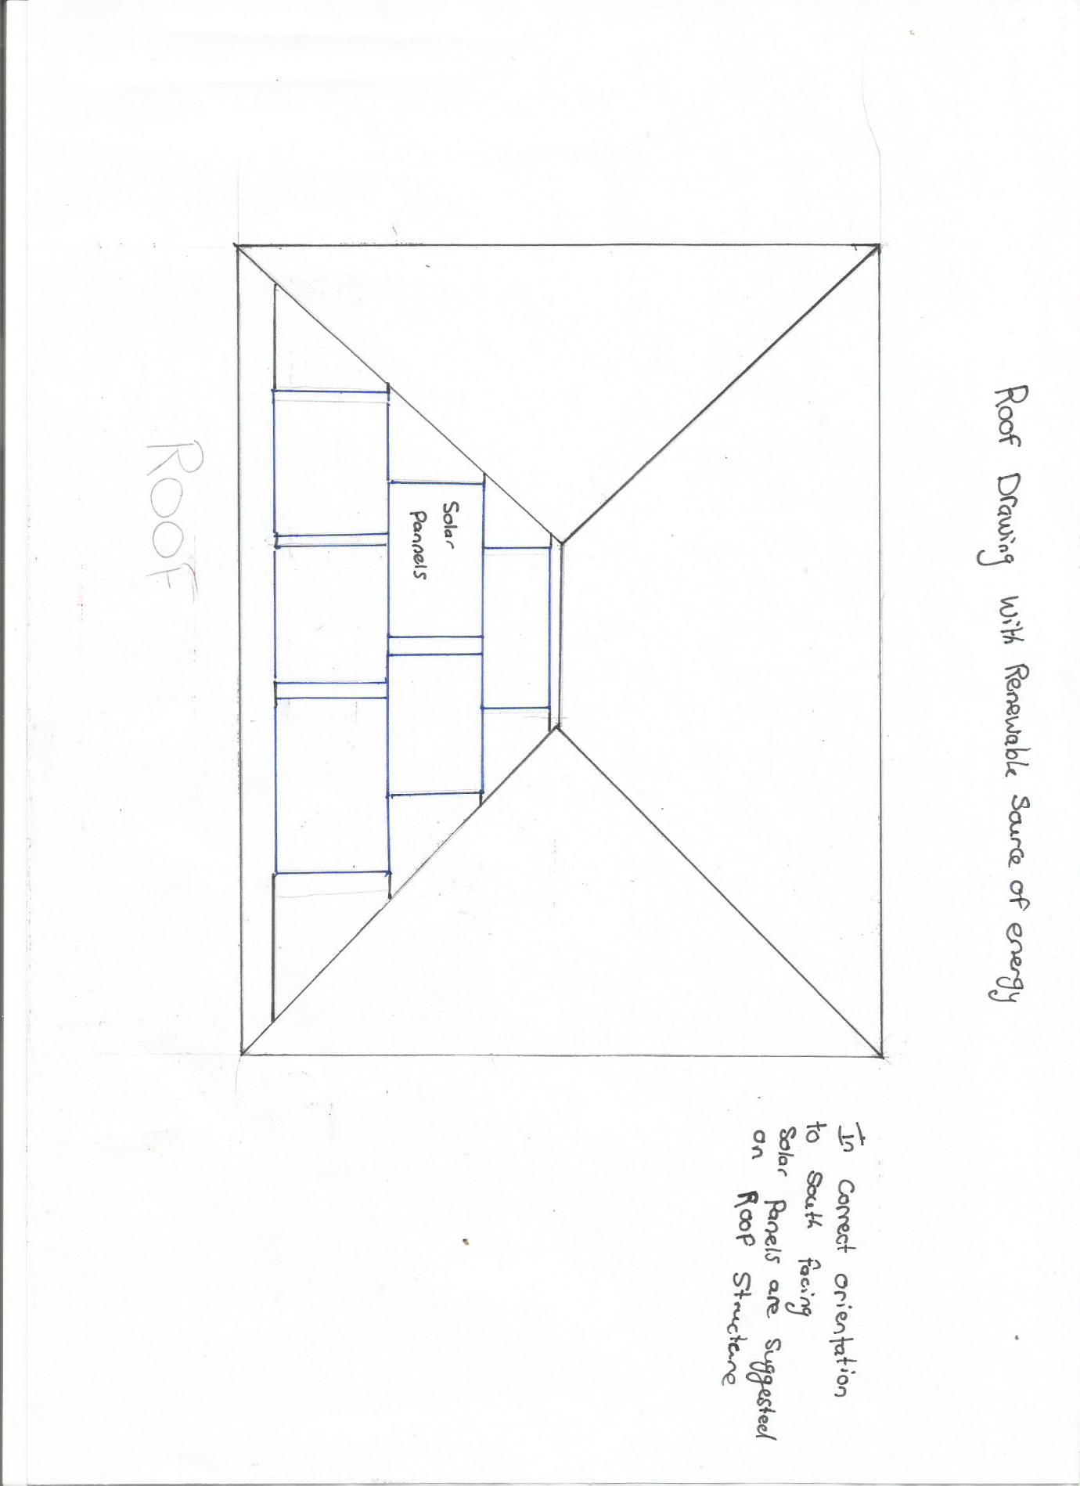

References
Popular mechanics (2019) 8 ways to power your home with renewable energy [online] [viewed 11th February 2020] available from: https://www.popularmechanics.com/science/energy/g2825/7-ways-to-power-your-home-with-renewable-energy/

Sound solutions consultants – Kingspan thermal insulation board [online] [viewed 11th February 2020] available from: https://www.soundsolutionconsultants.co.uk/acoustic-materials/thermal-insulation/kingspan-thermal-insulation-board/

Eagle builders (14th March 2017) what is thermal bridging? [online] [viewed on 11th February 2020] available from: https://www.youtube.com/watch?v=GUszzm1jsWg&t=3s
DuPont performance building solutions (26th September 2016) building better homes challenge: how to reduce thermal bridging [online][viewed on 10th February 2020] available from: https://www.youtube.com/watch?v=0gNUs84RHqc&t=2s

PowerPoint slides UWTSD- Lara Hopkins
PowerPoint slides UWTSD – Juan Ferriz-Papi

