Transferring data from a text file to a database

The data produced by Internet of Things devices is often very raw. Also, it usually not in an organised form, but instead, contained in a text file, which is also known as a “flat file” because it has no structure.

For example, we may have values written to a text file as follows:

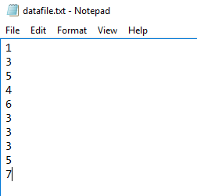

If we want to display this data in a meaningful way, we need to transfer it to a structured environment – ie a database.

In the example below, we will move the data from the text file into a database table shown below:

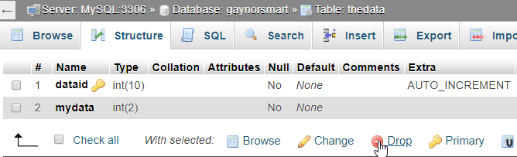

This table (thedata) has been set up with two fields. One is a primary key (dataid) and the other will hold the data from the text file (mydata)

- We need to read from the text file. Create a php file called transferdata.php

- We will start by telling PHP the name of our text file (datafile.txt):

$myfile="datafile.txt";

- Now we will open the file and read the entire thing into a variable called $data:

$filelink = fopen($myfile, "r") or die("Unable to open file!"); //open file for reading
$data=fread($filelink,filesize($myfile)); //read entire file
fclose($filelink); //close file

At this point, we have all the data crammed into $data. If we echo $data, we see all the data.

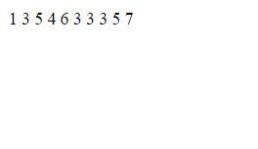

- We now need to separate this data so that we can deal with the individual values. An array is a convenient structure for this purpose.

We will use the explode() function to achieve this. Explode is used to break up a variable and store the individual parts in an array.

The data is separated by a line break, which we will use to separate the data. In PHP, chr(13) denotes a linebreak:

$incoming=array(); //declare array
$incoming=explode(chr(13),$data); //split data into array

Every time a line break is encountered, the code moves on to the next array element:

1 -> $incoming[0]
3 -> $incoming[1]
5 -> $incoming[2]
4 -> $incoming[3]
6 -> $incoming[4]
3 -> $incoming[5]
3 -> $incoming[6]
3 -> $incoming[7]
5 -> $incoming[8]
7 -> $incoming[9]

The code now looks like this (I’ve added a print_r so we can see the contents of the array)
$myfile="datafile.txt";

$filelink = fopen($myfile, "r") or die("Unable to open file!");//r for safety
$data=fread($filelink,filesize($myfile));
fclose($filelink);//close

$incoming=array();
$incoming=explode(chr(13),$data);//split data

print_r($incoming);

As you can see, the values from the text file are now in the $incoming array:

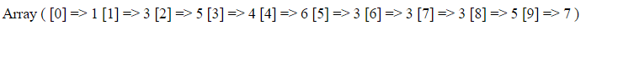

- Let’s write the contents of the array into the database:

include “conninfo.php”; //switch on link to database

$length=sizeof($incoming); //find out how many elements are in the array
for($x=0;$x<$length;$x++) //loop around every element in array
{
$incoming[$x]=trim($incoming[$x]);//trim any whitespace
$query="INSERT INTO thedata(mydata)VALUES($incoming[$x])";
$result=mysqli_query($link,$query); //write to database
}

As you can see, the data is now written to the database:

Primary key Data
(autonumbered)
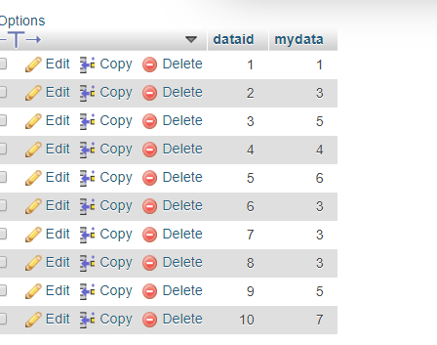
- We do not want to accidentally write two copies of the same data to our database, so now that the data is safely in our database, we will now wipe the text file (future data from our IoT devices will continue to be written to it, of course)

The simplest way to do this is to open our file for writing (w). This will wipe the file (therefore w must be used with caution!)

$filelink = fopen($myfile, "w") or die("Unable to open file!"); //w effectively wipes file
fclose($filelink); //close link to file

- We are almost there now, the only problem remaining is if we attempt to read from the file again before more values have arrived from the IoT device(s), which throws up a warning:

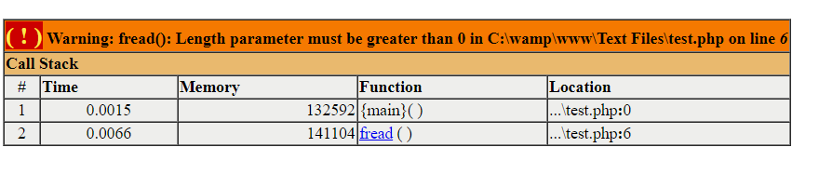

This won’t actually cause a problem with the database, but for the sake of completeness, we should put in an if statement to avoid reading from the file if there is nothing in it.

The complete code is shown on the following page:

<?include "conninfo.php"; //link to database

$myfile="datafile.txt"; //set name of text file

$filelink = fopen($myfile, "r") or die("Unable to open file!"); //open link to file for reading

if(filesize($myfile) > 0) //check there is something in the file
{
$data=fread($filelink,filesize($myfile)); //read whole file, store in $data
fclose($filelink); //close link to file

$incoming=array();
$incoming=explode(chr(13),$data); //split data into array

$length=sizeof($incoming); //find out how many elements in the array

for($x=0;$x<$length;$x++) //work through array and write into database
{
$incoming[$x]=trim($incoming[$x]); //trim any whitespace
$query="INSERT INTO thedata(mydata)VALUES($incoming[$x])";
$result=mysqli_query($link,$query); //write to db
}

$filelink = fopen($myfile, "w") or die("Unable to open file!"); //w effectively wipes file
fclose($filelink); //close link to file
}

else
{
echo "Nothing in the file";
}
?>

