PROBLEM
ANALYSIS AND SOLUTION
DEVELOPMENT

Module Name: Analysing and Solving Problems
Module Code: ACCA 4019
Student Name: ALISON SHERMAN VAS
Student ID: 2513127
Group:1
Lecturer’s Name: FAHAD AMHED

Table of Content
Introduction 3
Deconstruct the Problem 3
MoSCoW Technique Requirement 3
Table 1: MoSCoW Requirement Analysis 4
Variables Identification 5
Table 2: Variables Used in the Scheduling Process 5
Proposed Solution 6
Flowchart 7
Flowchart Explanation 7
Reflection and Justification 8
Abstract Thinking 8
Sub-dividing 8
Justification of the Solution 8
Limitation 8
Assumption 9
Conclusion 9
References 9

Introduction
Effective teamwork is one of the important skills that students learn during computing programs. Most hands-on courses require students to work in groups where ideas are shared jobs are spread out and the progress of the project is checked through meetings [1]. Even though working together helps improve how people talk and their technical abilities arranging meetings often turns out to be a job because every student has a different schedule. Classes at the university lab time jobs that're part-time family duties and personal activities often mix together which makes it hard to find a time that works for everyone in the group.
Bad planning for meetings can really affect how well the project does. When meetings are canceled or pushed back again and again the way team members talk to each other gets worse, big choices get put off and work might not get done before the dates [2]. In cases some students take part more than others because they know what is happening while others miss the talks because of conflicting times. Because of this having a way of planning the schedule is very important to make sure that every person in the group has a chance to help with the project. The situation described in this assessment is about creating a system that can pick the right meeting times. The goal is to avoid clashes in schedules and make sure meetings happen before deadlines. Of people using messages or emails to plan the solution uses logic to organize the scheduling. This helps make choices that're fair and based on the availability each person gives.

Deconstruct the Problem
Scheduling a meeting seems like a thing to do. When you have a lot of people with different things they have to do it gets really complicated [3]. Each person in a project team has their weekly schedule with things they have to do, like classes and things they can choose to do. So, the system that schedules meetings has to find a time that works for the people without messing up important things they have to do or missing deadlines for the project. One big problem is that not all the things’ people have to do are equally important. You cannot change things like lectures, lab sessions and exams. You might be able to change work shifts or personal things you want to do. So, the system has to figure out what things cannot be changed and what things can be moved before it suggests a meeting time. If it does not do this the meeting time suggests it might not work even if it looks good on paper.
The problem can be divided into several connected stages. Initially, information regarding each student's weekly availability must be collected. This information is then analyzed to identify overlapping free periods. Suitable meeting options are compared according to project deadlines, timetable conflicts, and meeting duration before the most practical option is selected. Where no common availability exists, alternative meeting arrangements should be considered using the option that creates the smallest overall disruption.

MoSCoW Technique Requirement
The new scheduling system needs to do what it is supposed to do. So, we use the MoSCoW prioritization technique [4]. This technique puts the system requirements into four groups: things the system must have are things the system should have, things the system could have and things the system won't have. We must have things first because they are important. Then we do the things if we have enough time and resources. Using the MoSCoW method helps us not make the system too complicated. It helps us make good decisions when we are developing the solution. The MoSCoW method is really useful for the scheduling system.

Table 1: MoSCoW Requirement Analysis
Priority | System Requirement | Purpose
Must Have | Collect availability from every group member. | Required to begin the scheduling process.
 | Identify common available time slots. | Enable meetings to be arranged fairly.
 | Ensure meetings occur before weekly deadlines. | Supports timely completion of project tasks.
 | Minimize timetable clashes. | Maximizes group attendance.
 | Notify members after confirmation. | Ensure every participant receives meeting details.
Should Have | Allow students to edit their weekly availability. | Keeps scheduling information up to date.
 | Notify members after confirmation. | Ensure every participant receives meeting details.
Should Have | Allow students to edit their weekly availability. | Keeps scheduling information up to date.
 | Recommend the most convenient meeting option. | Improves participation and convenience.
 | Record previous meeting schedules. | Supports better project organization.
Could Have | Send automatic reminder notifications. | Help reduce missed meetings.
 | Connect with digital calendars. | Simplifies personal schedule management.
 | Produce attendance summaries. | Allows groups to monitor participation.
Won't Have | Automatic timetable changes. | Outside the project's scope.
 | AI-based prediction of future availability. | Not essential for solving the current problem.
 | Integration with employer scheduling software. | Beyond the assessment requirements.

The MoSCoW technique helps us focus on what's really important. We use the MoSCoW technique to make sure the proposed solution works well and gives us scheduling functionality first. This means we do not add features that are not necessary until later. The MoSCoW technique helps us make a solution that's practical and easy to use. It also helps keep the system running easy to manage. The MoSCoW technique is a way to prioritize what we need to do. We prioritize the MoSCoW technique, so the system is efficient and manageable.

Variables Identification
The success of the scheduling process depends on a lot of things that affect when we can have meetings [1]. These things are like the information that the scheduling system looks at when it picks the time for a meeting. If we know how these things work together the scheduling process will be better. We can count on the scheduling system to find a good time for the meeting. The scheduling process is important. The scheduling system is a big part of it.

Table 2: Variables Used in the Scheduling Process
Member Availability | Time periods during which each student is free.
Academic Schedule | Fixed lectures, tutorials, and laboratory sessions.
Project Deadline | Weekly submission deadline that meetings must precede.
Group Size | Number of students involved in the project.
Project Deadline | Weekly submission deadline that meetings must precede.
Group Size | Number of students involved in the project.
Meeting Duration | Length of time required for each discussion.
Flexible Commitments | Activities that students may be able to rearrange.
Fixed Commitments | Activities that cannot normally be changed.
Preferred Meeting Period | Individual preference for morning, afternoon, or evening meetings.
Conflict Count | Number of timetables overlaps with the proposed meeting.
Notification Status | Indicates whether meeting information has been shared with members.

The scheduling process is affected by each variable in a way. For example, member availability is the factor because it decides if a meeting can be arranged or not. The academic schedules are like fixed appointments that usually come before activities that are not necessary. If we do not consider these things the meeting time that is suggested may not be practical. The project deadline is also very important because it sets the date when a meeting can be held. If we schedule meetings close to the deadline the students will not have enough time to finish their tasks after the meeting. So, it is better to have meetings when there are good options available [2].
The conflict count helps us make decisions when everyone is not available at the time [3]. If saying no to every meeting time that is not good the system checks how many members will be affected by each option. Choosing the meeting time with the conflict count allows the group to have the most members attend while being fair to everyone. In addition, being able to tell the difference between things that are set in stone and things that can be changed helps the scheduling process suggest options. Things that are fixed like exams or required classes must stay the same. Some work shifts or personal plans can be moved around once everyone in the group agrees. When these factors are looked at together at one at a time the scheduling system can make fair choices. This helps people work well together, reduces clashes in schedules and makes it more likely that project tasks will be done before the end of the week.

Proposed Solution
The problem of scheduling can be solved by following a step-by-step process. This process looks at when everyone is available checks for any problems with the timetable and only sets a meeting when everything is okay. If students have to talk to each other to set a meeting time the new way of doing things follows a clear order of steps. This helps make sure everything is consistent and reduces mistakes when scheduling meetings. The flow chart below shows all the steps involved in scheduling a meeting. It starts by gathering information about when people are available checks that the information is correct compares schedules looks at possible meeting times checks project deadlines and finally sets a meeting time that works best for everyone. This way of doing things makes sure that meetings are scheduled based on what makes sense than what someone likes [3]. The scheduling problem is solved by looking at the scheduling problem and finding a solution that works. The scheduling process is easy to follow and understand.

Flowchart
The scheduling process we are talking about is pretty straightforward. It checks the user information first. Then it picks the time for a meeting. This is different from doing it by hand. The new way looks at what time everyone's free makes sure there are no problems with the schedule and chooses a meeting time that helps us finish the project on time. The scheduling process is really about finding the meeting time. It does this by checking everyone’s schedule and making sure the meeting time works for the project.
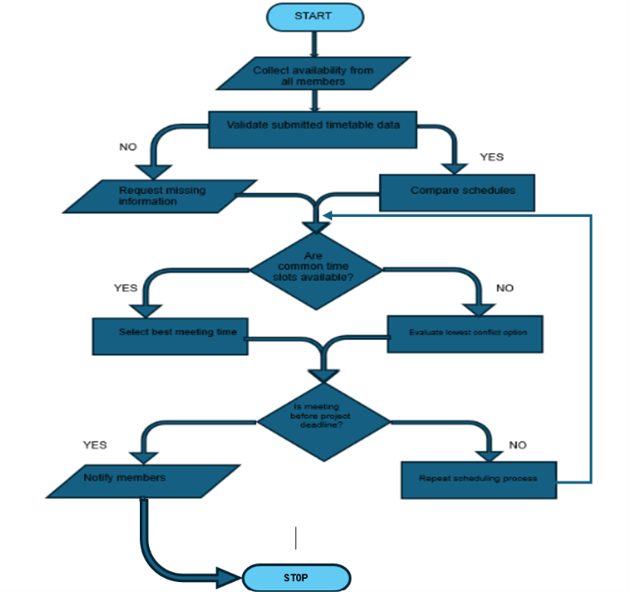

Flowchart Explanation
The flowchart shows how to plan group meetings in an organized way. It starts with asking every group member for their schedule. This means we need to know when they are in class when they are working and any other things they have to do that might stop them from coming to a meeting. We have to get this information because it helps us decide when to have the meeting. Next, we check to make sure everyone has given us all the details we need. If someone has not given us their schedule, we ask them to update it before we go on. This helps us make sure the meeting time we choose will work for everyone.
When we have all the schedules, we look for times when everyone's free. If we find a time that works, we pick the one. If there is no time that everyone can attend the system looks for possible times that have the least schedule problems. This method makes sure as many people as possible can join while being fair to everyone in the group. After that the chosen time is. Everyone gets a message about it. Going through this organized way makes talking easier to cut down on problems, with setting up meetings and helping work groups finish their tasks on time.

Reflection and Justification

Abstract Thinking
The scheduling solution was created with the help of thinking. This means that we did not look at everything that a student does every day. We only looked at the information that is needed to set up meetings [5]. We thought about things like when people are available, what their school schedule is like, how long meetings will be and when projects are due. These things are very important for scheduling meetings. We did not think about things, like why someone might not be able to meet at a time. This is because those things do not really matter when we are trying to schedule meetings. By keeping things simple we were able to come up with a solution that's easy to understand. The scheduling system is better because we only looked at the information that really matters. This made the scheduling system more efficient and easier to use. We focused on the scheduling solution. Made sure it was easy to use by only looking at the important information like the scheduling solution and the meetings.

Sub-dividing
Solving each task independently reduced complexity and ensured that every stage of the process was completed accurately. This structured method also made the flowchart easier to design because each activity represented one logical step within the complete scheduling process.

Justification of the Solution
The proposed solution is an idea because it gives us a simple way to plan meetings. It makes sure everyone in the group is available. We do not have to spend a lot of time talking about when to meet. This way of doing things is fair. It always works the same way. The proposed solution also checks the schedule to make sure there are no problems. It helps us pick a meeting time that works for everyone. The proposed solution checks meetings, against project deadlines. This means we will have time to do our work before it is due. The proposed solution is a way to plan meetings because it helps us avoid mistakes.

Limitation
The proposed solution will only work if students give up updated information about when they are available. Sometimes things come up like getting sick or having to deal with an emergency that can stop people from going to meetings they were supposed to attend. Also, when there are a lot of people in a project group it can be harder to schedule meetings because many schedules have to be looked at.

Assumption
The solution is based on the idea that all students will give information about their schedules and update it when things change. It also assumes that the deadlines for projects will not change and that students are willing to work by changing their schedules when they can. The solution also assumes that there will be a place to meet or a way to talk to each other online, for every meeting that is scheduled.

Conclusion
Meeting scheduling is really important for people to talk to each other and finish group projects on time. The idea we have comes up with a plan to find time for meetings, avoid conflicts with other things people have to do and get meetings set up before the week is over. We use a method called MoSCoW prioritization to figure out what is important, look at the things that affect meeting scheduling and make decisions in a logical way. This makes scheduling meetings more organised. Something people can count on. Course meeting scheduling is not perfect because students have different schedules and things come up that we do not expect. Our idea gives people a simple way to work together, coordinate what they have to do and finish projects on time. Effective meeting scheduling, like this, is essential for group projects to succeed.

References

[1] | I. Sommerville, Software Engineering, Harlow: Pearson, 2016.
[2] | R. S. Pressman and B. R. Maxim, Software Engineering: A Practitioner's Approach, New York: McGraw-Hill Education, 2020.
[3] | A. V. Aho, "Computation and computational thinking," The Computer Journal, vol. 55, no. 7, p. 832–835, 2012.
[4] | K. Schwaber and J. Sutherland, "The Scrum Guide," Scrum.org, 2020.
[5] | M. Arnold and J. P. Fusco, "Computational thinking: A framework for problem solving," Communications of the ACM, 2018.

