Carbon footprint and COVID-19

- Introduction
In May 2020, the UK Government postponed the 26th annual United Nations Climate Change (UNCC) Conference of the Parties (COP26) in Glasgow until 1st to 12th November 2021; which would have been the first time the UK had hosted such event (GOV.UK, 2020; UNCC, 2020). The postponement resulted due to the global COVID-19 pandemic that led to a national lockdown for the UK on 23rd March 2020 (GOV.UK, 2020). Implemented by the UNCC in March 1994, the purpose of the United Nations Framework of Convention of Climate Change (UNFCCC) means the primary objective is to reach an agreement between all parties of the UN to mitigate the increase of greenhouse gas concentration in the atmosphere. COP events allow all countries to agree on anthropogenic methodologies to help reduce adverse human impact on the climate equilibrium and influencing increased carbon footprint to allow sustainable natural adaptation of ecosystems COP (UNCC, 2017).
Goldsmith claims that COP26 will discuss how the UK and other countries can recover from the pandemic with economic and environmental benefits (section 2.5.). This paper will explain how the COVID-19 pandemic had an impact on current carbon footprint methodologies and to evaluate how the UK can recover from the pandemic economically and environmentally.

- Main Body
Although carbon footprint methodologies are subjectively measured for various countries in achieving environmental targets, there is no definitive meaning nor a definitive approach to measuring carbon footprint methodologies (Fang, 2020). The consequences of the COVID-19 pandemic implicates that carbon footprint methodologies impact on the environment had been temporarily alleviated in the UK and for the rest of the world (figures 1-7). However, such recovery action plan as the Green Recovery Challenge Fund will intend to support countries like the UK to economically progress with environmental benefits (section 2.6.; Pow, 2020; Goldsmith, 2020).

  - UK’s environmental targets
In 2011, the UK Government have implemented a strategy called Road to Zero. This strategy aims to reduce current carbon emissions by establishing targets for electric vehicles and low carbon-emitted vehicles as a method to improve the UK’s carbon footprint. The strategy was first implemented with the sales introduction of at least 40% of ultra-low vans emission and 50% of ultra-low emission cars by 2030 (Industrial Strategy, 2018). However, the UK Government have since improved their future targets;
- The sale of almost every recreational vans and cars will produce zero emissions by 2050 was implemented in 2015 (GOV.UK, 2015).
- The selling of new diesel and petrol vans and cars will be prohibited by 2040 was implemented in 2017 (DEFRA, 2017).
- Every new van and car on the road will produce zero emissions by 2040 was implemented in 2018 (GOV.UK, 2018).

Skidmore (2019), a member of BEIS, announced that the UK will target to stop producing greenhouse gas emissions to net-zero under legislation by 2050, as recommended by the Committee on Climate Change. To improve carbon footprint methodologies, the UK Government progressed from the previous target of at least 80% of greenhouse gases reduction from emission levels in 1990. To reach net-zero by 2050, schemes to implement such methods as tree planting and carbon capture and storage are probable in the future (Skidmore, 2019).

Although the COVID-19 pandemic may have negative short-term repercussions towards the progress in developing targeting sales for zero-emission vehicles and to legislate net-zero emissions, it is unknown if the pandemic has any negative long-term repercussions on the UK improving its carbon footprint methodologies.

  - Measuring impact from electricity demand
Figure 1: Usage of fuel in generating and supplying electricity from major power producers quarterly 2015-2020 (BEIS, 2020).

Figure 1 outlines the usage of fuel in generating and supplying electricity quarterly between 2015-2020; the second quarter of 2020 demonstrates as the lowest demand for fuel to supply and generate electricity with 9.16Mtoe, due to the impact of the UK’s national lockdown in March 2020. Renewable energy contributes to 5.98Mtoe out of 21.15Mtoe of all fuels used to generate and to supply the electricity in the first two quarters in 2020 including hydro (natural flow), wind, solar and bioenergy (GOV.UK, 2020) suggesting that the UK are currently heavily reliant on non-renewable and nuclear energy, despite the UK Government target to produce net-zero emissions by 2050 (section 2.1.).

  - Measuring the impact from road transport activity
Figure 2: The change (%) in oil demand (mb/d) for global road transport activity in the first quarter of 2020 relative to 2019 (IEA, 2020).
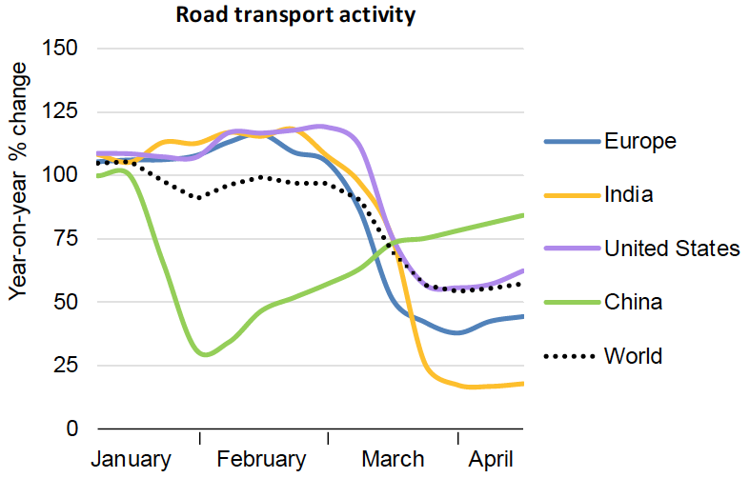

Although the UK Government have firmly set targets in improving carbon emissions quality (section 2.1.), the demand for road transport for the UK is unconfirmed due to the lack of statistical analysis as the road transport activity analysed compares Europe with the rest of the world (Figure 2). Nevertheless, the COVID-19 pandemic demonstrates its impact on China’s road transport activity from an estimated 100% down to 30% during their national lockdown at the start of February 2020 relative to 2019 From China, COVID-19 had spread throughout Europe enforcing national lockdowns as Europe had collectively resulted in their road transport activity to decrease from an estimated 110% to 40% in March 2020 relative to 2019.

Figure 3: The projected final energy demand by fuel and consumer sector from 2008-2035 in Millions of tonnes of oil equivalent (Mtoe) (GOV.UK, 2019).
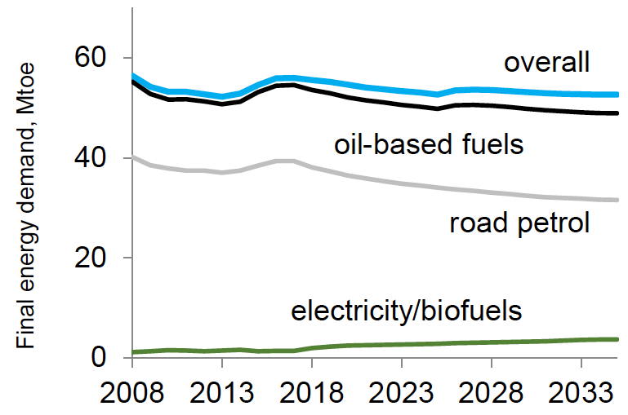

Although the UK Government implemented a target to produce every new van and car on the road with zero emissions by 2040 to improve on carbon footprint methodologies (section 2.1.), figure 3 displays the 2018 projection of the two most demanding fuel types are oil-based fuels and road petrol. Despite oil-based fuels and road petrol are predicted to stagnate from 55Mtoe down to 50Mtoe and from 40Mtoe to 30Mtoe respectively, the UK’s targets may become a challenge as the predicted demand for electricity/biofuels portrays a gradual flow with the highest demand projected to be approximately 5Mtoe by 2035.

  - Measuring the impact from aviation industry
Figure 4: CO₂ emissions from aircraft organisations monitored by EU Emissions Trading Scheme and assigned to the UK between 2013-2018 (Mtoe) (Environment Agency, 2020).

Figure 4 states the carbon dioxide emissions from aircraft organisations as a collective monitored by the EU Emissions Trading Scheme that was assigned to the UK between 2013-2018, although the data is only applicable to England. The dataset published by the Environment Agency (2020) is as recent as 2018 in regards to CO₂ emissions from aircrafts in the UK; the amount of CO₂ emissions appreciates by an estimate of 18% from 2013-2018. Despite the incline of CO₂ emissions, it is unknown if the dataset that will be published in 2021 or 2022 will portray a decline in CO₂ emissions for 2019 and 2020 from aircrafts in the UK due to the consequences of the BREXIT transition and the COVID-19 pandemic resulting to an increased difficulty to measure the UK’s current carbon footprint methodologies.

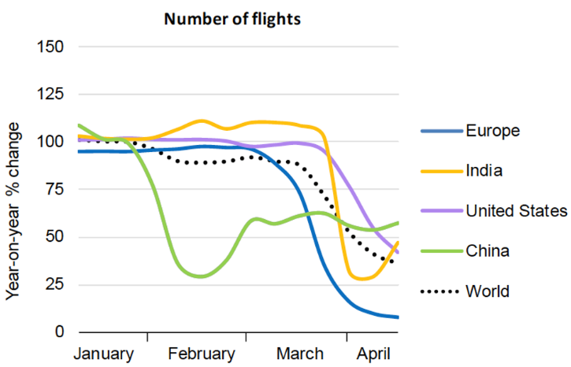
Figure 5: The change (%) in oil demand (mb/d) for global number of flights in the first quarter of 2020 relative to 2019 (IEA, 2020).

Figure 5 represents the demand of flights in Europe compared with the rest of the world in the first quarter of 2020 relative to 2019, measured in percentage of millions of barrels of oil per day (% mb/d). The demand for flights in the UK in 2020 is unconfirmed due to the lack of statistical analysis resulting in an increased difficulty to measure the UK’s current carbon methodologies. The demand for flights plummeting in Europe from approximately 100% in March 2020 down to 10% in April 2020 relative to 2019. Figure 5 trend shows similarity to figure 2 trend; the demand for flights in China had plummeted in February amidst their national lockdown followed by the rest of the world in March and April.

  - Measuring environmental impact
Figure 6: UK’s average daily nitrogen dioxide (NO₂) (μg/m³) statistics during the national lockdown in March and April 2020 relative to 2019 (DEFRA, 2020; Khoo, 2020).
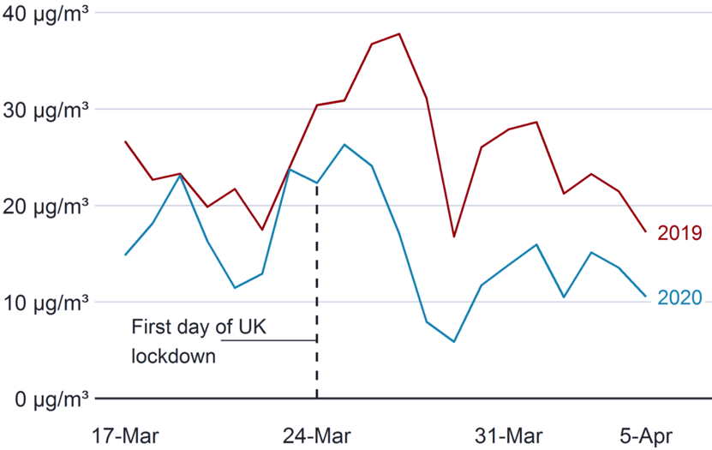

The COVID-19 pandemic resulted to a positive short-term impact on the environment, such as air quality; the demand for electricity, road transport activity and aviation activity plummet globally in the first quarter of 2020 resulting to the lack of carbon dioxide and other harmful greenhouse gases input into the atmosphere (Figures 1-5). Figure 6 outlines the UK’s average daily nitrogen dioxide (NO₂) (μg/m³) statistics during the national lockdown in March and April 2020 relative to 2019 (DEFRA, 2020). The first day of UK lockdown caused a decrease in NO₂ by approximately 7μg/m³ than on the same day in 2019 and the statistics remained to decline in 2020 relative to 2019; the reason being lack of road transport and aviation activity under COVID-19 restrictions, thus a decline in active carbon footprint methodologies.

  - Systematic recovery action plan for ‘green recovery’
In a press release by Pow (2020), the Parliamentary Under-Secretary of State for DEFRA establishes an incentive known as Green Recovery Challenge Fund along with Natural England and Environment Agency. The £40million scheme targets 3000 new jobs and protects another 2000 jobs in the field of environmental conservation. Funded by National Lottery Heritage Fund, grants from £50k to £5million are investments to conserve species, environmental conservation officers, creating environmentally friendly solutions to help mitigate the impact of climate change and encouraging methods to involve people with nature.

A statement by Goldsmith (2020) on Building a Clean and Resilient Recovery from COVID-19 in Support of Climate Action and the Sustainable Development Goals, the minister of Foreign and Commonwealth Office iterates how the Green Recovery Challenge Fund will be the focal point of COP26 (section 1.) suggesting the scheme allows other countries to design an action plan to economically and environmentally recover from the COVID-19 pandemic. This action plan is claimed to potentially reduce the cost of climate change mitigation methods by a third over the next decade;
- To enforce transnational companies to facilitate other countries’ economy using renewable energy to develop environmentally friendly jobs and enhance economic recovery providing cheaper power as part of the second phase of Mission Innovation.
- The next target is having vehicles with zero emissions to be cheaper than fossil fuel-based vehicles to allow a faster progression on implementing low-carbon transportation, thus reducing greenhouse gases emissions and improving human health.
- Implemented by the UN, all countries to focus on Call for Action on Adaptation and Resilience to have an approachable impact in mitigating the adverse consequences of climate change
- Lastly, to improve in protecting the natural environment. Globally, many people heavily rely on forests and seas. The adverse anthropogenic impact disproportionately contributes to climate change and poverty. Environmentally friendly based outcomes to tackle climate change include restoring and protecting woodlands and peatlands as well as planting trees to help reduce urban climate temperatures in cities.

- Conclusion
Although carbon footprint methodologies are measured subjectively in the UK as in other countries, comparing such methodologies as road transport activities and aviation activities vary between data sources, thus making such comparison prone to inconsistency. For example, figure 4 and figure 5 discuss measuring the impact from the aviation industry (section 2.4.); although both figures explain the impact as a carbon footprint methodology, figure 4 states how aircraft organisations contributed to CO2 emissions monitored by EU and affiliated with the UK and figure 5 states how the demand for flights, compared Europe with the rest of the world and not comparing the UK with the rest of the world. Furthermore, the difficulty in an attempt to analyse data from the same reputable source became evident due to the lack of statistical analysis. Although the UK Government have targeted to legislate the production of net-zero emissions by 2050 and to sell every new car and van producing net-zero emissions by 2040 (GOV.UK, 2018; Skidmore, 2019), the projection shows that the UK will still depend on oil-based fuels and road petrol as predicted for 2035 (figure 3).

The impact of the covid-19 pandemic had benefits and setbacks for the environment and economic progression. Such benefits for the environment include a short-term impact of improved the UK’s air quality (figure 6) caused by the lack of activity in carbon footprint methodologies; the activities to supply the electricity demand (figure 1), road transport (figure 2) and aviation (figure 4 and figure 5) were temporarily hindered with restrictions of national lockdowns globally. Such setbacks include a potential short-term hindrance in the economic progression, enforcing the UK Government to implement the Green Recovery Challenge Fund fundamentally for the UK and other countries (Goldsmith, 2020).

- References
- BEIS (2020). Dataset for quarterly and monthly supply and consumption for electricity. [electronic dataset] (Accessed: 27th November 2020).
- DEFRA (2017). UK plan for tackling roadside nitrogen dioxide concentrations. p4. (Accessed: 12th April 2020).
- DEFRA (2020). air pollution since lockdown for sharing. [electronic dataset] (Accessed: 27th November 2020).
- Fang, K. (2020). Environmental Footprints: Assessing Anthropogenic Effects. Switzerland: Springer Nature. (Accessed: 26th November 2020).
- Goldsmith, Z. (2020). Building back a green and resilient recovery. [speech] (Accessed: 9th November 2020).
- GOV.UK (2015). UK government pledges bold ambition for electric cars. Available at: https://www.gov.uk/government/news/uk-government-pledges-bold-ambition-for-electric-cars (Accessed: 12th April 2020).
- GOV.UK (2018) PM speech on science and modern Industrial Strategy: 21 May 2018. Available at: https://www.gov.uk/government/speeches/pm-speech-on-science-and-modern-industrial-strategy-21-may-2018 (Accessed: 12th April 2020).
- GOV.UK (2020). COP26 postponement. Available at: https://www.gov.uk/government/news/cop26-postponement (Accessed: 1st November 2020).
- GOV.UK (2020). Prime Minister on coronavirus (COVID-19): 23 March 2020. Available at: https://www.gov.uk/government/speeches/pm-address-to-the-nation-on-coronavirus-23-march-2020 (Accessed: 1st November 2020).
- GOV.UK (2020). Annual CO₂ emissions from aircraft operators. [electronic dataset] (Accessed: 27th November 2020).
- IEA (2020). Global Energy Review 2020. The Impact of the Covid-19 crisis on global energy demand and CO₂ emissions. p18. (Accessed 27th November 2020).
- Khoo, A. (2020). Coronavirus lockdown sees air pollution plummet across UK. BBC News. Available at: https://www.bbc.co.uk/news/uk-england-52202974 (Accessed: 27th November 2020).
- Industrial Strategy (2018). The Road to Zero. HM Government. pp 2-6. (Accessed: 12th April 2020).
- Pow, R. (2020). Government’s £40million Green Recovery Challenge Fund opens for Application [press release] (Accessed: 9th November 2020).
- UNCC (2020). The UK to host crucial climate change conference. Available at: https://www.ukcop26.org/ (Accessed: 1st November 2020).
- UNCC (2017). UN Climate Change Conference 2017 Aims For Further, Faster Ambition Together. Available at: https://unfccc.int/news/un-climate-change-conference-2017-aims-for-further-faster-ambition-together#:~:text=The%20ultimate%20objective%20of%20all,naturally%20and%20enables%20sustainable%20development. (Accessed 3rd November 2020).

