Corina Cernat 2019920
University of wales trinity saint david 2024
Impact of corporate sustainable initiatives on employee engagement and retention in South Wales

Abstract
In the present era of increased concern towards sustainability, organisations are progressively adopting environmental and social responsibility initiatives. This dissertation examines the influence of these activities on a vital element of company success - workforce retention and engagement. This research examines the connection between how employees perceive a company's sustainability initiatives and their level of commitment to the organisation, specifically in the context of South Wales, an area known for its distinctive industrial history and strong emphasis on sustainability.
The study's objectives are to:
- Examine the impact of employee perceptions of a company's sustainability procedures on their level of engagement and likelihood to stay with the organisation.
- Evaluate the level of employee knowledge and engagement in business sustainability initiatives.
- Identify possible barriers that prevent these programmes from promoting a more involved workforce.
The researcher uses a mixed methods approach to collect data from employees at different organisations located in South Wales. The findings provide significant insights for firms aiming to utilise sustainability to cultivate a more committed and devoted personnel. This research provides gains not just to South Wales but also to organisations worldwide, assisting them in designing sustainable programmes that improve the abilities of their employees.

Declaration and Statements

DECLARATION

This work has not previously been accepted in substance for any degree and is not being concurrently submitted in candidature for any degree.

Signed .......................... ..........................

Date ..................03.07.2024......................................................

STATEMENT 1

This work is the result of my own investigations, except where otherwise stated.

Other sources are acknowledged by footnotes giving explicit references. A bibliography is appended.

Signed ............. .............................................

Date ..............03.07.2024..........................................................

STATEMENT 2

I hereby give consent for my work, if accepted, to be available for photocopying and for inter-library loan, and for the title and summary to be made available to outside organisations.

Signed ............... ......................................

Date ....................03.07.2024....................................................

Contents
Abstract 1
Declaration and Statements 2
Acknowledgements 5
Chapter 1. Introduction 6
Chapter 2. Literature review 8
2.1. Sustainability concept 8
2.2. The significance of corporate sustainability programs in current business environments. 9
2.3. Corporate sustainability programmes in South Wales 11
2.4. Employee retention and engagement 11
Engagement 12
2.5. Importance of employee retention and engagement for businesses in South Wales. 12
Chapter 3. Methodology 14
3.1 Aims and Objectives 14
3.2 Research Rationale 14
3.3 Research Design 15
3.4 Research Paradigm 17
3.5 Data Collection 18
3.6 Population and Sample 19
3.7 Data and Analysis 20
3.8 Reliability and Viability 20
3.8.1 Limitations of the Research 20
3.9 Research Ethics 21
Chapter 4. Findings 22
4.1 Presentation and Interpretation of the Data 22
4.1.1 Introduction 22
4.1.2. Education and sustainability 22
4.1.3. Commitment and engagement 23
4.1.4. Retention 26
4.1.5 Qualitative analysis 27
4.2. Limitations 28
Chapter 5. Conclusion and Recommendations 29
5.1. Future research 29
5.2. Conclusion 29
5.3. Recommendations 30
Chapter 6. Reference List 32
Chapter 7. Appendices 44
Questionnaire 44
Ethics form 0

Figure 1 Research onion (Saunders et al, 2016) 15
Figure 2 Participation in sustainable practices according to level of education achieved 21
Figure 3 Level of awareness of sustainable initiatives in the workplace according to age group 22
Figure 4 Level of implication in sustainable business practices based on age groups 23
Figure 5 Relationship between level of commitment and organisation’s engagement with sustainability initiatives 23
Figure 6 Employees opinion on the company’s sustainable values 24

Acknowledgements
The successful completion of my dissertation would not have been achievable without the great assistance and mentorship provided by a few people. I would like to offer my sincere appreciation to my supervisor, Marie Pitson, for the constant support, feedback and commitment throughout this project. I would want to express my gratitude to the participating employees in South Wales who dedicated their time and provided valuable insights. Their desire to engage was crucial to the success of the study. Finally, I would like to extend my appreciation to my family and friends for their consistent support and empathy throughout this research project. I am extremely thankful for their support and confidence in me that provided me with motivation daily.

Chapter 1. Introduction
The 21st century has experienced a significant change in corporate responsibility. Sustainability has now become a fundamental principle of successful corporate operations. Corporate sustainability is a commonly used term that refers to the implementation of measures aimed at achieving sustainable development inside a company (Sheehy and Farneti, 2021). According to Sanchez‐Planelles et al (2022), the implementation of these principles includes the immediate and extended social, environmental, and economic success of a firm.
Businesses are increasingly recognising the influence on the environment and are embracing a broader objective that encompasses long-term sustainability, social responsibility, and conservation. Consumers are progressively determining their purchase choices by considering a company's ecological and impact on society (Deloitte, 2023). This phenomenon also applies to the workforce. According to an analysis conducted by Walters (2022), a substantial majority of professionals place a high value on working for organisations that demonstrate a commitment to environmental and social responsibility. The increasing focus on sustainability provides a compelling chance to examine its influence on a vital element of any organisation - its personnel. Employee engagement and retention are vital for the success of a firm, as they result in higher levels of productivity, creativity, and customer happiness (Koden, 2020).
This study examines the correlation between company sustainability activities and employee engagement and retention in South Wales. According to Lang and Marsden (2023), the government and in Wales has shown a greater interest in engaging with essential economics compared to other governments. Additionally, they have enacted well-being legislation specifically aimed at ensuring long-term sustainability. The Welsh Government has established environmental objectives, with the goal of achieving carbon neutrality by 2050, as stated in the Welsh Government's publication "Prosperity for Wales: A National Strategy 2020" (Climate Change Committee, 2023). The emphasis on sustainability in the region provides an ideal opportunity to explore the impact of business actions in this field on employee engagement and retention.
The aims and objectives of this research are to:
- Explore the relationship between employee perception of corporate sustainability efforts and their commitment to the organization.
- Assess the level of awareness and participation of employees in corporate sustainability initiatives.
- Investigate possible obstacles or problems that prevent corporate sustainability
initiatives from improving employee engagement and retention.

By recognising and understanding these obstacles, firms may formulate more efficient approaches to utilise sustainability to cultivate a workforce that is more committed and loyal.
This dissertation seeks to provide significant insights into the relationship between corporate sustainability and human capital, so contributing to the expanding knowledge in this field. The findings of this study can offer valuable insights to companies in the region and beyond. Businesses can identify specific areas where their sustainability strategies should be enhanced to retain and engage current and future workers, while also creating a beneficial influence on the environment and society.

Chapter 2. Literature review

2.1. Sustainability concept
Sustainability, as it applies to the business domain, denotes the implementation of operational and growth strategies that are both environmentally and socially responsible and achieve an optimal balance among these factors (Wosińska, 2023). The ultimate objective of business sustainability is to foster a future characterised by increased resilience, equity, and prosperity for every stakeholder—including but not limited to shareholders, employees, clients, and the wider community.
Sustainable Business Practices (SBPs) refer to actions, initiatives, or policies that seek to address environmental and social issues while still generating profits (Tura et al, 2019). The sustainable development of a company is given by the three pillars: environmental, economic, and social (Mori, 2022). The management systems of the organisation are integrated with the three pillars. The source of the three-pillar paradigm has been linked to the Brundtland Report, Agenda 21, and the 2002 World Summit on Sustainable Development (Purvis et al, 2019).
The social component of a company's sustainable growth relates to principles that foster fairness and uphold the rights of individuals. According to Safdie (2024), these principles include:
- Addressing social exclusions and prejudice, facilitating reintegration, advocating for gender equality, mitigating the gender wage disparity, fostering training opportunities, promoting open debate, and upholding universal social rights.
- Encouraging solidarity: contribute to the reduction of social disparities by partnering with local and international organisations and initiatives, and giving priority to fair trade items that provide a fair wage for farmers and support the advancement of sustainable agriculture.
- Enhancing the welfare of stakeholders by promoting information sharing and transparency, tailoring working hours to employee profiles, and ensuring accessibility for individuals with impaired mobility.
The economic pillar centres on the capacity of enterprises to make meaningful contributions to economic development and expansion (Beattie, 2024). Put simply, they need to actively support and advance environmental protection by minimising the hazards associated with their industrial processes (Gomes-Silva, 2022). Consequently, the incorporation of product recycling and the adoption of renewable energy sources are essential components in the advancement of the economic foundation.
The foundation of the environmental pillar according to Greenland et al (2022) is based on a dedication to safeguard the environment through the reduction of risks and the assessment of firms' activities' impact on the environment. Anderson (2023) suggests that the obstacles faced by firms in this domain are as follows:
- Conserving and safeguarding renewable energy and agricultural resources
- Evaluating their carbon footprint and minimising overall greenhouse gas emissions to effectively accomplish sustainable development objectives.
- Mitigate water shortages and minimise total waste for present and future generations.
Sustainable business practices typically promote positive social outcomes, including community engagement and equitable labour practices, in addition to reducing negative environmental impacts, such as waste generation and greenhouse gas emissions (Raza and Woxenius, 2023). The main reason for adopting SBPs typically arises from environmental legislation and regulations. However, there is also a growing emphasis on business goals, such as enhanced profitability and increased product quality. As a result, companies are increasingly engaging in SBPs to reach ideal conditions where there are economic, environmental, and social advantages for key stakeholders and networks. Essentially, this often results in higher financial gain and a stronger ability to stand out for the company, as well as a decrease in negative impact on the environment and an improvement in overall social welfare for the whole network, including suppliers, consumers, other interested parties, and society (DiBella et al. 2023).

2.2. The significance of corporate sustainability programs in current business environments.
Since 2010 there has been a growing interest in the topic of corporate sustainable initiatives in the literature on organisational behaviour and human resources management. Most of the research conducted has focused on the broader implications at a macro level (Jones & Rupp, 2018; Ahmad et al., 2022;) and the positive effects on companies' financial performance (Singh & Misra, 2021). Few studies have looked at how workers, as an internal stakeholder group, are impacted by the company's sustainability initiatives, even though employees are essential to the success of any organisation and represent a significant stakeholder group (Glavas, 2016). Several studies have attempted to investigate the influence of corporate sustainable programmes on employee attitudes and behaviours, and it was found that these initiatives influence job satisfaction (Glavas and Kelly, 2014), corporate loyalty (Rahman et al., 2016) and job efficiency (Chaudhary, 2018).
Some studies (Bapat & Upadhyay, 2021; Podgorodnichenko et al., 2021) have explored the impact of sustainable programmes on employee turnover intention and found a significant correlation between them. However, other studies (Ouakouak et al, 2019) have argued that employee retention is not influenced by their perception of internal or external sustainable activities. A study done by Farooq et al (2019) has shown that the impact on workers varies depending on the kind of corporate sustainability programmes. The activities that prioritise the wellbeing and development of workers have the most beneficial impact, followed by those that prioritise the improvement of the community and society. Employee engagement is expected to increase when individuals experience a sense of connection and belonging to a broader purpose inside their work environment.
Gen Zs and millennials consistently prioritise environmental sustainability with most of them actively engaging in efforts to reduce their environmental footprint. Furthermore, a significant majority of Generation Z individuals (77%) and millennials (79%) believe that governments should have a more prominent role in compelling businesses to tackle the issue of climate change, according to the most recent Gen Z and Millennial Report conducted by Deloitte (2024). Respondents of this survey believe that corporations have the most chance and essential power to effect change in the social problem of protecting the environment. Gen Zs and millennials are exerting pressure on businesses to do so, both through their professional choices and their purchasing actions. Approximately 54% of individuals belonging to Generation Z and 48% of millennials report that they and their peers are exerting influence on their employers to address the issue of climate change. This inclination has been consistently growing since 2022, when 48% of Generation Z and 43% of millennials expressed the same feeling (Deloitte, 2024). If individuals are unable to instigate transformation inside their own organisations, they may be inclined to transition to a new position, or even another sector.
In terms of education level, it has been proved that higher educated people are more eco conscious and involve in sustainable initiatives (Mendes et al, 2022). This is because they are expected to possess a good understanding of environmental matters and hold the necessary information to make sustainable decisions. Another reason is that education enables individuals to acquire the necessary abilities to investigate sustainable practices, evaluate environmental facts, and make well-informed decisions on consumption and behaviour.
According to Zhao et al (2021), many organizations in the twenty first century understand that a commitment to sustainability is essential to their continued existence and that adopting a new, environmentally conscious managerial style is imperative. The belief that sustainability is a critical component capable of producing a sustained competitive edge is supported by the evidence that it improves both financial and operational performance (Cachón-Rodríguez et al., 2021). Organisations need to maintain a balance between pro-environmental activities and financial development (Unsworth et al, 2021). Consequently, it is up to businesses to achieve sustainable objectives by considering the effects of their decisions on the environment (Ahmad et al. 2021).
Demands for Human Resource Management (HRM) to become sustainable are growing as more and more organisations claim that they have improved their sustainability and have made commitments to global sustainable development. The adoption of procedures and practices that enable the accomplishment of social, financial, and ecological objectives by having an impact on the inside and outside of a company over a longer time frame, while also considering unforeseen consequences and negative feedback, is a definition of sustainable human resource management (Ehnert, et al. 2016, Macke and Genari, 2019). It contributes to an organization's ability to confront labour market challenges such as retaining and attracting talented individuals, facilitating a healthy work-life balance for staff, cultivating employee trust, encouraging lifelong learning, managing the active ageing of the population, and enhancing the quality of life for both staff and the community (Cachón-Rodríguez, G. et al. 2022).

2.3. Corporate sustainability programmes in South Wales
The government and policy communities in Wales have shown a greater interest in engaging with fundamental economics compared to other governments, according to Lang and Marsden (2023). Additionally, they have enacted well-being legislation specifically aimed at ensuring long-term sustainability. The Well-being of Future Generations (Wales) Act 2015 (GOV, 2023) makes Wales the sole country globally to have laws specifically addressing the Sustainable Development Goals. The Act establishes national objectives for well-being and a principle of sustainable development. This enables businesses to make informed decisions that are integrated, proactive, and focused on the long-term. These decisions are made through collaboration among public, private, and third sector partnerships, and with the involvement of those who will be impacted by the results (GOV, 2023).

2.4. Employee retention and engagement
Any organization's ability to retain its workforce is essential to its success, and finding and keeping competent workers has grown more difficult for businesses all over the world. The practices implemented by an organisation to prevent employees from departing are referred to as employee retention (Book et al, 2019). According to Chaudhary (2019), employees who believe that their companies are ethical business partners find more meaning and purpose in their work, feel more comfortable being authentic at work, and become more psychologically available, all of which contribute to higher levels of engagement. Another study conducted by Lu et al (2020) concluded that there is a positive and strong relationship between corporate sustainable programmes and employee engagement and illustrate that providing proper care for employees is a beneficial investment, resulting in increased organisational commitment and employee engagement.

One of the biggest advantages of the company's sustainability initiatives so far, according to a Deloitte survey (2023), is the recruitment and retention of employees as well as their morale and wellbeing. This supports earlier research on the significance of sustainability for worker retention and satisfaction. With this perspective in mind, companies are encouraged to be socially conscious and lead the way in implementing successful sustainable activities.

Engagement
The notion of employee engagement has received increased attention in academic literature and management practices, and it has been regarded as a significant construct in the fields of business, human resource management, and organisational psychology (Kossyva et al. 2023)
According to Mone and London (2018), concepts like employee motivation, commitment, and employee satisfaction are not related to engagement (Mone and London, 2018). It even goes beyond as to characterise workers' emotional investment in their work, which motivates them to perform to the best of their abilities and encourages them to be more focused on results.
The psychologist Kahn (1990) is one of the first who tried to define engagement and says this concentrates on the ways in which individuals express themselves mentally, physically, and emotionally in the course of their work. The research that showed the greatest evidence of a relationship between engagement and performance was conducted using an Utrecht Work Engagement Scale (UWES) version (Schaufeli and Bakker 2004). They described engagement as a positive, satisfying, job-related state of mind and an engaged worker one who exhibits a high sense of enthusiasm towards, devotion to, and immersion in work tasks.
Academic literature (Saks, 2022) strongly defines employee engagement as a psychological condition that employees feel It must be distinguished from work quality, employee conduct, or managerial decisions. It is obvious that employees who feel engaged are healthier, happier, satisfied, or more driven (CIPD, 2023). Research suggests that there are positive connections between employee engagement and a variety of business KPIs for firms, including customer satisfaction, retention, innovation, productivity, efficiency, and health and safety performance (CIPD, 2021).
Employee engagement, within the context of sustainable business, involves developing a strong feeling of purpose and commitment among employees towards sustainability practices, projects, and values (Kolkowska, 2023). In such situations, personnel are driven by a deep connection to the organization's goal, a conviction in the significance of sustainable procedures, and a commitment to have a positive impact on both nature and society.

2.5. Importance of employee retention and engagement for businesses in South Wales.
In the current competitive environment, employee retention and engagement are essential for the success of businesses in South Wales. Welsh businesses that prioritise the satisfaction of their employees will experience substantial advantages, as a competent workforce is a critical component of economic growth.

High personnel turnover causes operational disruptions, results in the loss of important knowledge and expertise, and generates substantial expenses in terms of recruiting and training (Allen and Bryant, 2012). On the contrary, engaged employees demonstrate higher levels of productivity and contribute to maintaining a great work environment (Hunter, 2023). This, in turn, leads to a stronger brand reputation, enhanced consumer satisfaction, and improved loyalty. This promotes innovation and a competitive advantage, enabling businesses in South Wales to compete on a national and even international scale. In addition, given the distinctive economic environment of South Wales, which emphasises industries such as technology and renewable energy (Welsh Parliament, 2023), it becomes even more imperative to maintain a highly proficient workforce. In 2023 the Welsh Government has developed the Net Zero Skills Action Plan: ‘Stronger, Fairer, Greener Wales’ where the main objectives are to analyse the present skills landscape in various industries, develop a highly trained workforce capable of achieving net zero emissions, and enhance the overall skills framework (GOV Wales, 2023).
By allocating resources to enhance employee skills, providing attractive rewarding packages, and promoting a work environment that values both professional and personal life, companies can secure the necessary workforce to drive these industries and contribute to the general economic wellbeing of the region. To summarise, placing a high importance on retaining employees and ensuring their commitment is not just a recommended approach, but a crucial necessity for businesses in South Wales to thrive in the competitive market and contribute to the ongoing economic growth of the region.

Chapter 3. Methodology

3.1 Aims and Objectives
The aims and objectives of this research are to:
- To explore the relationship between employee perception of corporate sustainability efforts and their commitment to the organization.
- To assess the level of awareness and participation of employees in corporate sustainability initiatives.
- To investigate possible obstacles or problems that prevent corporate sustainability initiatives from improving employee engagement and retention.

3.2 Research Rationale
The rationale for this research links to the sustainability concept, that has become more significant and assumes a more crucial part in everyone’s daily lives. Therefore, it is important to comprehend how the adoption and integration of sustainable practices within organisations affect the connection between employees and the organisation. In addition to being a great asset for the overall success of firms, employees also play a crucial role in promoting sustainable habits inside their companies.
In the March 2023 worldwide State of the Consumer survey conducted by Deloitte (2023) Consumer Centre, 69% of employed individuals expressed a desire for their employers to allocate resources towards sustainability initiatives, such as carbon reduction, renewable energy utilisation, and waste reduction. The feeling is more pronounced among questioned employees aged 18 to 34, who shown a greater inclination towards sustainability activities compared to respondents from older age groups.
Employee engagement is an essential driver at the core of this transformational movement. It is the key to unleashing a multitude of benefits, including improved productivity and innovation, as well as increased consumer loyalty and reputation (Kolkowska, 2023). The level of support that employees perceive from their organisation towards environmental activities has a favourable correlation with their involvement in eco-initiatives. Employees who perceive that their companies appreciate and endorse their sustainable attitudes are more likely to exhibit sustainable behaviours and cultivate a positive attitude towards the workplace (Bhatnagar and Aggarwal, 2020).
Organisations can fully utilise the potential of their workers to drive sustainable practices by fostering a strong sense of purpose, offering chances for learning, acknowledging their efforts, and ensuring that their values are aligned. The mutually beneficial connection between engaged employees and long-term prosperity sets the stage for a future in which enterprises not only achieve financial success but also make a constructive and enduring contribution to the environment and society.

3.3 Research Design
The experimental arrangement or strategy utilised to investigate the question or hypothesis of interest is referred to as the research design (Kazdin, 2021). In general, the design process will involve the initial formulation of the research question, a consideration of the type of data to be collected and the method of collection, the planning of the sample, the decision of how the proposed data is to be analysed, and the consideration of the research's presentation and distribution (Hammond and Wellington, 2021).
- Ontology deals with the fundamental concerns regarding the nature of reality, existence, and being (Kumatongo and Muzata, 2021). It explores our beliefs and understanding of what makes reality.
- Epistemology explores inquiries into the nature of knowledge and truth, as well as the processes through which individuals acquire knowledge. It seeks to understand how people ascertain the validity of their knowledge and identify trustworthy sources of information (Onghena et al 2019).
- Axiology deals with topics related to ethics and value systems. It focuses on determining what is morally right or wrong, ethical, or unethical, and making normative judgements (Shannon-Baker, 2022).
- Methodology is a framework that helps researchers choose the most suitable methods for studying the world (Hanson-DeFusco, 2023). It supports them in determining how they should approach their inquiries.
Selecting a research technique, which is a suitable framework, is surely one of the most challenging and confusing stages encountered by most researchers. This is because each sort of study necessitates distinct methodologies and procedures for data collection and subsequent analysis, resulting in the presentation of major findings. There are many types of research procedures and frameworks, each with its own set of benefits and drawbacks. "The research onion" is a widely used and comprehensive research structure (Alturki, R. 2021). The research onion is a prominent and often utilised research structure in the field of research.
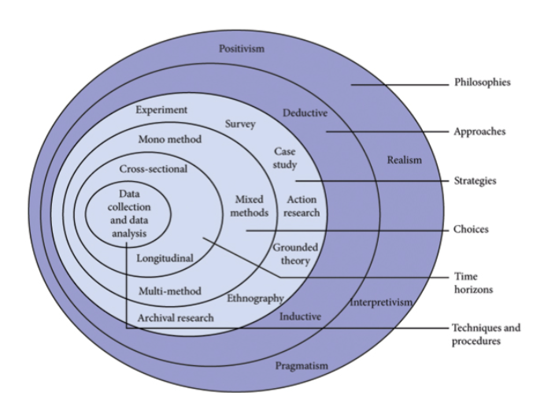
Figure 1 Research onion (Saunders et al, 2016)
Each layer of the onion addresses a distinct part of the study, illustrating the diverse perspectives, techniques, and choices employed by researchers in their studies. The model consists of six layers: the researcher's philosophical stance, the methodology, research methods, choices, research timeframes, and the data collecting methods utilised by the researcher (Bianchi, 2021).
The investigation for this topic will involve an inductive approach. Inductive research involves the process of moving from specific facts relating to a given phenomenon towards a more general or abstract understanding of the phenomenon (Varpio et al, 2020). The technique used is a bottom-up strategy, which means that it starts with data and then moves towards abstract conceptualizations. The researcher gathers data pertaining to an occurrence and analyses it to identify patterns, so developing a comprehensive understanding of the phenomenon (Proudfoot, 2023). An inductive approach is effective for the present study because the subject has not been extensively studied and the sampling group has not been previously included in research investigations (DeJonckheere et al, 2024). In such instances, an inductive approach enables the data to express itself without the influence of a preexisting framework.
The objective is to reach a comprehensive conclusion that will assist businesses in South Wales in comprehending the correlation between employee engagement and retention and corporate sustainability programmes.
A mixed method approach will be utilised since it may offer a comprehensive understanding of the research question and present a range of evidence (Poth & Munce, 2020). Mixed-method research utilises a mixture of qualitative and quantitative methodologies, selected based on the study's objectives and the nature of the research issue, with the aim of increasing comprehension of the subject field. These approaches integrate the advantages of both quantitative and qualitative techniques, making them beneficial when a single methodology is unsuitable for research (Bell and Waters, 2018).
When seeking to generalise the results to a larger population and gain a comprehensive knowledge of the significance of a phenomena or concept for individuals, it is advantageous to gather both closed-ended and open-ended questions. This approach aids in comprehending a study topic. (Dawadi et al, 2021). In addition, the use of qualitative data, like focus groups and interviews, can enrich the depth of research inquiry by enabling the analyst to get a more comprehensive knowledge of the phenomenon with narratives. Utilising a quantitative data collection technique can improve the study by allowing the researcher to collect data from several people, thereby gaining a full grasp of different aspects of an event. (Taherdoost, 2022).
Engaging in or assessing mixed methods research also comes with several limitations. The challenges may encompass several factors, such as the need for additional time, financial resources, expertise, or prior experience to adequately plan, implement, and record the study. In addition, there might be ethical, practical, or theoretical issues associated with the sample, data collection, data analysis, or data integration. Furthermore, if the qualitative and quantitative methodologies rely on conflicting or inconsistent beliefs, paradigms, or methods, it might result in conflicts or issues for both the examiner and the audience. (Arsic, 2023).

3.4 Research Paradigm
A research paradigm refers to the theoretical or philosophical foundation upon which a research study is based (Khatri, 2020). A paradigm is constructed upon fundamental beliefs on ontology, epistemology and the approaches used to study and understand phenomena. These parts are crucial for the basis of research, and it is necessary to possess full knowledge to achieve success in conducting the study.
It is regarded as a research philosophy. The research paradigm provides guidance to the researcher in structuring and conducting their study, as well as in interpreting the significance of the events being studied. It is important to remember that paradigms are often characterised by four distinct principles (Pabel et al, 2021). Positivism is a research paradigm that aims to understand and forecast events in the social environment by identifying patterns and cause-and-effect relationships among its components (Bonache and Festing, 2020). Critical Realism is a comprehensive philosophy of science that integrates positivist and constructivist approaches to provide a thorough comprehension of ontology and epistemology (Lawani, 2021). The objective of this strategy is to analyse the underlying cause-and-effect relationships between social events to get a more thorough understanding of issues and then provide strategic recommendations for addressing social problems (Fletcher, 2017).
Interpretivism disputes the notion of fundamentally identical truth. In the data analysis, the researcher integrates their own subjective perspective by including their personal values and views (Saunders, et al., 2012). The conclusions primarily rely on the researcher's interpretation. Through this strategy, individuals may examine social reality from many perspectives. Adopting an interpretivist position implies that the researcher will generate an unusual or surprising result, or at the very least a finding that may seem unexpected (Saliya, 2023). Pragmatism is a research approach that assumes it is possible to utilise both positivist and interpretivist perspectives, depending on which one is most effective for a certain research subject (Melnikovas, 2018). This paradigm is based on the notion of using the most efficient methods to analyse real-world problems, allowing for the use of several data sources and types of knowledge to solve research questions. This attribute deems it appropriate for conducting mixed methods research, whereby data from both quantitative and qualitative sources are collected and integrated within a single study, in addition to for multimethod research, which entails the utilisation of several forms of data, either qualitative or quantitative. (Saliya, 2023). The present study follows a pragmatism paradigm as it does not give special importance to any form of knowledge or research approach and enables the acceptance and acknowledgment of validity among different views, interests and various information (Allemang, et al 2022).

3.5 Data Collection
The main study involves the use of a questionnaire to gather extensive data, which assists in statistical analysis and theory development. A questionnaire is a research tool including a set of questions designed to collect information from respondents. This research approach comes with several benefits, such as accessing many participants, producing consistent, measurable, information, obtaining qualitative data by asking open-ended questions, all while maintaining confidentiality and ensuring anonymity (Davies and Hughes, 2014).
The questionnaire features a range of question formats aimed at collecting thorough and sensitive data, including closed-ended questions such as multiple-choice, Dichotomous, Likert scale, and yes/no questions, which produced organised and easily measurable data. Demographic questions collected data on the characteristics of survey participants, including their age, gender, and level of education. This information aids in comprehending distinct sectors of the population. Ranking questions prompted respondents to assign a priority to different objects and provided valuable information about their preferences and priorities.
The questionnaire also included open-ended questions that enabled the researcher to collect qualitative insights on assessing the influence of sustainable business practices on employees and identify any obstacles that hinder employee engagement with the corporate sustainable programmes in South Wales.

3.6 Population and Sample
It is crucial to guarantee that the sample is representative of the group being examined. Otherwise, the results may not adequately depict the traits, attitudes, or behaviours of the broader population, resulting in biassed or deceptive conclusions. Employing a well selected method of sampling enhances the probability of acquiring a sample that accurately represents the population (Lakens, 2022).
The study's population of interest consists of people, groups, organisations, or other entities that the researcher aims to comprehend and to whom or which the study's findings may be applied or transferred (Casteel and Bridier 2021). This population is the primary focus of the research. Populations establish parameters for the extent of a research and offer environmental and contextual signals for the reader. These constraints provide limits on the research, allowing the researcher to maintain a specific emphasis and avoid presenting generalised data. Defining boundaries enables the researcher to precisely define subpopulations, including the target population, sampling frame, and sample. It also ensures that these groupings are properly aligned in the research (Turner, 2020).
The target population is a clearly defined group of prospective subjects that the researcher may engage with, and it appropriately reflects the features of the community of interest. The term "well-defined target population" refers to the specific criteria that determine who or what entities are eligible to participate in the study, including both inclusion and exclusion criteria. To correctly transfer the results of a research to the population of interest, it is necessary to operationalize the features of interest of the unit based on the study variables (Ackerman et al., 2019). Upon evaluating the study purpose, the attributes of the target population, and the resources at hand, a random sample has been selected from the employed population of South Wales. The survey has been administered to a sample of 100 employed adult individuals in South Wales who work either full-time or part-time.

3.7 Data and Analysis
The survey included a variety of closed ended question types, like multiple choice, Likert and rating scale, dichotomous. The responses have been exported to an Excel spreadsheet and analysed using graphs and pivot tables. Open ended questions have also been incorporated as they promote more accurate responses, offer a chance for feedback, and act as an indication of response quality (Neuert et al, 2021). Thematic analysis was employed to precisely identify themes and patterns of behaviour or meanings within the open questions enclosed in the questionnaire. Thematic analysis is the methodical process of combining data into meaningful patterns. Coding facilitates the classification and arrangement of data units to aid in the recognition and exploration of patterns, such as themes (Dejonckheere et al, 2024). This approach was chosen due to its adaptable nature in uncovering the experiences, perspectives, and actions of participants, with the aim of comprehending their thoughts, emotions, and behaviours (Nzekwe-Excel, 2022).

3.8 Reliability and Viability
Validity and reliability are essential factors for assessing the quality of the study. The first term describes the extent to which the research properly assesses what it aims to evaluate and faithfully represents the actuality of the topic under investigation. Validity can be preserved throughout the entire study when researchers consistently implement methods and standardise the circumstances under which data is collected (Coleman, 2021).
Reliability relates to the validity of the research, particularly with regards to the choice of appropriate methodology and the way those methods were employed and carried out in a research study. (Rose and Johnson, 2020). Offering a rationale for the used methodologies, together with clear and precise analytical techniques, enhances the perceived reliability of a study. It relates to the consistency and stability of the study findings, as well as their ability to be duplicated by other researchers (Lamichhane et al, 2024). Both validity and reliability are crucial for generating high-quality research that can be relied upon and utilised by others.

3.8.1 Limitations of the Research
The results and interpretations of the study may be influenced or impacted by the issues and challenges that researchers encounter during the study. Limitations are variables that are typically beyond the researcher's control and may influence the study's outcomes or their interpretation (Akanle et al, 2020). Despite the meticulous planning and execution of all studies, they are subject to some degree of limitation. This limitation could be related to the theoretical or methodological selection for the investigation, or it may relate to challenges encountered during the data collection process.
The limitations of this study are related to the quantity of data that can be gathered, as well as time limits, as the study must be completed by a certain deadline. Identifying a theory that explores the influence of business sustainability initiatives on the employed population of South Wales may be challenging if the sample size is deemed inadequate.

3.9 Research Ethics
Ethical concerns are crucial in any research initiatives as they provide the fundamental+6536 basis of honesty and responsible conduct. Resnik (2020) asserts that ethical behaviour has the potential to enhance confidence in both the researcher and the institution, facilitate the creation of new knowledge, and foster values such as justice and responsibility. Researchers must prioritise the rights, dignity, and overall welfare of every study participant. This involves obtaining informed permission, safeguarding privacy, and confidentiality, and minimising the potential for harm or discomfort (McGregor, 2023). Furthermore, researchers are required to adhere to established ethical principles and norms such as honesty, transparency, and accountability. Ensuring fairness, equity, and justice is crucial to prevent any form of discrimination and exploitation. The selected participants who completed the questionnaire have been provided with information on the safeguarding of their privacy and the collection of their data, as well as the assurance of anonymity in the study.

Chapter 4. Findings

4.1 Presentation and Interpretation of the Data

4.1.1 Introduction
In this chapter, the research results from the action study outlined in Chapter 3 are presented and examined. The empirical data was collected from a questionnaire that featured a range of questions formats, including closed ended questions. The first section included demographic questions meant to capture place of living, age and educational level, but also length of employment in the current workplace and a rating question about the level of commitment towards their organisation.
The second section involves an analysis of the open ended and closed questions meant to gather insights for the objectives set in the previous chapter. The questions aim to measure the level of commitment and engagement, impact of the corporate sustainable initiatives on the job satisfaction and the desire of employees to remain in their current employment, as well as any challenges they are facing when trying to take part in the environmental strategies. The respondents also had the opportunity to list any activities they would like to be incorporated in their workplace.

4.1.2. Education and sustainability
One of the important insights gathered from the questionnaire relates to the level of participation in the company’s sustainable practices. It was revealed that 66% of those who achieved a higher level of education are constantly engaging in these activities in their workplace. This aligns with a study conducted by Piao and Managi (2023) indicating that education plays an important part in the conservation of the environment. Specifically, those with higher levels of education have a greater tendency for engaging in environmentally conscious behaviours. This is because individuals in these positions are required to have a comprehensive comprehension of environmental issues and possess the necessary skills to make decisions that promote sustainability.

To achieve environmental sustainability, it is necessary to promote a lifestyle and consumption habits that are sustainable. Higher education institutions play a vital role in facilitating more effective governance and collaborative urban initiatives (Valor et al, 2020).
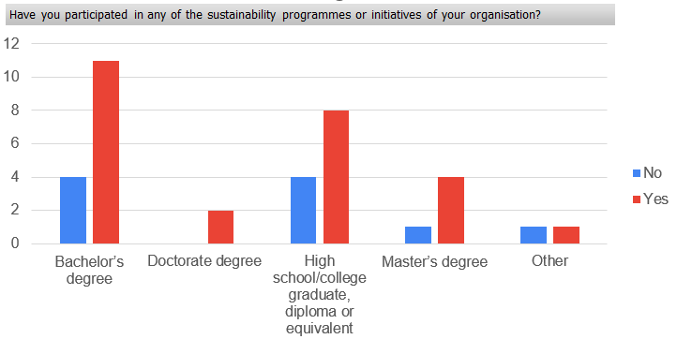
Figure 2 Participation in sustainable practices according to level of education achieved

4.1.3. Commitment and engagement
When it comes to ranking the level of commitment the respondents feel towards their organisation, 42% of them said they feel very committed, followed by 28% who are extremely committed to their workplace. When looking at the age group, 53% out of those who feel this level of commitment are part of the Millennial Generation (born between 1981-1996), followed by 32% belonging to Generation X (born between 1965-1980), and 20% are represented by the Baby Boomers (born between 1946-1964). The results from another statement in the survey revealed that 65% of the total respondents agree that their commitment to the organisation is positively influenced by the company’s sustainable initiatives, and 18% of them said they do not see any influence over their commitment. These findings link with the previously reviewed article by Kolkowska (2023) stating that in the context of sustainable business workers are driven by a deep connection to the organization's goals, a belief in the significance of sustainable practices, and a commitment to have a positive impact on the environment and society.

When asked about the awareness and implication in the sustainability programmes in their workplace, 85% of the millennials are very aware of the environmental initiatives and 71% of them are taking part in these programmes, 77% of the GenX individuals are also very aware and the same percentage are engaging with them, followed by 72% of Gen Z who are extremely aware of the corporate sustainable programmes and are also taking part in them. This enforces the initial findings of the research that states the millennials and Gen Zs constantly place a high importance on environmental sustainability, and most of them actively participate in initiatives to decrease their impact on the environment (Deloitte, 2024). These responses have contributed to the achievement of one of the objectives set for this research, which was to assess the level of awareness and participation of employees in corporate sustainability initiatives.
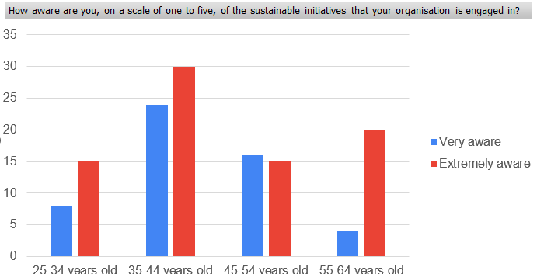
Figure 3 Level of awareness of sustainable initiatives in the workplace according to age group
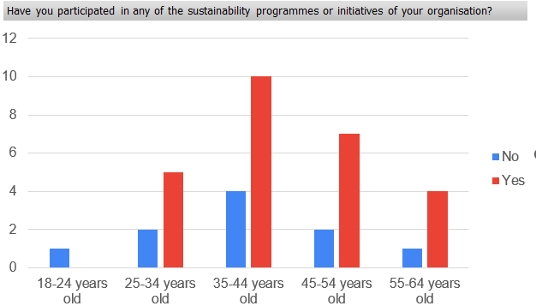
Figure 4 Level of implication in sustainable business practices based on age groups
The questionnaire responses also revealed that 67% of the people aged from 45-64 years old have been with the same employer for at least seven years, followed by 64% of the millennials. The survey results also show a strong connection between the level of commitment to the organisation and the belief that the company’s dedication to corporate sustainability makes it a desirable place to work. The responses have shown that 100% from the respondents who feel extremely committed to their organisation strongly believe their workplace is appealing due to its commitment to environmental strategies, whereas only 30% of the individuals who feel a moderate commitment share the same belief. These findings relate to the study conducted by Walters (2022) which revealed that a significant majority of professionals highly prioritise working for organisations that exhibit a strong dedication to social and environmental ethics.
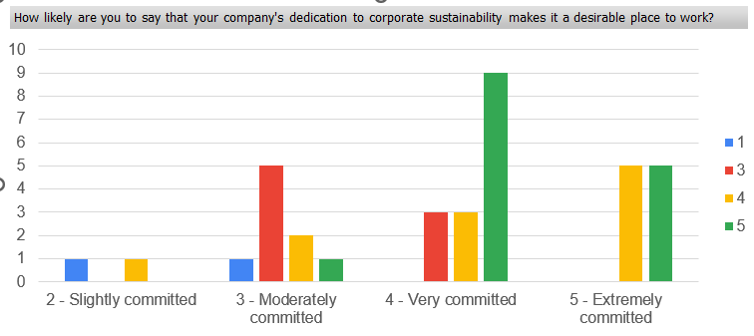
Figure 5 Relationship between level of commitment and organisation’s engagement with sustainability initiatives
The participants have also been asked to rate how much they agree or disagree with several statements that are meant to rate the impact of the sustainable practices on their level of engagement, commitment and motivation. The results show that 70% of them agree with the statement Corporate sustainability programmes positively impact employee engagement within the organisation and 12% disagree. Almost 65% of the respondents agreed the company shares the same sustainability values as their own, while 18% do not share the same views. These findings relate to the study conducted by Farooq et al. (2019) stating that employee engagement is anticipated to rise when individuals feel a sense of connection and belonging to a larger purpose inside their work environment.

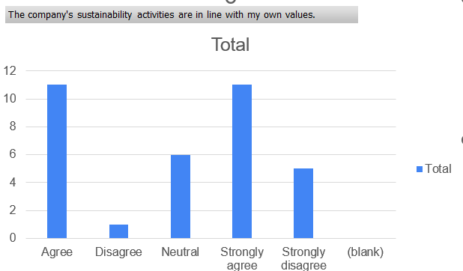
Figure 6 Employees opinion on the company’s sustainable values
The survey also revealed that 68% of the employees in South Wales agree that the company's environmental initiatives foster a sense of solidarity and collaboration among its personnel, followed by 18% of them who do not agree with this statement. A final declaration meant to measure the level of engagement revealed that 62% of the individuals feel that participating in the sustainable practices makes them feel more involved in the workplace. Those who do not agree with the positive impact on their engagement are representing 20% of the participants. A study undertaken by Lu et al (2020) has found a significant and strong correlation between corporate sustainable initiatives and employee engagement. It demonstrates that taking proper care of employees is a worthwhile investment, leading to higher levels of organisational dedication and employee engagement.
When asked to select the motivators that encourage the employees in participating in the sustainable initiatives, more than half of the respondents have selected the positive change this brings and the environmental impact. The alignment of personal values and teamwork are motivators for 33% of the employees. Also 33% stated that receiving rewards and recognition is a powerful motivator for engaging in the company’s sustainability programmes. According to Kolkowska (2023), providing recognition and rewards for sustainable efforts serves as a strong incentive for employees to actively participate in sustainable activities. Implementing formal recognition programmes that identify and promote employees' activities and accomplishments in sustainability fosters a constructive feedback chain. Incentives and rewards encompass a wide variety of offerings, including financial rewards linked to sustainability goals, public acknowledgment, awards, and professional growth prospects in sustainability-oriented positions (Marrucci et al. 2024). Acknowledging the work of employees not only strengthens their commitment but also evokes a feeling of satisfaction and accomplishment in contributing to a greater objective. Another statement meant to determine how many employees feel motivated to participate in the sustainable practices revealed that 60% of them are compelled to take part in such activities, whereas 20% are not influenced by these initiatives.

4.1.4. Retention
When analysing the retention level and the individuals’ opinion about the importance of a company’s dedication to sustainability in influencing their decision to remain or leave their job, 55.6% of them believe this is very important, followed by 25% who said is also significant. Nearly 3% of them said the organisation’s commitment to environmental responsibility has no influence in their decision to remain in the current employment. The respondents were also asked to select the impact of the corporate sustainability measures on their job satisfaction. The analysis shows that 89% of those who would remain with a company that engages in these policies rated their job satisfaction as excellent, followed by 50% who rated it as very good. Research conducted by Bapat & Upadhyay, (2021) and Podgorodnichenko et al. ( 2021) have examined the influence of sustainable programmes on employees' desire to leave their jobs and have identified a considerable association between them.
A company's sustainability programmes can significantly improve staff retention. Given the growing concern for social and environmental matters, employees need assurance that their organisation is actively promoting a diversified and healthy environment.
To achieve this, employers can request feedback from the staff on the modifications they seek. To initiate positive changes, it is desirable to provide energy-efficient technology in physical workspaces, make use of renewable energy sources, promote waste reduction, and encourage recycling (Sherman, 2023). Employers have the choice to provide incentives for sustainable mobility, such as commuting and public transit, or eliminate the need for commuting by promoting remote work opportunities.

4.1.5 Qualitative analysis
When asked about the sustainable initiatives their company engages in, 94% of the respondents indicated that their company engages in some form of sustainability practices. The most common programmes involve recycling, named by 50% of employees, the use of renewable energy, electric vehicles, operating a paperless office and using eco-friendly packaging, chosen by 22% of the respondents. The companies’ implication in sustainable practices in South Wales demonstrates the focus the government has placed on environmental strategies, considering is the first country in the world to implement legislation applicable to the Sustainable Development Goals (GOV, 2023).
Another 20% of people included carbon reduction policies and energy saving strategies, followed by nearly 10% who have said their company engages in volunteering programmes. These responses confirm the dedication of Wales to sustainable strategies, considering is among the first nations worldwide to include sustainability into its government policy and it aims to establish sustainable development as the primary guiding concept for government and public entities (GOV WALES, 2023). The country has set a goal to reach Net Zero by 2050 (Climate Change Committee, 2023) and has already achieved its objective for the first decade that ended in 2020 and is looking to intensify its efforts to stay on track.
The participants also had to name any obstacles they faced that prevented them from engaging more in the company’s sustainable practices, and 43% of them blamed the lack of time, followed by 20% who said they have not been offered the opportunity. Another 40% have said they have not encountered any difficulties when they have taken part in sustainable initiatives. When it comes to adjustments the participants would like to see in the workplace to increase the effectiveness of the sustainability efforts in improving staff retention and engagement, majority of them would like to see more environmental education and training for the staff on sustainable activities. On the opposite, only 8% of them mentioned rewards and recognition, which shows that for the employees the benefits these activities bring to the environment are more important than financial recognition. In their study, Farooq et al. (2021) found that providing environmental training to employees can enhance their awareness, knowledge, and abilities, leading to enhanced ecological behaviour.
The final question focused on extra environmental initiatives people would like their organisations to implement and majority of responses involved campaigning about the sustainability programmes they can participate in, as well as the impact on the environment. These responses are in accordance with the desire the participants have for companies to educate and provide more training for the employees on sustainability. A recent report by Deloitte (2024) found that more than half of GenZ and millennials are actively influencing their companies to tackle the problem of climate change.

4.2. Limitations
There are several methodological and conceptual restrictions that deserve attention. Firstly, the data gathering method was constrained to a certain time span, which resulted in the observation of a rather small sample. Moreover, the sample size could not adequately reflect the characteristics of the target population. According to Lakens (2022), this implies that the findings might only be applicable to the individuals who took part in the study, and it is important to use caution when generalising the findings to a larger group.
Another limitation is represented by the fact that not all the respondents provided answered for the closed ended questions, which had a negative impact on the insights that were gathered and the development of certain themes. Some of the qualitative questions were developed to investigate possible obstacles or problems that prevent corporate sustainability initiatives from improving employee engagement and retention, which represents one of the three objectives set of the research. The lack of responses from some of the participants implies that this goal could not have been achieved and a generalised theory has not been developed (Alvarez et al. 2021). Additionally, it is essential to recognise that the findings derived from the study are dependent upon the limitations of the sample's size and features, and hence cannot be universally extrapolated.

Chapter 5. Conclusion and Recommendations

5.1. Future research
To overcome the limitations of this study, future research initiatives might use a longitudinal approach that incorporates a bigger and more diversified population. Improving the generalisation of the results and enabling the determination of causal connections between variables would be facilitated by this (Andrade, 2020). However, the current research, due to its limited duration and sample size, was unable to demonstrate these connections. Furthermore, future investigations might examine the impact of contextual variables that may have had an effect but were not included in the objectives of this study. By overcoming these limitations, future research can expand upon the foundation established in this study and offer a more thorough comprehension of the influence of sustainable business practices on employee engagement and retention in South Wales.

5.2. Conclusion
The insights gathered from the data analysis had the scope to examine the aims and objectives set for this study. The first objective meant to explore the relationship between employee perception of corporate sustainability efforts and their commitment to the organization has been achieved as the results illustrated a strong connection between these variables. The second objective set to determine the level of awareness and participation of the employees in the business sustainability initiatives has also been established by revealing that more than 70% of individuals belonging to different generations take part in these programmes. This aligns with existing research by Deloitte (2024) indicating that millennials and Gen Zs consistently prioritise environmental sustainability and actively engage in efforts to reduce their environmental footprint.
The results also highlighted that in South Wales, organisations implement an extensive range of sustainability operations. There is an emphasis on green activities, like recycling programmes, carbon reduction, energy efficiency, the use of electric vehicles. Some companies also engage in volunteering opportunities. These sustainability approaches enhance employee engagement by cultivating a profound feeling of purpose and pride. Engaged employees have a greater tendency to have a sense of alignment between their job and their beliefs, as well as recognise the beneficial impact their work has. The findings also revealed a correlation between the sustainability activities and staff retention. Employees who consider their organisation as really dedicated to sustainability are less inclined to think about quitting their jobs.
In the present day, corporations are adopting a more significant objective, which encompasses
the concepts of protecting the environment, fulfilling social obligations, and ensuring a sustainable future (Irshad et al., 2023). In the current dynamic business environment, employees assess organisations and closely observe how they integrate sustainable practices into their daily activities. As a corporation, sustainability functions as a metric for assessing people’s influence and provides a means to evaluate the connection of environmental management, community wellbeing, and economic development. It can also lead to differentiation and offer possible advantage over competitors.
Employees desire to be involved in a mission that is worthy of their support. Simultaneously, employers are in pursuit of a stable, competent staff to improve the organization's capacity to adjust to evolving market conditions. There is a symbiotic relationship between employee retention and more sustainable efforts. Employers provide employees with a mission and purpose that are worth adhering to by creating strategies to optimise sustainability. Concurrently, it fosters a sense of loyalty and dedication to the organisation.
This research seeks to enhance the current understanding of company sustainability, staff retention and commitment to several aspects. This study presents empirical evidence from the South Wales area, enhancing the comprehension of the connection between these notions. The results confirm the idea that sustainability practices extend beyond external influences and have a beneficial impact on the internal work culture.

5.3. Recommendations
- Allocating resources to develop and support the staff may provide significant advantages for companies and play a crucial role in achieving sustained success, according to (Paillé et al.2020). A high turnover rate leads to both financial losses and the loss of key institutional knowledge. Companies may save recruiting and training costs and direct resources towards programmes that foster long-term development and innovation by prioritising the retention of skilled workers.
- Another recommendation for businesses in South Wales would be to promote and incentivize a shift in thinking and behaviour by implementing educational campaigns, conducting awareness-raising activities, and establishing a certificate or award system for enterprises that endorse the circular economy (Indeed, 2024). Until recently, most organisations have linked awards and incentives to sales and the productivity of their staff. Nevertheless, as organisations continue to enhance their dedication and initiatives towards the environment, it is imperative to establish a connection between incentive systems and the environmental achievements of the firm, as well as the environmental efficiency of individual corporate departments and employees.
- Other recommendations for companies would be to demonstrate the organization's dedication to sustainability through internal communication channels, social media, and mission statements (Ding et al, 2023). This can cultivate a sense of collective purpose among employees. By implementing programmes that reduce the company's environmental impact, including energy-saving measures, recycling initiatives, and the promotion of sustainable commuting options can induce employees to believe that they are making a positive environmental impact.

Chapter 6. Reference List
Ackerman, B., Schmid, I., Rudolph, K. E., Seamans, M. J., Susukida, R., Mojtabai, R., & Stuart, E. A. (2019). Implementing statistical methods for generalizing randomized trial findings to a target population. Addictive Behaviors, 94, 124-132. https://doi.org/10.1016/j.addbeh.2018.10.033
Ahmad, N., Ullah, Z., Aldhaen, E., Han, H., & Scholz, M. (2022). A CSR perspective to foster employee creativity in the banking sector: The role of work engagement and psychological safety, Journal of Retailing and Consumer Services, 67, 102968. https://doi-rg.ezproxy.uwtsd.ac.uk/10.1016/j.jretconser
Ahmad, S. et al. (2021) “Promoting green behavior through ethical leadership: a model of green human resource management and environmental knowledge,” Leadership & organization development journal, 42(4), pp. 531–547. Available at: https://doi.org/10.1108/LODJ-01-2020-0024.
Akanle, O., Ademuson, A.O. and Shittu, O.S., 2020. Scope and limitation of study in social research. Contemporary issues in social research, 105, p.114, available at Scope-and-Limitation-of-Study-in-Social-Research.pdf (researchgate.net), (Accessed on 28.05.2024)
Allemang, B., Sitter, K. and Dimitropoulos, G., (2022). Pragmatism as a paradigm for patient‐oriented research. Health Expectations, 25(1), pp.38-47, available at Pragmatism as a paradigm for patient‐oriented research - Allemang - 2022 - Health Expectations - Wiley Online Library, (Accessed on 15.06.2024)
Allen, D.G. and Bryant, P.C. (2012) Managing employee turnover: dispelling myths and fostering evidence-based retention strategies. 1st ed. New York: Business Expert Press.
Alturki, R. (2021) ‘Research Onion for Smart IoT-Enabled Mobile Applications’, Scientific programming, 2021, pp. 1–9. Available at: https://doi.org/10.1155/2021/4270998
Alvarez, G. et al. (2021) ‘Sample size, study length, and inadequate controls were the most common self-acknowledged limitations in manual therapy trials: A methodological review’, Journal of clinical epidemiology, 130, pp. 96–106. Available at: https://doi.org/10.1016/j.jclinepi.2020.10.018
Anderson, K. (2023) What are the 3 Pillars of Corporate Sustainability?, available at What are the 3 Pillars of Corporate Sustainability? (greenly.earth), (Accessed 30.05.2024)
Andrade, C. (2020) ‘The Limitations of Online Surveys’, Indian journal of psychological medicine, 42(6), pp. 575–576. Available at: https://doi.org/10.1177/0253717620957496.
Arsic, V., (2023), What are the benefits and challenges of mixed methods research?, available at Mixed Methods Research: Benefits and Challenges (linkedin.com), (Accessed on 26.05.2024)
Bapat, S. Upadhyay, P., 2021. Implications of CSR initiatives on employee engagement. Social Responsibility Journal, 17(2), pp. 149-163. Available at: https://doi.org/10.1108/SRJ-05-2018-0120.
Beattie, A. (2024) The 3 Pillars of Corporate Sustainability, available at The 3 Pillars of Corporate Sustainability (investopedia.com) (Accessed 30.05.2024)
Bell, J. and Waters, S. (2018) Doing your research project : a guide for first-time researchers. 7th edition. London: Open University Press, McGraw-Hill Education.
Bhatnagar, J. and Aggarwal, P., (2020). Meaningful work as a mediator between perceived organizational support for environment and employee eco-initiatives, psychological capital and alienation. Employee Relations: The International Journal, 42(6), pp.1487-1511, Available at: https://doi.org/10.1108/ER-04-2019-0187
Bianchi, L., (2021). Exploring ways of defining the relationship between research philosophy and research practice. Journal of Emergent Science, 20, p.32., available at https://www.ase.org.uk/system/files/Bianchi.pdf, (Accessed on 28.05.2024)
Bonache, J., & Festing, M. (2020). Research paradigms in international human resource management: An epistemological systematisation of the field. German Journal of Human Resource Management, 34(2), 99-123. https://doi-org.ezproxy.uwtsd.ac.uk/10.1177/2397002220909780
Book, L., Gatling, A. and Kim, J., 2019. The effects of leadership satisfaction on employee engagement, loyalty, and retention in the hospitality industry. Journal of Human Resources in Hospitality & Tourism, 18(3), pp.368-393, available at https://www.tandfonline.com/doi/abs/10.1080/15332845.2019.1599787, (Accessed on 12.04.2024)
Cachón-Rodríguez, G. et al. (2022) “How sustainable human resources management helps in the evaluation and planning of employee loyalty and retention: Can social capital make a difference?,” Evaluation and program planning, 95, pp. 102171-. Available at: https://doi.org/10.1016/j.evalprogplan.2022.102171
Cachón‐Rodríguez, G., Blanco‐González, A., Prado‐Román, C. and Diez‐Martin, F., (2021). Sustainability actions, employee loyalty, and the awareness: the mediating effect of organization legitimacy. Managerial and Decision Economics, 42(7), pp.1730-1739, available at Sustainability actions, employee loyalty, and the awareness: The mediating effect of organization legitimacy - Cachón‐Rodríguez - 2021 - Managerial and Decision Economics - Wiley Online Library, (Accessed on 10.04.2024)
Casteel, A. and Bridier, N. (2021) ‘Describing Populations and Samples in Doctoral Student Research’, International journal of doctoral studies, 16, pp. 339–362. Available at: https://doi.org/10.28945/4766.
Chaudhary, R. (2018), “Corporate social responsibility and employee performance: a study among indian business executives”, The International Journal of Human Resource Management, available at doi: 10.1080/ 09585192.2018.1469159
Chaudhary, R. (2019) “Corporate social responsibility perceptions and employee engagement: role of psychological meaningfulness, safety and availability,” Corporate governance (Bradford), 19(4), pp. 631–647. Available at: https://doi.org/10.1108/CG-06-2018-0207
CIPD, (2021), Employee engagement, An evidence review, available at Employee engagement: an evidence review (cipd.org), (Accessed on 05.05.2024)
CIPD, (2023), Employee engagement and motivation, available at Employee Engagement & Motivation | Factsheets | CIPD, (Accessed on 05.05.2024)
Climate Change Committee (2023) Progress report: Reducing emissions in Wales, available at Progress-Report-Reducing-emissions-in-Wales.pdf (Accessed 01.07.2024)
Coleman, P. (2021) ‘Validity and Reliability within Qualitative Research in the Caring Sciences’, International journal of caring sciences, 14(3), pp. 2041–2045, available at Validity and Reliability within Qualitative Research in the Caring Sciences - ProQuest, (Accessed on 27.05.2024)
Davies, M. and Hughes, N. (2014) Doing a successful research project: using qualitative or quantitative methods. Second edition. Houndmills, Basingstoke, Hampshire ; Palgrave Macmillan.
Dawadi, S., Shrestha, S., & Giri, R. A. (2021). Mixed-Methods Research: A Discussion on its Types, Challenges, and Criticisms. Journal of Practical Studies in Education, 2(2), 25-36 DOI: https://doi.org/10.46809/jpse.v2i2.20
DeJonckheere, M., Vaughn, L. M., James, T. G., & Schondelmeyer, A. C. (2024). Qualitative Thematic Analysis in a Mixed Methods Study: Guidelines and Considerations for Integration. Journal of Mixed Methods Research, 0(0). https://doi.org/10.1177/15586898241257546
Deloitte (2023), Deloitte 2023 CxO Sustainability Report, available at PowerPoint Presentation (deloitte.com), (Accessed on 05.05.2024)
Deloitte, (2023), Engaged employees are asking their leaders to take climate action, available at Engaged employees are asking their leaders to take climate action | Deloitte Insights, (Accessed on 20.06.2024)
Deloitte, (2023), What consumers need in order to adopt a more sustainable lifestyle, available at Sustainable Consumer 2023 - Sustainable Consumption | Deloitte UK (Accessed 02.07.2024)
Deloitte, (2024), 2024 Gen Z and Millennial Survey: Living and working with purpose in a transforming world, available at 2024 Gen Z and Millennial Survey: Living and working with purpose in a transforming world (deloitte.com), (Accessed on 20.06.2024)
DiBella, J. et al. (2023) “Exploring the potential of SMEs to build individual, organizational, and community resilience through sustainability‐oriented business practices,” Business strategy and the environment, 32(1), pp. 721–735. Available at: https://doi.org/10.1002/bse.3171
Ding, M.-C., Lii, Y.S. and Lai, K.F. (2023) ‘A great start? Sustainability mission statements affect consumer behaviour’, Environment, development and sustainability [Preprint]. Available at: https://doi.org/10.1007/s10668-023-04247-0.
Ehnert, I. et al. (2016) ‘Reporting on sustainability and HRM: a comparative study of sustainability reporting practices by the world’s largest companies’, The International Journal of Human Resource Management, 27(1), pp. 88–108. doi: 10.1080/09585192.2015.1024157.
Farooq, K. et al. (2021) ‘Exploring Challenges and Solutions in Performing Employee Ecological Behaviour for a Sustainable Workplace’, Sustainability, 13(17), pp. 9665-. Available at: https://doi.org/10.3390/su13179665.
Farooq, M., Farooq, O. and Cheffi, W. (2019) “How Do Employees Respond to the CSR Initiatives of their Organizations: Empirical Evidence from Developing Countries,” Sustainability (Basel, Switzerland), 11(9), pp. 2646-. Available at: https://doi.org/10.3390/su11092646
Fletcher, A.J. (2017) ‘Applying critical realism in qualitative research: methodology meets method’, International journal of social research methodology, 20(2), pp. 181–194. Available at: https://doi.org/10.1080/13645579.2016.114440
Glavas, A. and Kelly, K. (2014), “The effects of perceived corporate social responsibility on employee attitudes”, Business Ethics Quarterly, Vol. 24 No. 2, pp. 165-202, available at The Effects of Perceived Corporate Social Responsibility on Employee Attitudes | Business Ethics Quarterly | Cambridge Core, (Accessed on 24.024.2024)
Glavas, A., (2016). Corporate social responsibility and employee engagement: Enabling employees to employ more of their whole selves at work. Frontiers in psychology, 7, p.183377, available at Frontiers | Corporate Social Responsibility and Employee Engagement: Enabling Employees to Employ More of Their Whole Selves at Work (frontiersin.org), (Accessed on 20.04.2024)
Gomes Silva, F.J. et al. (2022) ‘The three pillars of sustainability and agile project management: How do they influence each other’, Corporate social-responsibility and environmental management, 29(5), pp. 1495–1512. Available at: https://doi.org/10.1002/csr.2287
GOV WALES (2023) Welsh Government’s Well-being of Future Generations continuous learning and improvement plan for 2023 to 2025, available at Welsh Government’s Well-being of Future Generations continuous learning and improvement plan for 2023 to 2025 [HTML] | GOV.WALES (Accessed 28.06.2024)
GOV Wales, (2023), Stronger, Fairer, Greener Wales: Net Zero Skills Action Plan, available at Stronger, Fairer Greener Wales: Net Zero Skills Action Plan (gov.wales), (Accessed on 30.04.2024)
GOV, (2023), Written Statement: Sustainable development in Wales and beyond: measuring our progress, Written Statement: Sustainable development in Wales and beyond: measuring our progress (10 November 2023) | GOV.WALES, (Accessed on 21.04.2024)
Greenland, S. et al. (2022) ‘Sustainable management education and an empirical five-pillar model of sustainability’, The international journal of management education, 20(3), pp. 100658-. Available at: https://doi.org/10.1016/j.ijme.2022.100658.
Hammond, M. and Wellington, J.J. (2021) Research methods: the key concepts. Second edition. London ; Routledge.
Hanson-DeFusco, J. (2023) ‘What data counts in policymaking and programming evaluation – Relevant data sources for triangulation according to main epistemologies and philosophies within social science’, Evaluation and program planning, 97, pp. 102238-. Available at: https://doi.org/10.1016/j.evalprogplan.2023.102238.
Hunter, A. (2023) ‘Why the new way of working requires a new era of employee benefits engagement’, Strategic HR review, 22(3), pp. 70–73. Available at: https://doi.org/10.1108/SHR-11-2022-0066.
Indeed (2024), 10 examples of sustainability in the workplace (plus tips), available at 10 examples of sustainability in the workplace (plus tips) | Indeed.com UK (Accessed 04.07.2024)
Irshad, A. ur R. et al. (2023) ‘Impact of Corporate Governance on Firms’ Environmental Performance: Case Study of Environmental Sustainability-Based Business Scenarios’, Sustainability, 15(10), pp. 7775-. Available at: https://doi.org/10.3390/su15107775
Jones, D. A., & Rupp, D. E. (2018). Social responsibility in and of organizations: The psychology of corporate social responsibility among organizational members. In N. Ander and organizational psychology (2nd ed., pp. 333–350). SAGE. https://doi-org.ezproxy.uwtsd.ac.uk/10.1093/acrefore/9
Kahn, W.A. (1990), “Psychological conditions of personal engagement and disengagement at work”, Academy of Management Journal, Vol. 33 No. 4, pp. 692-724
Kazdin, A.E., (2021). Research design in clinical psychology. Cambridge University Press, available at Research Design in Clinical Psychology - Google Books, (Accessed on 04.06.2024)
Khatri, K.K., (2020). Research paradigm: A philosophy of educational research. International Journal of English Literature and Social Sciences, 5(5), pp.1435-1440, available at 15IJELS-109202027-Research.pdf, (Accessed on 28.05.2024)
Kodden, B. (2020) The Art of Sustainable Performance A Model for Recruiting, Selection, and Professional Development. 1st ed. 2020. Cham: Springer Nature. Available at: https://doi.org/10.1007/978-3-030-46463-9.
Kolkowska, N. (2023), Employee Engagement in Sustainable Business, available at Employee Engagement in Sustainable Business — Sustainable Review, (Accessed on 20.06.2024)
Kossyva, D. et al. (2023) ‘Definitions and antecedents of engagement: a systematic literature review’, Management research review, 46(5), pp. 719–738. Available at: https://doi.org/10.1108/MRR-01-2021-0043,
Kumatongo, B. and Muzata, K.K., (2021). Research paradigms and designs with their application in education. Journal of Lexicography and Terminology (Online ISSN 2664-0899. Print ISSN 2517-9306)., 5(1), pp.16-32.
Lakens, D. (2022) ‘Sample Size Justification’, Collabra. Psychology, 8(1). Available at: https://doi.org/10.1525/collabra.33267
Lamichhane, B., Ward, T., Alphonse, Y., (2024), How do you evaluate the validity and reliability of your research and address the limitations and challenges?, available at How to Evaluate and Improve Research Validity and Reliability (linkedin.com), (Accessed on 28.05.2024)
Lang, M. and Marsden, T. (2023) “Territorializing sustainability: decoupling and the foundational economy in Wales,” Territory, politics, governance, 11(8), pp. 1635–1648. Available at: https://doi.org/10.1080/21622671.2021.1941230
LAWANI, A., (2021). Critical realism: what you should know and how to apply it. Qualitative Research Journal, 21(3), pp. 320-333.
Lu, J. et al. (2020) “Corporate social responsibility and employee behavior: Evidence from mediation and moderation analysis,” Corporate social-responsibility and environmental management, 27(4), pp. 1719–1728. Available at: https://doi.org/10.1002/csr.1919
Macke, J. and Genari, D., (2019). Systematic literature review on sustainable human resource management. Journal of cleaner production, 208, pp.806-815, available at Systematic literature review on sustainable human resource management - ScienceDirect, (Accessed on 10.04.2024)
Marrucci, L., Daddi, T. and Iraldo, F. (2024) ‘Creating environmental performance indicators to assess corporate sustainability and reward employees’, Ecological indicators, 158, pp. 111489-. Available at: https://doi.org/10.1016/j.ecolind.2023.111489.
McGregor, S. L. T, (2023), “Ethical Considerations in Research about Organizations: Compendium of Strategies,” Ethics in Progress, 14(2). Available at: https://doi.org/10.14746/eip.2023.2.1
Melnikovas, A., (2018). Towards an Explicit Research Methodology: Adapting Research Onion Model for Futures Studies. Journal of futures Studies, 23(2), available at Towards-an-explicit-research-methodology-Adaptingrsearch-onion-model-for-futures-studies.pdf (researchgate.net), (Accessed on 08.06.2024)
Mendes et al. (2022) Sustainable practices impacting employee engagement and well-being, Progress in Industrial Ecology, 15(2-4), pp 239-267, available at https://doi.org/10.1504/PIE.2022.125618
Mone, E.M. and London, M. (2018), Employee Engagement through Effective Performance Management: A Practical Guide for Managers, Routledge, London.
Mori, M. (ed.) (2022) Globalization and sustainability : recent advances, new perspectives and emerging issues. London: IntechOpen, available at Globalization and Sustainability - Recent Advances, New Perspectives and Emerging Issues | IntechOpen, (Accessed on 25.04.2024)
Neuert, C., Meitinger, K., Behr, D. and Schonlau, M., 2021. The use of open-ended questions in surveys. Methods, data, analyses: a journal for quantitative methods and survey methodology (mda), 15(1), pp.3-6, available at ssoar-mda-2021-1-neuert_et_al-Editorial_The_Use_of_Open-ended.pdf, (Accessed on 15.06.2024)
Nzekwe-Excel, C. (2022) ‘A qualitative study on the experiences and challenges of MBA students’ engagement with a business research methods module’, Journal of work-applied management, 14(1), pp. 46–62. Available at: https://doi.org/10.1108/JWAM-08-2020-0040.
Onghena, P., Maes, B., & Heyvaert, M. (2019). Mixed Methods Single Case Research: State of the Art and Future Directions. Journal of Mixed Methods Research, 13(4), 461-480. https://doi-org.ezproxy.uwtsd.ac.uk/10.1177/1558689818789530
Ouakouak, M. L., Arya, B., & Zaitouni, M. (2019). Corporate social responsibility and intention to quit: Mediating role of organizational citizenship behaviour. International Journal of Productivity and Performance Management, 69(3), 447–465. https://doi.org/10.1108/ IJPPM-02-2019-0087
Pabel, A, Pryce, J, & Anderson, A (eds) (2021), Research Paradigm Considerations for Emerging Scholars, Channel View Publications, Limited, Bristol. Available from: ProQuest Ebook Central, (Accessed on 28.05.2024)
Paillé, P., Valéau, P. and Renwick, D.W. (2020) ‘Leveraging green human resource practices to achieve environmental sustainability’, Journal of cleaner production, 260, pp. 121137-. Available at: https://doi.org/10.1016/j.jclepro.2020.121137
Piao, X. and Managi, S. (2023) ‘The international role of education in sustainable lifestyles and economic development’, Scientific reports, 13(1), pp. 8733–8733. Available at: https://doi.org/10.1038/s41598-023-35173-w
Podgorodnichenko, N. et al. (2021) “Sustainability through sensemaking: Human resource professionals’ engagement and enactment of corporate social responsibility,” Journal of cleaner production, 293, pp. 126150-. Available at: https://doi.org/10.1016/j.jclepro.2021.126150
Poth, C., & Munce, S. E. P. (2020). Commentary—Preparing today’s researchers for a yet unknown tomorrow: Promising practices for a synergistic and sustainable mentoring approach to mixed methods research learning. International Journal of Multiple Research Approaches, 12(1), 56-64, available at Commentary—Preparing today’s researchers for a yet unknown tomorrow: Promising practices for a synergistic and sustainable mentoring approach to mixed methods research learning | Semantic Scholar, (Accessed on 25.05.2024)
Proudfoot, K. (2023). Inductive/Deductive Hybrid Thematic Analysis in Mixed Methods Research. Journal of Mixed Methods Research, 17(3), 308-326. https://doi.org/10.1177/15586898221126816
Purvis, B., Mao, Y. and Robinson, D., (2019). Three pillars of sustainability: in search of conceptual origins. Sustainability science, 14, pp.681-695, available at Three pillars of sustainability: in search of conceptual origins | Sustainability Science (springer.com), (Accessed on 30.04.2024)
Rahman, S., Haski-Leventhal, D. and Pournader, M. (2016), The effect of employee CSR attitudes on job satisfaction and organizational commitment: evidence from the bangladeshi banking industry, Social Responsibility Journal, Vol. 12 No. 2, pp. 228-246, available at The effect of employee CSR attitudes on job satisfaction and organizational commitment: evidence from the Bangladeshi banking industry | Emerald Insight, (Accessed on 24.04.2024)
Raza, Z. and Woxenius, J. (2023) ‘Customer‐driven sustainable business practices and their relationships with environmental and business performance—Insights from the European shipping industry’, Business strategy and the environment, 32(8), pp. 6138–6153. Available at: https://doi.org/10.1002/bse.3477.
Resnik D. B., (2020) “Essay: What Is Ethics in Research & Why Is It Important?” National Institute of Environmental Health Sciences. Available online at: https://www.niehs.nih.gov/research/resources/bioethics/whatis/index.cfm, (Accessed on 20.05.2024)
Rose, J., and Johnson, C.W. (2020) ‘Contextualizing reliability and validity in qualitative research: toward more rigorous and trustworthy qualitative social science in leisure research’, Journal of leisure research, 51(4), pp. 432–451. Available at: https://doi.org/10.1080/00222216.2020.1722042
Safdie, S. (2024), What are the Three Pillars of Sustainable Development?, available at What are the Three Pillars of Sustainable Development? (greenly.earth), (Accessed on 30.04.2024)
Saks, A.M. (2022) ‘Caring human resources management and employee engagement’, Human resource management review, 32(3), pp. 100835-. Available at: https://doi.org/10.1016/j.hrmr.2021.100835.
Saliya, C.A. (2023) ‘Paradigm: Positivism, Interpretivism, Pragmatists, and Critical Thought’, in Social Research Methodology and Publishing Results: A Guide to Non-Native English Speakers. IGI Global, pp. 11–21. Available at: https://doi.org/10.4018/978-1-6684-6859-3.ch002
Sanchez‐Planelles, J., Segarra‐Oña, M. and Peiro‐Signes, A., (2022). Identifying different sustainable practices to help companies to contribute to the sustainable development: Holistic sustainability, sustainable business and operations models. Corporate Social Responsibility and Environmental Management, 29(4), pp.904-917, available at Identifying different sustainable practices to help companies to contribute to the sustainable development: Holistic sustainability, sustainable business and operations models - Sanchez‐Planelles - 2022 - Corporate Social Responsibility and Environmental Management - Wiley Online Library (Accessed 02.07.2024)
Saunders, M.N.K., Thornhill, A. and Lewis, P. (2016) Research methods for business students. Seventh edition. Harlow, England: Pearson Education Limited.
Shannon-Baker, P., (2022). Philosophical underpinnings of mixed methods research in education.
Sheehy, B. and Farneti, F. (2021) ‘Corporate Social Responsibility, Sustainability, Sustainable Development and Corporate Sustainability: What Is the Difference, and Does It Matter?’, Sustainability, 13(11), pp. 5965-. Available at: https://doi.org/10.3390/su13115965.
Sherman, J. (2023) Sustainability and Employee Retention: A Winning Combination for Businesses, available at Sustainability and Employee Retention: A Winning Combination (sensiba.com) (Accessed 25.06.2024)
Singh, K., & Misra, M. (2021). Linking corporate social responsibility (CSR) and organizational performance: The moderating effect of corporate reputation. European Research on Management and Business Economics, 27(1), 100139, https://doi-org.ezproxy.uwtsd.ac.uk/10.1016/j.iedeen.202
Taherdoost, H., (2022). What are different research approaches? Comprehensive Review of Qualitative, quantitative, and mixed method research, their applications, types, and limitations. Journal of Management Science & Engineering Research, 5(1), pp.53-63, available at What are Different Research Approaches? Comprehensive Review of Qualitative, Quantitative, and Mixed Method Research, Their Applications, Types, and Limitations by Hamed Taherdoost :: SSRN, (Accessed 25.06.2024)
Tura, N., Keränen, J. and Patala, S. (2019) “The darker side of sustainability: Tensions from sustainable business practices in business networks,” Industrial marketing management, 77, pp. 221–231. Available at https://doi.org/10.1016/j.indmarman.2018.09.002
Turner, D.P. (2020) ‘Sampling Methods in Research Design’, Headache: The Journal of Head & Face Pain, 60(1), pp. 8–12. doi:10.1111/head.1370
Unsworth, K.L. et al. (2021) “Employee green behaviour: How organizations can help the environment,” Current opinion in psychology, 42, pp. 1–6. Available at: https://doi.org/10.1016/j.copsyc.2020.12.006,
Valor, C., Antonetti, P. and Merino, A. (2020) The relationship between moral competences and sustainable consumption among higher education students, Journal of cleaner production, 248, pp. 119161-. Available at: https://doi.org/10.1016/j.jclepro.2019.119161.
Varpio, L., Paradis, E., Uijtdehaage, S. and Young, M., (2020). The distinctions between theory, theoretical framework, and conceptual framework. Academic Medicine, 95(7), pp.989-994, available at Academic Medicine (lww.com), (Accessed on 04.06.2024)
Welsh Parliament, (2023), Building the economy: Is the Welsh Government delivering on fair work, sustainability and the economy of the future?, available at Building the economy: Is the Welsh Government delivering on fair work, sustainability and the economy of the future? (senedd.wales), (Accessed on 30.04.2024)
Wosińska, K., (2023), What is the difference between sustainability, CSR and ESG in business context?, available at What is the difference between sustainability, CSR and ESG in business context? (linkedin.com), (Accessed on 25.04.2024)
Zhao F, Kusi M, Chen Y, Hu W, Ahmed F, Sukamani D. (2021) Influencing Mechanism of Green Human Resource Management and Corporate Social Responsibility on Organizational Sustainable Performance Sustainability (Basel, Switzerland), 13(16), pp. 8875-. Available at : https://doi.org/10.3390/su13168875.

Chapter 7. Appendices

Questionnaire
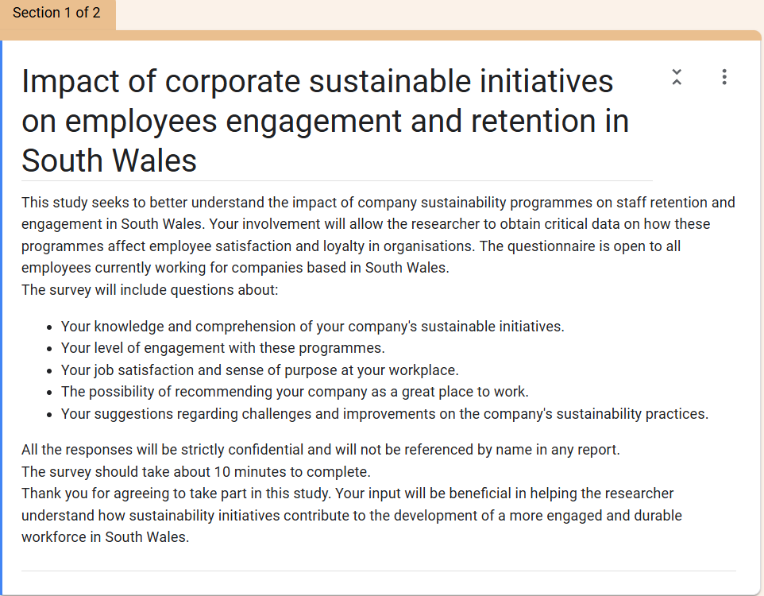
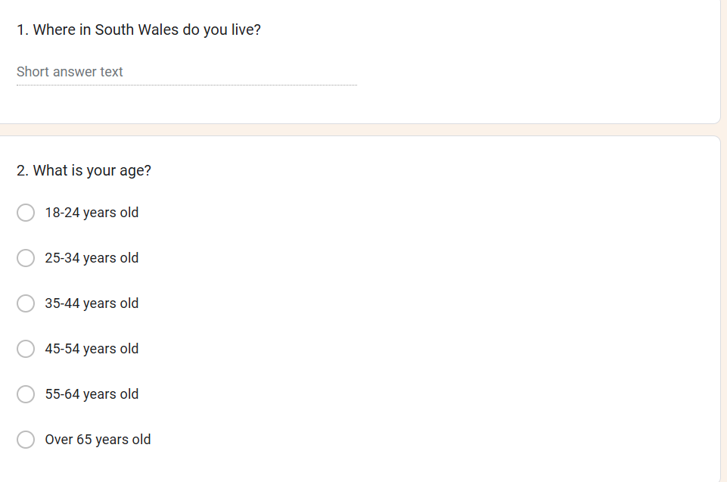
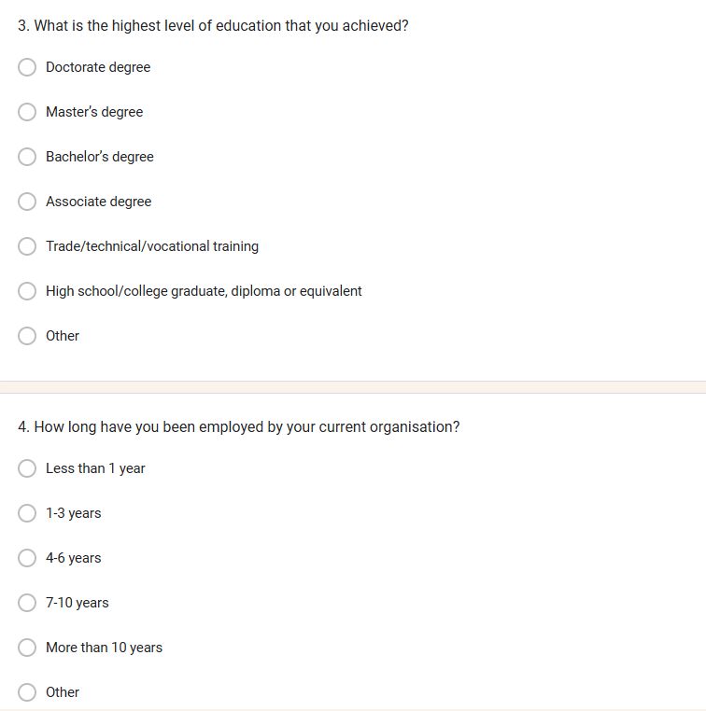
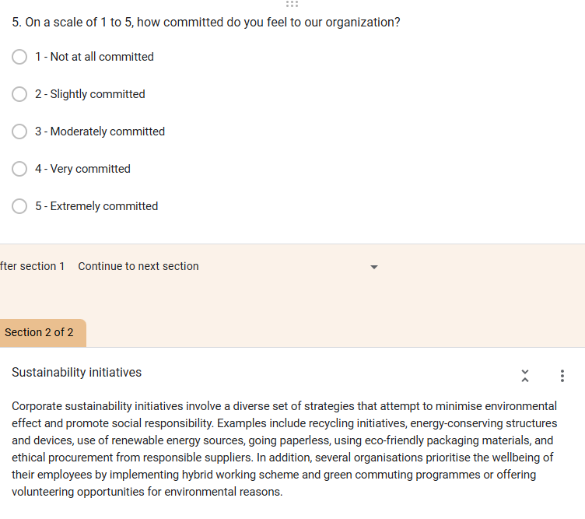
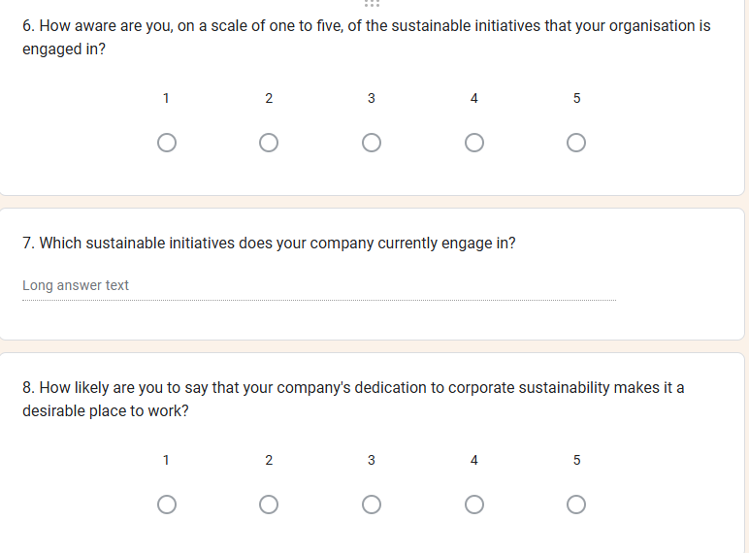
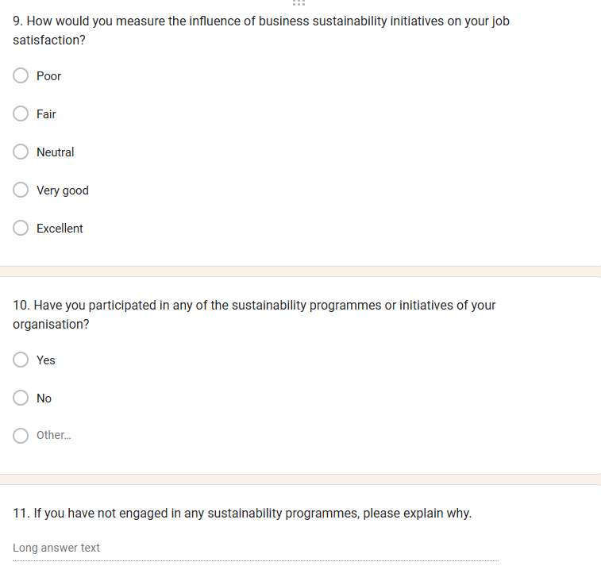
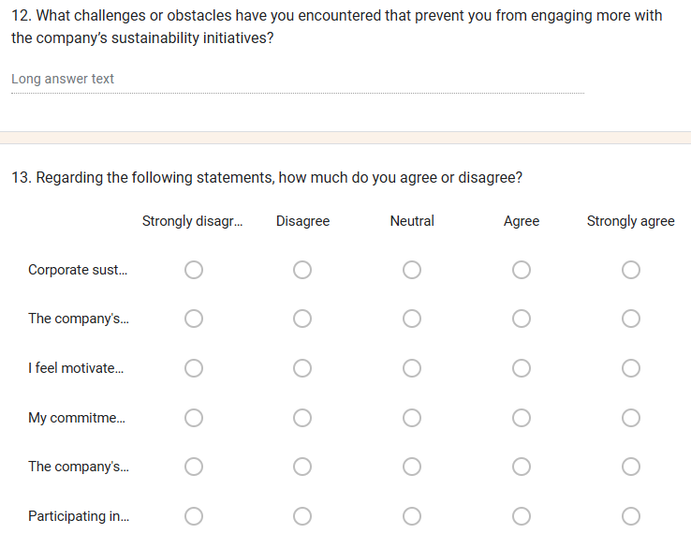
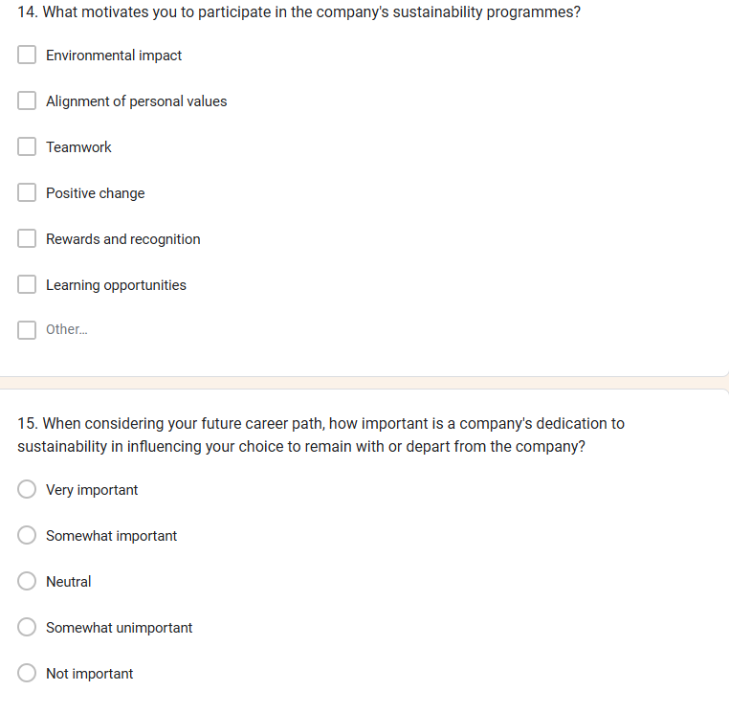
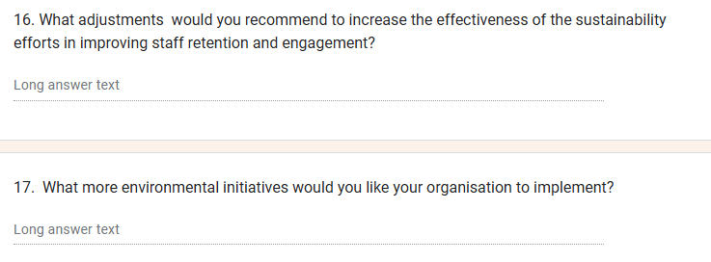

Ethics form



APPLICATION FOR ETHICAL APPROVAL – BA level

CAIS AM GYMERADWYAETH MOESEGOL – Lefel BA

Mae'r ffurflen hon i'w chwblhau gan bob BA myfyrwyr. Rhaid i bob ffurflen gael ei ystyried gan diwtor y modiwl.  Dylai un copi o'r ffurflen yn cael ei roi ar y ffeiliau Gyfadran ac un copi cadw ar y ffeil myfyrwyr. |  | This form is to be completed by all BA Leadership and Management students conducting independent projects. This form should be completed by the student. All forms must be considered by the Module Lead- Maria Heffernan. A copy of the form must be kept centrally and on the student file.
ADRAN 1 – MANYLION MYFYRIWR |  | SECTION 1 - STUDENT DETAILS
Enw Llawn  Full Name | Corina Elena Cernat
Ysgol/Cyfadran/  School/Faculty | Business School |  |  | Rhif Myfyriwr Student Number | 2019920
Cydlynydd prosiect / Tiwtor  Module Tutor/ Programme Co-ordinator | Maria Hefferman |  |  | Enw'r Gradd  Name of Degree | Bachelor of Arts Leadership and Management
Teitl dangosol yr Traethawd Hir: |  |  |  | Indicative Title of the Independent Project:
Put in title
The impact of corporate sustainability programmes on retention and employee engagement in South Wales

ADRAN 2 – MANYLION CYFRANOGWYR / CYNULLEIDFA |  |  | SECTION 2 - PARTICIPANT / AUDIENCE DETAILS
Pwy yw’r cyfranogwyr arfaethedig? |  | Who are the intended participants? |  |  | Ydw / Yes | Na / No
Myfyrwyr / staff Y Drindod Dewi Sant |  | Students / staff of Trinity Saint David |  |  | Yes
Oedolion (dros oed 16 ac yn gymwys i gydsynio) |  | Adults (over the age of 16 and competent to give consent) |  |  | Yes
Plant a phobl ifanc dan oed |  | Children / legal minors |  |  |  | No
Cleifion neu gleientiaid gweithwyr proffesiynol |  | Patients or clients of professionals |  |  |  | No
Rhywun sy’n cael ei gadw yn y ddalfa neu y mae’r llys wedi cymryd cyfrifoldeb amdano |  | Anyone in custodial care or for whom the court has assumed responsibility |  |  |  | No
Aelod o unrhyw sefydliad lle mae’n bosibl bod angen i unigolyn arall hefyd gydsynio. |  | A member of any organisation where another individual may also need to give consent. |  |  |  | No
Eraill: Nodwch: / Others: please identify:

Nifer, Oed a Ffynhonnell y Cyfranogwyr  Rhowch fanylion yr demograffeg y cyfranogwyr / gynulleidfa. |  |  |  | Participant / Audience Number and Age  Provide details of the demographics of the participants / audience.
Nifer o Gyfranogwyr / yn y Gynulleidfa | Participant/ Audience number |  |  | 100 employed individuals from South Wales
Grŵp oedran y Cyfranogwyr/y Gynulleidfa | Participant/ Audience age group |  |  | 18-65

ADRAN 3 – GWEITHGAREDD YMCHWIL |  |  | SECTION 3 – RESEARCH ACTIVITY
1. | Ydy’r prosiect yn cynnwys: | Does the project include: |  | Ydy / Yes | Nac ydy/No
Defnyddio holiadur neu offeryn ymchwil tebyg |  | Use of questionnaire or similar research instrument |  | Yes
Defnyddio prawf ysgrifenedig neu gyfrifiadurol |  | Use of written or computerised test |  |  | No
Cyfweliad (cysylltwch gwestiynau posibl) |  | Interview (attach provisional questions) |  |  | No
Dyddiaduron |  | Diaries |  |  | No
Arsylwi ar gyfranogwyr a hwythau'n ymwybodol o hynny |  | Participant observation with their knowledge |  |  | No
Arsylwi ar gyfranogwyr a hwythau ddim yn ymwybodol o hynny |  | Participant observation without their knowledge |  |  | No
Recordio fideo neu sain |  | Video or audio-taping |  |  | No
Mynediad i wybodaeth bersonol neu gyfrinachol heb gydsyniad penodol y cyfranogwyr |  | Access to personal or confidential information without the participants specific consent |  |  | No
Defnyddio unrhyw gwestiynau, ysgogiadau prawf, cyflwyniad y gallai rhai cyfranogwyr eu profi fel rhywbeth sy'n achosi niwed / tramgwydd corfforol, meddyliol neu emosiynol |  | Administration of any questions, test stimuli, presentation that may be experienced as physically, mentally or emotionally harmful / offensive |  |  | No
Cyflawni unrhyw weithredoedd allai achosi embaras neu effeithio ar hunan-barch |  | Performance of any acts which may cause embarrassment or affect self-esteem |  |  | No
Ymchwilio i gyfranogwyr sy’n ymwneud â gweithgareddau anghyfreithlon |  | Investigation of participants involved in illegal activities |  |  | No
Gweithdrefnau lle defnyddir twyll |  | Procedures that involve deception |  |  | No
Gweini unrhyw sylwedd, cyfrwng neu blasebo |  | Administration of any substance, agent or placebo |  |  | No
Dull arall o gasglu data neu fformat cyflwyno (esboniwch) |  | Other method of data collection or presentation format (please explain) |  |  | No

2. | Restrueich dull o gasglu data | List your method of data collection:
Describe your methods of data collection
Mixed method consisting of a questionnaire with both quantitative and qualitative questions;
Secondary research consisting of literature review;

3. | Risg Posibl:  (corfforol, seicolegol, cyfreithiol, cymdeithasol neu economaidd) | Potential Risk:  (physical, psychological, legal, social or economic)
A oes unrhyw risg bosibl i: |  | Is there any potential risk to: | Ydw / Yes | Na / No
A | Cyfranogwyr? | Participants? | yes
B | Ymchwilydd? | Researcher? | Yes
C | BrifYsgol/Cyfadran? | University? | Yes

4. | Rheoli Risg:  Os oes, beth yw'r risg a sut y bydd yn cael ei reoli? | Management of Risk:  If yes, what is the risk and how will it be managed?
Participants:
-loss of confidentiality risk
-loss of time
-emotional distress
Can limit the risk by maintaining anonymity and confidentiality during data collection and analysis.

Researcher:
- Psychological risks
- Ethical risks
- Legal risks
- Professional risks
- Project delays
Can manage the risks by conducting a risk assessment, obtain consent, protect privacy, use ethical guidance, seek support.

University:
- Reputational risk
- Legal risk
- Ethical breaches
- Controversial findings
- Intellectual property dispute
- Project delays
The University can manage these risks by setting realistic timescales, clarify intellectual property rights, implement strict guidelines, monitor the progress, follow ethical principles, and set up compliance procedures.

5. | Os ydych yn delio â phlant a / neu oedolion agored i niwed, rhaid i chi gyflwyno eich tystysgrif DBS i'ch tiwtor goruchwylio i'w cymeradwyo cyn i unrhyw gysylltiad â cyfranogwyr hyn. | If you are dealing with children and/ or vulnerable adults you must present your DBS certificate to your supervising tutor for approval before any contact with these participants.
 |  |  |  | Ydw / Yes | Na / No
A | Ydych chi wedi gwneud cais am dystysgrif DBS? |  | Have you applied for a DBS certificate? |  | No
B | A yw eich tiwtor weld a'i gadarnhau eich tystysgrif DBS? |  | Has your tutor seen and approved your DBS certificate? |  | No

6. | A fyddwch yn cael cydsyniad gwybodus ysgrifenedig gan eich cyfranogwyr? |  | Will you obtain written informed consent from your participants?
 |  |  |  |  |  | Ydw / Yes | Na / No
A | Os na fyddwch, pam hynny? |  |  | If no, why not? |  | yes
B | Os byddwch, sut byddwch yn sicrhau cydsyniad gwybodus? |  |  | If yes, how will you secure informed consent?
Rhowch eglurhad / Please explain: Participants will be informed at the beginning of the survey about the anonymity of the study and privacy protection.

Cynhwyswch gopi o’r ffurflen gydsynio os ydych yn defnyddio un. |  |  |  | Please include a copy of the consent form if you are using one.

ADRAN 4 |  | SECTION 4
CEFNOGWYD /APPROVED |  | NIS CEFNOGWYD/  NOT SUPPORTED
Datganiad  Mae'r wybodaeth a gynhwysir yma yn gywir, hyd eithaf fy ngwybodaeth a’m cred. Rwyf wedi ceisio dynodi unrhyw risgiau a phroblemau sy’n gysylltiedig â’r prosiect / ymchwil neu gynhyrchiad ac rwyf yn cydnabod f’ymrwymiadau innau a hawliau’r cyfranogwyr. |  |  | Declaration  The information contained herein is, to the best of my knowledge and belief, accurate. I have attempted to identify any risks and issues related to the project/research or production and acknowledge my obligations and the rights of the participants.
Llofnodau  Dylai'r ffurflen hon gael ei chwblhau a'i llofnodi gan y myfyriwr a'r Cydlynydd y prosiect /Twitor |  |  | Signatures  This form should be completed and signed by the student and the Module tutor/Programme Co-ordinator.
Myfyriwr / Student  Corina Cernat |  |  |  |  | Dyddiad: / Date: 23.02.2024
Cydlynydd y prosiect /Twitor  Project co-ordinator / Supervisor  Marie Pitson |  |  |  |  | Dyddiad: / Date:
Sefydliad / Organisation  University of Wales Trinity Saint David |  |  |  |  | Dyddiad: / Date:

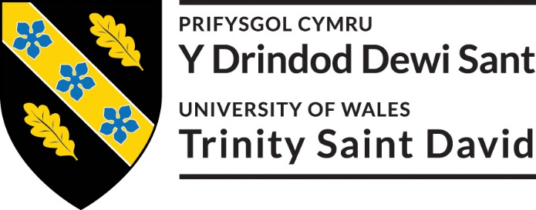
Cyfranogwr Rhif Adnabod:
Participant Identification Number:
CWESTIYNAU CYFWELIAD SAMPL | SAMPLE INTERVIEW/ SURVEY QUESTIONS
TEITL Y PROSIECT: / PROJECT TITLE: The impact of corporate sustainability programmes on retention and employee engagement in South Wales

1 | How long have you been working in the company?
2 | How familiar are you with your company's corporate sustainability programmes, on a scale of 1 to 5?
3 | How likely are you to say that your company's dedication to corporate sustainability makes it a desirable place to work?
4 | Could you give examples of how your level of involvement with your work and the company has changed because of the corporate sustainability programmes?
5 | Have you seen any obstacles or negative effects from your company's adoption of corporate sustainability programmes? If so, can you please explain?
6 | What changes, if any, do you believe the corporate sustainability initiatives could benefit from to better support employee retention and engagement?
7 | Regarding the following statement, how much do you agree or disagree? "Corporate sustainability programmes positively impact employee engagement within the organisation."
8

9

10

ENW A CHYFEIRIAD YR YMCHWILYDD | NAME & ADDRESS OF RESEARCHER  Corina Cernat  3 Heol Dewi Sant, Cardiff, CF144NN

Cyfranogwr Rhif Adnabod:
Participant Identification Number:
FFURFLEN GANIATÂD CYFRANOGIAD | PARTICIPATION CONSENT FORM
TEITL Y PROSIECT: / PROJECT TITLE: The impact of corporate sustainability programmes on retention and employee engagement in South Wales

Name of Researcher:
Please initial box

1. I confirm that I have read and understand the information sheet dated 23.02.2024 for the above study. I have had the opportunity to consider the information, ask questions and have had these answered satisfactorily.

2. I understand that my participation is voluntary and that I am free to withdraw at any time, without giving any reason.

3. I understand that any information given by me may be used in future reports, articles or presentations by the research team.

4. I understand that my name will not appear in any reports, articles or presentations.

5. I agree to take part in the above study.

________________________ ________________ _____________________________
Name of Participant Date Signature

_Corina Cernat____________________ _____________ _______23.02.2024______________________
Researcher Date Signature

You may decline to participate in this study. You may end your participation in this study at any time. If you decide to remain anonymous, maintaining your anonymity will be a priority and every practical precaution will be taken to disguise your identity. If you prefer anonymity, there will not be any identifying information on audiotapes or transcripts of this or any interview. No-one will hear any audiotapes or see any transcripts without your prior consent. All materials generated from this or any interview will remain confidential.

When completed, please return in the envelope provided (if applicable). One copy will be given to the participant and the original to be kept in the file of the research team at: PLACE:

ENW A CHYFEIRIAD YR YMCHWILYDD | NAME & ADDRESS OF RESEARCHER  Corina Cernat  3 Heol Dewi Sant  Cardiff  CF144NN

Cyfranogwr Rhif Adnabod:
Participant Identification Number:
FFURFLEN GANIATÂD CYFRANOGIAD | SAMPLE PARTICIPANT INFORMATION SHEET
TEITL Y PROSIECT: / PROJECT TITLE: The impact of corporate sustainability programmes on retention and employee engagement in South Wales

*THIS FORM IS TO BE AMENDED AND ADAPTED AS NECESSARY

Dear Participant:

My name is Corina Cernat and I am studying in the School of Business.

I would like to invite you to participate in my research project. This project will be analysing the corporate sustainability programmes and aims to establish the impact of these initiatives on the employee engagement and retention in South Wales.

*Attached to this letter is a short questionnaire developed by Corina Cernat which will assess the impact of the corporate sustainability programmes on employees. I believe your opinions will be extremely helpful to me.

Through your participation in the questionnaire and/or interviews, I hope to ascertain important findings and fill in a gap in the existing research.

All questionnaires will be kept strictly confidential to the researchers involved and at NO time will individual questionnaires be released to the public. This gives you a chance to express your views on your programme a confidential and anonymous forum and still be able to make a difference. Your participation in this study is completely voluntary so you can withdraw from the questionnaire at any stage.

Our questionnaire should take about 10 minutes to complete, but there is no time constraint. There are also no right or wrong answers. Attached to this letter along with the questionnaire is a consent form. As this is a new project, your feedback is also important to us and we would be much obliged if you could also complete the feedback sheet along with the questionnaire. We understand that your time is at a premium, but your opinions are very valuable to us.

After careful and precise analysis of the data obtained from this questionnaire, I will be happy to provide you with a copy of the findings at your request. The results of this questionnaire will hopefully enhance my understanding of the corporate sustainability programmes and their impact on employee engagement and will be stored on the University drive. The results of the research will be fed back to the University.

We thank you in advance for your time and participation. If any questions do arise, feel free to contact me at your convenience.
ENW A CHYFEIRIAD YR YMCHWILYDD | NAME & ADDRESS OF RESEARCHER  Corina Cernat  3 Heol Dewi Sant  Cardiff  CF144NN

