A Chi-sqUAre analysis to look for a difference between age, gender and preference for working at home or the workplace

Abstract

This research study explored if there was a significant difference between age, gender and the preference for working from home or their designated workplace. The researcher conducted secondary research to explore the variables tested. The study asked 41 participants through a questionnaire whether they would prefer to work from home or from their designated place of work. The researcher thought that there would be a significant difference between the variables. The participants who partook where students at the University of Wales Trinity Saint David aged 18-51 and consisted of people who identify as male, female and non-binary. A quantitative methodology was used to analyse the data obtained through this study. The data was collected and interpreted through a chi-square analysis. The results were interpreted and discussed.

Contents
Introduction 3
Research aims 4
Hypothesis 5
Methodology 6
Pilot study 6
Participants 6
Design 6
Materials 7
Procedure 8
Results 9
Discussion 12
References 14
Appendices 15
Appendix i 15
Appendix ii 16
Appendix iii 17
Appendix iv 18
Appendix V 20
Appendix vi 21

Introduction
Covid-19 is a newly identified virus that has impacted the world globally. (Balkhair, 2020) Over the last 18 months, the lives of every human being on this planet have changed dramatically. The way people live, socialise and work have changed drastically. With infection rates climbing from hundreds to thousands daily, people have been advised to stay at home and only go outside for essential travel, grocery shopping, exercising, for educational purposes and to attend to work. Many employers have decided that employees would have to work remotely from home. Whilst remote working is not a new trend, Covid-19 has changed the landscape in which people work, possibly forever (Kinman, et al., 2020). The Office for National Statistics surveyed UK workers and found that 47% of all workers were working from home as of April 2020 and 86% of participants did so as a result of the covid-19 pandemic (ONS, 2020).
Gender differences in the workplace is an ongoing trend that been amplified during the pandemic (Giurge, Whillans, & Yemiscigil, 2021). Hupkau and Petrongolo (2020) found that female dominated sectors such as education where teaching has been supported in virtual environments and an empathysis on distance learning may allow this sector to work from home. However male dominated sectors such as construction or manufacturing workers are less able to work from home as their duties must be fulfilled at the workplace. Chung et al (2021) discovered that more females were responsible for staying at home for childcare and housework however males who were fathers who worked from home were more likely to assist their partner with housework and childcare during lockdown, more so than they did previously. Chung further alluded that the expansion of remote working may reduce the gender inequalities that have exasperated over time. This may only be possible if society reflects on gender norms and rapidly changing existing work cultures.
Leslie et al (2012) argued that employers had a general lack of trust of employees and was reluctant for them to work from home. However, Caligiuri (2021) found that out of a sample of 944 employees had a positive preference for working from home post pandemic. It was also found that women were less likely to want to work remotely post pandemic. This may be because the boundaries from working at home may interfere with their personal life.

Research aims
This study aims to see if there is any significance between gender and the preference for working from home. The researcher answered the question through collecting primary and secondary data to formulate the following objectives:

- Investigate through secondary research the impacts of employees working from home through peer reviewed articles
- Establish the methodology to apply the appropriate design for the study
- Collect data regarding people’s preferences for working from home or their designated workplace to form the result
- Conclude the study by referring to the literature and findings from data collection

Hypothesis
The researcher hypothesised that there would be a significant difference between age, gender and preference for working from home or their designated workplace. This will be tested within the study.

Methodology

This chapter will outline the research methodology that the researcher adopted. The chapter further illustrates information regarding participants, design, materials, and the procedure.

Pilot study

Pilot studies are a crucial stage before collecting data as it highlights potential issues with the methods employed to test the feasibility of the overall study (Connelly, 2008). For the purpose of this report a pilot study was not completed.

Participants
A total of 41 participants completed the questionnaire for this study. The study consisted of 26 females (N=26), 14 males (N=14) and 1 participant identified as non-binary/third gender (N=1). The age range of participants were between 18-51 and the mean age of participants 26.48. One participant did not disclose their age. The sample study was taken from first year students completing a psychology and counselling degree at the University of Wales Trinty Saint David.

Design

A nonparametric design was used for this study in order to assess to see if there was a statistical difference between age and gender and preference to working from home or their designated workplace. A chi-square statistical analysis was used to identify correlation between the independent and dependent variables (McHugh, 2013). A quantitative methodology was used to analyse the data obtained for this study.

Materials
A questionnaire was used to collect the data for the study (see appendix i). The questions consisted of asking the participants age and gender. The questionnaire also asked, “Do you prefer to work from home or at your designated place of work?”. The participants could either choose from “I prefer to work from home” and “I prefer to work at my designated place of work”. The independent variables are age and gender, and the dependent variable is the question asking the preference whether to work from home or not. Descriptive information for participant demographics were summarised (see appendix ii).
A study information sheet was initially given to participants (see appendix iii). This gave an overall view on what the study entailed.
A consent form was also used (see appendix 4). Informed consent is crucial to the study to raise awareness of what the study entails before participation. It outlines that the information provided will remain confidential and stored in accordance with the data protection act.
A study debrief was also issued to participants (see appendix 5). The debrief summarised the study and highlighted the aims of what the researcher wanted to explore. The debrief is vital for participants who wish to withdraw from the study as after this point the data becomes anonymous as it is not possible to trace individual participants.

Procedure

The participants where split into 2 mixed groups it is important to know the two groups were random and had no influence on the independent variable. Participants who partook in the study were in the same room. Participants were handed an information sheet prior to consent. Participants were then asked to log into the Moodle platform to partake in the study. Once participants had completed the study, they were given a debrief form which outlined participants right to withdraw. Once all participants completed the study the data was collected for statistical analysis using Chi-square the Chi-square was then hand calculated to form the results.
The next chapter will explore the results of the data collection.

Results
This chapter will explore the primary data collected for this study. The data collected was used to seek correlation between participants age, gender and their preference for working from home or their designated workplace.
Chi-square is a non-parametric test to investigate the distributions of how categorical variables differ from one another. It measures the difference between what is observed and what is expected. The below table shows the critical values of the Chi-square distribution with degrees of freedom.

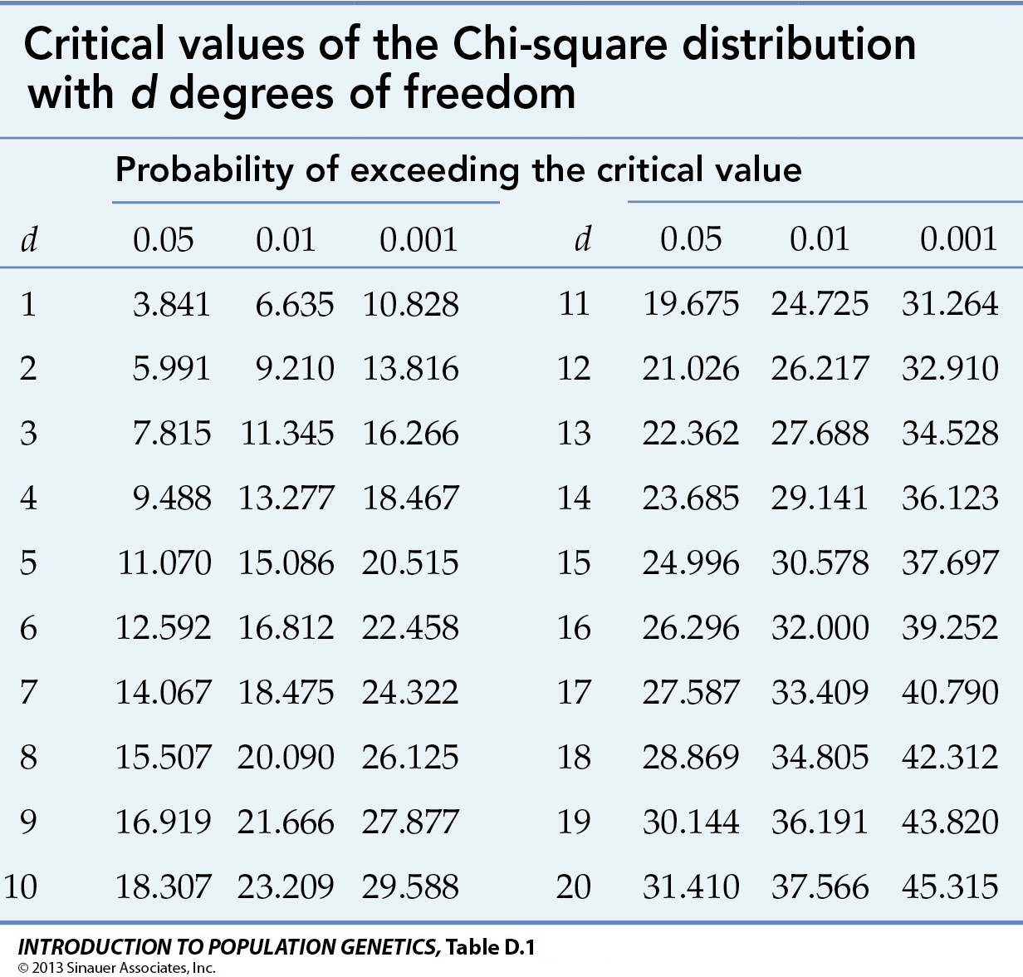

The table above enables the researcher to show if the result is significant or not. The Chi-square was handwritten for the purpose of this study (see appendix vi). Differences in gender, age and preference for working from home or their designated workplace were found in this study. The study found 4 males preferred to work from home whilst 10 males preferred to work from their designated place of work. The study found that 8 females preferred to work from home and that 18 females preferred to work from their designated place of work. Also found in the study was that 1 non-binary person also preferred to work from home.
The chi-square analysis of the difference between gender an age and preference for working from home or their designated workplace was significant, X² = (4, N=41) = 3.65, p<0.5.

The next chapter will discuss the results from the literature review and data collection conducted by the researcher.

Discussion
The research hypothesised that there would be a significant difference between age, gender and preference for working from home or their designated workplace. The results found that men and women would rather work from their designated place of work. Whereas the non-binary participant that took part in this study preferred working from home.
Working from home appears to be an upwards trend that has been exacerbated by the Covid-19 pandemic. This is shown by data from The National Office Of Statistics which said that of the 47% of workers currently working from home 86% are doing so due to the covid-19 pandemic. The study showed that more than half of females preferred to work from home compared to males, which agrees with the study conducted by Hupkau and Petrongolo (2020) who found that female-dominated sectors may have more access to remote working.
Caligiuri (2021) found that people had a positive preference to working from home however argued that women post pandemic were less likely to want to work from home. This disagrees with the present study which found that women were more likely to want to work from home compared to men. The researcher for this study did however find that women had preference for working in their designated workplace.
Chung et al (2021) found that more women were responsible for staying at home to look after children and to do housework which argues against the present study as the researcher found that the majority of women would rather work from their designated place of work rather than work from home.
The covid-19 pandemic has had a huge impact on ways of working with many more people working from home. This trend could continue to rise as employers favour hybrid working over traditional methods. The preference of working from home is not always the employee’s choice however it is a trend that employer must always consider in the future.

References
Balkhair, A. (2020). Covid-19 pandemic: a new chapter in the history of infectious diseases. Oman medical journal, 35(2), 123.
Caligiuri, P. (2021). Predictors of employees prefernce for working from home post pandemic. Business and economic research, 11(2), 1-19.
Chung, H., & Birkett, H. :. (2021). Covid-19, flexible working and implications for gender equality in the United Kingdom. Gender and society , 1-10.
Connelly, L. M. (2008). Pilot studies. Medsurg nursing, 17(6), 411.
Giurge, L., Whillans, A., & Yemiscigil, A. (2021). A multicountry perspective on gender differences in time use during COVID-19. Proceedings of the National Academy of Sciences, 118(12).
Hupkau, C., & Petrongolo, B. (2020). Work care and gender during the covid-19 crisis. CEP Covid-19 Analysis, 1-12.
Kinman, G., Grant, C., Fraser, J., Bell, N., Breslin, G., Colville, T., & MacKey, G. (2020). Working from Home: Healthy Sustainable Working During the Covid-19 Pandemic and Beyond. British Psychological Society, 1-14.
Leslie, L., Manchester, C. F., Park, T. Y., & Mehng, S. A. (2012). Flexible work practices: a source of career premiums or penalties? Academy of managment journal, 55, 1407/1428.
McHugh, M. (2013). The chi-square test of independence. Biochemia medica, 23(2), 143-149.
ONS. (2020, April). Coronavirus and homeworking in the UK: April 2020. Retrieved from Office of National Statistics: https://www.ons.gov.uk/employmentandlabourmarket/peopleinwork/employmentandemployeetypes/bulletins/coronavirusandhomeworkingintheuk/april2020

Appendices

Appendix i
Data Collection Questions for Report 1 – Chi-square

Please state you gender

- Male
- Female
- Non-binary / third gender
- Prefer not to say

Please indicate your age

_______________________

Do you prefer to work from home or your designated workplace?

- I prefer to work from home
- I prefer to work from my designated workplace

Appendix ii

Report 1 – Chi-square
Descriptive information for participant demographics

Number of participants:

Total sample: 41
Males: 14
Females: 26
Nonbinary / third gender: 1

Age range:
Total sample: 18-51 (26.48)
Males: 19-40
Females 18-51

Appendix iii


Centre for Psychology and Counselling
SA1 Campus

Swansea

Study Information Sheet

This document provides key information regarding the study and provides details about what will be expected of you as a participant. Therefore, please read this information carefully before providing consent to take part.
The purpose of this study is to explore whether there is significant association between gender and preference for working from home. The aim of this study is to determine whether there are a specific group of participants that prefer to work from home. Having an understanding of this may be useful for organisations in their efforts to allocate working from home time appropriately.
During this study you will be required to do the following:
- Fill out an online questionnaire asking for information about you on the following:
  - Your age
  - Your gender
  - Your preference on working from home
- At the end of the study you will be provided with the study debrief.
If you have any questions or concerns about this study, please contact the research supervisor Stacey Coleman on stacey.coleman@uwtsd.ac.uk.
If you are happy to take part in this study, please click the link provided on under the Week 3 tile on Moodle which will direct you to the online study.
Please note that data collection will start at 1pm on Wednesday 6th October and end at 5pm on Thursday 7th October, so you will not be able to access the study outside of these times.
If you feel you want to leave the study, you can do so at any time by closing the browser on your computer. Once the study has ended you will asked if you want your data to be saved as part of the study. If you agree then your data will be anonymised and therefore untraceable to later delete. If you do not wish for your data to be used, please close the tab before finishing the study.

Appendix iv

Centre for Psychology and Counselling
SA1 Campus
Swansea
Study Consent Form

I understand that this research study is being carried out by the module leader of the Research Methods I module for the purpose of a module assessment and that taking part in this study will involve answering a questionnaire on my age, gender, and indicating my opinions on working from home.

This study will take approximately 5 minutes to complete.

I understand that participation in this study is voluntary and I am free to withdraw participation at any time during or before the end of the study without giving a reason by closing the computer browser.

I understand that once I complete the study, I will not be able to withdraw my data, as it will be anonymised, and the researcher will be unable to trace my data back to me.

I am aware that if I have any questions or concerns about the study, I can contact the researcher supervisor, Stacey Coleman at any time before, during, or after the study on stacey.coleman@uwtsd.ac.uk.

I understand that the information provided by me will be held confidentially, with a code assigned in place of my name. These data will be stored indefinitely in accordance with the Data Protection Act.

I also understand that at the end of the study I will be provided with a debrief form.

Please select to agree with the statements below to give your consent to take part in this study.

You can download a copy of this consent form by clicking here: Consent Form
Please tick all the boxes below to confirm your consent into participating in this study:

I am 18 years of age or over

I understand I can withdraw at any time without penalty by closing the browser

I understand my data will be held confidentially and my identity will remain anonymous

I understand all the above information on this consent form

I consent to taking part in this study

Appendix V

Centre for Psychology and Counselling
SA1 Campus
Swansea

Study Debrief Sheet
An exploration into the potential relationship between gender and preference for working from home

Thank you for taking part in this study.

The aim of this study is to explore whether there is a significant relationship between gender and preference for working from home. We specifically want to find out whether more females in comparison to males say that they prefer to work from home if they had a choice between working at home or at their designated place of work.

If you wish to withdraw your data from the study, you must close your computer browser now. After this point, your data will become anonymous, and it will not be possible to trace it back to you. The data you submit will remain confidential.

If taking part in this study has raised any concerns or if you have any questions about the study, please contact the academic supervisor Stacey Coleman: stacey.coleman@uwtsd.ac.uk

You can download a copy of this debrief sheet for your records by clicking here: Debrief
If you are happy for your data to be included in this study, please click the arrow below to confirm.

Thank you once again for taking time to participate in this study.

BSc Psychology
BSc Psychology and Counselling

University of Wales Trinity Saint David, Swansea

Appendix vi

Results
 | Male | Female | Non-Binary | Row Total
Home | 4 | 8 | 1 | 13
Office | 10 | 18 | N/A | 28
Colum Total | 14 | 26 | 1 | 41

 | Observed | Expected
A | 4 | 4.44
B | 8 | 9.56
C | 10 | 9.56
D | 18 | 17.76
E | 1 | 0.32
F | 0 | 0.68

A = 13x14/41 = 4.44
B = 14x28/41 = 9.56
C = 28x14/41 = 9.56
D = 28x26/41 = 17.76
E = 1x13/41 = 0.32
F = 1x28/41 = 0.68

A = (4-4.44)²/4.44 --- 0.44²/4.44 --- 0.19/4.44 = 0.04
B = (8-9.56)²/9.56 --- 1.56²/9.56 ---2.43/9.56 = 0.25
C = (10-9.56)²/9.56 --- 0.44²/9.56 --- 0.19/9.56 = 0.02
D = (18-17.76)²/17.76 --- 0.24²/17.76 --- 0.06/17.76 = 0.00
E = (1-0.32)²/0.32 --- 0.68²/0.32 --- 0.46/0.32 = 1.45
F = (1-0.68)²/0.68 --- 0.32²/0.68 --- 0.10/0.68 = 0.15

Degrees of Freedom
(3-1) x (3-1)
2 x 2 = 4
(DF = 4)

Chi-square = 0.04+0.25+0.02+0.00+1.45+0.15 = 1.91
1.91x1.91 = 3.65
Chi-square = 3.65
Which shows there is significant difference (P<0.5) between participants age, gender and their preference for working from home or their designated workplace.

