University of Wales Trinity Saint David
Wales Institute of Science and Art


Electronic circuits testing and applications

Electrical control systems (ACHA4010)

Angel Stanley
2300932
24/03/24

Contents
Task 2 3
Scope Time Division Calculations (4) 3
Function Generator output sine wave (3) 3
Unsmoothed Rectifier Wave (3) 4
Smoothed Rectifier Wave with capacitor (3) 5
5
Drop in Voltage Question (4) 6
Different Voltage Readings Question (5) 6
Rectifiers use in Automotive applications Question. (4) 6
Probing Question (4) 7
Task 3 7
Scope Time Division Calculations (4) 7
Function Generator output square wave (3) 7
Capacitor charge and discharge wave marked at correct points. (3) 8
Basic Capacitor Calculations (3) 8
Capacitor discharge table (4) 8
Gradient Plot and calculations (4) 9
Capacitor Uses (5) 9
Inaccuracies Question (4) 10
References 11

Task 2

Scope Time Division Calculations (4)
Using the formula T = 1/f
T = period of waveform in seconds
f = frequency of the waveform in Hz f = 10Hz
T = 1/10 = 0.1 seconds

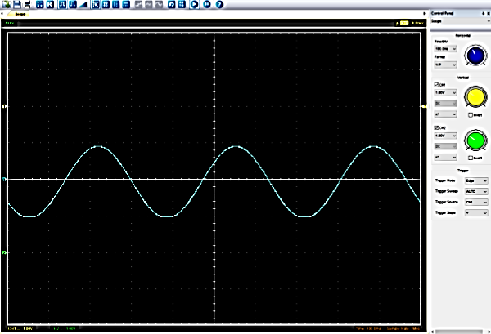
Function Generator output sine wave (3)

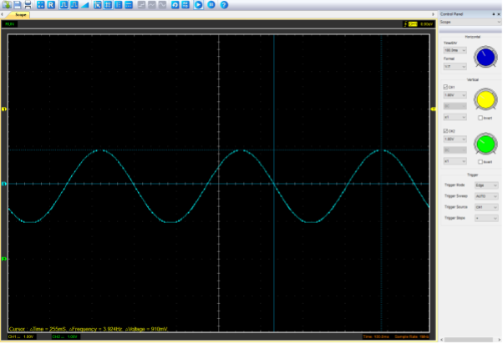

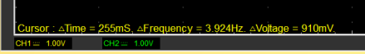

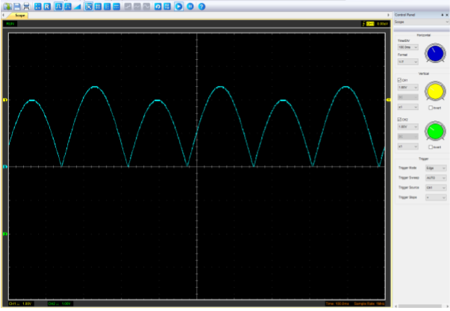
Unsmoothed Rectifier Wave (3)

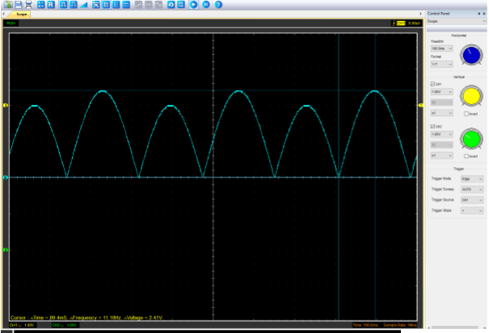



Smoothed Rectifier Wave with capacitor (3)
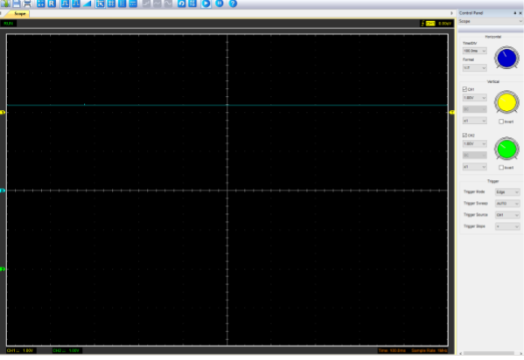

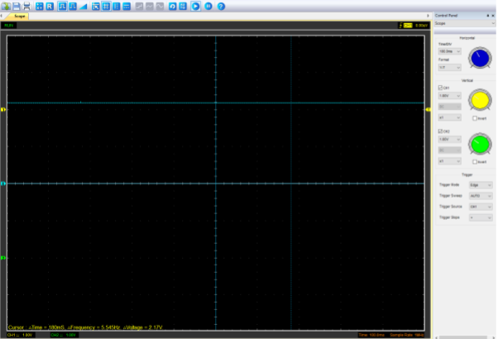

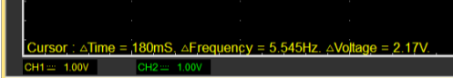

Drop in Voltage Question (4)
The voltage drop could’ve been caused by many different factors such as, but not restricted to :
- Resistance and inductance in the wires – if the wires used in the circuit had any resistance and/or inductance this could cause a drop in the voltage especially at higher frequencies or currents.
- Unusual behaviour of the components – all of the different components exhibit unusual behaviours which can then lead to a voltage drop.
- Load resistance – the load resistance that is connected to the rectifier circuit’s output will affect the output voltage. The higher the resistance the lower the voltage output.

Different Voltage Readings Question (5)
Peak voltage input position | Peak to peak voltage | Root mean square
(unable to do due to being unable to access the programme)
An RMS voltage is defined as the square root of the mean square of instantaneous values of the voltage signal. The RMS is also known as the quadratic mean. RMS voltage can also be defined for a continuously varying voltage in terms of an integral of the squares of the instantaneous values during a cycle. (electrical4u, 2021)
The RMS voltage is different from the peak voltage it uses the entire waveform over a period rather than just the maximum value. It also considers both the positive and negative values of the waveform, squaring them to make them positive, and then using the average before applying the square root.

Rectifiers use in Automotive applications Question. (4)
Here are some of the key applications of rectifiers in automotive:
- Polarity protection
- DC/DC conversion
- AC/DC conversion
- Freewheeling of inductive load
- Standard switching applications
- High-speed switching applications
- Engine and Transmission Control Unit
- Solenoid control
- Piezo injection (NEXPERIA, 2024)

Automotive electrical systems rely heavily on rectifiers for various functions. From powering the lights and entertainment systems to charging the battery while the vehicle is running, rectifiers are vital components in automobiles. (Rd-solucoes, 2023)

Probing Question (4)
This issue could be down to a multitude of reasons ranging from something as simple as out of date equipment to the oscilloscope being designed to only capture data from one channel at a time. This makes simultaneous probing difficult especially if the points are connected to different circuits or components as they could have different characteristics. The issue could also be down to a number of physical constraints such as physical probing limitations, where the points are far away from each other or there are other cables in the way.

Task 3

Scope Time Division Calculations (4)
R= 1K Ω C= 0.68 µ Cap marking = 684
T = r*(c*10⁻⁶)---- 1000 * (0.68*10⁻⁶) = 0.00068s
f= 1/T ---- 1/0.00068 = 1470.59 Hz
total time = 20 x 0.00068 = 0.0136s

Function Generator output square wave (3)
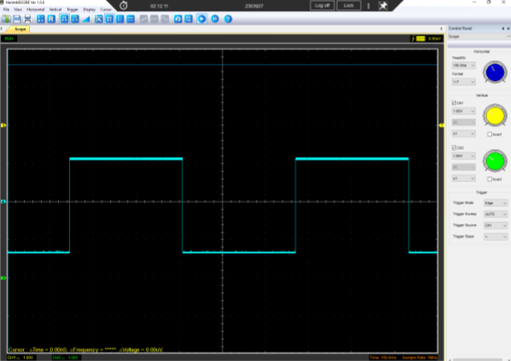

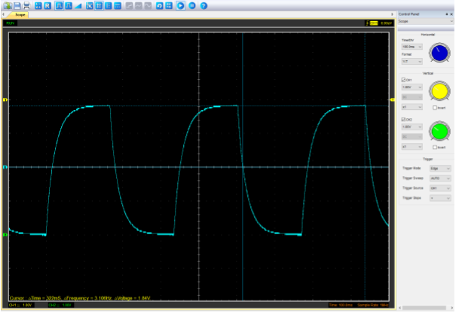
Capacitor charge and discharge wave marked at correct points. (3)

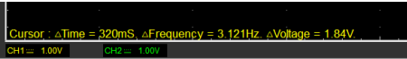

Basic Capacitor Calculations (3)
Peak = 1.84V
(1.84-0)*0.632+0 = 1.16V

Capacitor discharge table (4)
Time (s) | Voltage (V) | ln (V) | dy = y2 – y1  dy = ln(V)2-ln(V)1 | dx = x2- x1  dx = Time2 – Time1 | dy/dx
0.00068 | 1.84 | 1.26 | x | x | x
0.00136 | 0.68 | 0.83
0.00204 | 0.25 | 0.4
0.00272 | 0.09 | -0.05
0.00340 | 0.03 | -0.52
0.00408 | 0.01 | -1
0.00470 | 4.98*10⁻³ | -1.3
0.00544 | 1.68*10⁻³ | -1.77
0.00612 | 6.17*10⁻⁴ | -2.21
0.00680 | 2.27*10⁻⁴ | -2.64

Gradient Plot and calculations (4)
Time (s) | Voltage (V) | Capacitance | Percentage difference | Delta difference
0.00068 | 1.84 | 9.73*10⁻⁷ | 0.9999985691 | 0.679999027
0.00136 | 0.68 | 1.95*10⁻⁶ | 0.9999971324 | 0.67999805
0.00204 | 0.25 | 2.92*10⁻⁶ | 0.9999957059 | 0.67999708
0.00272 | 0.09 | 3.89*10⁻⁶ | 0.9999942794 | 0.67999611
0.00340 | 0.03 | 4.85*10⁻⁶ | 0.9999928676 | 0.67999515
0.00408 | 0.01 | 5.82*10⁻⁶ | 0.9999914412 | 0.67999418
0.00470 | 4.98*10⁻³ | 6.70*10⁻⁶ | 0.9999901471 | 0.6799933
0.00544 | 1.68*10⁻³ | 7.75*10⁻⁶ | 0.9999886029 | 0.67999225
0.00612 | 6.17*10⁻⁴ | 8.72*10⁻⁶ | 0.9999871765 | 0.67999128
0.00680 | 2.27*10⁻⁴ | 9.68*10⁻⁶ | 0.9999857647 | 0.67999032

Capacitor Uses (5)
- Automotive Applications:
  - Smoothing Voltage: Capacitors are essential for smoothing out voltage fluctuations in automotive systems. They help stabilize the electrical supply, ensuring consistent performance of various components.
  - Convenience Systems: Capacitors are used in convenience systems such as air conditioning, window wipers, and automatic window motors.
  - Safety and Control Systems: They play a crucial role in safety and control systems, including power steering, airbag controls, and braking systems.
  - Engine Control Units (ECUs): Capacitors are employed in ECUs for battery controls, gas- and diesel-engine controls, and electric motor drives (e.g., fuel pumps and fans) .

- general Electrical Applications:
- Blocking Direct Current: Capacitors block direct current while allowing alternating current to pass. This property is widely used in electronic circuits.
- Smoothing Power Supply Output: In analog filter networks, capacitors smooth the output of power supplies.
- Tuning Resonant Circuits: Capacitors tune radios to specific frequencies.
- Stabilizing Voltage and Power Flow: In electric power transmission systems, capacitors stabilize voltage and power flow . (copilot, 2024)

Inaccuracies Question (4)
The are a number of reasons as to why the measurement are different such as;
- General wear and tear of testing equipment – this could cause the data to be inaccurate even if it is only the smallest amount.
- A change in temperature – this effects the data because if the room temperature fluctuated at anytime during the test then this tampers with the testing conditions meaning they weren’t the same all the way through.
- Human error – like with any test there is always the factor of human error whether this be setting the circuit up slightly incorrect or knocking the probes during the test, this however can be solved by undertaking the test multiple times to see if the results change or stay the same.
- Tolerances – like all electronic components, the capacitors and resistors have tolerances that when pushed can alter the data and cause minor variations.
The precision and accuracy of voltage measurements made with a digital scope are affected by the speed at which samples are taken, i.e. the sampling rate, and sampling depth or bit depth. Bit depth is just the number of bits of information in each sample, and it directly corresponds to the resolution of each sample. It also relates to the dynamic range of the system, the largest and smallest amplitude signal that can be digitized. (herres, 2017)

References

copilot, 2024. capacitor uses. [Online]
Available at: https://www.bing.com/search?q=capacitor+uses+in+electrical%2C+automotive+and+motorcycle&PC=K433&FORM=K433DF&showconv=1
[Accessed 24 march 2024].
electrical4u, 2021. RMS Voltage: What it is? (Formula And How To Calculate It). [Online]
Available at: https://www.electrical4u.com/rms-or-root-mean-square-value-of-ac-signal/
[Accessed 24 march 2024].
herres, d., 2017. prescision and accuracy in oscilloscopes. [Online]
Available at: https://www.testandmeasurementtips.com/precision-accuracy-oscilloscopes/
[Accessed 24 march 2024].
NEXPERIA, 2024. automotive recovery rectifiers. [Online]
Available at: https://www.nexperia.com/products/diodes/automotive-diodes/automotive-recovery-rectifiers/#/p=1,s=0,f=,c=,rpp=,fs=0,sc=,so=,es=
[Accessed 24 march 2024].
Rd-solucoes, 2023. electrical repair. [Online]
Available at: https://solucoesinfinitas.com/understanding-the-function-and-importance-of-rectifiers-in-electrical-systems/#:~:text=Automotive%20electrical%20systems%20rely%20heavily%20on%20rectifiers%20for,is%20running%2C%20rectifiers%20are%20vital%20components%20in%20
[Accessed 24 march 2024].

