Fundamentals of Construction Technology
Assignment One
Site Investigation


Terence Leslie Jones

Contents

List of Figures and Tables
Executive Summary
Introduction
Site Details
Site History
Site Geological Appraisal including Borehole Log Interpretation
Recommended Further Investigation
Environmental Considerations
Archaeological Impact Assessment
Unexploded Ordnance
Planning Requirements
Recommendation for Building Foundations
References
Annex A – Borehole log
List of Figures and Tables

Figure 1. Showing approx. location of the proposed development site. (Google Maps, 2021)
Figure 2. Zoomed Airiel photograph of proposed development site. (Google Maps, 2021)
Figure 3. Site location and surrounding area with street names. (Lle.gov.wales, 2021)
Figure 4. Site looking Southwest. (Jones, 2021)
Figure 5. Site looking South. (Jones, 2021)
Figure 6. Site looking East showing the Marriott Hotel, centre behind the trees. (Jones, 2021)
Figure 7. Site looking West showing the Civic Centre (Council Offices). (Jones, 2021)
Figure 8. 1879 Ordnance Survey Map, showing site relative to historical use. (OS, 1879)
Figure 9. 1899 Ordnance Survey map of area. (OS, 1899)
Figure 10. 1919 Ordnance Survey Map depicting the proposed site in relation to historical landmarks. (OS, 1919)
Figure 11. January 1960 Ordnance Survey Map showing proposed site superimposed. (OS, 1960)
Figure 12. Ordnance Survey map showing dismantled railway and demolished engine shed. (OS, 1964)
Figure 13. 1990 Ordnance Survey map showing the eventual redevelopment of the area with the Civic Centre and Marriott Hotel. (OS, 1990)
Figure 14. BGS Geology of Britain viewer bedrock screenshot. Proposed Development shown in red rectangle. (BGS-ESRI, 2021)
Figure 15. BGS Geology of Britain viewer superficial geology screenshot. Proposed Development shown in red rectangle. (BGS-ESRI, 2021)
Figure 16. BGS-ESRI Geology of Britain viewer showing location of borehole in relation to proposed development. (BGS-ESRI, 2021)
Figure 17. Excerpt from “Blood and Thunder Rough and Tumble” The Sandfields Story – showing known bomb strikes relevant to the proposed development site. (Vollens, 2012)
Figure 18. Detail of Raft Foundation
Table 1. Geological strata from borehole log
Table 2. SPT N Values for Cohesionless Soils. (Whitlow, 2001)
Table 3. SPT N Values for Cohesive Soils. (Whitlow, 2001)

Executive Summary
This report has been compiled using the guidance contained in BS5930-2015, Section 11. The foundation recommendation follows guidance contained BS5930-2015, Section 7 and BS8004-2015.
The proposed development is of a building of gross internal floor area of 300m², comprising a coffee shop and ice cream parlour on the ground floor and manager accommodation and staff welfare facility on the first floor.
The site is located West of Swansea City centre, on the foreshore between the current Swansea City and County Council Civic Centre and the Swansea Marriott Hotel. The site is currently used by both partners for parking of vehicles and is landscaped with low earth berms and non-deciduous trees. The site is accessible by vehicle and on foot.
Historical usage of the site dating back to the mid-1800’s until the mid-1960’s was for a railway line and assorted industrial undertakings including an oil import and export business. This type of industrial usage, linked to the likelihood that demolished infrastructure may have been used to backfill the made ground identified on the borehole log, would indicate a likelihood of some type of ground contamination, which will need to be investigated further.
The geological investigation shows a bedrock of South Wales middle coal measures, formed with mudstone, siltstone, and sandstone, with a superficial geology of blown sand. An existing borehole log shows made ground of varying constituents down to approx. 5m, which bears out the likelihood of demolished infrastructure used to provide fill. At least another 3 investigation points should be carried out and preferably 4, ideally in each corner of the proposed development footprint.
Investigation of the Lle.gov.wales GIS portal, shows that there are no specific environmental considerations in respect of protected species, conservation, or public areas. There are no tree preservation orders on any trees on site. It should be noted that due to the proximity of the foreshore and the prevailing wind direction being South Westerly, this location is frequently subjected to the full force of any storms, resulting in saltwater and sand being deposited in significant quantities, hence the low earthwork berms and urban trees currently located here to protect the site.
It is extremely unlikely that there will be any archaeological impact on this site.
Unexploded ordnance is unlikely to be encountered as the site has had significant groundwork conducted since the cease of hostilities, during which it is surmised that any existing unexploded ordnance would have been discovered. There are no documented evidence of bomb strikes in the subject area.
Further geotechnical investigation is required in accordance with BS8004-2015 paragraph 4.2.1.1.8 and BS EN 1997-2:2007 Eurocode 7.
With the proposed development being low rise and lightly loaded, the ground being of horizontally variable ground fill with weaker zones down to approx. 5m, the recommended foundation is a spread type, raft foundation. This will provide a flexible foundation which would be the alternative to a deep piling foundation required to reach a sufficiently strong soil bedding at a depth of 7m.
The planning permission requirement defined by The Town and Country Planning Act 1990 in particularly section 57 should be adhered to and the process outlined in The Town and Country Planning (General Development Procedure) Order 1995 as amended, should be followed.
Introduction
The Site investigation was commissioned by “JackIce Ltd”, a partnership formed by the City and County of Swansea Council and Marriott International Inc, for the purpose of developing a retail facility for the provision of a coffee shop, food storage and preparation, light refreshments and the vending of ice cream.
The proposed location for the development is a brown field site in an area known as Sandfields. This is on the seafront between the Council Offices and the Swansea Marriott Hotel, to the West of Swansea City centre, overlooking Swansea Bay. The proposed development will consist of a two-storey building with a ground floor area of 300m². The ground floor given over to retail and the first floor will contain the managers accommodation and staff welfare facilities.
The site is currently given over to parking for both Swansea Council and Marriott Hotel.
The investigation will be conducted in accordance with the guidance provided in BS5930-2015 Section 2 and will comprise of a Desk Study, Field Reconnaissance, and the interpretation of an existing borehole log held by the British Geological Society. The investigation will provide any recommendation for any further investigation and recommendation for building foundations in line with guidance provided by BS8004-2015. Additional guidance has been taken from the Institute of Civil Engineers (Site Investigation Steering Group) publication “Effective Site Investigation”.
Site Details
The site is located at Longitude/ Latitude -3.946, 51.6131. Ordnance Survey GB Grid Reference SS 6536 9230. The proposed site is bounded to the North by Dunvent Place, the East by the Swansea Marriott Hotel, the South by the Sea Wall and Promenade, and the West by the City and County Council of Swansea Offices (Civic Centre).
The site is currently given over to parking with one side controlled by the Swansea Council and the other side by the Marriott Hotel. The parking areas are landscaped and screened by low earthwork berms and planted with small non-deciduous saltwater resistant urban trees, to protect the site from the prevailing weather conditions and its resultant seawater and sand deposition.
Investigation of Lle.gov.wales shows that there are not environmentally or statutory protected areas within the proposed site. There are no Tree Preservation Orders (TPO’s) on the site. A footpath bisects the site from North to South (between Dunvent Place and the Promenade), used by the public to access the seafront promenade. There are no above ground services on the site, but there are electrical services supplying the street lighting and parking ticket machines for the carparks.
The site can be accessed by vehicle and on foot from Dunvent Place and by pedestrians from the Seafront Promenade.
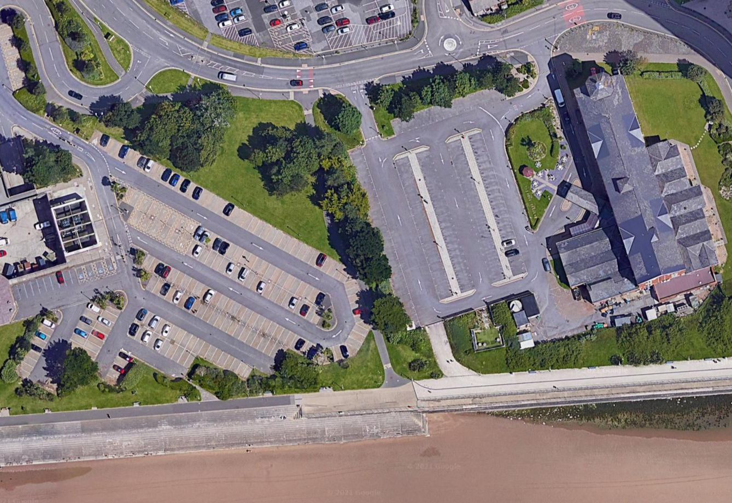

Figure 1. Showing approx. location of the proposed development site. (Google Maps, 2021)

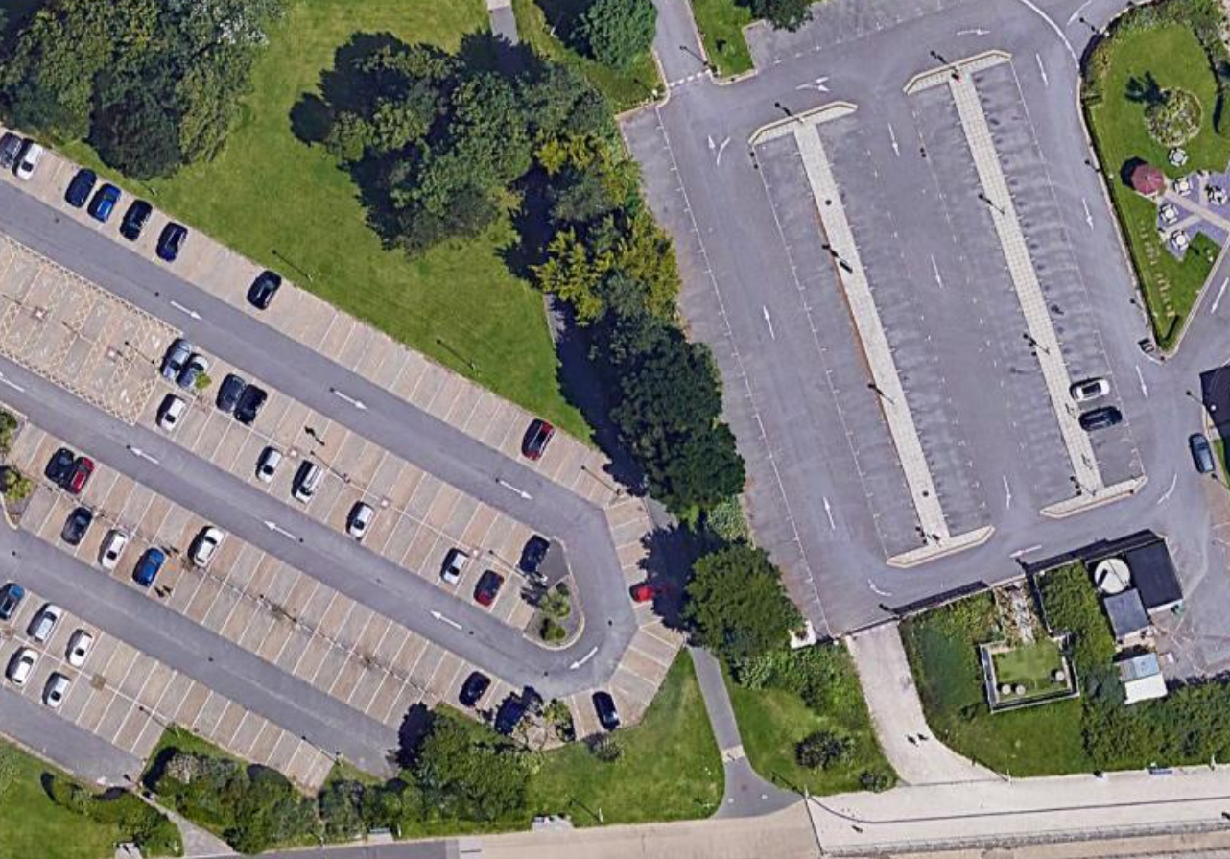

Figure 2. Zoomed Airiel photograph of proposed development site. (Google Maps, 2021)

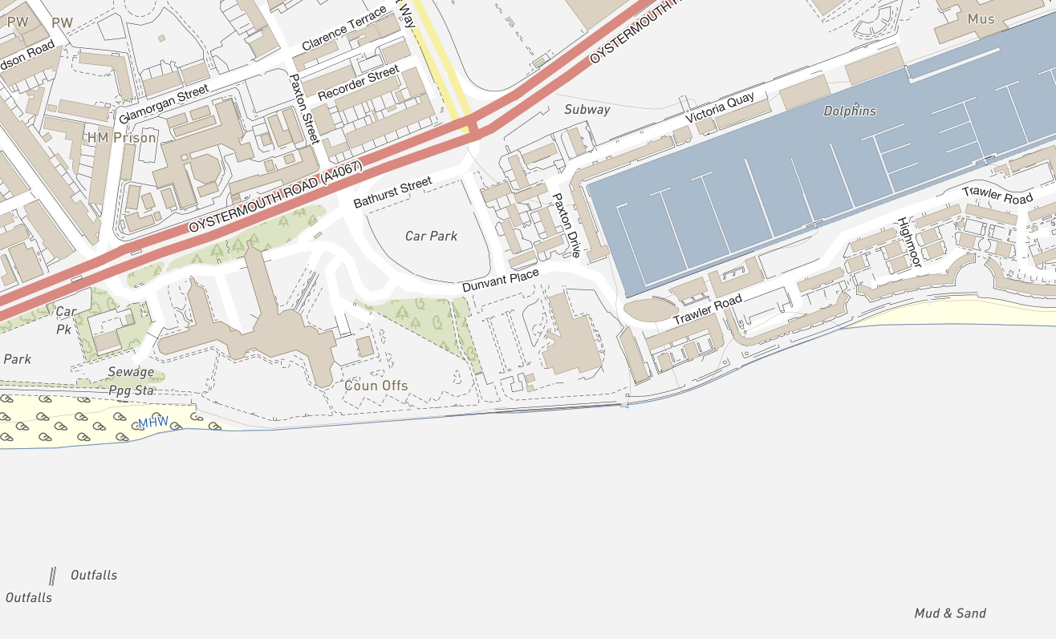

Figure 3. Site location and surrounding area with street names. (Lle.gov.wales, 2021)

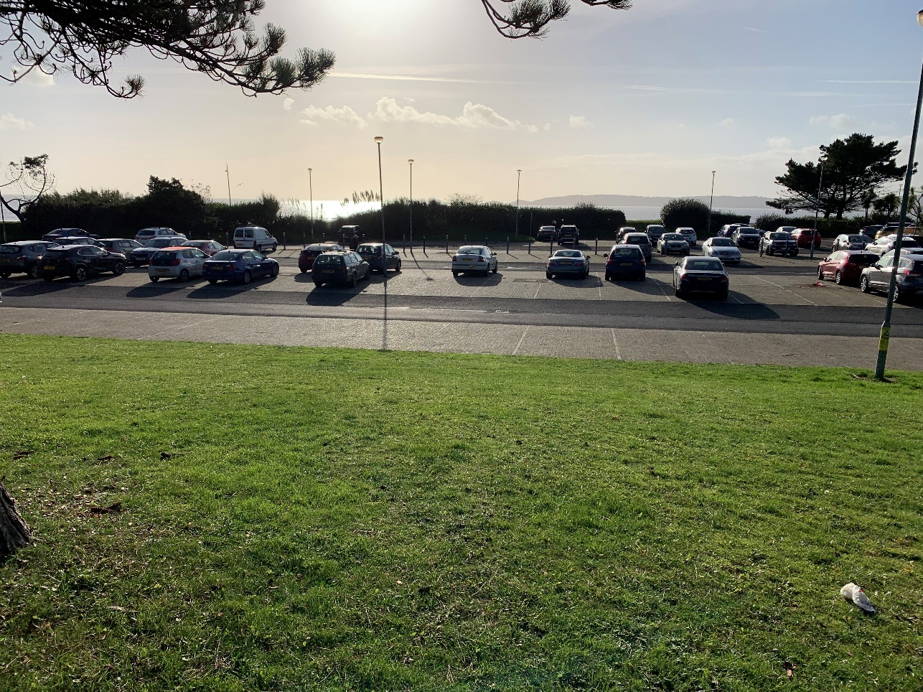
Figure 4. Site looking Southwest. (Jones, 2021)
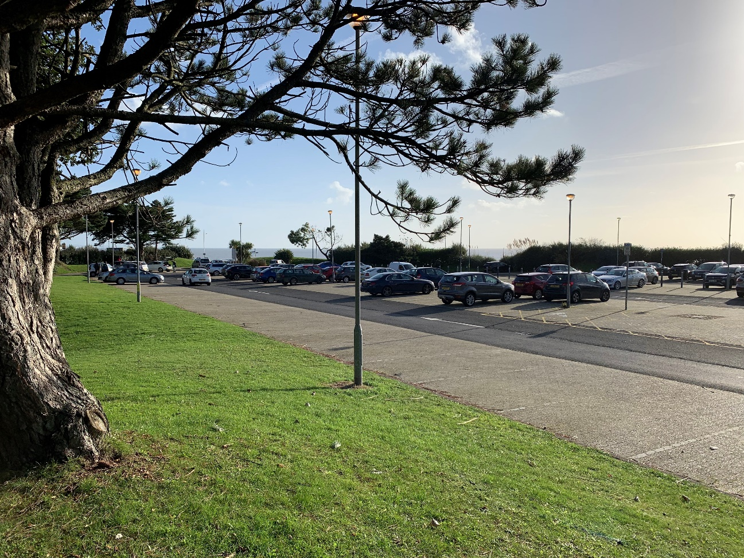
Figure 5. Site looking South. (Jones, 2021)
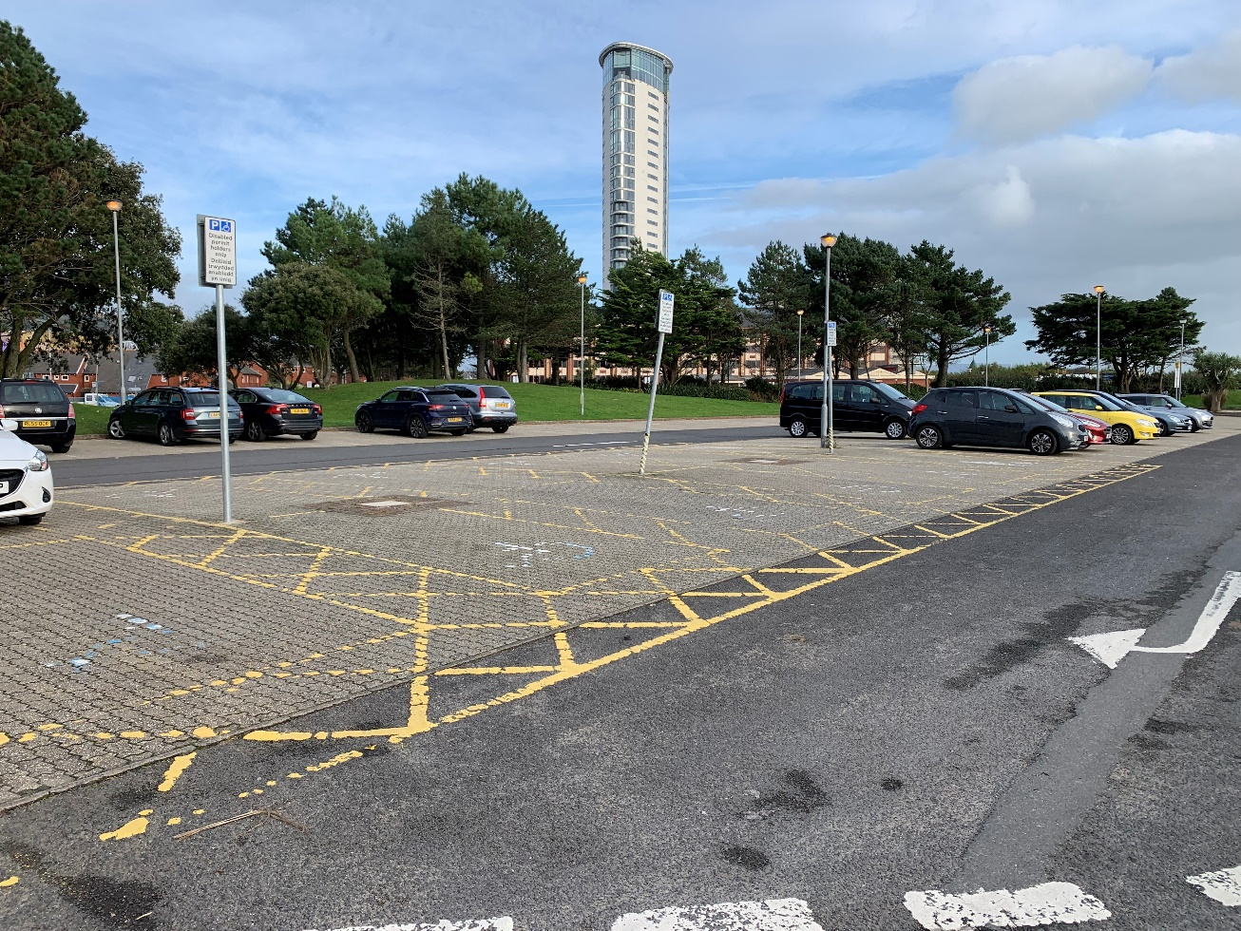
Figure 6. Site looking East showing the Marriott Hotel, centre behind the trees. (Jones, 2021)

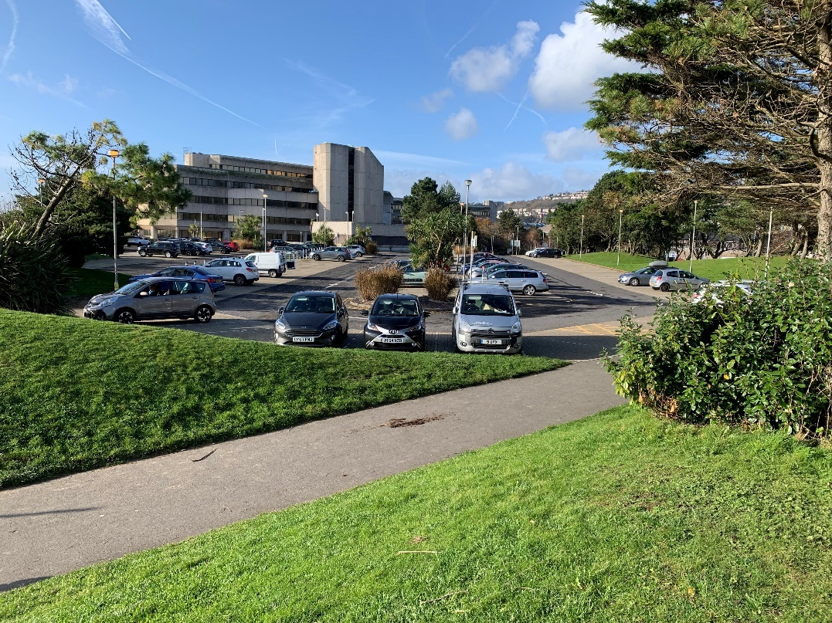
Figure 7. Site looking West showing the Civic Centre (Council Offices). (Jones, 2021)

Site History
In “Blood and Thunder Rough and Tumble” The Sandfields Story, published by the Sandfields Community Association, Dunvent Place was the site of the LMS (London Midland and Scottish) Railway which served the local colliery in the late 1950’s. (Vollens, 2012)
The Ordnance Survey Map of 1879 shows the site used by the L & NWR (London and North- Western Railway) main rail line. The Ordnance Survey Map of 1879 shows the Hospital for Contagious Diseases to the West of the site, a timber yard to the Northeast, and domestic dwellings to the North.

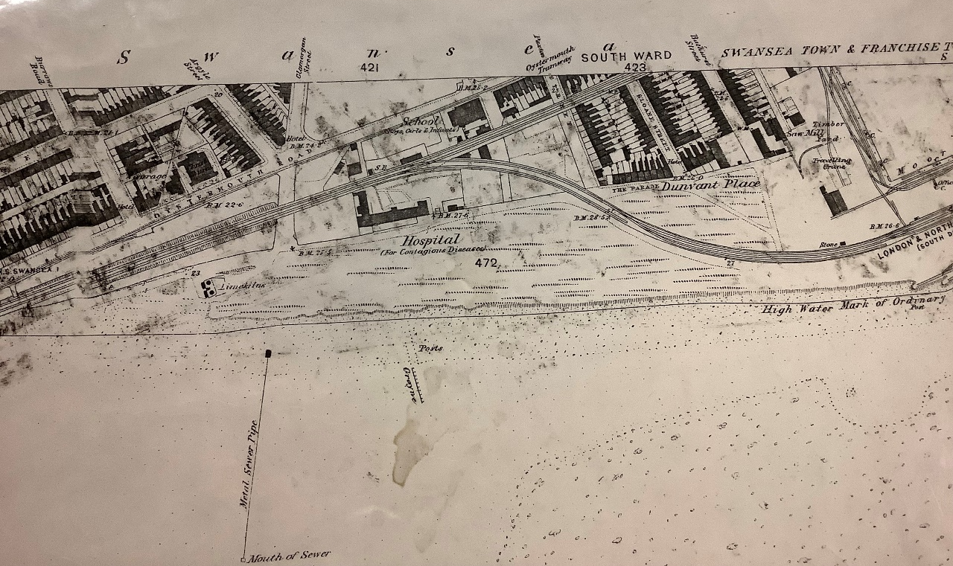

Figure 8. 1879 Ordnance Survey Map, showing site relative to historical use. (OS, 1879)
By 1899, the Hospital for contagious diseases to the West of the site had been demolished to make way for a railway engine shed and an additional timber yard was established slightly to the Northeast of the proposed site.
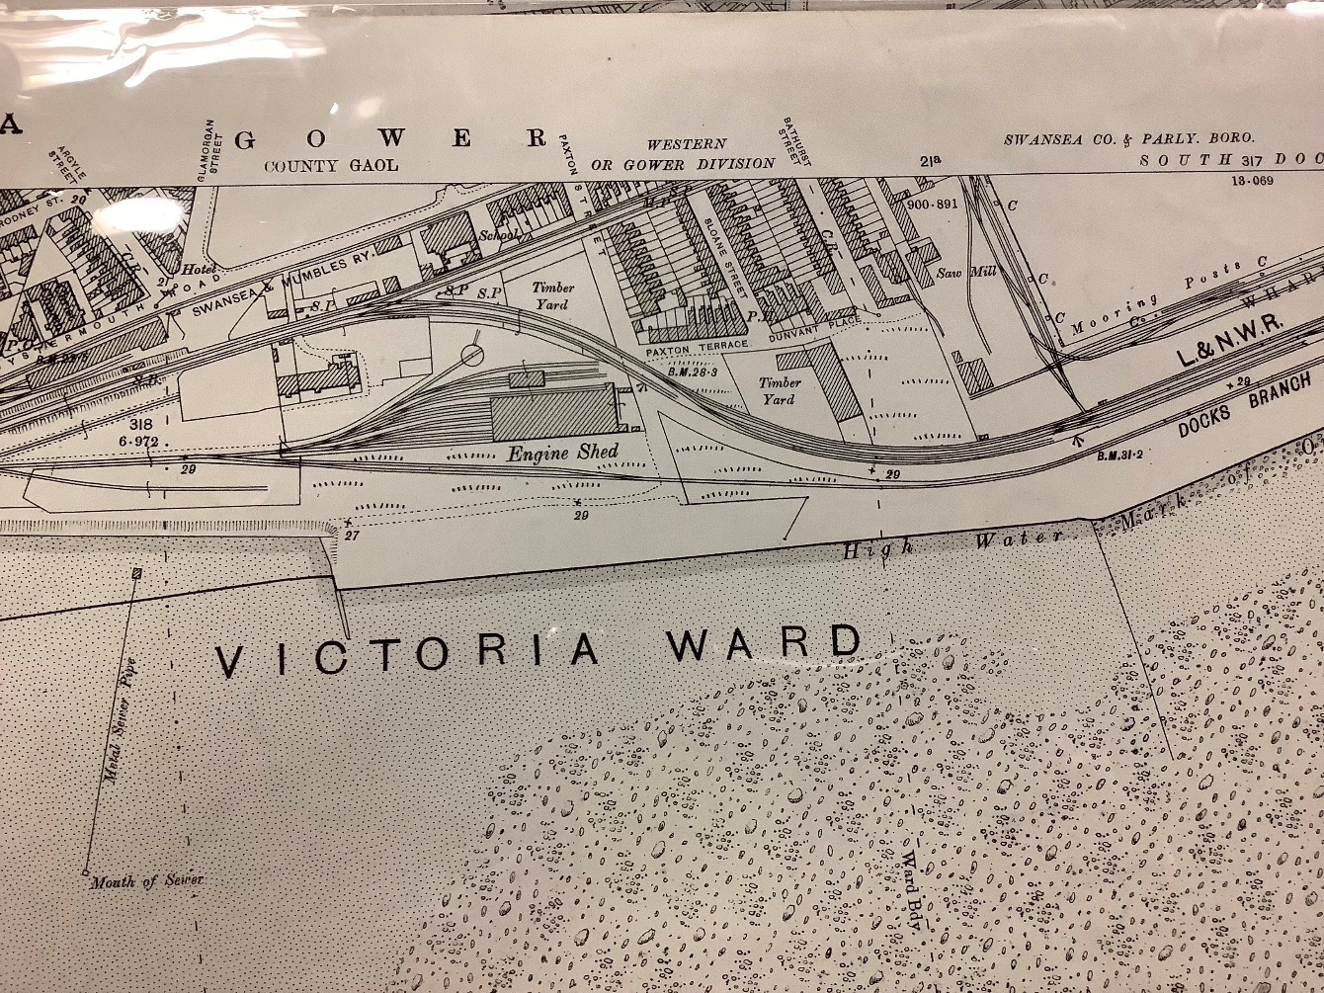

Figure 9. 1899 Ordnance Survey map of area. (OS, 1899)
In 1919, The timber yard had been replaced with the Canister Works.
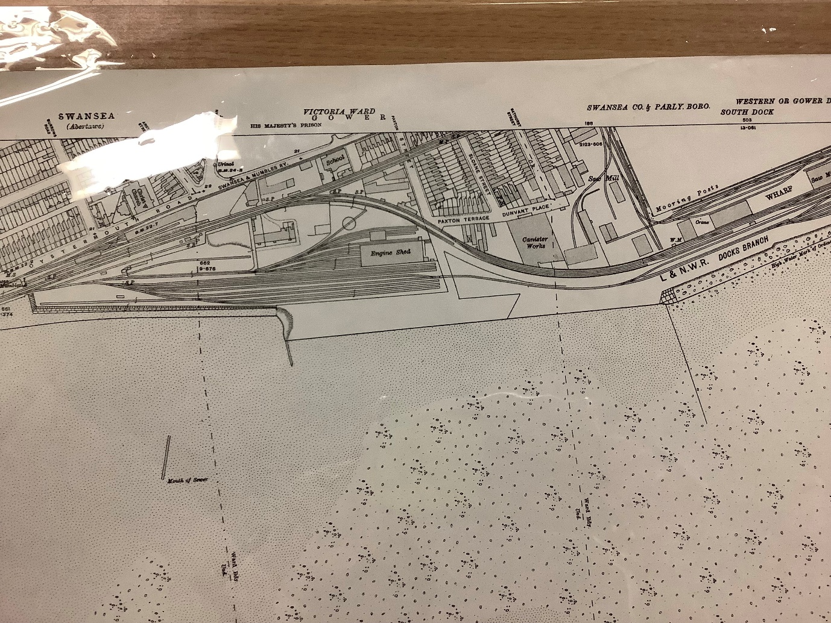

Figure 10. 1919 Ordnance Survey Map depicting the proposed site in relation to historical landmarks. (OS, 1919)

The Ordnance Survey map of January 1960 shows the Engine shed and rail facility extended, albeit disused after the recent closure of the railway, and the Canister Works replaced with a Factory and “Works”. The new works belonging to Holwill and Co Ltd. The Works supplied heating oil in the form of paraffin (Kerosene). Geoff Williams remembers in “Blood and Thunder Rough and Tumble” The Sandfields Story – “….between the sawmills and Holwills there was no shortage of firewood, for either our house or for bonfire night and loads of oily rags…”. (Vollens,2012).
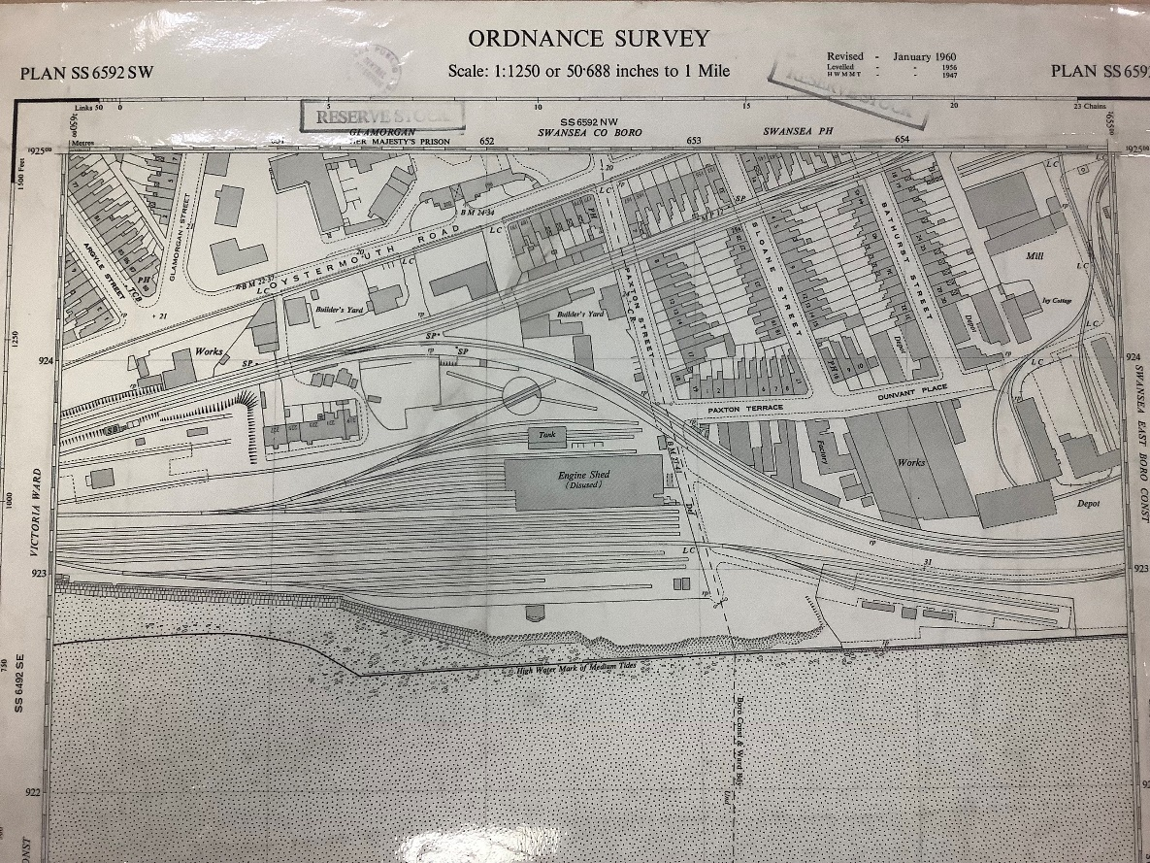

Figure 11. January 1960 Ordnance Survey Map showing proposed site superimposed. (OS, 1960)

Following closure of the rail line, the lines were dismantled, and the engine sheds were demolished and removed, leaving a clear open space. The warehouses and factory remain.
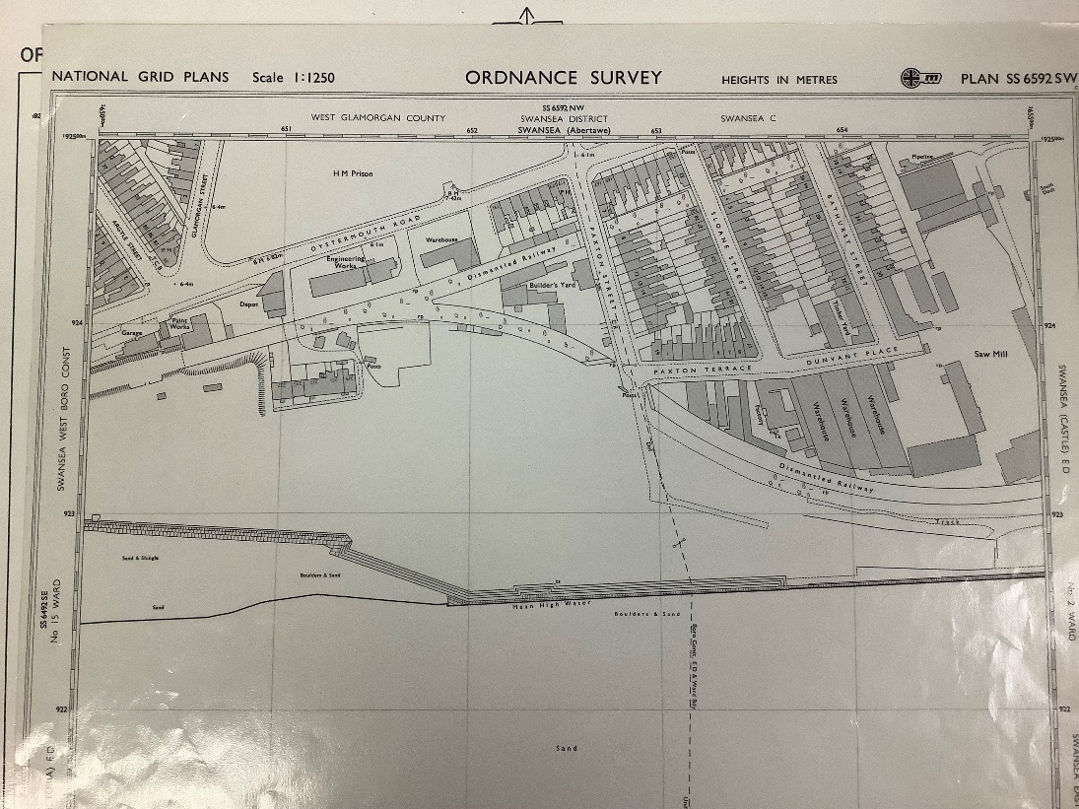

Figure 12. Ordnance Survey map showing dismantled railway and demolished engine shed. (OS, 1964)
Following the demolition of the engine shed and the dismantling of the railway, the residential properties in Paxton Street, Paxton Terrace, Sloane Street and Dunvent Place were also demolished. It is noted in The Swansea History Journal No 19 that “In the wake of Local Government reorganisation in 1974”. “A new administrative headquarters building was needed and a prestige site to go with it”. (Royal Institution of South Wales and contributors, 2011). The new Civic Centre was built to the West of the proposed development site, between 1979 and 1984. The 4 Star, 117 bed, Marriott Hotel, to the East of the proposed development, completed in 1989. (Strawbridge, 2007).

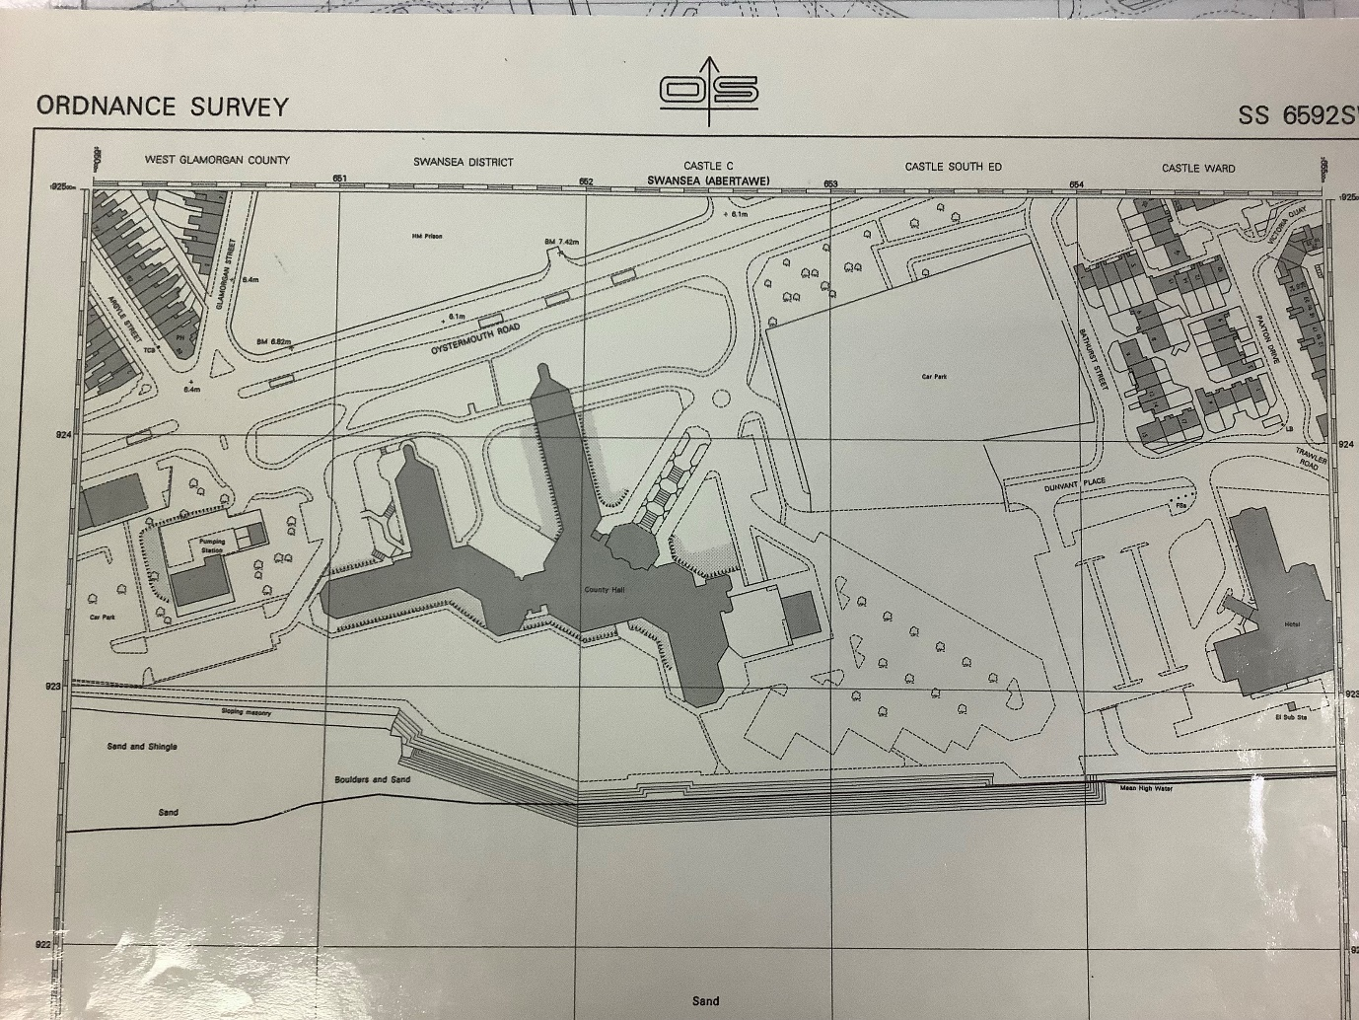

Figure 13. 1990 Ordnance Survey map showing the eventual redevelopment of the area with the Civic Centre and Marriott Hotel. (OS, 1990)

Site Geological Appraisal
The British Geological Survey (ESRI) online mapping of the area shows the bedrock to be South Wales middle coal measures, formed with mudstone, siltstone, and sandstone. The same Geology Viewer tool shows the superficial geology being blown sand deposits. (BGS-ESRI, 2021)
A bore hole log for a borehole driven to 22m in the location of OS GB Grid SS 6339 9228, is also available on the British Geological Survey online resource. The borehole was sunk in February 1975 for the development of the new Civic Centre. The borehole log is provided at Annex A to this report. The location of the borehole is shown on the map at Fig 16.
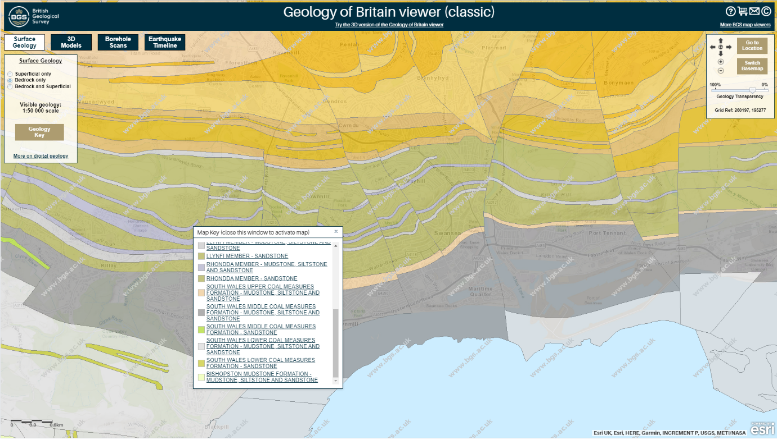

Figure 14. BGS Geology of Britain viewer bedrock screenshot. Proposed Development shown in red rectangle. (BGS-ESRI, 2021)
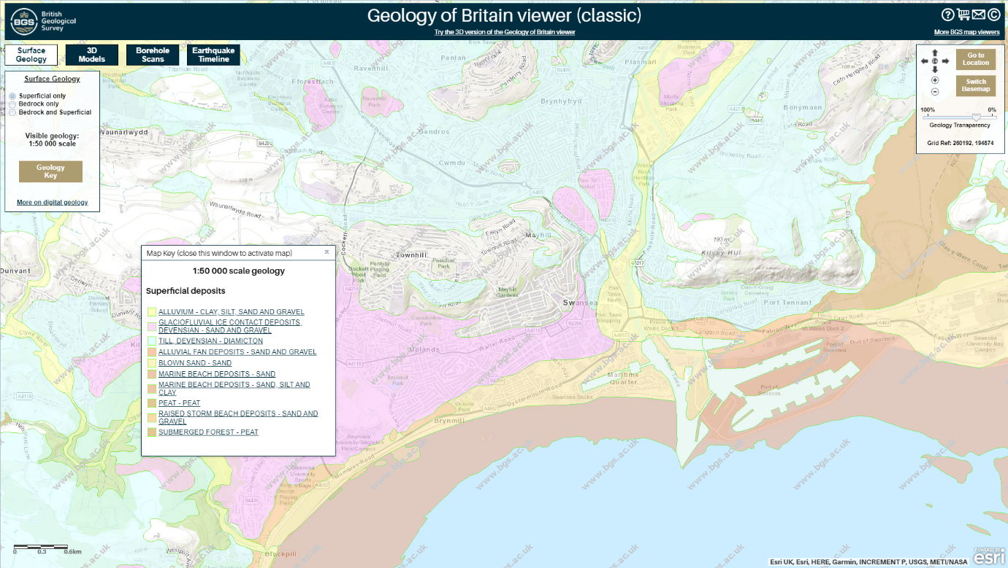

Figure 15. BGS Geology of Britain viewer superficial geology screenshot. Proposed Development shown in red rectangle. (BGS-ESRI, 2021)

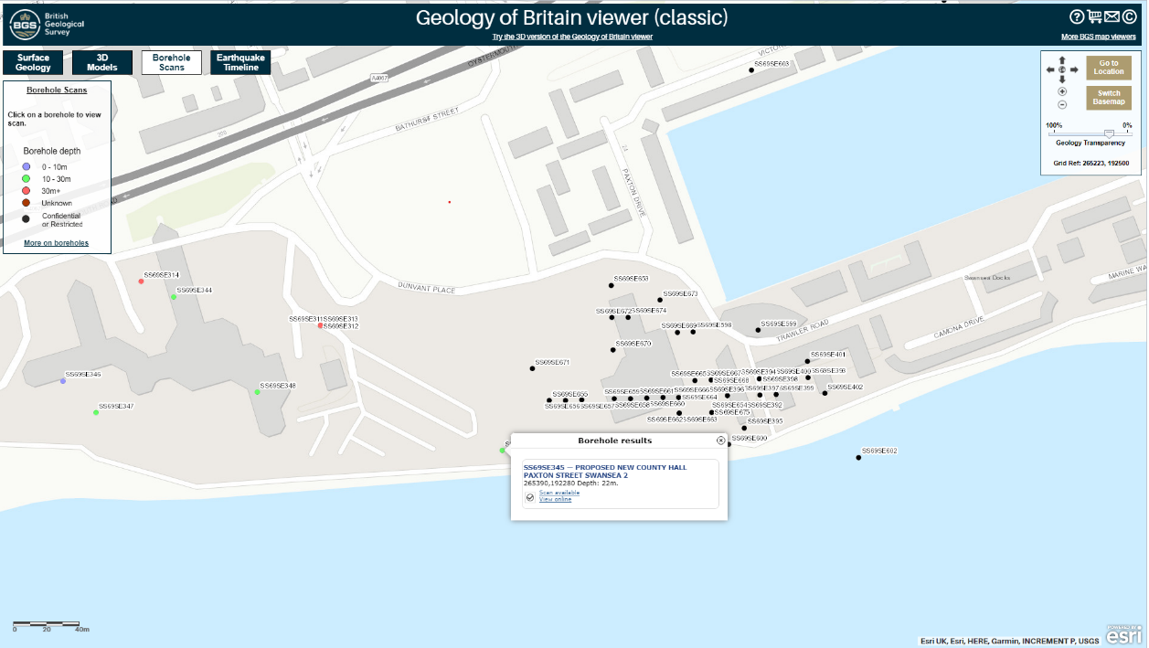

Figure 16. BGS-ESRI Geology of Britain viewer showing location of borehole in relation to proposed development. (BGS-ESRI, 2021)

Borehole Log Interpretation
Interpretation of the borehole log provides for the best insight to the site geology. Although it is only one borehole and further investigation will be required. Additionally, the borehole is located on the southernmost periphery of the proposed development site. There was no core recovery conducted on this borehole, nor was any Rock Quality Designation attempted. Ground water was encountered at 5.7m depth on each day of drilling.
Description of strata:
Serial | Depth (m) | N - Density (SPT) and depth in brackets | Description | Thickness (m)
1 | 0.5 | 8 | Made ground consisting of ashes | 0.5
2 | 1.5 | 8 | Made ground consisting of loose, light grey fine-medium sand | 1.0
3 | 2.55 | 8 | Made ground consisting of grey sand with layers of soft sandy clay | 1.05
4 | 3.5 | 9 | Made ground consisting of soft red-brown sand clay with brick shale | 0.95
5 | 4.95 | 150 (average calculated) | Made ground consisting of dense bricks, ashes, sand, and clay. | 1.45
6 | 7.0 | 140 (average calculated) | Very dense brown sandy gravel with traces of sandy clay | 2.05
7 | 7.85 | 77 | Very dense brown sand with some gravel | 0.95
8 | 11 | 34-67 | Stiff grey-brown gravelly boulder clay | 3.05
9 | 18.6 | 150 | Very stiff grey gravelly boulder clay | 7.6
10 | 22 | Not known - due to loose pebbles falling into hole | Grey mudstone | 3.4

Table 1. Geological strata from borehole log
The density of the strata can be indicated by the Standard Penetration Test (SPT) which is derived by the number of blows required by a 63.5kg driver falling 760mm, for the drilling or casing to progress 300mm through the strata. There are many correction factors to be applied, including for diameter of the borehole and for the length of the drill rod, which will be neglected for the purposes of this appraisal.
Whitlow in Basic Soil Mechanics classifies SPT N – values as:
Cohesionless Soils
SPT N - Value | Relative Density Description | Relative Density I_{d} (%)
Less than 4 | Very Loose | 0-15
4-10 | Loose | 15-35
10-30 | Medium Dense | 35-65
30-50 | Dense | 65-85
Greater than 50 | Very Dense | 85-100

Table 2. SPT N Values for Cohesionless Soils. (Whitlow, 2001)
Cohesive Soils
SPT N - Value | Consistency | Approximate undrained shear strength (kPa)
Less than 2 | Very Soft | Less than 20
2-4 | Soft | 20-40
4-8 | Firm | 40-75
8-15 | Stiff | 75-150
Greater than 15 | Very Stiff or Hard | Greater than 150

Table 3. SPT N Values for Cohesive Soils. (Whitlow, 2001)
Whitlow classifies cohesive soils as fine soils containing sufficient clay or silt particles to impart significant plasticity and cohesion. He classifies cohesionless soils as course soils, such as sands and gravels, which consist of rounded or angular (non-flaky) particles, which do not exhibit plasticity or cohesion. (Whitlow, 2001). Simply put, cohesive soils stick together and cohesionless soils are somewhat free running.
The SPT - N Value, with corrections applied can give an Allowable Bearing Capacity. Generally, the higher the N value the greater the allowable bearing capacity is.
Recommended Further Investigation
BS8004-2015 paragraph 4.2.1.1.8, recommends further investigation for low-rise buildings, the number of investigation points undertaken (n) should satisfy the following, unless the ground conditions can be shown to be sufficiently uniform to justify a greater spacing:
The number of investigation points n undertaken:
for A ≤ 300 m² - n is greater than or equal to 3
for A > 300 m² – n is greater than or equal to A/100 m²
where:
A is the plan area of each building's footprint.
As the proposed development is planned to have a gross internal floor area of 300m² it is recommended that a minimum of 3 further investigation points should be undertaken to establish geotechnical data to confirm the recommended foundation is correct.
Further geotechnical investigation should be conducted to BS EN 1997-2:2007 Eurocode 7.
Environmental Considerations
It was established, through research on the Lle.gov.wales online platform and the judicious application of the filters, that there are no protected species of flora or fauna, nor presence of statutory or local preservation conditions or conservation restrictions. The site is currently developed and landscaped for use as parking for vehicles. It was established through the local authority Tree Officer that there are no trees with preservation orders on the proposed development site.
The historical usage of the area, including an oil import and export business, warehousing, rail lines and timber sawmill, and historical accounts from local people, would suggest that contamination of the ground may be present. The borehole log shows that the site is composed of made ground, containing ashes, brick and other backfill, to an approximate depth of 5m. This fill, may contain other solid contamination, including asbestos. Exposing any contamination from ground working may cause harm to personnel and possible contamination of waterways
The guidance published in The Contaminated Land Statutory Guidance for Wales 2012, should be complied with, and a Land Quality Assessment conducted.
Archaeological Impact Assessment
The recent historical use of the land is well documented. To access ground that may contain archeologically important artifacts, significant deep groundwork would be required, which is unlikely to be required for this proposed development. Therefore, the foreseeable risk to any heritage is insignificant and therefore can be discounted as a risk for this project.
Unexploded Ordnance
Although the area was quite heavily bombed during World War 2, due to its proximity to the docks and the railway, which were the target for the Luftwaffe, there is no documented evidence of a bomb strike in this area. Additionally, as groundwork has been carried out in this area since the cease of hostilities, any unexploded ordnance would most likely have been encountered then.
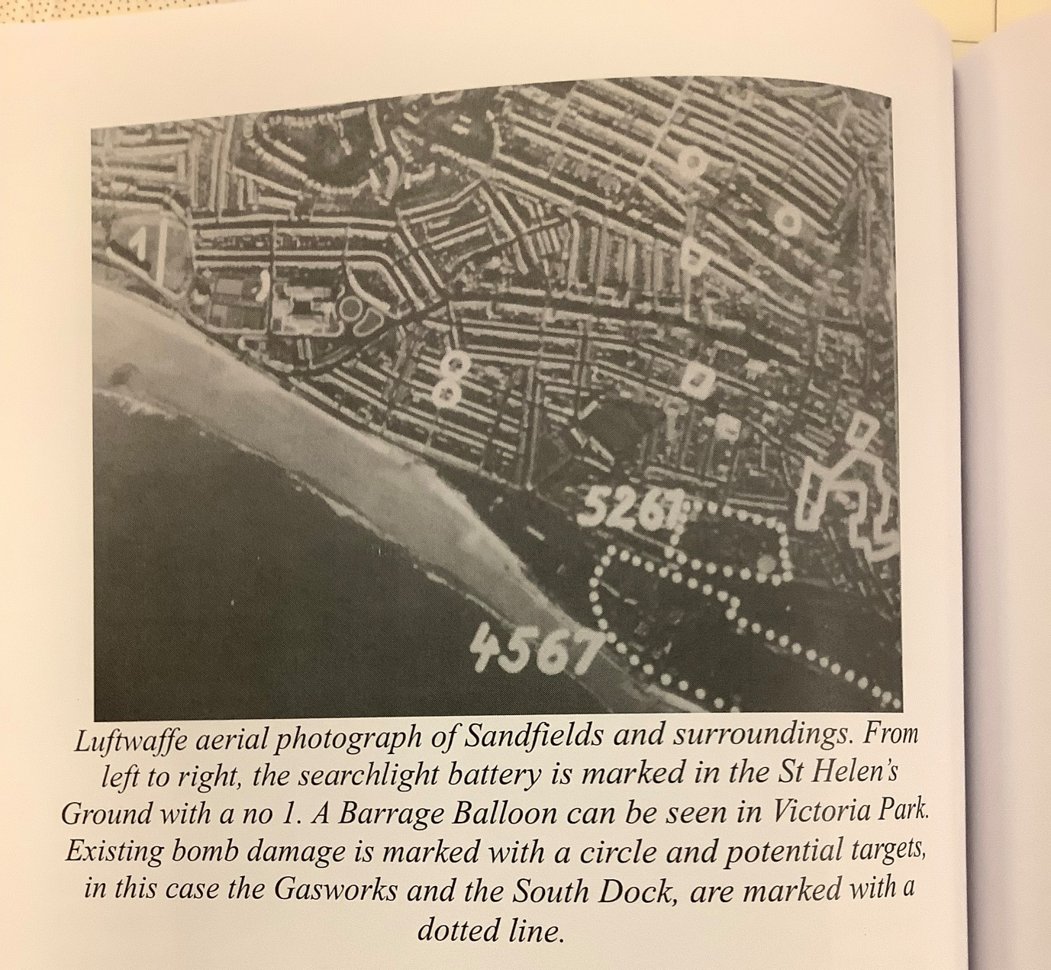

Figure 17. Excerpt from “Blood and Thunder Rough and Tumble” The Sandfields Story – showing known bomb strikes relevant to the proposed development site. (Vollens, 2012)
Planning Requirements
The Town and Country Planning Act 1990 is the overarching legislation governing development. Section 57 specifies the planning permission requirements. There exists a requirement under Section 61Z of the 1990 Act to carry out pre-application consultation, and this must be complied with. Section 65 of the 1990 Act requires notice of applications for planning permission.
The planning application should be made through the Local Planning Authority office and should follow the requirements of The Town and Country Planning (General Development Procedure) Order 1995 as amended. Section 10 of the 1995 Order specifies who should be consulted prior to permission being granted.
Recommendation for Building Foundations
Without further geotechnical investigation, it is prudent for the foundation requirements to be slightly over specified. For a 300m² gross internal area two storey building. It is assumed that the building will be rectangular with the length and breadth of the plan being similar.
With the geotechnical information currently available, with loose made ground down to approximately 3m and the water table at 5.7m a spread type of foundation of the raft type is recommended. BS8004-2015 paragraph 5.1.4.1 states:
Raft Foundations may be used to support:
- Lightly loaded structures on low strength natural ground, where it is necessary to spread the load across horizontally variable ground, fill, or weaker zones.
- Structures that are sensitive to differential settlement.
- Structures on ground where mining or other forms of subsidence are likely to occur and thus a flexible structure and foundation is required.
- Low rise dwellings and lightly framed structures on soils that are susceptible to excessive shrinking or swelling. (BS8004-2015)
The foundation should be designed to comply with Building Regulations 2010, Approved Document A, Part A1/2 Section 2E, unless a specific structural engineering solution is designed by a competent person, that is acceptable to the inspecting authority. See detail sketch below:

Cavity wall with reinforcing tied into foundation

Smooth layer of concrete for floor (50mm)

Reinforced Concrete Raft Mat with 2 layers of reinforcing mesh (one at top of slab and one at bottom) (shown in orange)

Damp Proof Membrane

Blinding layer of concrete (75mm) thick)

Depending on the eventual building design, it may be necessary to increase the thickness of the reinforced concrete raft mat below the external walls. Shown below:

Figure 18. Detail of Raft Foundation (Not to Scale)

References

British Standards Institution (2015) BS 5930:2015: Code of Practice for Ground Investigations: London: British Standards Institution.
British Standards Institution (2015) BS 8004:2015: Code of Practice for Foundations: London: British Standards Institution
Building Regulations (2010) Approved Document A – Structure. London: HM Government: Available at https://assets.publishing.service.gov.uk/government/uploads/system/uploads/attachment_data/file/429060/BR_PDF_AD_A_2013.pdf .
Ordnance Survey (1879)(1899)(1919)(1960)(1964)(1990) Map Sheet SS6592 SW. Southampton: Ordnance Survey
Porch, R. (2011) “The Civic Centre / County Hall: an example of Seafront Modernisation”: The Swansea Historical Journal. No 19: pp 19-28.
Site Investigation Steering Group. (2018) Site Investigation in Construction – Effective Site Investigation. London: Institution of Civil Engineers Publishing
Strawbridge, D. (2007) Swansea Bay… the Coastal Route. Swansea: The Gower Society
The Town and Country Panning Act 1990. Available at https://www.legislation.gov.uk/ukpga/1990/8/contents
The Town and Country Planning (General Permitted Development) (England) Order 2015. Available at https://www.legislation.gov.uk/uksi/2015/596/contents/made
Vollens, A. (2012) ”Blood and Thunder Rough and Tumble” – The Sandfields Story. Swansea: Sandfields Community Association
Whitlow, R. (2001) Basic Soil Mechanics. 4th Ed. London: Pearson
British Geological Survey (ESRI) (2021) Geology of Britain Viewer: Available at https://mapapps.bgs.ac.uk/geologyofbritain/home.html?&_ga=2.1471921.1898845543.1634218998-441634793.1634218998
Google Maps: Available at https://www.google.co.uk/maps
Lle.gov.wales: Geo – Portal Wales: Environmental Impact Assessment (Agriculture Wales). Available at http://lle.gov.wales/map/eia#m=-2.67559,52.53997,8&b=europa

Annex A to Assignment 1


