Llywelyn James
2217776
Module Code – ACBA 6009
For: Rhodi Thomas
Bryn Bragl Report
Advanced Construction Technology

Table of Contents

1.0 Introduction 2
2.0 Evaluation of the building envelope 2
2.1 Construction Method 2
2.2 Building Fabric 3
3.0 How has the buildings design been influenced 4
3.1 Environmental Factors 4
3.2 technology which influenced the design 5
4.0 Building Services 6
4.1 PKOM-4 System 6
4.2 Tesla Powerwall 2 8
4.3 Technology Apps 9
5.0 Conclusion 9
6.0 Reference list 11

1.0 Introduction
This report will be focused on the Bryn Bragl development, based in Bridgend, South Wales. It’s an energy-positive scheme completed for Wales & West Housing and features 14 affordable homes. It was primarily chosen to offer a real-world case study, which can then be compared to other UK projects aiming towards sustainability. This development will help give us an insight and some guidance for the company to try and move towards more sustainable construction methods. Also, it enables us to give an in-depth review on topics such as, construction methods, building fabric, impact that technology has in creating it sustainable and the building services used in the houses.

2.0 Evaluation of the building envelope

2.1 Construction Method
Kingspan TEK Structural Insulated Panels (SIPs) was the chosen construction method to undertake this project. The panels consist of rigid urethane insulation between OSB boards on either side of it. This is what formed the load bearing walls and roofs, whilst it provides a secure and highly insulated thermal envelope. In the Kingspan brochure which they published, it mentions that they can reach U-values of ~0.17 to 0.10 W/m²k for the walls/ roof. This figure is dependent on the thickness chosen for the SIPs panels, with the highest thickness (215mm) being labelled as Passivhaus graded. Figure 1.1 shows an example of the Kingspan TEK SIPs used.
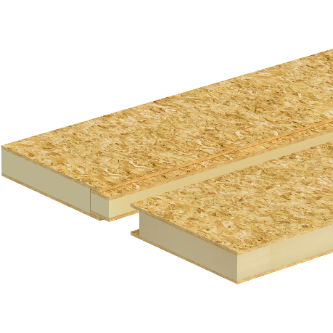
Figure 1.1
This method of construction allows for the panels to be factory made. This is beneficial from a sustainability aspect as it means that construction waste will be at a minimal, in comparison to other methods of construction such as brick and block which averages 10% wastage on mortar alone (T. Perkins 2023). It also increases the rate of construction as the panels are arranged together like a jigsaw, resulting in less labour time on site. However, there are arguably more sustainable SIPs options available, for example, Wull Technologies Ltd is a joint venture created by Vector Labs and Wool Insulation Wales and they specialise in SIPs with high density sheep wool. In comparison to the urethane insulation, it has lower embodied carbon, is a natural renewable material and provides economy sustainability due to the wool being sourced in Wales.
With doing some research, the Scandinavian countries (Denmark, Norway and Sweden) are some of the world's top performers when it comes to building sustainable homes. The most popular construction method which they use is timber frame, specifically prefabricated panels such as cross laminated timber (CLT) when it comes to sustainability. One of the reasons that this method wasn’t used in this project is the fact there isn’t a single CLT manufacturer within the UK, meaning the panels would’ve needed to be imported in concluding in higher costs. If CLT was used, then it would provide lower upfront carbon. However, the SIPs offer a lower operational carbon meaning it’s more efficient and has lower energy bills which is perfect for a site which is aimed towards affordable homes.

2.2 Building Fabric
All the walls on the site were installed with thermal insulation, and due to the airtightness of the SIPs, thermal bridging will be at a minimum, as well as its baseline energy demand is being reduced as less energy is required for heating. The airtightness is also improved by them having had an airtight layer installed, with it achieving 1.85m³/hm² @ 50 Pa, which isn’t hitting the Passivhaus targets of 0.6m³/hm², but is significantly better than average new builds of somewhere between 4-6m³/hm². The contractors had been given Passivhaus/ airtightness training before undertaking the work to ensure that the there was no possibility of air seeping through, otherwise it would affect the house is energy performance.
The windows throughout the houses are triple glazed, with the same intentions as the SIPs, to try and create an air-tight structure. It also improves thermal efficiency and compared to the double glazed windows it increases the energy efficiency by 5-10% per year. In addition to this, each window and doors are fitted with air-tight seals to also improve the house is energy performance and are fitted with aluminium clad timber frames. These frames like the windows themselves, are highly efficient with the timber acting as a layer of insulation and noise reduction fabrication.
Moving onto the external features, the houses were finished off with a single layer of brick and Cedral cladding. Although neither of these directly improve the efficiency, they both act as a protection barrier for the SIPs where the main source of efficiency for the houses is.
Finally, there is the roof which has a GSE in-roof PV system and was chosen to be used instead than the traditional slate or clay tiles and then the solar panels installed on top. The GSE design was chosen for a couple of reasons, such as the impact it has on the overall efficiency and sustainability, with low embodied carbon, a source of energy, lower lifecycle impact and improves thermal efficiency in comparison to the traditional method, by preventing heat pockets with it having created consistent airflow behind the panels.

3.0 How has the buildings design been influenced

3.1 Environmental Factors
There are a few things in which they needed to consider before determining what technologies they needed, to make it an efficient affordable home. Such factors influenced the design of the buildings. For example.
- An important consideration was the need to optimize the sun in the most efficient and effective way possible. Which was by having the site’s orientation facing South capitalizing on the direction which receives the most direct sunlight and therefore maximizing solar input.
- Another consideration is the temperature drop there is during the winter season, where robust heating is required for South Wales. With temperatures often dropping below freezing point. This also means there is a need to minimize heat loss in the winter. This is achieved by using high insulation, MVHR and airtightness.
- In the summer season the temperatures are quite mild in comparison to countries such as Spain, Portugal etc. Very rarely does Wales experience extreme hot weather, which excludes the need for any air-conditioning in these homes. Having said that, the design ensures internal comfort and air quality via MVHR.
- Due to all properties on this project being affordable housing, its target audience is people who are on lower incomes, and some who may be having some financial struggles. The design in this development therefore has social sustainability embedded in it.

3.2 technology which influenced the design
Diving into the building’s design in the development, they have ensured that they have South facing roofs. The reason behind this is because they’ve fitted photovoltaic (PV) panels instead and this is the direction which produces the highest energy yield. On top of this, they had to also take the structure into account as the load of this is significantly less than traditional tiles, allowing them to use less/ lighter rafters or purlins. Adding to this, the cables are being run from the roof through the house to the battery, which needed to be pre-planned to minimize cable exposure to make it as aesthetically pleasing as possible.
A Tesla Powerwall 2 with a lithium-ion battery has also been dedicated to each household to store electricity generated from the PV panels. The battery is 115cm x 75cm x 14.7cm in size and weighs 114kg, meaning that the design was influenced to allow space to install this battery within the house. However, they can also be installed outside but is not recommended in countries like Wales due to cold and damp climate we have which can reduce its efficiency.
Transpired solar collectors (TSC) have also been installed in the South facing exterior walls again this where they will benefit the most and capture the most energy, for the same reasonings as the PV panels. An example of how this system works can be seen in figure 1.2. With this, Hore Lea architects is sustainability team who played a key role behind this project stated, “energy modelling for all the house types allowed us to demonstrate that the design is capable of being energy positive (i.e. putting more energy into the National Grid than it takes out).”

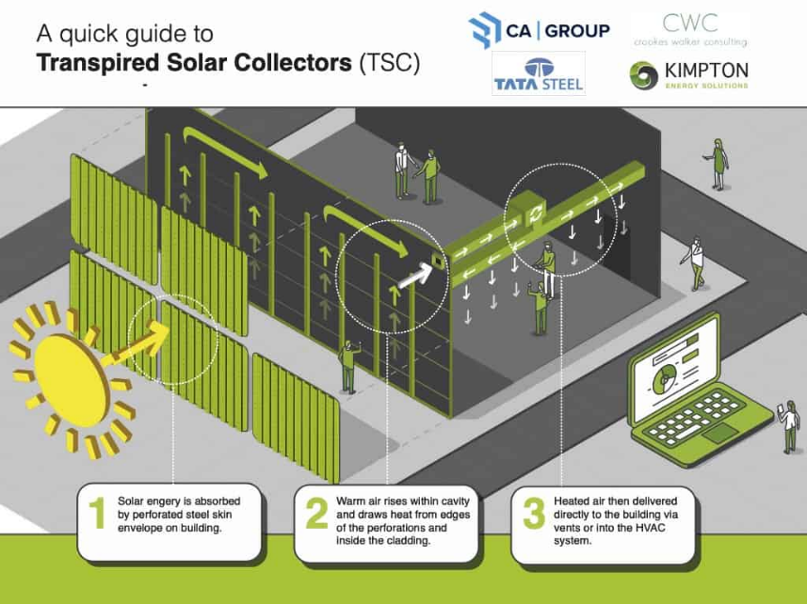

Figure 1.2
In respect of the heating and hot water, they’ve installed a PKOM-4 system, which is a compact service unit which includes a built-in air-source heat pump (ASHP) and a mechanical ventilation with heat recovery (MVHR) system on each property. With warm air distribution being used as primary heating there is no need for radiators and pipework, only an electric towel rail in the bathrooms, opening more wall space throughout. Similarly to the Powerwall 2 battery, this system must also be installed in each house with the architects needing to configure somewhere for this to be fitted, ensuring that it doesn’t take up too much space and fits into the design as best as it can.
The ductwork required for the PKOM-4 system plays an important role on the design of the building, as they ducts are run throughout the entire property, they had to be pre-planned to ensure they are well coordinated. The ceiling voids are large due to the duct sizes required for the system, meaning the storey height will be adjusted for this design as well as the joist depth. With the ductwork running through the house, access to it is important for maintenance such as cleaning, but also acoustic noise which may have influenced the design spec specifically around the bedrooms, where acoustic plasterboard or duct type may/ could have been used.

4.0 Building Services

4.1 PKOM-4 System
The building services installed throughout these buildings play a critical role in creating Bryn Bragl not only to be energy efficient, but to also be made a comfortable living space for the occupants. Firstly, looking at primarily the PKOM-4 system, this is a compact all in one service unit which provides ventilation, domestic hot water, heating and cooling which all combine resulting in it being highly energy efficient and meets ‘Passivhaus’ standards. The heat pumps in this system are electric and therefore allowing them to be run by the PV panels, which is in line with the companies aim to avoid the use of gas. An example of how this system works can be seen in figure 1.3.
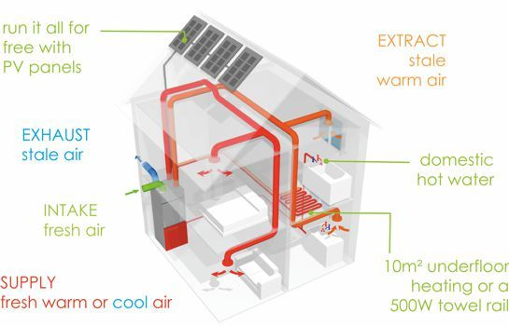

Figure 1.3
This system not only provides good energy efficiency, but it creates a good living environment with improved human comfort in a couple of ways. There is constant filtered air flowing around the homes, efficient heat recovery, domestic hot water supply, temperature control and a touchscreen control panel, which is how the system is managed, or on a smartphone app, allowing the owners to adjust the settings their desired comfort from anywhere.
As briefly touched upon, there is a good ventilation system there, within the PKOM-4, which is called the MVHR (Mechanical Ventilation with Heat Recovery). This reduces each household’s carbon footprint by up to 70% (Clean Energy Homepage, 2025), in comparison to a typical gas boiler. The system works by extracting stale air from kitchens, bathrooms, cellars etc, where stale air is most common. To then capture the extracted heat and collide with the filtered fresh air pulled through the fan within the heat exchanger. After that, the heat exchanger will mix the fresh air with the heat captured and release the fresh filtered air into the house. With filters being installed it improves the air quality by removing pollutants, dust, pollen etc. An example of this can be seen in figure 1.4.


Figure 1.4
By having this installed it improves the overall efficiency of the building by recovering heat from outgoing stale air, with an impressive 85% of the heat being recovered. With that in mind, with the fresh air coming in partially warmed, the amount of energy required from the heating system is massively reduced.
From the owner’s perspective it improves the living environment with the system being able to prevent cold spots and mold growing indoors with the system exporting the moisture content. It’s also designed to reduce noise creating acoustic comfort by having sound attenuators, enabling it to operate quietly and blocking outdoor noise from seeping through. Likewise, to the PKOM-4 this is all controlled on the control panel or smartphone app.

4.2 Tesla Powerwall 2
The Tesla Powerwall plays a key role in reducing the home’s energy costs by storing energy captured by the PV panels throughout the day or charging the lithium-ion battery from the grid during the off-peak grid hours and being able to store the power there until it’s needed, like when the rates are high. As well as this, it gives the owners peace of mind as it acts as a backup, by automatically detecting when the grid is down and becoming the home’s main power source, then switch back when the grid is restored. Adding to this, the design of the Powerwall system itself is very modern and aesthetically pleasing, with an enclosed design it creates a safer home environment if any children or pets are living there. The lithium-ion battery has a round-trip efficiency of a minimum of 95% in comparison to the 80-85% that lead-acid batteries use, it has also got an energy capacity of 13.5 kWh, which is around the average battery storage for houses at this size. By having PV panels and battery combination it hugely improved the house is sustainability. If there are occasions where the battery is full and no more energy can be stored there, then power is fed back into the electrical grid, enabling that energy to be used on other houses.

4.3 Technology Apps
Finally, you’ve got all the technology systems in place. As touched upon the PKOM-4 and the Tesla Powerwall 2 have smartphone apps which enables you to change the settings for each of the services, but also see how much energy is being used/ saved, the PV generation, energy left in the battery etc. This is beneficial for the occupants as it’ll help give them a guide of how much their energy bills cost each month. However, this is an area which may trouble the older generation due to lack of knowledge or training, in this case maybe installing simpler wall controls would suffice or provide training, guides and support.

5.0 Conclusion
The Bryn Bragl housing development has become a real eye opener for me, with what I believe are finding which we can incorporate into the company moving forward or in the near future, with many lessons learned regarding sustainability, energy efficiency, building services, construction methods, technology used and many more. Firstly, having evaluated SIPs as a form of construction, I believe that this route should be considered moving forward as a company for multiple reasons, specifically the Kingspan TEK panels over the sheep’s wool option as it is cheaper and meets Passivhaus targets. These reasonings include it being manufactured off-site, having a fast construction rate, reduced waste on site (up to 90%) in comparison to traditional methods and better energy efficiency than them also. It’s also suited for the climate we have in South Wales, with it being an airtight envelope and has high performance insulation for year-round benefits by improving the energy efficiency.
A comparison of this project would be Goldsmith Street in Norwich, where they were able to successfully design and build houses specifically for affordable housing, making it sustainable and reducing energy bills. They achieved their target by using high performance building envelopes, MVHR systems and accurate detailing in the design. Due to them having very similar targets as the Bryn Bragl project, it creates it more credible and highlights to us that creating sustainable houses are possible, whether it be private homes or affordable homes.
Contrast to this, you’ve got the Energiseprong retrofit trials in Nottingham and Sutton who used similar technology/ smart apps to what the Bryn Bragl site used. However, there had been complaints from residents who were unable to work it, which lead to the properties not being able to maximize its energy performance. The key thing here is to ensure that we need to ensure that systems are properly installed, monitored and provides training for residents to make it work.
Overall, this review indicates that Bryn Bragl is a key example for companies in South Wales and the rest of the UK, who are looking to developing their own sustainable houses. With the key points of prioritising the building envelope, invest in training/ support and integrate systems intelligently.

6.0 Reference list
Ball, D. (2025). Sheep wool insulation innovation secures £300k to scale production. [online] Build News - Building and Construction News. Available at: https://www.buildnews.co.uk/sheep-wool-insulation-innovation-secures-300k-to-scale-production/ [Accessed 3 Dec. 2025].
Beam Vacuum & Ventilation. (2025). What Is MVHR and How Does It Work? [online] Available at: https://beamcentralsystems.com/blog/what-is-mvhr-and-how-does-it-work [Accessed 30 Oct. 2025].
Clean Energy Homepage. (2025). Install a heat pump - Clean Energy Homepage. [online] Available at: https://cleanenergy.campaign.gov.uk/heat-pump/ [Accessed 30 Oct. 2025].
Domac, M. (2020). Construction in the North - The Nordic approach to building. [online] PlanRadar. Available at: https://www.planradar.com/gb/construction-nordic-region/.
Glo Renewables. (2024). Sustainable Living with Tesla Powerwall: Exploring Its Ability to Run Your Home. [online] Available at: https://glo-renewables.co.uk/sustainable-living-with-tesla-powerwall-exploring-its-ability-to-run-your-home/ [Accessed 5 Dec. 2025].
Hoare Lea. (2018). Bryn Bragl Housing. | Hoare Lea. [online] Available at: https://hoarelea.com/project-story/bryn-bragl-housing/ [Accessed 30 Oct. 2025].
Jenkins, M. (2024). Double vs. Triple Glazed Windows: Energy Savings and Benefits Explained - KMJ Windows and Doors Ltd. [online] KMJ Windows and Doors Ltd. Available at: https://kmjwindowsanddoors.co.uk/double-vs-triple-glazed-windows-energy-savings-and-benefits-explained.
Kimpton Energy Solutions. (n.d.). Transpired Solar Collectors and Their Five Benefits | Kimpton Energy. [online] Available at: https://www.kimpton.co.uk/our-services/renewables/transpired-solar-collector/ [Accessed 30 Oct. 2025].
Kingspan (2023). An Introduction Structural Insulated Panels Building System Kingspan. [online] Available at: https://www.kingspan.com/content/dam/kingspan/kil/products/tek-building-system-gb-and-ireland/kingspan-tek-building-system-introduction-brochure-en-gb-ie.pdf?utm_source=chatgpt.com [Accessed 28 Oct. 2025].
McFadden, C. (2024). 7 Easy Ways To Improve Your Property’s EPC Rating. [online] The Eco Experts. Available at: https://www.theecoexperts.co.uk/solar-panels/tesla-powerwall-costs.
P O W E R W A L L. (2019). Available at: https://www.tesla.com/sites/default/files/pdfs/powerwall/Powerwall%202_AC_Datasheet_en_AU.pdf.
Perkins, T. (2023). Brick Calculator. [online] Travisperkins.co.uk. Available at: https://www.travisperkins.co.uk/content/brick-calculator [Accessed 30 Oct. 2025].
Sketchley, E. (2019). Why SIPs are crucial to the future of the UK construction industry. [online] Planning, BIM & Construction Today. Available at: https://www.pbctoday.co.uk/news/mmc-news/sips-uk-construction/68942/.
South, in (2019). Carnego Systems. [online] Carnego Systems. Available at: https://www.carnego.net/bryn-bragl-case-study [Accessed 5 Dec. 2025].
Stokes, A. (2018). Welsh Government support for our innovative Bridgend housing development. [online] Wales & West Housing Association. Available at: https://www.wwha.co.uk/en/news/welsh-government-support-for-our-innovative-bridgend-housing-development/.
Stokes, A. (2020). Homes of the future in Bridgend. [online] Wales & West Housing Association. Available at: https://www.wwha.co.uk/en/news/homes-of-the-future-near-completion-in-bridgend/.
Svarc, J. (2022). Tesla Powerwall 2 review 2019. [online] CLEAN ENERGY REVIEWS. Available at: https://www.cleanenergyreviews.info/blog/tesla-powerwall-2-solar-battery-review.
Ukpanah, I. (2024). Top 15 Sustainable Green Building Materials. [online] GreenMatch.co.uk. Available at: https://www.greenmatch.co.uk/blog/green-building-materials.
www.totalhome.co.uk. (n.d.). PKOM 4 Compact Service Unit. [online] Available at: https://www.totalhome.co.uk/ventilation/?pid=594.

