

Methods and Search Strategy Academic Poster

Student name: Charlotte Esi Jackson
Student ID: 2223874
Module Name : BSc (Hons) Health and Social Care
Module code : BMHP6020
lecture Name : Joanne Davies

An exploration of breast-cancer burden and care pathways among women in the United Kingdom: a systematic review
01 Introduction and Research Aim  In this poster, the approach taken to investigate the perception of breast cancer in clinical settings and in the society as a whole and the mental health interventions that come with the perceptions are included. This study will bring about the gap between medical understandings and social accounts to investigate the role of each on shaping patient experience and mental health. The study aims to comprehend the connection between the two clinical treatment models and how cultural attitudes to breast cancer influence mental health support systems. Finally, it is aimed at offering insights that can be used to develop comprehensive care plans that combine medical and psychosocial interventions. | 02 Search Strategy  The systematic search method was used to locate literature on breast cancer perception and the use of mental health interventions. Sources that were included in databases like PubMed, PsycINFO, and Google Scholar are relevant and peer reviewed and are published within the past decade with the use of Boolean operators and filters.
03 Searching for Information  Key terms that were used to initiate the search process included breast cancer, clinical perception, societal understanding and mental health intervention. To combine these keywords and focus on the results, Boolean operators (AND, OR) were used. The reputable databases, such as PubMed, PsycINFO, and Google Scholar were searched. To be relevant and credible, filters were selected to include peer-reviewed journals published in the English language in the last three years (2013-2023). The abstracts were carefully looked at to ensure they were as per the research objectives and duplication was eliminated. This methodological practice ensured a thorough review of publications that dealt with clinical and social approach to breast cancer and its corresponding mental health intervention measures. | 04 Picture / Graph / Visual Aid / Statistics  A bar chart that shows the amount of articles that were obtained in each database: PubMed (35), PsycINFO (20), Google Scholar (45).  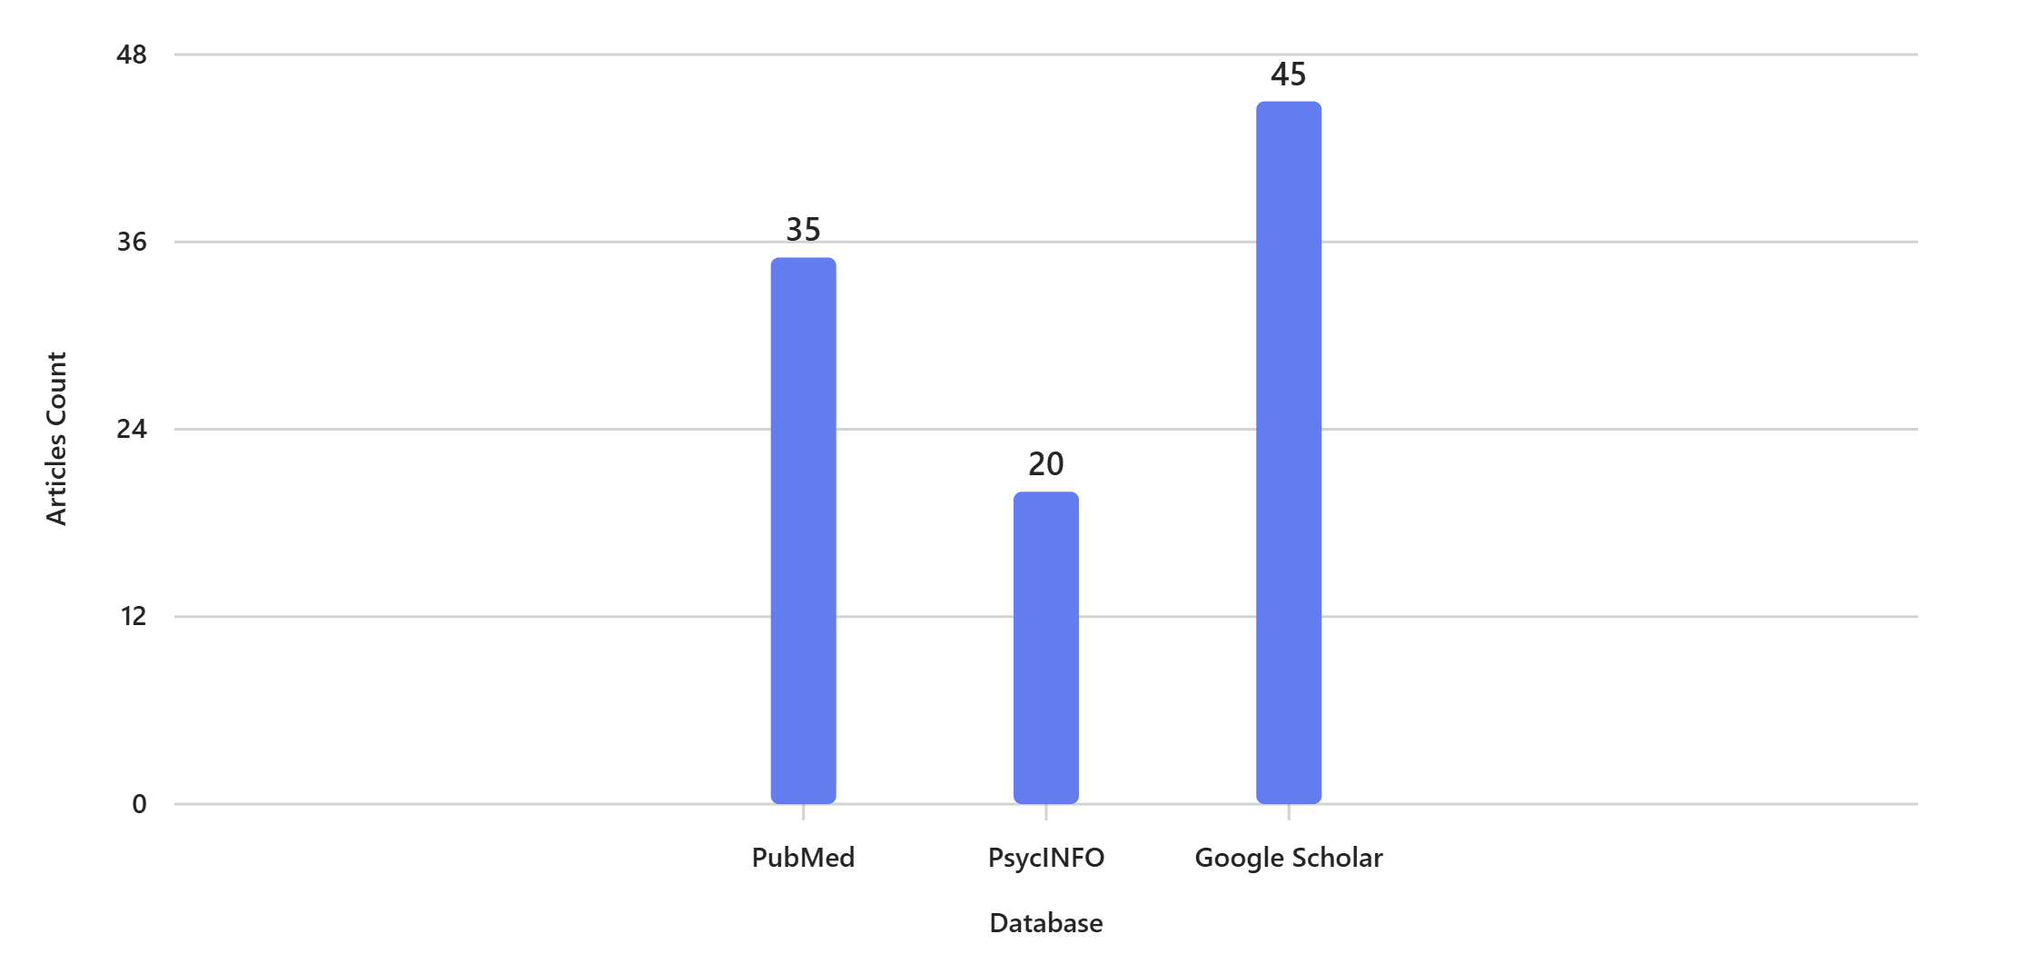
05 Research Validation and Analysis

Validation was done by prioritizing peer reviewed materials and cross reference to findings. Thematic analysis was performed to reveal similar themes which include: clinical treatment narratives, social stigma and psychological coping mechanisms.

06 Inclusion Criteria  - Publications that are not older than 10 years old.  - Peer-reviewed journals  - Research relating to breast cancer perceptions and mental health. | 07 Exclusion Criteria  - Articles older than 10 years  - Non-English publications  - Research not related to mental conditions or social attitudes.
08 Ethical Considerations

Ethics were covered by proper reference listing, plagiarism was avoided, and the use of academic resources available publicly. No patient data had been utilized and so the secondary research ethics were adhered to.

References

Bower, J. E. (2019). Behavioral symptoms in breast cancer patients: Mental health interventions. Journal of Clinical Oncology.
Distelhorst, S. R., Cleary, J. F., Ganz, P. A., Bese, N., Camacho-Rodriguez, R., Cardoso, F., ... & Anderson, B. O. (2015). Optimisation of the continuum of supportive and palliative care for patients with breast cancer in low-income and middle-income countries: executive summary of the Breast Health Global Initiative, 2014. The lancet oncology, 16(3), e137-e147.
Fallowfield, L., & Jenkins, V. (2015). Effective communication and breast cancer care. Psycho-Oncology.
Holland, J. C. (2018). Psycho-oncology: Mental health care for cancer patients. Springer.
Knaul, F. M., Arreola-Ornelas, H., Rodriguez, N. M., Méndez-Carniado, O., Kwete, X. J., Puentes-Rosas, E., & Bhadelia, A. (2018). Avoidable mortality: The core of the global cancer divide. Journal of global oncology, 4, 1-12.
Lebel, S., Maheu, C., Tomei, C., Bernstein, L. J., Courbasson, C., Ferguson, S., ... & Figueiredo, D. (2018). Towards the validation of a new, blended theoretical model of fear of cancer recurrence. Psycho‐Oncology, 27(11), 2594-2601.
Montazeri, A. (2018). Health-related quality of life in breast cancer patients. Expert Review of Pharmacoeconomics & Outcomes Research.
Partridge, A. H. (2015). Chemotherapy in premenopausal breast cancer patients. Breast Care, 10(5), 307-310.Stanton, A. L. (2016). Psychosocial concerns and interventions in breast cancer. Annual Review of Psychology.
Siegel, R. L., Miller, K. D., & Jemal, A. (2019). Cancer statistics, 2019. CA: a cancer journal for clinicians, 69(1), 7-34.

