Nazish Shazady
2224320
MSc Public Health and Social Care in Practice
LCHS7009
Population Health and Digital Health Promotion
Raheela shaikh
Component 1

BLOG 1: Wearable Sleep Technologies:
Improving Sleep Health Through Digital Health and Behaviour Change

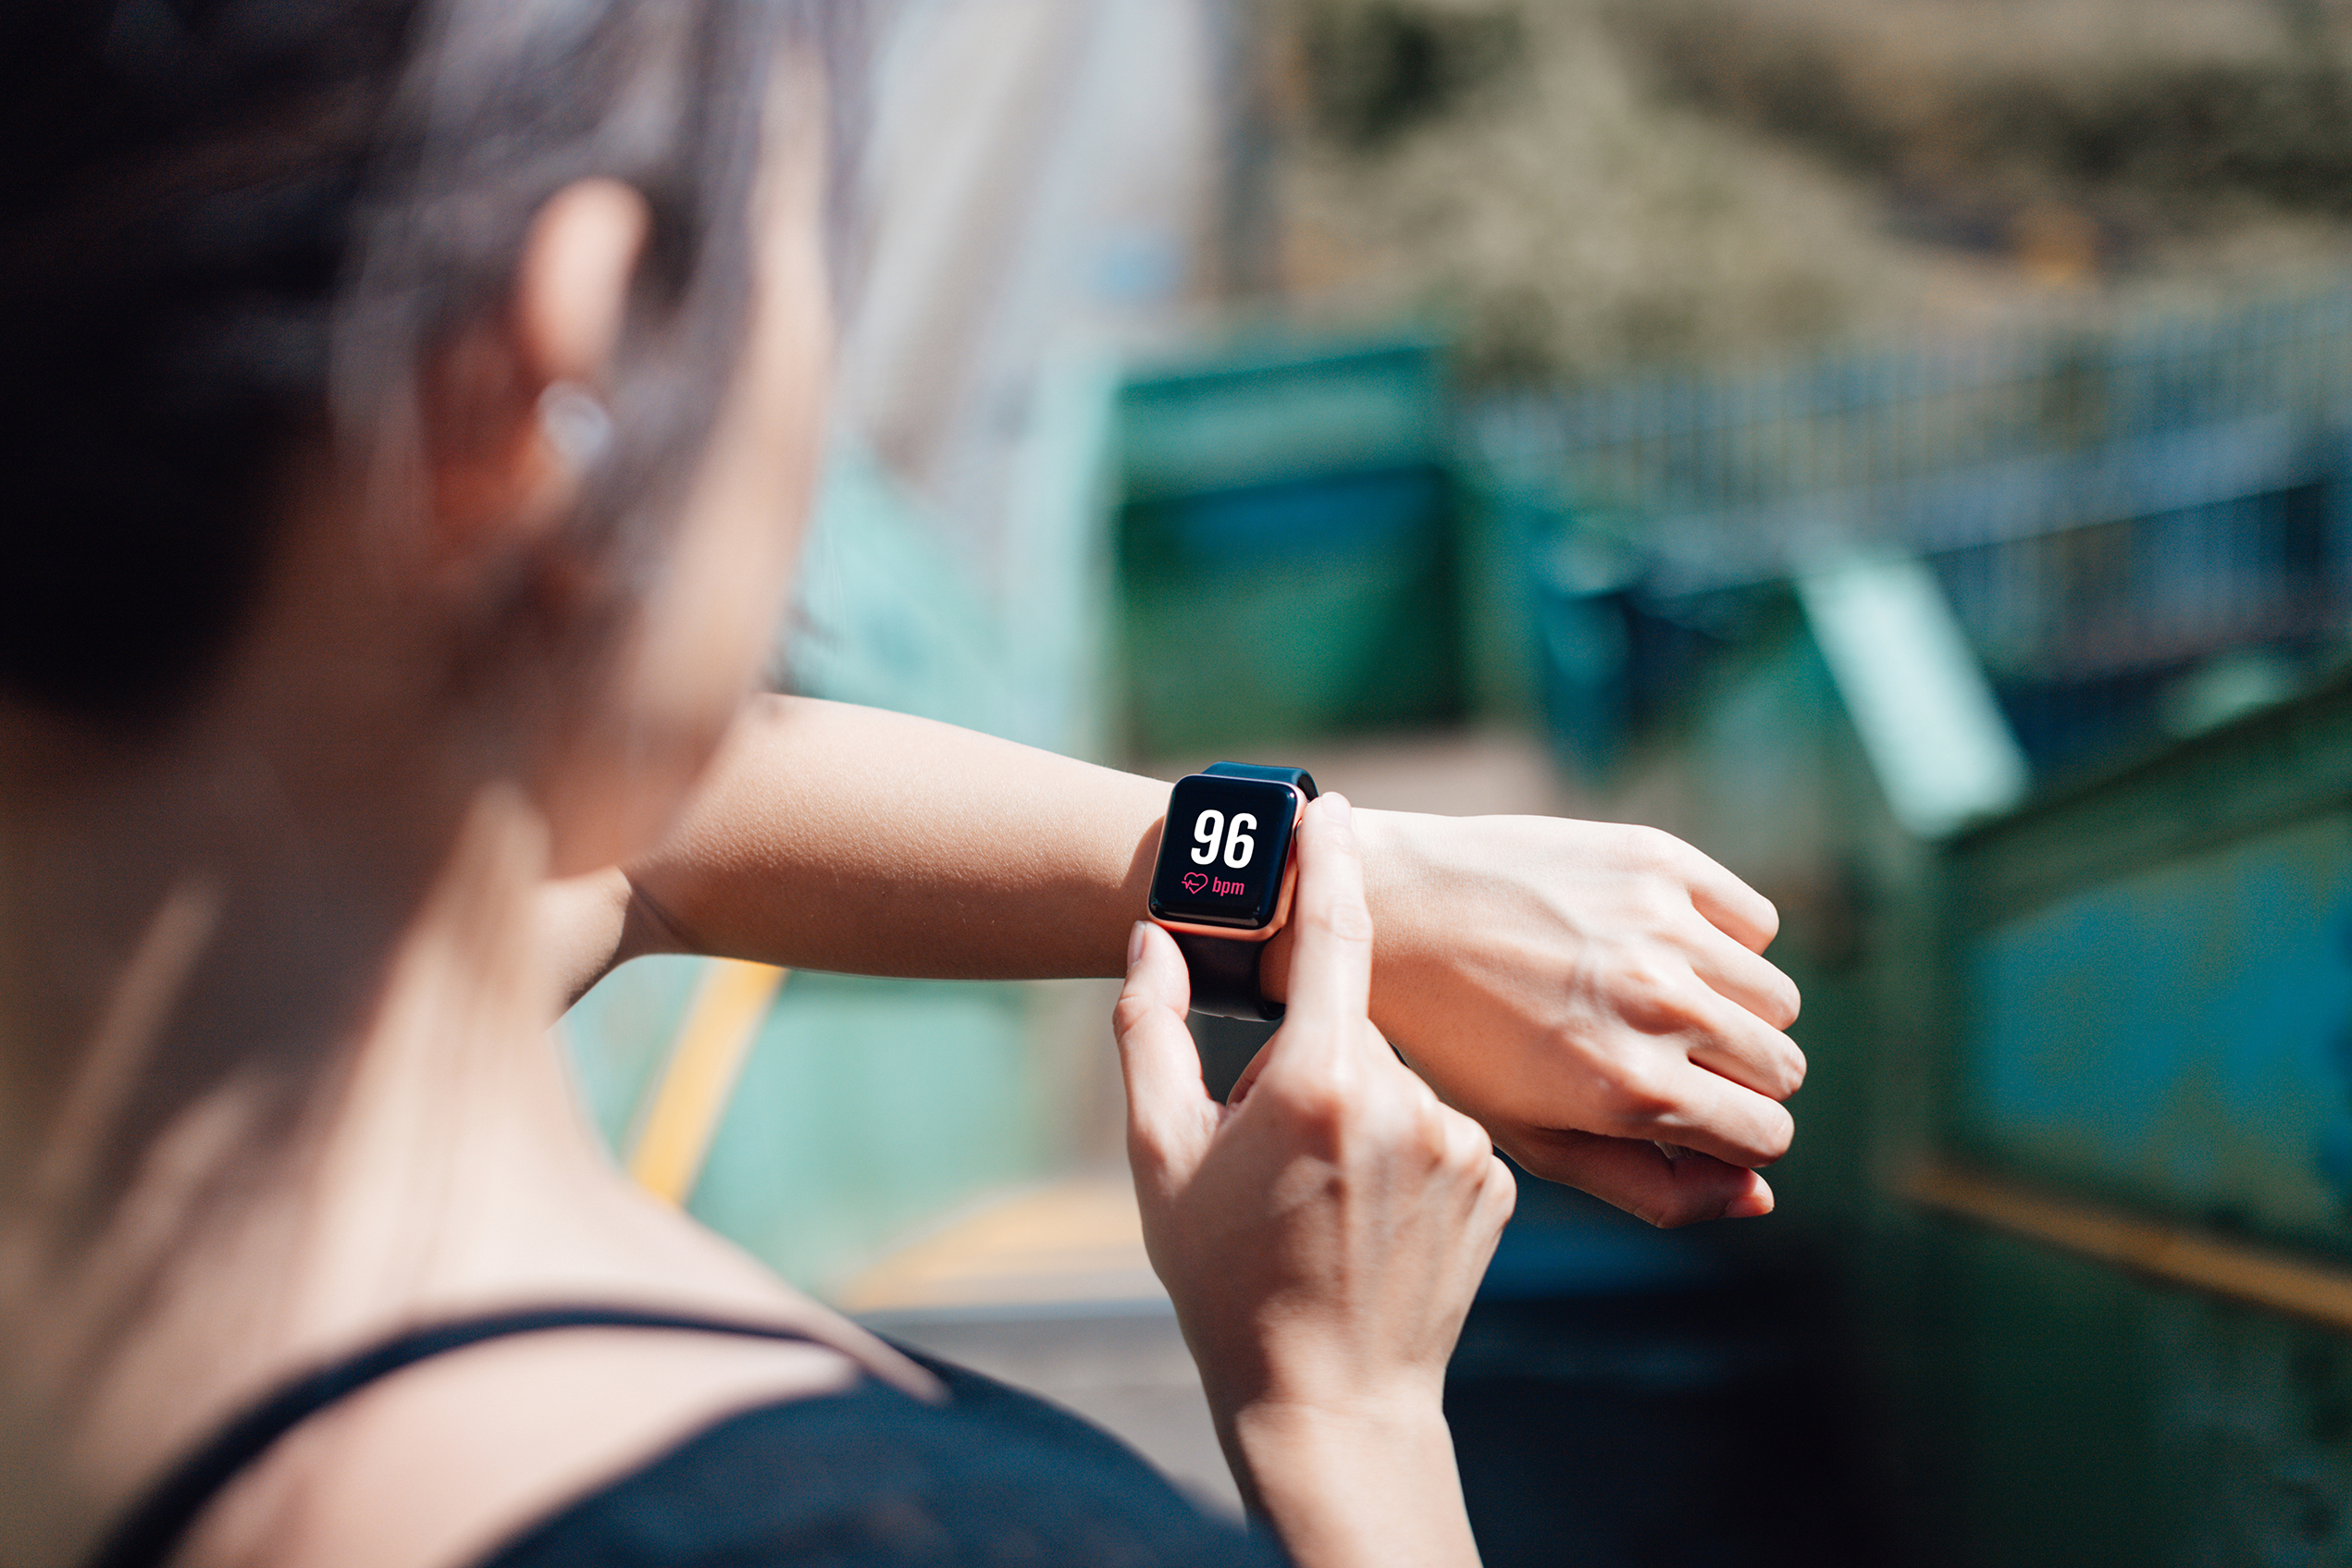(Stock images)

Poor Sleep as a Public Health Concern
Sleep is essential for supporting physical and mental wellbeing; however, poor sleep has become a major public health concern worldwide. Research has linked inadequate sleep with an increased risk of cardiovascular disease, obesity, type 2 diabetes, anxiety, and depression (World Health Organization, 2021; Grandner, 2020).
In England, approximately 29% of adults experience symptoms of insomnia, with higher prevalence among women and socioeconomically disadvantaged groups (de Lange et al., 2024). Poor sleep also contributes to reduced productivity, increased healthcare utilisation, and wider economic burden.

Wearable Sleep Technologies in Health Promotion
Wearable sleep technologies, such as Fitbit, Apple Watch and Oura Ring, are increasingly being used to support digital health promotion initiatives. These devices use sensors to collect data on sleep duration, sleep stages, heart rate and physical activity, providing users with personalised information about their sleep patterns (de Zambotti et al., 2019).
This approach reflects key health promotion principles by encouraging prevention, empowerment, and individual participation in health management. For example, an Oura Ring user may find that late-night caffeine consumption negatively affects their sleep quality and adjust their behaviour accordingly.
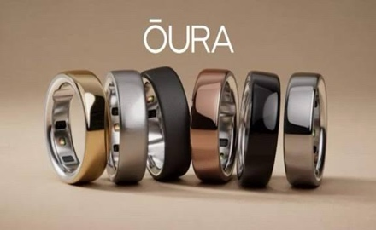

(Oura Health, 2025)

Evidence Supporting Wearable Sleep Technologies
Research suggests that wearable sleep technologies have the potential to support public health interventions by increasing user engagement and enabling continuous health monitoring. A systematic review by Robbins et al. (2019) found that commercially available sleep trackers may positively influence health behaviours and sleep management practices.
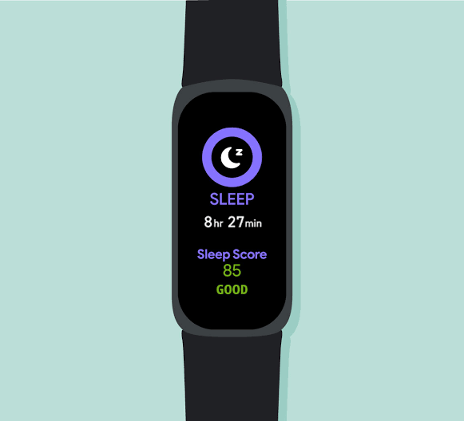
Furthermore, wearable technologies generate substantial amounts of real-time health data, which may contribute to population health surveillance and future public health research initiatives (Ko et al., 2015).
(Image Thompson, 2022).

Benefits and Limitations of Wearable Sleep Technologies
Wearable sleep technologies have the potential to support behaviour change by providing individuals with personalised health information. The COM-B model suggests that behaviour change is influenced by capability, opportunity, and motivation (Michie et al., 2011). For example, a user receiving consistently poor sleep scores may be encouraged to improve their sleep hygiene practices. This shows how digital technologies can support public health interventions by promoting personal responsibility and behavioural modification.
However, several limitations remain. Studies have reported that consumer sleep trackers demonstrate variable accuracy when compared with clinical sleep assessment methods (Lee et al., 2023). Furthermore, the cost of wearable devices may widen digital health inequalities, while concerns on privacy and confidentiality require compliance with the UK General Data Protection Regulation (UK GDPR) and the Data Protection Act 2018.

Addressing Current Shortfalls
To maximise the public health benefits of wearable sleep technologies, future developments should focus on improving clinical validation, interoperability, and integration with healthcare services (de Zambotti et al., 2019). Greater collaboration between technology developers, researchers and healthcare providers may improve reliability, strengthen public trust, and support the effective implementation of wearable technologies within public health practice (World Health Organization, 2021).

Conclusion
Wearable sleep technologies have significant potential to support public health promotion. However, improving clinical reliability, accessibility and integration with healthcare services will be essential to maximise their long-term effectiveness.

BLOG 2: Skin Guard AI+: An Artificial Intelligence in Skin Cancer Prevention and Early Detection:
Evaluating the Potential of Skin Guard AI+ as a Digital Health Intervention
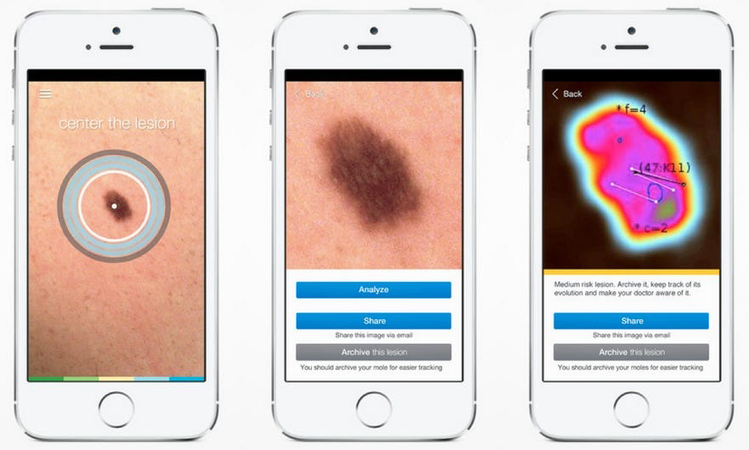
Source: Cosmopolitan UK (2022)

Skin Cancer as a Public Health Concern
Skin cancer is one of the most common and preventable forms of cancer worldwide, being a growing public health concern due to increasing incidence rates and associated healthcare costs. Excessive exposure to ultraviolet (UV) radiation stays the leading preventable risk factor for the development of skin cancer (World Health Organization, 2024).
In the United Kingdom, more than 17,500 people are diagnosed with melanoma annually, with incidence rates continuing to rise (Cancer Research UK, 2025). For example, delayed recognition of changes in skin lesions or moles can result in later diagnosis, more intensive treatment, and poorer health outcomes.

Skin Guard AI+: A Digital Health Promotion Intervention
Skin Guard AI+ is a proposed digital health intervention that combines artificial intelligence (AI), smartphone imaging, and personalised digital health support to help individuals in monitoring skin changes. The application would allow users to capture and store images of skin lesions and moles, enabling AI algorithms to analyse changes in visual characteristics over time (Behara et al., 2024; Salinas et al., 2024).

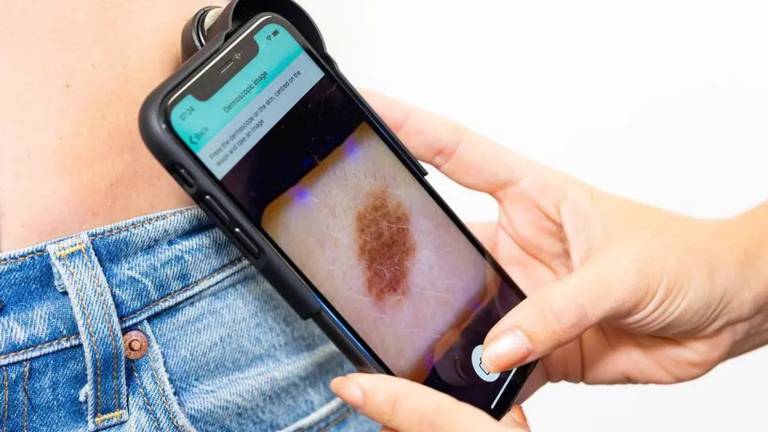
In addition, SkinGuard AI+ would provide personalised educational content, behavioural prompts, and digital monitoring features to encourage ongoing engagement with skin health management. For example, users could receive notifications if previously recorded skin images show significant changes requiring further assessment (World Health Organization, 2024).
Image Skin Analytics (2025)

Evidence Supporting AI Skin Health Technologies
Recent research suggests that artificial intelligence has considerable potential within dermatology and digital health promotion. Salinas et al. (2024) demonstrated that AI systems achieved diagnostic performance comparable to clinicians in selected skin cancer detection studies. Furthermore, AI-supported digital platforms may improve access to dermatological assessment and facilitate earlier clinical decision-making (Behara et al., 2024).
However, evidence on consumer-facing skin assessment applications stays inconsistent. Studies have reported variability in diagnostic accuracy, emphasising the need for robust clinical validation and regulatory approval before widespread implementation in public health practice (Sun et al., 2022).
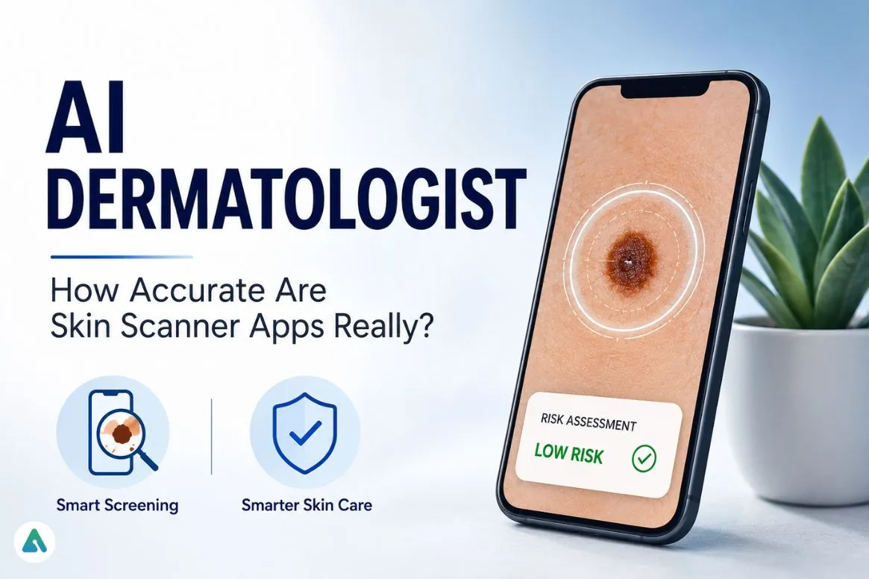
Image AI Insights News (2025)

Benefits and Limitations of Skin Guard AI+
Skin Guard AI+ has the potential to enhance public engagement with skin health through personalised digital interventions. The COM-B behaviour change model proposes that behaviour change occurs through increased capability, opportunity, and motivation (Michie et al., 2011). For example, users receiving personalised feedback regarding their skin health status may be more likely to adopt protective health behaviours and engage with healthcare services when appropriate.
However, several challenges stay. Artificial intelligence technologies have shown concerns about equitable performance across diverse populations, particularly among individuals with darker skin tones due to limitations within existing datasets (Daneshjou et al., 2021). Furthermore, the collection and storage of personal health images raise important ethical and legal considerations regarding privacy, confidentiality and compliance with the UK General Data Protection Regulation (UK GDPR), the Data Protection Act 2018, and the Medical Devices Regulations 2002.

Addressing Current Shortfalls
To improve the effectiveness of Skin Guard AI+, future development should prioritise the use of diverse and representative datasets to enhance equity and generalisability across different population groups (Daneshjou et al., 2021). This may help improve the inclusivity of AI-supported skin health technologies.
In addition, greater collaboration between technology developers, dermatologists and healthcare organisations may improve implementation pathways and increase public confidence in AI-assisted healthcare interventions (Behara et al., 2024). Ongoing evaluation will also be essential to ensure that digital health technologies stay responsive to changing public health needs (World Health Organization, 2021).

Conclusion
Skin Guard AI+ has the potential to support digital health promotion through artificial intelligence and personalised health interventions. However, ensuring equity, public trust and effective implementation will be essential for its successful integration into future healthcare services.

Reference list
Behara, K., Bhero, E. and Agee, J.T. (2024) ‘AI in dermatology: a comprehensive review into skin cancer detection’, PeerJ Computer Science, 10, e2530. Available at: https://doi.org/10.7717/peerj-cs.2530 (Accessed: 30 June 2026).
Cancer Research UK (2025) Skin cancer statistics. Available at: https://www.cancerresearchuk.org/health-professional/cancer-statistics/statistics-by-cancer-type/skin-cancer (Accessed: 1 July 2026).
CPC Logistics (2025) ‘Highway to health: sun safety’. Available at: https://cpclogistics.com/tandem-talk/april-2025-tandem-talk/highway-to-health-sun-safety/ (Accessed: 2 July 2026).
Daneshjou, R., Vodrahalli, K., Liang, W., et al. (2022) ‘Disparities in dermatology artificial intelligence assessments using diverse clinical images’, Science Advances, 8(31), eabq6147. Available at: https://doi.org/10.1126/sciadv.abq6147 (Accessed: 29 June 2026).
Esteva, A., Kuprel, B., Novoa, R.A., Ko, J., Swetter, S.M., Blau, H.M. and Thrun, S. (2017) ‘Dermatologist-level classification of skin cancer with deep neural networks’, Nature, 542(7639), pp. 115-118. Available at: https://doi.org/10.1038/nature21056 (Accessed: 30 June 2026).
Green, A.C., Williams, G.M., Logan, V. and Strutton, G.M. (2011) ‘Reduced melanoma after regular sunscreen use: randomised trial follow-up’, Journal of Clinical Oncology, 29(3), pp. 257-263. Available at: https://doi.org/10.1200/JCO.2010.28.7078 (Accessed: 28 June 2026).
Gregoor, A.M.S., et al. (2023) ‘Artificial intelligence in mobile health for skin cancer diagnosis: a prospective feasibility study’, eClinicalMedicine, 60, 102019. Available at: https://doi.org/10.1016/j.eclinm.2023.102019 (Accessed: 1 July 2026).
Haenssle, H.A., Fink, C., Schneiderbauer, R., et al. (2018) ‘Man against machine: diagnostic performance of a deep learning convolutional neural network for melanoma recognition compared with dermatologists’, Annals of Oncology, 29(8), pp. 1836-1842. Available at: https://doi.org/10.1093/annonc/mdy166 (Accessed: 30 June 2026).
Krakowski, I., et al. (2024) ‘Human-artificial intelligence interaction in skin cancer diagnosis’, NPJ Digital Medicine, 7, 69. Available at: https://doi.org/10.1038/s41746-024-01031-w (Accessed: 1 July 2026).
Michie, S., van Stralen, M.M. and West, R. (2011) ‘The behaviour change wheel: a new method for characterising and designing behaviour change interventions’, Implementation Science, 6(42). Available at: https://doi.org/10.1186/1748-5908-6-42 (Accessed: 24 June 2026).
National Health Executive (2025) ‘Researchers using artificial intelligence to detect skin cancer in Wales’. Available at: https://www.nationalhealthexecutive.com/articles/researchers-using-ai-detect-skin-cancer-wales (Accessed: 2 July 2026).
National Institute for Health and Care Excellence (NICE) (2025) Artificial intelligence skin cancer detection systems: conditional recommendation for NHS use. Available at: https://www.nice.org.uk (Accessed: 1 July 2026).
NHS England (2025) AI-based skin lesion analysis technology. Available at: https://www.england.nhs.uk/elective-care/best-practice-solutions/ai-based-skin-lesion-analysis-technology/ (Accessed: 1 July 2026).
Salinas, M.P., Sepúlveda, J., Hidalgo, L., Peirano, D., Morel, M., Uribe, P., Rotemberg, V., Briones, J., Mery, D. and Navarrete-Dechent, C. (2024) ‘A systematic review and meta-analysis of artificial intelligence versus clinicians for skin cancer diagnosis’, NPJ Digital Medicine, 7(1), 125. Available at: https://doi.org/10.1038/s41746-024-01103-x (Accessed: 30 June 2026).
Skin Analytics (2025) DERM: Artificial intelligence technology for skin cancer detection. Available at: https://skin-analytics.com (Accessed: 1 July 2026).
Statista (2025) Surge in UK skin cancer deaths since the 1970s. Available at: https://www.statista.com (Accessed: 2 July 2026).
Sun, M.D., et al. (2022) ‘Accuracy of commercially available smartphone applications for skin cancer diagnosis’, Journal of the American Academy of Dermatology, 87(2), pp. 425-427 (Accessed: 29 June 2026).
UK Government (2002) Medical Devices Regulations 2002. Available at: https://www.legislation.gov.uk/uksi/2002/618/contents (Accessed: 1 July 2026).
UK Government (2018) Data Protection Act 2018. London: The Stationery Office. Available at: https://www.legislation.gov.uk/ukpga/2018/12 (Accessed: 1 July 2026).
UK Government (2021) UK General Data Protection Regulation (UK GDPR). Available at: https://www.legislation.gov.uk/eur/2016/679/contents (Accessed: 1 July 2026).
World Health Organization (1986) Ottawa Charter for Health Promotion. Geneva: World Health Organization. Available at: https://www.who.int (Accessed: 2 July 2026).
World Health Organization (2021) Global Strategy on Digital Health 2020-2025. Geneva: World Health Organization. Available at: https://www.who.int/publications/i/item/9789240020924 (Accessed: 1 July 2026).
World Health Organization (2024) Ultraviolet radiation and health. Available at: https://www.who.int/news-room/fact-sheets/detail/ultraviolet-radiation (Accessed: 2 July 2026).
123RF (2025) Person-centred care illustration. Available at: https://www.123rf.com/clipart-vector/person_centred_care.html (Accessed: 2 July 2026).
Freepik (2025) Icons and illustrations for diversity and digital health. Available at: https://www.freepik.com (Accessed: 2 July 2026).

