Changemakers: Building your Personal Brand for Sustainable Employment
BMHP5015

Component 2: Assignment (Report)
Developing My Employability Skills and Professional Identity for a Career as a Healthcare Assistant within the NHS

Student Name: Ejiro P. Opiri Odi
Student Number: 2309592

Word count: 2180

Introduction
In an ageing population‚ with a rise in chronic disease and demand for integrated health and social care services‚ there continues to be an increased demand on the health and social care workforce․ Therefore‚ the NHS continues to employ healthcare assistants (HCAs) to support registered healthcare professionals to deliver safe‚ compassionate and person-centred care (NHS England‚ 2023). Healthcare Assistants are not nurses‚ nor do they do the tasks normally undertaken by nurses․ However‚ they do monitor patients‚ assist with activities of daily living‚ maintain confidentiality and dignity and assist in the delivery of positive patient experiences․ Therefore the employability skills‚ professional values‚ and commitment to learning and development that the role demands are increasingly important․
Employability is more than employment‚ including the knowledge‚ skills and personal attributes that make graduates more likely to gain employment and be successful in their chosen occupation․ According to Yorke (2006), in health care‚ the competences of communication‚ teamwork‚ emotional intelligence‚ professionalism‚ digital literacy and ethics (CIPD‚ 2024; Health Education England‚ 2022) affect patient safety and the quality of care․ Similarly‚ professional identity also prepares healthcare professionals to align their core values with their profession's values by helping them to act ethically‚ compassionately and accountably (Cruess‚ Cruess and Steinert‚ 2019).
This report will examine a Band 2 Healthcare Assistant role‚ advertised by the Somerset NHS Foundation Trust‚ highlighting the skills and attributes needed to be successful․ An assessment of my skills in relation to employer expectations‚ professional identity‚ personal brand and an action plan for career development are presented․

Overview of the Chosen Job Role
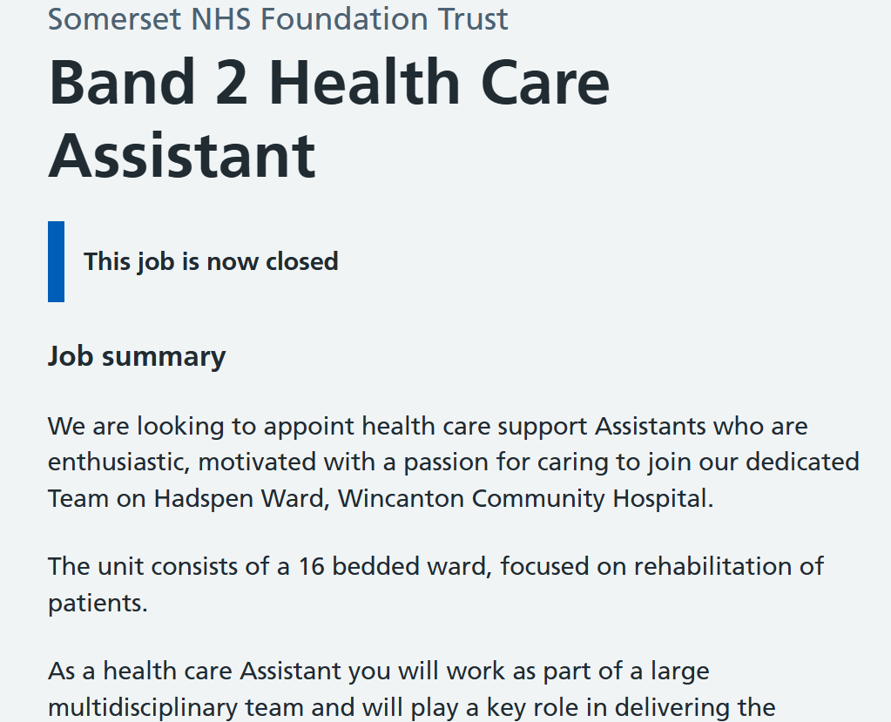
As a Band 2 HCA with Somerset NHS Foundation Trust you will be providing direct patient care (e․g․ assisting with personal care‚ mobility and nutrition and enabling patients to carry out daily living activities) and supporting registered nurses to provide high quality‚ evidence-based‚ person-centred care․ You will monitor patients and accurately report changes in their condition‚ respect individuals' confidentiality‚ work within a multidisciplinary team‚ and participate in continuing professional development.
HCAs work under the supervision of registered practitioners and hold a high level of responsibility because Healthcare Assistants have more contact with patients than all other members of the multidisciplinary team․ HCAs are often the first professionals to notice when a patient is physically or psychologically unwell‚ and report this to more senior clinicians․ Skills for Care (2024) state that the work of Healthcare Assistants is integral to patient safety‚ continuity of care‚ and service quality‚ as they provide consistent support during a patient's care․
This role has diversified and extended in recent years‚ due in part‚ to increased demand for healthcare and a shortage of workforce in the healthcare sector․ The NHS Long Term Workforce Plan notes that support workers have an important role in delivering high-quality care to patients and helping to deliver the future sustainability of services (NHS England‚ 2023). Consequently‚ employers of Healthcare Assistants now expect the workforce to have flexibility‚ IT skills‚ effective communication and a commitment to lifelong learning․
Somerset NHS Foundation Trust‚ for example‚ states: 'As part of values-based recruitment across the NHS‚ you will be expected to show compassion‚ respect‚ kindness‚ teamwork and professionalism in addition to your skills as set out in the NHS Constitution (Department of Health and Social Care‚ 2024).' Francis (2013) argued that healthcare failures are more the result of negative organisational culture and attitude than that of a lack of clinical expertise and called for the employment of people with values aligned to compassionate healthcare․ This role appealed to me as it fits perfectly with my longer-term career aims and my own personal values․ In Component One of my portfolio‚ I discussed my sense of empathy‚ responsibility and respect for others and my wish to work in health and social care․

Skills Required for Employability/Possible Areas of Employment
Healthcare Assistants require technical knowledge‚ transferable skills and professional behaviours in the provision of safe‚ effective and compassionate care․ A modern healthcare workforce is multidisciplinary‚ works with advanced technologies and is increasingly patient focused and therefore requires an ability to adapt to the changing demands of the organization whilst upholding professional standards (World Economic Forum‚ 2025).
Communication and Interpersonal Skills
Communication is one of the most important employability skills demanded in healthcare‚ supporting patient care‚ teamwork and clinical decision-making․ Healthcare Assistants need to communicate constantly with patients‚ patient families‚ nurses‚ doctors‚ and other healthcare professionals․ They need to show verbal and written communication skills‚ and non-verbal skills․ Arnold and Boggs (2020) state that good communication skills help strengthen the nurse-patient relationship‚ and increase patient satisfaction and minimise clinical error․ Similarly‚ the Nursing and Midwifery Council (2018) recognises that effective communication is fundamental to nursing‚ and is an important contributor to patient safety and care quality․
According to McCormack and McCance (2021), health care communication should go beyond exchanging information‚ since health care providers should listen to patients‚ be empathic and culturally capable‚ and adapt to their physical‚ emotional and cognitive needs․ These skills can be applied to work with older adults‚ people with dementia and distressed patients․ Communication is one of my strongest employability skills․ My portfolio shows that I can be an excellent listener‚ and that I work well and respectfully with others‚ regardless of people's skills‚ abilities or backgrounds․
Compassion and Emotional Intelligence
Compassion is integral to person-centred care‚ because it allows practitioners to express understanding of what the patient is experiencing and appreciation of the patient's needs․ Sinclair et al․ (2021) concluded that compassionate care leads to improved patient satisfaction‚ strengthened therapeutic relationship and patient recovery․ Emotional intelligence builds on compassion by enabling healthcare professionals to successfully manage their own emotions‚ show empathy and handle challenging situations (Goleman‚ 2020).
Compassion shouldn't be thought of as simply a personal characteristic․ According to West et al․ (2022), organisational cultures‚ leadership and workloads also have an important role to play‚ with organisational support preventing both compassion fatigue and burnout‚ both of which have an adverse effect on the wellbeing of staff and the quality of care. This also aligns with my personal brand of empathy and respect and how these work with the expectations of Somerset NHS Foundation Trust․ Nevertheless‚ I know that sustaining compassion requires resilience‚ reflection‚ and a commitment to lifelong learning․
Teamwork and Multidisciplinary Collaboration
Healthcare Assistants (HCAs) work with nurses‚ doctors‚ therapists and other healthcare professionals to provide patient care․ According to Reeves et al․ (2018), multidisciplinary teamwork is associated with improved patient outcomes such as improved communication‚ reduced incidents of clinical error and coordinated care․ The World Health Organization (WHO‚ 2023) cites interprofessional practice as a key component of quality healthcare systems․
Successful teams develop a culture of accountability‚ collegial respect‚ effective communication‚ and a willingness to share information․ Healthcare Assistants can contribute to continuity of care through timely observations and assistance․ Collaborating with peers at university has helped me to develop the ability to work in a diverse team․ I am aware that multidisciplinary teams at the NHS work in a more challenging environment‚ where communication with others is vital to ensure patient safety․
Digital Competence
Digital literacy is a core employability skill‚ as the NHS increasingly makes use of electronic health records‚ digital observations‚ telehealth and other technologies․ NHS England (2023) has included digital capabilities as one of the six core components of the Long Term Workforce Plan and recognises the increasing use of technology in order to improve efficiencies‚ communication and patient outcomes․ Healthcare Assistants are therefore expected to document patient details‚ maintain confidentiality and communicate with other staff using electronic communications systems․
However‚ digitalisation of healthcare is not without its challenges․ According to Good Things Foundation (2024), older people‚ people with disabilities and people from disadvantaged backgrounds may be digitally excluded if they do not have the skills or resources to access digital health services․ Healthcare professionals have an important role in supporting patients to have the knowledge skills and confidence to use digital technologies while providing person-centred care amid digital transformation․
This was demonstrated in my Component One blog‚ showing my critical understanding of the importance of digital inclusion in health care‚ as well as my understanding that technology should not replace‚ but improve‚ compassionate care․ I can use digital learning platforms and digital communication technologies but need training and continuing professional development for NHS clinical information systems․
Professionalism‚ Safeguarding and Ethical Practice
Professionalism is a core employability attribute for Healthcare Assistants because they have direct contact with vulnerable clients who require safe‚ respectful and ethical care․ Professional behaviour includes confidentiality‚ dignity‚ accountability and safeguarding (Care Quality Commission‚ 2023). As well as this‚ values for the NHS workforce as an employer are compassion‚ respect‚ integrity and commitment to quality care as set out within the NHS Constitution (Department of Health and Social Care‚ 2024).
Because Healthcare Assistants may spend more time with patients than other staff‚ they may be the first to notice any changes in a patient's condition‚ neglect or abuse․ Safeguarding knowledge and ethical responsibility is a key role․ Healthcare professionals have an obligation to consider the ethical principles of autonomy‚ beneficence‚ non-maleficence and justice in the process of making decisions that affect patients (Beauchamp & Childress‚ 2019).
In reflecting on my own development‚ I think that my values around responsibility‚ respect and empathy align well with NHS professional standards, and I understand that professionalism is developed by experience‚ reflection and learning․ I intend to complete safeguarding training‚ keep reflective journals‚ and actively solicit feedback to improve my professional judgement․

Evaluating my employability skills․
Thinking about employability helps me to recognise my strengths and weaknesses before actually applying for a position as a Healthcare Assistant․ A particular strength I possess is empathic and respectful care․ In my Component One portfolio‚ I demonstrated that my values of empathy‚ responsibility and willingness to learn align with the NHS Constitution and the values of Somerset NHS Foundation Trust․
Another strength I bring is my understanding of current healthcare topics‚ such as digital inclusion and patient-centred care․ I have a powerful sense of how technology can be effectively applied to healthcare‚ and I am aware of the importance of equitable access for all patients․
I have only experienced a limited number of clinical placements within the NHS and‚ according to Benner (1984), competence is achieved through clinical experience․ Volunteer roles and experience under supervision allow the practitioner to develop confidence‚ clinical judgement and practical skills that support a capable practitioner․
Other areas I identified that require improvement were my leadership skills‚ networking skills‚ presentation skills․ I have a strong academic network but my professional network is weak․ I will build up my LinkedIn and NHS careers event networking‚ and volunteer‚ in order to increase my understanding of the sector and my future employability․ Granovetter (1973) states that job opportunities are usually generated through wider professional networks‚ so I will work to develop both my social and my professional capital․

Personal brand and professional identity
Personal branding can be defined as the intentional communication of an individual's professional values‚ skills and experiences to employers and peers (Gorbatov‚ Khapova and Lysova‚ 2019). In healthcare settings‚ personal branding strategies are required to focus on authenticity‚ professionalism and ethical behaviour rather than self-promotion․ Professional identity is the outcome of the integration of personal values and professional knowledge and practice‚ and leads to safe and humane practice (Cruess‚ Cruess and Steinert‚ 2019).
In my portfolio for Component One‚ I identified my four personal brand values as empathy‚ respect‚ responsibility and willingness to learn․ These are the same values espoused by Somerset NHS Foundation Trust and the NHS․ I will continue to develop these values through volunteering‚ networking and attending professional training as described in my career plan․
Maintaining an up-to-date LinkedIn profile‚ attending NHS careers events‚ attending appropriate CPD courses and engaging in the process of reflective practice during training will support my career identity․ These actions will increase my visibility to potential NHS employers‚ enable me to develop‚ and ease my transition to an NHS employee․

Action Plan and Career Development
Career development is a continuing process of planning‚ setting objectives and evaluating․ Bridgstock (2009) argues that graduates actively managing their career by developing employability skills‚ professional networks‚ and relevant experience are likely to attain sustainable employment prospects․ This is also echoed by NHS England (2023) who claim that lifelong learning and continuing professional development are fundamental to building and sustaining a quality workforce․ The action plan below identifies the steps I will take to improve my employability and prepare for a career as a Healthcare Assistant․
Table 1: Career Development Action Plan
Goal | Action | Skills Developed | Resources Needed | Timeline | Expected Outcome
Complete my Health and Social Care degree | Successfully complete all remaining modules and assessments | Critical thinking, research and professional knowledge | University resources, lecturers and academic support | January 2026 – January 2027 | Graduate with the qualifications required for NHS employment
Strengthen my professional profile | Create and optimise a LinkedIn profile and update my CV to reflect my skills and achievements | Personal branding, digital communication and self-presentation | LinkedIn, university careers service | February 2026 | Develop a professional online presence visible to employers
Improve understanding of NHS recruitment | Attend NHS careers fairs, employability workshops and interview preparation sessions | Interview skills, career planning and confidence | NHS Jobs, university careers team | April – June 2026 | Improved understanding of NHS recruitment processes
Gain practical healthcare experience | Volunteer in hospitals, care homes or community healthcare organisations | Communication, teamwork, patient-centred care and professionalism | Local healthcare providers and voluntary organisations | July – December 2026 | Gain practical experience supporting patients
Develop professional competence | Complete CPD courses including Safeguarding, Basic Life Support, Dementia Awareness and Infection Prevention | Safeguarding, patient safety and professional competence | NHS e-Learning and CPD providers | September – November 2026 | Obtain additional qualifications that strengthen employability
Expand professional network | Attend healthcare conferences and connect with healthcare professionals through LinkedIn | Networking and professional communication | Professional organisations and university events | October 2026 – January 2027 | Build relationships with potential mentors and employers
Apply for Healthcare Assistant roles | Tailor CV and supporting statements to NHS job specifications and submit applications | Application writing and interview preparation | NHS Jobs website and careers advisers | February – April 2027 | Receive invitations to NHS interviews
Secure employment and continue professional development | Begin employment and participate in NHS induction, mandatory training and CPD | Clinical competence, confidence and reflective practice | NHS Trust induction and workplace mentorship | May 2027 onwards | Successfully establish my career as a Healthcare Assistant

As shown in table 1, I think employability means much more than simply having a qualification․ By gaining qualifications‚ experience‚ contacts and skills and undertaking CPD‚ I am showing my readiness to meet the needs of healthcare employers and providing myself with the best possible foundation for my future career development within the NHS․

Conclusion
This report has demonstrated that employability in the NHS is not only about the degree but also the need for Healthcare Assistants in Somerset NHS Foundation Trust to show communication and interpersonal skills‚ compassion‚ teamwork‚ digital skills and professionalism․ All of these skills contribute to safe‚ effective and person centred care within the NHS․ Of the above skills‚ my strengths are in empathy‚ respect and willingness to learn‚ and my weaknesses are in practical experience‚ leadership ability and networking․ Following my own personal career development plan and engaging in lifelong learning will enable me to have a stronger identity and employability and be an effective and productive person as a Healthcare Assistant within the NHS․

References
Arnold, E.C. and Boggs, K.U. (2020) Interpersonal Relationships: Professional Communication Skills for Nurses. 8th edn. St. Louis, MO: Elsevier.
Beauchamp, T.L. and Childress, J.F. (2019) Principles of Biomedical Ethics. 8th edn. New York: Oxford University Press.
Benner, P. (1984) From Novice to Expert: Excellence and Power in Clinical Nursing Practice. Menlo Park, CA: Addison-Wesley.
Bridgstock, R. (2009) ‘The graduate attributes we've overlooked: Enhancing graduate employability through career management skills’, Higher Education Research & Development, 28(1), pp. 31–44.
Care Quality Commission (2023) The State of Health Care and Adult Social Care in England 2022/23. Newcastle upon Tyne: Care Quality Commission.
Chartered Institute of Personnel and Development (CIPD) (2024) Employability and Skills. London: CIPD.
Cruess, R.L., Cruess, S.R. and Steinert, Y. (2019) Teaching Medical Professionalism: Supporting the Development of a Professional Identity. 2nd edn. Cambridge: Cambridge University Press.
Department of Health and Social Care (2024) The NHS Constitution for England. London: DHSC.
Francis, R. (2013) Report of the Mid Staffordshire NHS Foundation Trust Public Inquiry. London: The Stationery Office.
Goleman, D. (2020) Emotional Intelligence: Why It Can Matter More Than IQ. Updated edn. London: Bloomsbury.
Good Things Foundation (2024) The Digital Divide: Understanding the Challenge. Sheffield: Good Things Foundation.
Gorbatov, S., Khapova, S.N. and Lysova, E.I. (2019) ‘Get noticed to get ahead: The impact of personal branding on career success’, Frontiers in Psychology, 10, 2662.
Granovetter, M.S. (1973) ‘The strength of weak ties’, American Journal of Sociology, 78(6), pp. 1360–1380.
Health Education England (2022) Values Based Recruitment Framework. London: Health Education England.
McCormack, B. and McCance, T. (2021) Person-Centred Practice in Nursing and Health Care: Theory and Practice. 3rd edn. Oxford: Wiley-Blackwell.
NHS England (2023) NHS Long Term Workforce Plan. London: NHS England.
Nursing and Midwifery Council (2018) The Code: Professional Standards of Practice and Behaviour for Nurses, Midwives and Nursing Associates. London: NMC.
Reeves, S., Pelone, F., Harrison, R., Goldman, J. and Zwarenstein, M. (2018) ‘Interprofessional collaboration to improve professional practice and healthcare outcomes’, Cochrane Database of Systematic Reviews, (6), CD000072.
Sinclair, S., Puchalski, C.M., Raffin-Bouchal, S., Brandon, D., Ritvo, P., Relf, M., Cogo, E., Tenniglo, L., Chochinov, H.M. and Hack, T.F. (2021) ‘Compassion in healthcare: An updated systematic review’, BMC Palliative Care, 20(1), pp. 1–15.
Skills for Care (2024) The State of the Adult Social Care Sector and Workforce in England. Leeds: Skills for Care.
Somerset NHS Foundation Trust (2026) Healthcare Assistant (Band 2) Job Description and Person Specification. NHS Jobs.
The King's Fund (2024) The NHS Workforce in England: Challenges and Priorities. London: The King's Fund.
West, M., Bailey, S., Williams, E., Dawson, J. and Kaur, M. (2022) Compassionate Leadership for Compassionate Health and Care. London: The King's Fund.
World Economic Forum (2025) The Future of Jobs Report 2025. Geneva: World Economic Forum.
World Health Organization (2023) Framework for Action on Interprofessional Education and Collaborative Practice. Geneva: World Health Organization.
Yorke, M. (2006) Employability in Higher Education: What It Is – What It Is Not. York: Higher Education Academy.

