Name: Chris Morris
Student number: P149915
Module title: Wireless Network and Simulation
Assessment: Assignment 1
Module code: ACCA5004
Lecturer: Carlene Campbell
Abstract
There are several types of wireless networks, each with their own advantages and drawbacks that one must consider when choosing one. In this case, the technique in question, QAM, is a complex but considerably strong modulator that is flexible and comes in many varieties. It was tested in Simulink and considered against other techniques such as BPSK and QPSK.
Introduction
The aim is to demonstrate an understanding of wireless networks by choosing one type to evaluate and then applying it to fit a scenario. Once research has been carried out, it should be evaluated against the created network, and any conclusions are required to be justifiable, such as the task to apply the technique in Simulink and provide explanations for the data output. At the end, it should be decided overall whether the chosen modulator is the most efficient, after considering factors such as data rate, and explain why.
Content
Task 1
There are several types of modulation techniques that help wireless networks function; the one that has been chosen for discussion is QAM (Quadrature Amplitude Modulation). It will be compared against two other techniques; BPSK (BinaryPhase Shift Keying), and QPSK (Quadrature Phase Shift Keying).
The job of a modulator in a network system is to control important aspects so that they can be displayed as data efficiently. [1] Relating to QAM, these aspects include the network frequency (the total quantity of the network signal) and amplitude (the strength of the signal).
QAM is a technique that can perform as either an analog modulator (providing data with no limits or restrictions) or a digital modulator (one that works based on a set of values provided). This is one of the ways it differs from other modulators such as BPSK and QPSK, both of which are core digital modulators.
QAM is a technique that merges two signals to form one overall, thereby providing double the network strength. [2] While there are many varieties of QAM, consisting of any multiples of the number eight, there are three core types; QAM16, QAM64, and QAM256. The higher the number, the more points are created on the modulation’s constellation diagram (a visual representation of the signal). [3] [4]
QAM was created due to a high demand for a non-digital modulation technique. A common example of where it could be used is television, where it could help combine information so that television and video games can be played on one device as the signals connect. Other uses include radio to gain a better balance for controlling signals.
While being both analog and digital gives QAM more flexibility, as a possible analog modulator it suffers from a higher risk of signal noise disrupting the data. This is due to more surface area. Another factor to consider is that while merging data means a higher total overall, this can cause a strain on the modulator due to more resources being consumed, especially if the signal is low (which results in the network operating slowly).
The fundamentals of QAM is to function as a bandpass network (allowing two signals to link and function as one). As implied, it does this by increasing the amplitude on the signal’s sine wave (the curve displaying the amplitude). The amplitude is often merged with the network’s phase (a specified select key position on the sine wave) to extract more data out of the network [5], resulting in an amplitude shift key (ASK) and a phase shift key (PSK) joining together to create a final wave (QAM).
A simulation can applied to a network communication system. A user can input a set of values and the simulation will predict what the outputs will be as a result. This saves the user time with an early outcast and does not restrict the user to only using values provided in the network. However, simulations are expensive to construct due to the depth of knowledge required to implement one, therefore making them difficult for inexperienced users.
Simulations can be compared to other methods such as a testbed. This is similar to a simulation in that it provides a clear picture of data output. However, while on a simulation a user can change which variables are outputted, a testbed provides pinpoint data based on exact values. This, in the author’s opinion, benefits a simulation, due to more flexibility being provided. However, authors such as Sakellari and Loukas disagree, stating realism benefits testbeds. [6]
Simulations can also be compared to mathematical data. In this case, data is broken up into equations, allowing mathematicians to provide predictions as to how a system will end up functioning. While this strengthens accuracy, which is arguably lacking in a simulation due its low restrictions and high variety of availability, it can be argued that it is too complex to use in this case.
Task 2
A model was created in Simulink to measure how a wavelength would be recorded in QAM format. The criteria to measure was bit error rate (the quantity of errors likely to occur) against signal-to-noise ratio (how much noise a signal makes as it increases).
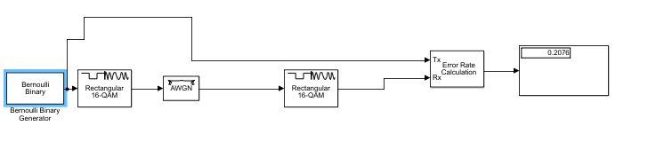
Figure 1: Simulink QAM model
The model consists of a Bernoulli Binary Generator to form a binary sequence, an Error Rate Calculation in order to measure the listed bit error-rate (displayed in a scope), a modulator/demodulator to display the data as a sine wave but also ensure that no information is lost in the process, and an AWGN (additive white gaussian noise) to enable signal-to-noise ratio.
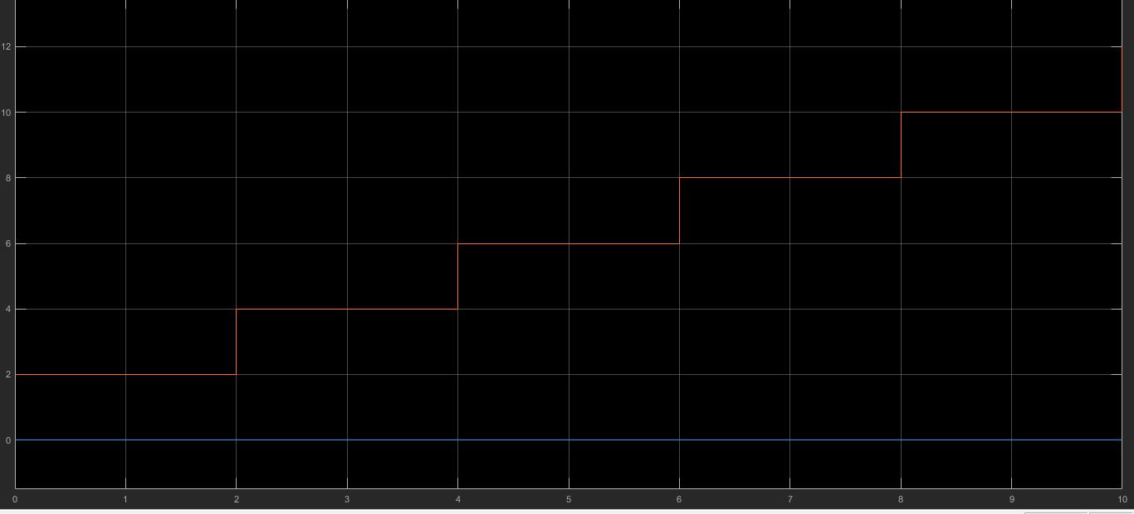
Figure 2: Simulink scope
The expectation was that bit error-rate and signal to-noise ratio would progress in a parallel pattern as both values increased. However, data showed that both moved in a zigzag pattern, with the error rate being double that of the noise ratio.
This links to the assumption made in Task 1 that QAM is more likely to be affected by noise levels, resulting in errors being more likely. This also adds strength to the assumption that QAM is the most complex of the listed techniques, as having more freedom to send and create data comes at a higher risk of errors.
This is an indication that QAM is one of the weaker modulations in terms of robustness. The rates for QPSK and BPSK in particular tend to be lower overall. [7] To combat this, a user would to ensure that the noise levels are as low as possible, in both error rate and noise ratio.
Task 3
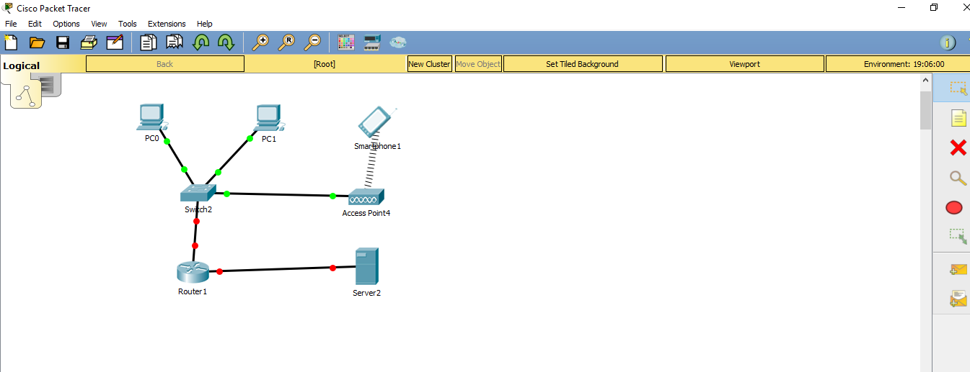
Figure 3: Created WSN
This is a wireless network constructed in Cisco Packet Tracer. There are two switches to encompass both the wired (management and reception) and wireless (health and safety) devices listed in the client brief.
These connect to a router which provides a gateway to the main network server. The wireless device will firstly be required to connect to an access point to verification in granting access. This layout was chosen so that any data could easily be changed, and both wired and wireless devices are given a gateway to connect.
The features that this network encompasses include a full duplex connection to allow data to flow freely and DHCP IP addresses on the switch, router, and server to allow for manual settings of DHCP IP addresses.
A VLAN provided with an IP address was established between the switch and router to allow the network to link more efficiently. The two wired devices have been assigned static IP addresses on the identify the uniqueness of them, and secret passwords on the switch and router to make them harder to intrude.
Comparison to BPSK and QPSK
There are several factors that can result in a comparison between QAM and BPSK/QPSK. [8] The first of these factors is bandwidth (the overall range of signals). As previously stated, bandwidth is one of QAM’s biggest strengths, due to it having double the amount of data. [9] This gives it twice as much as the digital modulators and the advantage in this area.
However, in terms of simplicity, BPSK could be considered superior, as it is designed to be a digital modulator that simplifies data as easily as possible via a multiplication loop. [10] QAM, on the other hand, as previously stated, could be considered not ideal for users looking to gain experience in the area.
If robustness if the key criteria, then QPSK could be considered ideal, due to how much information signals are able to withhold (double the amount of a BPSK network). QAM is weaker in this aspect, as noise is more likely to cause harm due to the higher total of bandwidth. This is evidenced by the work done in Task 2, which indicated that QAM was more prone to errors and therefore less robust.
As previously mentioned, it was concluded that BPSK would be the best technique to use in terms of bit error rate, as data for it tends to be equal to that of its signal-to-noise ratio. QAM can be considered the weakest of the three techniques in this department, and therefore more counter-measures need to be taken for users who wish to use it.
Efficiency can be considered an aspect in which all three modulators excel. BPSK does this by allowing data transfers that can reach the point of the total bandwidth, and QPSK by doubling the overall amount. QAM, meanwhile, achieves efficiency via the previously mentioned bandpass operation.
Conclusion
Overall, it can be concluded that QAM is an efficient wireless modulation technique, due to its higher overall quantity and flexibility. While it may not personally be the author’s first pick compared to BPSK or QPSK, due to its higher potential for noise disruption, and the fact that inexperienced users may struggle with it, the appeal for it is clear and it is beneficial for those experienced in this area due to its higher total for data storage.
The author, however, would consider it the most suitable option for those who have veteran knowledge of wireless networks or those wishing for a modulation technique that is not strictly digital.
References
[1] R. F. Masood, M. Ieee, and M. Pak, “Adaptive Modulation (QPSK, QAM ),” 2013.
[2] B. Keiser, " Digital Telephony and Network Integration ", 2012.
[3] D. Coleman and D. Westcott, “CWNA Certified Wireless Network Administrator Official Deluxe Study Guide: Exam CWNA-106,”, pp. 669, 2015.
[4] S. Sharma and H. Singh, “Comparison of Different Digital Modulation Techniques in LTE System using OFDM AWGN Channel : A Review,” vol. 143, no. 3, pp. 9–12, 2016.
[5] N. Vlajic, “Analog Transmission of Digital Data (PPT),” Computer Systems Engineering, 2010.
[6] G. Sakellari and G. Loukas, “A survey of mathematical models, simulation approaches and testbeds used for research in cloud computing,” Simulation Modelling Practice and Theory, vol. 39, pp. 92–103, 2013.
[7] V. Sharma, A. Shrivastav, A. Jain, and A. Panday, “BER performance of OFDM-BPSK,-QPSK,- QAM over AWGN channel using forward Error correcting code,” Ijera, vol. 2, no. 3, pp. 1619–1624, 2012.
[8] A. Gurusami and M. Nekhamkin, “Making a modulation choice (Which one is right for you?)”, 1997.
[9] RFWireless-World.com, “Advantages of QAM| Disadvantages of QAM | 16QAM,64QAM,256QAM,” 2012.
[10] P. Sharma, B. Singh, and P. S. Tanwar, “A Review in Multiple Modulation Techniques 16 and 64 QAM MIMO-OFDM BPSK-QPSK-PSK System,” International Journal of Electrical, Electronics, vol. 3, pp. 196–200, 2014.

