ACBA 5004
Soil Mechanics Practical
By Ben Kneeshaw
SN: 1902457

Abstract

The contents of this report outline the results obtained from ‘Atterburg limit’ tests and ‘Constant Head Permeability’ tests on soil samples. With discussion on: the methodology used, the results, and the implications of the results from a civil engineering context.

Contents

1. Atterburg limits ………………………………………………………. Pages 3-10
1.1 Introduction …………………………………………………………. Page 3
1.2 Methodology ………………………………………………………... Pages 3-7
1.2.1 Liquid limit test …………………………………………………... Pages 3-6
1.2.1.1 Equipment …………………………………………………….… Pages 3-4
1.2.1.2 Procedure …………………………………………………….…. Pages 5-6
1.2.2 Plastic limit test ……………………………………………….….. Pages 6-7
1.2.2.1 Equipment ………………………………………………….…… Page 6
1.2.2.2 Procedure ………………………………………………….……. Pages 6-7
1.3 Results & analysis …………………………………………………. Pages 7-9
1.4 Conclusions …………………………………………………………. Pages 9-10
2. Constant head permeability ……………………………………….. Pages 11-15
2.1 Introduction …………………………………………………………. Page 11
2.2 Methodology ………………………………………………………… Pages 11-13
2.2.1 Equipment …………………………………………………………. Pages 11-12
2.2.2 Procedure ………………………………………………………….. Pages 12-13
2.3 Results & analysis ………………………………………………….. Pages 13-14
2.4 Conclusions …………………………………………………………. Pages 14-15
3. List of figures …………………………………………………………. Page 16
4. List of references …………………………………………………….. Page 17

1. Atterburg limits

1.1 Introduction

The ‘Atterburg limits’ test was first developed by a Swedish soil scientist named Atterburg in 1911 (Capper & Cassie, 1969, pg.6). Used for fine-grained soils, such as clay or silt, it defines the limits at which the soil acts in a plastic or liquid state (Atkinson, 2007, pg.58). From these limits a plasticity index can be calculated. The soil can then be classified, for engineering purposes, by plotting the plasticity index in comparison to the liquid limit using the correct chart, known as the ‘plasticity chart’, from the relevant standards (BS EN ISO 14688-2:2018). This is an important test from a civil engineering perspective as it defines how soil will act at certain water contents, having major implications for slope stability. The test consists of two parts, one for liquid limit and another for plastic limit. Capper & Cassie (1969, pg.22) cite the liquid limit as being the minimum moisture content at which the soil flows under its own weight’. Atkinson (2007, pg.58) defines the plastic limit as where the soil ceases to be plastic and become brittle, this can also be defined as the point at which soil can be rolled into a thread one eighth of an inch (3mm) in diameter without breaking (Capper & Cassie, 1969, pg.22).

1.2 Methodology

1.2.1 Liquid limit test

1.2.1.1 Equipment

The liquid limit test carried out was via the ‘Casagrande method’. As such, a ‘Casagrande apparatus’ was required, as shown in figure 1. This is a device designed to consistently bump a small cup, containing the soil, onto a rubber block (Atkinson, 2007, pg.87). BSI (2018, clause 4.3) states that this should meet the following requirements:
- As the base and feet are designed to provide isolation of the base from the work surface, they must comply with the requirements of table 2, shown in figure 2.
- The cup should be comprised of stainless steel or brass. It should not be polished. It must remain smooth with use and should be replaced if the smooth surface has become noticeably damaged.
- The cam should be designed so as to raise the cup smoothly and continuously to its maximum height, with the cup not developing an upwards or downwards velocity when the cam follower leaves the cam.
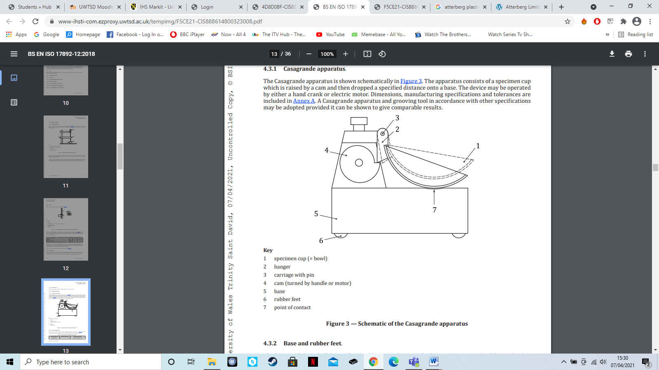
- The carriage should be designed so as to allow secure adjustment of the 10mm drop-height of the cup.
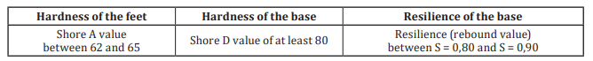
Figure 1: Schematics of the ‘Casagrande apparatus’ (BSI, 2018, Figure 3).
Figure 2: Table detailing the ‘base and feet’ rubber requirements (BSI, 2018, table 2)

Alongside the ‘Casagrande apparatus’ a grooving tool was required. This was used to make grooves in the soil sample as defined in the procedure below. BSI (2018, clause 4.3.7) cites this should be flat or curved with a bevelled tip, comprised of either plastic or a non-corroding metal.
Additionally, common items such as: a spatula, a mixing bowl (metal) and a water spray (for adding moisture to the soil) were required.

1.2.1.2 Procedure

The procedure was carried out in accordance with the relevant standards (BS EN ISO 17892-12:2018).
As with any soil testing proper specimen preparation is crucial. This was carried out in accordance with clause 5.2 of BS EN ISO 17892-12:2018. In this case the soil was finely grained and did not include any material over 0.4mm in aperture, as such it was possible to carry out the test with no interference to the sample, as is preferred (BSI, 2018, Clause 5.2).
The test was then carried out using the following procedure:
- Four containers were chosen, marked and weighed. The individual weights were then recorded.
- A soil sample of roughly 250g was placed in a metal mixing bowl; small amounts of water were intermittently introduced and mixed with the soil using a spatula. This was done until the soil reached a consistency that allowed a 12mm groove in the soil to be closed by roughly 35 blows of the ‘Casagrande apparatus’, in our case 32, bringing it in line with the consistency required for the test (BSI, 2018, clause 5.2.8).
- Once the correct consistency had been reached, a portion of the remoulded paste was added to the cup bowl of the ‘Casagrande apparatus’. This was squeezed down with a spatula as flat as possible to a depth of 10mm, whilst taking care to avoid any air bubbles (BSI, 2018, clause 5.4.2). Excess soil was then returned to the mixing bowl (BSI, 2018, clause 5.4.3).
- A groove was then cut into the paste using the grooving tool, running back to front through the middle of the sample and exposing the cup at the base of the groove (BSI, 2018, clause 5.4.4). Care was taken to avoid cracking or movement of the sample (BSI, 2018, clause 5.4.5).
- Once the drop counter was reset to zero on the ‘Casagrande apparatus’, the cam was rotated at a rate of 2 revolutions per second (BSI, 2018, clause 5.4.6). Once the groove had closed over the 12mm gap created using the grooving tool, the rotation of the cam stopped and the number of drops was recorded (BSI, 2018, clause 5.4.8).
- A slice of soil the width of the spatula was removed from the area in which the groove closed, roughly 15g in weight (BSI, 2018, clause 5.4.10). This was then placed in the first of the four containers.
- This was then weighed to ascertain the wet weight of the soil.
- This was then repeated for a further three samples with slightly more water added to the mixture each time, reducing the number of blows required to close the gap. This culminated in data above and below the 25 blow mark, allowing for effective calculation of the liquid limit (BSI, 2018, clause 5.4.12)
- The four samples were then oven dried and weighed to ascertain their dry weight. Allowing for calculation of the moisture content.
- These were then plotted on a graph alongside the number of blows taken. A line of best fit was plotted using these results.
- The point where the line of best fit meets the 25 blow mark is the liquid limit. A ‘moisture content’ for this can be ascertained from the graph.

1.2.2 Plastic limit test

1.2.2.1 Equipment

The plastic limit test required a glass plate and measuring rods, of diameter 3mm and 6mm, to assess the width of soil rolled using the below procedure.

1.2.2.2 Procedure

The procedure was carried out in accordance with the relevant standards (BS EN ISO 17892-12:2018).
As the test was carried out using the same soil sample as the liquid limit test the sample was already prepared in accordance with clause 5.2 of BS EN ISO 17892-12:2018.
The test was carried out using the following procedure:
- Three containers were chosen before the test then weighed and marked accordingly.
- A sample of roughly 20g from the previous liquid limit test was placed on a mixing plate (BSI, 2018, clause 5.5.1). This was then left to dry until it was plastic enough to be rolled into a ball (BSI, 2018, clause 5.5.2).
- The ball was rolled between the hands until it was dry enough that cracks begun to appear, at this point it was divided into two equal portions (BSI, 2018, clause 5.5.3).
- One of these portions was then divided into three sub-portions (BSI, 2018, clause 5.5.4). These were kept separate from each other.
- Using the 6mm glass measuring rod each sub-portion was rolled into a thread of 6mm diameter on the glass mixing plate (BSI, 2018, clause 5.5.5). Each thread was intact and homogenous (as is crucial for the test).
- The thread was then rolled gently until the diameter was 3mm, measured using the 3mm measuring rod, this was repeated until the thread crumbled at the 3mm diameter mark (BSI, 2018, clause 5.5.6). Crumbling can be defined as shearing both longitudinally and transversally. It is crucial this is due to moisture content reduction as opposed to pressure, as such, care was taken to ensure this was the case.
- The crumbling point is the plastic limit moisture content. As such, the pieces were collected and placed in one of the marked containers before being weighed to ascertain a wet weight.
- The process was then repeated for the other two sub-portions.
- All samples were then dried and weighed to ascertain a dry weight. Allowing for calculation of the moisture content.
- A mean average was then calculated from the three samples to give a ‘moisture content’ indicative of the plastic limit for the soil sample.

1.3 Results & analysis

Container Number | 1 | 2 | 3 | 4
Weight of wet soil and container (g) | 9.43 | 13.35 | 13.39 | 12.89
Weight of dry soil and container (g) | 8.02 | 10.66 | 10.68 | 10.24
Weight of container (g) | 4.72 | 4.69 | 4.69 | 4.72
Weight of moisture (g) | 1.41 | 2.69 | 2.71 | 2.65
Weight of dry soil (g) | 3.3 | 5.97 | 5.99 | 5.52
Moisture content (%) | 42.72 | 45.06 | 45.24 | 48.01
Number of blows | 32 | 22 | 19 | 15
The results obtained from the ‘liquid limit test’ are detailed in the table below. The weight of moisture was found from the difference between the wet and dry soil in containers, the weight of dry soil was found from the weight of dried soil in container minus the weight of the container. Moisture content was then calculated by dividing the weight of moisture by that of the dry soil and multiplying by 100.
Figure 3: Table showing results from the liquid limit test

The liquid limit, as per the ‘Casagrande’ method, can be defined as the moisture content at which 25 blows from the ‘Casagrande apparatus’ closes the groove in the soil (Capper & Cassie, 1969, pg.23). As such, a graph with a ‘line of best fit’ was used to calculate this, shown in figure 4, based on the information from the above table. The liquid limit was found to be 44.4%, as is shown below.
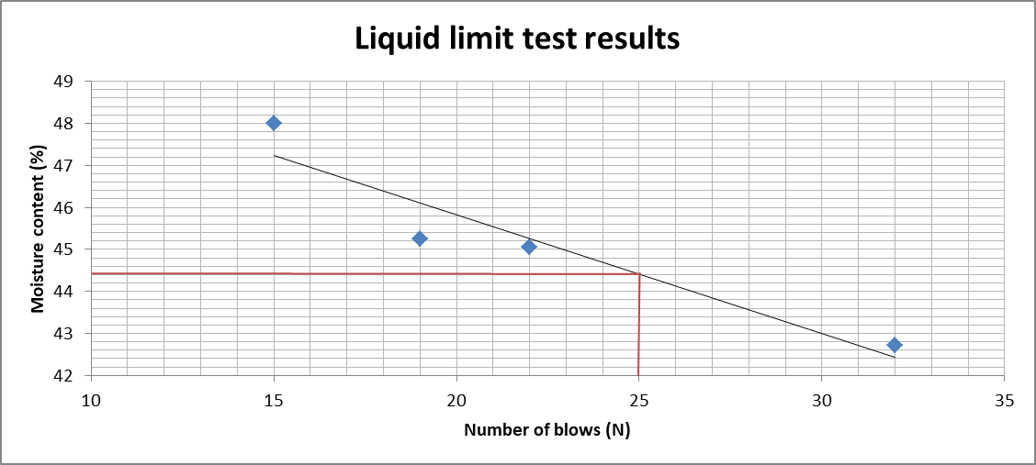
Figure 4: Graph showing results for the liquid limit test, with a red line plotted to show the moisture content at the 25 blow mark

The next stage in the ‘Atterberg limits’ test was to define the plastic limit for the sample. The table below, figure 5, shows the results obtained from the plastic limit test. With moisture content, wet weight, dry weight etc. being calculated in the same way as previously detailed with the liquid limit data.
Container number | 1 | 2 | 3
Weight of wet soil and container (g) | 8.01 | 9.4 | 8.18
Weight of dry soil and container (g) | 7.24 | 8.31 | 7.39
Weight of container (g) | 4.73 | 4.73 | 4.81
Weight of moisture (g) | 0.77 | 1.09 | 0.79
Weight of dry soil (g) | 2.51 | 3.58 | 2.58
Moisture content (%) | 30.68 | 30.45 | 30.62
Average moisture content (%) | 30.53
Figure 5: Table showing results from plastic limit testing.

As shown above, the mean average for the three samples used in plastic limit testing was found to be 30.53%. This is the plastic limit for the soil sample.
With the plastic limit and liquid limit found it was possible to determine a plasticity index for the sample, this was found by subtracting the plastic limit from the liquid limit. In the case of this sample it was 13.87%, this can be used to determine the soils classification using the ‘plasticity chart’ below (figure 6).
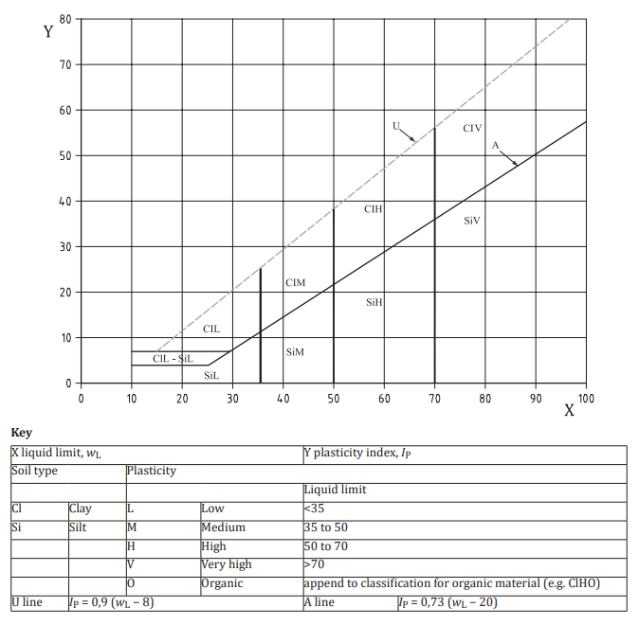
Figure 6: ‘Plasticity chart’ for definition of fine-grained soils from BS EN ISO 14688‑2:2018 (BSI, 2018, Figure 1).

From the above table it was possible to classify the soil sample tested as silt with medium plasticity.

1.4 Conclusions

Atterberg limits are important in civil engineering as any soil at or above its liquid limit will undergo liquefaction, causing it to act as a liquid. Inversely any soil at or below its plastic limit will become a brittle solid after undergoing shrinkage, due to loss of moisture. Neither of these are ideal situations from a civil engineering perspective, both leading to instability in the soil in question.
The sample tested showed a low plasticity index and liquid limit, having major implications on its stability. A low plasticity index indicates that the soil will change significantly in terms of consistency, even with a small change in moisture content (Wagner, 2013). Coupled with the low liquid limit, we have a soil that could rapidly reach a state of liquefaction with little to no warning in periods of intense rainfall or flash flooding. This makes it a severe landslide risk and slopes with this composition of clay/silt should be treated with extreme caution.
The dangers present in this type of soil are illustrated by the soil responsible for the Aberfan disaster of 1966. During which mining waste comprised of soil and rocks removed during excavation, entered a state of liquefaction, causing the waste to form a landslide burying parts of the Welsh mining town of Aberfan. ‘Atterberg limits’ tests conducted showed the soil to have a liquid limit of roughly 20% and a plasticity index of roughly 5%, as shown in figure 7. Although this is an extreme example, it is a candid reminder of the dangers present in soil such as this. With the mainly silt composition unable to absorb water on the level of clay soils (Wagner, 2013).
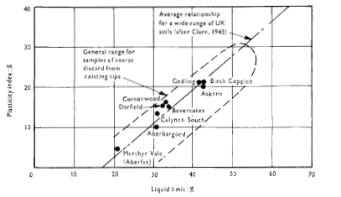
Figure 7: Chart showing liquid limit/plasticity index for Aberafon in relation to other colliery spoil tips (Thomson & Rodin, 1973, fig. 46b)

2. Constant head permeability

2.1 Introduction

The constant head permeability test is used to determine the coefficient of permeability for coarse-grained soils, such as gravel or sand (Atkinson, 2007, pg.89). The principle of the test is to cause water to flow through a soil sample whilst measuring the hydraulic gradient and rate of discharge, the coefficient of permeability can then be calculated using Darcy’s equation (Capper & Cassie, 1969, pg.283). This is important for civil engineering as it defines the rate at which water will flow/seep through the soil, having large implications structures such as dams and landfills.

2.2 Methodology

2.2.1 Equipment

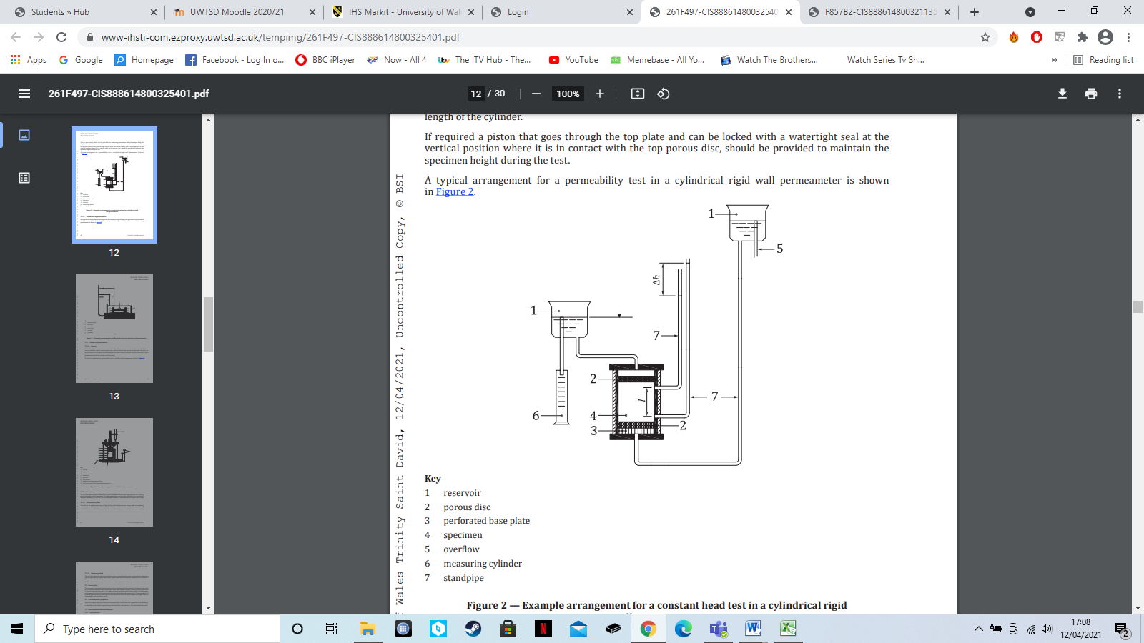
There are a number of different permeameters, for this test a cylindrical rigid wall permeameter was used, this was set up as shown in figure 8.
Figure 8: Cylindrical rigid wall permeameter set-up for constant head permeability testing (BSI, 2019, figure 2).
As shown in figure 8, the permeameter should be set-up with a number of elements. These include: reservoir, porous disc, a perforated base plate, overflow, measuring cylinder and standpipes (manometer tubes).
BSI (2019, clause 5.2) state that a rigid wall cylindrical permeameter should meet the following criteria:
- Minimum internal dimensions of the permeameter must be at least 6 times larger than the largest particle size of the specimen.
- Made of corrosion resistant materials, sufficiently rigid to resist deformation during testing.
- Outlet and inlet of sufficient capacity so as to not influence test results.

2.2.2 Procedure

The procedure was carried out in accordance with the relevant standards (BS EN ISO 17892‑11:2019).
Measurements for cross-sectional area (A) and length of flow line (L) were recorded prior to specimen preparation so as to ensure easy calculation of test results.
In order to properly prepare the specimen for the tests, precautions were required. As the test relates to saturated soils, it is important to ensure the sample is fully saturated and as much air as possible is removed prior to testing (BSI, 2019, clause 6.1.1). In this case the sample was compressed and compacted in the cylindrical tube using a rod, water was then ran through the specimen before testing began (BSI, 2019, clause 6.2.1.3).
With the sample properly prepared, the test was then carried out using the following procedure:
- With the water flowing through the sample at a constant rate prior to the beginning of the test; the first step was to open the valves on the manometers. This established a constant head difference (H), this relates to the head used up in pushing the water through the length of the test sample (L).
- Water was collected in the measuring cylinder over a recorded time (T). From this a flow rate could be ascertained (Q).
- Hydraulic gradient was calculated by dividing the height difference of the two manometer tubes by the height difference of the manometer connections to the cylindrical tube.
- The results obtained were then inserted into Darcy’s equation to find a coefficient of permeability.
- This was then repeated two more times over different time periods, with the results used to find a mean average based on the three tests.

2.4 Results & analysis

The results obtained for the ‘constant head permeability’ test are detailed in the table below (figure 9). Results have been converted into metres and seconds for ease of calculation.
Test number | 1 | 2 | 3
Water collected ($m^{3}$) | $$\text{920 × }{10}^{-7}$$ | $$185 ×{10}^{-6}$$ | $$36.8×{10}^{-5}$$
Time taken (Seconds) | 165 | 330 | 660
Diameter of sample ($m$) | 0.1
Head difference ($m)$ | 0.68
Difference between manometer connections ($m)$ | 0.2

Figure 9: Table showing information obtained from ‘constant head permeability’ test.

These results were then inserted into Darcy’s equation for coefficient of permeability, shown in figure 10. Where: water collected=Q, time taken=T, head difference=H, difference between manometer connections=L, coefficient of permeability=K and cross-sectional area=A. Cross-sectional area can be derived from the sample diameter because$A=πr^{2}$ , therefore$A={0.05}^{2}$.
$$K=\frac{Q×L}{A×H×T}$$
Figure 10: Darcy’s equation for coefficient of permeability.

This was worked out for each test, with an average calculated for the three results, shown below in figure 11.
Test number | 1 | 2 | 3
Coefficient of permeability (m/s) | $$9.086×{10}^{-4}$$ | $$2.097×{10}^{-4}$$ | $$2.085×{10}^{-4}$$
Average coefficient of permeability (m/s) | $2.092×{10}^{-4}$

Figure 11: Table showing results for coefficient or permeability.
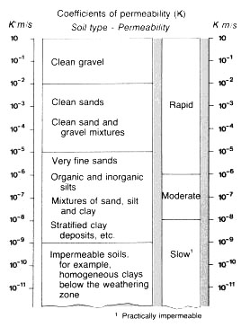
With a mean average coefficient of permeability found, the sample was then be classified using the table shown in figure 12. In this case the sample is classified as ‘clean sand and gravel mixture’ with rapid drainage capacity.
Figure 12: Table of coefficients of permeability (FAO, 2021)

2.4 Conclusions

This is an important test from a civil engineering perspective because it gives an idea of how quickly moisture will drain through the soil in question, with different levels of permeability being suited to different projects. For example, a dam creating a reservoir over permeable soil, such as the sample tested, will have issues with water seeping into the ground rather than being retained within the reservoir (Roy & Bhalla, 2017). This is also useful for excavations, as the permeability of the soil can help ascertain the pumping capacity required in order to keep the excavations from becoming waterlogged during works (Roy & Bhalla, 2017).
The sample tested was semi-permeable, sitting around the middle of Darcy’s table for coefficient of permeability. This makes it unsuitable for water-based works such as previously mentioned. Considerations would also have to be taken into account for any structure built on this soil. Being of a sandy gravel mixture it is unlikely to be able to bear large loads so deeper foundations may be required depending on the project.
There are, however, some issues with this method of testing. Principle among these is the fact that permeability can vary drastically over even a small site. As such, the one sample tested on this occasion would be insufficient to give an overall picture for coefficient of permeability on any site. Multiple tests would need to be conducted in order to get a true picture of the sites permeability.

3. List of figures

- Figure 1: BSI (2018). BS EN ISO 17892-12:2018. Geotechnical investigation and testing - Laboratory testing of soil Part 12: Determination of liquid and plastic limits. [Online] Available at: https://www-ihsti-com.ezproxy.uwtsd.ac.uk/tempimg/16C872A-CIS888614800323008.pdf (Accessed: 04.04.21)
- Figure 2: BSI (2018). BS EN ISO 17892-12:2018. Geotechnical investigation and testing - Laboratory testing of soil Part 12: Determination of liquid and plastic limits. [Online] Available at: https://www-ihsti-com.ezproxy.uwtsd.ac.uk/tempimg/16C872A-CIS888614800323008.pdf (Accessed: 04.04.21)
- Figure 3: Own work
- Figure 4: Own work
- Figure 5: Own work
- Figure 6: BSI (2018) BS EN ISO 14688‑2:2018. Geotechnical investigation and testing – Identification and classification of soil Part 2: Principles for a classification (ISO 14688-2:2017). [Online] Available at: https://www-ihsti-com.ezproxy.uwtsd.ac.uk/tempimg/16C872A-CIS888614800321135.pdf (Accessed: 10.04.21)
- Figure 7: Thomson, G & Rodin, S (1973) Colliery spoil tips - after Aberfan. [Online] Available at: https://www.icevirtuallibrary.com/doi/pdf/10.1680/iicep.1973.4702 (Accessed: 11.04.21).
- Figure 8: BSI (2019) BS EN ISO 17892‑11:2019. Geotechnical investigation and testing - Laboratory testing of soil Part 11: Permeability tests.[Online] Available at: https://www-ihsti-com.ezproxy.uwtsd.ac.uk/tempimg/16C872A-CIS888614800325401.pdf (Accessed: 12.04.21)
- Figure 9: Own work
- Figure 10: Own work
- Figure 11: Own work
- Figure 12: FAO (2021) SOIL PERMEABILITY. [Online] Available at: http://www.fao.org/fishery/static/FAO_Training/FAO_Training/General/x6706e/x6706e09.htm#top (Accessed: 15.04.21).

4. List of references

- Atkinson, J (2007).The mechanics of soils and foundations. Second edition. Abingdon, UK: Taylor & Francis
- BSI (2018) BS EN ISO 14688‑2:2018. Geotechnical investigation and testing – Identification and classification of soil Part 2: Principles for a classification (ISO 14688-2:2017). [Online] Available at: https://www-ihsti-com.ezproxy.uwtsd.ac.uk/tempimg/16C872A-CIS888614800321135.pdf (Accessed: 10.04.21)
- BSI (2018) BS EN ISO 17892-12:2018. Geotechnical investigation and testing - Laboratory testing of soil Part 12: Determination of liquid and plastic limits. [Online] Available at: https://www-ihsti-com.ezproxy.uwtsd.ac.uk/tempimg/16C872A-CIS888614800323008.pdf (Accessed: 04.04.21)
- BSI (2019) BS EN ISO 17892‑11:2019. Geotechnical investigation and testing - Laboratory testing of soil Part 11: Permeability tests.[Online] Available at: https://www-ihsti-com.ezproxy.uwtsd.ac.uk/tempimg/16C872A-CIS888614800325401.pdf (Accessed: 12.04.21)
- Capper, P & Cassie, W (1969).The mechanics of engineering soils. Fifth edition. Bungay, UK: The Chaucer press
- FAO (2021) SOIL PERMEABILITY. [Online] Available at: http://www.fao.org/fishery/static/FAO_Training/FAO_Training/General/x6706e/x6706e09.htm#top (Accessed: 15.04.21).
- Roy, S & Bhalla, S (2017). Role of Geotechnical Properties of Soil on Civil Engineering Structures, Resources and Environment, Vol. 7 (4) pp. 103-109. [Online] Available at: http://article.sapub.org/10.5923.j.re.20170704.03.html#Sec2.3 (Accessed: 15.04.21).
- Thomson, G & Rodin, S (1973) Colliery spoil tips-after Aberfan. [Online] Available at: https://www.icevirtuallibrary.com/doi/pdf/10.1680/iicep.1973.4702 (Accessed: 11.04.21).
- Wagner, J (2013) Mechanical Properties of Clays and Clay Minerals, Developments in clay science, Vol.5 pp. 347-381. [Online] Available at: https://www.sciencedirect.com/topics/earth-and-planetary-sciences/atterberg-limit (Accessed: 11.04.21).

