Operating Systems
Module Name: Computer Architecture & OS
Module Code: ACCA4022
Student Name: Haci Babir
Student ID: 2524810
Lecturer Name: Dr Md Shantanu Islam

Submission date: 14/07/2026

Contents
Introduction 4
Key functions of general Operating Systems 4
Task Management: 4
Application/Program Management: 5
File/Directory Management: 6
Device Management: 7
Security Management: 8
Use of Windows OS CLI commands 9
Example 1: 10
Example 2: 10
Example 3: 11
Example 4: 11
Example 5: 12
Example 6: 12
Example 7: 12
Example 8: 14
Example 9: 14
Example 10: 15
Use of Linux OS CLI commands 15
Example 1: 16
Example 2: 16
Example 3: 17
Example 4: 17
Example 5: 18
Example 6: 18
Example 7: 19
Example 8: 19
Example 9: 20
Example 10: 20
Use of Windows OS scripts 21
Example 1: 21
Example 2: 22
Use of Linux OS scripts 23
Example 1: 23
Example 2: 24
Conclusion 25
References 26
Appendices 27

Introduction
In this assignment I will be producing a technical report that shows both theoretical understanding and practical skills in operating systems. I will be researching the core functions of general-purpose operating systems and explain how they manage processes, memory, files, users, and system resources. I will be doing tasks using command-line tools in both Windows and Linux. This includes documenting a range of commands related to process control, file management, networking, user administration, and task scheduling, using screenshots and explaining each screenshot.

Key functions of general Operating Systems
The Windows OS, first released by Microsoft in 1985, has become one of most popular used platforms for personal and professional computing. Its importance are user friendly, strong hardware compatibility, and essential functions such as process management, file handling, memory control, and system security. These features support efficient system operation and accessibility for more than one user [1], [2].

Task Management:
Task manager is one of the most useful system utilities for monitoring and controlling what happens on a PC. It shows real time insights into applications, background processes, and overall system performance, making it a key tool for troubleshooting and optimization.
Task manager lets users view how much CPU, memory, disk, network, and GPU resources each process in using. This helps identify programs that may be slowing down the system. When an application becomes unresponsive, users can force it to close using end task, restoring system stability.
Task manager includes lots of advantages features. The performance tab displays live graphs and hardware statistics, such as GPU speed, memory usage, and system uptime. The startup tab allows users to manage which programs launch automatically, improving boot times [3], [4].

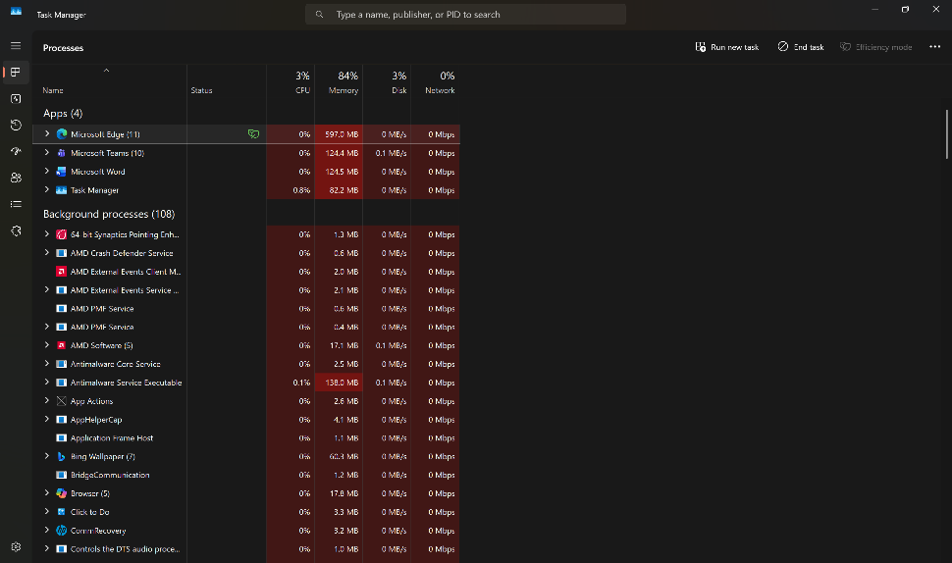
Figure 1: Task Manager

Application/Program Management:
Windows application/program management focuses on how apps are installed, maintained, updated, and controlled across a windows system. It ensures that users and administrators can keep software organized, secure, and functioning properly.
At the user level, windows provide multiple ways to install applications, including Microsoft store, and line of business applications. Users can manage install programs through settings and then apps, where they can uninstall software, modify app permissions, or reset malfunctioning applications.
Windows includes built in mobile device management capabilities that allow administrators to deploy, update, inventory, ad remove applications across any devices, this makes consistency and security across an enterprise environment [5], [6].

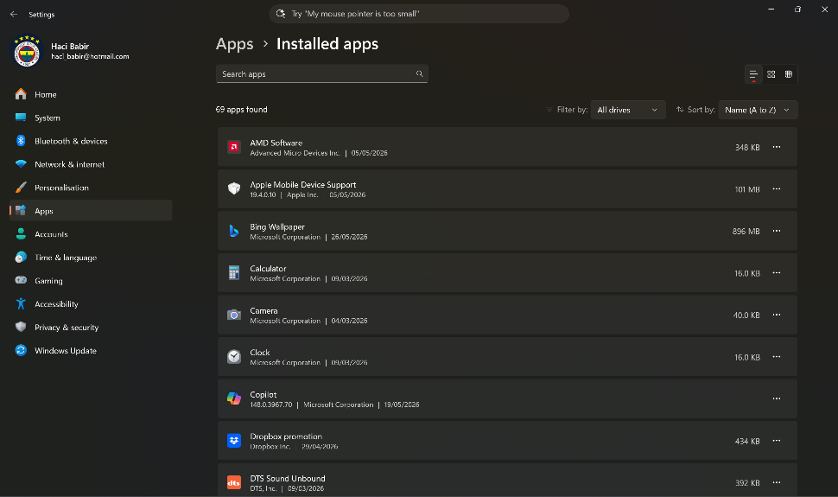
Figure 2: Program Manager

File/Directory Management:
File explorer, the built-in tool that helps users organize and locate data. Windows uses hierarchical directory structure, meaning files are stored inside folders, which can contain additional subfolders. This structure makes it easier to navigate and maintain an organized system.
File explorer allows users to create, rename, move, copy, and delete files and folders. Common actions, such as cut, copy, paste, and rename are accessible through the ribbon interface or right click context menu. Users can also customize views, search for files, and pin their most used folders to quick access for faster navigation.
Windows directories follow a standardized layout, including key locations such as C:\Windows, C\Users, and C\Program files. Understanding this structure helps users manage storage, troubleshoot issues, and maintain system efficiency [7].

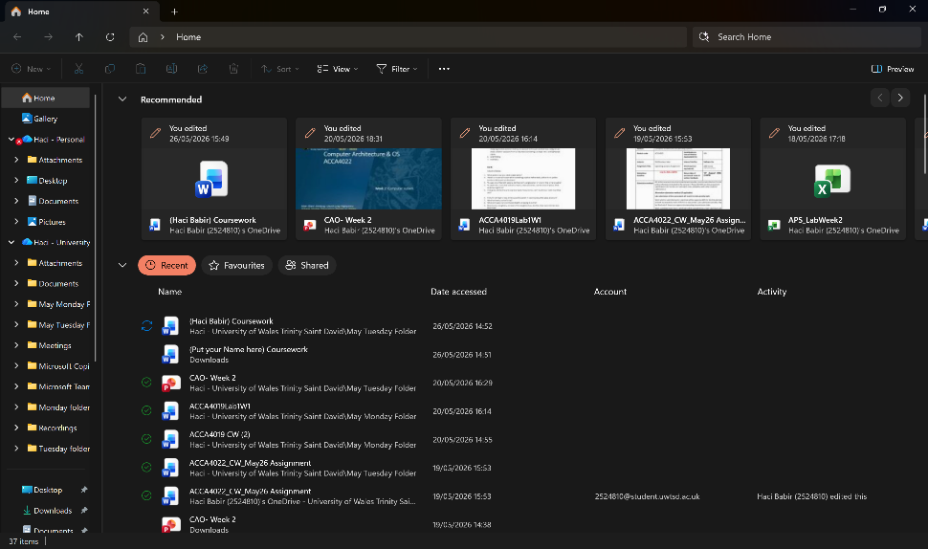
Figure 3: File Explorer

Device Management:
Device management windows focus on controlling, monitoring, and maintaining the hardware components connected to a computer system. The central tool for this is device manager, which provides a structured view of all installed hardware, including processors, network adapters, storage controllers, and peripheral devices, through device manager, users can enable or disable devices, update drivers, roll back drivers, view device properties, and troubleshoot hardware issues. Windows highlights malfunctioning devices using icons such as yellow warning triangles or grey arrows helping users quickly identify problems.
Driver management is a key part of device management. Windows can automatically install or update drivers through windows update, but users may also manually update or reinstall drivers through device manager [8].

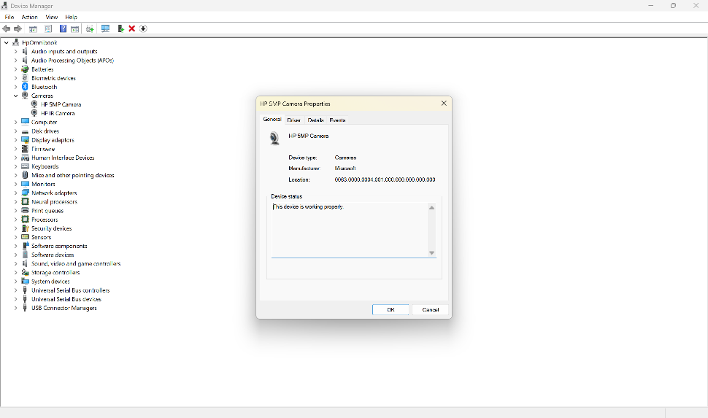
Figure 4: Device Manager

Security Management:
Security management in windows focuses on protecting the operating system, user data, and network resources from unauthorized access, malware, and system vulnerabilities. Windows includes a built-in suite of tools under windows security, which provides real time protection through features such as virus & threat protection, firewall & network protection, and account protection. These components work together to detect malicious activity, block suspicious connections, and safeguard user identities.
A critical part of windows security is windows security is windows defender antivirus, which continuously scans files, monitoring system behaviour, and update threat definitions automatically. Windows also uses user account control to prevent unauthorized changes by prompting for administrator [9].

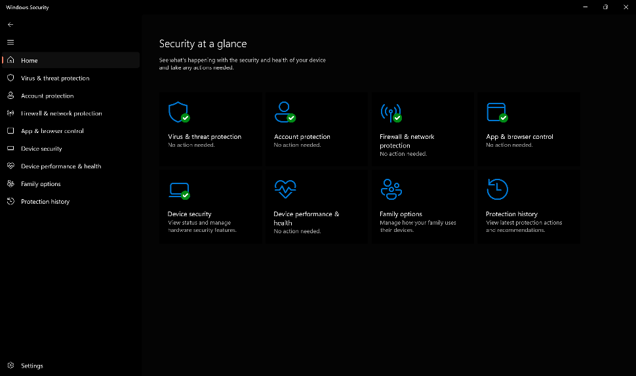
Figure 5: Windows Security

Use of Windows OS CLI commands
Primarily command prompt (CMD) and PowerShell provide powerful ways to manage system tasks, automate processes, and perform administrative functions. CMD offers classic commands such as dir for listing files, copy and move for file operations, and ipconfig for viewing network configurations.

Example 1:
The command shown is Dir, which lists the contents of the current directory in windows command prompt. It displays folders like documents, downloads, and OneDrive, along with dates and <DIR> tags indicating directories, the output also shows number of files, total folders, and available disk spaces remaining.
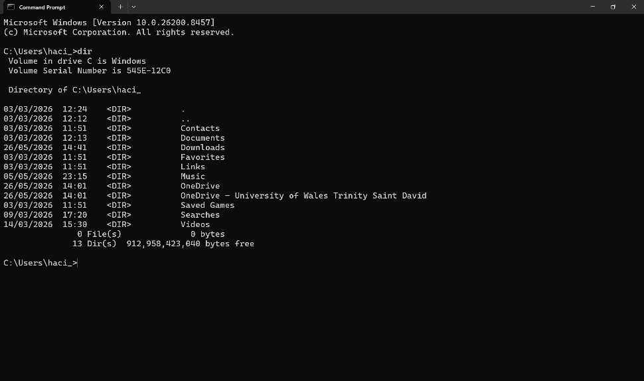
Figure 6: Command Prompt

Example 2:
The command for this is cd (change directory) to navigate through folders in command prompt. The first attempt, cd Desktop, fails because the path is incorrect. Then I use cd .. multiple times to move up directories until reaching c:\. Finally, cd User\haci_\Desktop correctly changes to the Desktop folder.
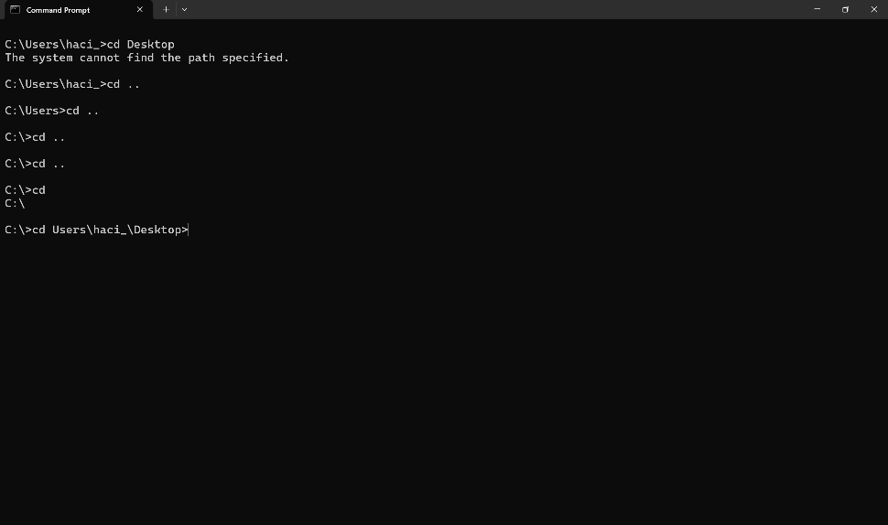
Figure 7: Command 1

Example 3:
The command mkdir “NewFolder” creates a ne directory named “NewFolder” in the current location. After that, the dir command lists all files and folders. The output confirms the new folder was successfully created, as “NewFolder” appears in the directory list.
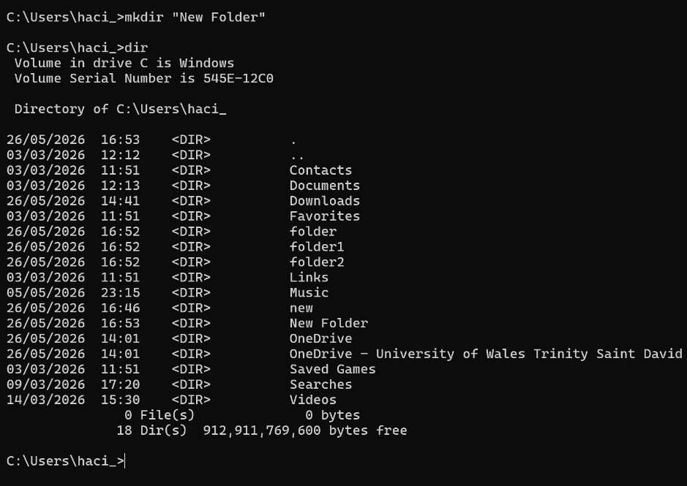
Figure 8: mkdir “new folder”

Example 4:
The command rmdir new “NewFolder” folder1 folder2 removes multiple directories at once from the current location. It successfully deletes the specified folders. The dir command then lists the remaining contents of the directory, confirming those folders are gone.
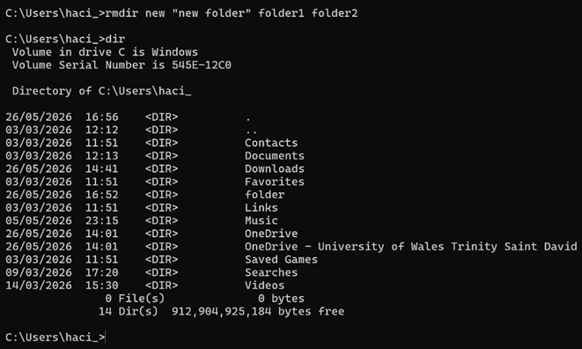
Figure 9: new folder commands

Example 5:
The commands use cd to move into the documents folder, then echo Hello > new.txt to create a new text file and write “Hello” inside it. The output shows the file was created successfully. On the right, the text editor displays the contents of new.txt.
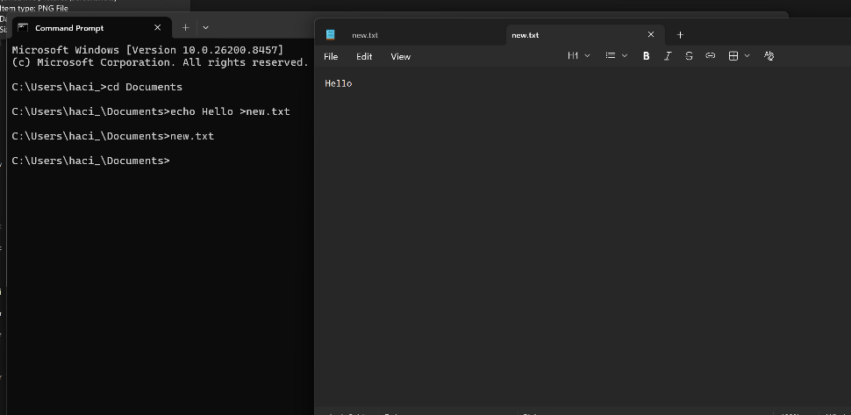
Figure 10: command and output

Example 6:
The command ipconfig displays the computers network configuration details. The output shows information for different network adapters. Two Wi-Fi adapters are disconnected, while one active adapter displays its IPv4 address (172.20.10.2), subnet mask, and default gateway.
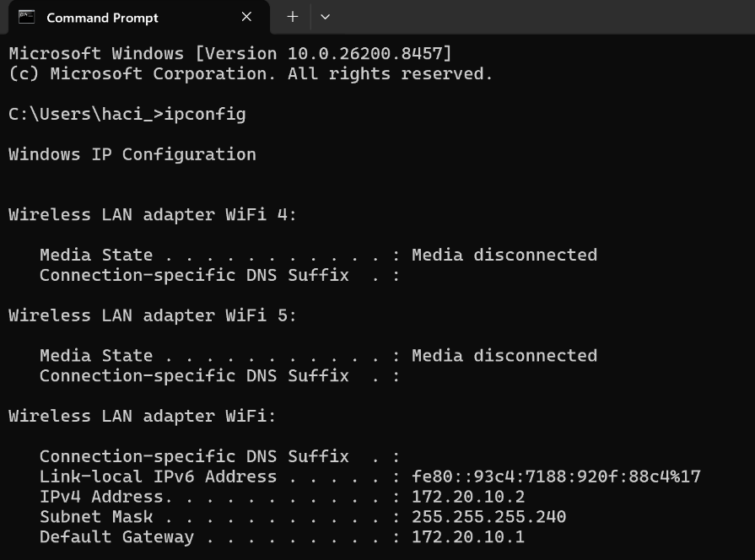
Figure 11: IP configuration

Example 7:
The command ping www.google.com tests network connectivity between the computer and the google server. The output shows four successful replies, including the IP address, time taken, and TTL value. Ping statistics confirm 4 packets sent and received with 0% loss.
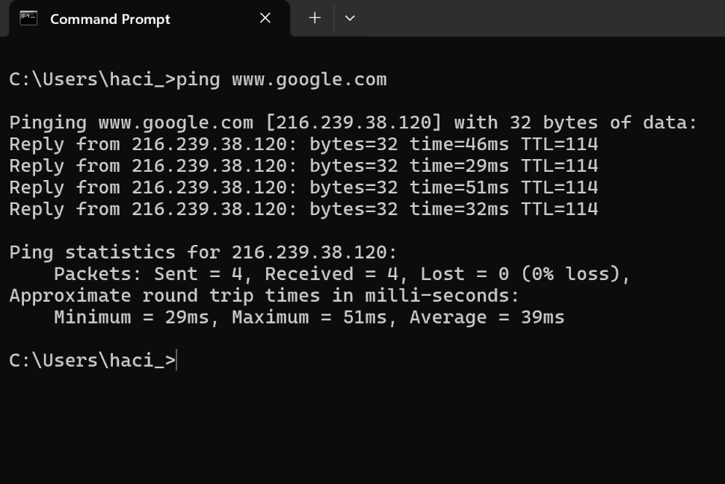
Figure 12: ping www.google.com

Example 8:
The command netstat displays active network connections and listening ports on the computer. The output lists protocols (TCP), local and foreign IP addresses, and connection states like ESTABLISHED, TIME_WAIT, and CLOSE_WAIT. It shows ongoing communications between the device and external servers.
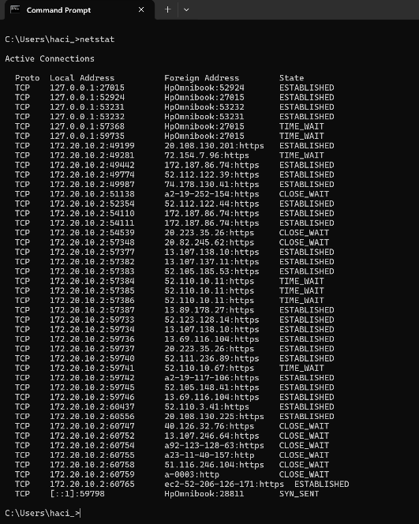
Figure 13: network stats

Example 9:
The command systeminfo is used in command prompt to display detailed information abut a computer system. The output shows system details such as the operating system. The output shows system details such as the operating system, processor, memory (RAM), device model, and installed updates.
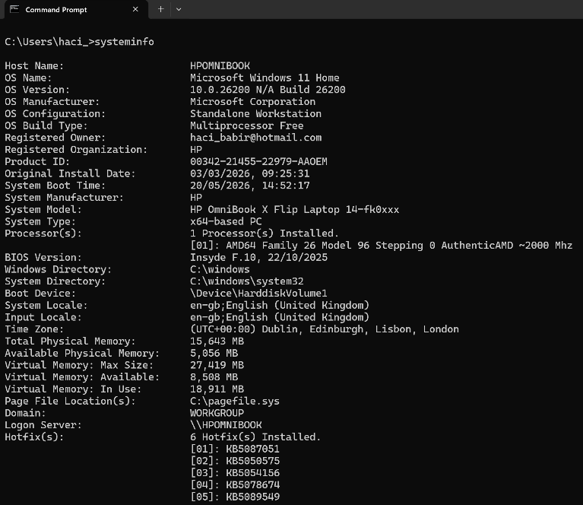
Figure 14: system information

Example 10:
The command tasklist is used in commands prompt to display all running processes on a computer. The output shows each process name, process ID (PID), session type, and memory usage. This helps users monitor system activity.
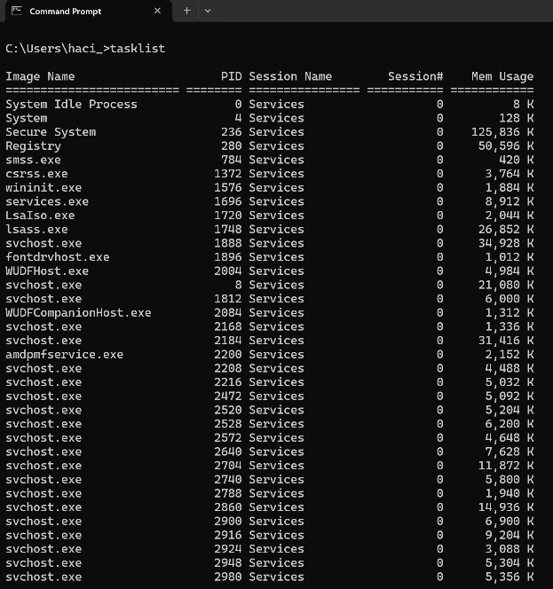
Figure 15: tasklists

Use of Linux OS CLI commands
The Linux command line interface is a text-based environment used to interact with the operating system by typing commands. It allows users to perform tasks efficiency, such as managing files, running programs, configuring system settings, and monitoring performance.

Example 1:
The user enters the username student and a password at the Linux Login prompt. The system responds with “Authentication failure”, meaning the username or password is incorrect.
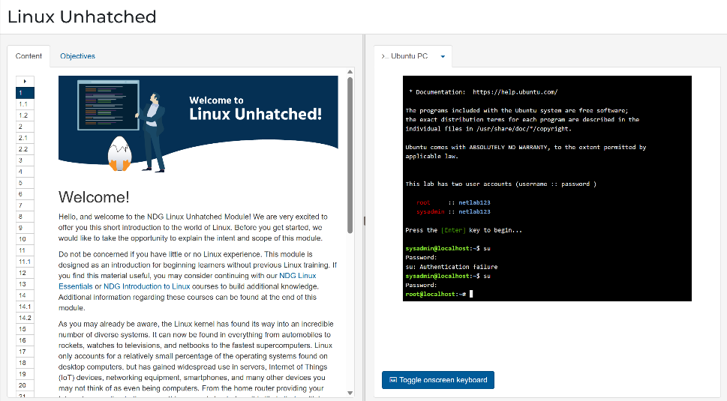
Figure 16: netlab123

Example 2:
The ls -al command lists all files and directories in the current location, including hidden files. The -a option displays hidden files, while -l shows detailed information such as permissions, owner, size, and date.
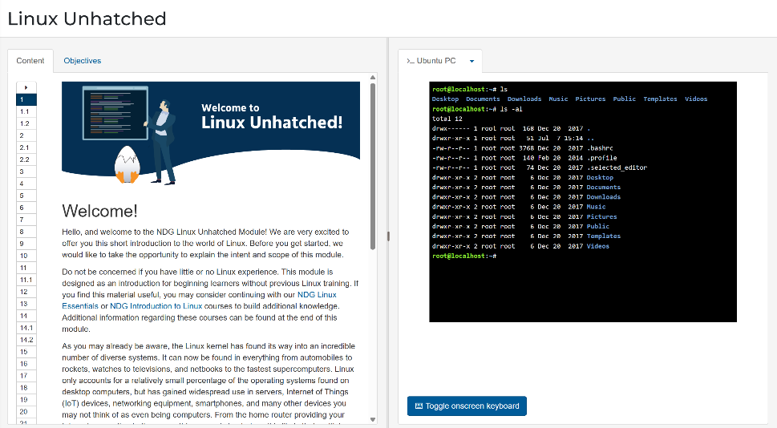
Figure 17: ls -al

Example 3:
Explain the command and output.
The cd Desktop/ command changes the current working directory to the Desktop folder. Cd stands for “change directory.” The output shows the command prompt changing from root@localhost:~# to root@localhost:~/Desktop#, confirming that the system successfully moved from the home directory into the Desktop directory.
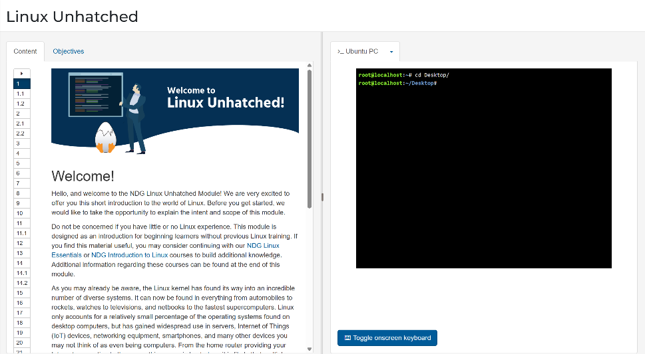
Figure 18: cd Desktop

Example 4:
Explain the command and output.
The mkdir new command creates a new directory named new inside the current Desktop folder. After that, the ls command lists the command lists the contents of the current directory.
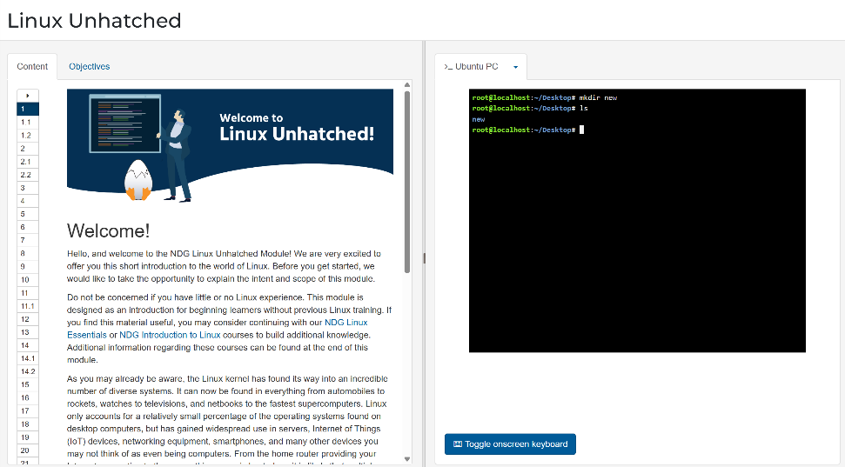
Figure 19: mkdir new

Example 5:
Explain the command and output.
The rmdir new command removes the directory named new from the current location. rmdir can only delete empty directories. The output returns directory to the command prompt with no error message.
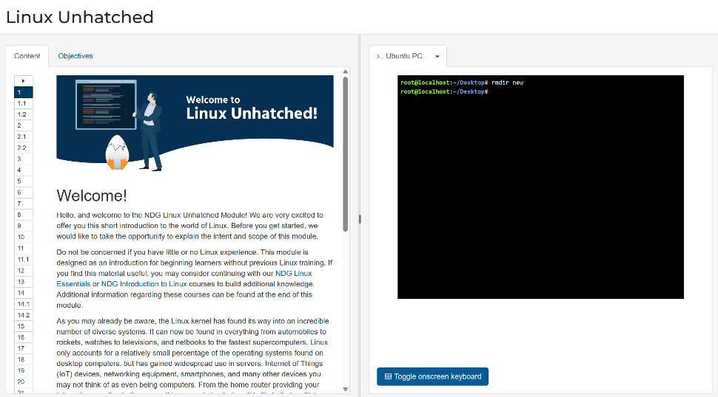
Figure 20: rmdir new

Example 6:
Explain the command and output.
The mv new copy command renames the directory new to copy. The mv command is used to move or rename files and directories. Afterward, the ls command lists the content of the current directory.
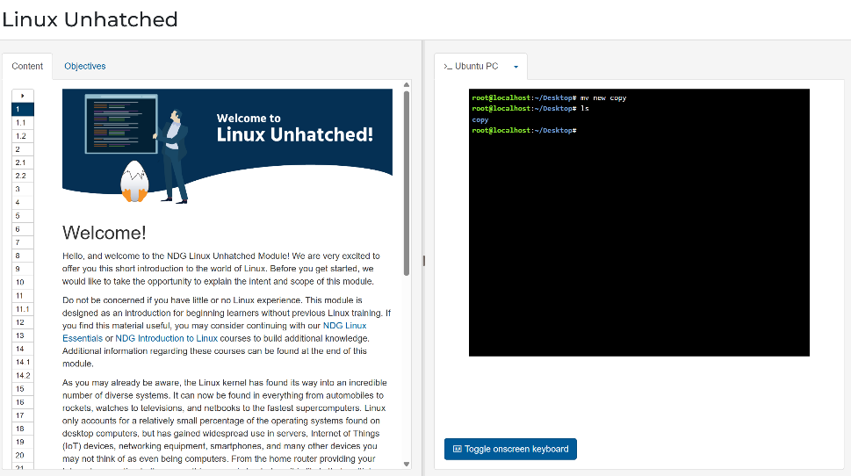
Figure 21: mv new copy

Example 7:
Explain the command and output.
The touch new.txt command creates a new empty text file named new.txt in the current directory. The ls command then lists the directory contents. The output shows copy and new.txt.
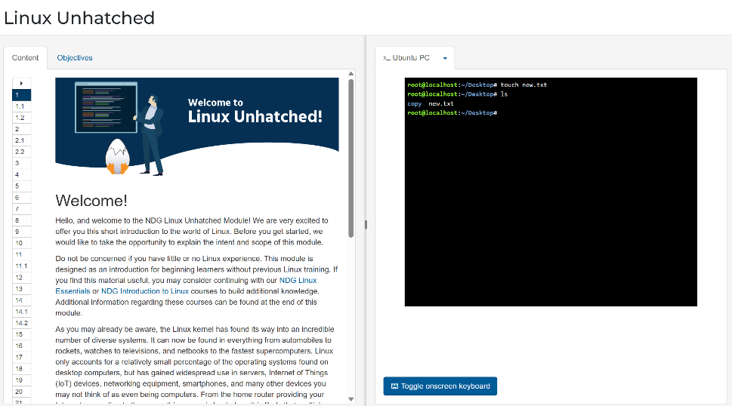
Figure 22: touch new.txt

Example 8:
Explain the command and output.
The echo HI > new.txt command writes the text HI into the file new.txt, replacing any existing content. The cat new.txt command displays the files contents on the screen.
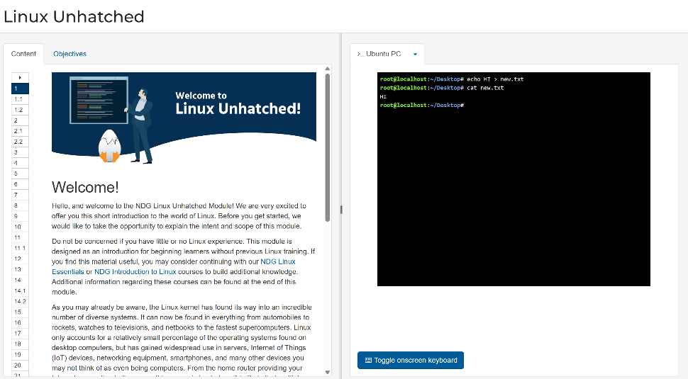
Figure 23: echo HT new.txt

Example 9:
Explain the command and output.
The ifconfig command displays network interface configuration details on a Linux system. The output shows information for the eth0 network adapter, including its IP address (192.168.1.2), subnet mask, and network statistics.
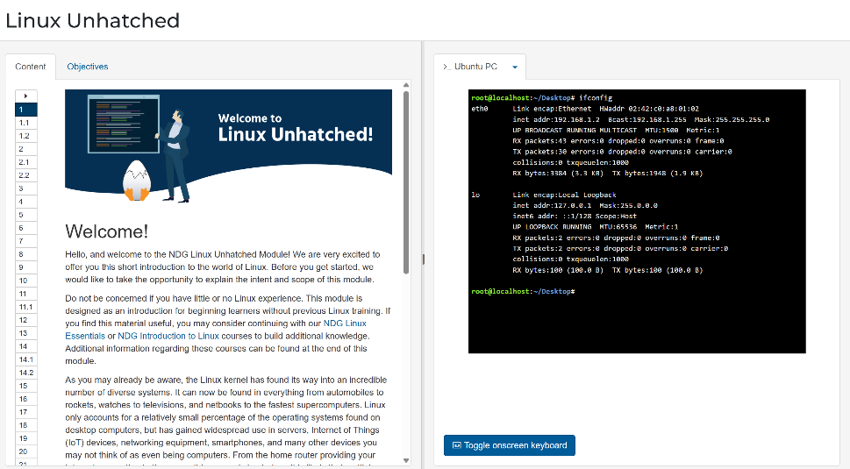
Figure 24: ifconfig

Example 10:
Explain the command and output.
The whoami command displays the username of the currently logged-in user. The output shows sysadmin, confirming at active account. The date command displays the current system date and time.
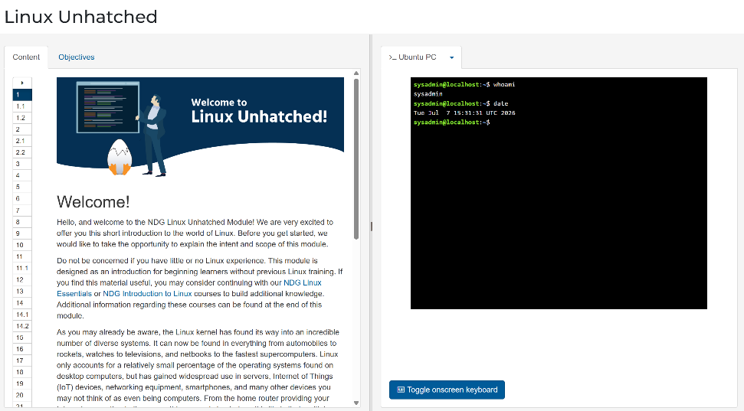
Figure 25: whoami

Use of Windows OS scripts
Batch scripting is a method of automating tasks in windows using text files with a .bat or .cmd extension. Batch scripts execute a series of a command prompt command automatically, reducing manual effort and improving efficiency. They are commonly used for file management, system maintenance, software installation, backups, and network administration.

Example 1:
This batch script is a simple windows program that performs an addition calculation using user input. The first command, @echo off, is used to prevent commands from being displayed on the screen while the script runs, this makes the output cleaner and easier for the user to read.
The next two commands use set /p to request input from this user. The script first asks the user to enter the first number and stores it in a variable called number1. It then asks for a second number and stores the value in number2.
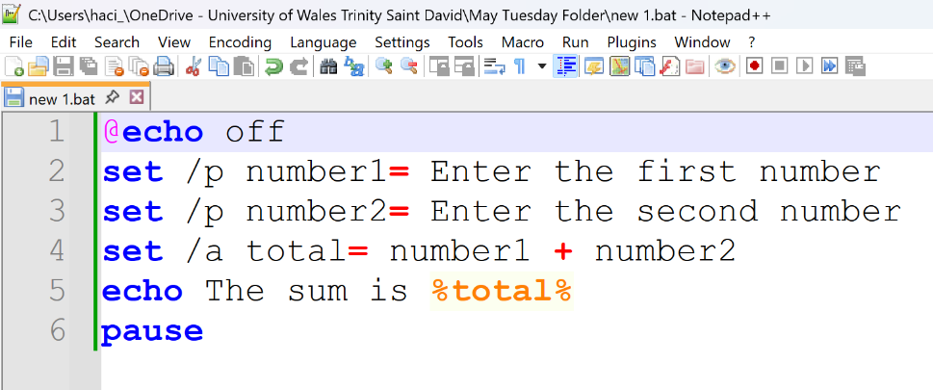
Figure 26: /p number1

The output shows that the batch script ran successfully, but no numbers were entered when prompted. The script first asked for the first number and then the second number. Since both inputs were left blank, the variables number1 and number2 had no values. During the calculation, windows treated the empty values as 0, so the result displayed was “The sum is 0.”
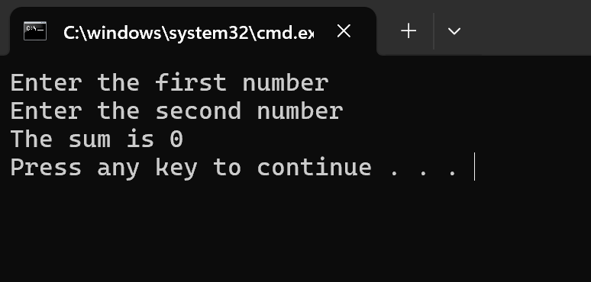
Figure 27: calculation

Example 2:
Explain the script and output.
This batch script is used to check if a person is olds enough to vote. It asks the user to enter their age and then compares the age with 18. If the age is 18 or greater, the script displays a message saying that the person is eligible to vote. If the age is less than 18, it displays a message saying that the person is not eligible to vote yet.
The command @echo off hides the commands from the appearing on the screen and makes the output look cleaner. The command set /p age=enter your age: asks the user to enter an age and stores the value in a variable called age. The if %age% geq 18 statement checks whether the entered age is greater than or equal to 18. The word geq means “greater than or equal to.”
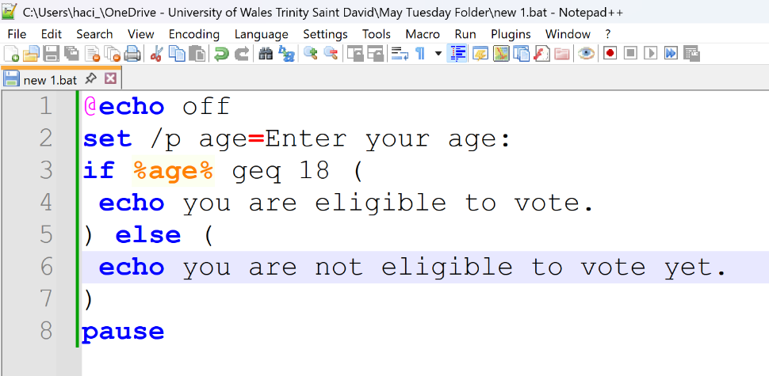
Figure 28: /p age
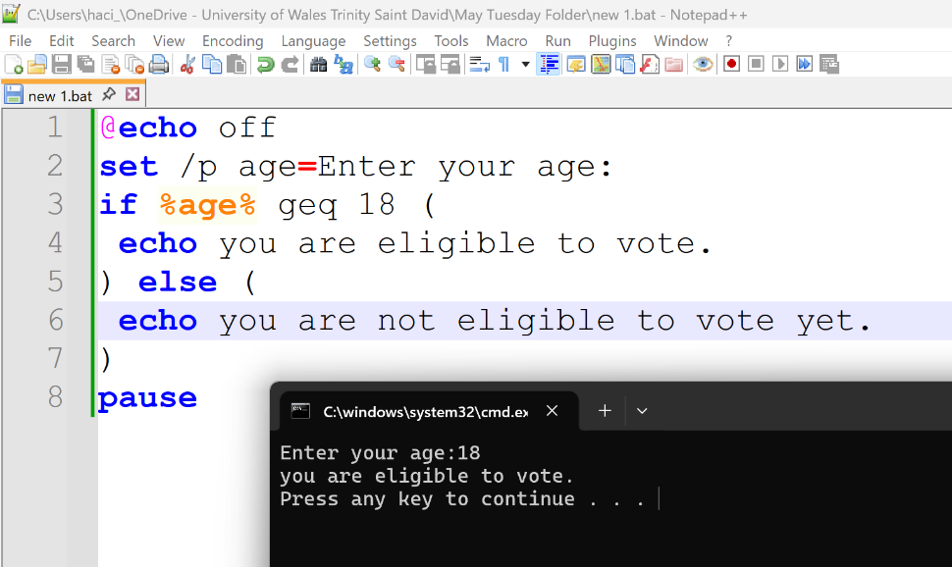
Figure 29: script and output

Use of Linux OS scripts
Write about BASH scripting and its applications.
BASH scripting is a way of automating tasks in Linux using script files that contain a series of commands. BASH scripts help users perform repetitive tasks quickly and efficiently. They are commonly used for file management, system administration, software installation, backups, process monitoring, and task scheduling [10].

Example 1:
This Bash is a simple program that calculates the sum of two numbers entered by the user. It is designed to help beginners understand basic Linux shell scripting concepts such as input, output, variables, and arithmetic operations.
First, the script uses the echo command to display the message “Enter the first number” on the screen. The read command then waits for the user to type a number and stores it in the variable num1.
Next, the script displays another message asking for the second number. The user enters a value, and the read command stores it in a variable num2.
Overall, this script is a simple example of how Bash scripts can interact with users and process data. It is commonly used as a beginner exercise because it introduces key programming concepts such as variables, input handling, calculations, and output in a clear and easy to understand way.
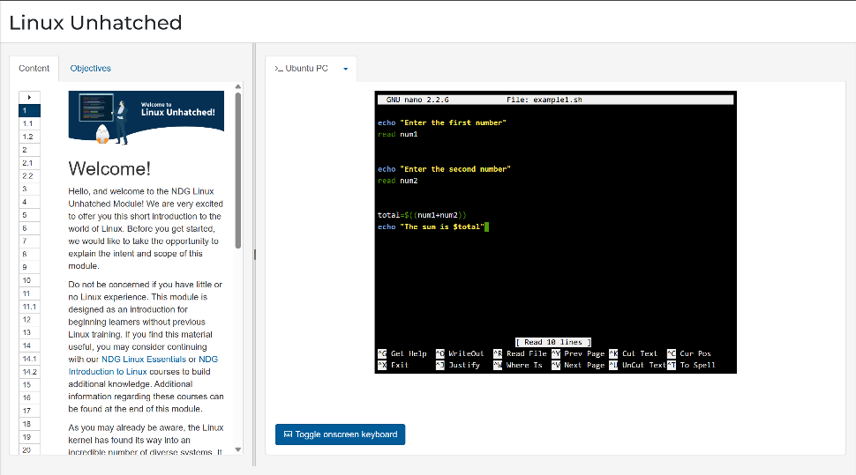
Figure 30: example1.sh
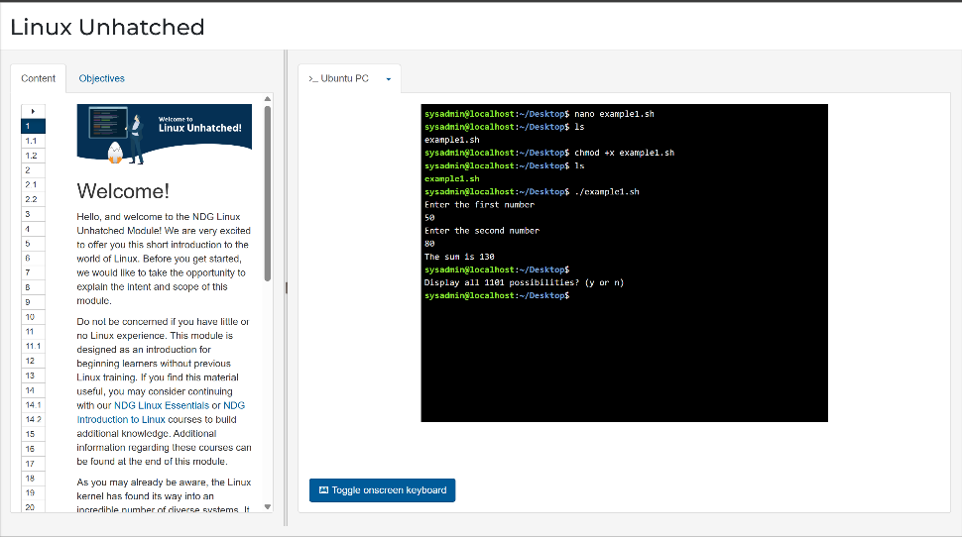
Figure 31: nano example.sh

Example 2:
This Bash script demonstrates the use of a for loop in Linux shell scripting. The script first asks the user, “How many times you want to run”, using the echo command. The user’s response is then stored in the variable count using the read command. This value determines how many times the loop will execute.
The lip starts by setting the variable I to 1. During each iteration, the condition i<=count is checked. As long as the condition remains true, the loop continues to run. After each interaction, the value of I is increased by 1 using i++.
This script is useful for understanding how loops work in Bash and how repetitive tasks can be automated using iteration. It introduces concepts such as loop control, counters, user input, and output display, which are fundamental skills in Linux shell scripting. The example clearly shows how a program can repeat an action a specifies number of times based on user input.
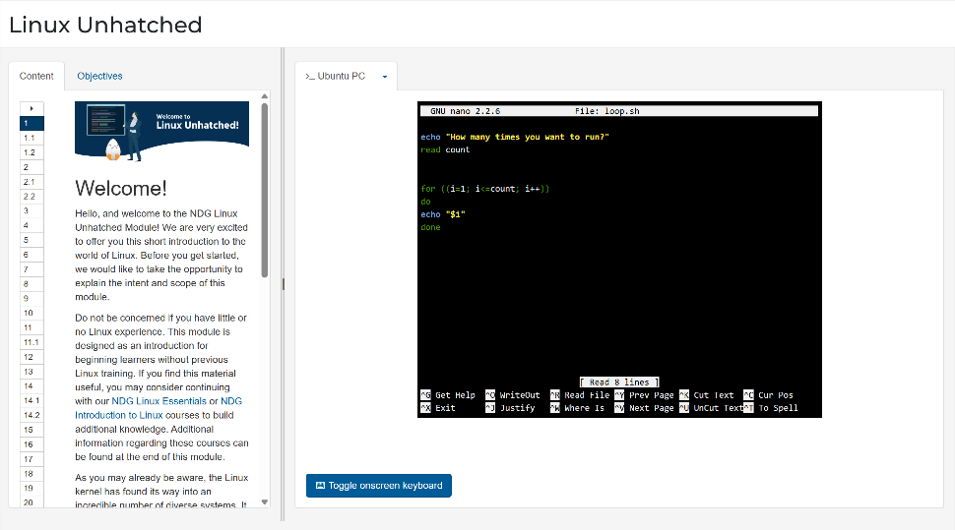
Figure 32: loop.sh
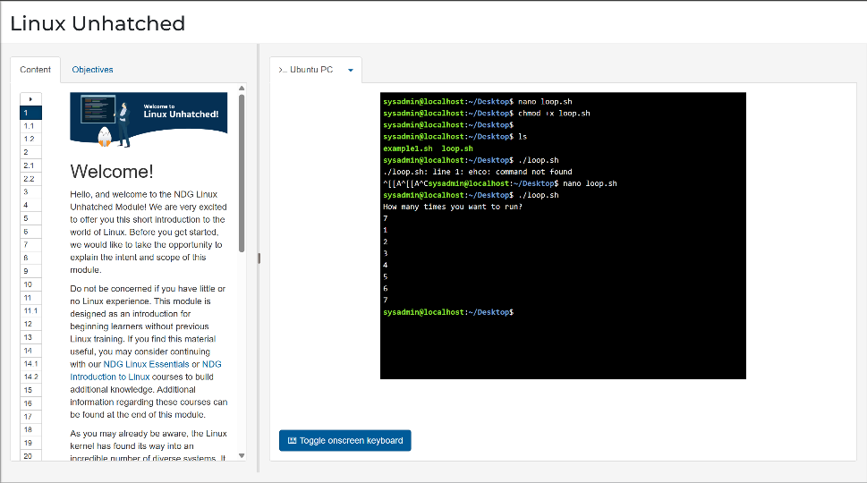
Figure 33: nano loop.sh

Conclusion
Summarize the report and your understanding of these tasks.
This assignment looked at the problems students face with deadlines, time management, and group work. A university app was suggested to help students stay organised by using reminders, timetables, secure login, and meeting scheduling. The flow chart showed a simple wat to arrange group meetings and solve scheduling conflicts.

References

[1] Microsoft, “Windows Operating System Overview,” Microsoft Learn, 2024.
[2] Microsoft, “Windows Operating System Overview,” Microsoft Learn, 2024.
[3] Microsoft, “Task Manager for Windows 10,” Microsoft Support, 2023.
[4] C. Hoffman, “How to Use the Windows Task Manager,” How-To Geek, 2022.
[5] Microsoft, “Manage apps,” Microsoft Learn.
[6] Microsoft, “Application management overview for Windows,” Microsoft Learn, 2023.
[7] Microsoft, “Work with files and folders in Windows,” Microsoft Support, 2024.
[8] Microsoft, “Using Device Manager to update drivers,” Microsoft Support, 2024.
[9] Microsoft, “Windows Security: Protect your device,” Microsoft Support, 2024.

Appendices
Online Course name: Linux Unhatched

Figure 34: Certificate of completion

