Slide 1:
1920269
Congeita Clarke-Young
Psychology for Health and Social Care
BMHP4019_BIRM
Tutor: Rebecca Kavanagh.

“A Child’s experience between the ages of 0 – 5 years can affect the rest of their lives.”

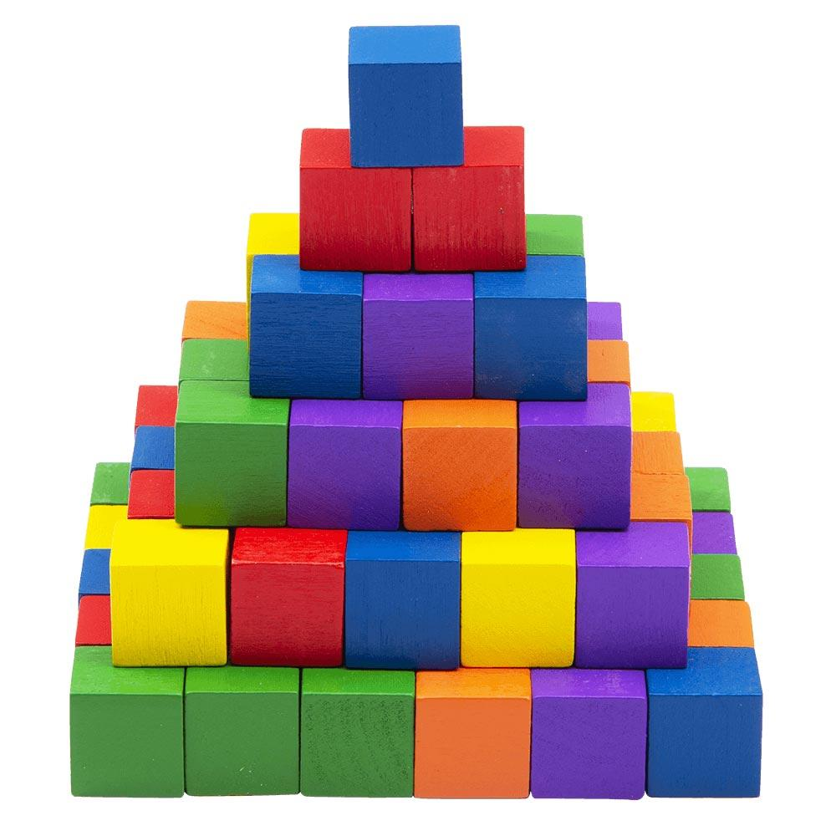
(Jacques London, 2021)

Slide 2: Main ideas and approaches of two theories of child development

I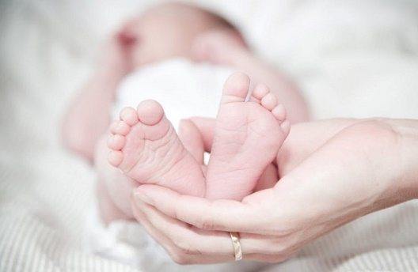
(iCapture Ltd, 2019)

1. Sociocultural Theory.
Lev Vygotsky (1934)
- Comprises of social & cultural factors.
Social factor beliefs:
- Understanding is built in steps over time
- Social interaction is a fundamental aspect
- All understanding is socially constructed (social constructivism).
Key concepts:
- Biological development and cultural experience affect children’s ability to learn.
- Each social contact is critical to intellectual development.
Implication:
- Children should be given opportunities for frequent social interaction to develop socially and cognitively (Cherry, 2020).
The main concept of Vygotsky’s theory is that as a child develops, they reach positions where learning cannot continue without help to progress (‘scaffolding’). In practice this theory emphasizes social element of play, learning and development and the significance of adult-led and child-initiated play (Professional Association for Childcare and Early Years, 2016).

Slide 3: Main ideas and approaches of two theories of child development
2. Psychosocial Theory
Erik Erikson – (1940s to 1960s)
- Describes 8 psychosocial developmental phases from birth to death.
First 3 stages relevant here:
1. learning to trust - first year of child’s life &
2. personal control – toddler years
3. self-initiative - three and five.
- Each phase is a conflict that the child must overcome.
- How parents or society react to the child (in each stage) defines if they
- Overcome the conflict or fail.
Key concepts:
- Personality develops in stages
- Each phase includes a distinctive psychological crisis.
- If the crisis is met positively the child develops normally.
Implication:
- Parents must understand and be receptive to children’s needs at
each development stage, giving support through crises (Cherry, 2020).
The main concept of Erikson’s theory is that personality develops in psychosocial phases across the whole life span including a distinctive psychological crisis at each phase that if responded to positively results in normal child development. Therefore, parents demonstrating encouraging reactions are critical for heathy child development (Cherry, 2020).

Slide 4: References
Cherry, K. (2020) Child Development Theories and Examples [Online]. Available at: https://www.verywellmind.com/child-development-theories-2795068 (Accessed 07 November 2021).
Children’s Bureau (2021) Child development stages: Ages 1-5 the early years [Online]. Available at: https://www.all4kids.org/news/blog/why-the-first-5-years-of-child-development-are-so-important/ (Accessed 8 November 2021).
iCapture Ltd (2019) Child’s development:0-5 years [Image], Available at: https://capture-education.co.uk/product/child-development-0-5-years/ (Accessed: 30 November 2021).
GoodToKnow (2021) Child development stages: ages 1-5 child development stages: Age one https://www.goodto.com/family/child-development-stages-ages-1-5-4829 (Accessed 07 November 2021).
Jacques London (2021), Small Wooden Blocks - Construction Cubes for Kids Creativity through Construction, [image], Available at: https://www.jaqueslondon.co.uk/products/lets-play-junior-building-blocks# (Accessed 30 November 2021).
McLeod, S. A. (2019) What is he one of proximal development? [Online]. Available at: https://www.simplypsychology.orgor/Zone-of-Proximal-Development.html (Accessed 30 November 2021).
Professional Association for Childcare and Early Years (PACEY), (2016) Theories of child development: A practice guide to help you understand theories of child development and their influence on early years practice [Online]. Available at: https://www.pacey.org.uk/Pacey/media/Website-files/PACEY%20member%20practice%20guides%20(PDFs)/PG28-Theories-of-child-development.pdf (Accessed 07 November 2021).
Verywell Mind. (2021) Erikson's Psychosocial Developmental Theory Erikson's Psychosocial Developmental Theory [Online]. Available at: https://www.verywellmind.com/child-development-theories-279506 8 (Accessed 07 November 2021).

Annotated Bibliography.
Cherry, K. (2020) Child Development Theories and Examples [Online]. Available at: https://www.verywellmind.com/child-development-theories-2795068 (Accessed 07 November 2021).
This source summarises the major development theories to help explore and explain various aspects of child development. Even though some of these theories nowadays are only partially acknowledged, they have all had a substantial influence on our understanding of child development. To fully understand how children change and develop over their lifetime current psychologists use several theorist’s views to provide different viewpoints on the factors impacting child development, for example, interactions between genetics and environment regulate how children develop physically and cognitively (Cherry, 2020).
Children’s Bureau (2021) Child development stages: Ages 1-5 the early years [Blog] [Online]. Available at: https://www.all4kids.org/news/blog/why-the-first-5-years-of-child-development-are-so-important/ (Accessed 8 November 2021).
Information within this blog focused on a child’s development and the milestones that define the abilities most children can perform at a young age, for example, learning insight into self-movement, learning how to touch and hold things and put objects in their mouths. These development steps are normally achieved before a child reaches the age of one year old. Although only a blog and not a peer reviewed it was however very interesting and informative with some hands on, practical facts for parents and carers. It discussed how within the first stage of development most parents develop close bonds and trust with their baby, then after their first birthday there is a new important focus on supporting them to achieve the milestones ahead of them.
GoodToKnow (2021) Child development stages: ages 1-5 child development stages: Age one https://www.goodto.com/family/child-development-stages-ages-1-5-4829 (Accessed 07 November 2021).
This article focuses on a parents support towards their child and physical and mental development. I chose this website, as although it is only a platform for some of the United Kingdom’s best lifestyle magazines, writing about articles that might be of interest to its mostly female readers, many of them mothers. It discusses in an easy-to-read informal manner the different developmental phases/milestones that children go through and the importance of parents being aware of these milestones and the age they occur, and the pace babies and small children go through these phases in these early years to better understand and support their child in the important and influential early stages from the first months of bonding to toddler years and ages 3 and 5 years.
iCapture Ltd (2019), Child’s development:0-5 years, [Image], [Online]. Available at: https://capture-education.co.uk/product/child-development-0-5-years/ (Accessed: 30 November 2021).
Looking at this image of a mother figure holding a tiny baby in her hands is the first part of life that a baby knows when they come into the world. These are the first steps of life that helps you as parents how to build and understand why it is important for a mother and her new-born to have a connection from birth. That emotional, caring and loving bond starts to develop between a mother and her new-born from birth. It is essential as a parent that your baby learns by the smell of their mother, also by touch, breast feeding and listening to their mother’s voice. These factors are very important for the mother to develop a special bond of closeness with their baby and for them to develop normally.

Jacques London (2021), Small Wooden Blocks - Construction Cubes for Kids Creativity through Construction, [image], Available at: https://www.jaqueslondon.co.uk/products/lets-play-junior-building-blocks#, (Accessed 30 November 2021).

This image of building blocks represents a child’s developmental stages from 0-2 years. This form of play helps parents to understand the concepts of visual learning, demonstrated through interactive adult-led play how building blocks can be used to build and learn about shapes, different colour codes and this play can also help with teaching young children how to count. These blocks are namely for what children would use at this age. This image is useful to demonstrate to parents that building blocks are a useful tool for early years’ stage learning for a child from 0-2 years. Looking at this from my own perspective, this encourages the child to focus on learning colours, different shapes with the interactive support from parents makes bonding more interesting for them and their child

McLeod, S. A. (2019) What is he one of proximal development? [Online]. Available at: https://www.simplypsychology.orgor/Zone-of-Proximal-Development.html (Accessed 30 November 2021).

The rationale for using McLeod’s account (article) of proximal development is because it examines the reasons how and why Vygotsky’s sociocultural theory infers that in a child aged between 0-5 years, their culture, values and behaviours are all developed through social interaction – ‘zone of potential development’ with the role of the parent teacher. This idea makes sense when parents are developing a good relationship with their child though play and communication and acting as tools for cognitive development. Social interacting represents good parent attitude towards their child’s development and teaching them from an early age will result in positive learning and development outcomes for the child. A parent’s perspective should always be focused on teaching and giving positive encouragement to their child, making sure the right decisions are made for both.

Professional Association for Childcare and Early Years (PACEY), (2016) Theories of child development: A practice guide to help you understand theories of child development and their influence on early years practice [Online]. Available at: https://www.pacey.org.uk/Pacey/media/Website-files/PACEY%20member%20practice%20guides%20(PDFs)/PG28-Theories-of-child-development.pdf (Accessed 07 November 2021).

This source was clear and concisely written with practical examples to highlight Vygotsky’s theory in action and how to help to understand theories of child development and their impact on early years practice, supporting children to develop through child-led and adult-led social interaction. The paper also had a full Harvard reference list for reference. The Professional Association for Childcare and Early Years (PACEY), (2016). PACEY (2016) was formed in 1977 and are a charity supporting anyone working in childcare and early years with quality care and early learning for children and families. It also provides training and practical help/expert advice to parents, practitioners and carers working in early learning in England and Wales support the vital role practitioners play in helping prepare children for a productive future.

Very well Mind. (2021) Erikson's Psychosocial Developmental Theory Erikson's Psychosocial Developmental Theory [Online]. Available at: https://www.verywellmind.com/child-development-theories-279506 (Accessed 07 November 2021).

This paper summarises Erikson's theory of psychosocial development and how like Freud, Erikson believed personality development was sequential. Erikson's theory however described the impact of social experience across the lifespan, and he was interested in how social interaction and relationships informed the individual development (Verywell Mind, 2021). Verywell Mind (2021) content is for informational and educational purpose only and the website is not intended to be a substitute for professional medical advice, diagnosis, or treatment. Nevertheless, to achieve credibility all articles submitted for publication are medially review for content and misinformation by individuals with PhDs. It is important to remember that the psychosocial stages are just one theory of personality development. It is useful though to think about the difference challenges that individuals experience as they go through life

