Portfolio 1: Brief

Student： Zeyu Xie
Student ID: 2400706
Time: 29/09/2025

Task 1: Network Test
S-DC
GOAL: Run the following commands and verify the outputs:
ü IPCONFIG /ALL: Confirm the IP address matches the topology provided.
ü ping 192.168.1.10: Must be successful.
ü ping 192.168.2.1: Must be successful.

Experimental screenshot：
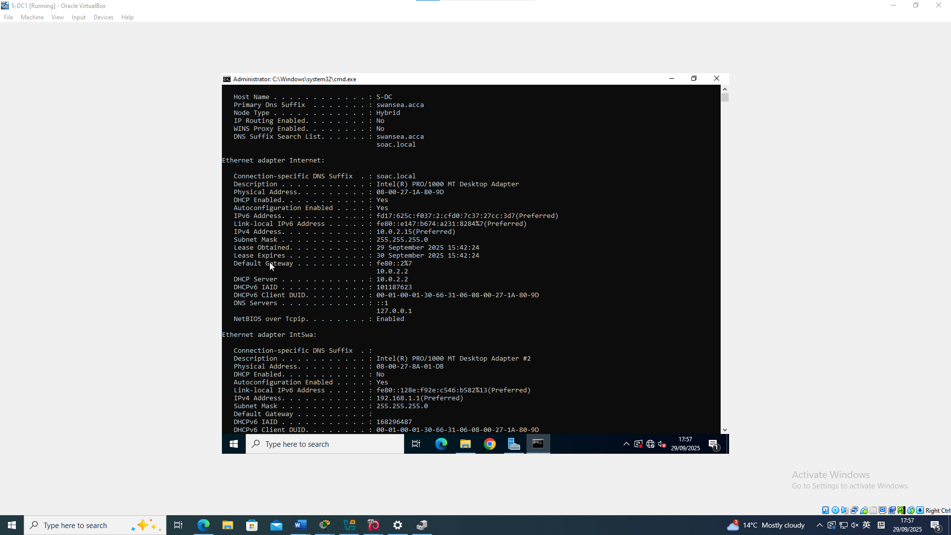

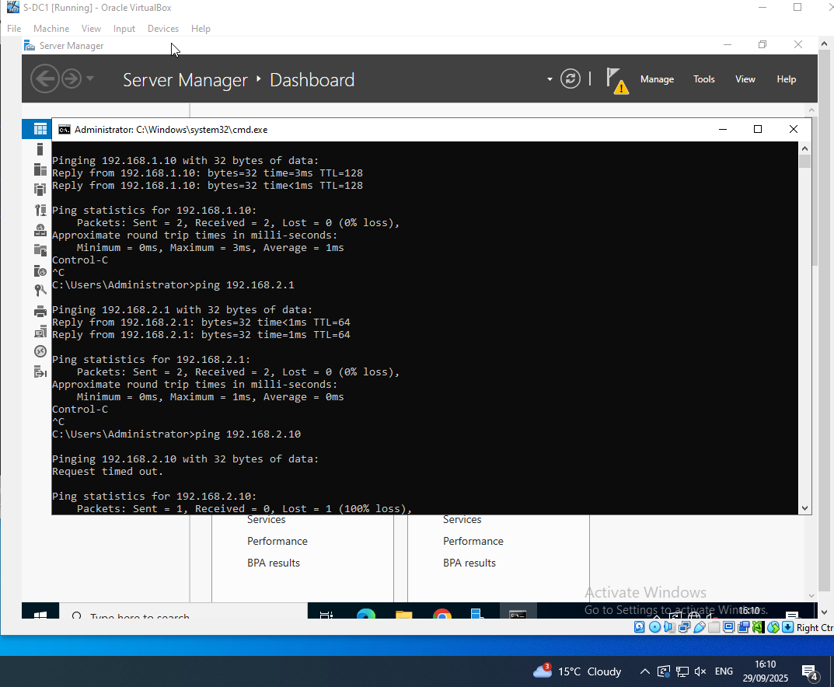

Experimental results：
Achieve the goal in accordance with the experimental requirements.

L-CD
GOAL:Run the following commands and verify the outputs:
ü ip address: Confirm the IP address matches the topology provided.
ü ping 192.168.1.10: Must be successful.
ü ping 192.168.1.1: Must be successful.

Experimental screenshot：
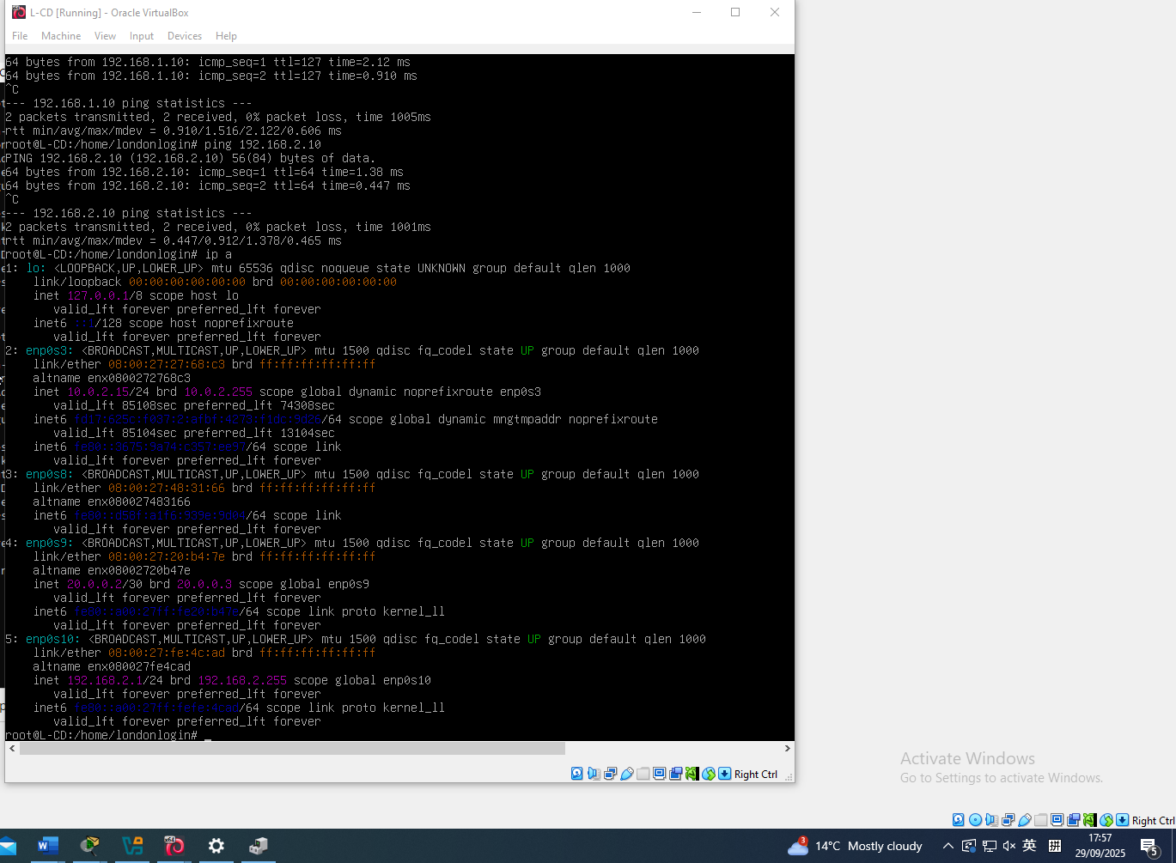

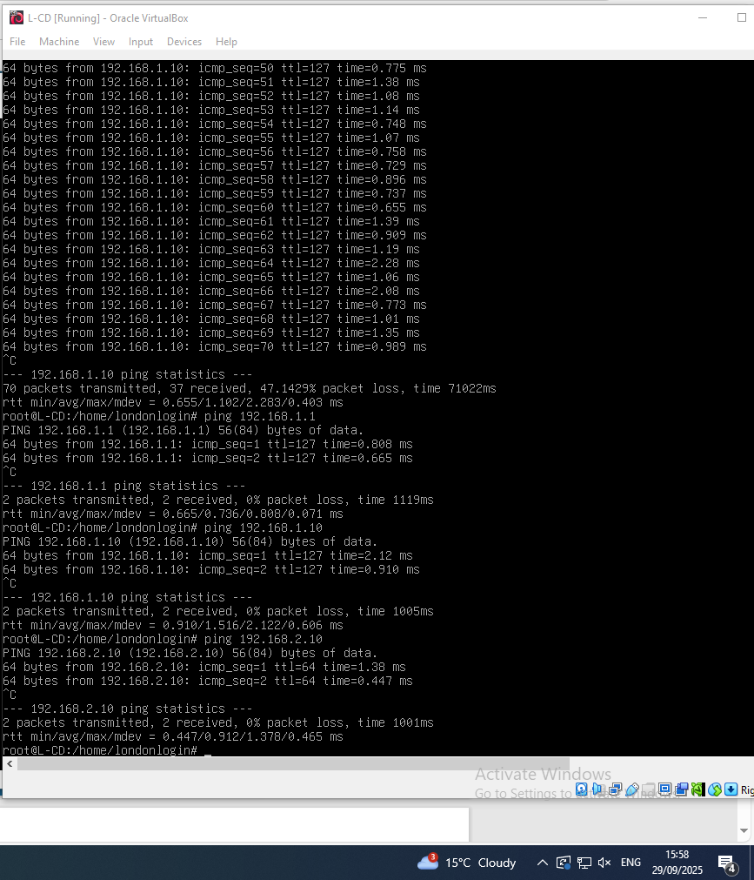

Experimental results：
Achieve the goal in accordance with the experimental requirements.

