Poster for Managers – Recommendations
  - Natalie Mills – 1451133
Word Count 910
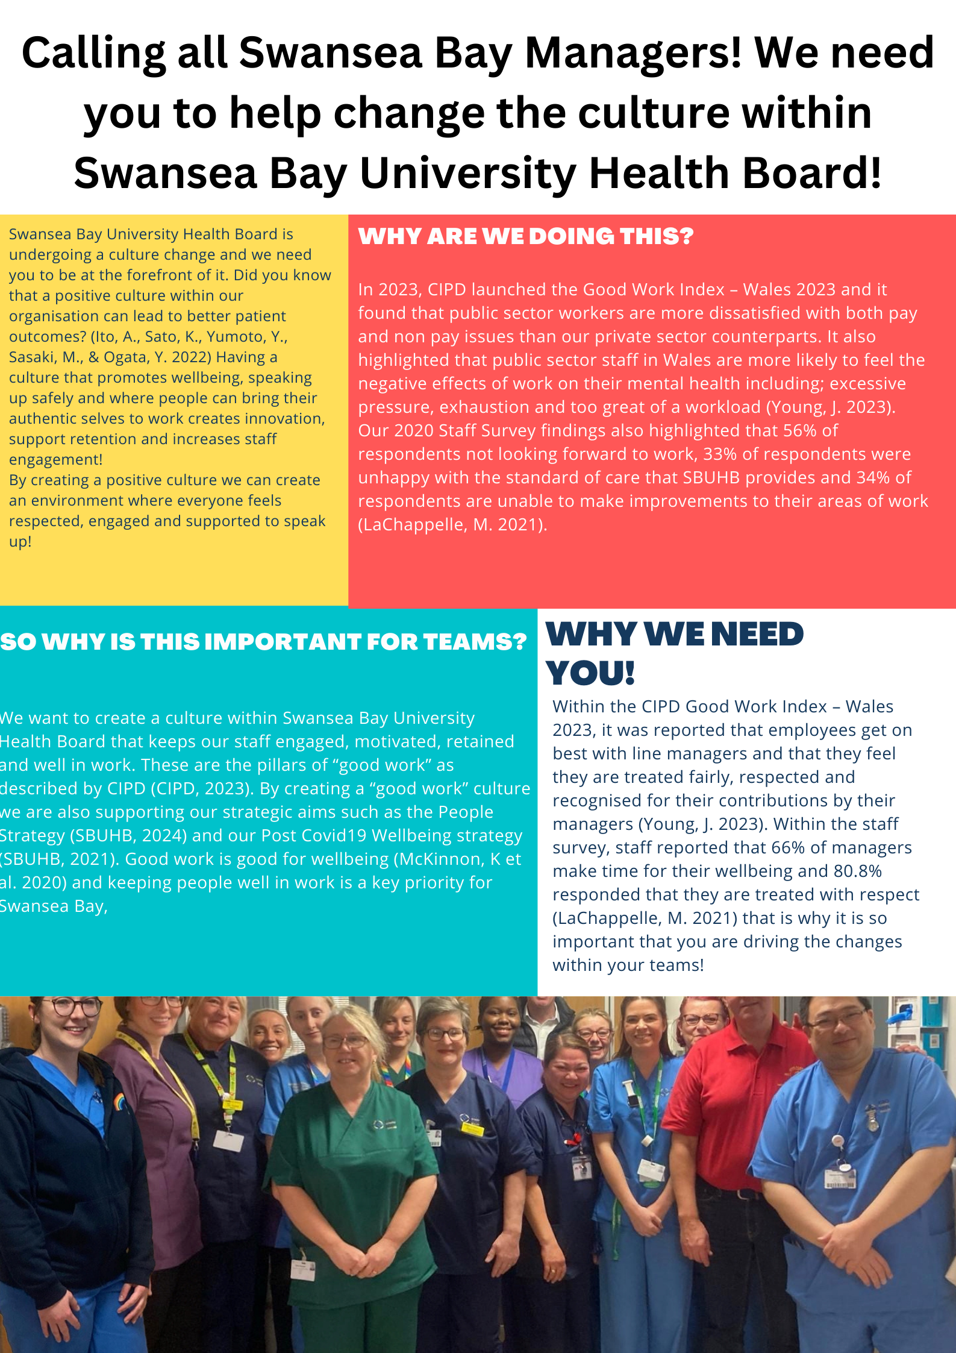
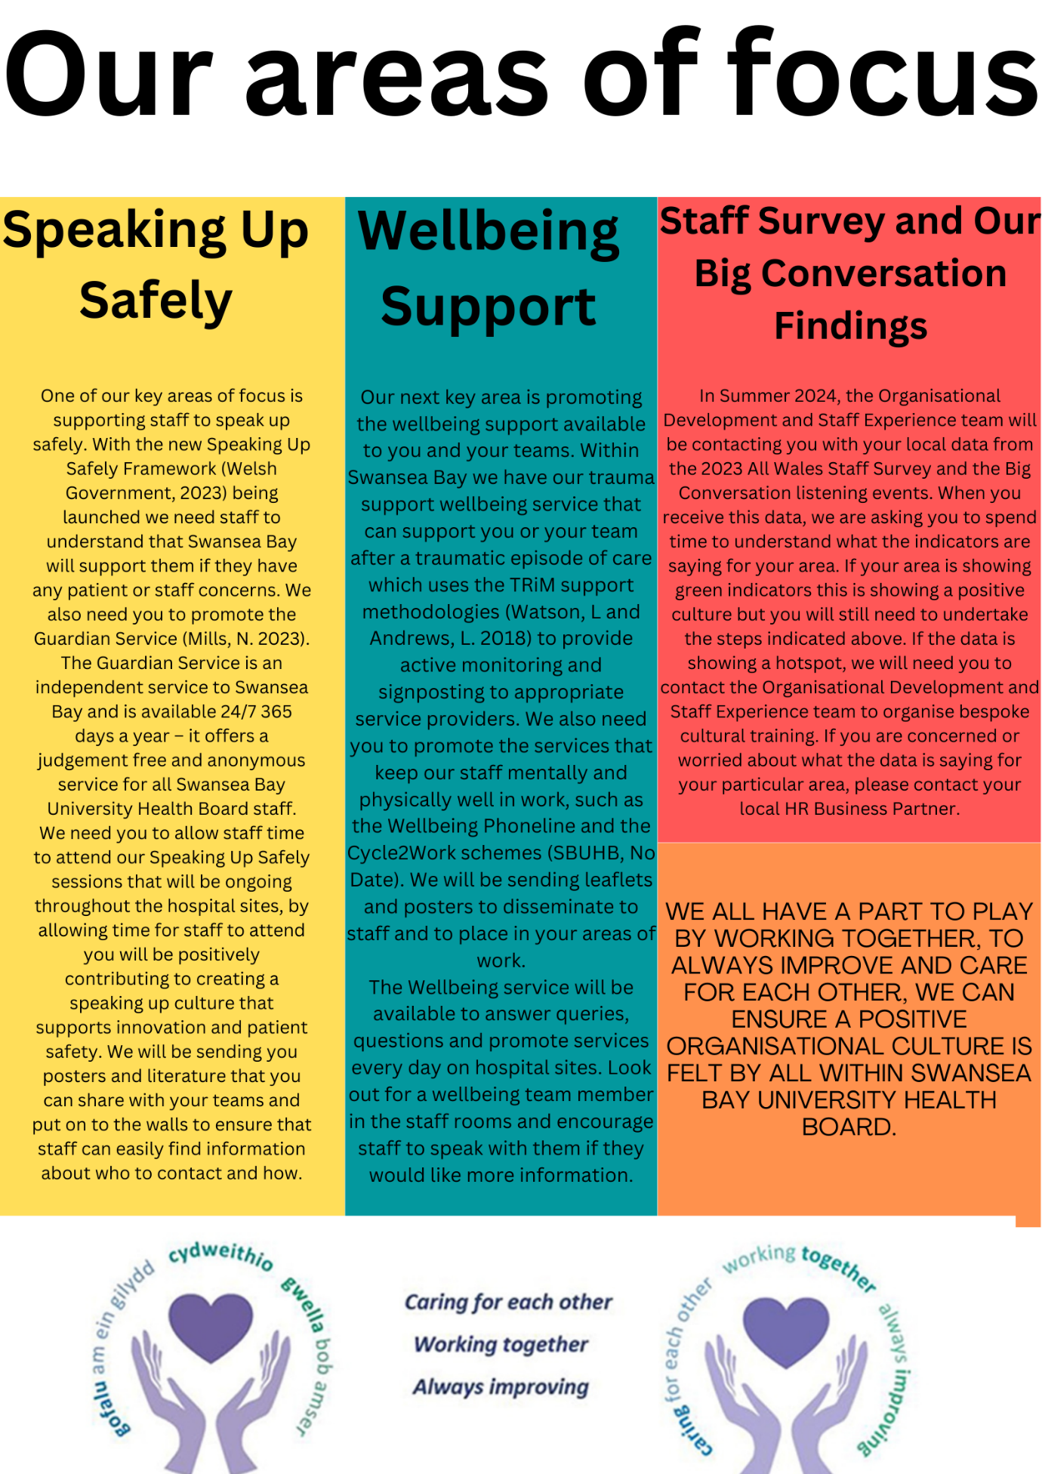

Notes from Poster
Calling all Swansea Bay Managers! We need you to help change the culture within Swansea Bay University Health Board!
Swansea Bay University Health Board is undergoing a culture change and we need you to be at the forefront of it.
Did you know that a positive culture within our organisation can lead to better patient outcomes? (Ito, A., Sato, K., Yumoto, Y., Sasaki, M., & Ogata, Y. 2022) Having a culture that promotes wellbeing, speaking up safely and where people can bring their authentic selves to work creates innovation, support retention and increases staff engagement!
By creating a positive culture we can create an environment where everyone feels respected, engaged and supported to speak up!
Why are we doing this?
In 2023, CIPD launched the Good Work Index – Wales 2023 and it found that public sector workers are more dissatisfied with both pay and non pay issues than our private sector counterparts. It also highlighted that public sector staff in Wales are more likely to feel the negative effects of work on their mental health including; excessive pressure, exhaustion and too great of a workload (Young, J. 2023). Our 2020 Staff Survey findings also highlighted that 56% of respondents not looking forward to work, 33% of respondents were unhappy with the standard of care that SBUHB provides and 34% of respondents are unable to make improvements to their areas of work (LaChappelle, M. 2021).
Why we need you!
Within the CIPD Good Work Index – Wales 2023, it was reported that employees get on best with line managers and that they feel they are treated fairly, respected and recognised for their contributions by their managers (Young, J. 2023). Within the staff survey, staff reported that 66% of managers make time for their wellbeing and 80.8% responded that they are treated with respect (LaChappelle, M. 2021) that is why it is so important that you are driving the changes within your teams!
So why is this important for teams?
We want to create a culture within Swansea Bay University Health Board that keeps our staff engaged, motivated, retained and well in work. These are the pillars of “good work” as described by CIPD (CIPD, 2023). By creating a “good work” culture we are also supporting our strategic aims such as the People Strategy (SBUHB, 2024) and our Post Covid19 Wellbeing strategy (SBUHB, 2021). Good work is good for wellbeing (McKinnon, K et al. 2020) and keeping people well in work is a key priority for Swansea Bay,

Figure 1 SBUHB Staff (SBUHB, 2023)
Our areas of focus:
Speaking Up Safely
One of our key areas of focus is supporting staff to speak up safely. With the new Speaking Up Safely Framework (Welsh Government, 2023) being launched we need staff to understand that Swansea Bay will support them if they have any patient or staff concerns. We also need you to promote the Guardian Service (Mills, N. 2023). The Guardian Service is an independent service to Swansea Bay and is available 24/7 365 days a year – it offers a judgement free and anonymous service for all Swansea Bay University Health Board staff.
We need you to allow staff time to attend our Speaking Up Safely sessions that will be ongoing throughout the hospital sites, by allowing time for staff to attend you will be positively contributing to creating a speaking up culture that supports innovation and patient safety. We will be sending you posters and literature that you can share with your teams and put on to the walls to ensure that staff can easily find information about who to contact and how.
Wellbeing Support:
Our next key area is promoting the wellbeing support available to you and your teams. Within Swansea Bay we have our trauma support wellbeing service that can support you or your team after a traumatic episode of care which uses the TRiM support methodologies (Watson, L and Andrews, L. 2018) to provide active monitoring and signposting to appropriate service providers. We also need you to promote the services that keep our staff mentally and physically well in work, such as the Wellbeing Phoneline and the Cycle2Work schemes (SBUHB, No Date). We will be sending leaflets and posters to disseminate to staff and to place in your areas of work.
The Wellbeing service will be available to answer queries, questions and promote services every day on hospital sites. Look out for a wellbeing team member in the staff rooms and encourage staff to speak with them if they would like more information.
Staff Survey and Our Big Conversation Findings:
In Summer 2024, the Organisational Development and Staff Experience team will be contacting you with your local data from the 2023 All Wales Staff Survey and the Big Conversation listening events. When you receive this data, we are asking you to spend time to understand what the indicators are saying for your area. If your area is showing green indicators this is showing a positive culture but you will still need to undertake the steps indicated above. If the data is showing a hotspot, we will need you to contact the Organisational Development and Staff Experience team to organise bespoke cultural training. If you are concerned or worried about what the data is saying for your particular area, please contact your local HR Business Partner.
We all have a part to play by working together, to always improve and care for each other, we can ensure a positive organisational culture is felt by all within Swansea Bay University Health Board.

References
CIPD (2023) CIPD Good Work Index. Available at: URL https://www.cipd.org/uk/knowledge/reports/goodwork/#:~:text=CIPD%20view%20on%20good%20work,to%20securely%20make%20a%20living (Accessed: 11.02.2024).

Hall, L.H. et al. (2016) “Healthcare Staff Wellbeing, Burnout, and Patient Safety: A Systematic Review,” PloS one, 11(7), pp. e0159015–e0159015. Available at: https://doi.org/10.1371/journal.pone.0159015.
Ito, A., Sato, K., Yumoto, Y., Sasaki, M., & Ogata, Y. (2022). A concept analysis of psychological safety: Further understanding for application to health care. Nursing Open, 9, 467–489. https://doi.org/10.1002/nop2.1086
LaChappelle, M (2021) All Wales NHS Staff Survey 2020 - Findings. Swansea: Swansea Bay University Health Board. Available at: URLhttps://sbuhb.nhs.wales/about-us/key-documents-folder/board-papers/january-2021-health-board/2-4-nhs-staff-survey-and-appendices-pdf/ (Accessed: 10.02.2024).
McKinnon, K. et al. (2020) “Is being in work good for wellbeing? Work Integration Social Enterprises in regional Australia,” Australian geographer, 51(3), pp. 361–375. Available at: https://doi.org/10.1080/00049182.2020.1781322.
Mills, N. (2023) Guardian Service - Annual Update. Swansea Bay University Health Board. Unpublished.
Murray, J.S., Kelly, S. and Hanover, C. (2022) “Promoting Psychological Safety in Healthcare Organizations,” Military medicine, 187(7–8), pp. 808–810. Available at: https://doi.org/10.1093/milmed/usac041.
SBUHB (no date) Wellbeing Support. Available at: URL https://sbuhb.nhs.wales/about-us/staff-info/occupational-health-staff-wellbeing-service/ (Accessed: 15.02.2024).
SBUHB (2021) Post Covid 19 Wellbeing Strategy. Swansea Bay University Health Board Available at: URL https://sbuhb.nhs.wales/about-us/key-documents-folder/workforce-and-od-committee-papers/workforce-and-od-committee-papers-august-2021/4-3-appendix-1-pdf/. (Accessed: 14.02.2024).
SBUHB. (2023) 'Charitable Donation to Ward' [Twitter] 08.02.2024. Available at: URL https://twitter.com/SwanseabayNHS/status/1755667823186375157 (Accessed: 11.02.2024).
SBUHB (2024) People Strategy. Swansea Bay University Health Board Available at: URL https://sbuhb.nhs.wales/about-us/key-documents-folder/board-papers/health-board-november-2023/4-3-appendix-1-pdf/#:~:text=Our%20people%20strategy%20aligns%20to,health%20system%20for%20our%20communities.&text=Our%20strategy%20is%20also%20aligned,facing%20challenges%20and%20changes%20ahead. (Accessed: 14.02.2024).
Watson, L. and Andrews, L. (2018) “The Effect of a Trauma Risk Management (TRiM) Program on Stigma and Barriers to Help-Seeking in the Police,” International journal of stress management, 25(4), pp. 348–356. Available at: https://doi.org/10.1037/str0000071.
Welsh Government (2023) Speaking Up Safely Framework. Welsh Government Available at: URL https://www.gov.wales/nhs-wales-speaking-safely-framework. (Accessed: 14.02.2024).
Young, J (2023) CIPD Good Work Index 2023: Wales. London: Chartered Institute of Personnel and Development Available at: URL https://www.cipd.org/globalassets/media/knowledge/knowledge-hub/reports/2023-pdfs/2023-cipd-good-work-index-wales-report-8407.pdf (Accessed: 01.02.24).

