Name – Mick Lowe (2434734)
Module title – Employability and Career development
Module Code – LCLM4005
Lecturer’s Name – Daminabo Pokubo
Assignment Title – Interview
Date – 12/02/2026

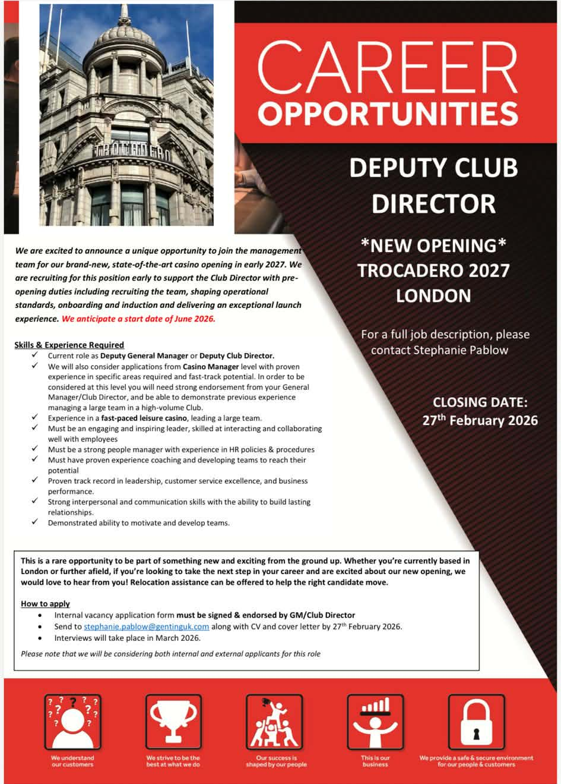
Michael Lowe
26 Pendigo Way
Birmingham, B4 QRS
07775 938 886
2434734@student.uwtsd.ac.uk
12 February 2026
Hiring Manager
Trocadero Casino London
Dear Sir/ Madam,
I am writing to express my strong interest in the Deputy Club Director position for the new Trocadero Casino opening in 2027. With over 19 years’ experience in the gaming industry, including more than a decade in senior management within high-pressure, customer-focused casino environments, I offer a proven ability to lead large teams, deliver operational excellence, and maintain the highest standards of compliance, security, and guest experience.
In my current role as Casino Manager at Resorts World Casino Birmingham, I have played a key part in pre-opening recruitment and operational readiness while leading management teams overseeing more than 250 employees across multiple departments. My responsibilities include recruitment, coaching and development, rota planning, HR case management, compliance, and performance delivery within a high-risk cash environment. I work closely with senior leadership to exceed commercial targets while ensuring strict regulatory and brand standards are consistently maintained.
A significant career achievement includes designing and delivering a UK-wide staff engagement event attended by over 1,800 employees, which became the most successful internal event in the organisation. I was also honoured to receive the Excellence in Leadership Award in 2025, recognising my commitment to people development, culture, and operational performance.
Earlier in my career, I progressed rapidly through multiple operational roles at Broadway Casino, gaining strong hands-on experience in floor management, compliance, cash control, and customer resolution. This foundation, combined with my senior leadership experience and current business degree studies at the University of Wales Trinity Saint David, positions me well to support a successful pre-opening phase and contribute to building a high-performing leadership culture at Trocadero.
I am highly motivated by the opportunity to contribute to a flagship London opening and confident that my experience in recruitment, operational readiness, leadership development, and customer-focused delivery would enable me to add immediate value. I would welcome the opportunity to discuss how my background and leadership approach align with your vision for Trocadero 2027.
Thank you for your time and consideration. I look forward to hearing from you.
Yours sincerely,
Michael Lowe

MICHAEL LOWE
26 Pendigo way
Birmingham, B4 QRS
Phone number: 07775 938 886
Email: 2434734@student.uwtsd.ac.uk

PROFESSIONAL PROFILE
I have worked in the Gaming industry for 19+ years with being a results-driven casino manager with over 10 years’ experience in high-pressure, customer-focused environments. Proven track record of leading large teams, delivering operational excellence, maintaining strict compliance standards, and improving commercial performance.

KEY STRENGTHS
- Multi-site & large-team leadership
- Performance & target delivery
- Operational & process improvement
- Compliance, audit & risk management
- Recruitment, training & staff development
- Customer experience & issue resolution
- Rota planning & workforce optimization

PROFESSIONAL EXPERIENCE

Casino Manager – Resorts World Casino Birmingham (2015–Present)
- Part of pre-opening leadership team supporting recruitment and operational readiness
- Led management teams overseeing over 250 employees across multiple departments
- Delivered high operational standards, compliance, and security in a high-risk cash environment
- Recruited, trained, coached, and developed high-performing teams
- Managed rotas, disciplinaries, investigations, and HR matters
- Worked with senior leadership to exceed targets and improve efficiency
- Maintained health & safety and brand standards across all areas
Key Achievements: Designed and delivered a UK-wide staff engagement event attracting over 1,800 employees, now the most successful internal event in the company.
Awarded the Excellence in Leadership Award 2025 as voted for by our employees in the group.

Junior Manager / Cashier / Door Supervisor (Security) – Broadway Casino (2nd time of work 2012–2015)
- Managed daily floor operations and staff deployment
- Monitored performance results, cash controls, and compliance
- Resolved customer escalations and operational issues
- Promoted three times within 14 months due to strong performance

Earlier Experience
Self-Employed Door Supervisor (2011–2012)
Croupier / Inspector – Grosvenor, Broadway & Gala Casinos (2006–2011)

EDUCATION
University of Wales Trinity Saint David (2025 - Present)
Business skills- Bachelor’s degree
Halesowen College (2004-2006)
BTEC National Diploma – IT Practitioner (2x Merit)
Langley High School (1999 – 2004)
GCSEs including Math’s (B), English (C), Science (C) & Engineering (Pass)

ADDITIONAL INFORMATION
- Strong interest in leadership development and continuous improvement
- Experienced in digital engagement and communication
- Flexible and open to multi-site responsibility and relocation

