
Programme: BA Business Management
Module: Management Economics
Assignment Title: Component 1
Coursework: Essay
Student Name: Yanislav Georgiev
Student ID: 2219323
Lecturer: Riaz Bhatti
Submission Date: 27/07/2024

Contents
Introduction 3
Discussion 4
Conclusion 10
Reference List 12
Appendix 15


Figure 1 https://atc.org.uk/wp-content/uploads/2021/02/Picture4-1.png

Introduction
Two of the most important events in the recent history of the UK are Brexit and the COVID-19 pandemic. These two impacts have significantly impacted the economy of the country. Different types of economic issues have been developed which are interrelated to each other. The process of every business has significantly changed due to the impact of these two events. The COVID-19 pandemic has significantly impacted the supply chain of the UK. Different problems such as staff shortage, inflation, and increased cost of living are affecting the population of the country. The following essay will look into the major economic problems of the UK during the time of the pandemic and will create various responses which will be able to address these problems. The primary focus of the essay will be on the issues of supply and demand.

Discussion
A major problem during the pandemic was the shortage of supply and the main reason was the shortage of drivers. After Brexit, many UK drivers left for different EU countries due to political unrest and unstable economic conditions in the UK. This was further escalated by the impact of the COVID-19 pandemic. The shortage of drivers heavily impacted the delivery services in the UK. Before Brexit and the pandemic, nearly 10% of the driver workforce in the UK was made up of EU nationals. The numbers drastically fell to -37% during March 2021 (Institute for Government, 2021). The two main drivers of this situation are post-Brexit immigration laws and strict lockdown rules during the COVID-19 pandemic. Staff shortage further increased during the pandemic period as 45% of the managers in the UK institutions reported that the staff were quitting their jobs voluntarily (Institute for Government, 2021). The job market of the UK noticed that nearly 394,000 people were inactive during the time of the pandemic, which represented nearly 1% of the workforce of the UK. Additionally, the staff absence rates were increased to 15% at that time. These are some of the primary reasons for the staff shortage in the UK. The government could not arrange more manpower and due to that the demands kept increasing whereas the supply shortage kept increasing. Another major reason behind this problem is disrupted vocational training for the new staff in the UK during the pandemic. Industries like logistics, meat processing and others were seeing an enormous shortage of skilled drivers since the trainings were closed during the pandemic. Brexit and the COVID-19 pandemic, both were the catalysts of these supply shortages, especially in the fuel stations. The daily news of supply shortage resulted in a panic among the customers who were rushing to fill their tanks. This furthermore increased the demand, increasing the supply shortage. This is one of the biggest examples of economic shortage within the country.

Figure 2 https://driverrequire.co.uk/news/item/brexit-covid-and-ir35-perfect-storm-to-hit-driver-recruitment
The economic problems related to energy and fuel sectors continued to grow in the UK for various reasons. Panic buying is one of them. Household consumption behaviour depends on several preferences such as external economic conditions and others (Aigner-Walder, 2015, p.34). Being a scarce resource, the panic buying of fuel disrupted the supply chain. Simultaneously the global gas prices were increased at the same time, resulting in the limited gas storage facilities in the UK increasing the prices, This rocketed the price increase of fuels and gas, which were at its peak during December 2021. Another major impact of the COVID-19 Pandemic is the rise of inflation. The disrupted supply chain increased the shortage of supply issue, helping inflation to rise in the UK. It resulted in the cost of living crisis within the country. In October 2021, the inflation hit 3.8%. This unstable economic condition was squeezing household income and resulting in competitive price discrimination which was remaining consistent with the market (Baker, 2003, p.643). Then issues in the supply chain were affecting the morale and confidence of the business leaders in the UK as well as the consumers. Despite the government’s energy price cap, consumers were suffering due to the rise in wholesale prices. From a business perspective, the Institute of Directors Economic Confidence Index saw a low investment during the financial year of 2021-2022.
The primary way to encounter the economic problems created due to the Brexit issue and the Covid-19 Pandemic is the interventions of the UK Government. To identify different ways to counter the ineffective performance of different industries, their previous performances need to be compared with the current ones. It can be done by looking into a firm’s ability to set prices under current and previous circumstances. To intervene, the Government of the UK first needs to upgrade its structure, communications and policies. Primarily a specific team should be developed to assess the depth of the current economic crisis. In this matter, the UK Government has already developed a National Economy Recovery Taskforce. Public communication should be upgraded with the help of frequent interviews and press conferences. For example- During the Conservative party conference, then Prime Minister Boris Johnson termed the post-Brexit time as a ‘Period of Adjustment’ (Institute for Government, 2021). However, this term was not enough for the businesses and their consumers to understand the basic goal behind this movement. Looking at a better future for the economy of the UK, the government needs to restrict some of the stringent Covid-19 rules such as temporary bans of several export goods and factory closures. In this way, the manufacturing organisations will be able to breathe a shy of relief. To resolve the staff shortage, especially the driver shortage problems, the government needs to provide funding to the licence programmes for the drivers. To encourage EU drivers to come to the UK, the UK Government needs to issue more temporary visas to them. The inactive drivers should be encouraged by the government through letters and financial benefits. The numbers and timing of staff training programmes should be increased by the government. Apart from this, the government should invest in roadside facilities.
The development of waste products needs to be controlled with the proper application of waste management strategies. The 3Rs principle of circular economy can help, where the 3Rs represent reduce-reuse-recycle (Zhang et al., 2022, p.2). This method reduces the production of waste and transforms waste into resources. In this way, the country will have enough resources to manage the supply chain. Improving a supply chain throughout the country requires a proper flow of information which can be ensured by proper advertising as this is the main tool which can transform the business of a merchant to a ‘big business’ (Bagwell, K. (2005, p.2). Furthermore, this process is highly useful in updating all the stakeholders of a business. Since, the primary issue during post-Brexit and the pandemic times is supply chain management, an improved management team strategy is the primary requirement. The understanding of price elasticity will help the managers to segment the market demand according to their price elasticity (Cigliano, 1980, p.17). This would increase the revenue of the market and create lucrative employment opportunities. Alternatively, the businesses can adopt a supplier network collaboration, where different stakeholders such as suppliers, distributors and manufacturers will share information and coordinate their operations (Oboloo, 2024).
The epidemic of coronavirus caused a disruptive impact on the supply chain distribution network which generated pressure to maintain equilibrium in demand and supply (Shahed et al., 2021, p.1). In this context, to overcome the supply chain disruption and pressures in demand and supply the integration of a dynamic pricing strategy will be beneficial in which competitors fix their prices on market conditions (Schlosser et al., 2022, p.1). Setting the prices in alignment with the real-market situation will help in managing a balance in the aggregated demand and supply in both peak and lean times.
In addition, in the context of managing a balance in demand and supply the business firms tactically deal with the vendors to cut off their prices and reduce the cost of supply of materials which automatically reduces the product price. Therefore, a larger volume of consumers gets attracted through offering quality products at budget-friendly pricing through proper negotiation with vendors.
The demand and supply of goods determine the pricing of the products (Conlon and Gortmaker, 2020, p.1). Therefore, an equilibrium between the demand and supply helps in managing the inventories (Yavari et al., 2020, p.5). It also helps in preventing the overstock or understock of goods which are major inventory-oriented issues (Fathy et al., 2024, p.1727). For example, Amazon, the world’s largest online retailer, maintains a balance in the demand and supply of products. The organisation assess the market trends and consumer preferences using modern technologies such as AI or ML (Liu, 2022, p.5). Therefore, it helps the organisation to assess the consumer demand and the organisation adequately stocks the items and offers the products to the consumers accordingly. Therefore, a balance in consumer demand and product supply helps the organisation to avoid overstock or understock and enhance the productivity of the business as well.
Adoption of a proper marketing strategy also plays a key role in managing the demand and supply of the products. In this advanced digitalised era, the integration of social media marketing strategy is beneficial to reach a larger volume of consumers and promote business offerings. Using this particular strategy, the business firms can leverage social networking sites such as Facebook, Instagram, YouTube, and so forth to promote the offerings to a greater scale of target audience (Khanom, 2023). It will help enhance brand recognition and the consumers will become aware of the product which will enhance the demand for the items (Febriyantoro, 2020, p.3). Accordingly, the organisations will enhance their productivity and increase the product supply (Syaifullah et al., 2021, p.524). Hence, as a whole, the balance between consumer demand and product supply is facilitated using this marketing strategy.
Proper demand and supply in this way facilitate the inventory management system. There are some dynamics in demand and supply which balance the inventory management strategy. For instance, the tactic of just-in-time helps the business to assess consumer demand and manage the stock levels accordingly which helps in managing supply. Therefore, the operational costs and degree of waste are reduced and also help the business to deal with market fluctuations.
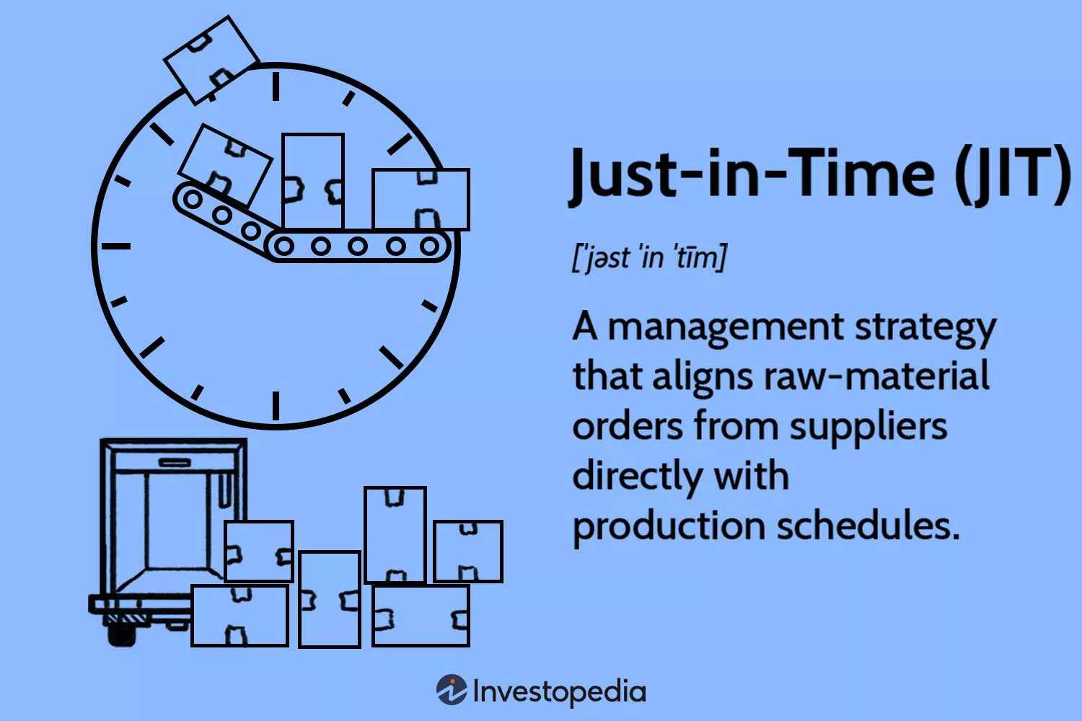
Figure 3 https://www.investopedia.com/terms/j/jit.asp
The demand and supply are also shaped by the organisational financial strategies associated with fundraising. For instance, initial public offering, popularly known as IPO helps in enhancing the degree of company demand and results in the enhancement in funds. The issue of shares is restricted by the organisation which helps in managing the supply as well. The organisations increase the value of shares when the demand exceeds as compared to the availability of shares which enables the firm to manage demand and supply.
Adequate demand and supply also facilitate the staff satisfaction and retention ratio for the long term of the business. Fostering adequate equilibrium in demand and supply ensures the proper enhancement in revenue and profit margin which enhances the net earnings of the business. Therefore, due to the improvement in financial performance, the business firms can provide higher salaries to the employees which enhances their job satisfaction and also ensures staff retention.
There are several risks associated with managing the balance between demand and supply of goods which incorporate market fluctuations, inflations, hindrances in distribution networks, shifts in consumer tastes, and so forth. Therefore, assessing the market dynamics, negotiating with vendors and assessing the customer demand using technologies like AI and ML ensures proper management of such aforementioned risks. Hence, improved risk management ensures the proper balance between consumer demand and product supply.
The market fluctuations sometimes disrupt the demand and supply of products. Hence, to get rid of it, business firms formulate strategies regarding enhancing production capacities, enhancing inventory optimisation, and diversifying the distribution networks Effective strategic adaptations in these disciplines help the business firms to match the supply with the market demand which prevents the shortage.
There is a huge difference in the elasticity and inelasticity of demand. Elasticity refers to the state in which consumers' purchasing behaviours shift in response to increases in earnings or prices (Diaz and Medlock, 2021, p.1). On the other hand, a product's demand is said to be inelastic when consumer buying patterns remain unchanged despite higher product pricing. For example, luxurious products with one of the substitutes are elastic in terms of demand whereas necessary products are inelastic in demand. However, this difference can also be portrayed by using the example of fuel which is an execution in this regard. During the Covid-19 pandemic and Brexit, the rate of inflation increased to a great extent and the price of products including fuel experienced a high boost in price (Hlaimi, 2021, p.23). The Russia-Ukraine war also enhanced the cost of fuels due to supply chain disruption. Therefore, the rising fuel prices led the the consumer preference shift towards spending for battery-powered or electric vehicles.
According to research, the demand as well as market for battery vehicles is increasing at an annual growth rate of 9.82% gradually (Statista, 2024). Hence, the consumer demand has shifted towards battery-powered cars which signifies that the the fuel demand is elastic enough. The demand of the consumers if not shifted towards the battery-powered cars, their consumption of fuel remained the same which could be stated then as inelastic. However, as the consumer preference has shifted towards battery-run vehicles, the fuel demand is considered elastic enough. On the other hand, demand elasticity incorporates several benefits including price optimisation, tax relief, and revenue maximisation whereas the drawbacks incorporate the continuous shifts in consumer preference. On the other hand, the elasticity of demand’s benefits incorporate revenue maximisation while having drawbacks of sluggish profit margin growth.
There are specific laws in the discipline of demand and supply of products. The basic law of demand and supply underlines the fact that when the price of the product increases, the demand for the product is reduced and the supply of the product is increased and vice versa. This is the ground law of demand and supply. This law can be illustrated in four distinct ways. First, an increase in a product's price raises customer demand if the supply of the good stays the same. This is because a limited supply will compel customers to buy the goods even with the price increase. However, if the product's supply stays constant and demand declines, businesses will be forced to lower their prices to draw in customers, which will result in a price fall. On the flip side, if the demand is unchanged and the supply of products is increased the price will be decreased and a greater volume of goods will be sold at lower prices. Conversely, if the demand is constant and the supply of products is decreased, the price of the products will be increased and the lower volume of products will be sold at higher prices. These are the grounded laws in the field of demand and supply.

Conclusion
Conclusively, it can be said that demand and supply are the key economic parameters which shape the firm's profitability and financial performance. There are several risk factors which can disrupt the overall demand and supply balance. For example, the outbreak of covid-19 and Brexit led to geopolitical and socio-economic distortions which resulted in supply chain shortages. This disruption in the distribution network resulted in an imbalance between the demand and supply which resulted in a huge loss in the business profitability as well as the overall economy. Hence, enhancing proper risk management strategies is necessary to manage with such certain risks which may hamper the demand and supply balance. Overall, it can be said that every single business firm must focus on assessing the market and consumer demand first and then manage their supply by fixing the proper price of the product. It will help in managing an equilibrium between the market demand and product supply and ensure the sustainability of the business for the long-term.

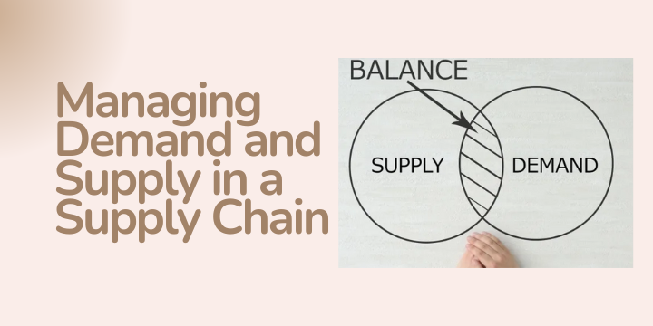
Figure 4 https://supplychainjournal.net/managing-demand-and-supply-in-a-supply-chain/

Reference List
Aigner-Walder, B. (2015) Effects of the Demographic Changes on Private Consumption: An Almost Ideal Demand System Analysis for Austria. Journal of Economic and Social Studies, 5, 1, 33-57 http://dx.doi.org/10.14706/JECO
Bagwell, K. (2005) The Economic Analysis of Advertising. Columbia University Discussion Papers No. : 050601 https://doi.org/10.1016/S1573-448X(06)03028-7
Baker, J. (2003) Competitive Price Discrimination: The Exercise of Market Power Without Anticompetitive Effects (Comment on Klein and Wiley). Articles in Law Reviews & Other Academic Journals. Paper 278. https://digitalcommons.wcl.american.edu/cgi/viewcontent.cgi?article=2130&context=facsch_lawrev
Cigliano, J. (1980) Price and Income Elasticities for Airline Travel: The North Atlantic Market, Business Economics, pp. 17–21. https://www.jstor.org/stable/23482366
Conlon, C. and Gortmaker, J. (2020) Best practices for differentiated products demand estimation with pyblp. The RAND Journal of Economics, 51(4), pp.1108-1161. https://bfi.uchicago.edu/wp-content/uploads/pyblp.pdf
Díaz, A.O. and Medlock, K.B. (2021) Price elasticity of demand for fuels by income level in Mexican households. Energy Policy, 151, p.112132. https://www.bakerinstitute.org/sites/default/files/2021-01/import/medlock-diaz-energypriceelasticity-2021.pdf
Febriyantoro, M.T. (2020) Exploring YouTube Marketing Communication: Brand awareness, brand image and purchase intention in the millennial generation. Cogent Business & Management, 7(1), p.1787733. https://www.tandfonline.com/doi/pdf/10.1080/23311975.2020.1787733 Khanom, M.T. (2023) Using social media marketing in the digital era: A necessity or a choice. International Journal of Research in Business and Social Science (2147-4478), 12(3), pp.88-98. https://doi.org/10.20525/ijrbs.v12i3.2507
Hlaimi, S. (2021) The Effects of Brexit and Covid-19 on Food Inflation in the United Kingdom. Journal of Interdisciplinary Food Studies, 1. https://ore.exeter.ac.uk/repository/bitstream/handle/10871/129801/document.pdf?sequence=1
Institute for Government. (2021) Institute for Government analysis of ONS, Business Impact of COVID-19 Survey (BICS). https://www.instituteforgovernment.org.uk/publication/supply-chains/causes (Accessed 22 July 2024)
intactone. (2022) Law of Demand. [online] intactone. Available from: https://intactone.com/law-of-demand/ (Accessed 23 July 2024).
Liu, B. (2022) Artificial Intelligence and Machine Learning Capabilities and Application Programming Interfaces at Amazon, Google, and Microsoft (Doctoral dissertation, Massachusetts Institute of Technology). https://dspace.mit.edu/bitstream/handle/1721.1/146689/Liu-Boyan-MSMS-Sloan-2022.pdf?sequence=1&isAllowed=y
Fathy, A., M Mostafa, A. and AbdelGaber, S. (2024) Comprehensive study for the inventory control management strategies. المجلة العلمية للبحوث والدراسات التجارية, 38(2), pp.1725-1750. https://sjrbs.journals.ekb.eg/article_359074_80e668abfdb509acc1cc5b364f1ca03e.pdf
Oboloo. (2024) What is Supplier Network Collaboration? – Definition – oboloo. [online] Available from: https://oboloo.com/what-is-supplier-network-collaboration-definition/ (Accessed 22 July 2024).
Schlosser, R., Westphal, J., Pörschke, M., Maltenberger, T. and Kaminsky, Y. (2022) Self-Adaptive Agents in a Dynamic Pricing Duopoly: Competition, Collusion, and Risk Considerations. SN Computer Science, 3(3), p.234. https://doi.org/10.1007/s42979-022-01114-z
Shahed, K.S., Azeem, A., Ali, S.M. and Moktadir, M.A. (2021) A supply chain disruption risk mitigation model to manage COVID-19 pandemic risk. Environmental Science and Pollution Research, pp.1-16. https://doi.org/10.1007/s11356-020-12289-4
Statista. (2024). Electric Vehicles - Worldwide | Statista Market Forecast. [online] Statista. Available from: https://www.statista.com/outlook/mmo/electric-vehicles/worldwide#:~:text=Looking%20ahead%2C%20it%20is%20expected (Accessed 23 July 2024).
Syaifullah, J., Syaifudin, M., Sukendar, M.U. and Junaedi, J. (2021) Social media marketing and business performance of MSMEs during the COVID-19 pandemic. The Journal of Asian Finance, Economics and Business, 8(2), pp.523-531. https://doi.org/10.13106/jafeb.2021.vol8.no2.0523
The Economic times. (2024) The Economic Times: Business News, Personal Finance, Financial News, India Stock Market Investing, Economy News, SENSEX, NIFTY, NSE, BSE Live, IPO News. [online] economictimes.indiatimes.com. Available from: https://economictimes.indiatimes.com/defaultinterstitial.cms (Accessed 23 July 2024).
Yavari, M., Enjavi, H. and Geraeli, M. (2020) Demand management to cope with routes disruptions in location-inventory-routing problem for perishable products. Research in Transportation Business & Management, 37, p.100552. https://www.ncbi.nlm.nih.gov/pmc/articles/PMC7486877/pdf/main.pdf
Zhang, C., Hu, M., Di Maio, F., Sprecher, B., Yang, X. and Tukker, A. (2022) An overview of the waste hierarchy framework for analyzing the circularity in construction and demolition waste management in Europe. Science of the Total Environment, 803, p.149892.https://doi.org/10.1016/j.scitotenv.2021.149892

Appendix

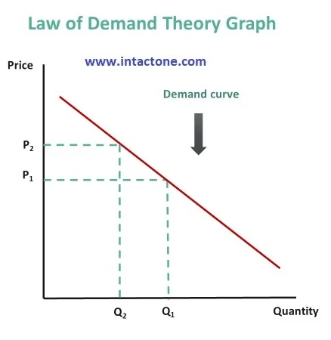
Figure: Law of Demand
(Source: intactone, 2022)

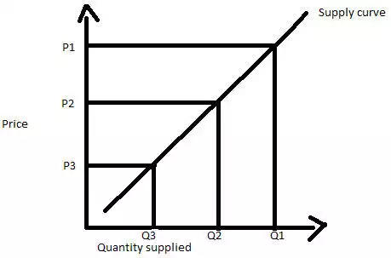
Figure: Law of Supply
(Source: The Economic times, 2024)

‌

