Student Name | Jose M. Lopete
Student Number | 1808701
Lecturer Name | Afzal Mannua
Module Title | Problem Solving and Decision Making
Module Code | BMSK4004

Contents
PROBLEM SOLVING AND DECISION MAKING 1
1.INTRODUCTION 3
2. DEFINITION PROBLEM SOLVING 4
3. LATENESS ISSUE 6
4. MY EXPERIENCE OF LATENESS/ABSENCE 8
5. SEVEN STEPS TO PROBLEM SOLVING WITH ATTENDANCE. 9
6.TYPE OF DECISIONS MAKIING 12
8. FACTORS AFFECTING DECISION MAKING WITH ATTENDACE ISSUE 12
9. INGREDIENTS OF DECISION MAKING IN ATTENDANCE. 13
10. ATTENDANCE FISHBONE ANALYSIS 14
11. PROPOSED SOLUTION 1 ATTENDANCE ISSUE 15

INTRODUCTION
Effective problems solving and decision-making ability are essential life skills. Therefore, an effective problem-solving skill is important in our day to day life, at home, at work, at school. In fact, in these places every day we fight to choose the best options and challenging common issues without knowing that we are using our problems solving and decision-making skills.
In this report the author discussed how to deal and face in the event of a problems either in the work place or daily life as well as how to decide a good decision. The key topic to analyses is the cause and effect of employee attendance problem. The aim of this report is to learn how to build a problem-solving toolbox in order to improve skills and gain a clear understanding of this matter within the work place. Furthermore, in order to keep the business going we will approach attendance issue by determine what happed, why it happen and select a valuable solution so it will not happen again. So, the report is divided in different section. We begin with brief introduction, the next section we explain the concept and definitions from the literature reviewed. We will them start breakdown the topic study which is attendance problem in the workplace. The next section We will also mention the author experience with lateness. In the middle of this report we will describe in four separate chapters the seven steps tool for problem solving, types of decision making, finally different factors affecting decision making and the ingredient we need to consider when taking a good decision. We will spend some time looking at the well know Ishikawa diagram as one best tool using in problem solving procedure. Finally, the report will suggest or give two possible solution when facing Attendance problem in the work place

DEFINITION PROBLEM SOLVING
Life is about learning sometimes we learn from experience, mistake or from our lacks knowledge whatever tools we consider, we always looking forward to solving an issue and take the best decision in order to keep the business going. (Maund, et al. 2017) point out that problem solving is about making quality election and is about thinking in an appropriate solution that all team member will start implement the decision.
As the graph bellow explain problem always appear in the organization when what we are being expected or planning is opposite what we have. In other words, company goal is going in different direction than the company current situation. Automatedly, management always must bear in mind the company goal when dealing with problem solving. The graph bellow describing a scenario for example, according to management team anticipation the ideal situation of attendance during the winter was 5%. however, the current situation says that employee attendance raises to 15% in the winter period. So, the gap is almost 10% above the normal expectation. Therefore, we have a problem with attendance in work place.

Ideal situation
We expected 5% of employee attendance during winter

PROBLEM: Is the Gap between the desire situation or the company goal and the current situation
G a p

Current situation
Employee attendance in winter is 15%

In the event of any issue we will think and design the strategy that help us solve the problem and take the best decision, so, there is nothing new under the sun, before we are facing a problem, we start by PDCA; PLAN-DO-CHECK-ACTION. Fortunately, the literature has been describing many problem-solving and decision-making techniques depending on people preference. In the chart below we mention strategies that use when approached any event in the work place.

TECHNIC | DESCRIPTIONS
Plus-Minus-Interesting (PMI) | When we consider Plus as positive, minus as negative and interesting refer to criteria of the problem solving
E. Evaluating/judging | When we are making a quantitative or quantitative judgment/comparison of worth (Bloom et al., 1956)
Ishikawa/Fishbone Diagram | We are looking for the cause and effect of the problem. In section eight we describe with more details.
PESTLE Analysis
A. Analysis | When spot the element of a scenario and consideration of all the relations among all parts (Bloom et al., 1956)
Categorizing/classifying | the process of recognize and choose rules to ideas, events, people, etc.
Thinking aloud | While our partner is listening for any errors, we are verbalizing about an issue with a solution.
Network analysis | The process using in large project planning. Network system where we have relationships between events, and we must develop the shortest way or solutions. CPM-Critical Path Method is an example of Network Analysis.
Task analysis | In order to perform an issue, we need some knowledge and perform abilities.
Brainstorming | With nonjudgmental stile all team member will write different solutions for fix the issue, then explain the outcome and creating alternative  factor will be considered when decide which solution are the best for the organization.
Taking another's perspective | The process is knowing as “be someone else”. The individual deliberately using someone point of view.
Random word technique | In This process we use brainstorming technique. After pick a word randomly and them compare it with the debating issue.
Incubation | The process when after taking aside the issue we start making something different so the mind will think in something different
SWOT Analisy
Gradients of Agreement | when team members trying to reach an agreement rarely it is not always 100% agree or disagree. All is not about say “YES” or “NOT” it helps identify where every team member stand for the solution. I

While Problem solving raise the company efficiency and productivity it is one of most demanded soft skills by organization when looking for employee. there are large numbers of skills we need to implement in order to excel and make it less difficult the problem solving and decision-making ability such as: Thinking and creative skills, Team working skill, communication skill and effective leadership.

LATENESS ISSUE
The word absence is defined as, when someone not sow-up at work place and he or she required to do. (Johns, 2003) referred to absence as missing workload for all the entered shift. In some organization absence policy distinguished two type of absence; in one hand authorized absence is went management authorized he or she not to sow-up at the work place and can be paid or unpaid, in the other hand authorized absence as there is not authorization for missing your shifts and you not sow-up, in this case is always unpaid. So, lateness is went the employee start his or her workload late or finish before the end of the shift (Koslowky, 2000). Alternatively, in some policies to much lateness are register as absence. Absences can be put together in the same box as employee’s lateness and employees intend to leave furthermore, we will rename this box as withdrawal behavior box. According to (Kaplan et, al 2009) employee withdrawal behavior is went your coworker staying on the job but not sowing no interest and non-intention with the job therefore decreasing his or her participation. Intend to leave is went voluntary the employee start making all he or she can so the organization will remove him from the job.
Example of lateness vs absences issue at the work place: an employee calling the company`s control center to inform that he will be late because it has been a disruption in underground.
Employee: “Hi good morning this is john with ID No. xxxxxxx am Colling regarding my shift, just to let you know I will be thirty-five minute late”.
Employer: “we had been tried to reach as your phone is off and you shift started 1 hour ago, can you tell us why you late because this is the second time you late in two week period, as you well know you are the only delivery driver this month and am afraid this will cost many and lose of customer, please let me know went you back because we need to discuss this matter in my office asap”.
There are many reasons for attendance issue either voluntary or involuntary, however what we know from some organization point of view is this behavior are detrimental and cause allots of problems such as: productions lose, reduce coworker motivations and bad for the company effectiveness. (Harvey & Nicholson, 1993) define absenteeism like so far, the single source of lost production in few company and organization. The direct impact of absenteeism is wage pay to co-worker and cost for replacement coworker. (Ho, 1997) assert by not only mentioned the direct cost of attendance issue but he outlines the indirect impact in the company such as: extra disruption at work, reduce of company reputation due customer dissatisfaction and poor quality of goods, however, the real cost of attendance is even bigger. In the chart below we mention the impact of attendance issue:

EMPLOYER IMPACT  - Reduction in productivity and profits  - Wages pay to absent employee  - Customer/client dissatisfaction/poor quality of goods  - Extra Disruption to work  - cost for replacement workers/replacement workers.  - Reduce your company reputation  - Administrative cost of managing absenteeism | EMPLOYER IMPACT  - Feelings of stress and/or guilt  - Colleague resentment/poor morale among them.  - Inefficient start to the day  - Increase college own absence  - Lose trust from your team work

As the above figure describe there are more disadvantage than advantage when we are mentioning the impact of attendance at work place. According to (Liu & Meyer, 2005) low salary is a Singh of employee happiness and therefore this impact on employee miss behavior within the organization. Both employers and employees they expected thrust from each other: in one hand employee expect extra benefit, acceptable salary and decent working condition, in the other hand the organization expect loyalty and respect form employee. (Bayram et al., 2009) point out that absenteeism in the work place is a breach of job agreement between the employee and the organization, So, if both want to stay fairly this relationship, they must consider employee Contract. (Meyer & Allen, 1997) mentioned tree type of Company Commitment: first affective commitment refer to employee involvement in the company and their identification with the organization second is Normative Commitment is the sense of obligation to continue working for the organization and third is the Continue commitment is went people prefer stay in the organization because the cost of leaving the company is high. Having outline all commitments the question in this report is: what make the level of employee attendance?
HEALTH AND LIFESTYLE FACTORS  - Bad habit: smoking  - Excessive use of alcohol  - Lack of exercise  - weight | WORK PLACE FACTOR  - Health and safety issue  - Working life  - Travel |Time  - Extreme hours
ATTITUDINAL AND STRESS FACTOR  - Job satisfaction  - Career satisfaction  - Intention to leave  - Organizational commitment  - Stress  - Bullying/Harassment | DOMESTIC AND KINGSHIP FACTOR  - Gender  - Number of Children under 15  - Lack of flexible hours Arrangement

ATTENDANCE EXPERIENCE
I am Work in TSS security service it’s a security company based in London with a wide range of offices all over UK and employees over five hundred staff. The company`s vision is: “It is our intention to attract the best staff and management and to be the number one choice not only for customers, but also for those seeking employment in security services”
With no intention to undermining the vision there are few values that defining the type of organization TSS is and what it will like to be in the future. This value is: Teamwork, Respect, Integrity, Excellent and Development. Some values and ambitions of TSS business are outline below.

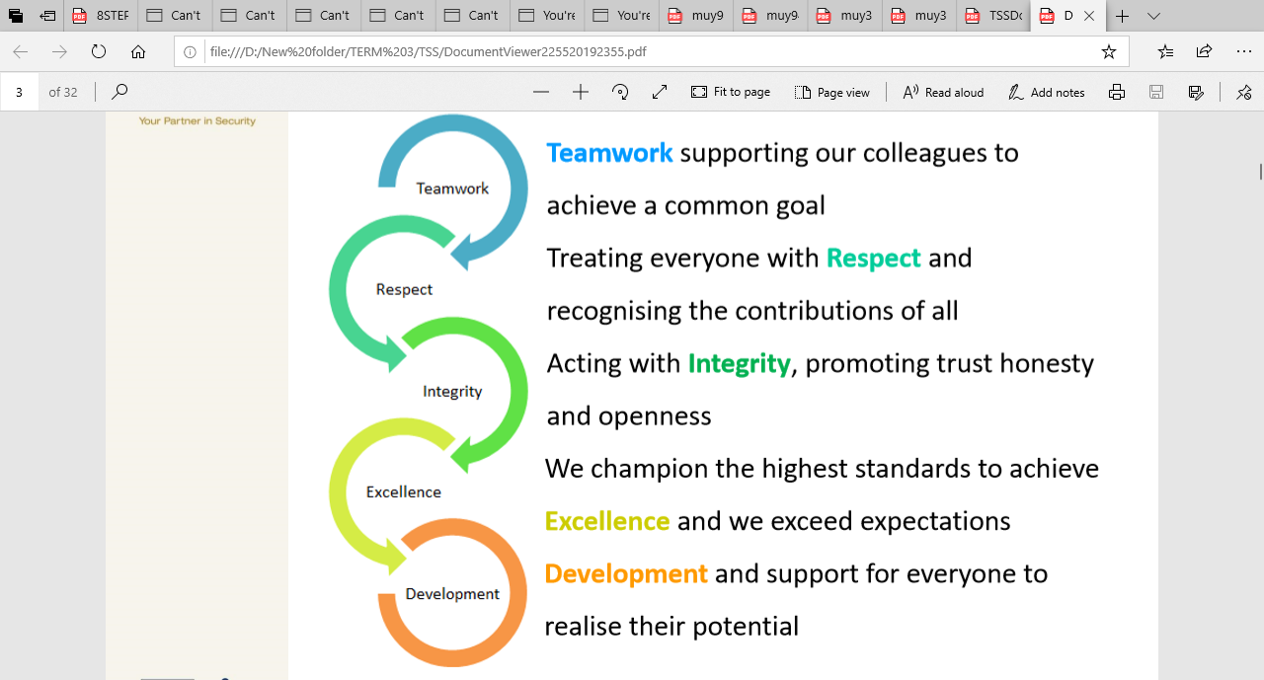
Value like “promoting trust and honesty, supporting and treating everyone with respect” will be fundamental in employee attendance issue. In order to meet this value, there is a need for the company to work as one team, treat everyone with respect and dignity, for managers to help and inspire staff and finally give staff the chance to work flexibly in order to balance their job and family life. TSS management understands that their workforce is crucial if they one to continue success and delivery all their essential values. TSS is currently facing many human resources issues and management must deal with problems like lateness, few members of staff not sow-up and absenteeism. In order to reduce worker absence levels, enhance employee motivation and increase performance and productivity the company priority is to help employees enjoy an appropriate work life balance and providing a wide range of flexibly hours. The author believes that a company`s biggest assets its people, and the greatest asset employees have is their health and well-being so, it will be wrong decision if the company does not look after their health issue. Therefore, the main drivers for this report will be the need to address attendance issue and implement solutions.
Company Handbook: in this document the employees will find all concerning lateness and absence, you must be on site 15minute before your shift start if you are late you most ring control center and tell them why and when you will be on site, you only be pay for the time you are working.
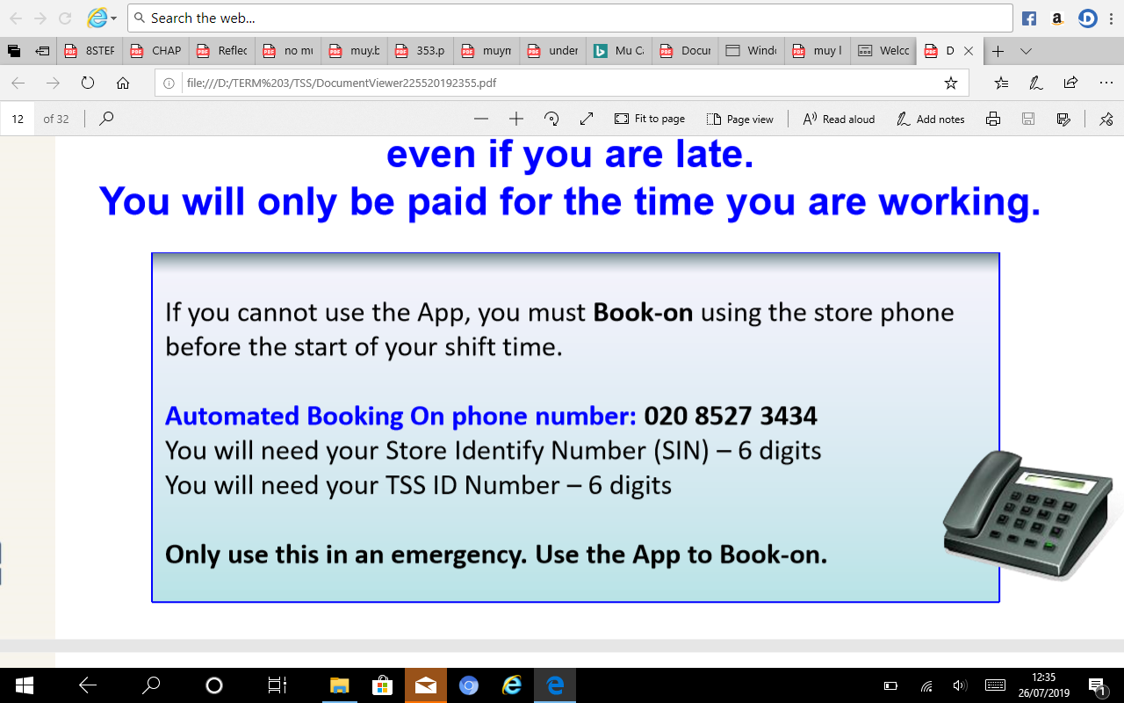
Source: Tss hand book

SEVEN STEPS TO PROBLEM SOLVING WITH ATTENDANCE.
Normally, all problem solving, and decision-making models have at least four distinctive stage (Dewey, 1933), any stage of the process have some type of specific steps that we must completed and them get into the next level or step. Always be prudent and think always in your goal because the solutions you get in mind must be equal to the company goal. So, in this section we will discussed with detail all step by step problem solving method and we will be focus in seven step problem solving and decision-making process.
first step is to identify the problem there are many strategies such as: RCA (Root Cause analysis), 5 Why analysis. The first thing is to get clear knowledge and understanding of the issue. Basically, we start by identify the issues and state them transparently and precisely. When we say identify the problem its means defining as concisely as possible the breach or space between the present or actual circumstance and what we will like to happen or been planned. Below is the 5-Why diagram Analysis describe with more details by asking why most employees are always late or not sow-up at the work place.

Second step in this step we breakdown and analyse the attendance issue within the company Why your colleague is been always late, is that because excessive use of alcohol or because he or she have intention to leave so this will be the roots cause of our topic however, what are the effects? Fishbone and Brainstorming is a good tool to face the problem-solving and decision-making process. Fishbone tool will be wide discussed further in section eight of this report.

Third Step in this phase is to identify and state some criteria, evaluate and selected some possible solutions and write dawn what make the company management have difficult to deal with attendance issue. We will gather all data and relevant factors that will be used to solve the problem or deciding (Beinstock, 1984) note that gather too many information can cause sometime confuse the issue rather than make it better. Before we face this step and in order to plan a good decision that the company will be fallow, we need get clear understanding of the company`s vision. Again, as we did in second step in this section we will be using brainstorming technic, all team members quickly note those facts that anyone think is relevant for fix attendance issue.
Fourth Step In this step the exercise is to evaluate, selected and develop solutions that can aloud us solve our topic. We will start by developing any alternatives or possible solutions so, plenty time will need to spend on this task to make sure that the entire range of acceptable solutions are identify. Although will face this phase by quickly write all options using brainstorming technic then once we have discovered possible decision we will weighing the pros and cons by using PMI strategy for share and discussed as a group the disadvantages what is bad, advantages or what is good and interesting or what is interesting aspects for any solution. Our table below we use PMI technic to evaluate one possible solution:
PMI
make sure your employees absence policy is read and understood by any employees.

Plus + | Minus - | Interesting
-Employee will manage more accurate they time. (+3)  -No misunderstand in term of employee contract. (+3)  -Company will know any individual level of commitment. (+5) | -Tame lost for reading and understood the policy document. (-2)  -Management will work more hours for implement and design the document. (-5)  -More complain from some worker because the new rule. (-4)  -Employee will fill like the company do not trust them.  (-2) | -The company will know:  Who they must Trust? (+5)  Who has commitment? (+5)  -customer know about this policy customer will get. (-4)  -It’s not good for company with few employees. (-4)  -must write daw a policy with non-discrimination. (+5)
Total = +11 | Total = -13 | Total= 7

Five Step In this phase we plan, develop and choose those strategies that team members consider is the best option that will successfully help solve the absence and lateness issue. However, if the previous steps have been done well sometime selecting any solution is not going to be complicate (Simon, 1969), Also before jump into next step we must take into consideration any worst scenario and double check for possible problem with the selected solutions.

Six Step During the six step a plan has been developed and the decision are already implemented. While the plan must be enough detailed we must put in place methods of evaluations so it will allow us a god implementation. This step we are using technique such as SWOT analysis, Network analysis, etc.
Seven Step this is the review phase the aim of the problem solving, and decision-making is to implement and assed the select solution however because we omit the review step sometime the process is often failed. Therefore, if we are looking forward to implementing and make valid any decision we must take into consideration the review step. We must evaluate any outcomes in term of efficiency, also we must judge and check the selected alternatives for any impact in the business.

TYPE OF DECISIONS MAKIING
In this section we are discussing different types of decision making using in the event of an issue. The diagram bellows the author list and describe tree different type each one has different orientation of decision-making process.
INNOVATIVE this type of decision is necessary when problems
are uncommon and rare. ROUTINE we select this type of
decision when sing a predetermined rule and organisation.
Policy for example in the event of a fire or emergency
resuscitation procedure.
ADAPTIVE this type of decision appears when he
problem is unusual and we must make some extra change for
example, changing working hours.

FACTORS AFFECTING DECISION MAKING WITH ATTENDACE ISSUE
There are a variety of factors affecting our problem solving and decision making so, in this section we are analyzing and define some element affecting the decision-making process. The level of the elected solutions will depend on factors considered when we make our decision process.

INGREDIENTS OF DECISION MAKING IN ATTENDANCE.
In the previous chapter we mention few factors that affecting the decision-making process in this section we will mention the ingredient we have consider when in order to have an effective decision making.
- Always PDCA, follow a systematic procedure PLAN-DO-CHECK-ACTION for example in the even of any issue such as: costumer complaining, problem with supplier we face the problem step by step. First, we PLAN after identifying we close the identify stage, next phase we DO by implementing possible solutions for your target problems after found out and closing own we jump into the next phase and so on.
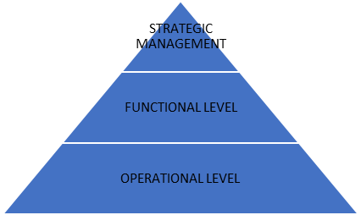
- Involve any team member from the organization. This mean we
must open mind and gather information from all party starting
from the lowest Operation, jump to Functional level and then top
of the organization which is Strategic management.

- Delegate some decision: Depending of the factors involving decision making such as: routine or non-routine, Experience, Knowledge or personal ability of your coworker, etc. in some cases is good if we delegated some decision to functional or operational level. There is many accepted working as team theories such as: Tuckman model (Tuckman & Jensen, 1977) and Equilibrium model (Gersick, 1988) both authors assume that any organization in order to achieve good level of performance management team must start encouraging employee to work as a team.

- Use Brainstorming technic and generate creative ideas: there are few benefits to have a good decision-making working as group. Management will lead a meeting with a group and will listening all proposal from participants. Any team members will write different solution using the Brainstorming technic. For the brainstorming technic we must bear in mind that quality of the solution is more important than the quantity.

ATTENDANCE FISHBONE ANALYSIS
Some Employees miss job for variety reasons, some of which are legitimate, and others are less legitimate. Study from (Personal Finance Report 2013) outline some of the causes of employees not being sow-up from the work place, the report mention: health and lifestyle issue like depression, work place problems such as: injuries, bullying and harassment. Alternatively, to explain the cause of attendance issue we going to be using the cause and effect Ishikawa Diagram or also calling Fishbone Diagram as tool for obtaining the causes and effect of attendance.

ISHIKAWA-DIAGRAM
CAUSE |  | EFFECT
INTENTION TO LEAVE
HHH
BULLYING/ARASSMENT

ATTITUDINAL AND STRESS FACTORS

HEALTH AND LIFESTYLE FACTORS
WORK PLACE FACTORS

ABSENCE
LATENESS
IN THE WORKPLACE

DOMESTIC AND KINGSHIP FACTORS

PROPOSED SOLUTION 1 ATTENDANCE ISSUE
The organization need to put in place a policy that include and describe all fact that concerning attendance issue. In the Employee Handbook we must contain a clear and effective lateness policy that all the organization from the top management to the lowest employee must follow. The policy should be clearly read and understood and well communicate furthermore employee policy must include the following information:
- A declaration warning employee that they are expected to arrive at least fifteen minutes before the start of the shifts, arriving with zero time it is not acceptable as we need to give any individual a security brief, signing preparation, etc.
- Who employee going to report in case of any lateness or absence and explain clearly the what is the company definition of tardiness.
- Describe formal and fear the Disciplinary Procedure for example, what action the company will put in place in case the employee is always late.
- Outline clearly the company Disciplinary Procedure in the event of employee tardiness for example, what will happen in term of payment, the location of the disciplinary meeting and the way we going to carry on the meeting like through phone, skype, wasap or a brief letter.

- PROPOSED SOLUTION 2 ATTENDANCE ISSUE
Employees is an asset in the company furthermore the success or the failure of the organization depends on the level of an individual withdrawal behavior such as: ethical behavior and lack of physical presence at where or when someone is expected to be. We should not have to stuck in the dark edge, Therefore, in order to stop or decrease any withdrawal behavior the Human resource department must listening, recognized and detect on time any problem that affect employees. After management ensuring that attendance policy is on place and understood by all individual there are numbers of actions we must put in place and make sure employee aware of the company`s commitment with attendance issue.
- Introducing a clocking-in and clocking out procedure.
- Implement monthly or annual bonuses.
- Increase punishment like suspension of one day without salary for each three tardiness.
- Use Disciplinary Interviews; management will have a face-to-face interview by asking and it is possible he will threaten the employee.
“are you conscious about the damage your lack of absence creating in the whole company”
“Sorry am afraid we are not going to be renewed your next contract”
“I ave to let you know your promotion to management position have been cancelled until you
recovered your attendance level”

Reference list:
Arnold, J. (1978). The seven building blocks to better decisions. New York: AMAACON
Brayram, N., Gursaka, I., Bilgel, N. (2009). Counterproductive work behaviour among white- collar employees: a study from Turkey. International Journal of Selection $ Assessment. 17(2), pp. 180-188
Beinstock, E. (1984). Creative Problem Solving. Stamford, CT: waldentapes.
Bloom, B., Englehart, M., Furst, E., Hill, W., Krathwohl, D. (1956). Taxonomy of educational objective: The classification of educational goal. Handbook I: Cognitive domain. New York: Longmans Green.
Dewey, J. (1933). How we think. New York: Health. (Originally Published in 1970).
Harvey, J., Nicholson, N. (1993). “Incentives and Penalties as a means of Influencing Attendance: a study in the UK public sector”. International Journal of Resource Management, Volume 4, No 4, pp 641-855.
Ho, J.T.S. (1997) “Corporate wellness programmes in Singapore: effect on stress, satisfaction and absenteeism”, Journal of Managerial Psychology, volume 12, No. 3, 177-189.
Jhons, D. (2003). How Methodology Improved our understanding of absenteeism from work, human resort management review, pp. 13, 257-184.
Koslowsky, M. (2000) “A New perspective on employee lateness,” Applied Psychology: An International Review, 49, 320-335.
Morgan, P. (2017). The business Student`s Guide to Study and Employability. London. Sage Publications.
Maund, A., Schriek, M., K. Tinkler, P. (2017). Certificate in Higher Education: Skills for the Workplace Student Yearbook. London. Sage. Publication
Personal Finance (2013). The causes and costs of absenteeism in the workplace. [online] Available at: http://www.forbes.com/suites/investopedia/2013/10/thecauses-cost-of-absence-in-the-workplace. [Accessed on 24 August]
Simon, H. (1969). The sciences of the artificial. Cambridge: M.I.T. Press.
Tuckman, B. W., & Jensen, M. (1977). Stages of small-group development revisited. Group and Organization Studies, 2, 419-427.

